Screening and Identification of Azo Dye Decolourizers from Mangrove Rhizospheric soil
Akhilesh Modi^{1,2}, Sunita Singh²*, Jyoti Patki², Naveen Padmadas²

1: Gujarat Biotechnology Research Centre, Sector 11, Gandhinagar-382011, Gujarat India
2: School of Biotechnology and Bioinformatics, D.Y Patil deemed to be University, Navi Mumbai- 400706 (India)
*Corresponding Author: Dr. Sunita Singh, Associate Professor
School of Biotechnology and Bioinformatics, D.Y Patil deemed to be University, Navi Mumbai- 400706 (India)
Email Address:*sunita.singh@dypatil.edu

Supplementary file
S1. Analysis of bacterial growth
The growth of all isolated bacterial cultures was spectrophotometrically monitored at 600nm at varied time intervals during dye decolorization.
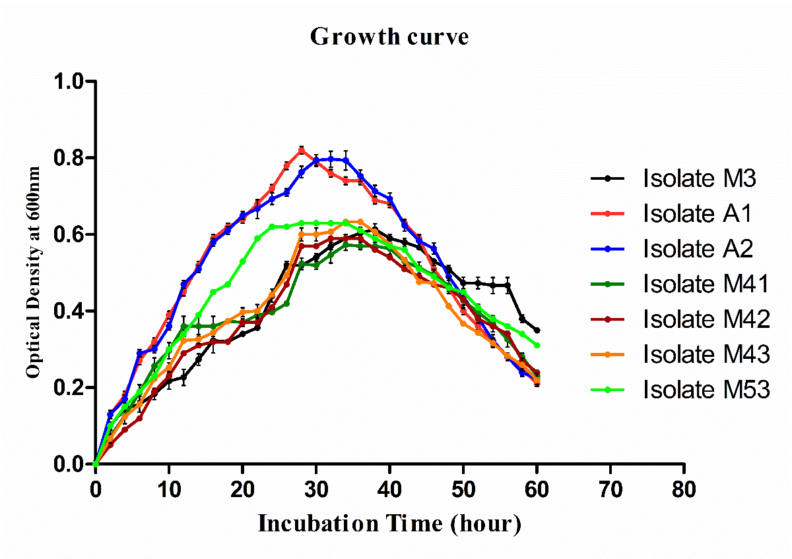
Figure S1: Growth curve of all bacterial isolates during dye decolourization

S2. Screening of dye decolourizers based on clear zone on Nutrient agar plate containing Methyl Orange dye.

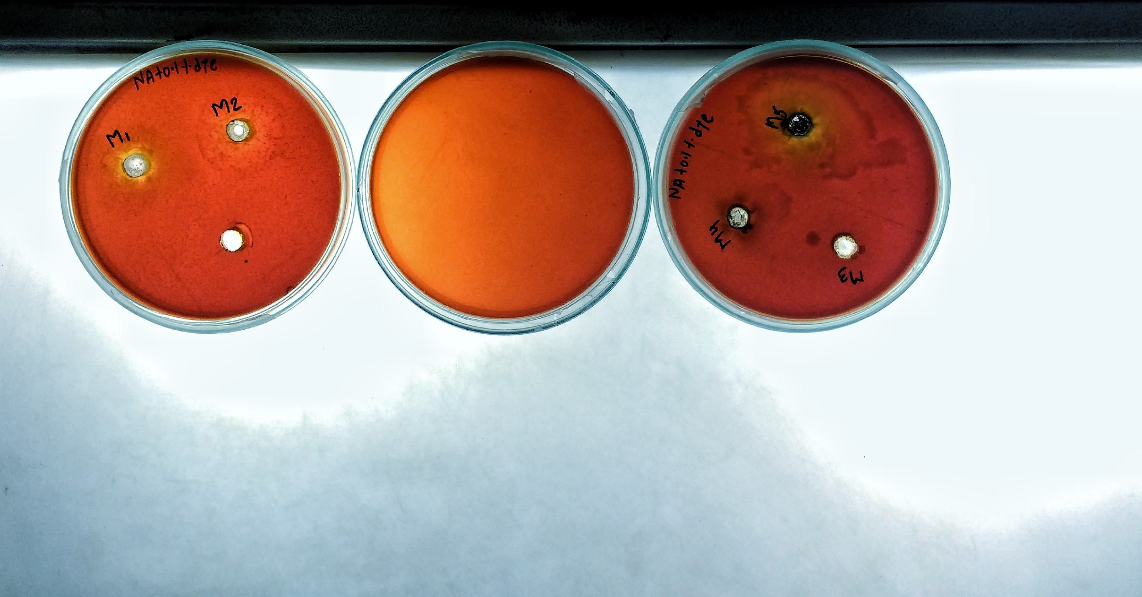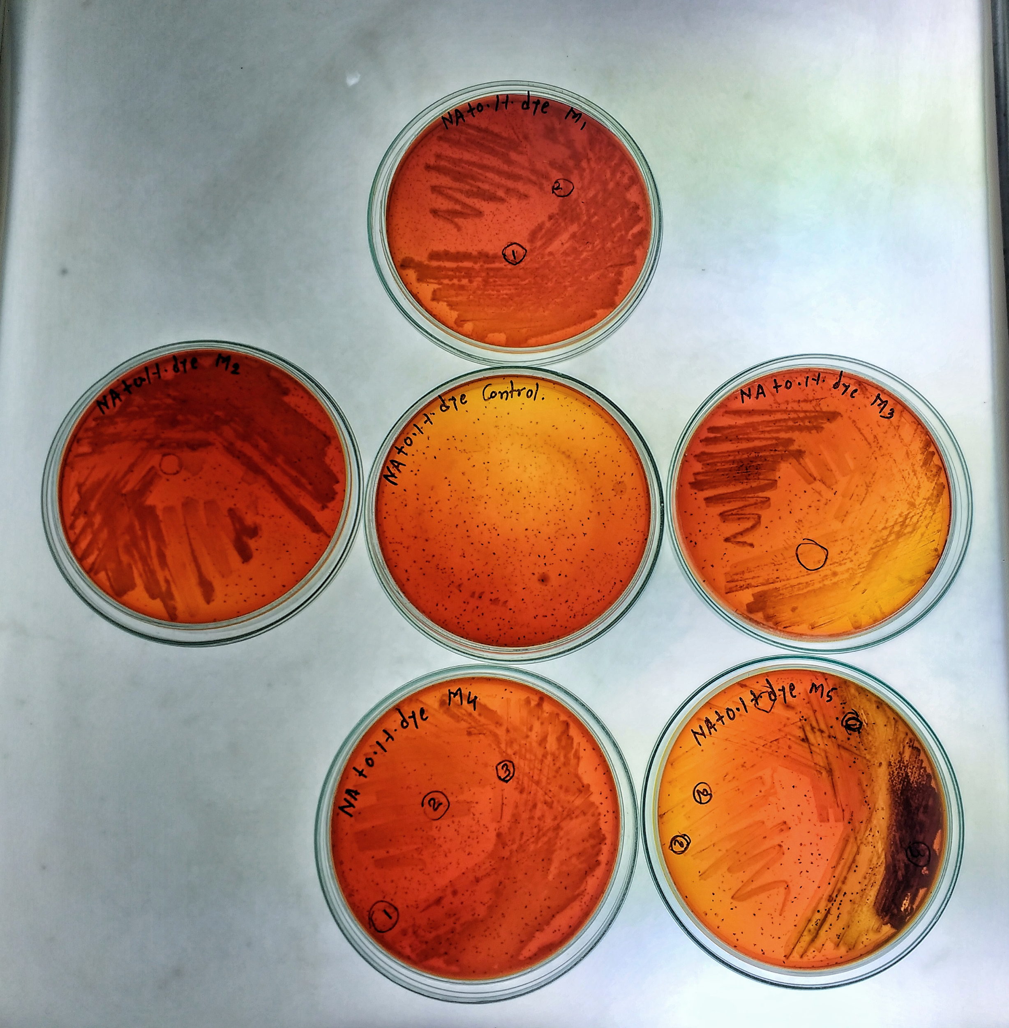
a- control NA plate with 0.1% MO dye b- decolourization zone on NA plate with 0.1% MO
c- control NA plate with 0.1% MO dye d- decolourization zone on NA plate with 0.1% Mo
Figure S2. Bacterial Colonies from five soil sample showing decolourization zone on NA plate with 0.1% dye.

S3. Effect of dye concentration on dye decolourization

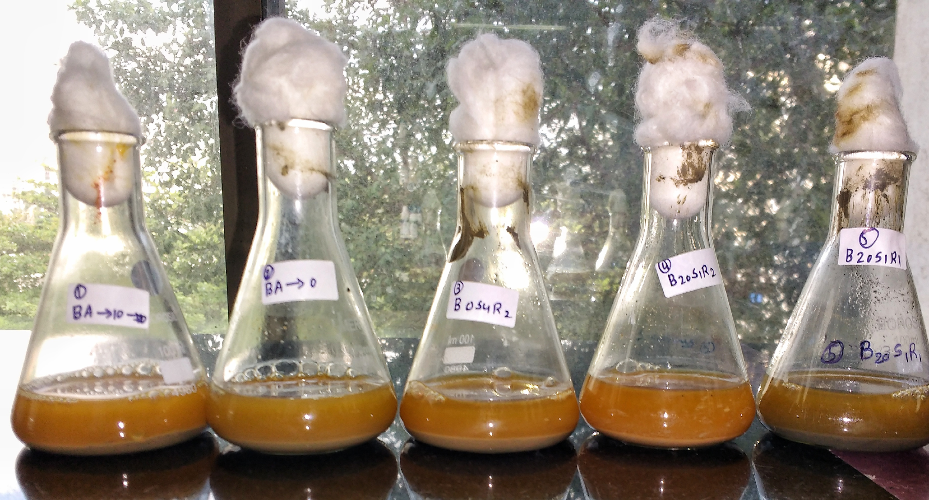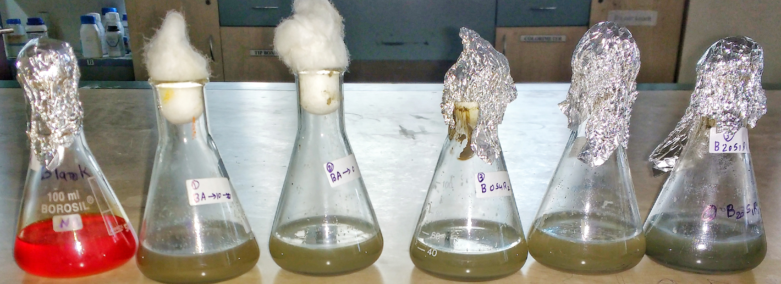
a- At zero-hour incubation in NB b- At 48-hour incubation in NB
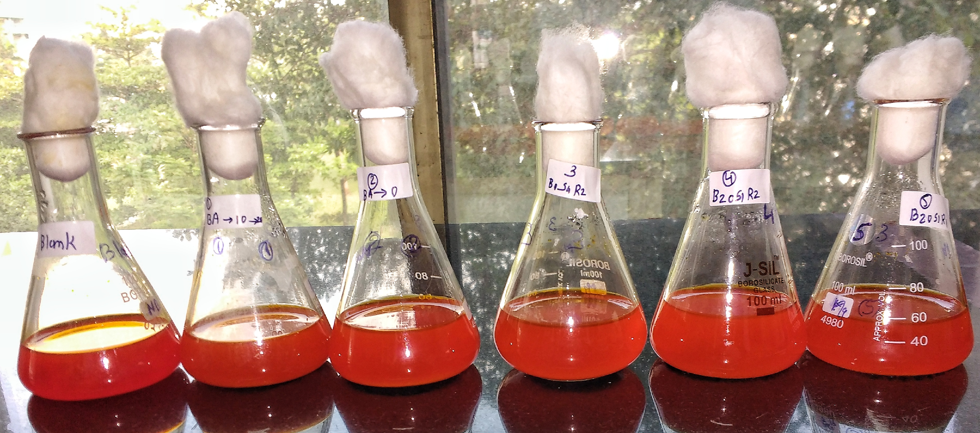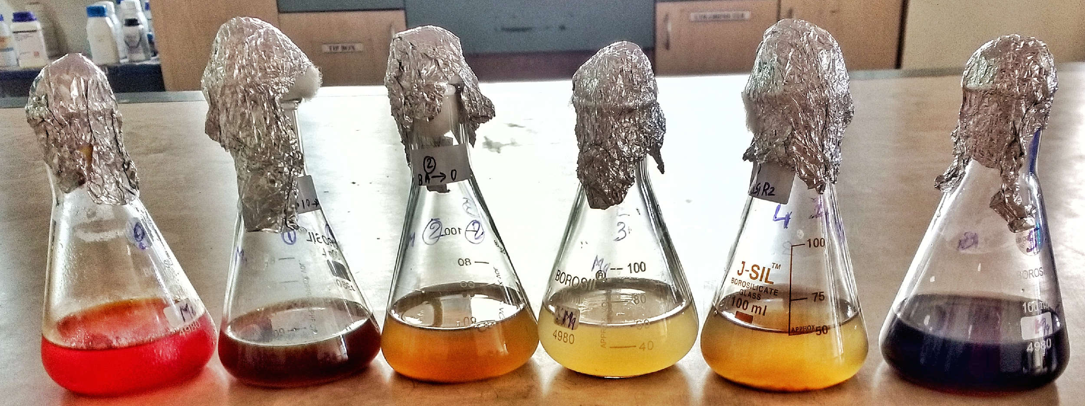
c- At zero-hour incubation in MBM d-At 48-hour incubation in MBM
Figure S3A. Enrichment of five soil sample in NB media (a&b) and (c&d) MBM media with 0.2% Methyl Orange at pH 7.0, 25°C under static condition
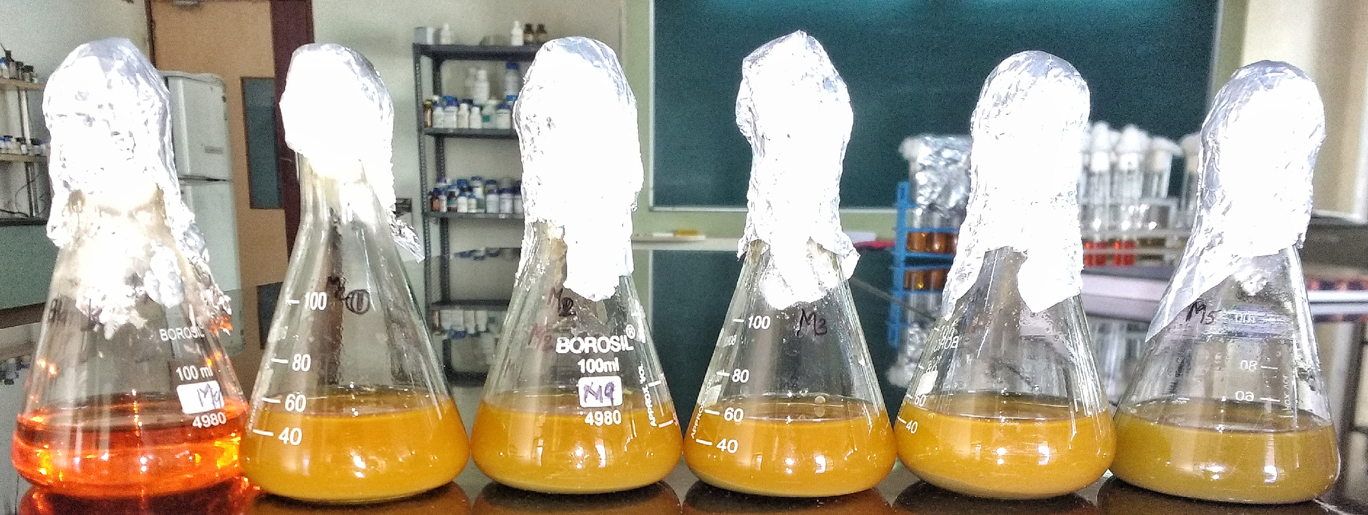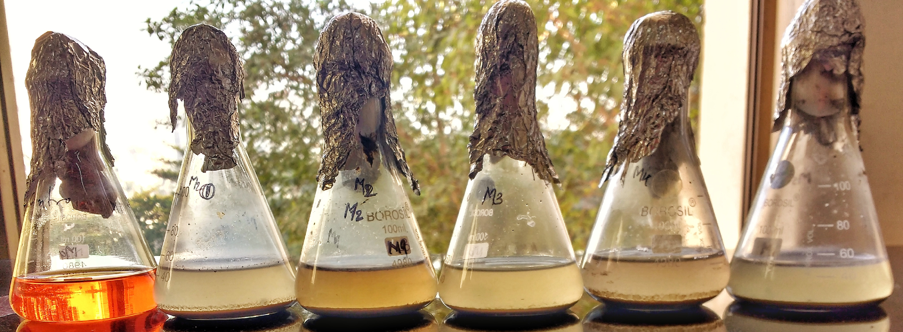
a-At zero-hour incubation in MBM b-At 48-hour incubation in MBM
Figure S3B. Enrichment of five soil sample in MBM media with 0.1% Methyl Orange at pH 7.0, 25°C under static condition

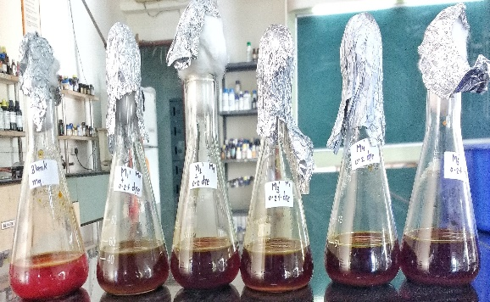
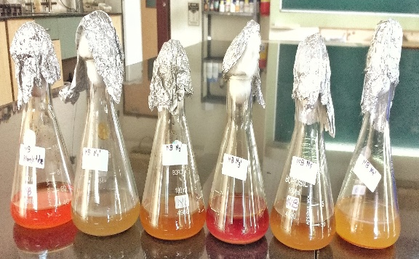
S4. Effect of media on dye decolourization

a. Dye decolourization in NB media b. Dye decolourization in MBM media
Figure S4. Effect of media on dye decolourization of Methyl Orange

S5. Effect of pH on dyed decolourization.

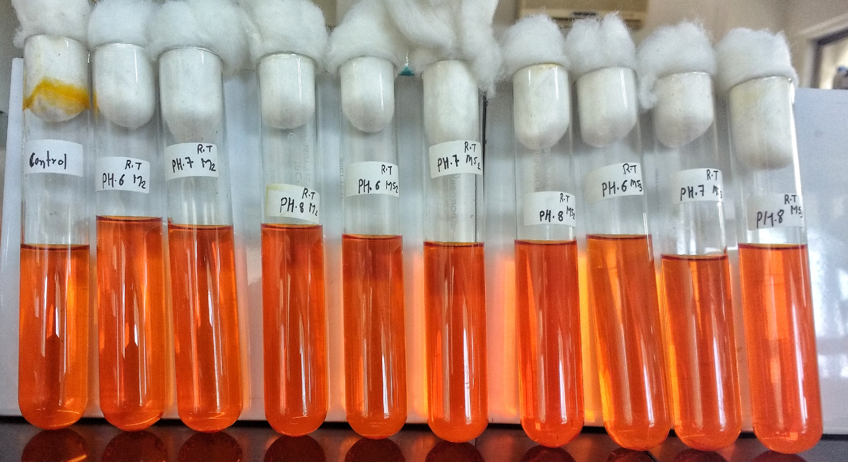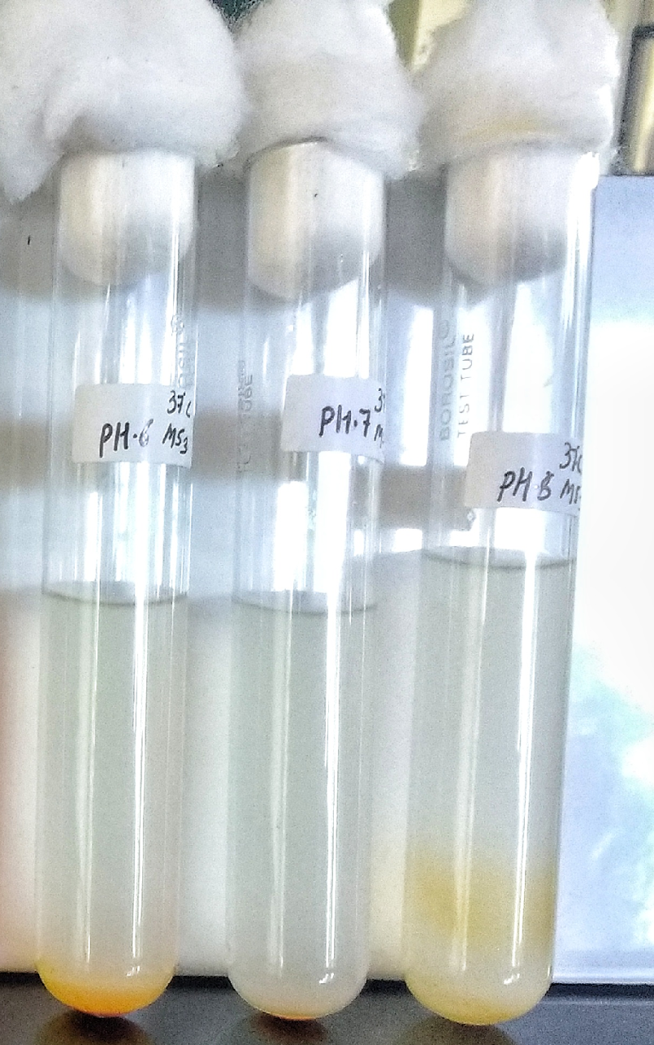
a-At zero-hour incubation b-At 26-hour incubation
Figure S5. Effect of pH on dye decolourization of Methyl Orange (at 1000 mg/L dye concentration, 37°C under static.

S6. Effect of temperature on dye decolourization

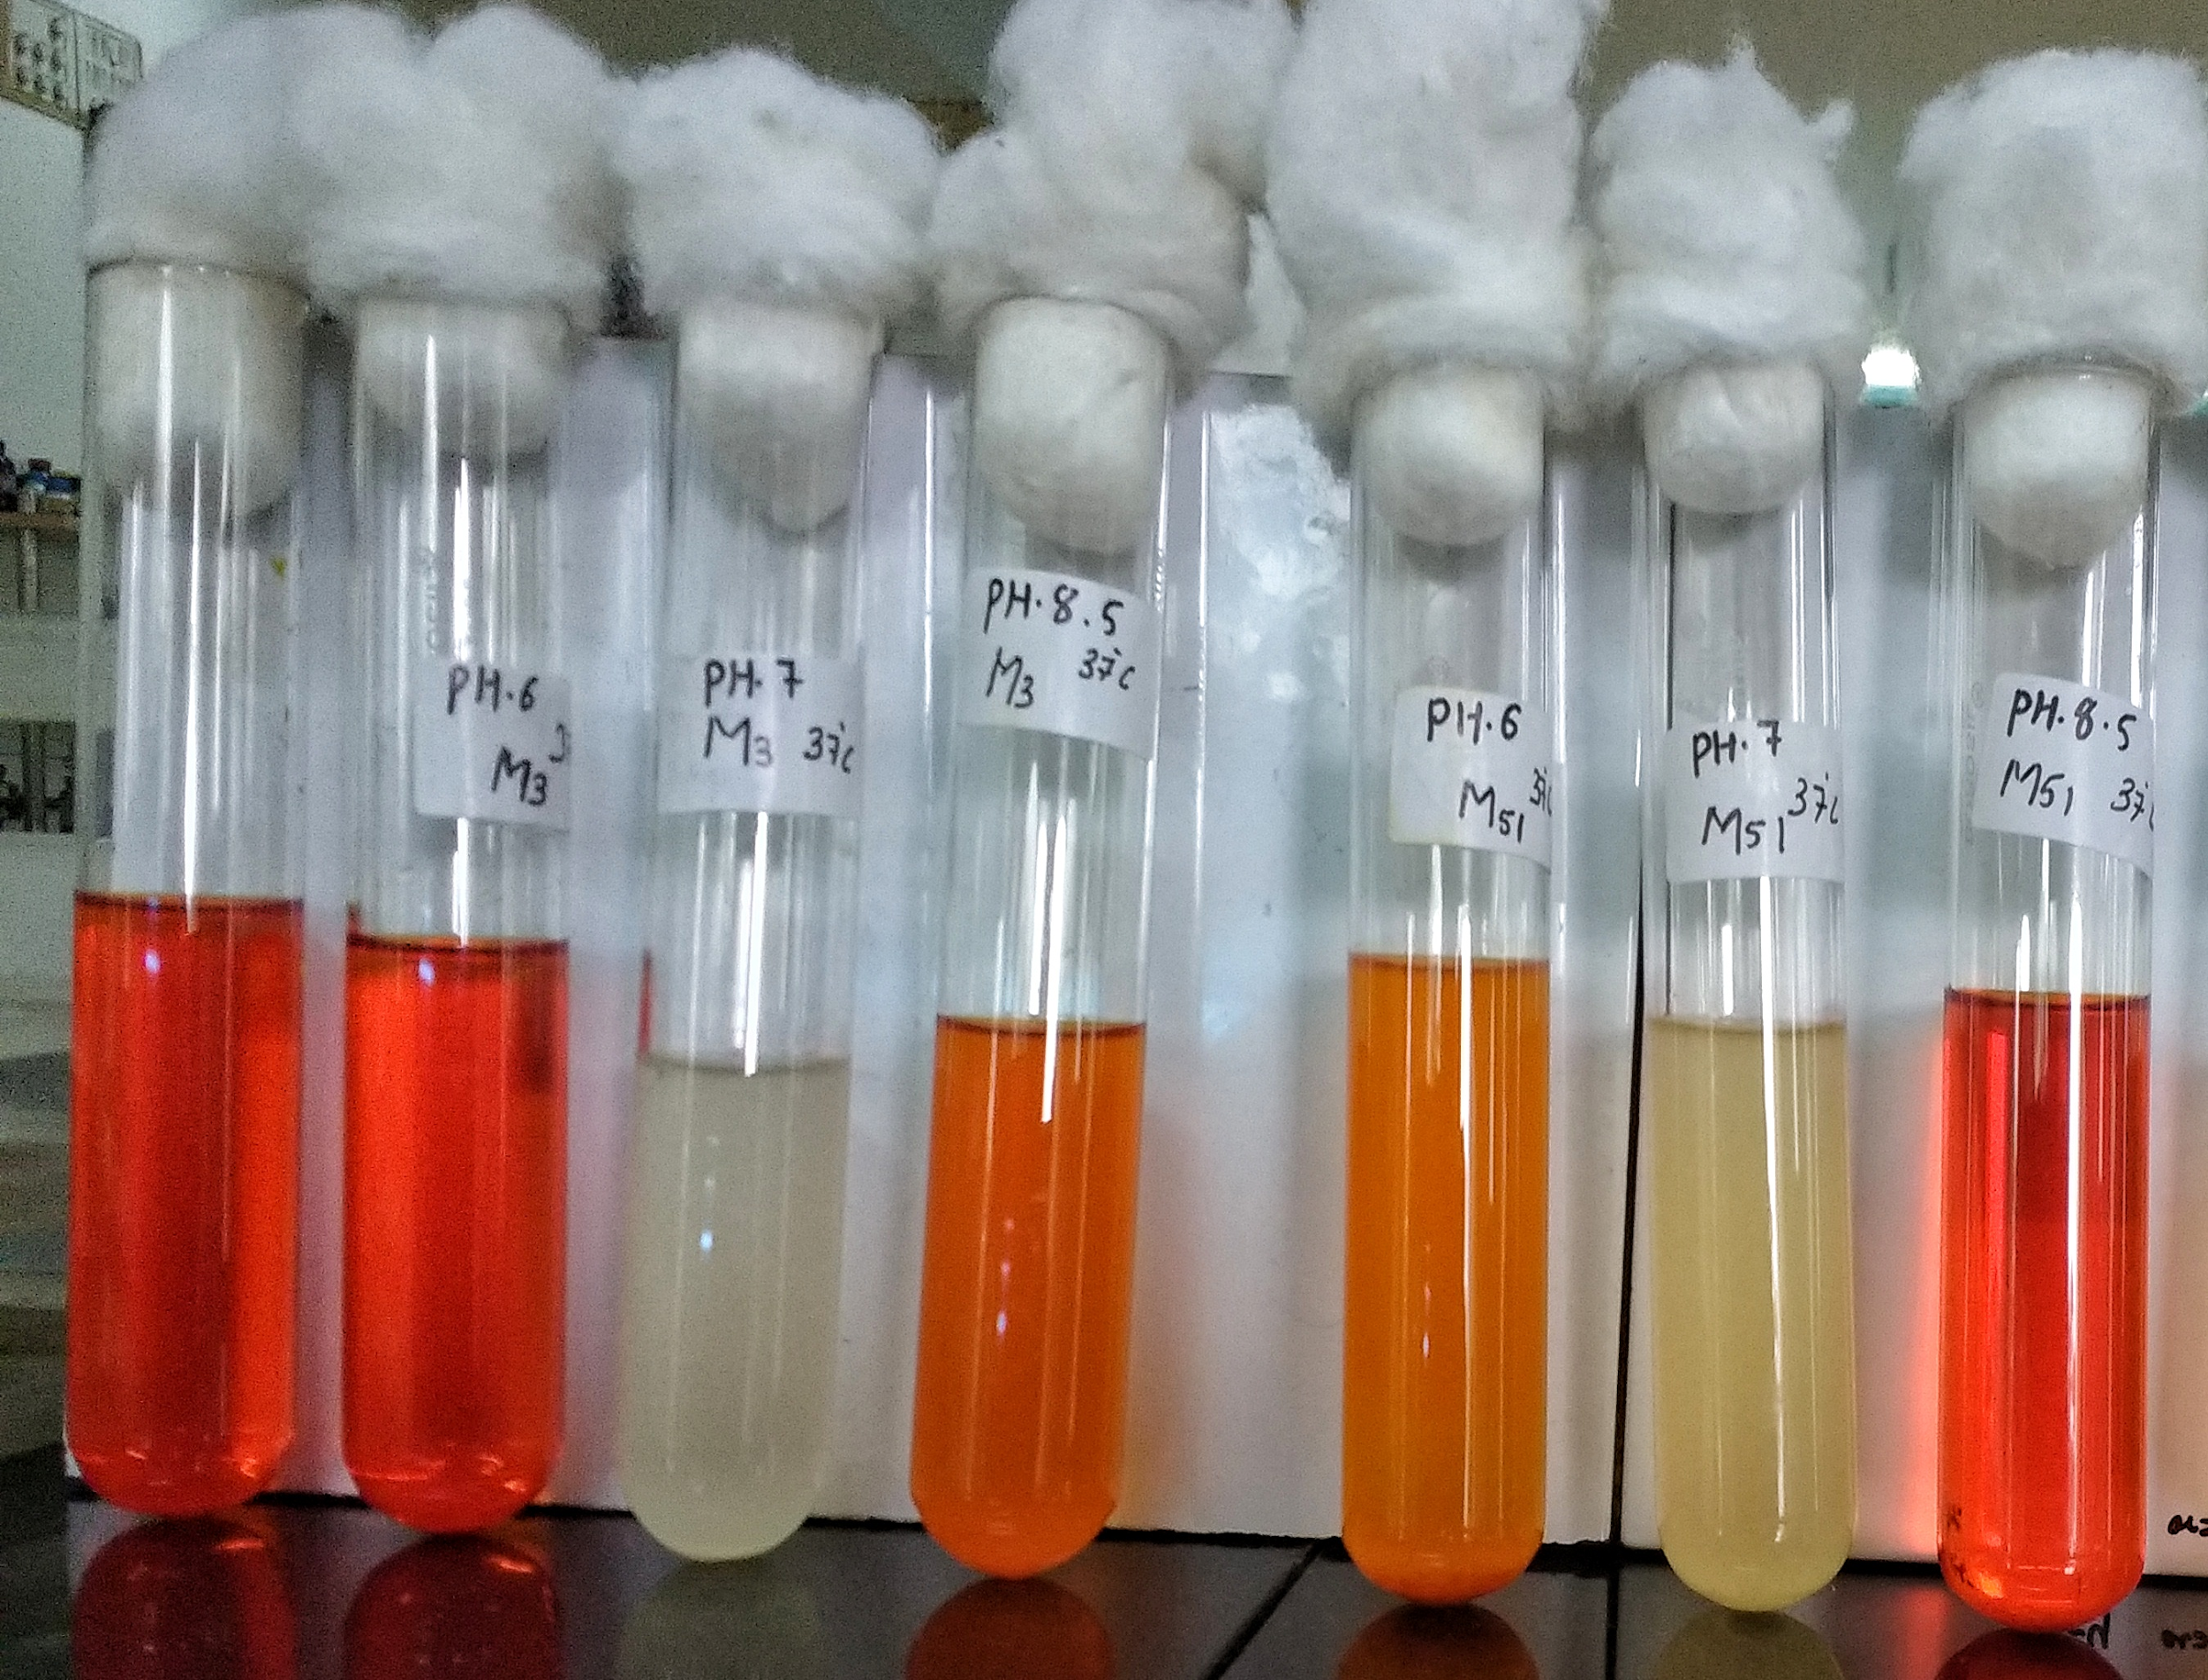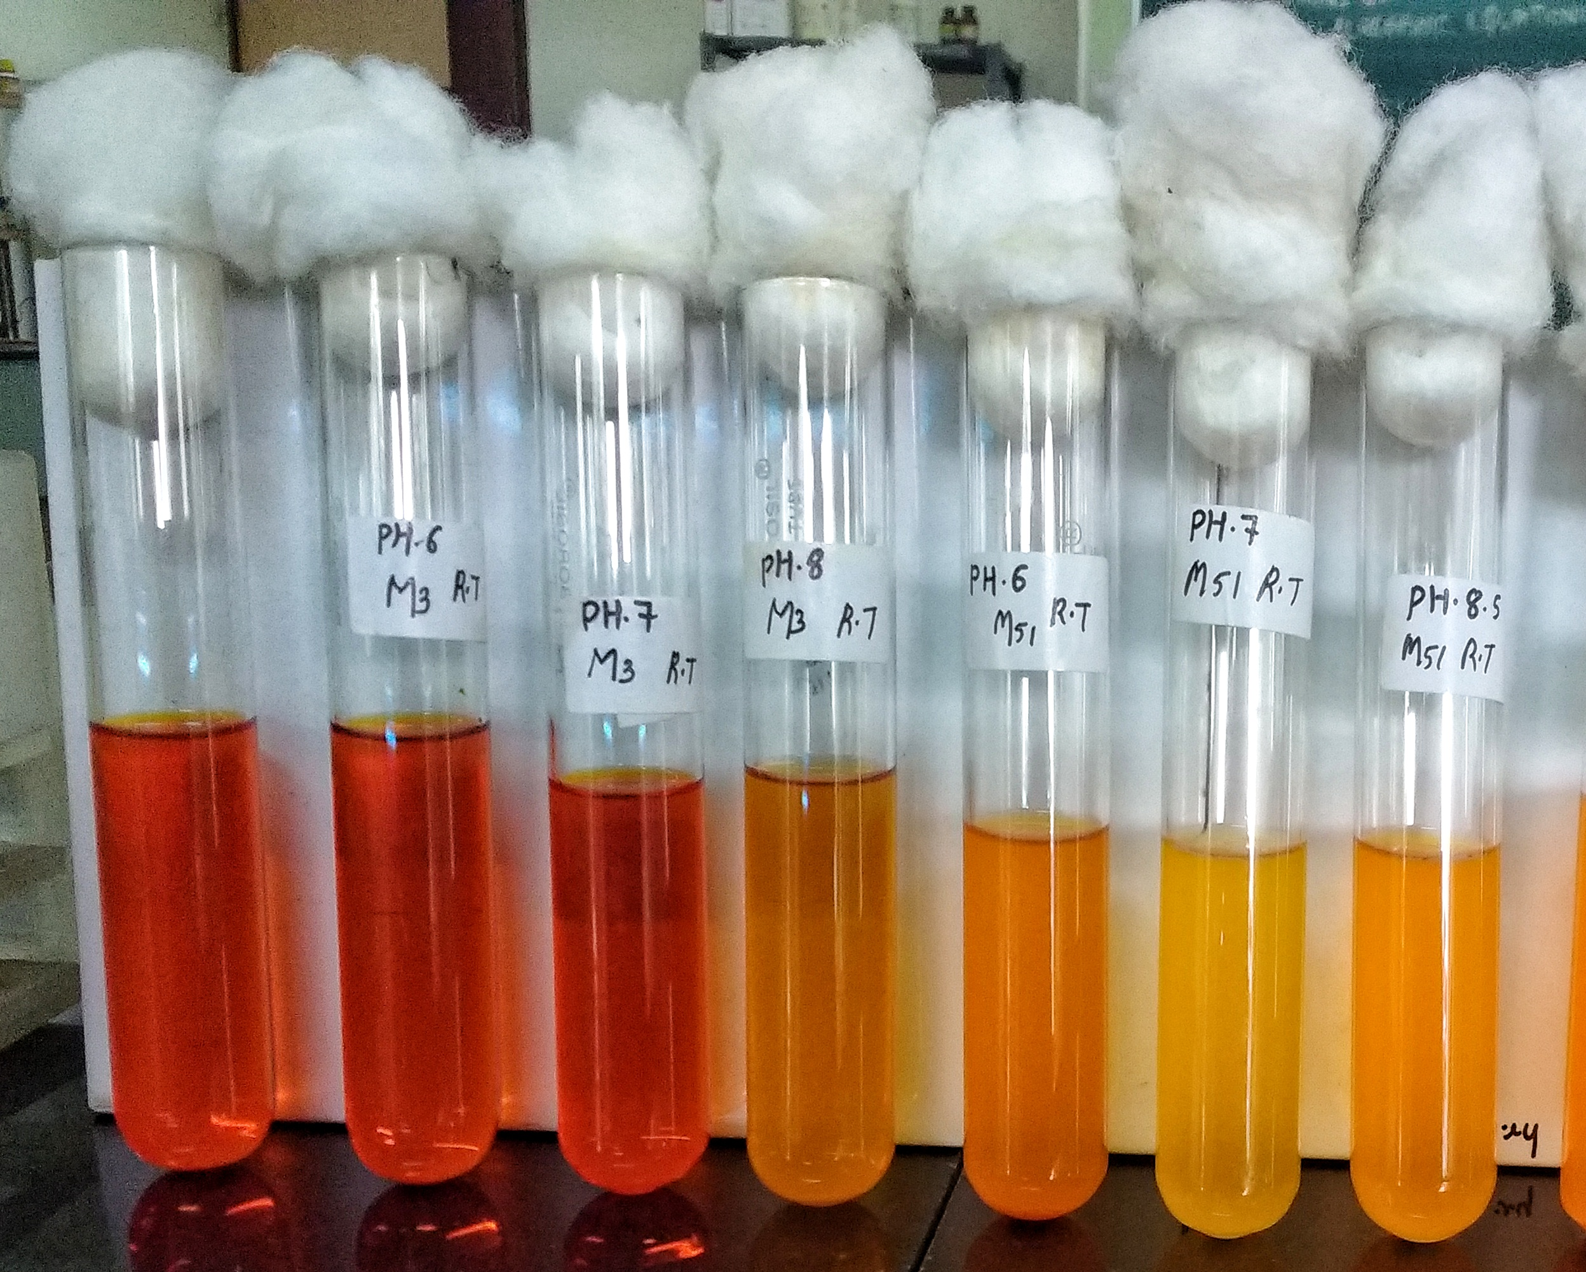
a- Decolourization at 37°C b- Decolourization at RT

Figure S6. Effect of temperature on decolourization of Methyl Orange (at 1000 mg/L dye concentration, pH 7.0, under static condition after 66 hours)

Table S1. Summary of the closest neighbours of 7 strains from Kamothe area
Isolate No. | Closest Neighbour | Accession No. | % Similarity
A1 | Bacillus Paramycoides NH24A2(T) | MT256266 | 100%
A2 | Pseudomonas taiwanensis BCRC 1775 | MT256267 | 100%
M41 | Citrobacter murliniae CDC 2970-59(T) | MT256269 | 99.12%
M42 | Acinetobacter pitti CIP 70.29 | MT256270 | 99.90%
M43 | Exiguobacterium acetylicum DSM 20416 | MT256271 | 99.53%
M3 | Psychrobacter celer SW-238 | MT256273 | 99.17%
M53 | Aeromonas taiwanensis A2-50 | MT256274 | 99.88%

Table S2. One-way ANOVA analysis of 7 isolates at different pH (6, 7, and 8.5) and different temp (25°C and 37°C) after 66 hours

One-way ANOVA analysis of 7 isolates at different pH and different temperature
 | Source of Variation | SS | df | MS | F | P-value | F crit
7 isolates at pH range of (6, 7, and 8.5) at 37°C | pH 6.0 | 3.033431 | 7 | 0.202229 | 2311.186 | 3.73E-44 | 1.99199
7 isolates at pH range of (6, 7, and 8.5) at 37°C | pH 7.0 | 3.253748 | 7 | 0.216917 | 2539.511 | 8.27E-45 | 1.99199
7 isolates at pH range of (6, 7, and 8.5) at 37°C | pH 8.5 | 4.175315 | 7 | 0.278354 | 7859.416 | 1.18E-52 | 1.99199
7 isolates at 25°C and 37°C at pH 7.0 | Temp 37°C | 3.253748 | 7 | 0.216917 | 2539.511 | 8.27E-45 | 1.99199
7 isolates at 25°C and 37°C at pH 7.0 | Temp 25°C | 4.26313 | 7 | 0.284209 | 2236.393 | 6.3E-44 | 1.99199

