Photocatalytic degradation activity of goji berry extract-mediated green synthesized antibacterial silver-zinc oxide nanocomposites under simulated solar light irradiation
Abdulrahman Ahmed Sharwaniª, Kannan Badri Narayanan^{a,b*}, Mohammad Ehtisham Khan^{c}, Sung Soo Han^{a,b*}

ªSchool of Chemical Engineering, Yeungnam University, 280 Daehak-Ro, Gyeongsan, Gyeongbuk 38541, South Korea
^{b}Research Institute of Cell Culture, Yeungnam University, 280 Daehak-Ro, Gyeongsan, Gyeongbuk 38541, South Korea
^{c}Department of Chemical Engineering Technology, College of Applied Industrial Technology (CAIT), Jazan University, Jazan 45971, Saudi Arabia

*Corresponding authors
Dr. Kannan Badri Narayanan, Email ID: okbadri@gmail.com, okbadri@yu.ac.kr
Prof. Sung Soo Han, Email ID: sshan@yu.ac.kr
Tel: +82–53–810–2773; Fax: +82–53–810–4686

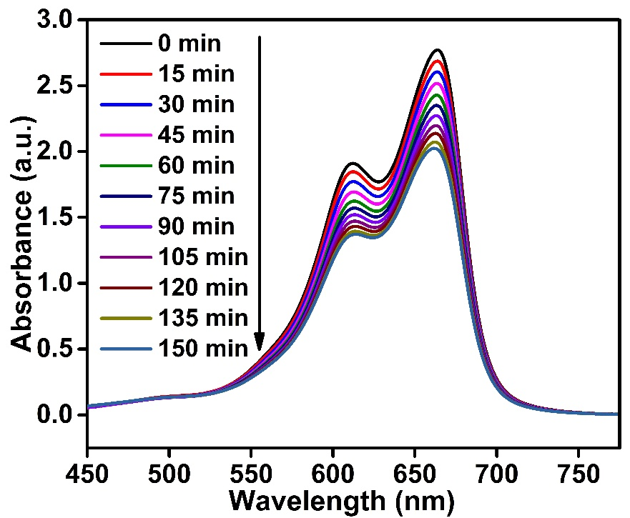
Supplementary Figure 1. Photolysis of methylene blue dye without Ag@ZnO NCs (photocatalyst).

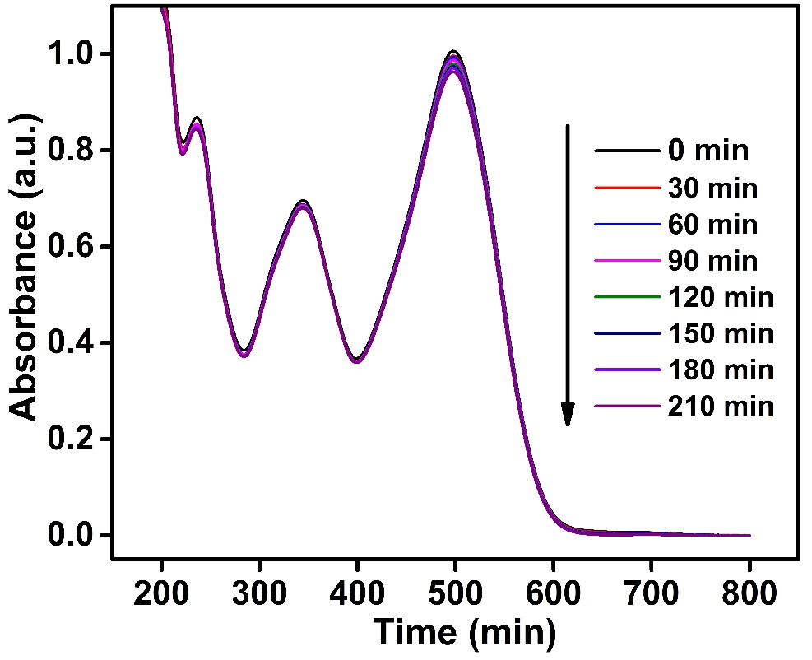
Supplementary Figure 2. Photolysis of congo red dye without Ag@ZnO NCs (photocatalyst).

