Soft X-ray Characterization of Halide Perovskite Film by Scanning Transmission X-ray Microscopy

Haeyeon Jun^{[a,b]}, Hee Ryung Lee^{[a]}, Denis Tondelier^{[a]}, Bernard Geffroy^{[c,a]}, Philip Schulz^{[d]}, Jean-Éric Bourée^{[a]}, Yvan Bonnassieux^{[a]}, and Sufal Swaraj^{*[b]}

^{[a]}LPICM, CNRS, Ecole Polytechnique, Institut Polytechnique de Paris, route de Saclay, 91128 Palaiseau, France
^{[b]}Synchrotron SOLEIL, L'Orme des Merisiers Saint-Aubin, BP 48 91192 Gif-sur-Yvette Cedex, France
^{[c]}Université Paris-Saclay, CEA, CNRS, NIMBE, LICSEN, 91191, Gif-sur-Yvette, France
^{[d]}IPVF, 18 boulevard Thomas Gobert, 91120 Palaiseau, France

* Corresponding author
Phone number: +33 (0)1 69 35 81 82
E-mail address: sufal.swaraj@synchrotron-soleil.fr

Contents
Figure S1 presents energy-dispersive x-ray (EDX) spectra of methylammonium iodide (MAI) film on indium tin oxide coated glass. The experimental percentages of each element, including carbon, nitrogen, and iodine, are shown in Table S1. The atomic ratio of all components obtained by the measurement is different from the ratio in the chemical formula of CH₃NH₃I. The atomic percentage of iodide is much smaller than those of carbon and nitrogen indicating that most iodine is volatilize after deposition on sample substrate.

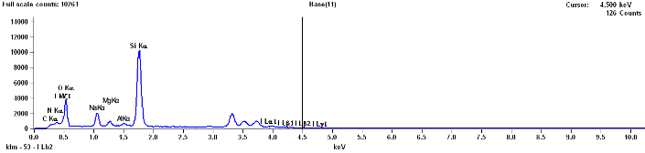
Figure S1 Energy-dispersive x-ray (EDX) spectra of methylammonium iodide (MAI) thin film as described in experimental details.

Table S1 Energy-dispersive x-ray spectroscopy (EDX) analysis of carbon (C), nitrogen (N), and iodine (I) in MAI film.
Element line | Net counts | Atom %
C K | 4217 | 10.82±1.2
N K | 6305 | 20.43±1.8
I L | 572 | 0.17±0.03

Surface morphologies of MAPbI₃ with different deposition ratios of PbI₂ and MAI are shown in Figure S2. In MAPbI₃ film with the ratio of PbI₂:MAI = 1:0.5, the average grain size is around 100 nm (Figure S2a). As the amount of MAI increases with the ratio PbI₂:MAI = 1:1, the size of most grains does not change, however bigger grains with a size of 150 nm appear Figure S2b. When the ratio of PbI₂ and MAI equals 1 to 2.5, the grain size is the biggest in all films, and the average grain size is around 250 nm Figure S2c. Figure S2d shows X-ray diffraction (XRD) patterns of MAPbI₃ with the different ratios. Major peaks (2θ) at 14.2°, 28.6°, and 32.2° are shown in the spectra, and they indicate three tetragonal phases of (001), (220), and (301) in MAPbI₃, respectively. In addition, the peak at 2θ = 12.5° (black star) is (001) phased PbI₂. When the amount of MAI in deposition increases, the peak of PbI₂ at 12.5° decreases, and it is negligible in MAPbI₃ with the ratio of 1 to 2.5. Furthermore, the phase (110) in MAPbI₃ is relatively more dominant compared than the phase (220) as the proportion of MAI increases. Table S2 indicates net counts and atomic percentages of each element (carbon, nitrogen, lead, and iodine) calculated from EDX spectra of MAPbI₃ with different ratios of PbI₂ and MAI. The atomic percentages of carbon and lead don’t change. However, the percentages of nitrogen and iodine increase as the amount of MAI increases.

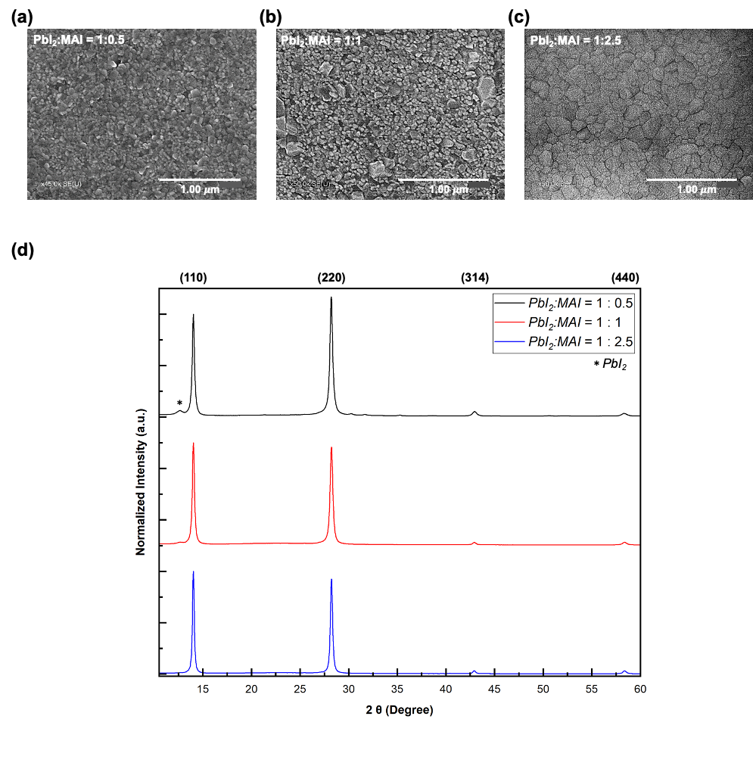
Figure S2 Scanning electron microscopy (SEM) images of MAPbI₃ film with different deposition ratio of PbI₂ and MAI a) 1:0.5, b) 1:1 and c) 1:2.5, d) X-ray diffraction (XRD) patterns of MAPbI₃ film with different deposition ratio of PbI₂ and MAI.
Table S2 Energy-dispersive x-ray spectroscopy (EDX) analysis of carbon (C), nitrogen (N), lead (Pb), and iodine (I) in MAPbI₃ according to deposition ratio of PbI₂ and MAI.
PbI₂: MAI deposition ratio | 1 : 0.5 | 1 : 1 | 1 : 2.5
Net counts of C | 3613 | 4247 | 4550
Atom % of C | 10.66 | 10.66 | 10.31
Net counts of N | 4461 | 5431 | 6561
Atom % of N | 18.49 | 19.07 | 21.19
Net counts of Pb | 7411 | 9072 | 8290
Atom % of Pb | 1.02 | 1.05 | 0.95
Net counts of I | 5407 | 5982 | 6492
Atom % of I | 2.04 | 2.19 | 2.27
Pb/I ratio | 0.50 | 0.48 | 0.42

