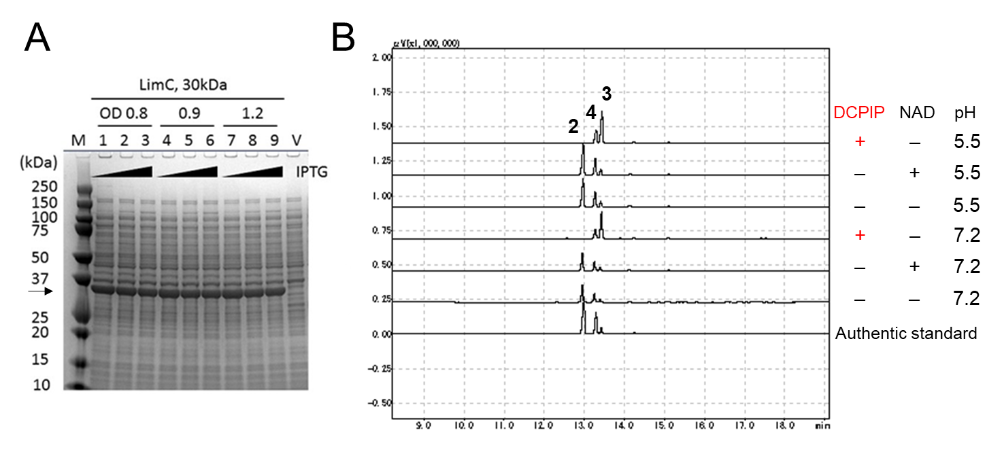

Additional file 1. Expression of Rhodococcus erythropolis carveol dehydrogenase in E. coli
Carveol dehydrogenase (CDH) gene limC from Rhodococcus erhthropolis DCL14 was cloned into pET-3a and expressed in E. coli BL21(DE3). (A) SDS-PAGE image showing LimC (30kDa, indicated by an arrow) was expressed in soluble fraction. Cells were induced at OD indicated. IPTG was added at final concentration of 10 μM (lane 1, 4, 7), 100 μM (lane 2, 5, 8), and 1000 μM (lane 3, 6, 9) respectively. V indicates vector control strain. M indicates size marker and the positions of the molecular mass are displayed. (B) Gas chromatography (GC) analysis showing LimC expressed in E. coli converted (−)-trans-carveol (2) to (−)-carvone (3), only in the presence of artificial electron acceptor dichlorophenolindophenol (DCPIP). (−)-Carveol was analyzed as an authentic standard. Commercially available (−)-carveol contains (−)-trans-carveol (2), (−)-cis-carveol (4), and trace of (−)-carvone (3).

