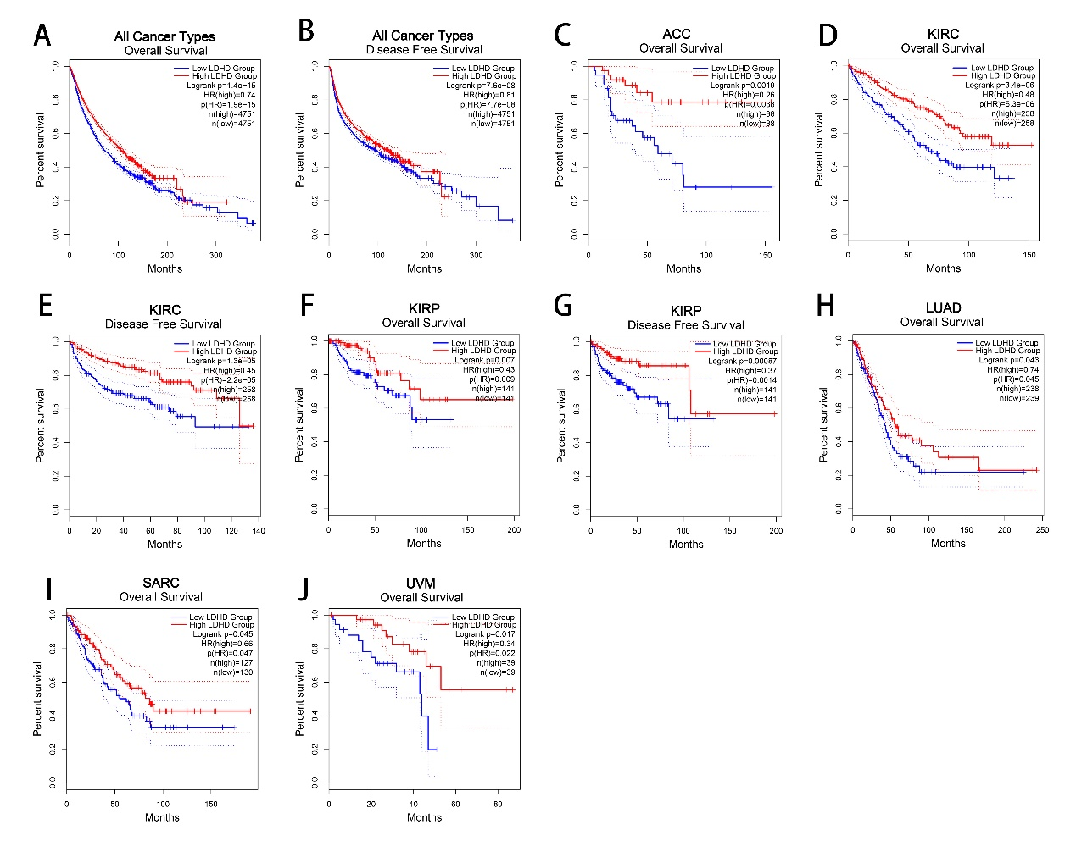
Figure S1. Kaplan–Meier survival curves comparing the high and low expression of LDHD across different types of cancer in GEPIA2.
(A,B) OS and DFS in all cancer types. (C) OS in adrenocortical carcinoma (ACC). (D,E) OS and DFS in kidney renal clear cell carcinoma (KIRC). (F,G) OS and DFS in kidney renal papillary cell carcinoma (KIRP). (H) OS in lung adenocarcinoma (LUAD). (I) OS in Sarcomav (SIRC). (J) OS in uveal melanoma (UVM).

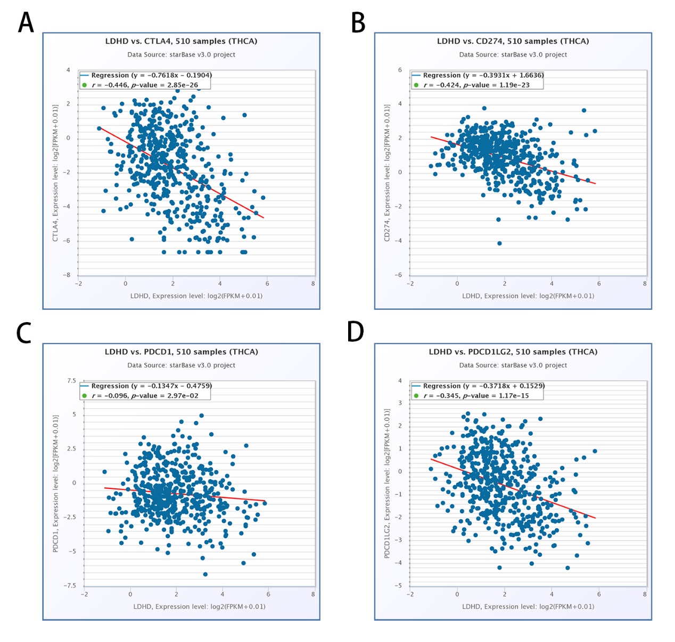
Figure S2. Correlation of LDHD expression with major immune checkpoints in THCA.
The expression of LDHD was significantly negatively correlated with the expression of CTLA4(A), CD274(B), PDCD1(C) and PDCD1LG2(D) in THCA.

