SUPPORTING INFORMATION FOR

Operational stability, low light performance, and long-lived transients in mixed-halide perovskite solar cells with a monolayer-based hole transport layer
Richard Murdey^{*,1}, Yasuhisa Ishikura², Yuko Matsushige¹, Shuaifeng Hu¹, Jorge Pascual¹, Minh Anh Truong¹, Tomoya Nakamura¹, Atsushi Wakamiya¹
¹Institute for Chemical Research, Kyoto University, Gokasho, Uji, Kyoto 611-0011, Japan
²Enecoat Technologies, Co. Ltd., Sakosotoyashiki 43-1, Kumiyama, Kuse, Kyoto 613-0031, Japan
*Corresponding author
E-mail address: murdey@scl.kyoto-u.ac.jp (R. Murdey)

Table of Contents

Contents | Page
Experimental Methods | 3
Supplementary Figures | 9
Fig. S1. Cross-sectional SEM images | 9
Fig. S2. J–V curves recorded during the MPPT experiment | 10
Fig. S3. 100 h MPPT test of Spiro-OMeTAD n-i-p devices | 11
Fig. S4. X-ray diffraction measurements | 12
Fig. S5. Evolution of the low-Br device properties | 13
Fig. S6. Properties of the PTAA p-i-n device | 14
Fig. S7. Evolution of the parallel resistance under AM1.5G | 15
Fig. S8. Device output relative to the Shockley–Queisser limit | 16
Fig. S9. The spectral intensity of the white LED. | 17
Fig. S10. Detailed balance calculations | 18
Appendix A: Complex Impedance Spectra | 19
Appendix B: Light Intensity Dependence | 26

Experimental Methods

Materials
Unless otherwise stated, all materials were used as received without further purification. [2-(3,6-dimethoxy-9H-carbazol-9-yl)ethyl]phosphonic acid (MeO-2PACz, > 98.0, cesium iodide (CsI, > 99%), methylammonium bromide (MABr, >98.0%), lead(II) bromide (PbBr₂, >98.0%), lead(II) iodide (PbI₂, 99.99%, trace metals basis), formamidinium iodide (FAI, > 98.0%), and bathocuproine (BCP) were purchased from Tokyo Chemical Industry Co., Ltd. (TCI).
Poly[bis(4-phenyl)(2,4,6-trimethylphenyl)amine] (PTAA), [tris(2-(1H-pyrazol-1-yl)-4-tert-butylpyridine)cobalt(III) tris(bis(trifluoromethylsulfonyl)imide)] (FK209) and 4-tert-butylpyridine (TBP) were purchased from Sigma-Aldrich Co., Ltd. (Sigma-Aldrich). 2,2′,7,7′-tetrakis(N,N-di-pmethoxyphenylamino)-9,9′-spirobifluorene (spiro-OMeTAD) was purchased from Merck Co., Ltd. Lithium bis(trifluoromethylsulfonyl)imide (LiTFSI) was purchased from Wako Pure Chemical Industries Co., Ltd. Fullerene C₆₀ (sublimed, 99.99%) was purchased from ATR Company. Fullerene C₆₀ (sublimed, 99.99%) was purchased from ATR Company. Dehydrated dimethyl sulfoxide (DMSO, super dehydrated) was purchased from FUJIFILM Wako Pure Chemical Co., Ltd. Dimethylformamide (DMF), toluene, and chlorobenzene solvents were purchased from Kanto Chemical. Co., Inc. Before use, the solvents were degassed by Ar gas bubbling for 1 h and further dried over molecular sieves (3 Å) in an Ar-filled glove box (H₂O, O₂ < 0.1 ppm).

Substrate and precursor solution
Glass/ITO substrates (10 Ω sq^{–1}) were etched with zinc powder and HCl (6 M in de-ionized water), and consecutively cleaned with 15 min ultrasonic bath in water, acetone, detergent solution (Semico Clean 56, Furuuchi chemical), water, and isopropanol. The substrates were dried with an air gun, and finally plasma treatment. The substrates were transferred to an inert gas-filled glove box for further processing.
The precursor solutions of Cs_{0.05}FA_{0.80}MA_{0.15}PbI_{2.75}Br_{0.25} and Cs_{0.05}FA_{0.80}MA_{0.15}PbI₂Br were prepared from stoichiometric amounts of CsI, MABr, PbBr₂, PbI₂, and FAI dissolved in a mixture of 3:1 DMF and DMSO. After stirring at 40 °C for 30 min, the solution was filtered with a 0.45 µm PTFE filter. The concentration of Pb was 1.05 mol L⁻¹.

p-i-n device fabrication (MeO-2PACz, PTAA)
The hole transporting monolayer MeO-2PACz (1 mmol L^{–1} in anhydrous ethanol) was deposited on plasma-treated ITO substrates by using spin-coating (3000 rpm for 30 s, 5 s acceleration), followed by heating on a hot plate at 100 °C for 10 min. For the PTAA devices, the hole transporting material PTAA (2 mg mL^{–1} in anhydrous toluene) was deposited using spin-coating (4000 rpm for 30 s, 5 s acceleration), followed by heating on a hot plate at 100 °C for 10 min. 190 µL of the perovskite precursor solution was placed on an ITO/MeO-2PACz substrate and spread by spin-coating (slope 1 s, 1000 rpm 10 s, slope 5 s, 3000 rpm 20 s, slope 1 s) to make a thin film. 300 µL of chlorobenzene antisolvent was dripped over the rotating substrate 3 s before the end of the spinning at 3000 rpm. The films were then annealed on a hot plate at 150 °C for 10 min.
The samples were transferred under an inert atmosphere to a vacuum deposition chamber, where 20 nm of C₆₀ (deposition rate 0.05 nm s^{–1}) and 8 nm of BCP (deposition rate 0.01 nm s^{–1}) were deposited by thermal evaporation.
The top electrode was prepared by depositing 100 nm of silver (deposition rate 0.005 nm s^{–1}) through a shadow mask.

n-i-p device fabrication (Spiro-OMeTAD)
The SnO₂ layer was prepared by spin-coating a colloidal dispersion (15% in H₂O, 3.0 mL) diluted with deionized water (3.0 mL) on the glass-ITO substrates (slope 2 s, 2000 rpm 30 s, slope 2 s) followed by annealing at 150 °C for 30 min. A plasma treatment was performed after cooling the substrate to room temperature, before transferring the samples to an inert gas-filled glove box.
190 µL of the perovskite precursor solution was placed on an ITO/SnO₂ substrate and spread by spin-coating (slope 1 s, 1000 rpm 10 s, slope 5 s, 3000 rpm 20 s, slope 1 s) to make a thin film. 300 µL of chlorobenzene was dripped over the rotating substrate at 3 s before the end of the spinning at 3000 rpm. The films were then annealed on a hot plate at 150 °C for 10 min.
Hole-transporting material (Spiro-OMeTAD 0.06 M) was mixed with an oxidizing agent [tris(2-(1H-pyrazol-1-yl)-4-tert-butylpyridine)cobalt(III) tris(bis(trifluoromethylsulfonyl)imide)] (FK209, 0.03 equiv) into a solution of chlorobenzene (1 mL), 4-tert-butylpyridine (TBP, 3.3 equiv), and lithium bis(trifluoromethylsulfonyl)imide (LiTFSI, 0.54 equiv). After stirring at 70 °C for 30 min, the suspension was filtered with a 0.45 µm PTFE filter to remove insoluble Co(II) complexes. 90 µL of the solution was spin-coated on top of the perovskite layer (slope 4 s, 4000 rpm, 30 s, slope 4 s), followed by annealing at 70 °C for 30 min.
Gold electrodes (80 nm) were thermally deposited on the top face of the devices using a shadow mask.

The measurement environment
All devices were briefly exposed to air to remove material covering the ITO electrode, and apply solder to the exposed ITO to lower the contact resistance. From this point onwards all devices were stored in the dark in a nitrogen-filled glovebox. A single substrate was transferred to a small, inert-gas-filled chamber (ALS technologies, KC-94) for measurement. The cell under test, which had an active area delimited by a 0.1 cm² metal mask, could be exposed to light through a quartz window. The measurement environment is not temperature controlled, and the sample temperature under AM1.5G rises to about 30 °C above ambient. At no point after fabrication were the devices exposed to air.
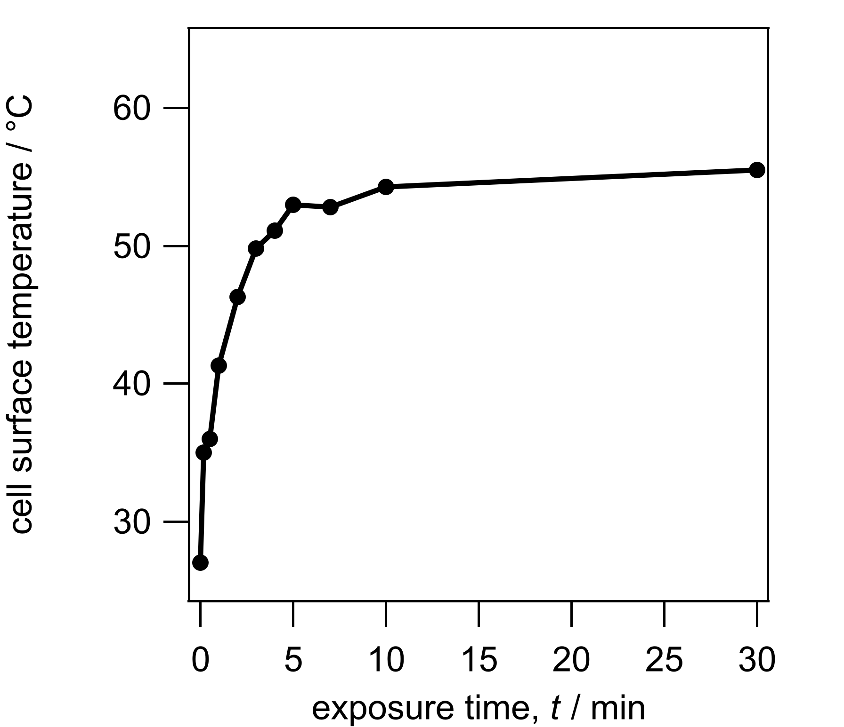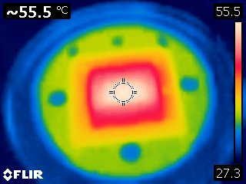
Estimation of the cell temperature under AM1.5G using an infrared camera (FLIR C2).

Scanning electron microscopy
Scanning electron microscopy (SEM) was performed with a Hitachi S8010 ultra-high-resolution scanning electron microscope (Hitachi High-Tech Corporation).

Light sources
AM1.5G and attenuated AM1.5G light were generated with a Bunkoukeiki SMO-250PV solar simulator using a 150 W Xe lamp. The light intensity was calibrated using a Bunkoukeiki BS-520BK reference silicon photodiode with an IR-cut filter. Attenuation over a wide range of intensity was enabled by using various neutral density filters (100, 40, 20, 10, 5, and 1% transmittance) in combination with the variable aperture built into the solar simulator. Transmission through the neutral density filters is wavelength-dependent, hence the true attenuation of each filter depends on the spectral sensitivity of the device. The filters were therefore calibrated using a perovskite solar cell with the same bandgap as the sample. Calibration factors, given in the table below, are determined by cross-correlating attenuation data at three different aperture settings.
Calibrated transmission of the neutral density filters for the Cs_{0.05}FA_{0.80}MA_{0.15}PbI_{2.75}Br_{0.25} “low-Br” and Cs_{0.05}FA_{0.80}MA_{0.15}PbI₂Br “high-Br” perovskite materials.
Transmittance (%)
Nominal Value | Calibrated with the  Low-Br/MeO-2PACz device | Calibrated with the  High-Br/MeO-2PACz device
100 (No Filter) | 100 (Reference) | 100 (Reference)
40 | 44.1±0.5 | 43.6±0.1
20 | 22.3±0.2 | 21.9±0.1
10 | 11.6±0.1 | 11.3±0.1
5 | 6.33±0.10 | 6.03±0.05
1 | 1.27±0.03 | 1.17±0.01

Ambient light was simulated with a 50 W white LED (OptoSupply OSW4XAHCE1E) powered by an adjustable power supply set to 25 V and 12 mA (0.31 W) producing an irradiance of 250 μW/cm² (835 lx) at the sample. The source-to-sample distance was about 15 cm. No temperature rise was noted, and no focusing optics were used. Ambient light measurements were performed in a light-tight environment. The spectral irradiance between 380 and 780 nm was determined with a Sekonic Spectromaster C-7000 handheld spectrometer.

J–V and MPPT measurements
J–V curves were obtained using a Keithley 2450 sourcemeter. Forward and reverse scans were measured between −0.1 and 1.2 V at a scan rate of 50 mV s⁻¹. The Keithley 2450 was also used to perform the maximum power point tracking (MPPT) measurements, using a step-and-check algorithm written in Labview.
J–V curves were normally measured following 300 s operation under MPPT conditions. The final output power at the end of the 300 s MPPT sequence was taken as the device PCE, while J_{sc}, V_{oc}, and FF were calculated as the value from the forward and reverse J–V curves. We find this methodology generally provides a more reliable assessment of the electrical characteristics than instantaneous J–V curves recorded immediately after the device is exposed to the light source. An exception was made when measuring the light intensity dependence using attenuated AM1.5G. The properties of the perovskite devices often varied slightly depending on their measurement history. To minimize this effect while taking measurements at widely different light intensities, exposure times were kept low by only measuring J–V scans. During the 100 h MPPT stability test, the MPPT algorithm is briefly halted every 20 minutes while forward and reverse J–V curves are recorded. This allows us to monitor the change in J_{sc}, V_{oc}, and FF over the 100-h interval as well as the PCE.

EQE spectra
EQE spectra were recorded between 300 and 1100 nm with light from a Bunkoukeiki SM-250 Monolight System featuring a 150 W Xe lamp and M25 monochromator. The output was calibrated with a Bunkoukeiki S1337-1010BQ silicon photodiode. Device currents were measured with a Keithley 2450 sourcemeter.

X-ray diffraction measurements
XRD measurements were performed with a Rigaku SmartLab.

Impedance measurements
A Keysight E4990A impedance analyzer was used to record the complex impedance spectra. The oscillation amplitude was 30 mV, and the frequency is scanned from 200 Hz to 20 MHz. The applied forward DC bias was stepped from 0 to 1.2 V, in 0.1 V steps, and a frequency scan recorded at each step. Impedance measurements were taken under AM1.5G following 300 s operation under MPPT.

Shockley–Queisser Calculations
The principle of detailed balance is used to derive the theoretical maximum cell output as a function of the absorber energy gap and the spectral intensity of the light source. Known as the radiative, or Shockley–Queisser limit (SQ limit), the results are typically calculated for the AM1.5G solar spectrum. The narrow bandgap of the low-Br material is more favorable for operation under AM1.5G since more light from the wideband solar spectrum is absorbed., while the wide bandgap of the high-Br perovskite is better suited for operation under the white LED due to the higher cell voltage.
J_{sc}
J_{d}
J, V
$$J =J_{sc}-J_{s}\left(e^{\frac{V}{nV_{T}}}-1 \right)$$
$$J_{d} =J_{s}\left(e^{\frac{V}{nV_{T}}}-1 \right)$$
The equivalence circuit for a simple solar cell neglecting any resistive or capacitive elements is shown above. In this example, the photogenerated current – shown as a constant current source – is equal to the short circuit current, J_{sc}. The diode current, J_{d}, is defined by the Shockley diode equation, given above, which depends on the saturation current, J_{s}. In these calculations, the ideality factor, n, is unity. The thermal voltage, V_{T} = q/k_{B}T, is calculated for T = 298 K. k_{B} is the Boltzmann constant. In the method given by W. Shockley and H. J. Queisser (J. Appl. Phys. 1961, 32, 510–519.) the J–V relationships are determined from the maximum obtainable values for J_{sc} and J_{s}, which are in turn estimated from the absorber bandgap after making several simplifying assumptions: Nonradiative recombination is neglected, and the EQE is approximated by a Heaviside step function transitioning at the absorber bandgap energy E_{g}, i.e. H(x−E_{g}). This leads to,
$$J_{sc}^{SQ}=q\int_{E_{g}}^{∞}{ϕ_{AM1.5G}\left(E\right) dE}$$
$J_{s}^{SQ}=q\int_{E_{g}}^{∞}{ϕ_{BB}\left(E\right) dE}$ .
According to the principle of detailed balance, the saturation current, $J_{s}^{SQ}$, can be calculated using the blackbody spectral irradiance,
$ϕ_{BB}\left(E\right)=\frac{2πE^{2}}{h^{3}c^{2}}\frac{1}{exp\left(\frac{E}{k_{B}T}\right)-1}$ .
The device efficiency determined from the J–V curves calculated under these assumptions is known as the Shockley–Queisser (SQ) limit. Normally the short circuit current is determined using $ϕ_{AM1.5G}$, the reference spectral irradiance of sunlight, but $J_{sc}^{SQ}$ may be readily determined for any arbitrary light source and intensity by substituting a new irradiance function, such as the one for a white LED shown in Fig. S6.

Supplementary Figures

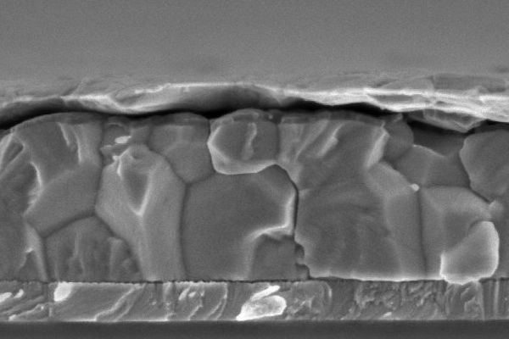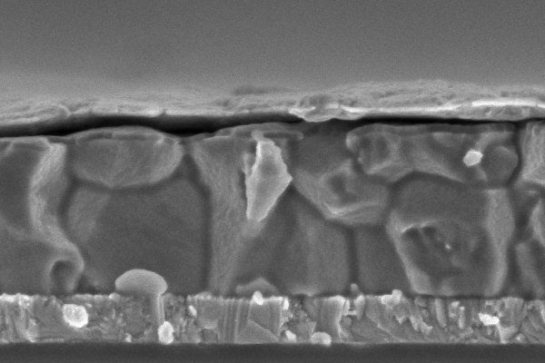
a)
b)
Low-Br/MeO-2PACz
High-Br/MeO-2PACz
500 nm
500 nm
ITO PVSK C₆₀/BCP Ag
ITO PVSK C₆₀/BCP Ag

Fig. S1. Cross-sectional SEM images of the p-i-n perovskite solar cells with MeO-2PACz monolayer HTL, fabricated with (a) low-Br perovskite composition and (b) high-Br perovskite composition. The thickness of the perovskite layers is about 600 nm, and the thickness of the bottom ITO layer is 150 nm. The MeO-2PACz monolayer is not resolved. The C₆₀ and BCP ETL materials form a 30 nm crust on the top surface of the perovskite, while the Ag electrodes are seen to be partially delaminated. Delamination most likely occurred when the device was cleaved in preparation for the SEM measurements.

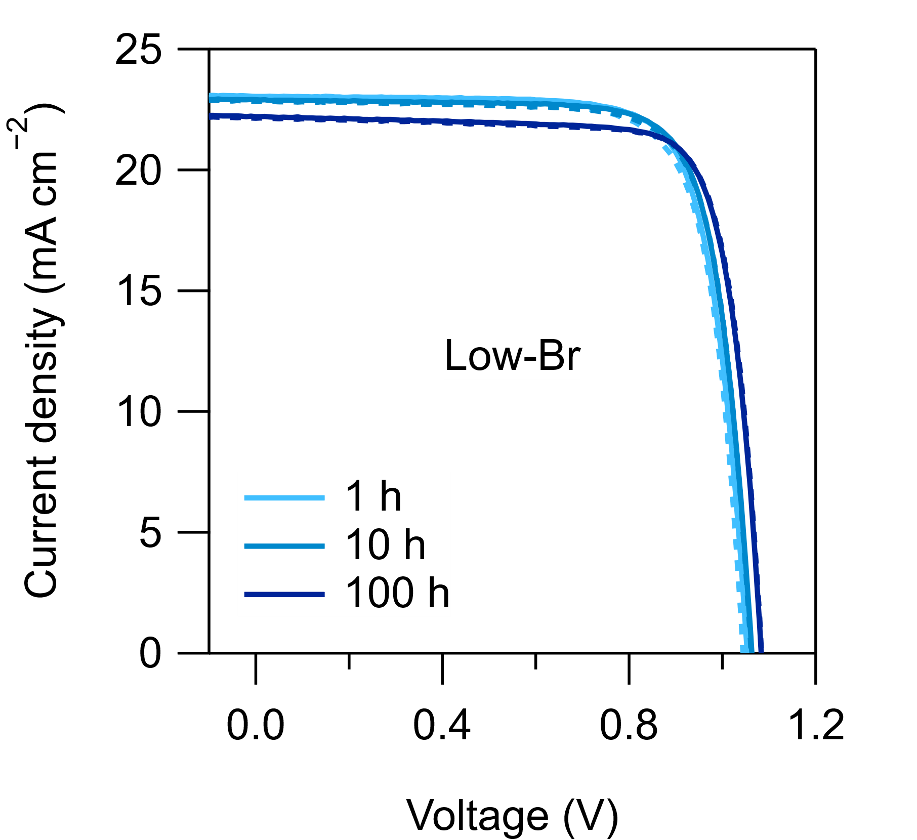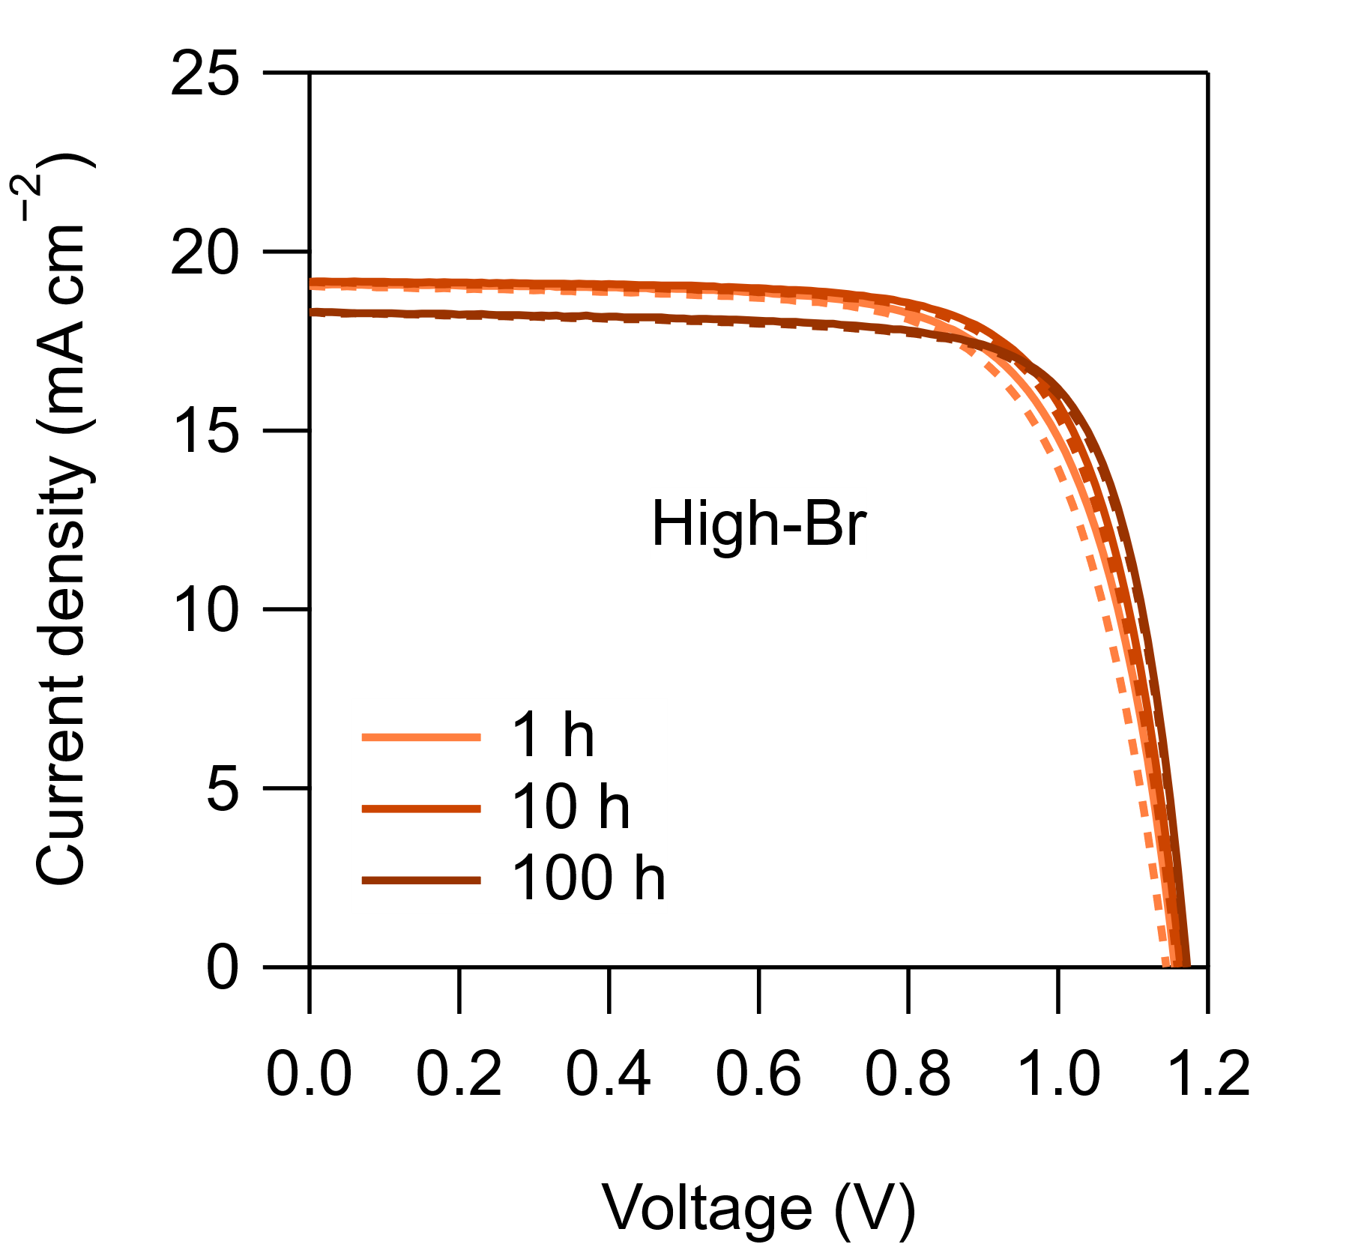
a)
b)

Fig. S2. J–V curves recorded after 1, 10, and 100 h MPPT under AM1.5G for the (a) narrow bandgap and (b) wide bandgap devices. (Solid lines: forward scans, dashed lines: reverse scans.)

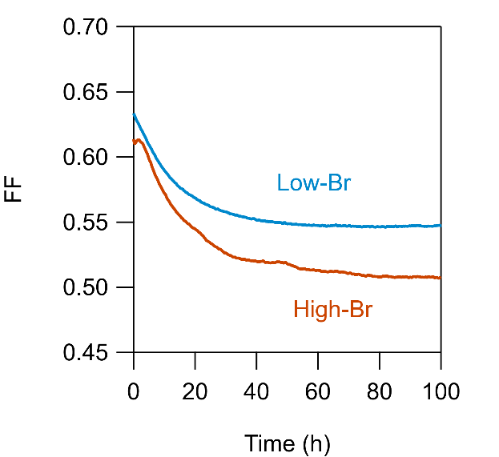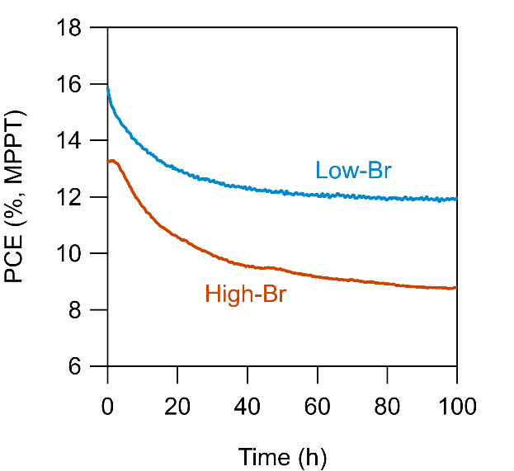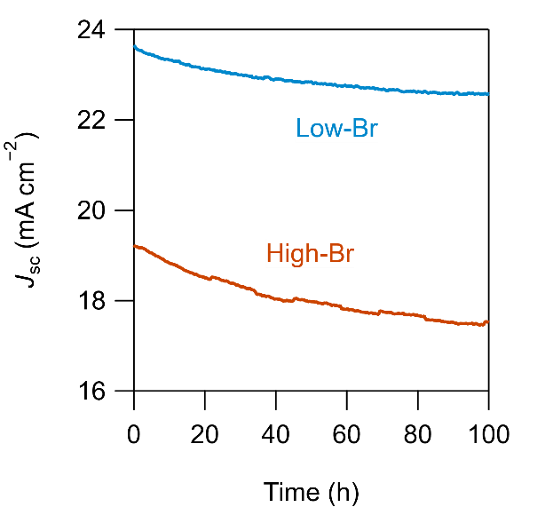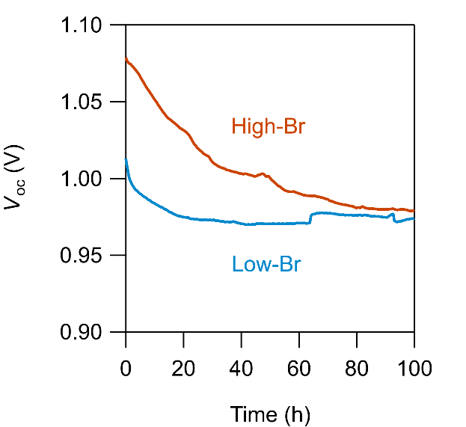
a)
d)
b)
c)

Fig. S3. Electrical performance of n-i-p solar cells (ITO/SnO₂/perovskite/Spiro-OMeTAD/Au) recorded during 100 h MPPT. (a) J_{sc}, (b) V_{oc}, (c) FF, and (d) PCE. The PCE values are determined directly from the MPPT data. The other parameters are derived from J–V curves recorded at 20-minute intervals.

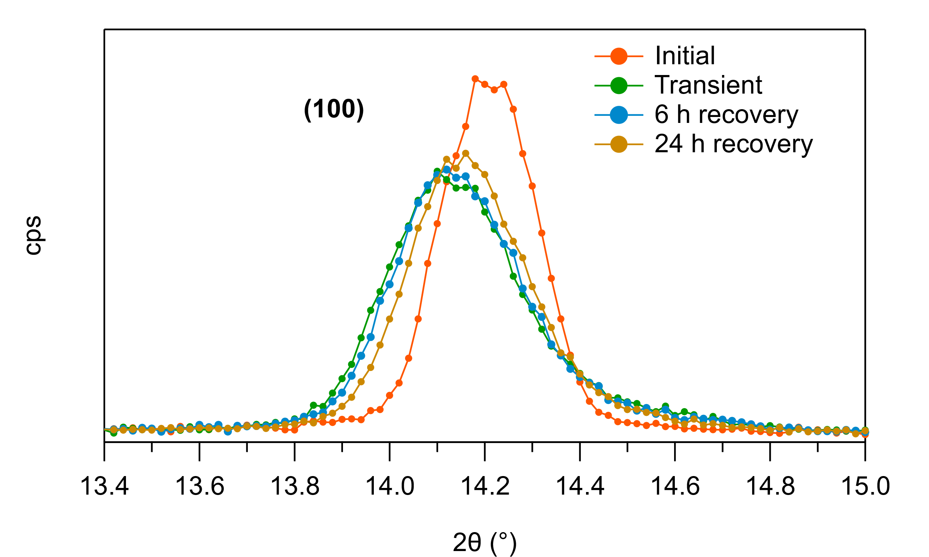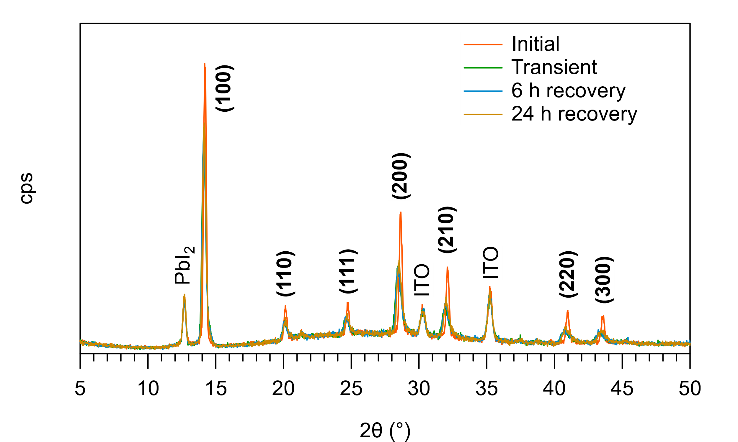
a)
b)

Fig. S4. X-ray diffraction patterns for the high-Br perovskite film on ITO/MeO-2PACz before (Initial) and shortly after 100 h exposure to AM1.5G (Transient), as well as after 6 h and 24 h recovery in the dark.

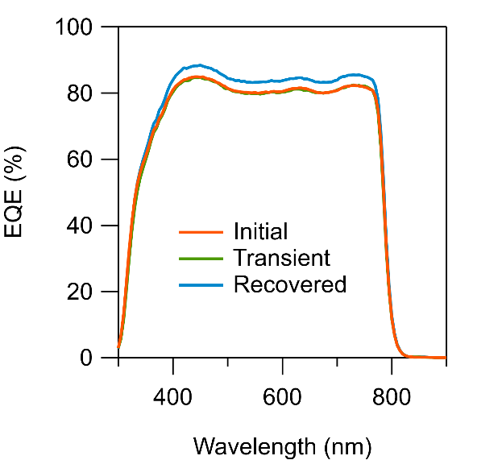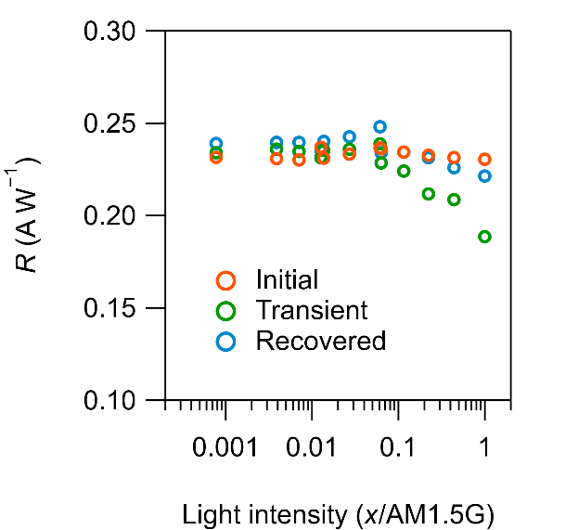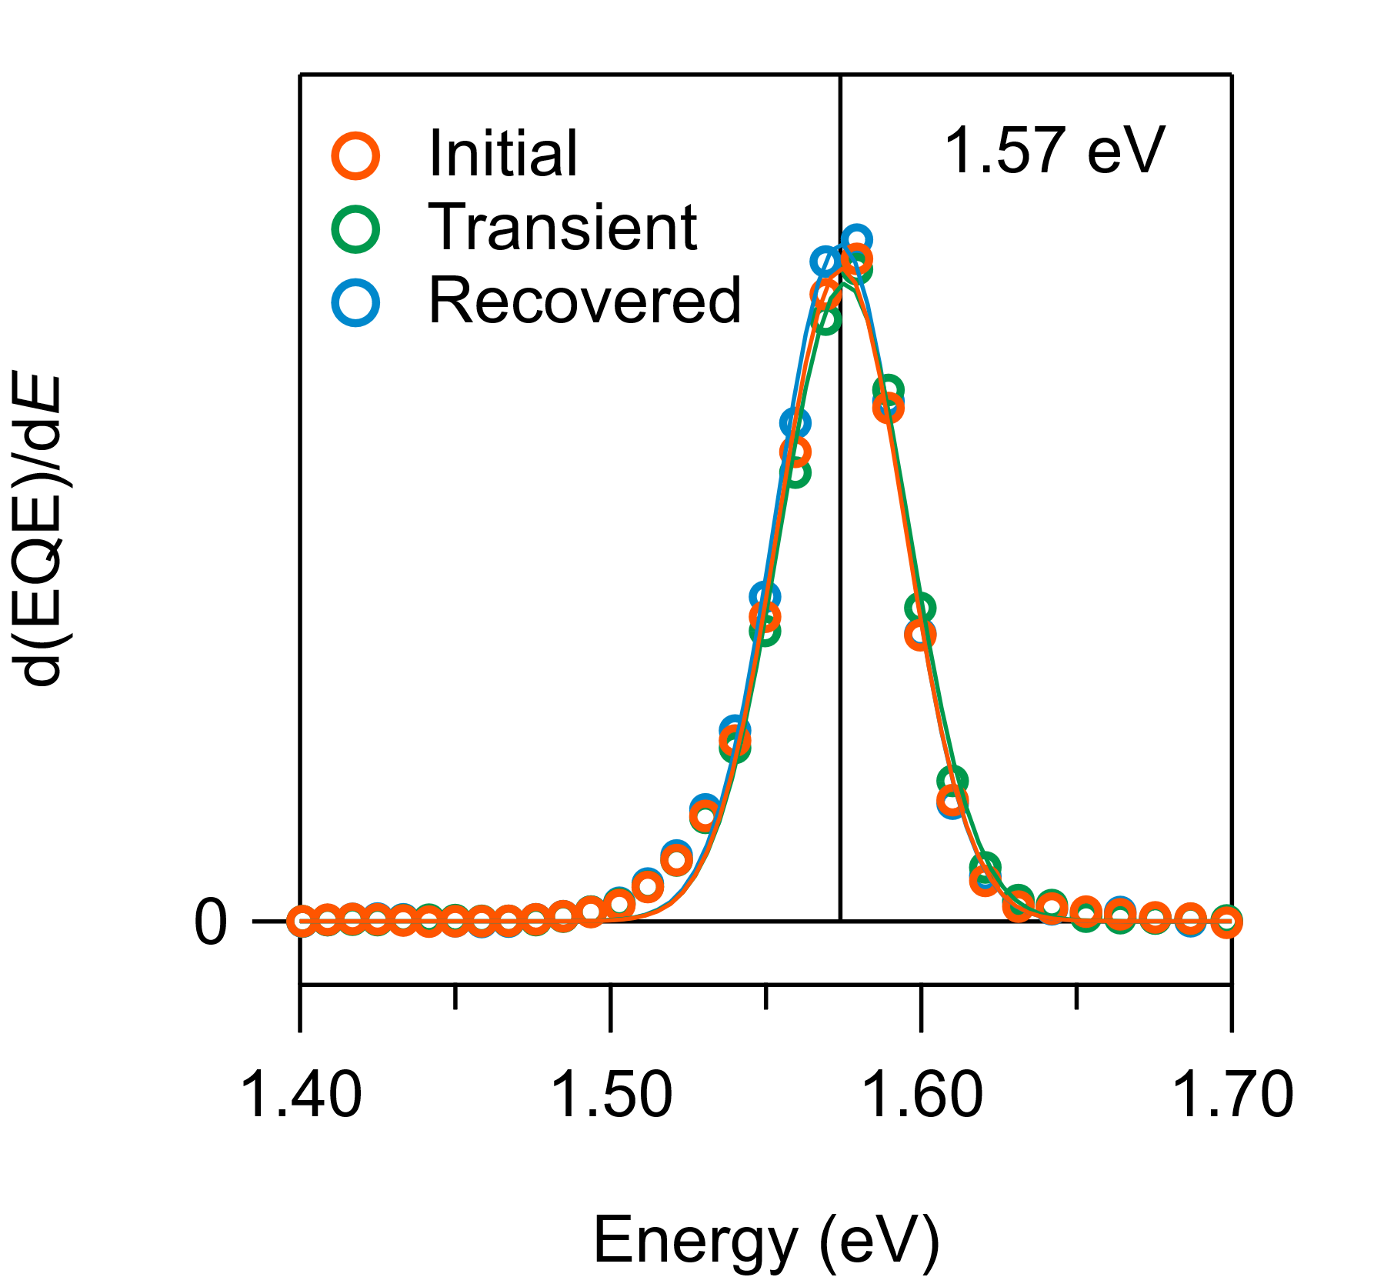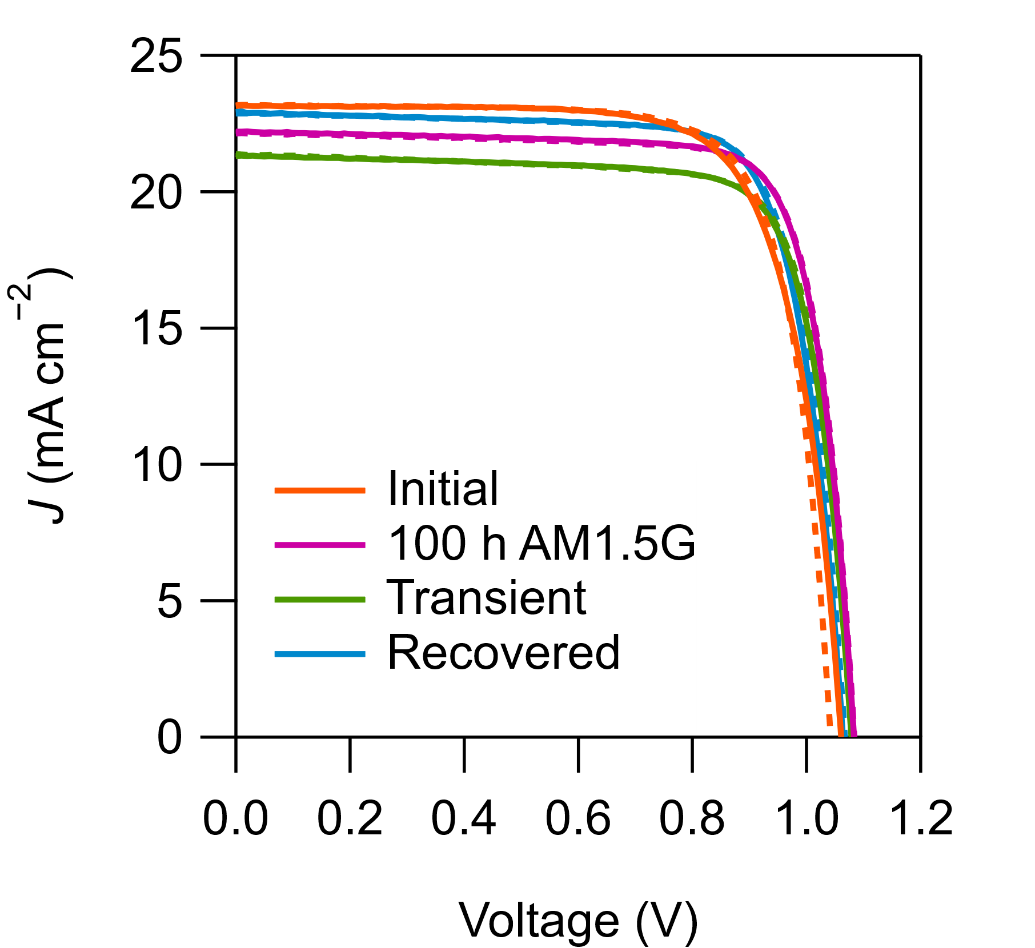
a)
d)
b)
c)

Fig. S5. Properties of the low-Br device before (Initial) and after the 100 h MPPT test (100 h), in the hours following 100 h MPPT (Transient), and after 500 h, by which point the transient effects have subsided (Recovered). (a) Forward (solid line) and reverse (dashed line) J–V curves under AM1.5G show the significant loss of J_{sc} in the hours following 100 h MPPT. (b) Corresponding loss of device responsivity as a function of light intensity. (c) EQE spectra. (d) The differential of the EQE signal around the onset region. Gaussian peak fits of the experimental data are indicated by the solid lines.

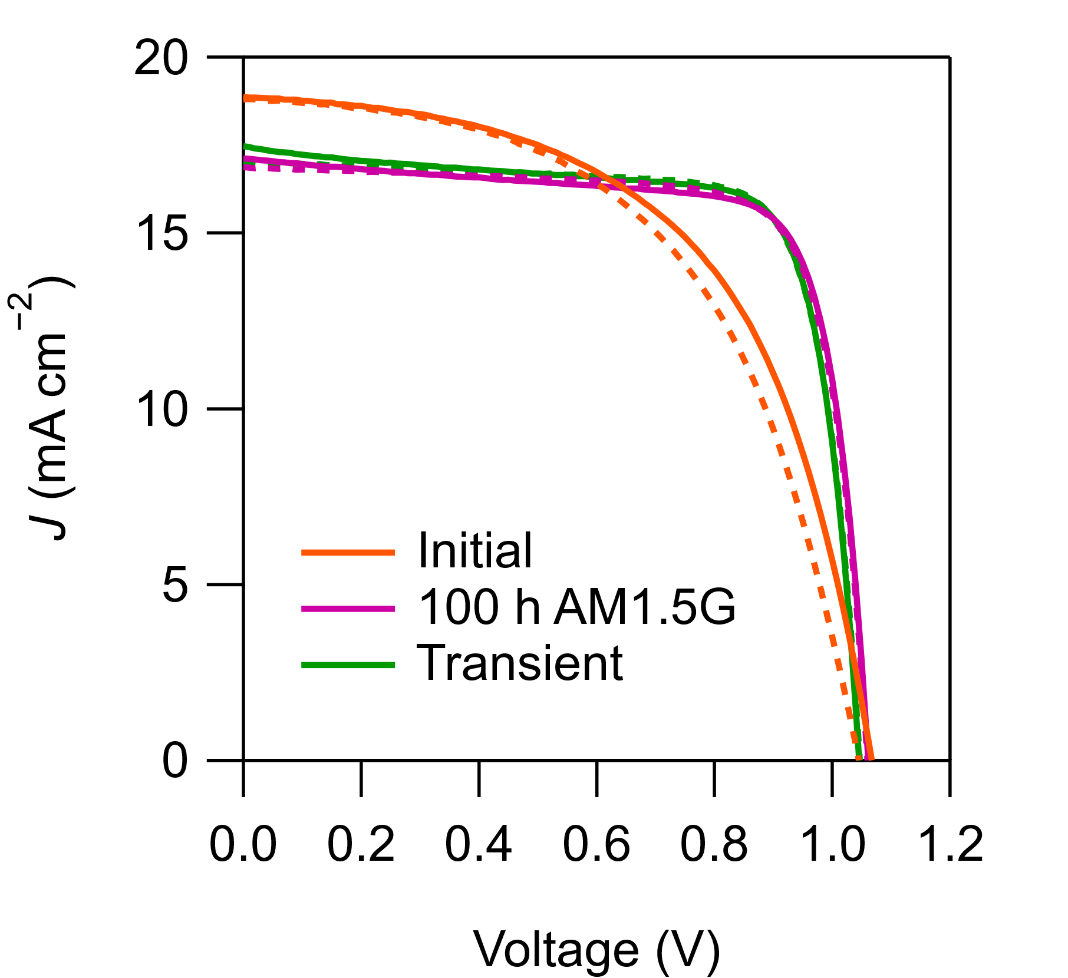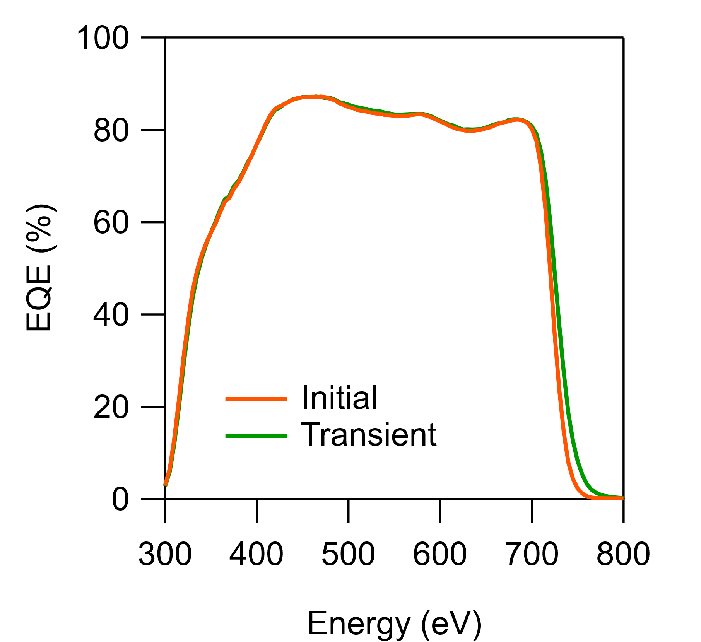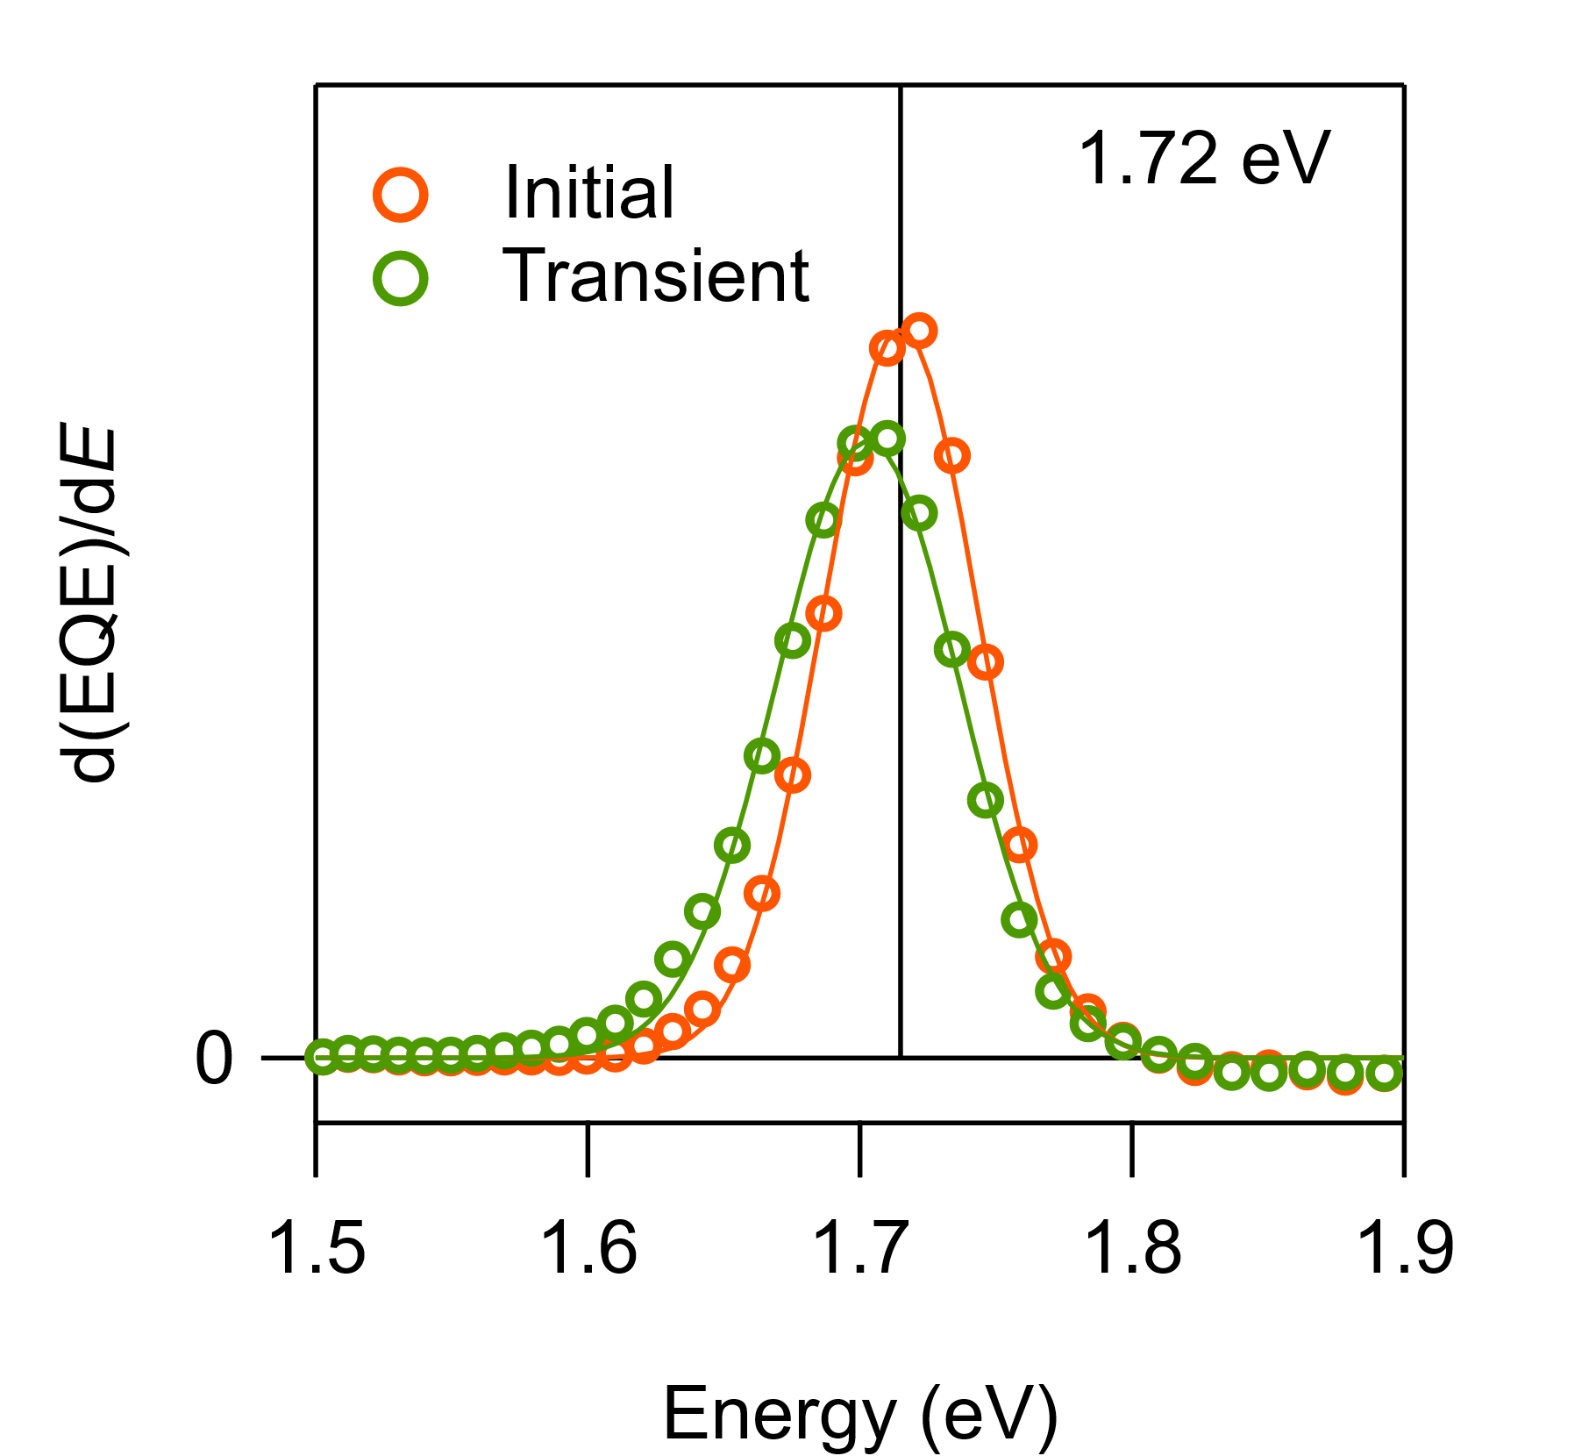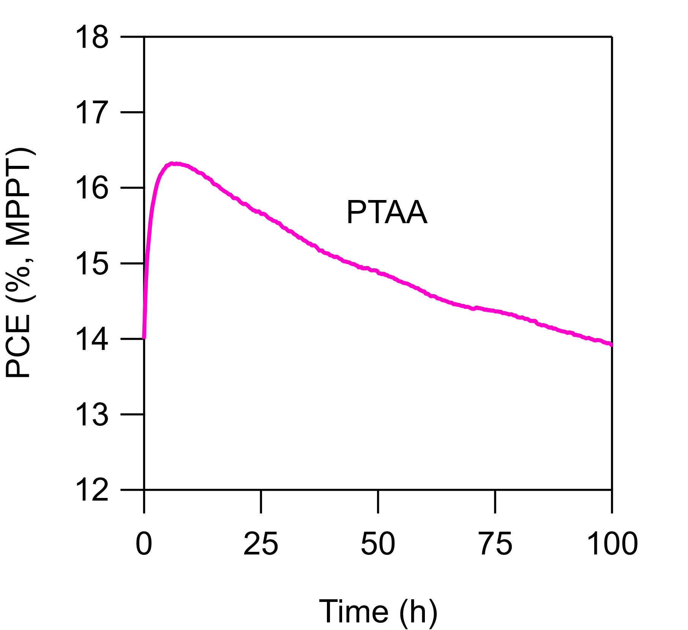
a)
b)
c)
d)

Fig. S6. Characteristics of a p-i-n device fabricated with a PTAA hole transport layer instead of the MeO-2PACz monolayer. The absorber was high-Br perovskite. (a) 100 MPPT stability test under AM1.5G. (b) J–V curves under AM1.5G. (c) EQE spectra. (d) The differential of the EQE signal around the onset region. Gaussian peak fits of the experimental data are indicated by the solid lines.

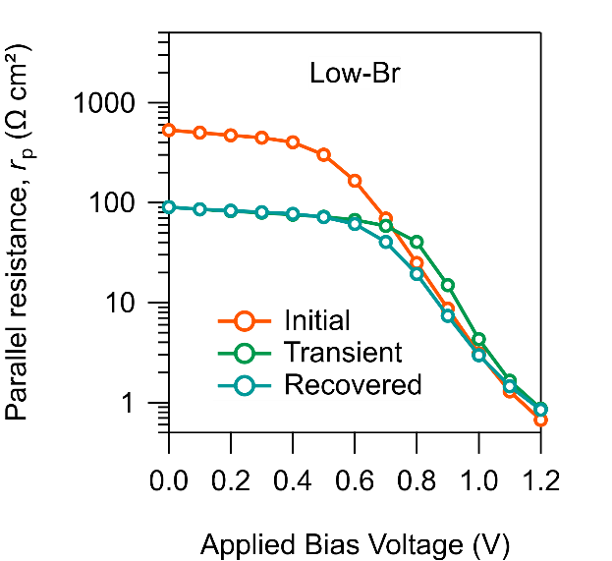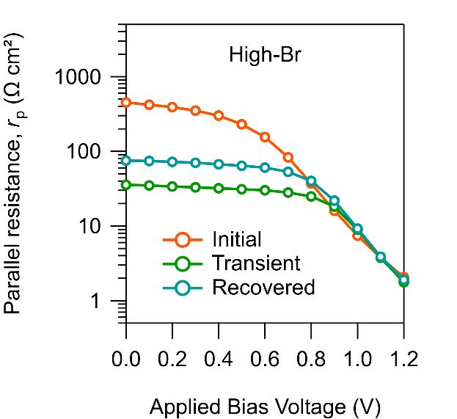
a)
b)

Fig. S7. Evolution of the parallel resistance, r_{p}, of the test cells as a function of applied bias voltage. Results for the devices before and the 100 h MPPT test (Initial), and in the hours following the end of the MPPT test (Transient), and after the transient effects subside (Recovered) shown for (a) low-Br and (b) high-Br devices. r_{p} is determined from the complex impedance spectra measured under AM1.5G (data and model fits are given in Appendix A).

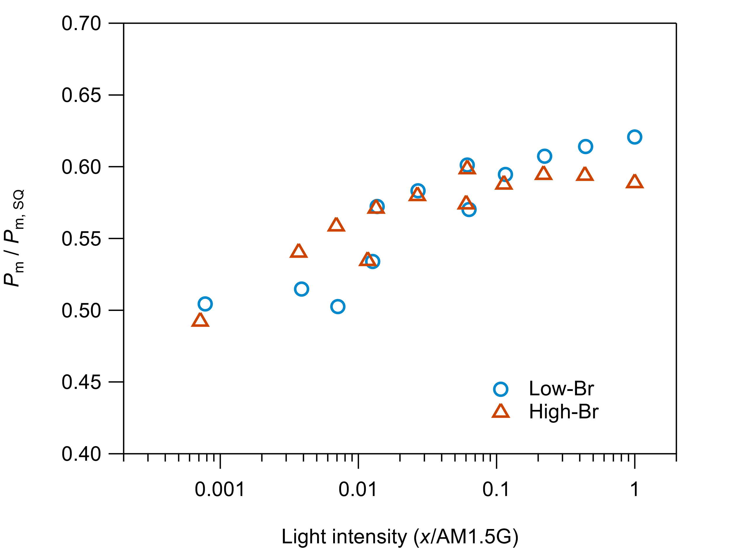

Fig. S8. A plot showing the ratio of the measured maximum output power (determined from the average P_{m} of the forward and reverse J–V scans) and the Shockley–Queisser limit (P_{m, SQ}) for the low-Br and high-Br devices as a function of light intensity. Attenuated AM1.5G illumination was used for these measurements.

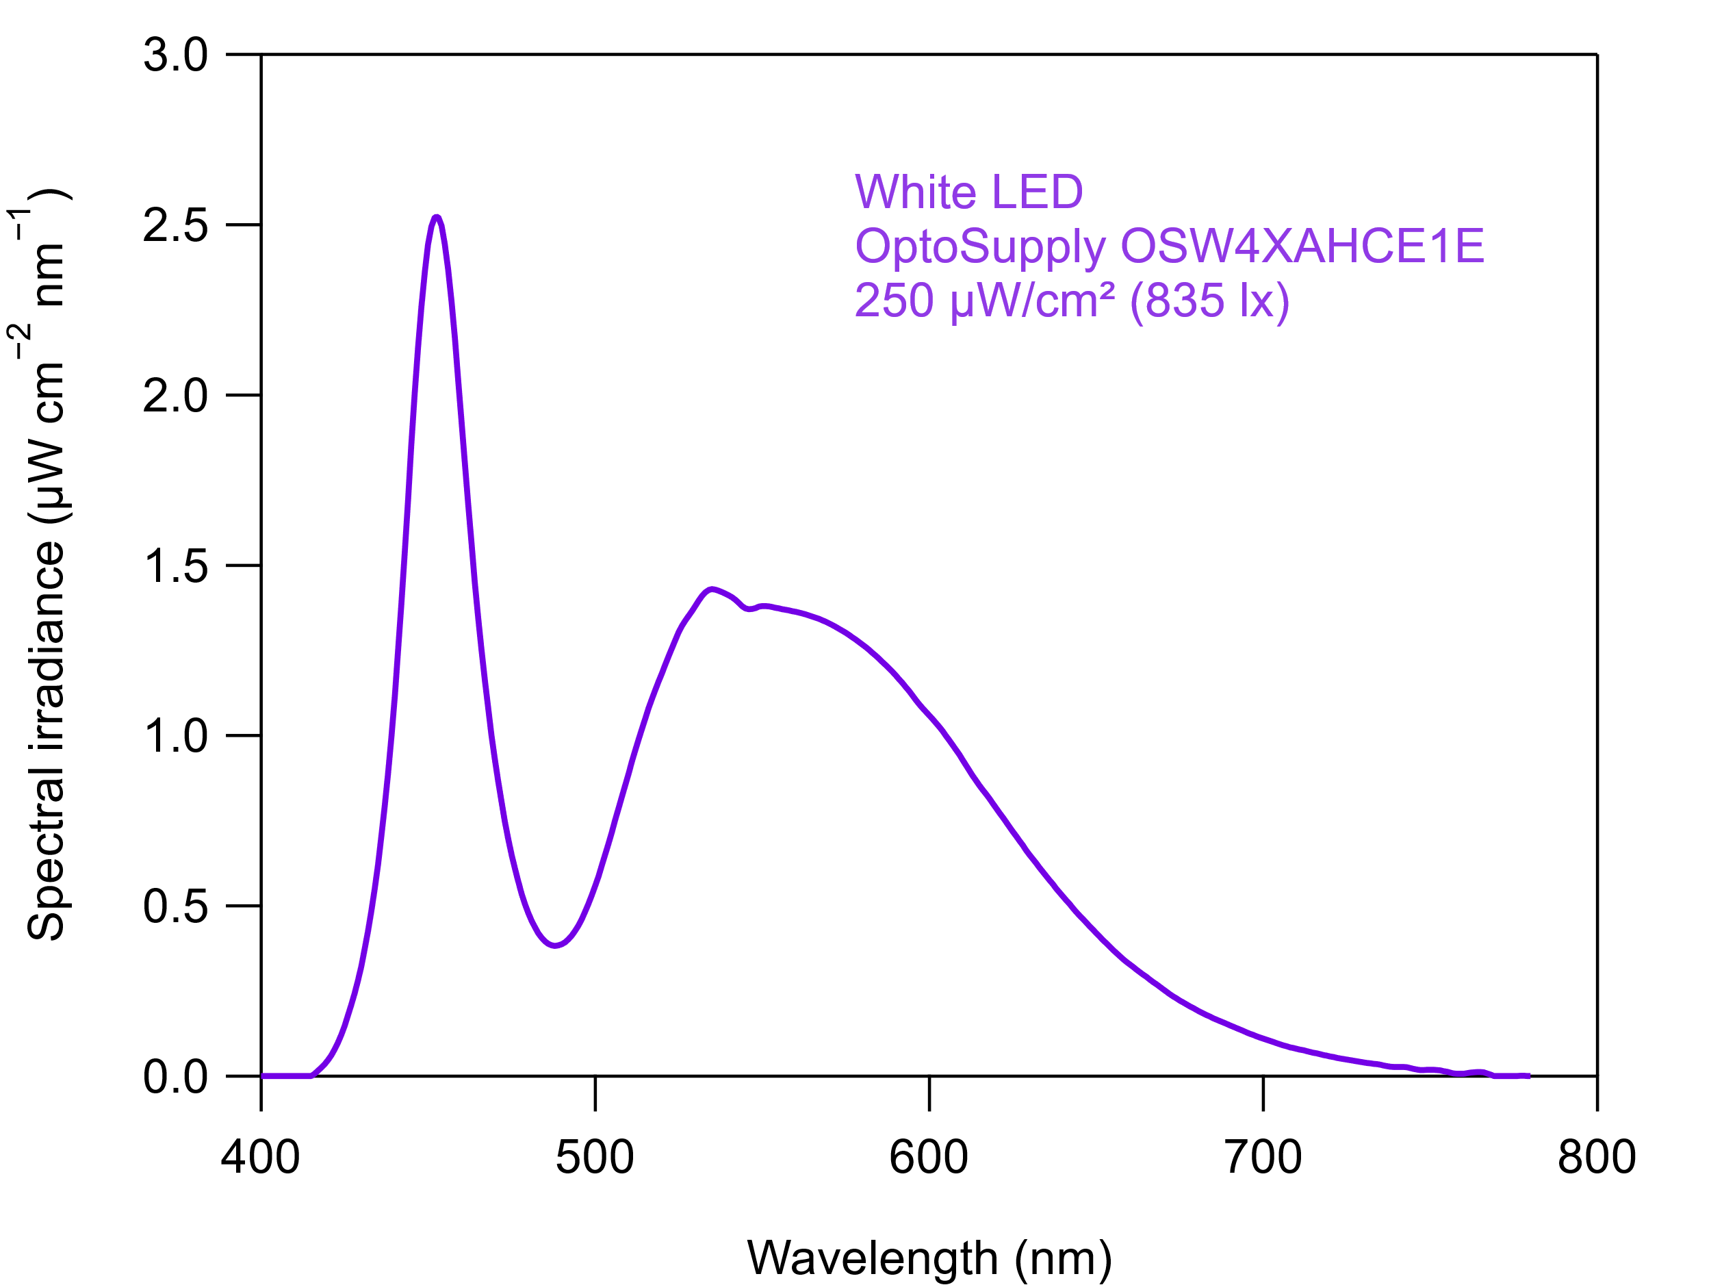

Fig. S9. Spectral intensity of the white LED (OptoSupply OSW4XAHCE1E) that was used to simulate ambient indoor lighting. The irradiance of 250 μW cm⁻² translates to an illuminance of 835 lx, a typical brightness for a well-lit work environment. The spectrum was recorded with a Sekonic C-7000 color meter.

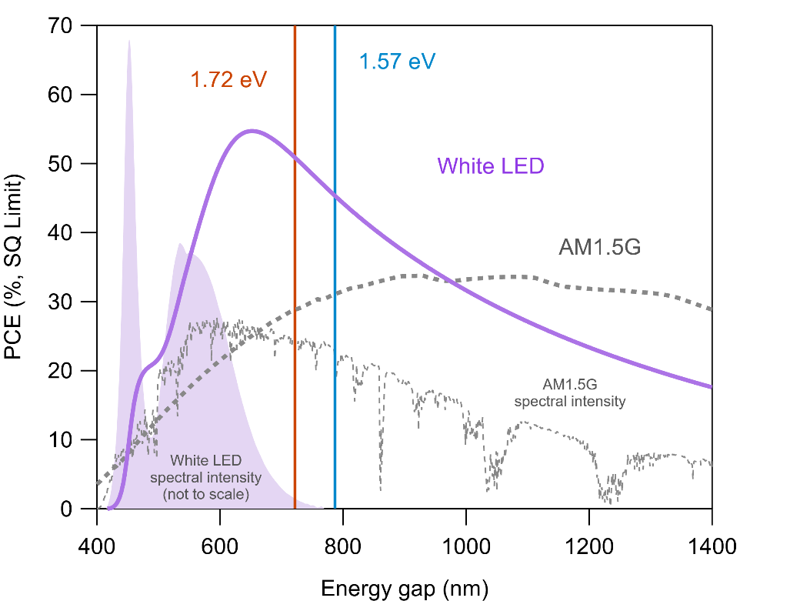

Fig. S10. Detailed balance calculations comparing the theoretical PCE under solar radiation (ASTM G173-03, AM1.5G, 100 mW cm⁻²) and the low-intensity white LED (irradiance 250 μW/cm²) used in this work for the ambient light tests. Very high efficiencies are theoretically possible with the LED due to the narrow bandwidth of the emitted light.

Appendix A: Complex Impedance Spectra

Impedance measurements were taken with a Keysight model E4990A impedance analyzer. The frequency range was scanned from 200 Hz and 20 MHz while the applied bias was increased stepwise from 0 to 1.2 V. The parallel resistance, r_{p}, is obtained from the model fits indicated by the grey solid line as the diameter of the semicircular feature. Samples were measured under AM1.5G, under an inert atmosphere.
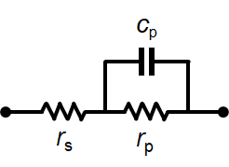
The model circuit for fitting the impedance data.

In the model circuit, the parallel resistance, also called the recombination resistance, derives from the parallel conductance of the diode and shunt resistance elements in the standard solar cell equivalent circuit. The formal relation is –(dJ/dV) = r_{p} + r_{s}, where r_{s} is the series resistance of the device and J is the calculated current of the equivalent circuit. r_{p} will converge to the shunt resistance of the cell at low bias voltages and decrease exponentially at higher voltages due to conduction through the diode element. The current at high bias voltage is eventually limited by the series resistance of the diode element.

Data shown for the following devices and conditions:

Low-Br (Initial)
Low-Br (Transient)
Low-Br (Recovered)
High-Br (Initial)
High-Br (Transient)
High-Br (Recovered)

Low-Br (Initial)

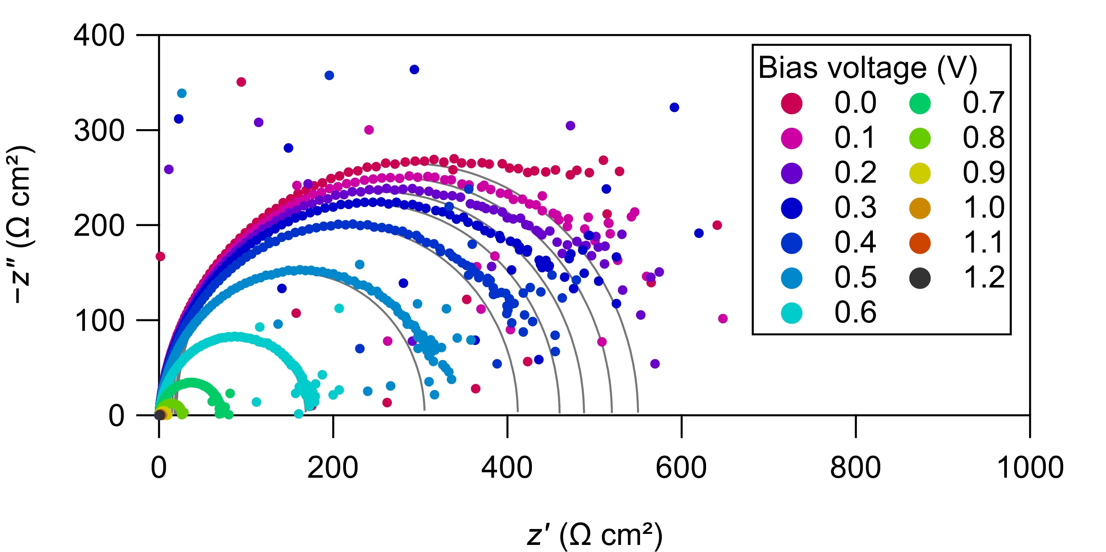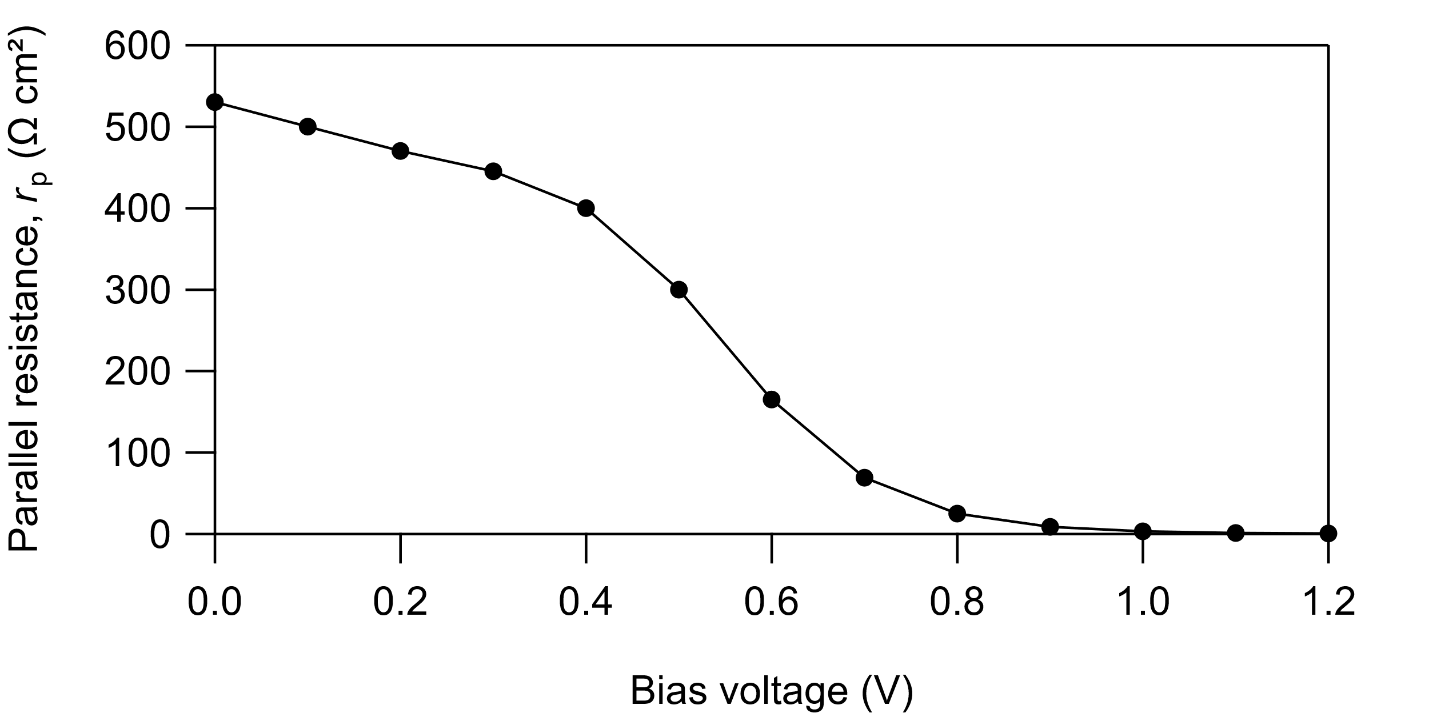

Low-Br (Transient)

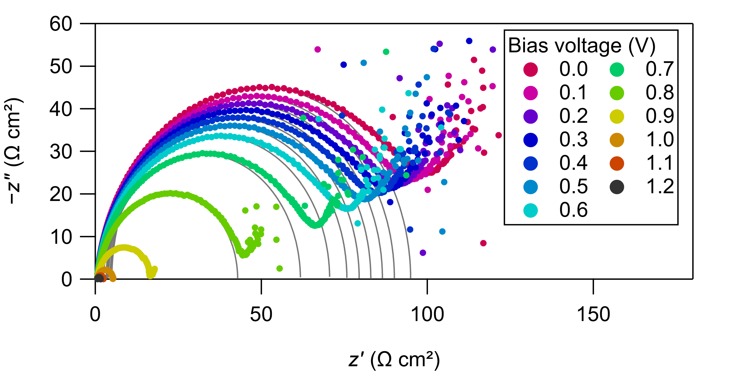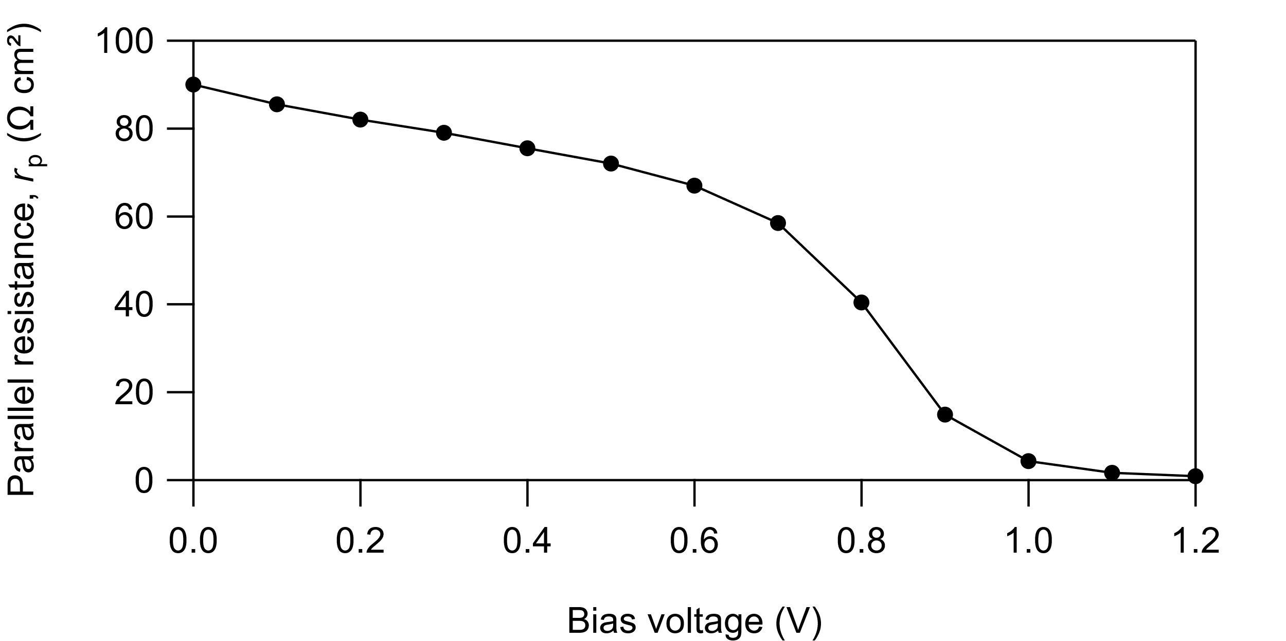

Low-Br (Recovered)

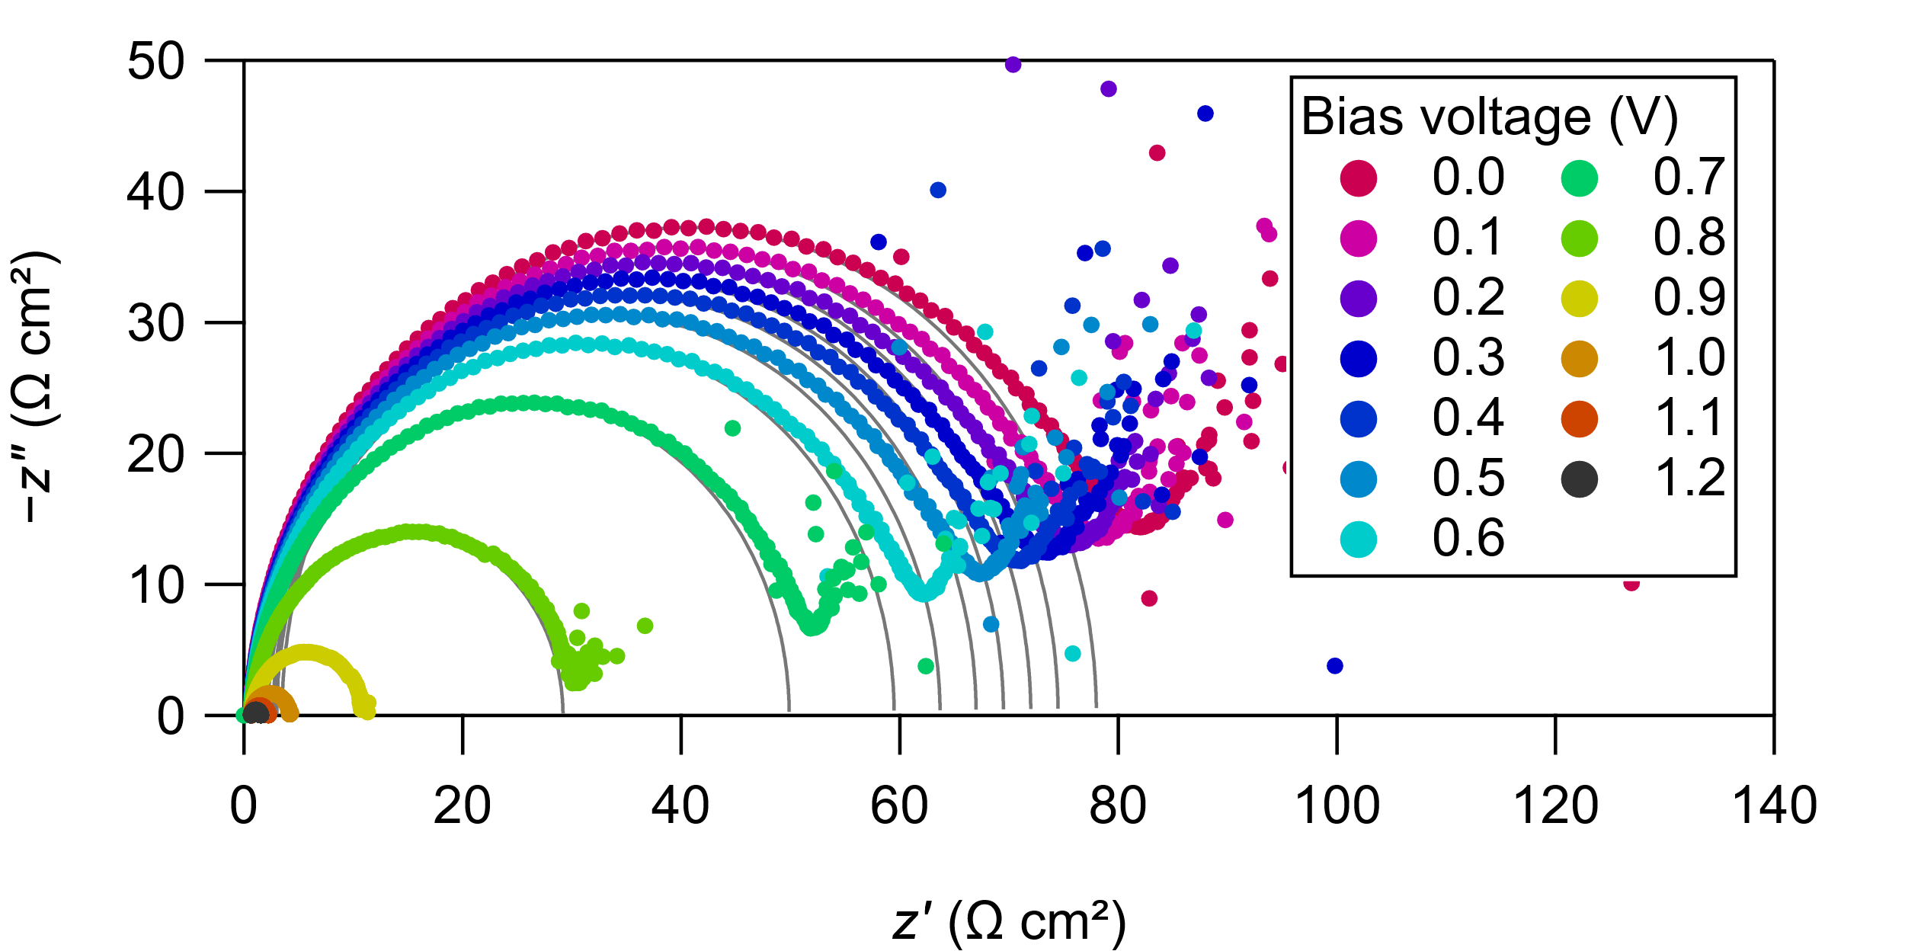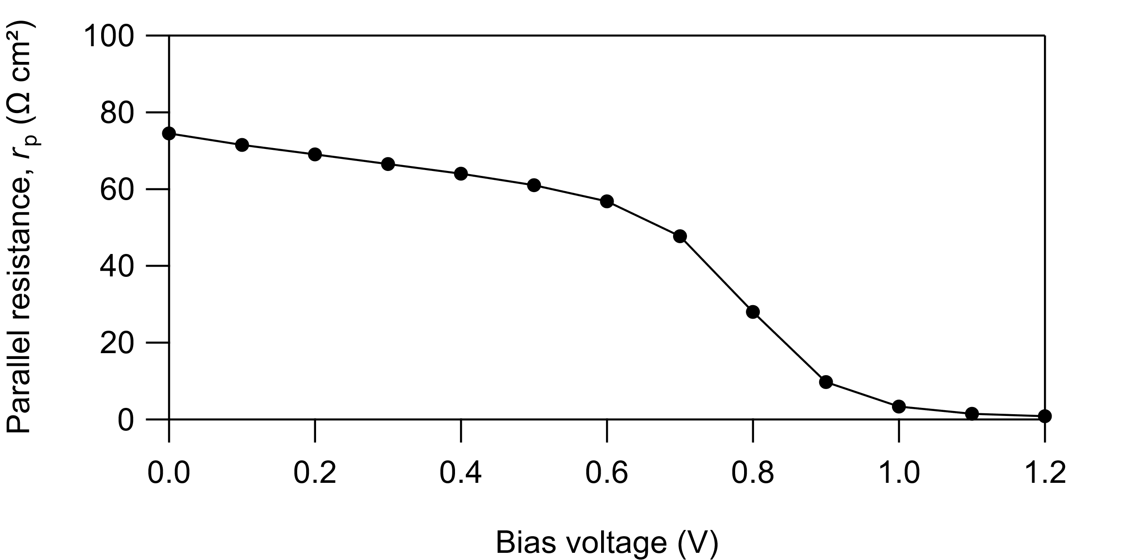

High-Br (Initial)

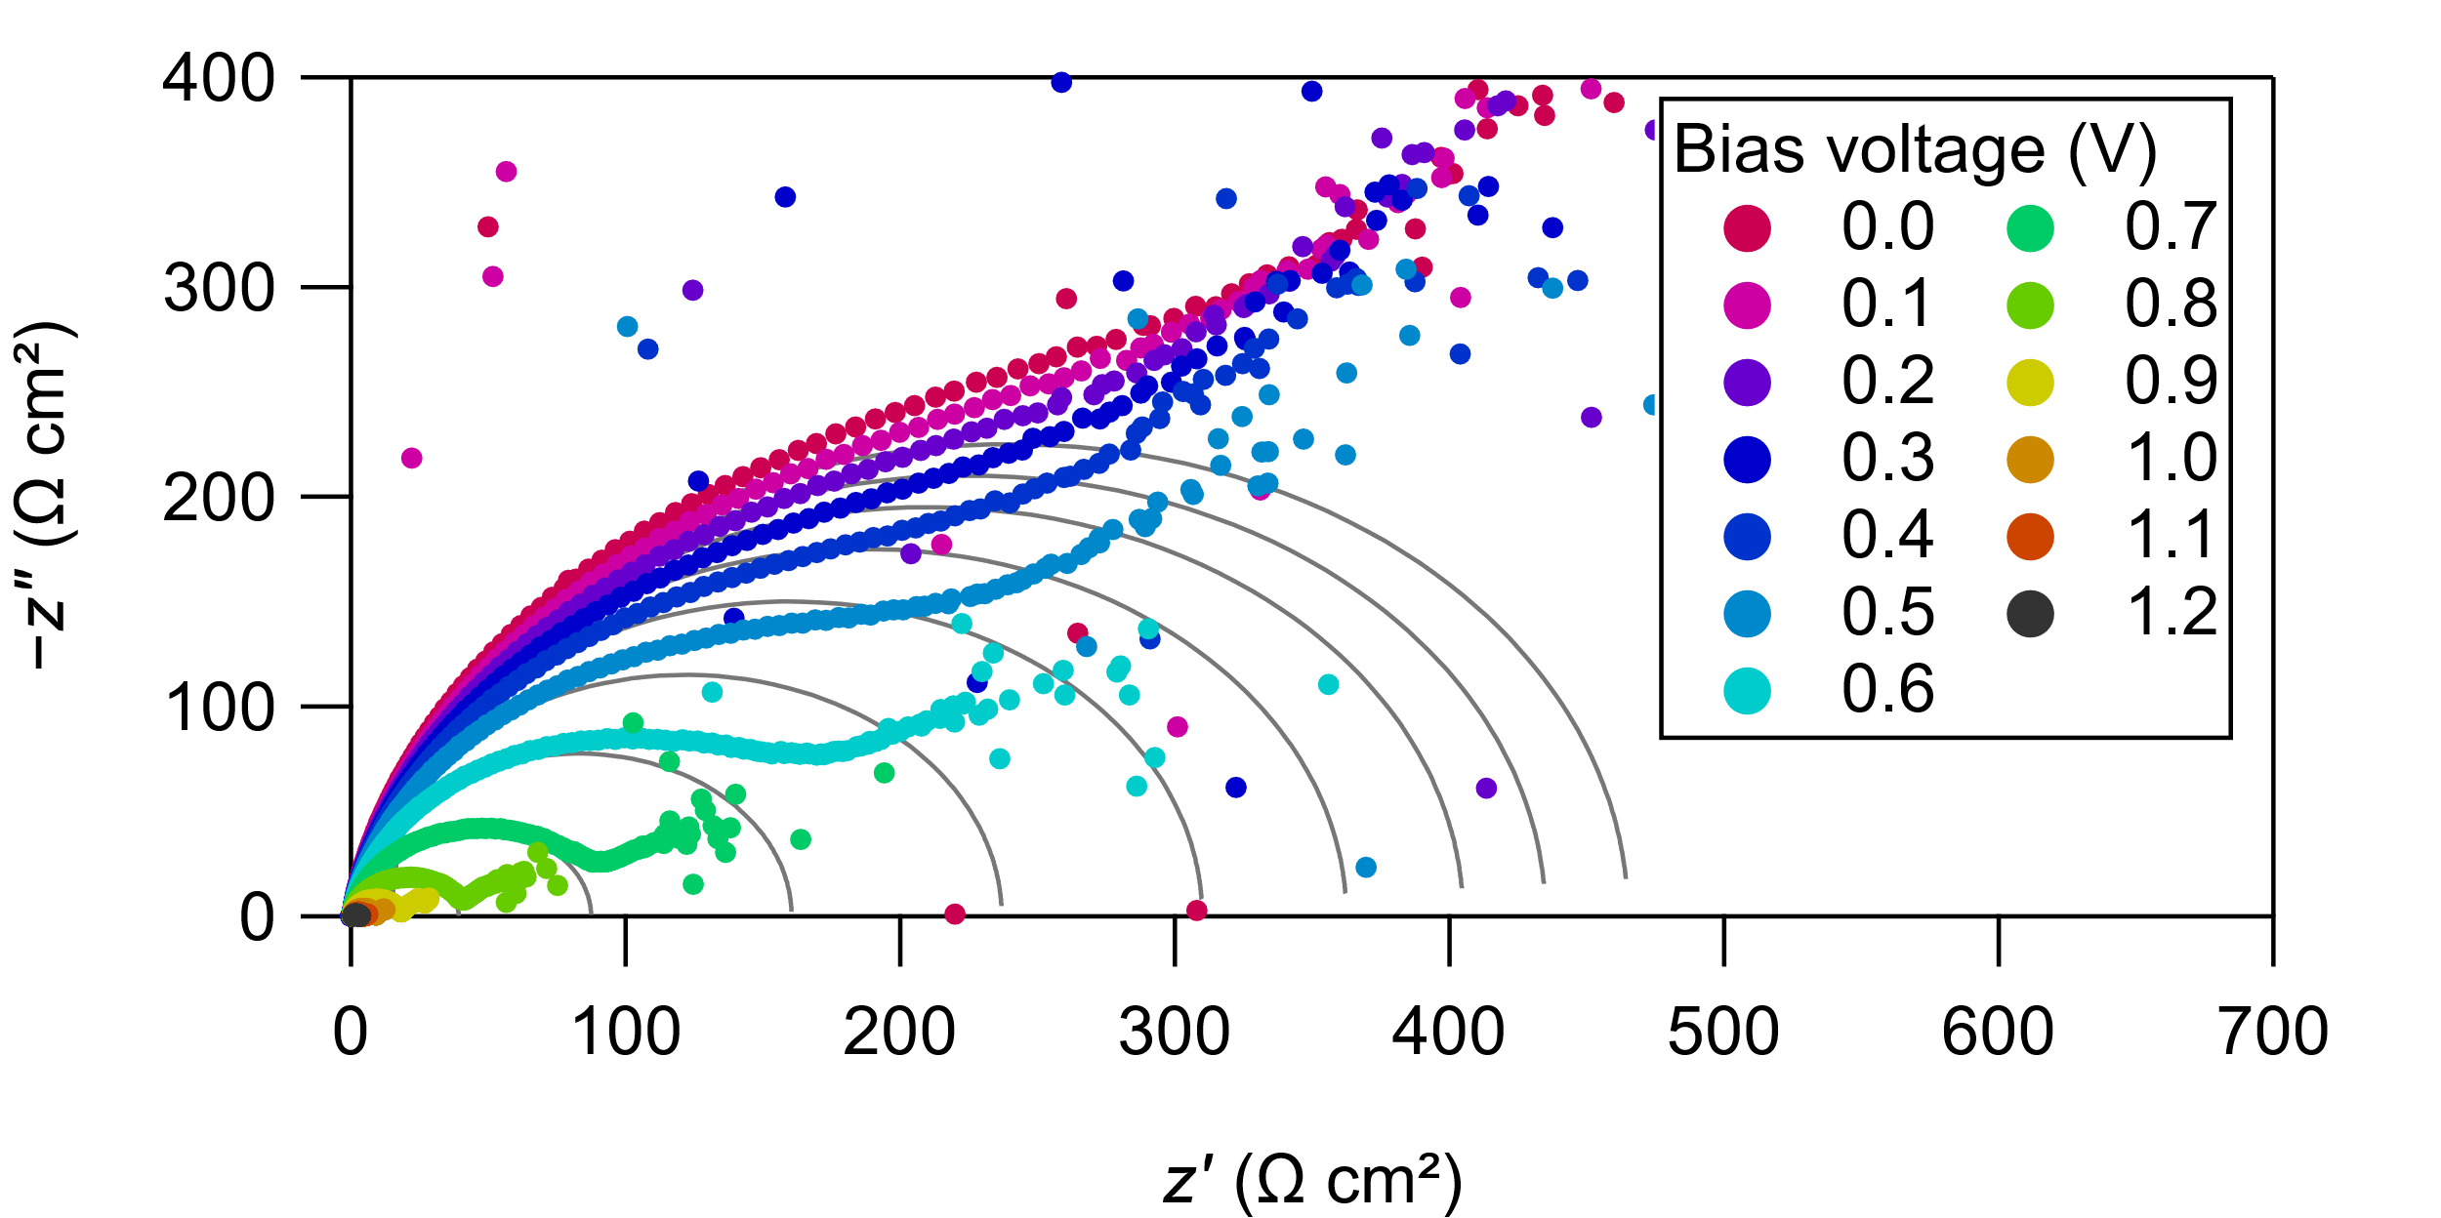
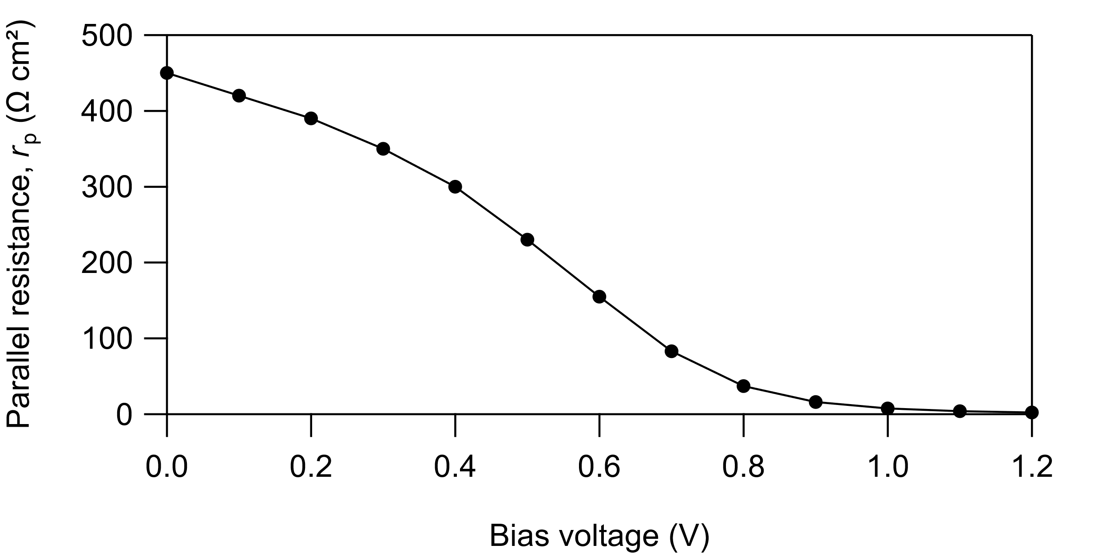

High-Br (Transient)
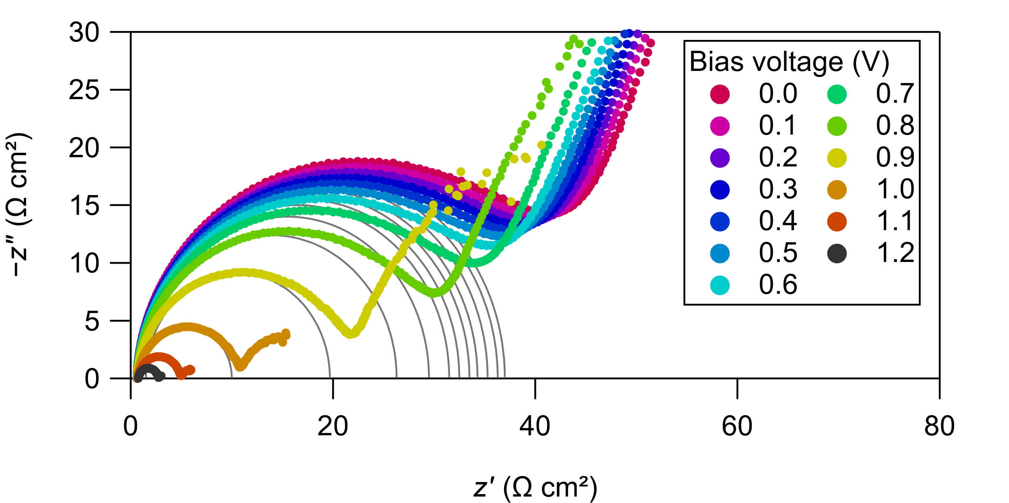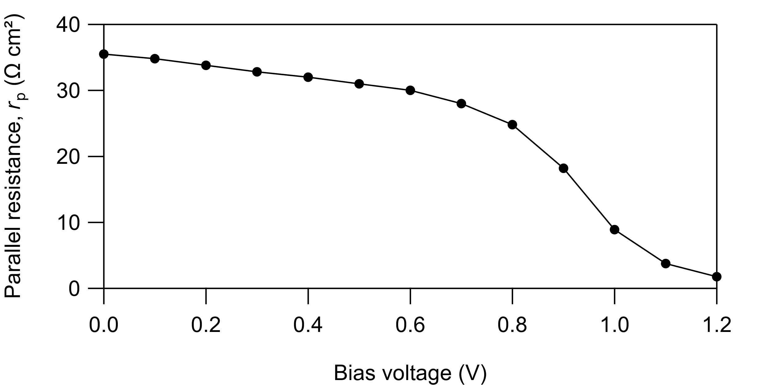

High-Br (Recovered)
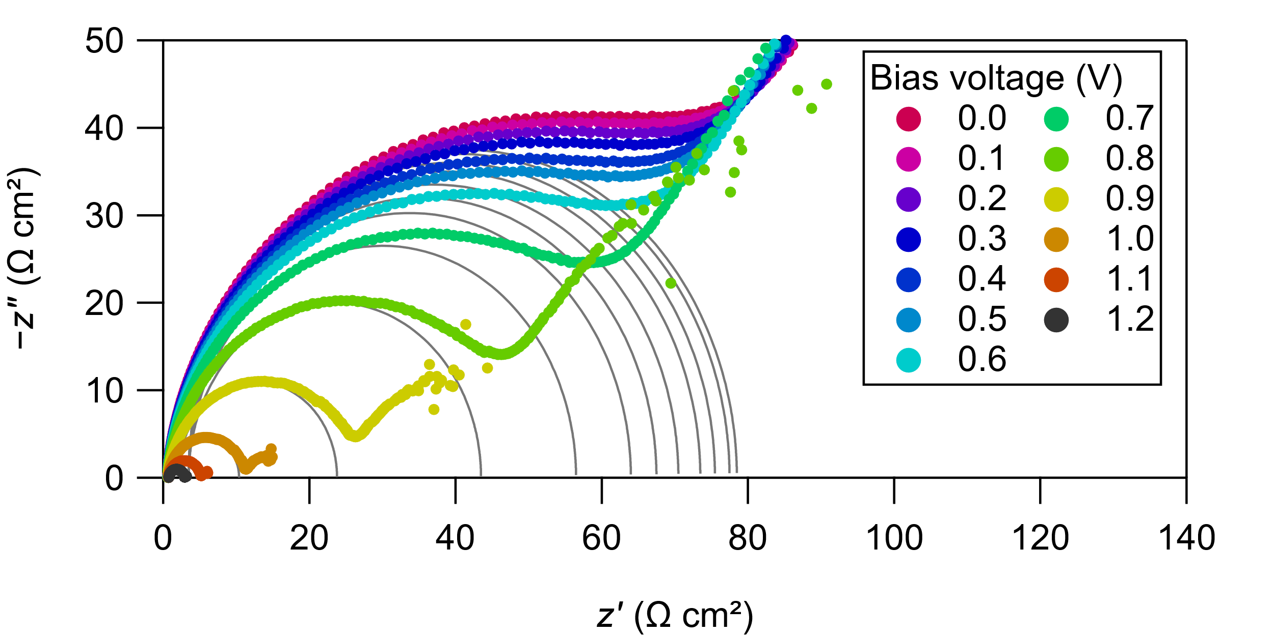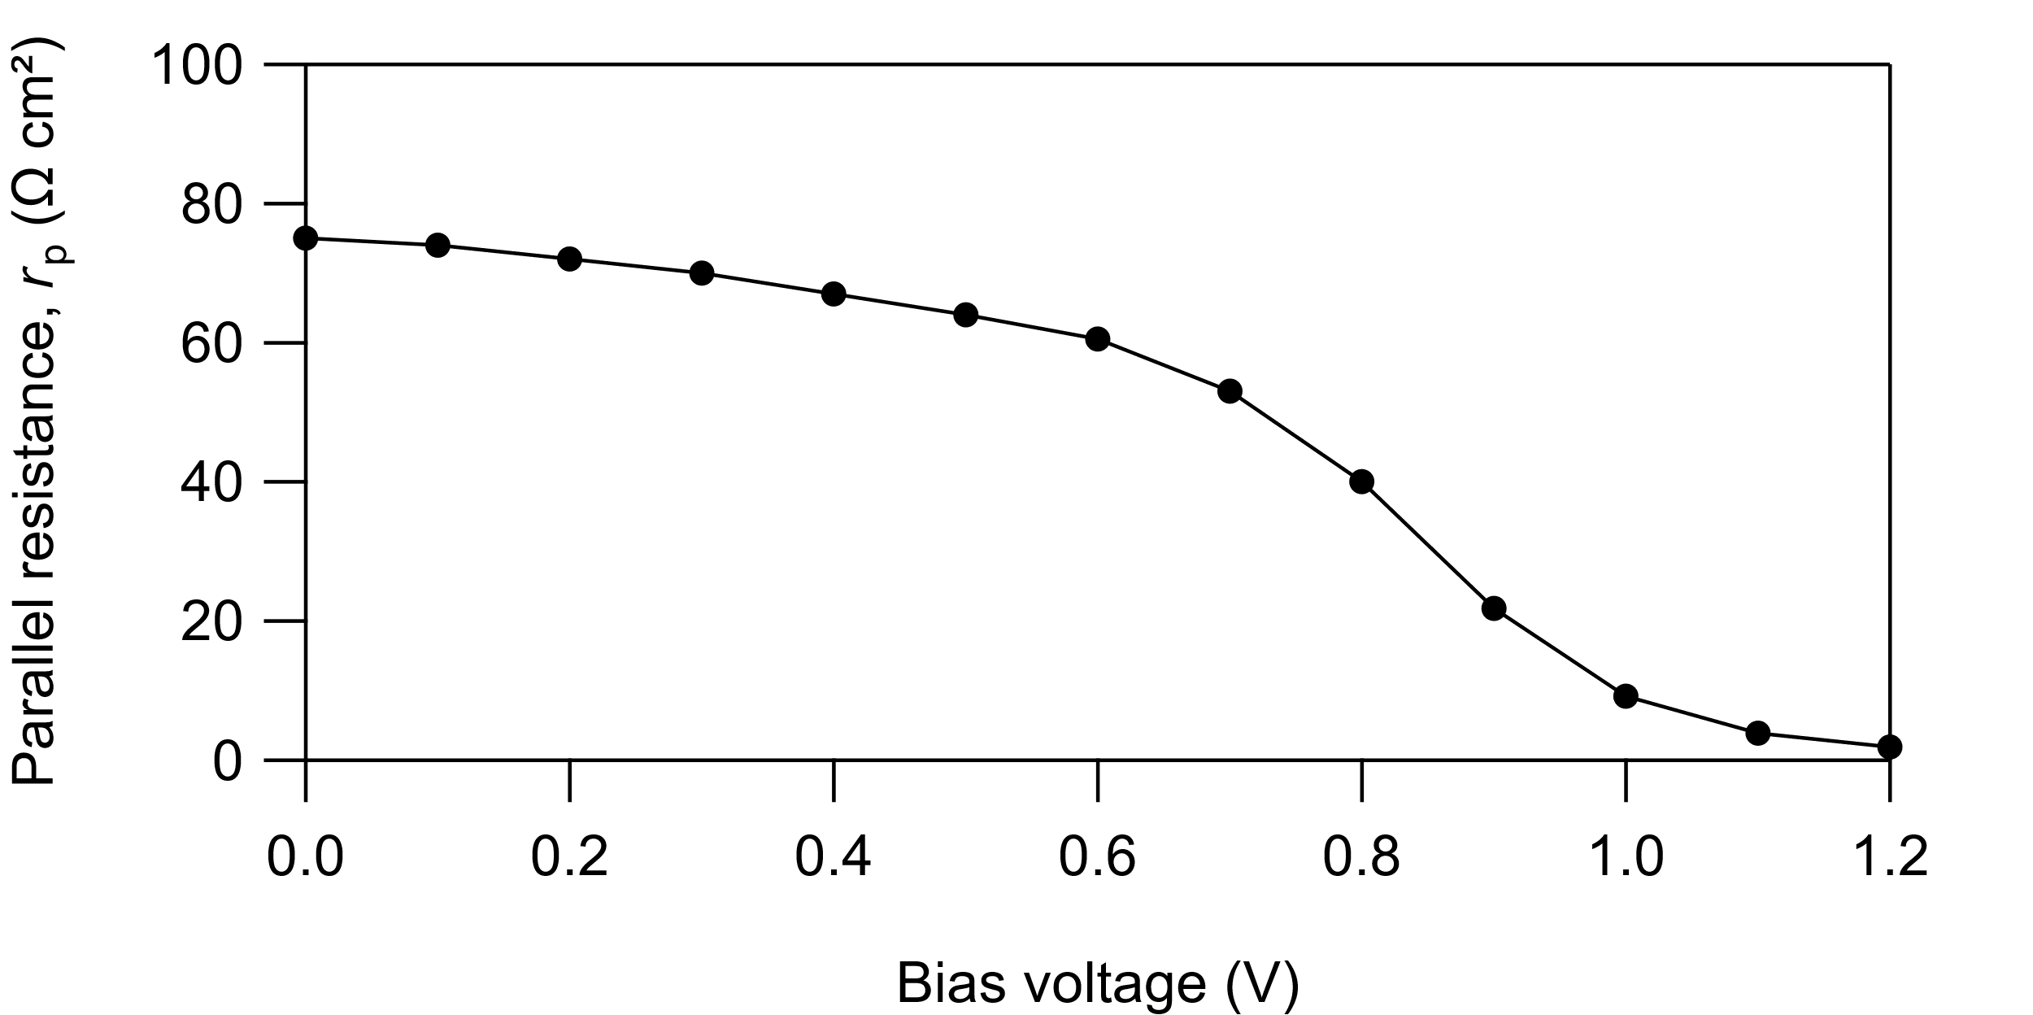

Appendix B: Light Intensity Dependence

Forward and reverse J–V scans were measured between −0.1 V and the open circuit voltage at a scan rate of 50 mV s⁻¹ using a Keithley 2450 sourcemeter. The algorithm had a “soft return” feature such that the scan direction switched automatically to the reverse direction once the scan voltage exceeded V_{oc}. This prevents strong forward bias from being applied to the device, minimizing hysteresis.
J–V scans were measured as the light intensity was increased from less than 1/1000 sun to 1 sun. Attenuation was achieved by inserting neutral density filters combined with a variable aperture into the light path. The devices were operated for several minutes under AM1.5G before the measurement sequence began, and light exposure at each point was minimized. This helps maintain the device at a constant quasi-equilibrium state throughout the experiment. To keep the measurement times low, only J–V scans were measured: 300 s MPPT stability tests were not performed.
The J_{sc}, V_{oc}, PCE, and FF were determined for each scan direction and averaged together. J–V plots show the averaged data from the forward and reverse scans.

Data shown for the following devices and conditions:

Low-Br (Initial)
Low-Br (Transient)
Low-Br (Recovered)
High-Br (Initial)
High-Br (Transient)
High-Br (Recovered)

Low-Br (Initial)
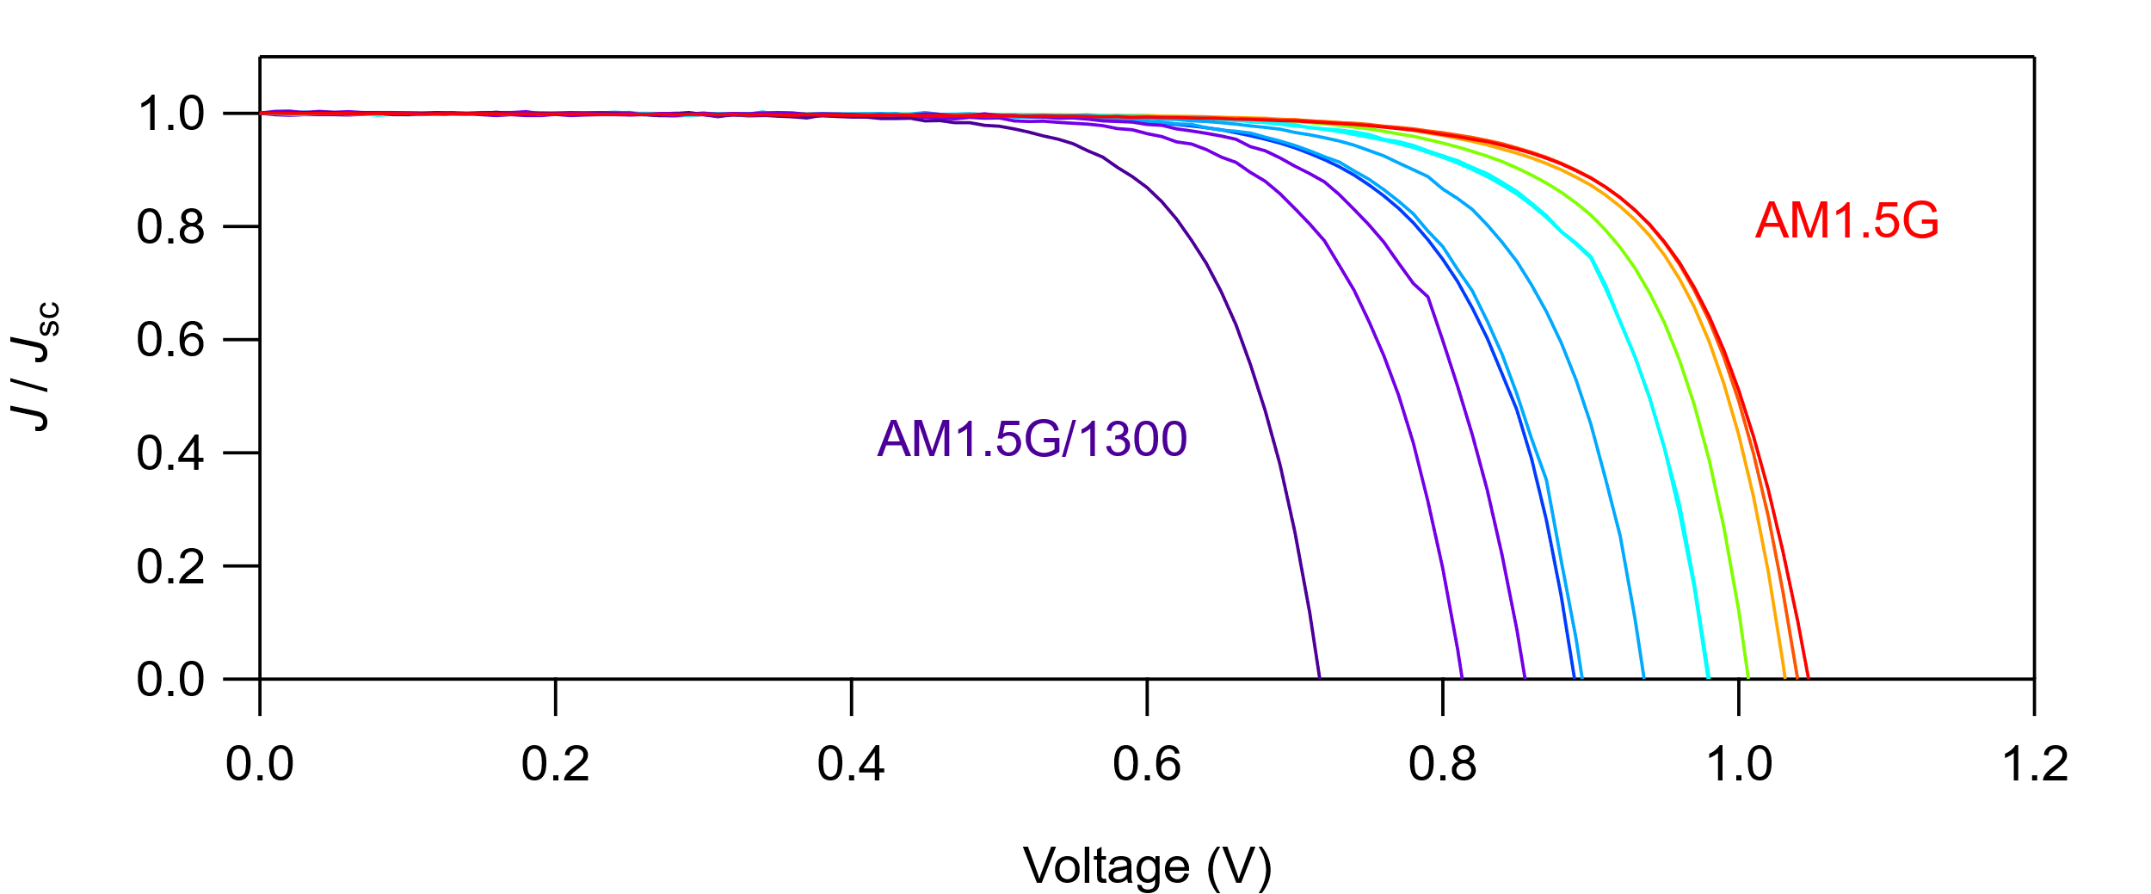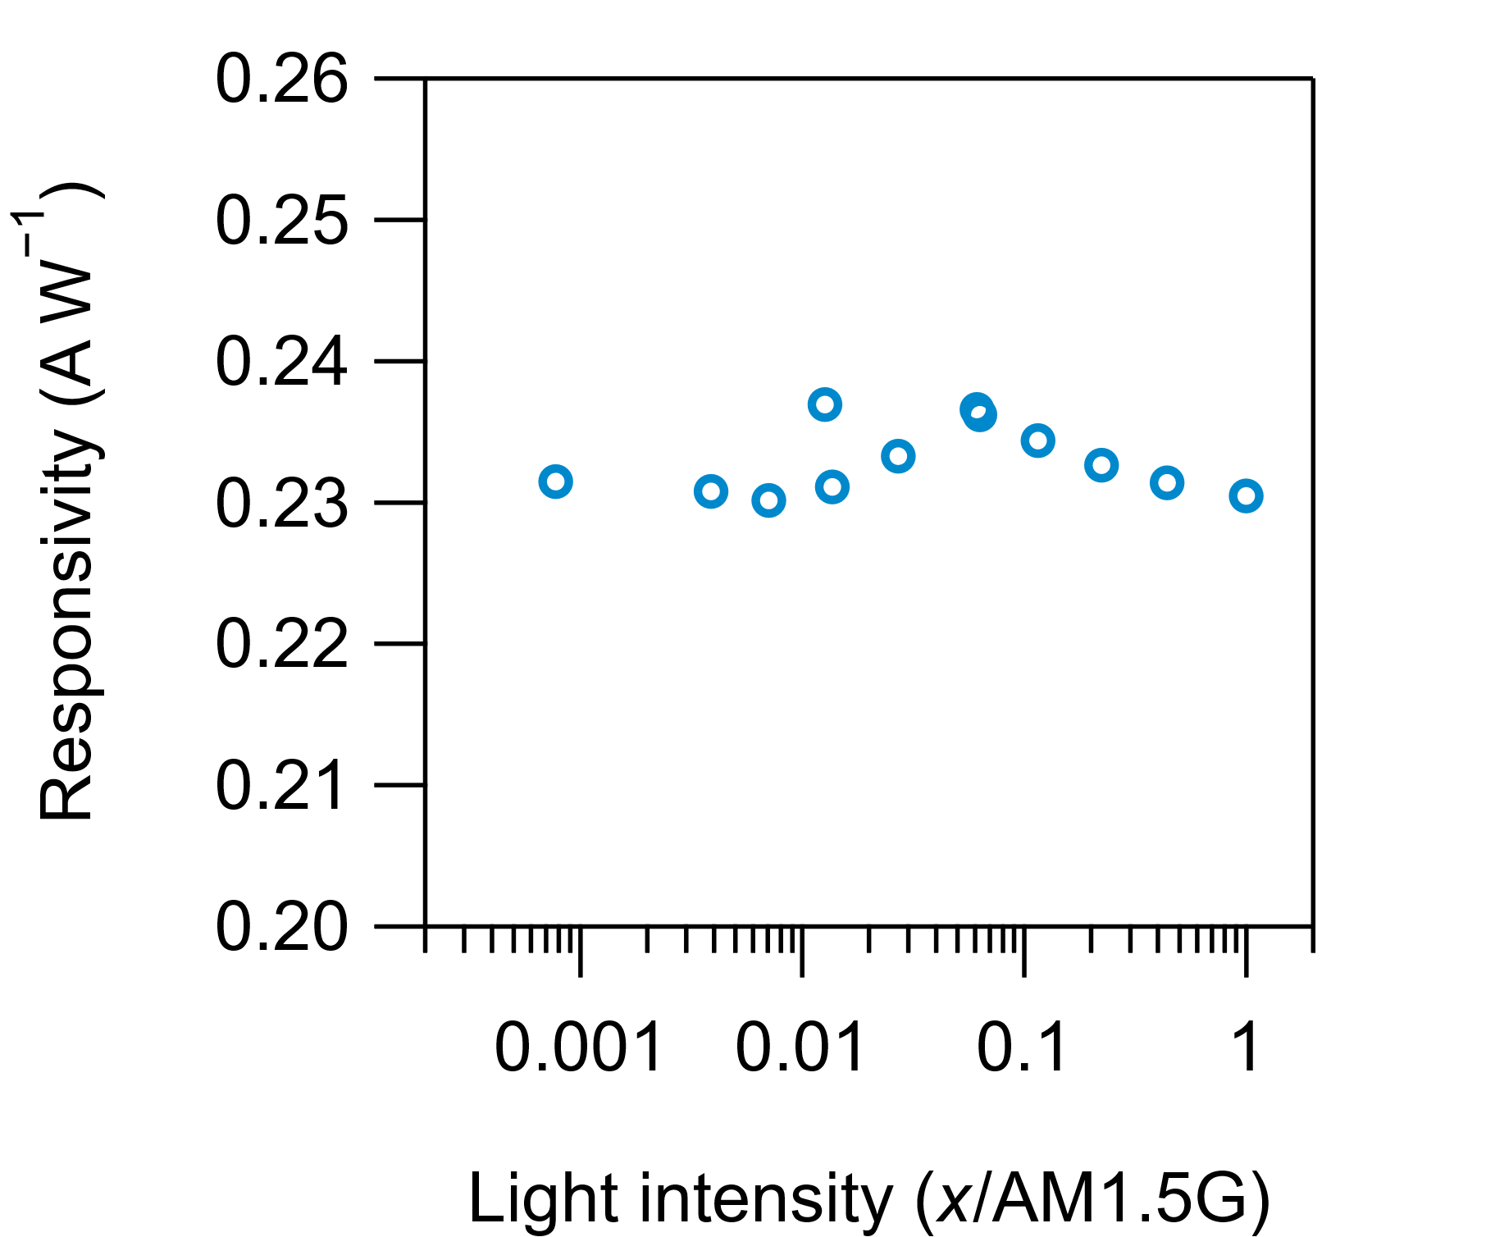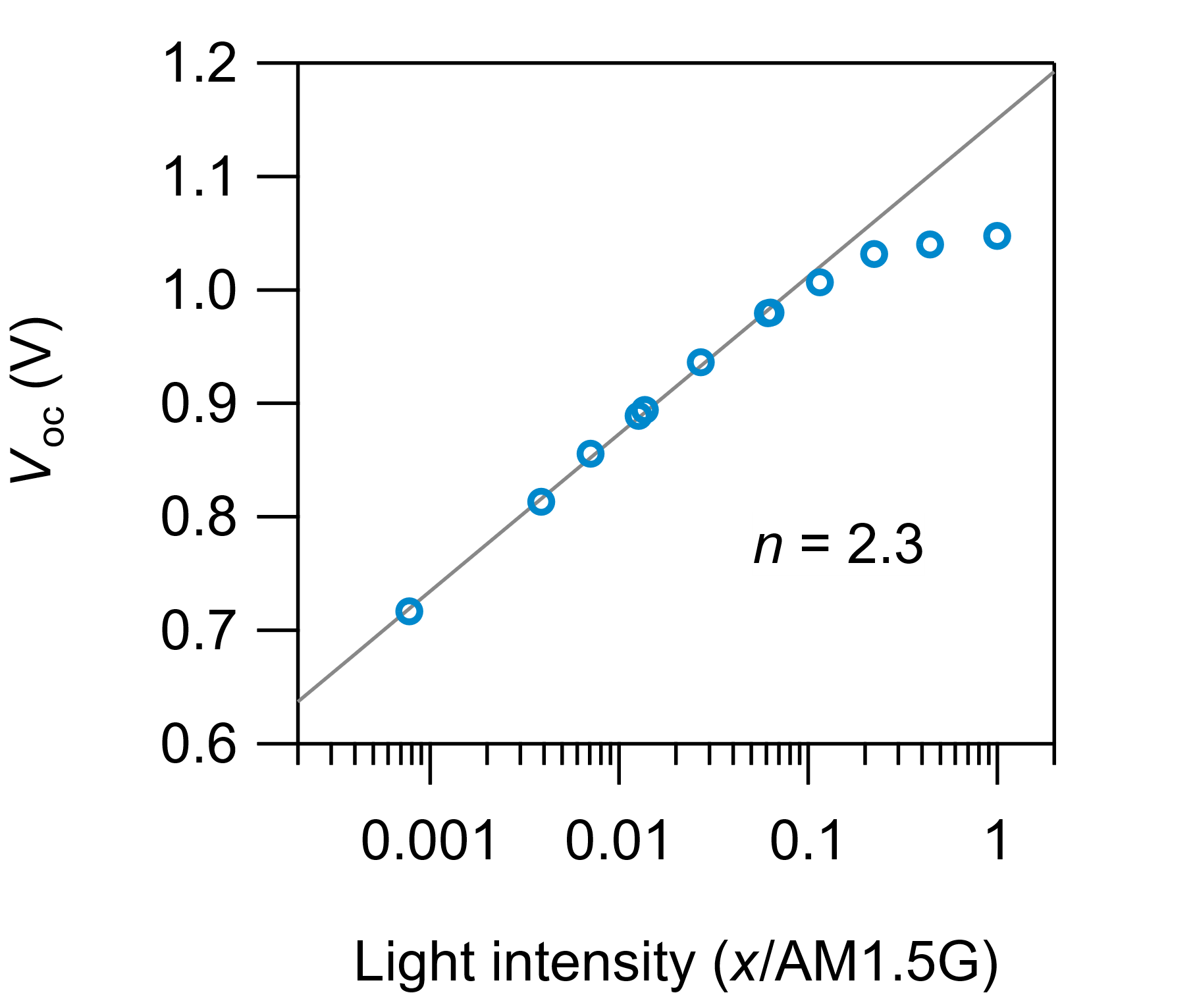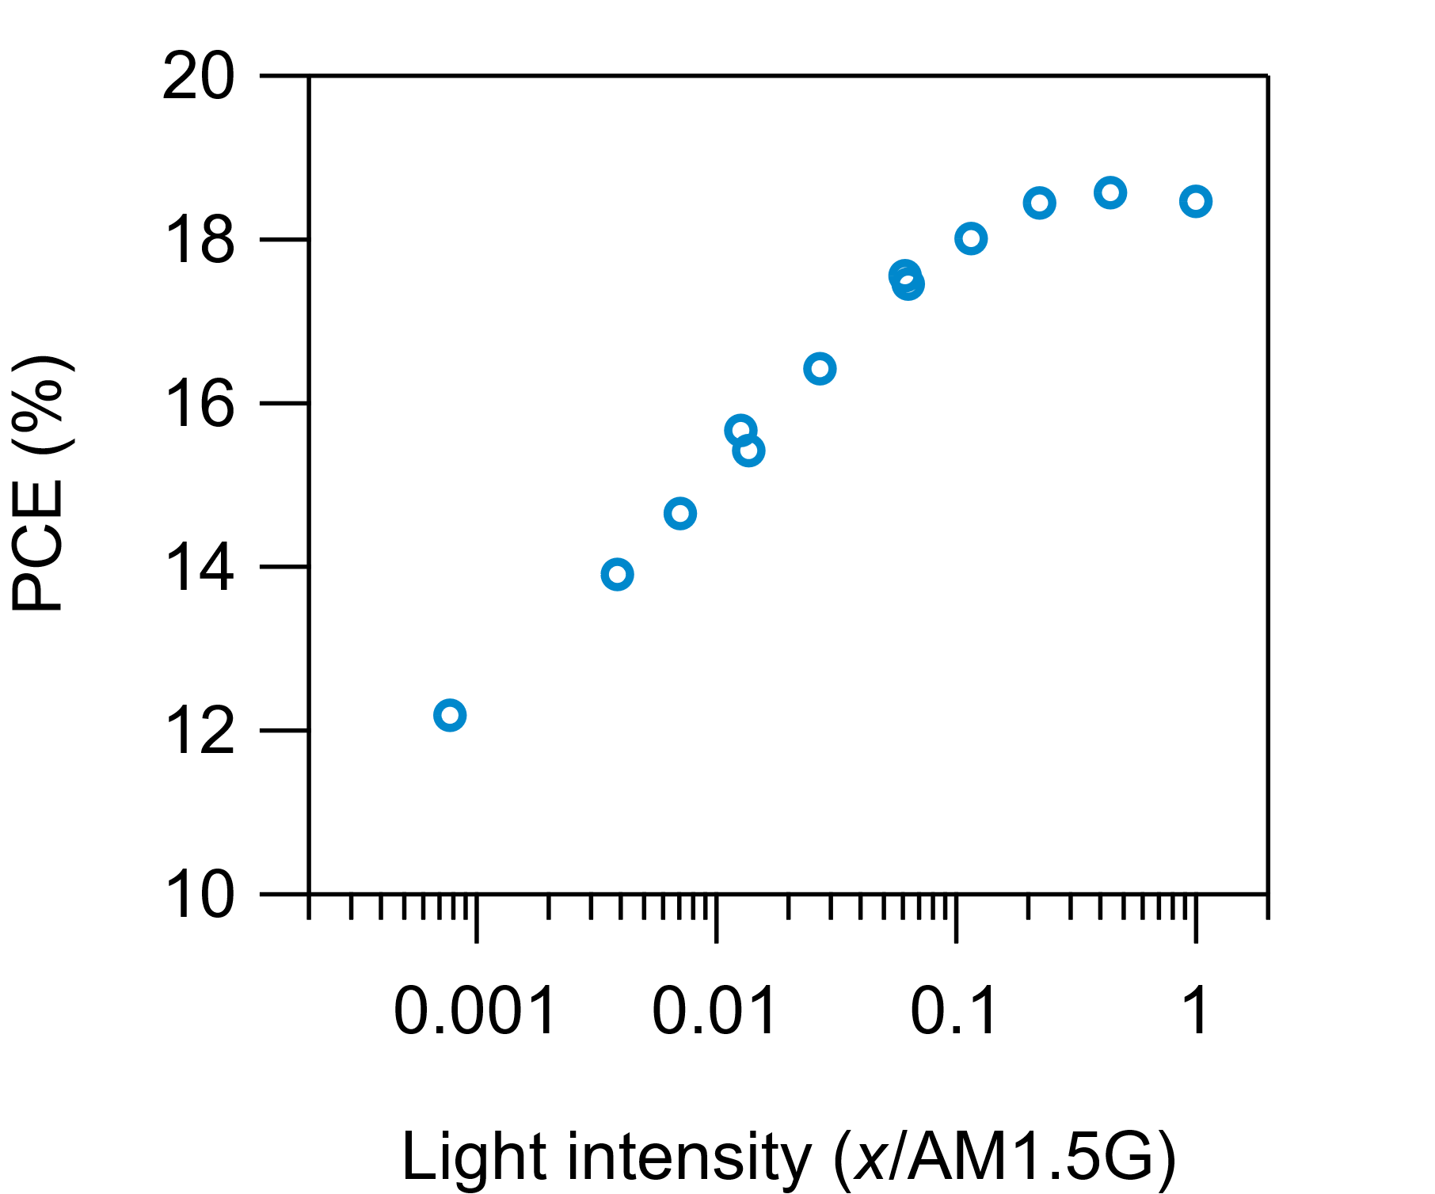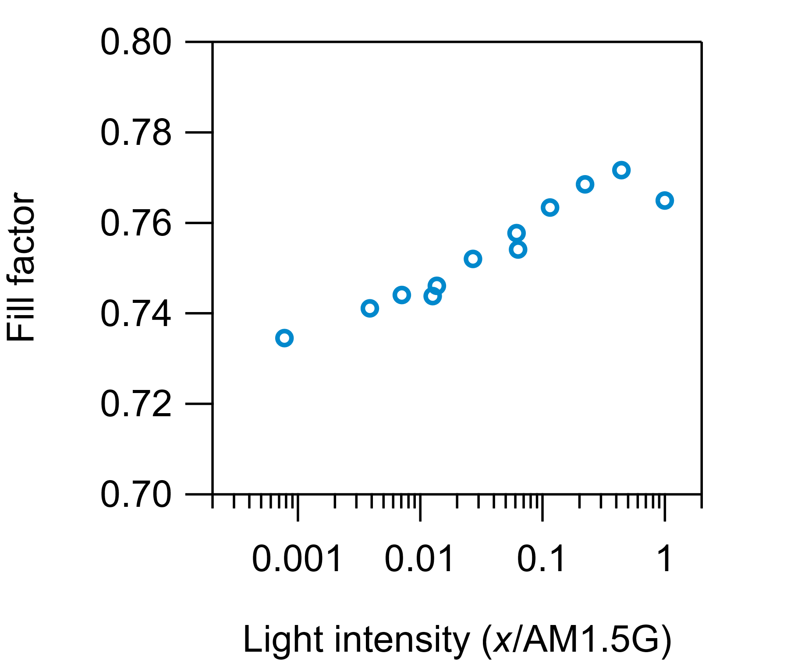

Low-Br (Transient)
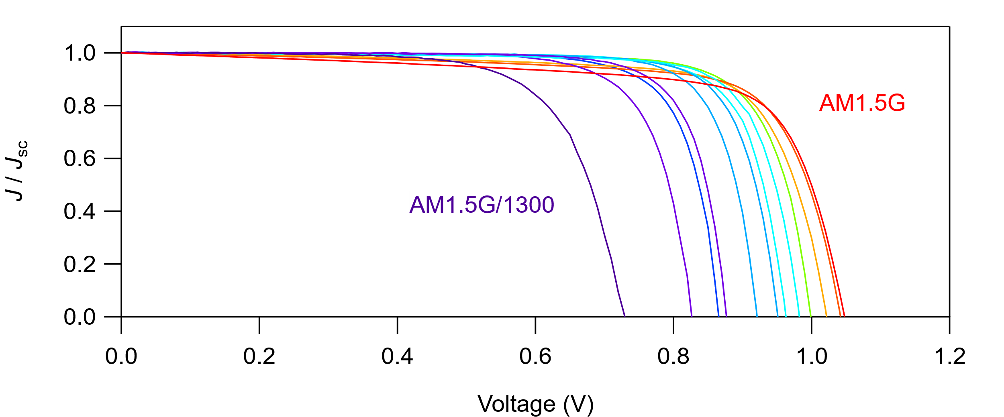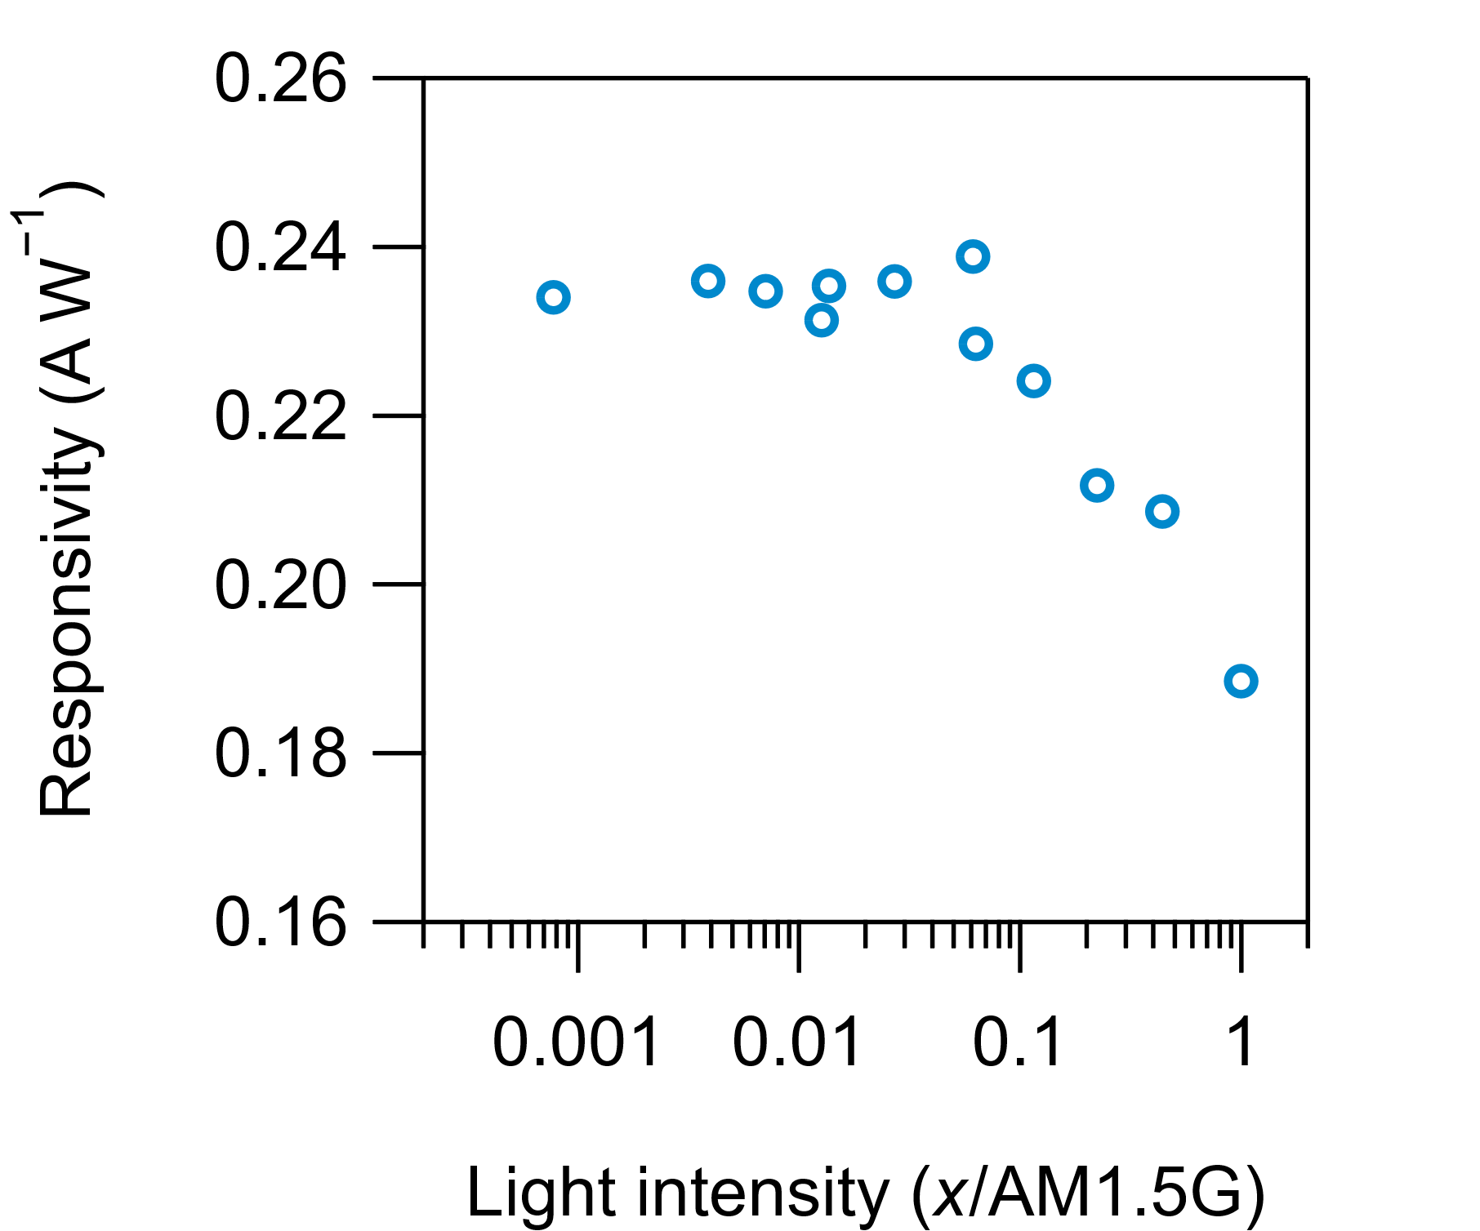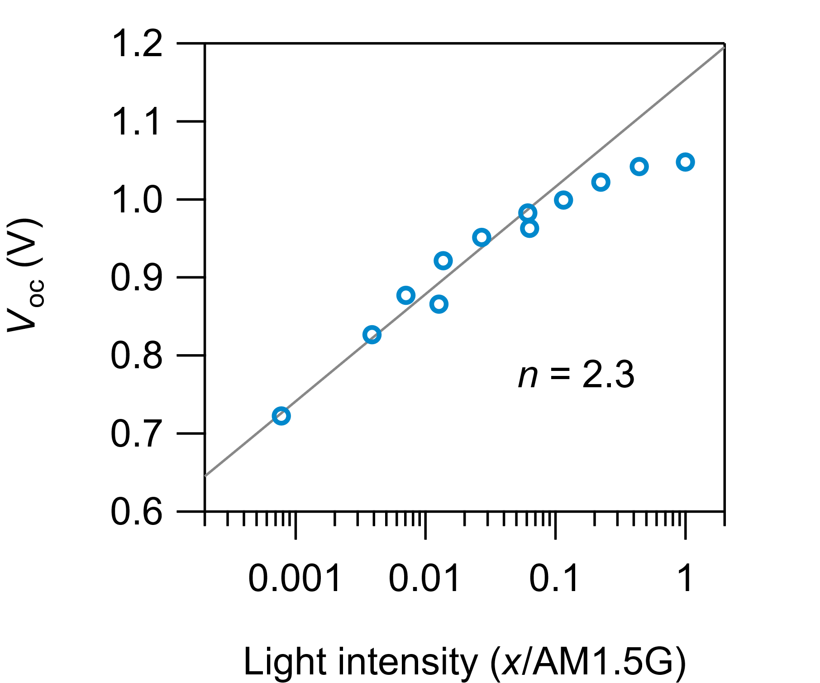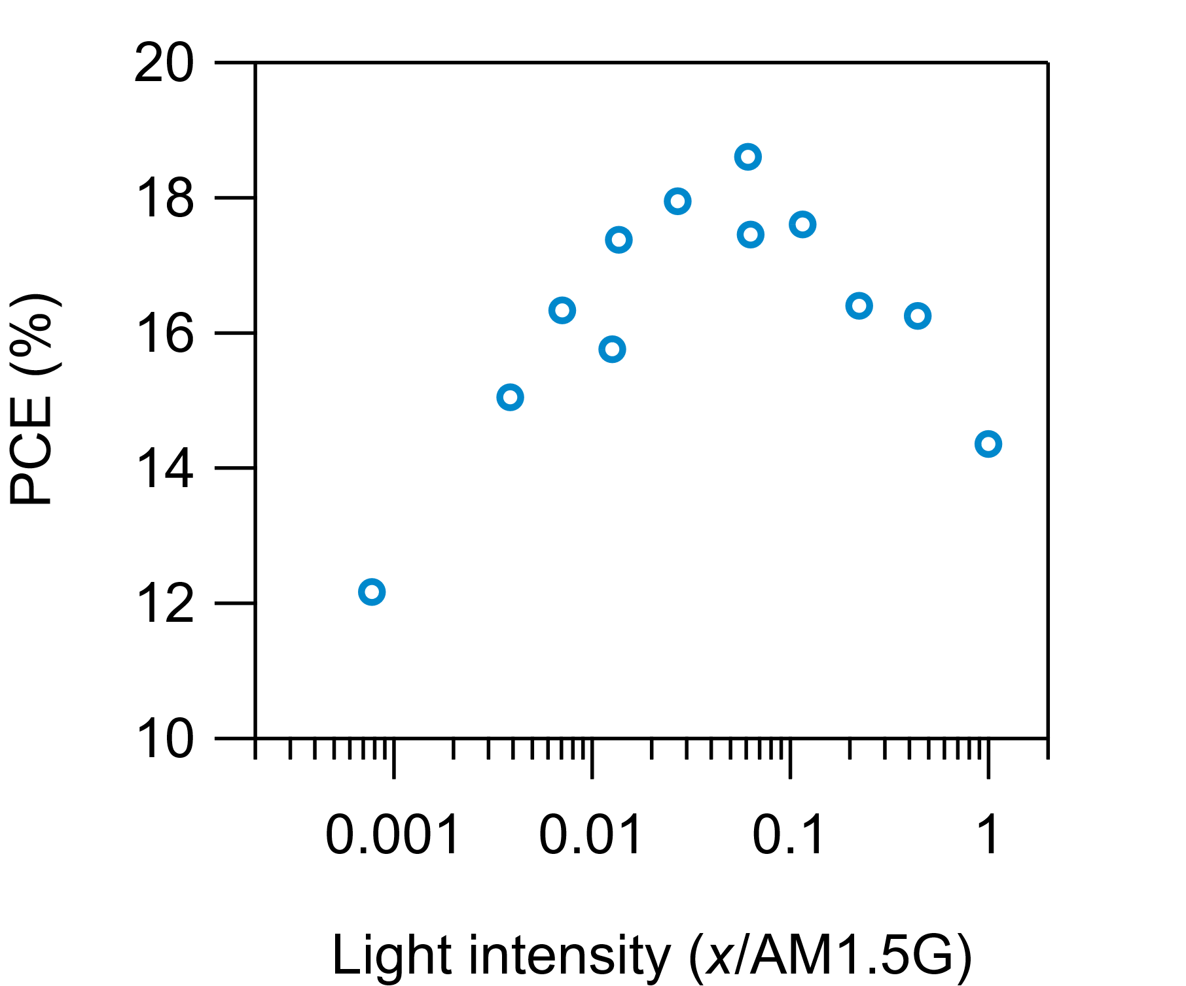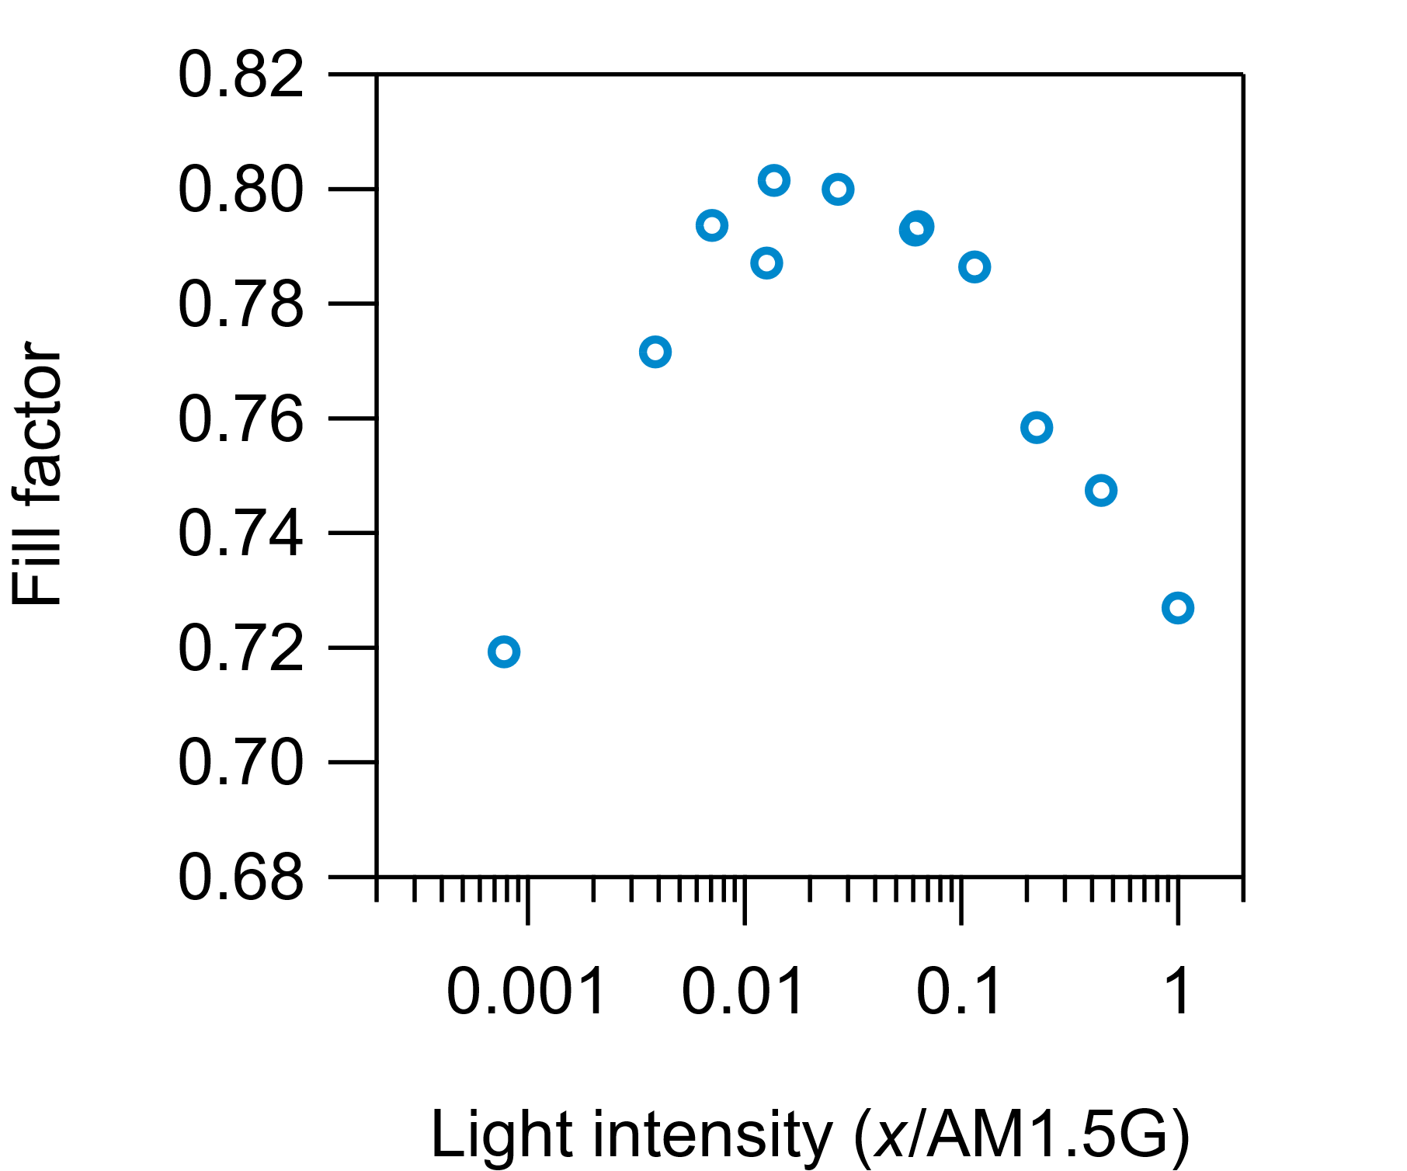

Low-Br (Recovered)
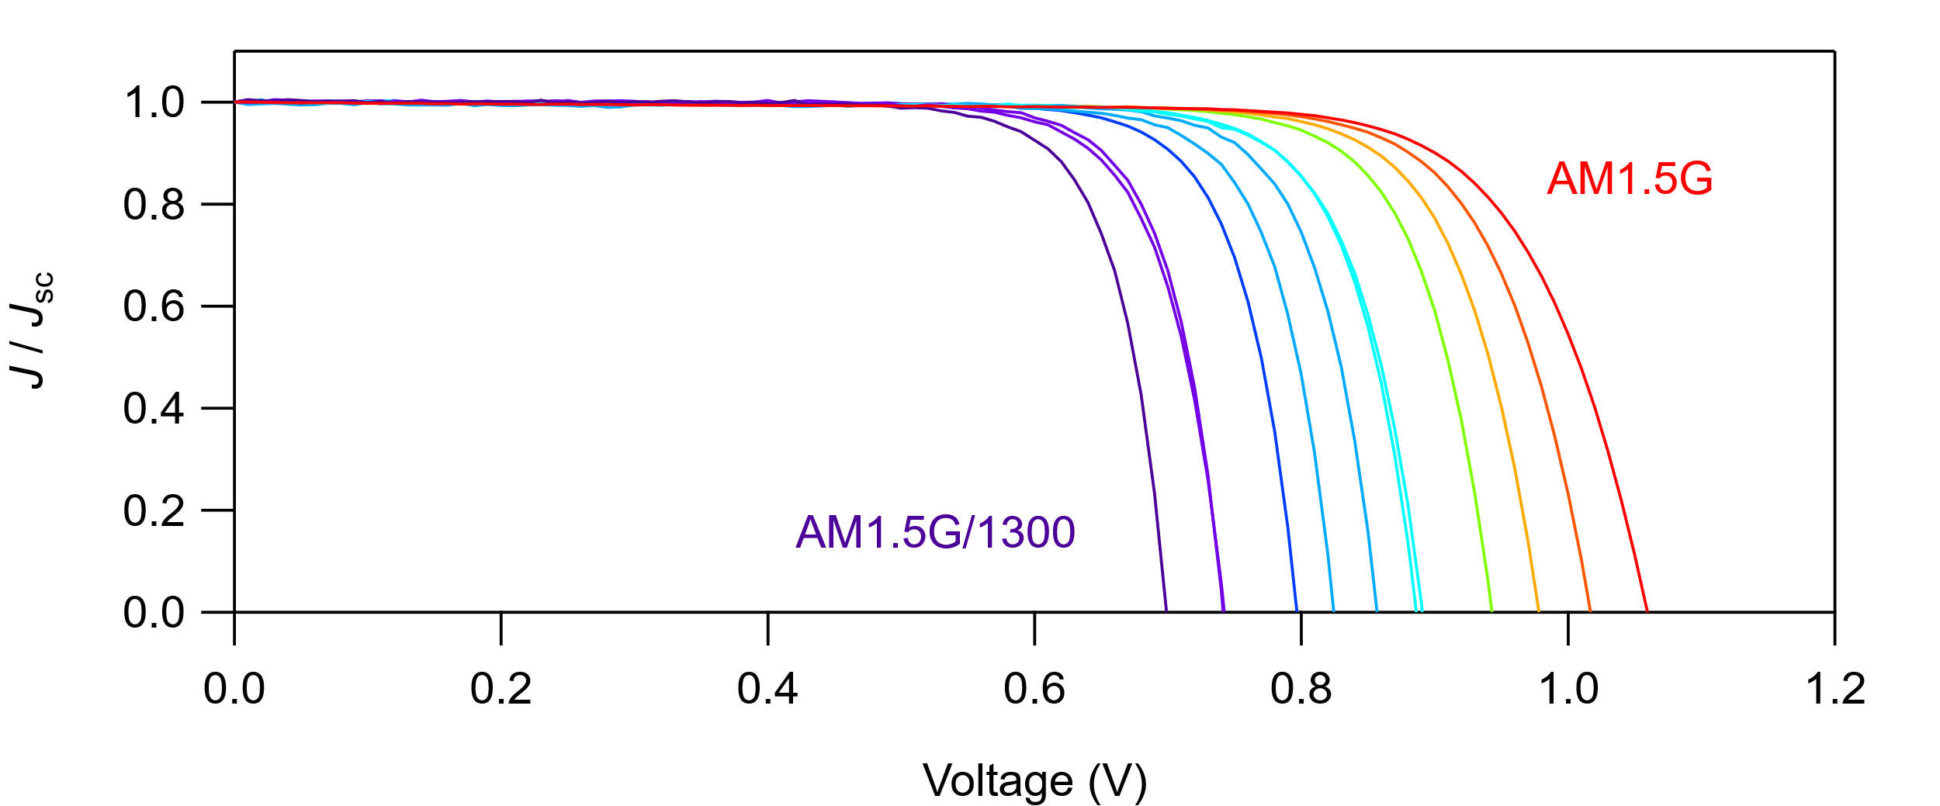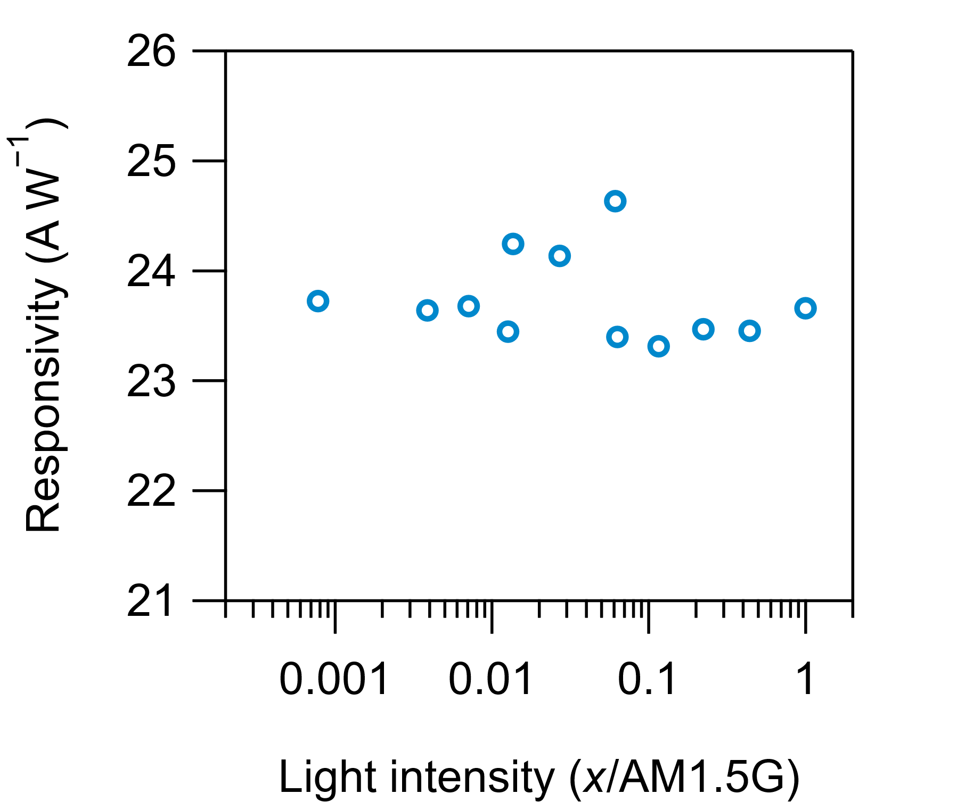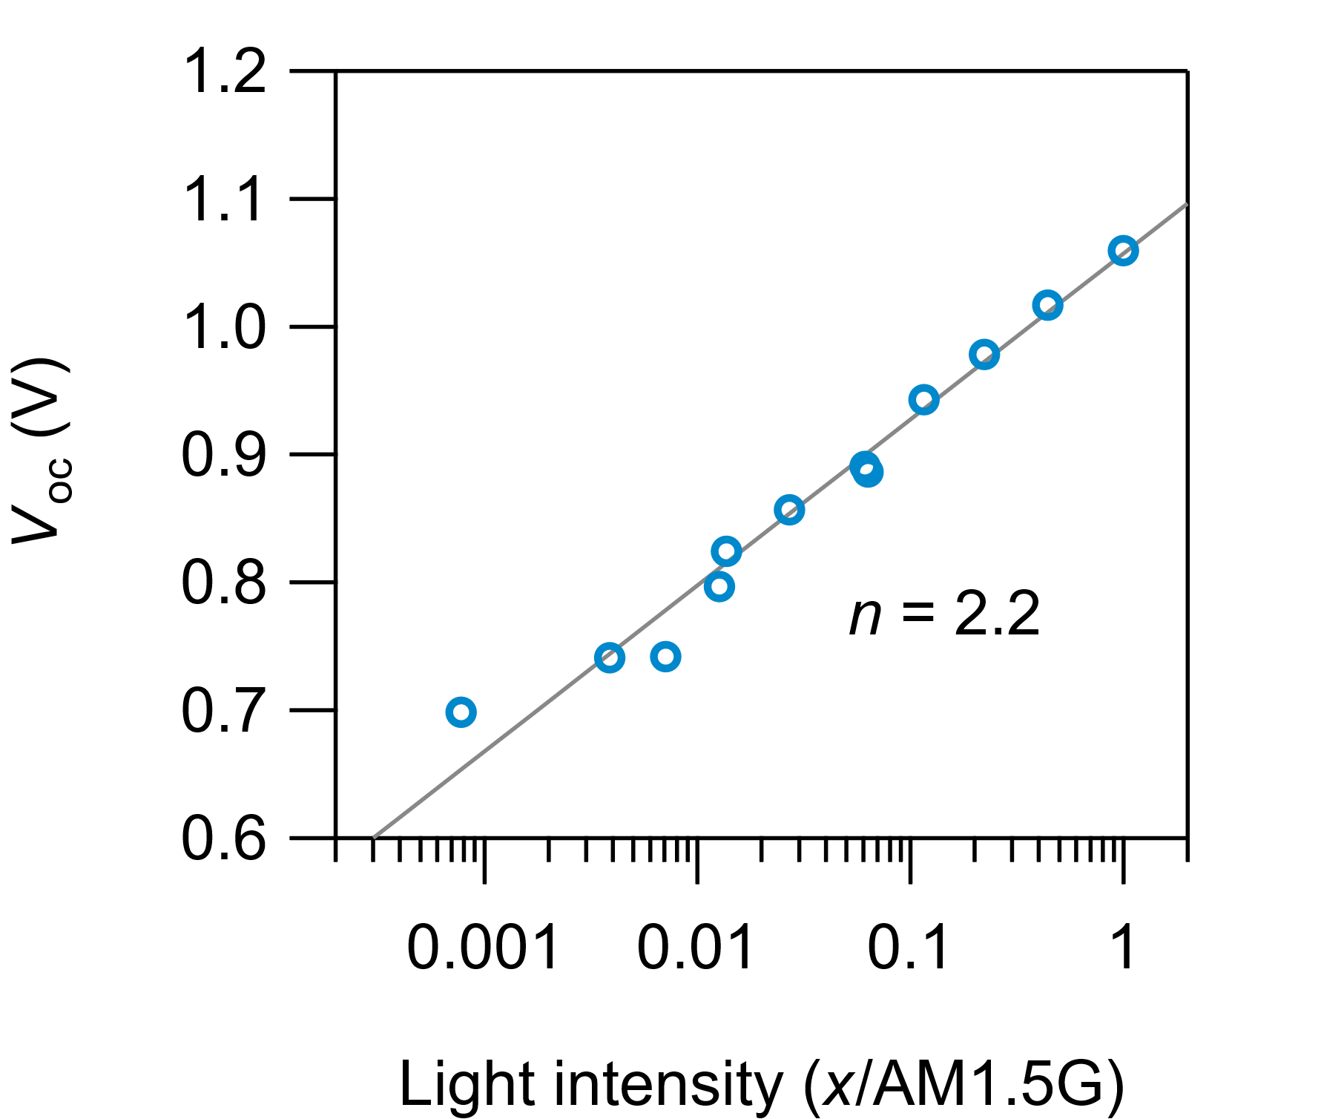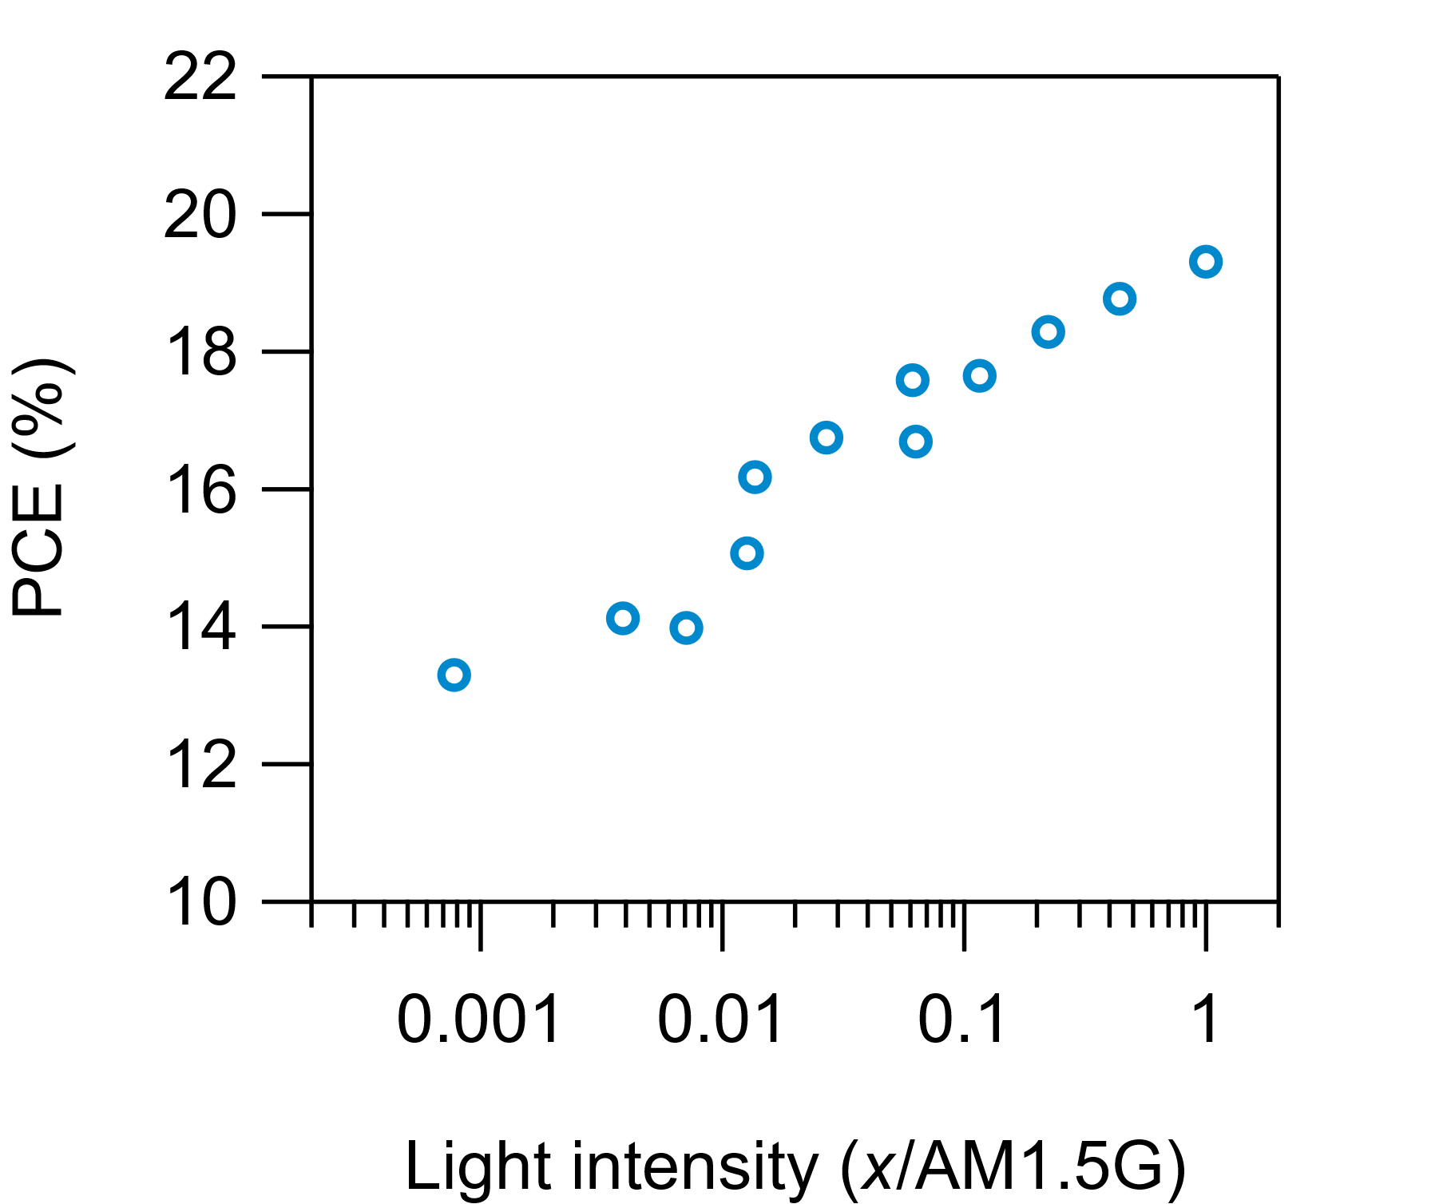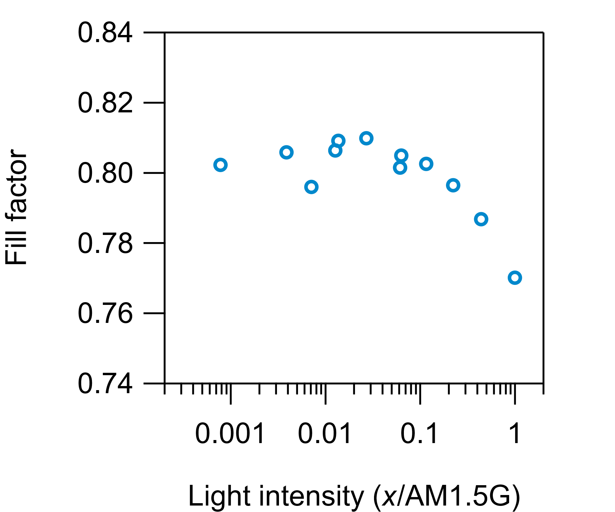

High-Br (Initial)
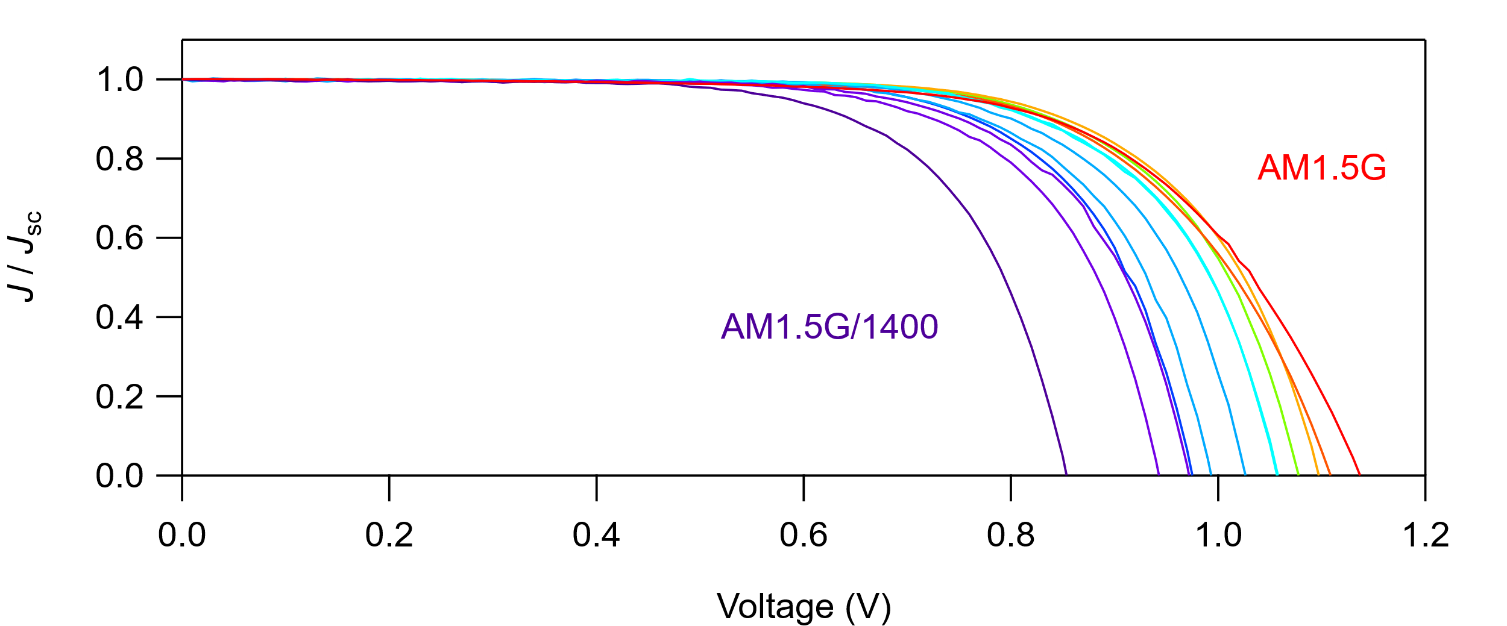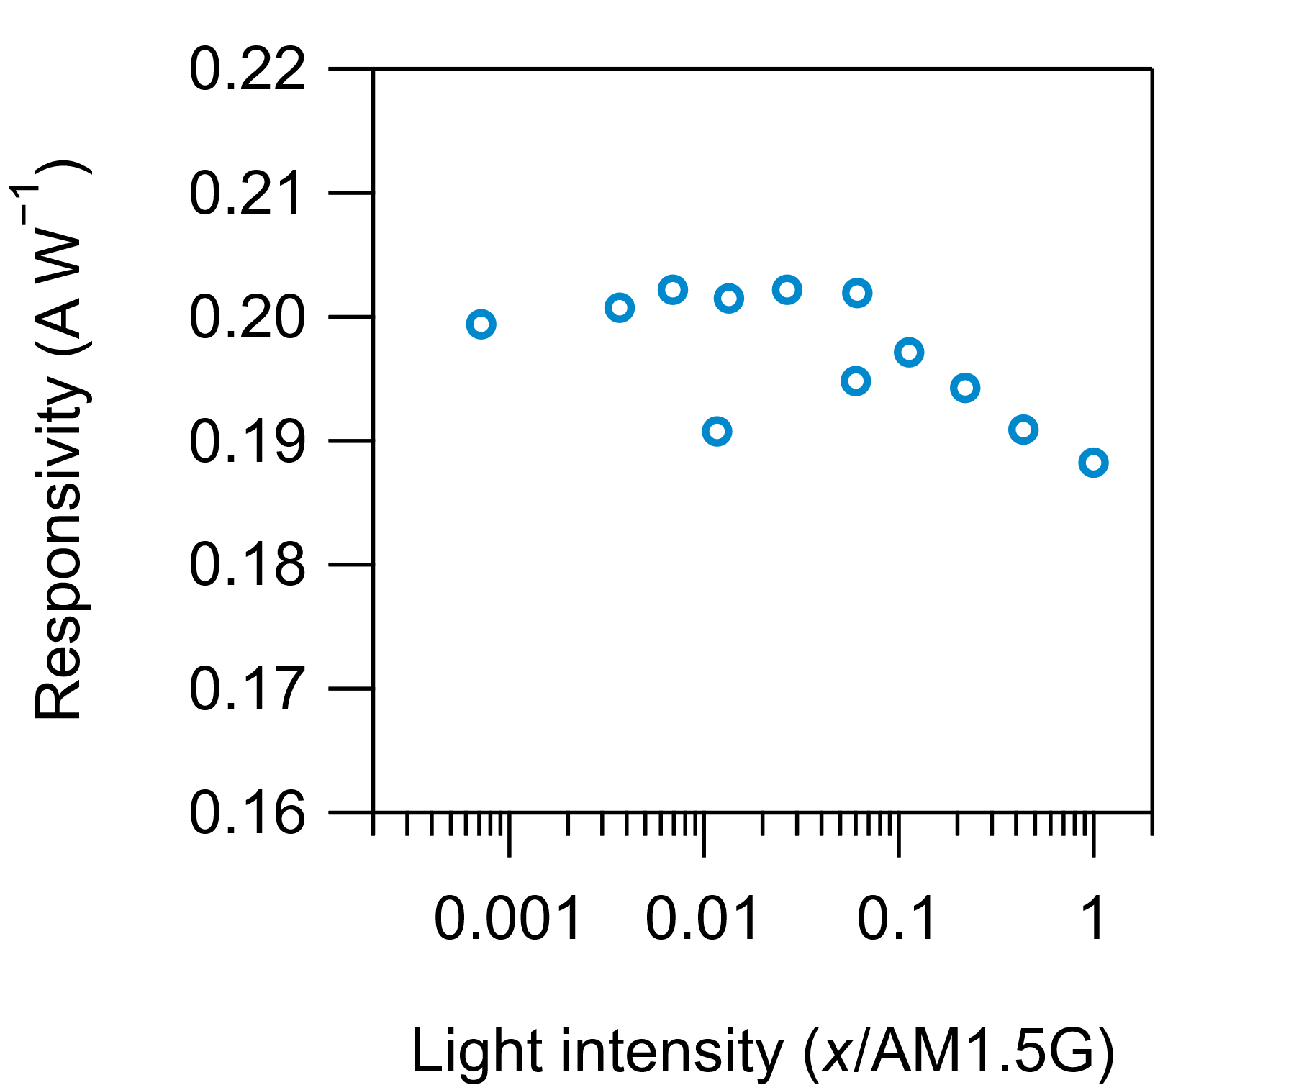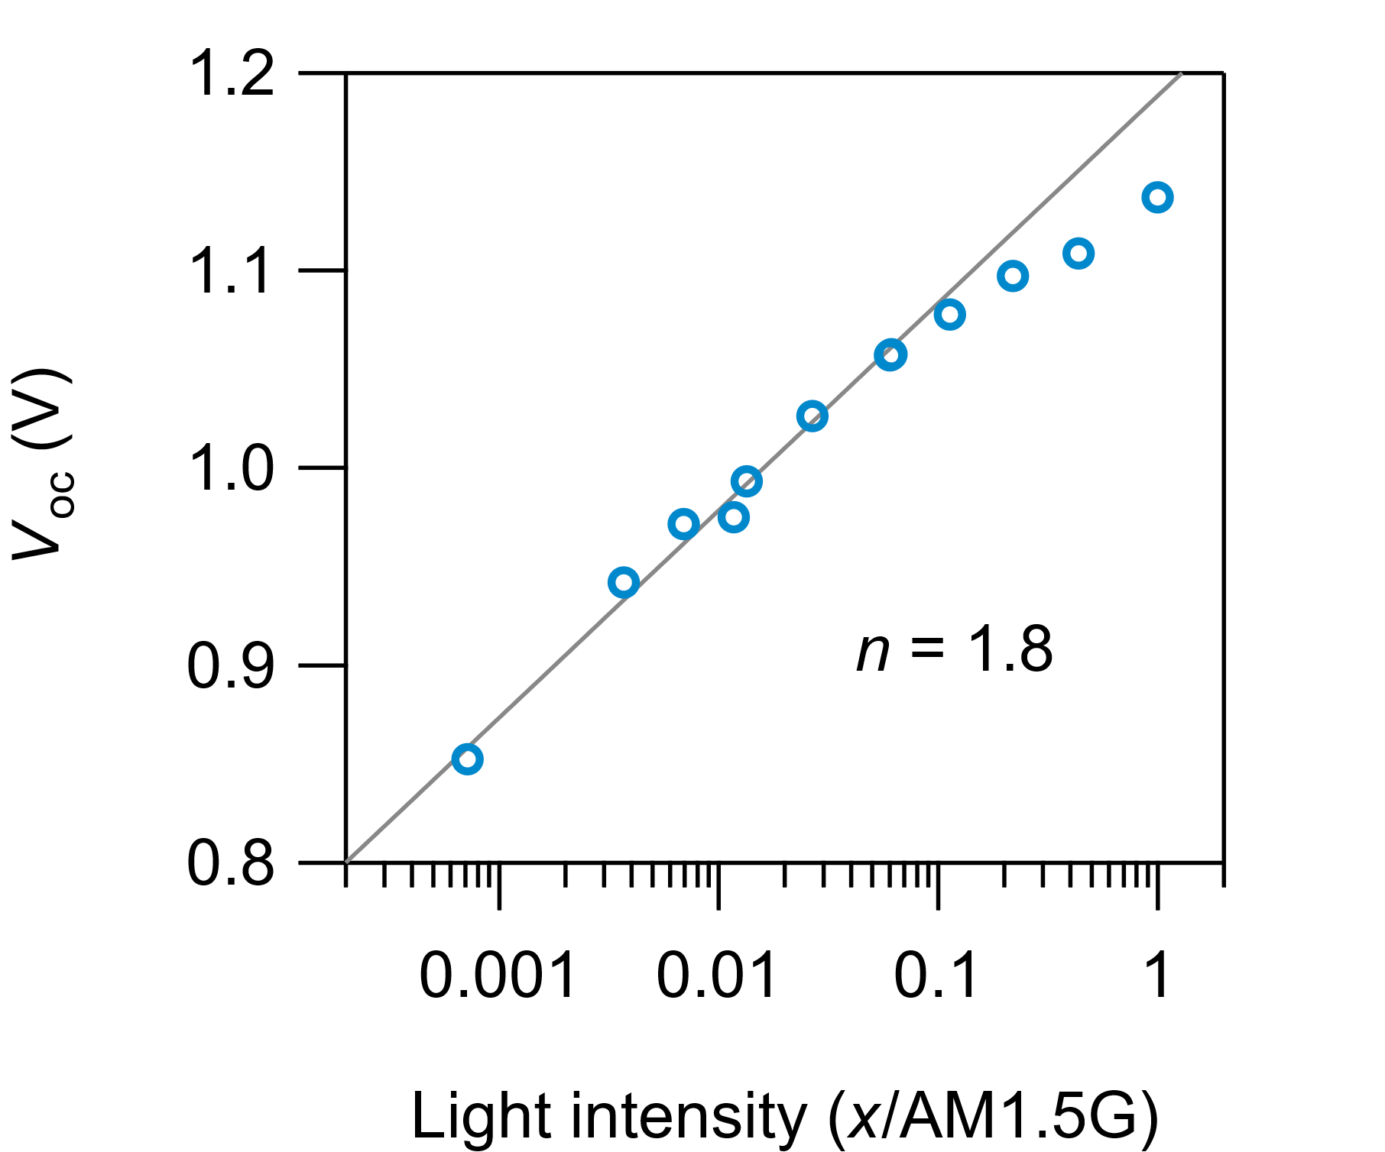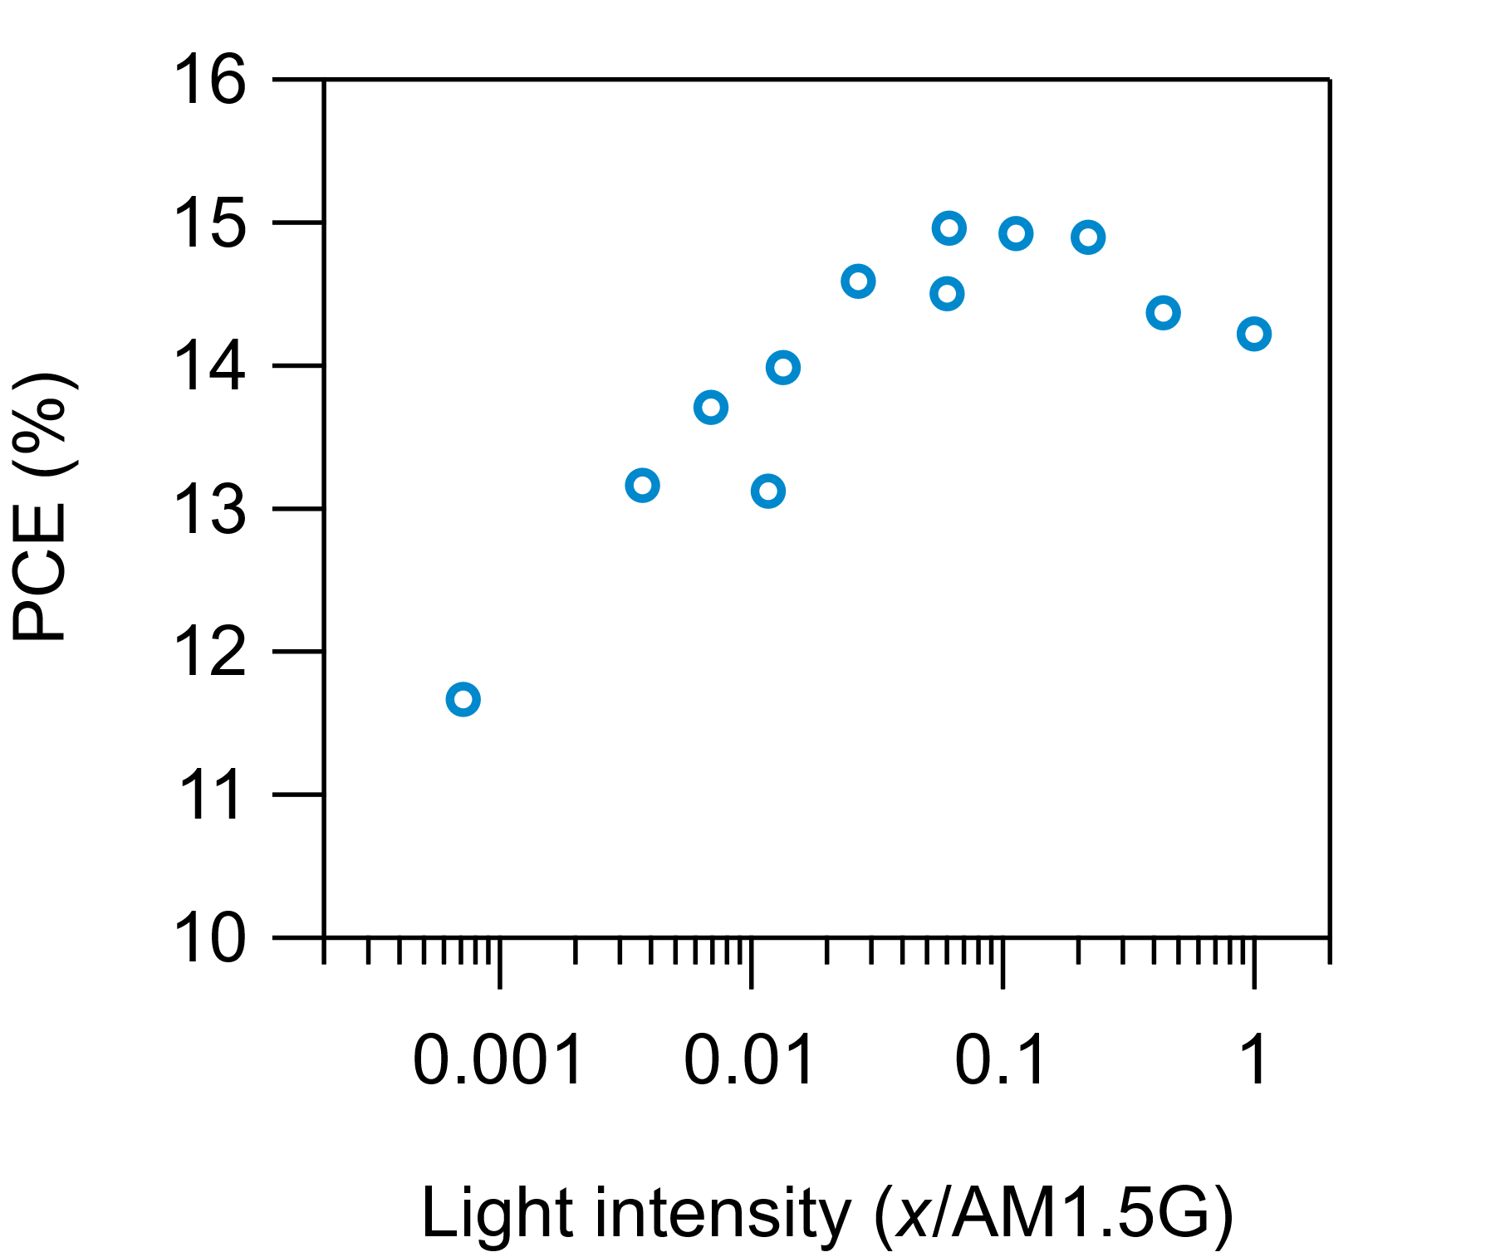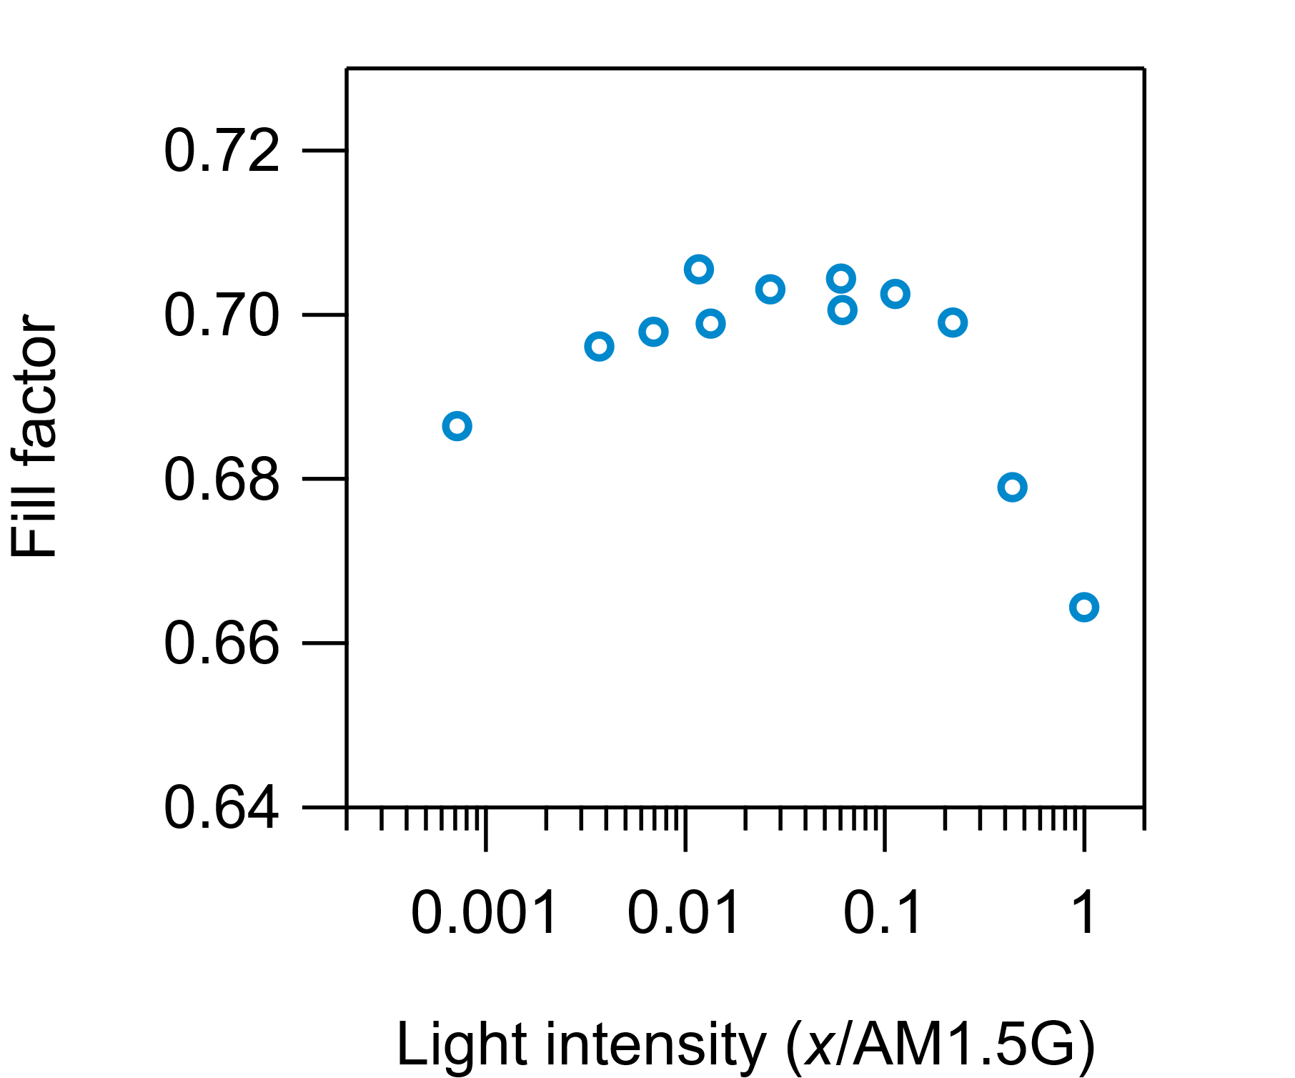

High-Br (Transient)
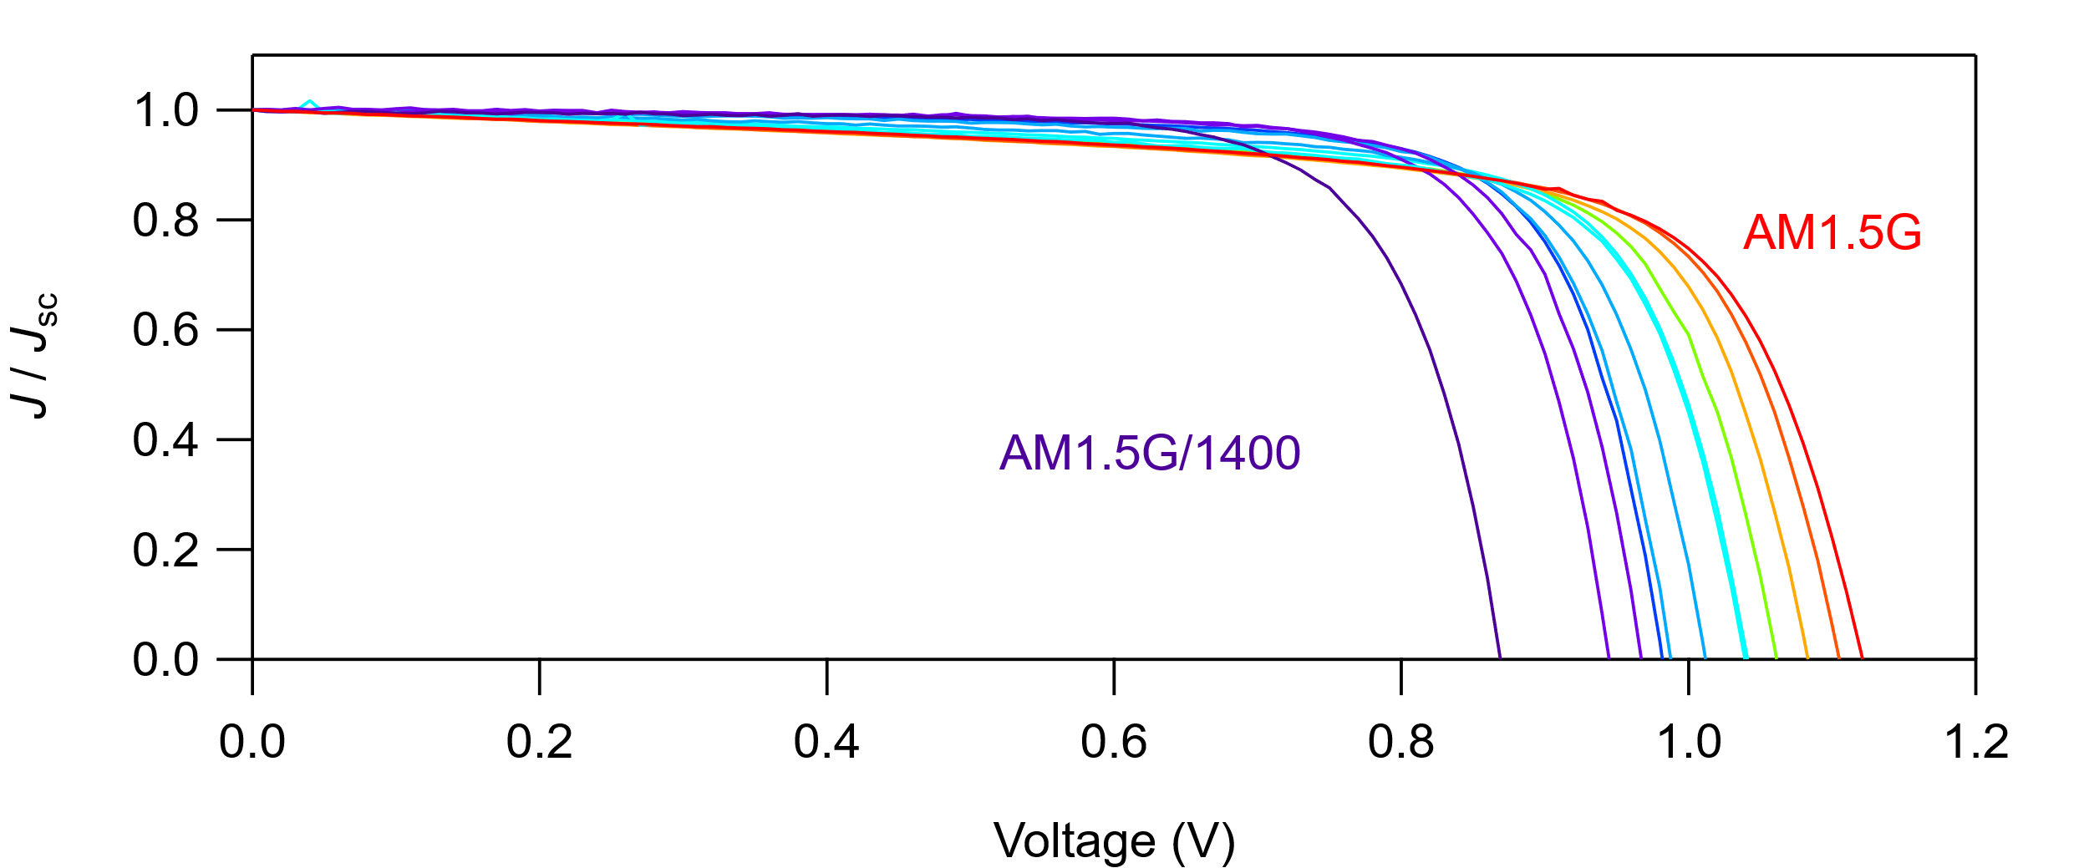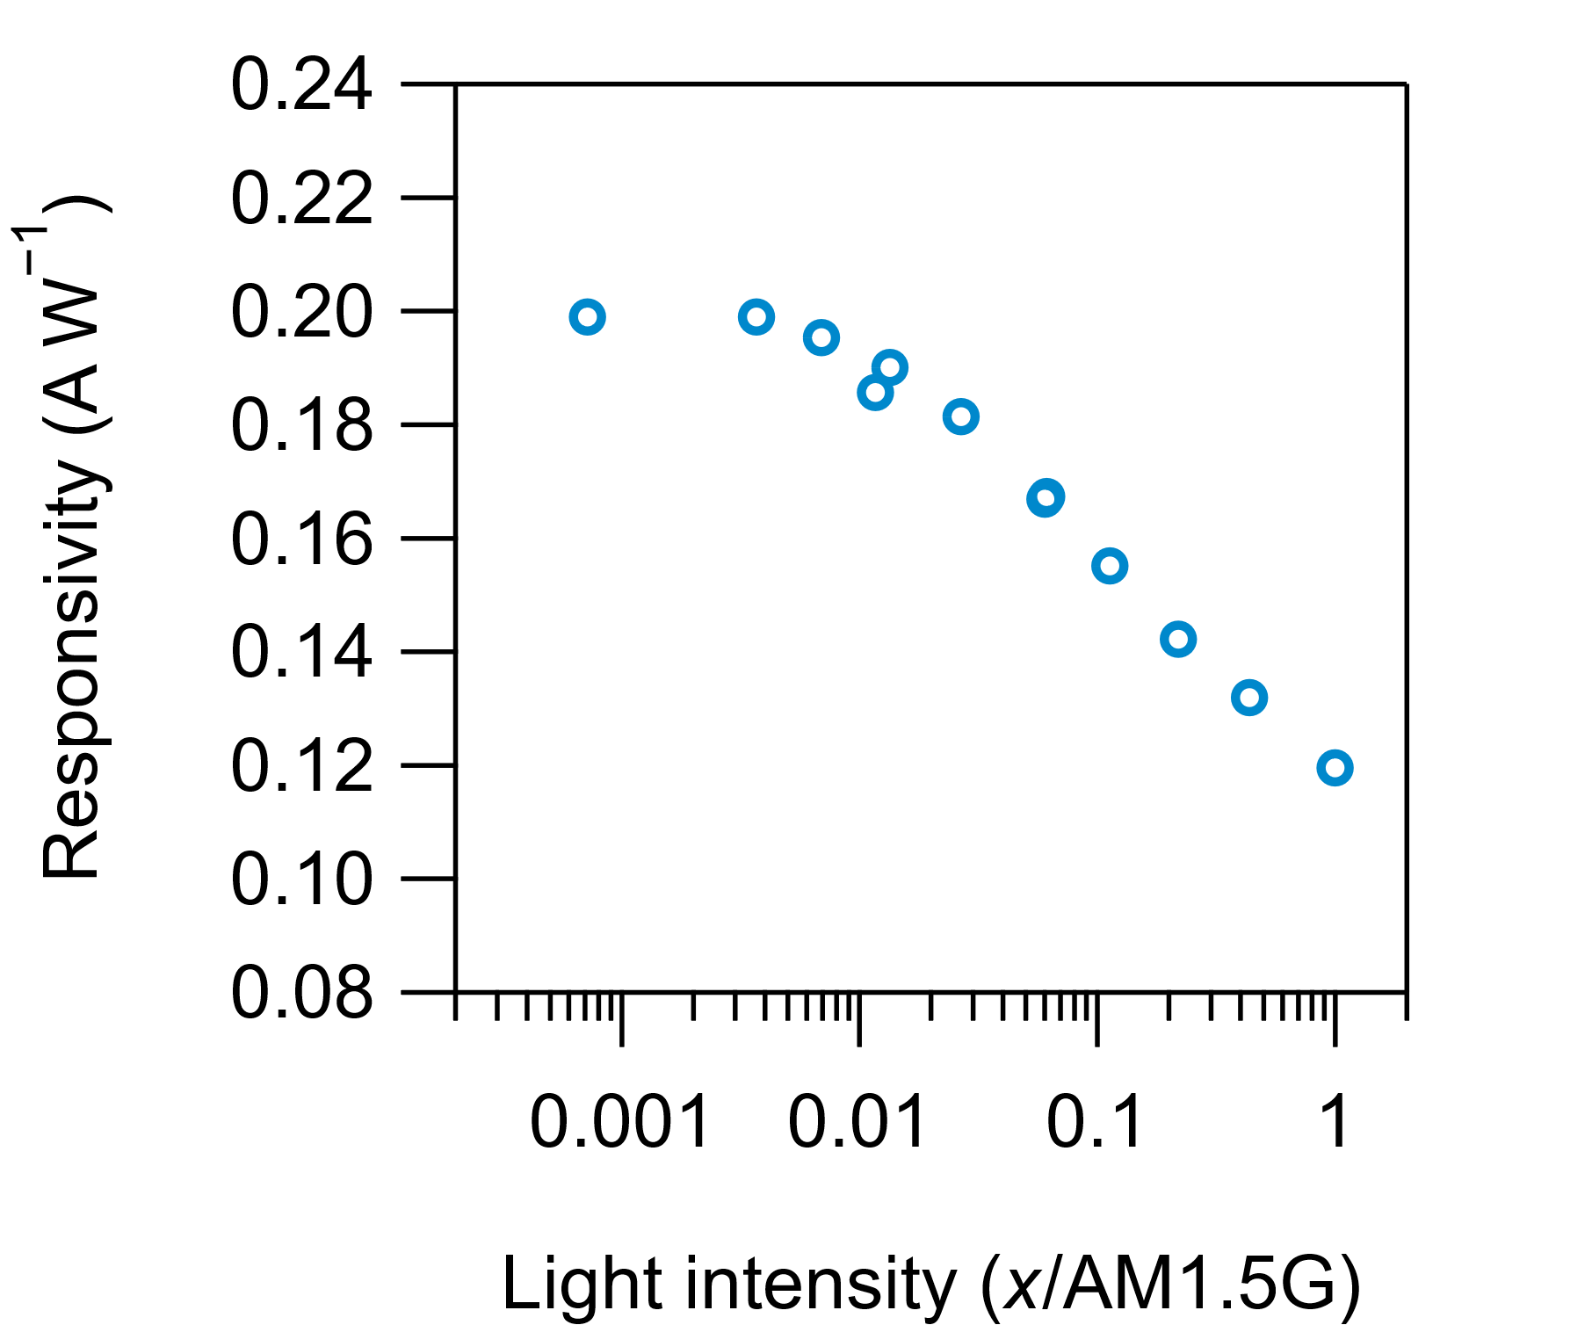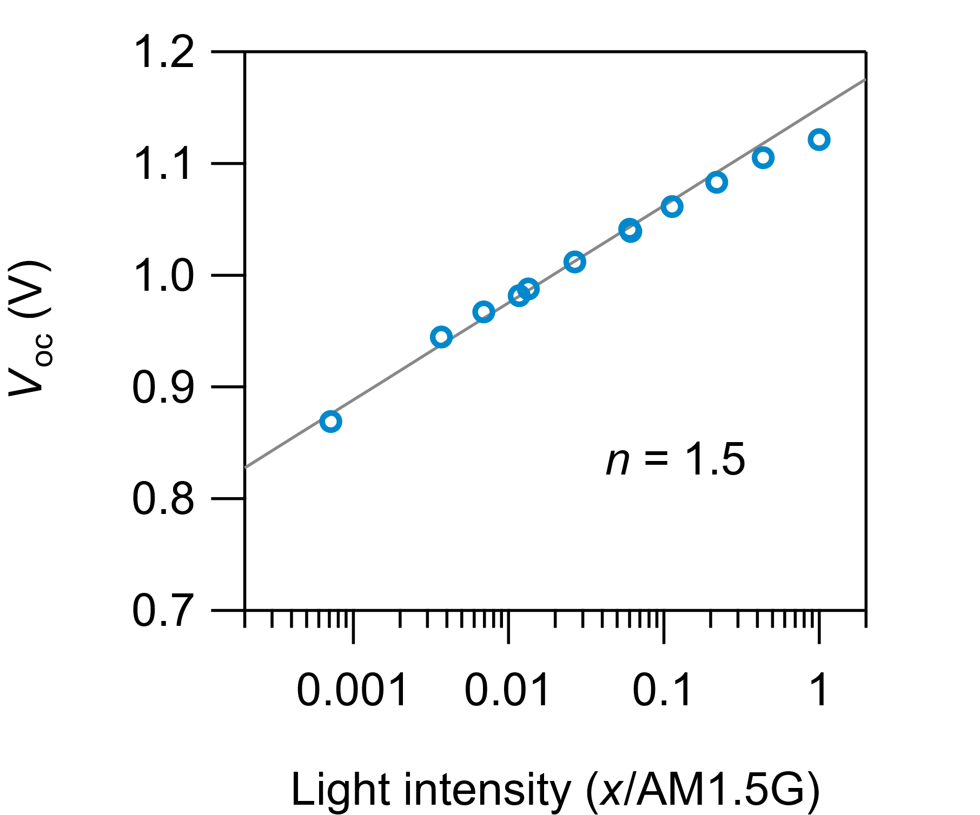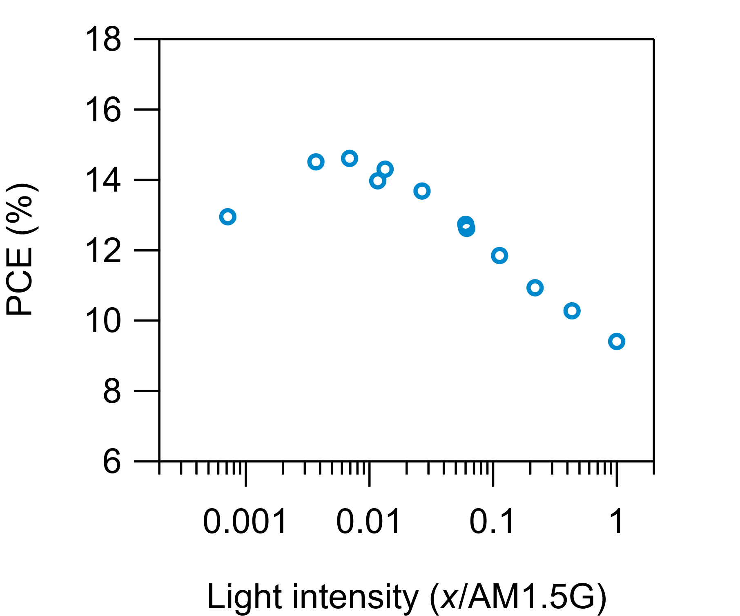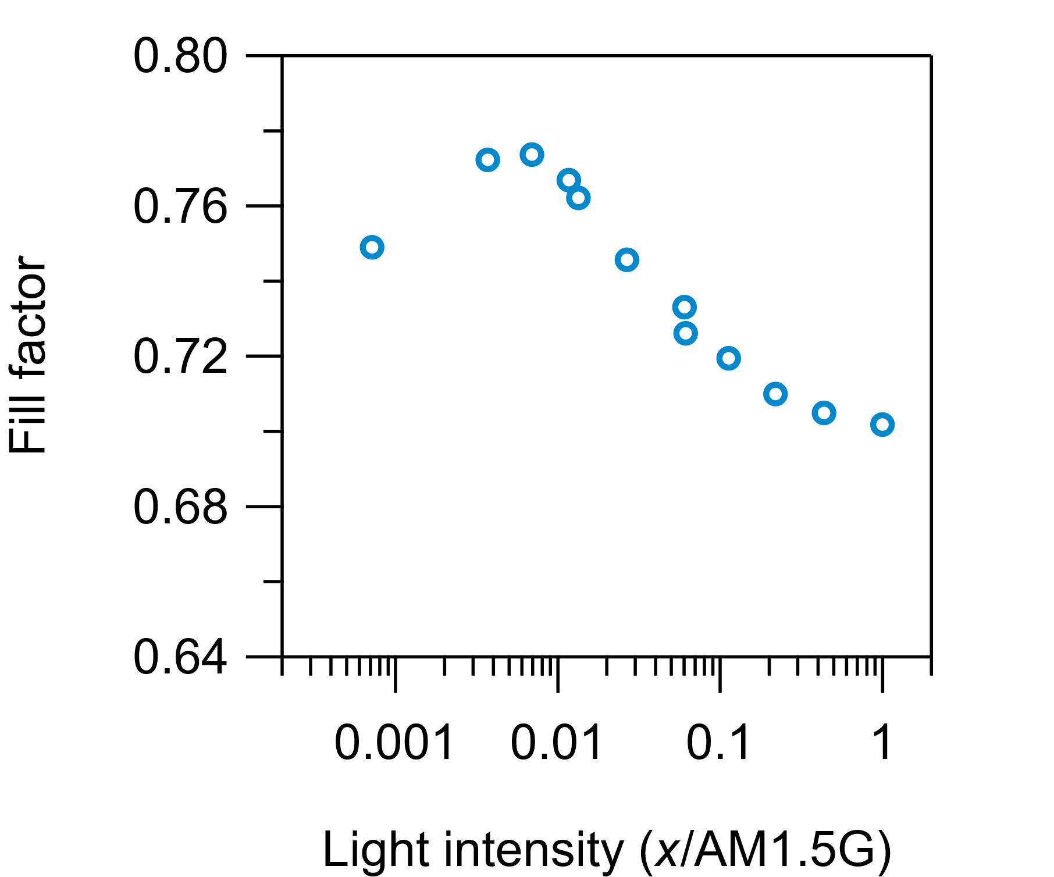

High-Br (Recovered)
