APPENDIX
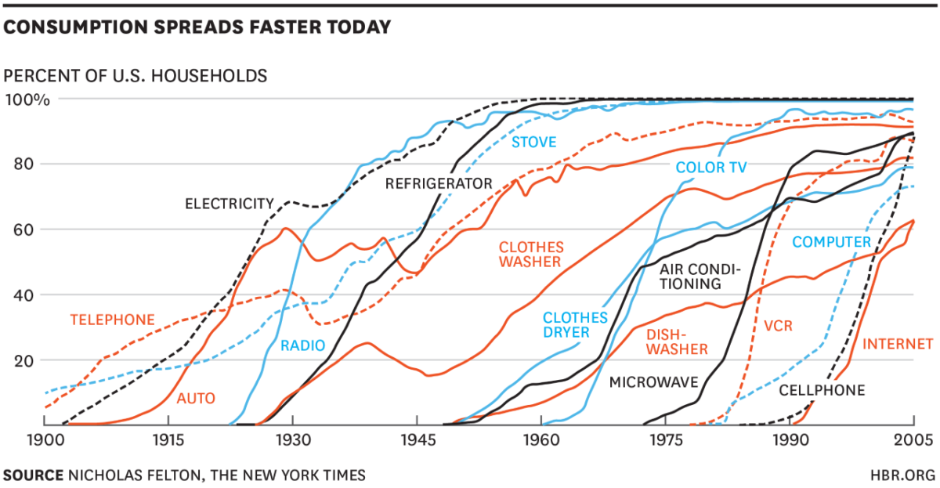
Figure A1: The Pace of Technology Adoption
Source: Nicholas Felton, New York Times, Extracted from the article by McGrath (2019)

Table A1: Results: Emerged Themes from the Data
Research Question | Research Dimensions | Themes Emerged from Data | Supporting Quote
E-waste Awareness Levels | E-waste Awareness Level | Degree Program | “I got to know about the E-waste from my CS degree program.” (Participant, FGD 1)
E-waste Awareness Levels | E-waste Awareness Level | Self Interest | “I learned the concept of e-waste when I watched the documentary [World Bank].” (Participant, FGD 2)
E-waste Awareness Levels | Awareness Level of Environmental Consequences of E-waste | Greenhouse Gases Emissions | “I think the e-waste causes the Greenhouse gas emission.” (Participant, FGD 3)
E-waste Awareness Levels | Awareness Level of Environmental Consequences of E-waste | Radiations | “E-waste, if left open, will cause the radiations.” (Participant, FGD 2)
E-waste Awareness Levels | Awareness Level of E-waste Management Practices | Reuse | "Once I found that my laptop is of no use, I extracted its HDD, and currently, I am using it as an extension to store my data [data bank]." (Participant, FGD 2)  "Let me tell you one problem here. Due to rapid technological advancements, we cannot frequently reuse the parts of e-products in the new devices. There is an issue of compatibility. There is an issue with speed and software usage. For instance, I cannot use the RAM with old specifications on my new laptop." (Participant, FGD 1)
E-waste Awareness Levels | Awareness Level of E-waste Management Practices | Repair | “Whenever I go for the repair of my device, the technical person asks for a high cost which I cannot pay.” (Participant, FGD 4)
E-waste Awareness Levels | Awareness Level of E-waste Management Practices | Family Sharing | "When I got a new laptop from Prime Minister's Laptop Scheme, I gave that to one of my family members, as I already had a better laptop [better specifications], so that they may use it." (Participant, FGD 1)
Factors Hindering the Disposal of E-waste | Factors Hindering the Disposal of E-waste | Lack of Awareness | "I have a cellphone that is not working properly, but I have stored it for future use. So, I think that it is not e-waste as I can use it in the future after repair." (Participant, FGD 2)
Factors Hindering the Disposal of E-waste | Factors Hindering the Disposal of E-waste | Nostalgic Association | “I will never ever sell or dispose of the first cellphone I bought from my salary.” (Participant, FGD 1)
Factors Hindering the Disposal of E-waste | Factors Hindering the Disposal of E-waste | High-Security Concerns | “I will never go for disposing of my mobile and laptop as I think my data will not be safe.” (Participant, FGD 1)
Factors Hindering the Disposal of E-waste | Factors Hindering the Disposal of E-waste | Monetary Benefits | "I need financial benefits offered by organizations committed to disposing of phones. Other than this [monetary benefits], I need surety that they will not leak or share my data with any sources." (Participant, FGD 3)  "For sure, I need monetary benefits to dispose of my e-waste because I bought these devices from my money. To offset the effect, I need compensation." (Participant, FGD 4)
Factors Hindering the Disposal of E-waste | Factors Hindering the Disposal of E-waste | Complicated Disposal Process | "We do not have the time. We are students and busy with multiple assignments and projects [given by the university]. In this condition, we do not find the time to go for the disposal of our devices. Therefore, we simply store it. Also, I heard that the e-waste disposal process is complicated.” (Participant, FGD 1)
Factors Hindering the Disposal of E-waste | Factors Inducing the Sale of E-devices | High Monetary Benefits | “Once I luckily got the high price of my laptop, so I immediately sold it to the market.” (Participant, FGD 3)
Factors Hindering the Disposal of E-waste | Factors Inducing the Sale of E-devices | Family Sharing | "When I bought the new laptop, I sold my previous laptop to my younger brother instead of selling it to the market due to two main reasons. One is the privacy concerns, as my data may not be safe, and second is that although I was getting less monetary benefit from my brother, I could feel some sense of ownership." (Participant, FGD 3)
Factors Hindering the Disposal of E-waste | Factors Inducing the Storage of E-devices | High-Security Concerns | "I need financial benefits offered by organizations committed to disposing of phones. Other than this [monetary benefits], I need surety that they will not leak or share my data with any sources." (Participant, FGD 3)
Factors Hindering the Disposal of E-waste | Factors Inducing the Storage of E-devices | Nostalgic Association | “Whenever I think about selling my mobile, the idea comes into my mind that I will show this to my children.” (Participant, FGD 3)
Factors Hindering the Disposal of E-waste | Factors Inducing the Storage of E-devices | Lower Resale Price | "When we sell our product, we get less amount than we paid when we bought this. That is why we do not go for selling it to the market." (Participant, FGD 2)
Factors Hindering the Disposal of E-waste | Factors Inducing the Storage of E-devices | Lack of Information | "E-waste sites are unknown to me. I know that there are some scrap sites in the city [Sukkur] and Pakistan. However, I do not know about the e-waste sites.” (Participant, FGD 4)
Factors Hindering the Disposal of E-waste | The solution to Reduce E-Waste | Reuse | “I think the best solution to reduce e-waste is to reuse.” (Participant, FGD 4)
Factors Hindering the Disposal of E-waste | The solution to Reduce E-Waste | Family Sharing | “Family sharing is the best option to reduce the e-waste and storage of the e-devices.” (Participant, FGD 1)
Factors Hindering the Disposal of E-waste | The solution to Reduce E-Waste | Proper Channels for Disposal | “I think at the organizational level; the tech companies should think about developing the proper channels for e-waste collection.” (Participant, FGD 4)
Factors Hindering the Disposal of E-waste | The solution to Reduce E-Waste | Extraction of Precious Metals | “It is the responsibility of the organizations to come forward and dispose of the e-waste by extracting the precious materials.” (Participant, FGD 1)
Factors Hindering the Disposal of E-waste | The solution to Reduce E-Waste | Monetary Benefits | “The government must provide us some sort of monetary benefits like German government provides for disposing of the plastic bottles.” (Participant, FGD 4)
Factors Hindering the Disposal of E-waste | The solution to Reduce E-Waste | Awareness Campaigns | “It is the responsibility of the government to run awareness campaign to induce the e-waste disposal.” (Participant, FGD 2)
Factors Hindering the Disposal of E-waste | The solution to Reduce E-Waste | Penalty | “I think it is the responsibility of the government law enforcing agencies to monitor the e-waste strictly and put some penalty on the organizations who do not recycle.” (Participant, FGD 3)
Table Source: Authors collectively developed the themes based on the suggestions of Miles et al. (2018) and the table used by Sarofim et al. (2020).

