Supplementary figure 1- The temporal variability of Viral hepatitis, typhoid and diarrhea in Ahmedabad city from 2010-17

Supplementary figure 2- Maps depicting the spatial distribution of socio-demographic variables in Ahmedabad city as per 2011 census
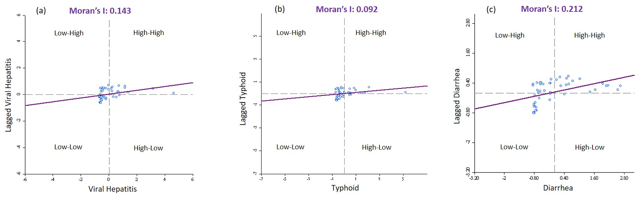
Supplementary figure 3- Moran’s scatter plot along with Moran’s statistic of (a) Viral Hepatitis, (b) Typhoid, and (c) Diarrhea

