Supplementary material

Ion-dynamic Capacitance Enables Multimode Transistors and Multimode Neural Networks

Xiaoci Liang¹, Yiyang Luo¹, Yanli Pei¹, Mengye Wang², Chuan Liu^{1, *}
¹State Key Laboratory of Optoelectronic Materials and Technologies and the Guangdong Province Key Laboratory of Display Material and Technology, School of Electronics and Information technology, Sun Yat-Sen University, Guangzhou, China
² School of Materials, Sun Yat-Sen University, Shenzhen, China

*Email: liuchuan5@mail.sysu.edu.cn

Table of content

Supplementary Note 1. Analytic solution to the drift-diffusion and Poisson equation

Supplementary Note 2. The compact model and TCAD simulation

Supplementary Note 3. The analysis of EIS and the extraction of diffusion coefficient

Supplementary Note 4. The high apparent μ mode

Supplementary Note 5. The sub-thermionic SS mode

Supplementary Note 6. The mem-resistive characteristics in simulation

Supplementary Note 7. Device fabrication

Supplementary Note 8. Application by coupling modes

Supplementary Note 9. Application by building neural network

Supplementary Note 10. A multimode transistor calculator

Supplementary Reference

Supplementary Note 1. Analytic solution to the drift-diffusion and Poisson equation

For the drift-diffusion equation (Eq. S1) and Poisson equations (Eq. S2,3), there is an unconstrained solution for the case without the initial condition and boundary condition (Eq. S4,5), where c₁, c₂ and c₃ are the undetermined coefficients.

$\frac{∂p\left(x,t\right)}{∂t}=\left[D_{i}\frac{∂^{2}p\left(x,t\right)}{∂x^{2}}\right]-\left[μ_{ion}∙E\left(x,t\right)\frac{∂p\left(x,t\right)}{∂x}+μ_{ion}∙p\left(x,t\right)\frac{∂E\left(x,t\right)}{∂x}\right]$, (Eq. S1)
$\frac{∂E\left(x,t\right)}{∂x}=\frac{p\left(x,t\right)e}{ε}$, (Eq. S2)
$E\left(x,t\right)=-\frac{∂V\left(x,t\right)}{∂x}$, (Eq. S3)
$p\left(x,t\right)=-\frac{2D_{i}c_{1}^{2}{sech}^{2}\left(c_{1}x+c_{2}t+c_{3}\right)}{μ_{ion}\frac{e}{ε}}$, (Eq. S4)
$E\left(x,t\right)=-\frac{c_{2}+2D_{i}c_{1}\tanh\left(c_{1}x+c_{2}t+c_{3}\right)}{μ_{ion}c_{1}}$, (Eq. S5)

If the distribution of ions reaches steady state, the drift-diffusion equation would become equation S6. For the equation S6 and Poisson equations (Eq. S2,3), there is an unconstrained solution if not considering the initial condition and boundary condition (Eq. S7,8), where c₄ and c₅ are the undetermined coefficients.

$0=D_{i}\frac{∂p\left(x,t\right)}{∂x}-μ_{ion}E\left(x,t\right)p\left(x,t\right)$, (Eq. S6)
$p\left(x,t\right)=c_{4}\sec^{2}\left[\sqrt{\frac{{c_{4}e}^{2}}{2{εk}_{B}T}}\left(x+2c_{5}\right)\right]$, (Eq. S7)
$E\left(x,t\right)=\sqrt{\frac{{2c}_{4}k_{B}T}{ε}}\tan\left(\sqrt{\frac{{c_{4}e}^{2}}{2{εk}_{B}T}}\left(x+2c_{5}\right)\right)$, (Eq. S8)
The equation S7, S8 are consistent with numerical simulation results as verified in Supplementary Fig. 1. The symbols used in Eq. S1 to Eq. S8 are listed in Supplementary Table 1.

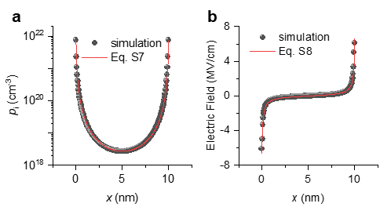
Supplementary Figure 1. The steady distribution of ion and electric field. The thickness of dielectric layer is 10 nm. Only cations are doped. In the absence of external electric field, the distribution of the model (lines) and the numerical simulation (dots) are close.

Supplementary Table 1. Symbol table for the drift-diffusion equation and Poisson equations
Symbol | Unit | Description
$$p$$ | cm⁻³ | The density of the charged ions
$$x$$ | cm | The position
$$t$$ | s | The time
$$D_{i}$$ | cm²/s | Ionic diffusion coefficient
$$μ_{ion}$$ | cm²/V s | ionic mobility
$$E$$ | V/cm | Electric field
e | C | Elementary charge
$$ε$$ | F/cm | Permittivity ($ε=ε_{0}ε_{r}$)
$$k_{B}$$ | J/K | Boltzmann constant
$$T$$ | K | Temperature
$$c_{1}, c_{2}, c_{3},c_{4}, c_{5}$$ | - | Undetermined coefficients

Supplementary Note 2. The compact model and TCAD simulation

Numerical simulations of ion dynamics following the drift-diffusion equation was performed with an Al₂O₃ dielectric (40nm) film containing anions and cations. The interfacial ion concentration increases over time and the increasing rate is affected by the bias amplitude V_{ox} and diffusion coefficient D_{i} (Supplementary Fig. 2). The simulation results are fitted very well with the compact model (Eq. 2 in the main context) and the parameters are shown in Supplementary Table 2. The ions concentration calculated by Eq. 2, dimensionless potential u calculated by Eq. 3 and dynamic capacitance C calculated by Eq. 4 at various V_{ox} or D_{i} are shown in Supplementary Fig. 3.

Supplementary Figure 2. Interfacial ion concentration: theory and TCAD simulation. The cation concentration calculated by the model (lines) and the numerical simulation (dots) under various (a) potential, (b) diffusion coefficient.

Supplementary Figure 3. Interfacial ion concentration, dimensionless potential and capacitance in theory. a, d The calculated p_{i} over time with constant D_{i}=D₀ =6.67×10⁻¹¹ cm²/s and various V_{ox} (a), or with various D_{i} and constant V_{ox}=5 V (d). b,e The dimensionless potential u. c, f The ratio of capacitance to Debye capacitance C/C₀.

Supplementary Table 2. The parameters for using Eq. 2 to fit the numerical simulation results.
$$n_{i0}, p_{i0}$$ | $$p_{i, max}$$ | $$D_{0}$$ | $$β_{0}$$
10²⁰cm⁻³ | 2×10²¹cm⁻³ | 6.67×10⁻¹¹cm²/s | 1
$$A$$ | $$V_{0}$$ | $$η$$ | $$α$$
-2.03 | 0.102V | 1.90×10⁻¹⁴ Vcm² | 0.07

According to the compact model of the TFT¹ and the calculated C, Q_{i} and V_{FB} (Supplementary Fig. 4), the drain current of the transistor with the solid-state electrolyte dielectric can be calculated through the Equations S9-S12, where $G_{off}$ is the conductance of the TFT in off-state, β_{T} and V_{TO} are the fitting parameter and the transition voltage, respectively, for the transition function. The symbols used in Eq. S9 to Eq. S12 are listed in Supplementary Table 3. The simulation results can be reproduced through the compact model by varying the ionic diffusion coefficient D_{it} or sweep rate. If the Faraday charge transfer occurs at the interface, a small part of $Q_{i}$ will affect the conductivity by electro-chemical doping. The factor k evaluates the proportion of the interfacial accumulated ions involved in the reaction.

$I_{d_above}=\frac{W}{L}μ_{0}\left[C\left(V_{g}-V_{th}\right)+kQ_{i}\right]V_{d}$, (Eq. S9)
$I_{d_sub}=I_{0}\frac{W}{L}\ln\left(1+e^{ln10\frac{V_{g}-V_{on}}{{SS}_{0}}}\right)\left(1-e^{-ln10\frac{V_{d}}{{SS}_{0}}}\right)+\frac{W}{L}G_{off}V_{d}$, (Eq. S10)
$I_{d}=I_{d_above}×\frac{1+tanh\left[β_{T}\left(V_{g}-V_{TO}\right)\right]}{2}+I_{d_sub}×\frac{1-tanh\left[β_{T}\left(V_{g}-V_{TO}\right)\right]}{2}$, (Eq. S11)
$\left\{\begin{aligned}V_{th}=V_{th0}+V_{FB} \\ V_{on}=V_{on0}+V_{FB} \\ V_{TO}=V_{TO0}+V_{FB}\end{aligned}\right.$, (Eq. S12)
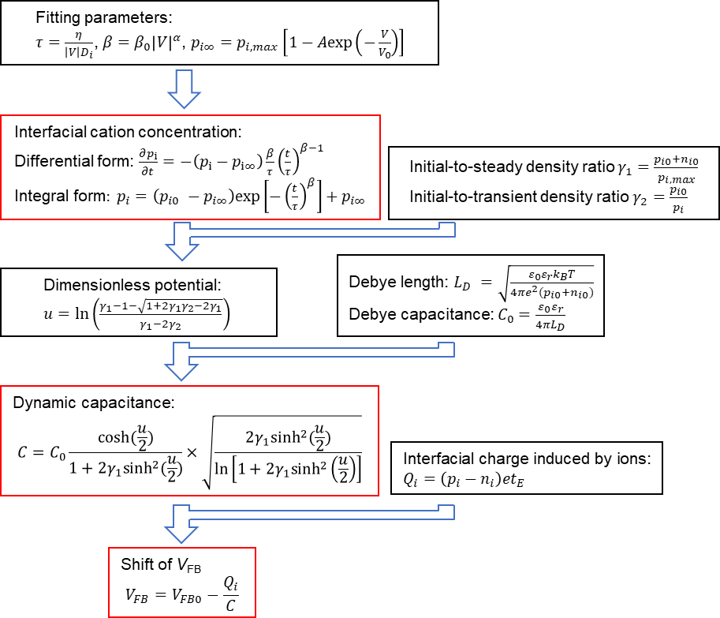
Supplementary Figure 4. The flowchart of calculation of the interface cation concentration, dynamic capacitance and the flat band voltage. In the transistor, the V is equal to V_{ox}. When operating in linear region, it can be approximated as V_{g}.

Supplementary Table 3. Symbol table for the of electrolyte-gated transistor model
Symbol | Unit | Description
$$I_{d_above}$$ | A | The above-threshold drain current
$$W$$ | cm | Width of the channel
$$L$$ | cm | Length of the channel
$$μ_{0}$$ | cm²/V s | Mobility of the semiconductor
$$C$$ | F/cm² | Dynamic capacitance
$$V_{g}$$ | V | Gate voltage
$$V_{th}$$ | V | Threshold voltage
$$k$$ | % | The proportion of the interfacial accumulated ions involved in the reaction
$$Q_{i}$$ | C/cm² | Interface charges induced by ions
$$V_{d}$$ | V | Drain voltage
$$I_{d_sub}$$ | A | Subthreshold drain current
$$I_{0}$$ | A | Drain current per W/L at V_{g} = V_{on}
$$V_{on}$$ | V | Turn-on voltage
$${SS}_{0}$$ | V/dec | Subthreshold swing
$$G_{off}$$ | S | Specific conductance per W/L of TFTs in the off-state
$$I_{d}$$ | A | Drain current
$$β_{T}$$ | - | Transition fitting parameter
$$V_{TO}$$ | V | Transition voltage
$$V_{th0}$$ | V | Initial threshold voltage
$$V_{on0}$$ | V | Initial turn-on voltage
$$V_{TO0}$$ | V | Initial transition voltage
$$V_{FB}$$ | V | Flat-band voltage
$$V_{FB0}$$ | V | Initial flat-band voltage

Numerical simulations of a bottom-gate top-contact IGZO/Al₂O₃ transistor was performed by using an Al₂O₃ dielectric film with the same number of monovalent cation and anion, serving as the solid-state electrolyte. The dielectric film was divided in three parts: two interfacial layers and one bulk layer. The parameters are list in the Supplementary Table 4. The simulations were performed with the same drain voltage of 0.1 V. Various D_{it} with same sweep rate of 1 V/s or various sweep rate with same D_{it} were used. Depending on the diffusion coefficient of the interfacial layers D_{it}, the I_{d}-V_{g} curves show rich characteristics as shown in Fig. 3 in the main text. To study the mechanisms, the potential, electric field, ion concentration, and electron concentration were extracted from the cutline at the middle of the transistor from the top surface of the IGZO to the bottom surface of the dielectric layer as shown in the Supplementary Fig. 7e. The data at the semiconductor/dielectric interface were also extracted from this cutline.

Supplementary Table 4. The parameters used in the simulations of a transistor.
Symbol | Value | Unit | Description
d_{ox} | 40 | nm | Thickness of the dielectric layer
d_{it} | 5 | nm | Thickness of the interfacial layer
d_{semi} | 70 | nm | Thickness of the semiconductor layer
W | 400 | μm | Width of the channel
L | 8 | μm | Length of the channel
p₀ | 10²⁰ | cm⁻³ | cation concentration
n₀ | 10²⁰ | cm⁻³ | anion concentration
$$D_{ib}$$ | 6.67e-6 | cm²/s | Diffusion coefficient at bulk layer
$$D_{it0}$$ | 1.42e-16 | cm²/s | Unit Diffusion coefficient at interfacial layer
ε_{r} | 9 | / | Relative dielectric constant of the dielectric layer
ε_{s} | 10 | / | Relative dielectric constant of the semiconductor layer
E_{g} | 3.7 | eV | The bandgap of the semiconductor
W_{F} | 4.16 | eV | Workfunction of source/drain electrodes
W_{FG} | 4.10 | eV | Workfunction of gate electrodes
φ_{s} | 4.16 | eV | Affinity of the semiconductor
μ₀ | 15 | cm^{2/}Vs | Mobility of the semiconductor

Supplementary Note 3. The analysis of EIS and the extraction of diffusion coefficient

Supplementary Figure 5 shows the electrochemical impedance spectroscopies (EIS) for the ionic AlO_{x} and thermal silicon oxide (~100 nm). A parallel RC circuit with a contact resistance can describe the dielectric behavior of the SiO₂. The extracted C_{bulk} is about 3.7×10⁻⁸ F/cm², which is close to the areal capacitance 3.4×10⁻⁸ F/cm² for the standard SiO₂ film. In contrast to SiO₂, the dielectric behavior of the ionic AlO_{x} can be described by a Randles cell, which is composed of an electric double layer capacitor and a small part of pseudocapacitance². The results confirm significant mobile ions in the AlO_{x} layer. Note that, the components in the equivalent circuit, including C_{bulk}, C_{pseudo} and C_{edl}, represent the equilibrium state in AC bias and they are different from the dynamic capacitance C representing a transient effect in DC bias in the main text. The capacitance parameters are summarized in Supplementary Table 5.

Supplementary Figure 5. Electrochemical impedance spectroscopies of AlO_{x} capacitor and silicon oxide capacitor. Bode impedance plot (a) and Bode angle plot (b) of a solution-processed AlO_{x} capacitor annealed at low temperature with the equivalent circuits, containing bulk resistance (R_{bulk}), bulk capacitance (C_{bulk}), charge transfer resistance (R_{f}), double layer capacitance (C_{edl}) and pseudocapacitance (C_{pseudo}). Bode impedance plot (c) and Bode angle plot (d) of a silicon oxide capacitor with the equivalent circuits, only containing bulk resistance (R_{bulk}), bulk capacitance (C_{bulk}), and contact resistance (R_{contact}).

The peak current in CV data is known to obey the Randles-Sevcik equation³:
$I_{peak}=\left(2.69×{10}^{5}\right)n_{r}^{3/2}AD_{i}^{1/2}c_{0}s^{1/2}$ (Eq. S13)
where n_{r} is the stoichiometric number of electrons consumed in the electrode reaction (here, n_{r} is assumed to be 1), A is the electrode area,$D_{i}$ is the diffusion coefficient, $c_{0}$ is the ion concentration in the unit of mol/cm³, s is the sweep rate.³ By extracting the peak current from the CV data (Supplementary Fig. 6a) and fitting with the square root of s (Supplementary Fig. 6b), the fitting slope can be used to calculate the diffusion coefficient. By assuming the c₀=p_{i0}/N_{A}=1.66$×$10⁻⁴ mol/cm³, the diffusion coefficient is estimated as 1.33×10⁻¹⁸ cm²/s.
For the EIS data, the diffusion coefficient is extracted by³:
$D_{i}=\frac{R^{2}T^{2}}{2A^{2}n_{r}^{4}F^{4}c_{0}^{2}σ^{2}}$ (Eq. S14)
where the R, T, F is the gas constant, thermodynamic temperature and faraday constant, respectively, σ is the slope of the Z-w^{-1/2} curve.³ Supplementary Figure 6(c)-(f) show the linear fitting at various biases. The diffusion coefficients extracted at various bias are close to 1.6×10⁻¹⁷ cm²/s. According to our previous study^{4,5}, the ion specie in the solution-processed AlO_{x} is probably the hydrogen ion. Diffusion coefficients calculated from EIS and CV are close to the report value of hydrogen diffusivity in amorphous alumina, which is between those in α-Al₂O₃ (~10⁻²¹ cm²/s) and those along with grain boundary of α-Al₂O₃ (~10⁻¹⁶ cm²/s).^{6–8}

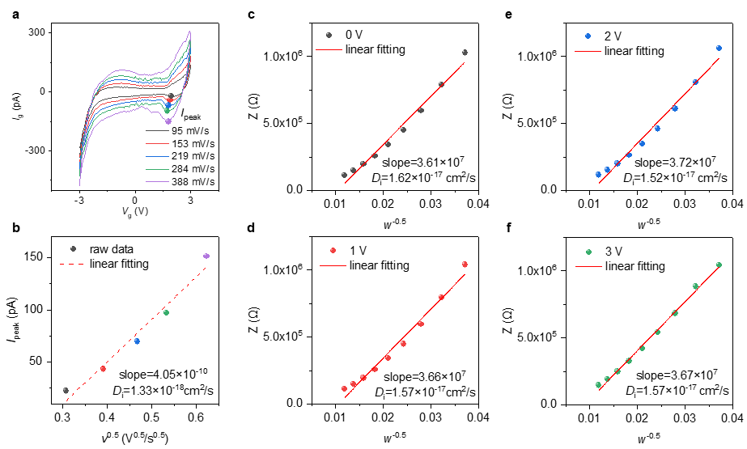
Supplementary Figure 6. The calculation of the D_{i}. a Cyclic voltammetry (CV) data at various sweep rates. The marked points are the peak current I_{peak}. b The linear fitting of the I_{peak} as a function of the square root of sweep rate. c-f The linear fitting of the impedance Z as a function of the reciprocal of square root of angular frequency w at various bias.

Supplementary Table 5. The capacitance or capacitance-like parameters
 | Symbol | Description | Formula
DC  (or Quasi-static) | C | Dynamic capacitance | $${C=C}_{0}\frac{cosh⁡(\frac{u}{2})}{1+2γ_{1}\sinh^{2}(\frac{u}{2})}×\sqrt{\frac{{2γ_{1}sinh}^{2}(\frac{u}{2})}{ln⁡\left[1+2γ_{1}\sinh^{2}\left(\frac{u}{2}\right)\right]}}$$
DC  (or Quasi-static) | C₀ | Debye capacitance | $$C_{0}=\sqrt{\frac{ε_{0}ε_{r}e^{2}\left(p_{i0}+n_{i0}\right)}{{4πk}_{B}T}}$$
DC  (or Quasi-static) | C_{ox} | Geometric capacitance | $$C_{ox}=\frac{ε_{0}ε_{r}}{d_{ox}}$$
DC  (or Quasi-static) | $$θ$$ | characteristic capacitance for SS and μ | $$θ=\left(2/γ_{1}-1/γ_{2}\right)\frac{e}{t_{E}}\frac{p_{i0}D_{i}}{s}$$
AC  (Component in equivalent circuit) | C_{edl} | Electric double layer capacitance | -
AC  (Component in equivalent circuit) | C_{pseudo} | Pseudocapacitance | -
AC  (Component in equivalent circuit) | C_{bulk} | Bulk capacitance | -

Supplementary Note 4. The high apparent μ mode

In the high apparent μ mode, due to the accumulated ions at the interface (Supplementary Fig. 7a), the resulting large electric field (Supplementary Fig. 7c) and the large local potential drop (Supplementary Fig. 7b) leads to enhanced charge carrier concentration (Supplementary Fig. 7d).
The apparent device mobility is denoted as $μ$. It is extracted by FET characterization which contains the capacitance calculated by the usually used dielectric constant C_{ox}: $μ=\frac{L}{WV_{d}C_{ox}}\left({∂I_{d}}/{∂V_{g}}\right)$. The high apparent μ is dependent on the initial ion concentration p_{i0} which affects the Debye capacitance (Supplementary Fig 8). With various amount of the migrated ions (Supplementary Fig. 9b), the transistor can show various μ-V_{g} behaviors (Supplementary Fig 9a).

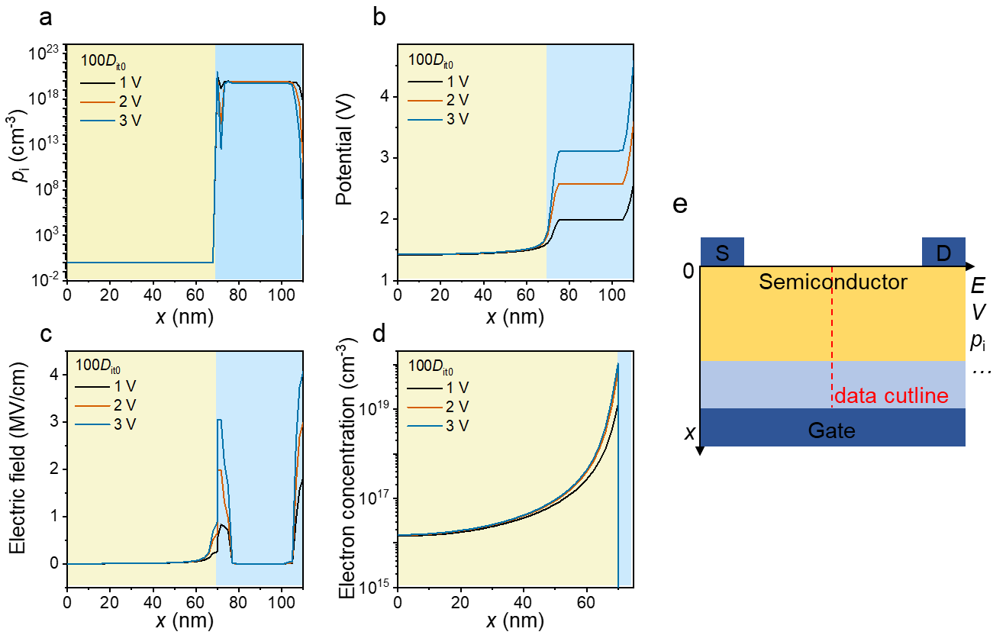
Supplementary Figure 7. Signatures of electric double layer. a The cation concentration b the potential c the electric field and d the electron concentration of the electrolyte-gated transistor with diffusion coefficient of 100D_{it0} at a gate potential from 1V to 3V in the forward sweep. The data are extracted from the middle vertical cutline as the red dash line shown in e from semiconductor layer (x=0-70nm) to the dielectric layer(x=70-110nm). The follow data are analyzed in the same way. The distribution of the cation contributes to the distribution of the potential and electric field in the dielectric.

Supplementary Figure 8. Impacts of ion concentration p_{i} on apparent mobility μ. The transfer characteristics of the electrolyte-gated transistor with various ions concentration (a) at low diffusion coefficient of 40D_{it0}, (b) at high diffusion coefficient of 1000D_{it0}.

Supplementary Figure 9. Impacts of diffusion coefficient D_{it} on apparent mobility μ. a The transfer characteristics and the mobilities for the diffusion coefficient from D_{it0} to 100D_{it0}. b The corresponding interfacial cation concentration as a function of gate.

The ratio between $μ$ and true carrier mobility $μ_{0}$ follows:
$\frac{μ}{μ_{0}}=\frac{∂Q_{i}}{C_{ox}∂V_{g}}=\frac{et_{E}}{C_{ox}}\frac{∂p_{i}}{∂t}\frac{∂t}{∂V_{g}}=\frac{et_{E}}{C_{ox}s}\frac{∂p_{i}}{∂t}=\frac{et_{E}}{C_{ox}s}\left(p_{i∞}-p_{i}\right){\frac{β_{0}}{η}\left(\frac{t}{η}\right)}^{β-1}{\left|V_{g}\right|}^{α+β}D_{i}^{β}$ (Eq. S15)
where $Q_{i}=p_{i}et_{E}$ (the term $n_{i}$ is neglected) and $s={∂V_{g}}/{∂t}$. By considering $p_{i∞}=\frac{2}{γ_{1}}p_{i0}$, $p_{i}=\frac{1}{γ_{2}}p_{i0}$, $V_{ox}=V_{g}$, and the fitting parameters $α$ and $β$ is close to 0 and 1, respectively, the expression in the linear regime can be further simplified as
$\frac{μ}{μ_{0}}=\frac{et_{E}}{C_{ox}s}\left(p_{i∞}-p_{i}\right){\frac{β_{0}}{η}\left(\frac{t}{η}\right)}^{β-1}{\left|V_{g}\right|}^{α+β}D_{i}^{β}=\frac{et_{E}}{C_{ox}s}\left(\frac{2}{γ_{1}}-\frac{1}{γ_{2}}\right)p_{i0}\frac{β_{0}}{η}\left|V_{g}\right|D_{i}=\frac{θ}{C_{ox}}t_{E}^{2}\frac{β_{0}}{η}\left|V_{g}\right|∝\frac{θ}{C_{ox}}\left|V_{g}\right|$ (Eq. S16)
where $θ={e\left(2/γ_{1}-1/γ_{2}\right)p_{i0}D_{i}}/{\left(s∙t_{E}\right)}∝{D_{i}p_{i0}}/s$. In the case of constant gate voltage, it becomes the simplest form $\frac{μ}{μ_{0}}∝\frac{Q_{i}}{C_{ox}V_{g}}=\frac{et_{E}}{C_{ox}}\frac{p_{i}}{V_{g}}$. The Eq. S16 are validated by examining the relationship between the mobility and these parameters as shown in Supplementary Fig. 10. In addition, Supplementary Figs. 11-12 show how to program by varying V_{g} and sweep rate to obtain different apparent mobility in the InO_{x}/AlO_{x} transistors in experiments. Supplementary Figure 13 shows the programming process in the InO_{x}/ZrO_{x} transistors in experiments.

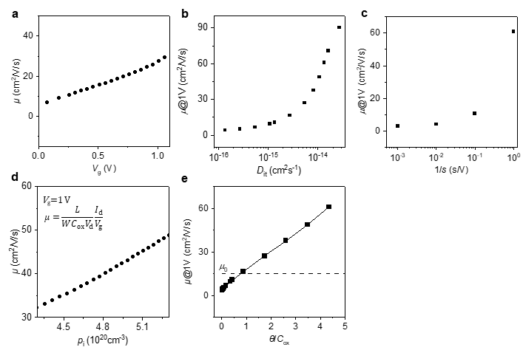
Supplementary Figure 10. Examination of Eq. 6 by numerical simulations: $\frac{μ}{μ_{0}}=\frac{θ}{C_{ox}}t_{E}^{2}\frac{β_{0}}{η}V_{g}∝\frac{θ}{C_{ox}}$, $θ={e\left(2/γ_{1}-1/γ_{2}\right)p_{i0}D_{i}}/{\left(s∙t_{E}\right)}$.The mobility as a function of (a) gate voltage V_{g}, (b) interfacial diffusion coefficient D_{it}, (c) the reciprocal of sweep rate s and (d) cation concentration p_{i}. The mobilities in (a-c) were extracted from the transfer curves. The extracted apparent mobility at constant gate voltage of 1V by using the equation in (d). (e) The extracted apparent mobility as a function of $θ$/C_{ox}. The apparent mobility increases almost linearly with $θ$/C_{ox}.

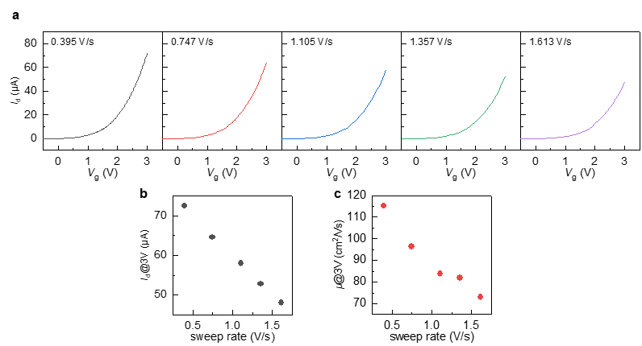
Supplementary Figure 11. Experiments of varying sweep rate in the InO_{x}/AlO_{x} transistors to obtain high apparent μ. a The transfer curves of the InO_{x}/AlO_{x} transistor at various sweep rates. b The I_{d} at V_{g}=3 V as a function of the sweep rate. c The mobility at V_{g}=3 V as a function of the sweep rate.

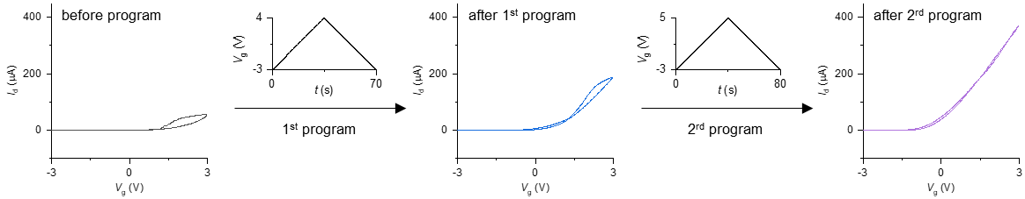
Supplementary Figure 12. Experiments of programming the InO_{x}/AlO_{x} transistors to obtain high current and high apparent μ. Before programming, the transistor shows a low drain current with a hysteresis. After the first triangular wave (from -3 V to 4 V), the drain current becomes larger. After the second triangular wave (from -3 V to 5 V), the drain current becomes more larger with an ignorable hysteresis.

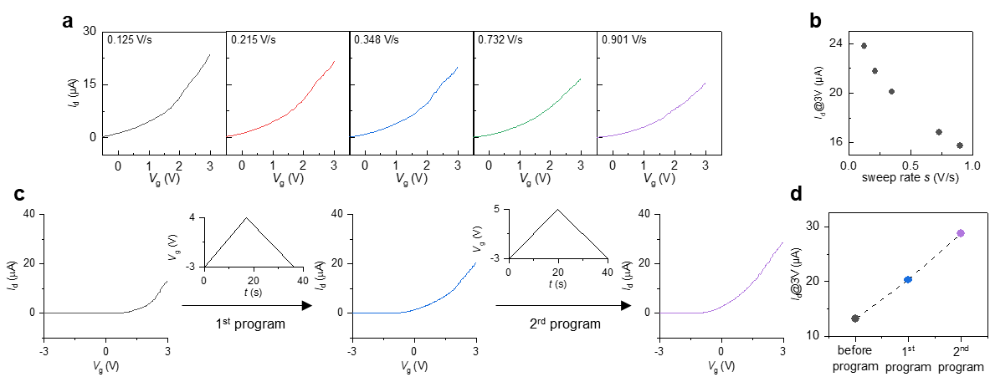
Supplementary Figure 13. The programmable of I_{d} in InO_{x}/ZrO_{x} transistor through sweep rate and preset V_{g}. a The I_{d}-V_{g} curve at various sweep rate and b corresponding I_{d} at V_{g}=3V as a function of sweep rate. c The I_{d}-V_{g} curves before and after a triangular wave of V_{g}. and d corresponding I_{d} at V_{g}=3V.

Supplementary Note 5. The sub-thermionic SS mode

The SS is defined as $SS=\frac{∂V_{g}}{∂\log_{10}I_{d}}=\frac{∂φ_{s}}{∂\log_{10}I_{d}}\frac{∂V_{g}}{∂φ_{s}}=\frac{kT}{e}ln10\left(1+\frac{C_{s}}{C_{ox}}\right)$, where $φ_{S}$ is the surface potential of the channel, $C_{s}$ is the semiconductor capacitance and $C_{ox}$ is the dielectric capacitance. When $C_{ox}≫C_{s}$, the SS would reach a limiting minimum value of 60 mV/dec at room temperature. In simulations, the transistor with conventional dielectric layer shows a consistent result in either the forward sweep or reverse sweep. For the transistor with solid state electrolyte, the reverse $I_{d}$ could overcome this limitation and decrease with a SS of 5 mV/dec (Supplementary Fig. 14a). The $\frac{∂V_{g}}{∂φ_{s}}$ is less than 1 in the subthreshold regime (Supplementary Fig. 14b). For a reference, the $\frac{∂φ_{s}}{∂\log_{10}I_{d}}$ show no difference for these two cases and both are about 60mV/dec (Supplementary Fig. 14c). It indicates that the small SS is originated from the small $\frac{∂V_{g}}{∂φ_{s}}$. As the $V_{g}$ could be decomposed into the voltage drop on the dielectric layer and semiconductor layer, we have $V_{g}=V_{ox}+φ_{s}$ and then $\frac{∂V_{g}}{∂φ_{s}}={\left(1-\frac{∂V_{ox}}{∂V_{g}}\right)}^{-1}$. For conventional transistors, interfacial traps result in the positive $\frac{∂V_{ox}}{∂V_{g}}$ and an SS over $\frac{kT}{e}ln10$. For transistors with ions in dielectrics, interfacial ions in the dielectric are accumulated with as V_{g} increases during the forward sweep. During the backward sweep, interfacial ions in the dielectric are released but the response to V_{g} is delayed due to small D_{i}, giving a negative $\frac{∂V_{ox}}{∂V_{g}}$ and $\frac{∂V_{g}}{∂φ_{s}}<1$ (Supplementary Fig. 14d). As a result, the SS for the reverse current could be lower than $\frac{kT}{e}ln10$ (i.e., the “sub-thermionic SS” mode). This process could be comprehended by the response of the potential induced by the interfacial ions u to gate sweep V_{g}. In the “ion-free” limit without u, SS returns to that of conventional FETs. As shown in Supplementary Fig. 15, as $∂$u/$∂$V_{g} increases, SS deceases to be lower than $\frac{kT}{e}ln10$.
Supplementary Figure 14. Origins of sub-thermionic SS. $SS=\frac{∂V_{g}}{∂\log_{10}I_{d}}=\frac{∂φ_{s}}{∂\log_{10}I_{d}}\frac{∂V_{g}}{∂φ_{s}},$ $\frac{∂V_{g}}{∂φ_{s}}={\left(1-\frac{∂V_{ox}}{∂V_{g}}\right)}^{-1}$ a The comparison of transfer curves for normal transistor (dash line) and electrolyte-gated transistor (solid line). b The surface potential as a function of gate voltage, $\frac{∂V_{g}}{∂φ_{s}}$. c The drain current as a function of surface potential, $\frac{∂φ_{s}}{∂\log_{10}I_{d}}$. d The $\frac{∂V_{ox}}{∂V_{g}}$ as a function of gate voltage.

Supplementary Figure 15. The SS calculated from the compact model as a function of the $∂$u/$∂$V_{g}, the ratio of the respond rate of ion and sweep rate.

According to the compact theory, SS is determined by p_{i}, which could be varied by different D_{i} or presetting p_{i}. By increasing the diffusion coefficient from D_{it0} to 100D_{it0}, the minimum SS decreases from 83.2 mV/dec to 4.8 mV/dec (Supplementary Fig. 16). In addition, the subthreshold regime can be adjusted by controlling the ion-releasing process. The $V_{g}$ where the minimum SS is reached is denoted as V_{SS}. With increasing the diffusion coefficient from D_{it0} to 100D_{it0}, V_{SS} negatively shift from -0.7V to -2.5V, and then increases to -1.6V. The negative shift of V_{SS} is because the accumulated interfacial cations results in a negative shift of threshold voltage. While for the increase of V_{SS}, it is actually due to dynamic positive shift of threshold voltage. Such a variation of the hysteresis window in Supplementary Fig. 16a also occurs in negative capacitance transistors.⁹ The examples of presetting p_{i} are given in Supplementary Fig. 17, where the small SS can be realized in forward sweep by presetting a high concentration of anion at the interface at off-state in simulation.

Supplementary Figure 16. Impacts of diffusion coefficient D_{it} on SS. a The transfer characteristics of the electrolyte-gated transistors with various diffusion coefficient from D_{it0} to 100D_{it0}. b The corresponding p_{i} at gate voltage sweeping. The corresponding SS as a function of the c gate voltage and d drain current.

Supplementary Figure 17. Impacts of preset ion concentration p_{i} on SS. To realize the sub-thermionic SS in the forward sweep, a pre-accumulation process was implemented. a The transfer characteristics with various presetting process. Black: without ions; brown: presetting a low concentration of ion; blue: presetting a high concentration of ion. The corresponding SS as a function of (b) gate voltage and (c) drain current. The dashed line represents 60 mV/dec.

The reversed subthreshold slope SS are extracted by $SS=\left({∂φ_{s}}/{∂\log_{10}I_{d}}\right){\left(1-{∂V_{ox}}/{∂V_{g}}\right)}^{-1}$,where $V_{ox}={Q_{i}}/C$. In the subthreshold regime, C can be approximately expressed as $C=δV_{g}$, so
$\frac{∂V_{ox}}{∂V_{g}}=\frac{∂\frac{Q_{i}}{C}}{∂V_{g}}≈\frac{∂\frac{Q_{i}}{δV_{g}}}{∂V_{g}}=\frac{1}{C}\left(\frac{∂Q_{i}}{∂V_{g}}-\frac{Q_{i}}{V_{g}}\right)$ (Eq. S17)
where
$\frac{∂Q_{i}}{∂V_{g}}=\frac{et_{E}∂p_{i}}{∂t}\frac{∂t}{∂V_{g}}=\frac{et_{E}}{s}\frac{∂p_{i}}{∂t}=θt_{E}^{2}\frac{β_{0}}{η}V_{g}$ (Eq. S18)
By substitute Eq. S17 and S18 in the expression of SS, SS can be expressed as:
$SS=\frac{kT}{e}ln10\frac{1}{1+\frac{1}{C}\left(θt_{E}^{2}\frac{β_{0}}{η}\left|V_{g}\right|-\frac{{et}_{E}p_{i0}}{\left|V_{g}\right|}\right)}=\frac{kT}{e}ln10\frac{1}{1+\frac{1}{C_{0}}\left(aθ-b\right)}$ (Eq. S19)
where, ${a=t}_{E}^{2}\frac{β_{0}}{η}\left|V_{g}\right|$, $b=\frac{{et}_{E}p_{i0}}{\left|V_{g}\right|}$, $θ={e\left(2/γ_{1}-1/γ_{2}\right)p_{i0}D_{i}}/{\left(s∙t_{E}\right)}∝{D_{i}p_{i0}}/s$, and C is approximately C₀ in the subthreshold regime. The Eq. S19 are validated by examining the relationship between the SS and these parameters as shown in Supplementary Fig. 18. Supplementary Figs. 19-21 show the programmable SS for the experimental InO_{x}/AlO_{x} transistor and InO_{x}/ZrO_{x} transistor by sweep rate and V_{g} in experiments.

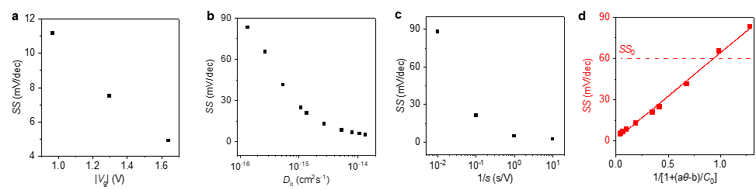
Supplementary Figure 18. Examination of Eq. 7 by numerical simulations: $SS=\frac{dV_{g}}{d\log_{10}I_{d}}=\frac{kT}{e}ln10\frac{1}{1-{∂V_{ox}}/{∂V_{g}}}=\frac{kT}{e}ln10\frac{1}{1+{\left(aθ-b\right)}/{C_{0}}}$. The SS as a function of (a) gate voltage, (b) interfacial diffusion coefficient, (c) the reciprocal of sweep rate. (d) The SS as a function of $1+{\left(aθ-b\right)}/{C_{0}}$. With increasing $θ$, the $\frac{1}{1+{\left(aθ-b\right)}/{C_{0}}}$ decreases, then the SS decreases.

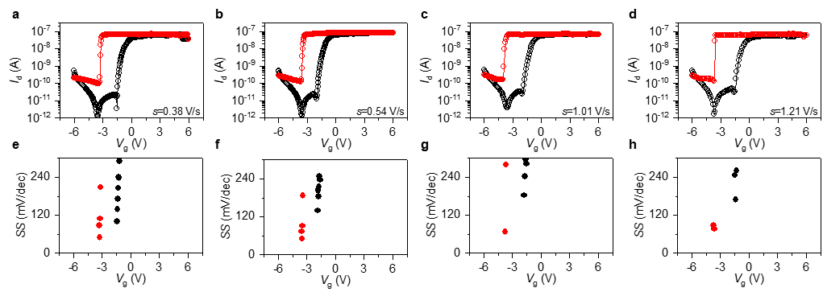
Supplementary Figure 19. Experiments of varying sweep rate to obtain various SS in the InO_{x}/AlO_{x} transistor. a-d the transfer curves of the InO_{x}/AlO_{x} transistor at various sweep rates. e-h the corresponding SS as a function of V_{g}.

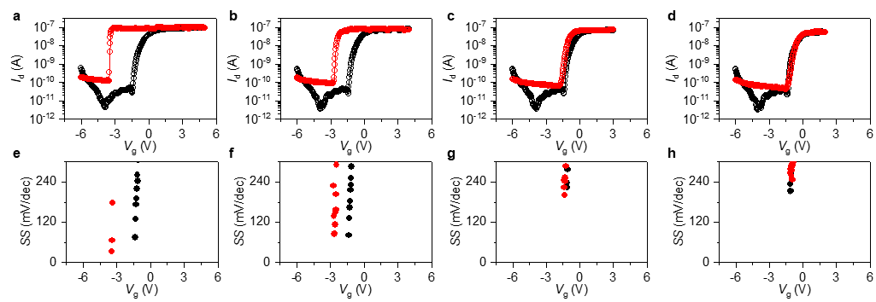
Supplementary Figure 20. Experiments of varying scan range to obtain various SS in the InO_{x}/AlO_{x} transistor. a-d the transfer curves of the InO_{x}/AlO_{x} transistor at various sweep range (from -6V-5V to -6V-2V). e-h the corresponding SS as a function of V_{g}.

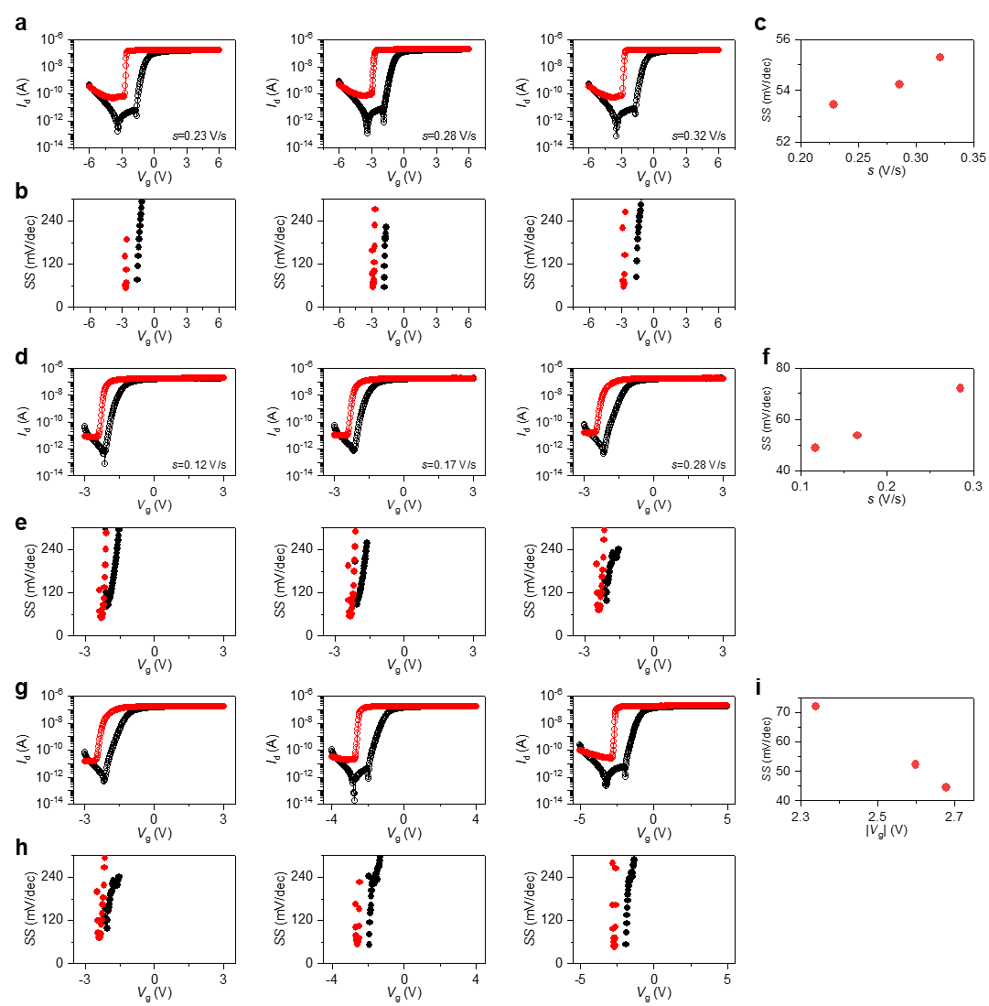
Supplementary Figure 21. The programmable of SS in InO_{x}/ZrO_{x} transistor through sweep rate and sweep range of V_{g}. a The I_{d}-V_{g} curve at various sweep rates, b the corresponding SS- V_{g}, and c SS as a function of sweep rate. d-f The data obtained within a smaller sweep range than (a)-(c). g The I_{d}-V_{g} curves at various ranges of V_{g}, h the corresponding SS-V_{g} and i SS as a function of the absolute value V_{g} with minimum SS.

Supplementary Note 6. The mem-resistive characteristics in simulation

To understand the resistance switching, we extracted the potential, electric field, and electric concentration profile (Supplementary Fig. 22). During forward sweep and before the decrease of $I_{d}$, the electric field and potential mainly drop near the interface. When the cation concentration at the interface reaches saturation and $V_{g}$ continues to increase, the capacitance decreases due to the steric effect and the potential drops on the whole dielectric leading to a decreased electric field and reduced channel charge carriers. It also explains reason why the apparent mobility decreases at high $V_{g}$.
At reverse sweep, the drain current becomes nearly independent on the $V_{g}$ from $V_{g}$=3V to $V_{g}$=1V. As the cation concentration is saturated, an almost constant surface potential (Supplementary Fig. 23a) and almost constant electric field is kept at the interface (Supplementary Fig. 23b). Thus, the corresponding channel charge concentration keeps constant (Supplementary Fig. 23c). In other word, the $V_{g}$ is screened by the accumulated ions and the local electric field for charge carriers in semiconductors is totally provided by the interfacial ions. To reach the saturation of ions during the sweep, the C-u curve need to be gull-wing shaped. Accordingly, the γ₁ should be smaller than 1/3. It means the interface should accommodate at least three times the initial ion concentration (Supplementary Fig. 24).

Supplementary Figure 22. Evolution of potential, field, and electron concentration in forward sweep. a The potential b the electric field and c the electron concentration of the electrolyte-gated transistor with diffusion coefficient of 1000D_{it0} at a gate potential from 2V to 2.4V in the forward sweep where the resistance switches from low to high.

Supplementary Figure 23. Evolution of potential, field, and electron concentration in backward sweep. a The potential b the electric field and c the electron concentration of the electrolyte-gated transistor with diffusion coefficient of 1000D_{it0} at a gate potential from 3V to 1V in the reverse sweep. Although the gate voltage decreases from 3V to 1V, the surface potential, electric field and channel charge concentration do not change with gate voltage.

Supplementary Figure 24. The relationship between γ₁ and u_{M}. The ratio of calculated dynamic capacitance C and the Debye capacitance C₀ as a function of the u at various $γ_{1}$. When the $γ_{1}>1/3$, the curves are bell-shaped. In this case, the u_{M} could not be reached within the measurement. When the $γ_{1}<1/3$, the curves are gull-wing shaped. In this case, the u_{M} could be reached within the measurement. However, if the $γ_{1}$ is very low, a large u will be needed to reach the u_{M}.

Supplementary Note 7. Device fabrication

The InO_{x} precursor solution (0.2 mol/L) was prepared by dissolving 526.9 mg of indium nitrate hydrate (In(NO₃)₃•xH2O, Alfa Aesar, 99.999%) in 10 mL of deionized water. The AlO_{x} precursor solution (0.2 mol/L) was prepared by dissolving 375 mg of aluminum nitrate hydrate (Al(NO₃)₃•9H2O, Alfa Aesar, 99.999%), 160 mL of nitric acid (aq) (HNO₃, 65%-70% HNO₃ in water, Alfa Aesar, 99.999%), and 222 mL of ammonium hydroxide (aq) (NH₄OH, 28% NH₃ in water, Sigma-Aldrich, 99.99%) in 5 mL of hydrogen peroxide. The ZrO_{x} precursor solution (0.2 mol/L) was prepared by dissolving 232 mg of Zirconium oxynitrate hydrate (ZrO(NO₃)₂, Sigma-Aldrich, 99.99%), 160 mL of nitric acid (aq) (HNO₃, 65%-70% HNO₃ in water, Alfa Aesar, 99.999%), and 222 mL of ammonium hydroxide (aq) (NH₄OH, 28% NH₃ in water, Sigma-Aldrich, 99.99%) in 5 mL of hydrogen peroxide. All precursor solutions were stirred for 24 h at room temperature, filtered through a 0.22 μm syringe filter. The metal-insulator-metal (MIM) capacitors were fabricated by solution-deposition. Before the spin-coating, the heavily doped silicon wafer was treated by the oxygen plasma. The AlO_{x} precursor solution was spin-coated on the silicon wafer and annealed on the hot plate at 300°C for 30 min. The spin-coating process was repeated five times and the total thickness of AlO_{x} film was about 30 nm. Al top electrode (150 nm) with a diameter of 1 mm was deposited by thermal evaporation through a shadow mask. The AlO_{x}/InO_{x} thin film transistors (TFT) were fabricated after the deposition of AlO_{x}. The InO_{x} precursor solution was spin-coated on the AlO_{x} and annealed on the hot plate at 230°C for 2 hours. After the photolithography process and etching with hydrochloric acid, the channel layer was patterned with a channel width of 96 μm and a channel length of 24 μm. Finally, Al source/drain electrodes (150 nm) were deposited to fabricate the bottom-gate, top-contact transistors. Conventional TFTs were fabricated by the similar method but the AlO_{x} was annealed at 500°C. The electrolyte-gated ZrO_{x}/InO_{x} TFTs were fabricated by the similar method but the ZrO_{x} was annealed at 230°C.

Supplementary Note 8. Application by coupling modes

Supplementary Figure 25. A visualized synapse in the form of TFT-LED integration. The LED was connected with the source electrode of the AlO_{x}/InO_{x} TFT. a The I_{d}-t curve by applying square wave of V_{g} (0 – 6 V). b The I_{d}-V_{g} curve by applying triangular wave of V_{g}. The inset graphs show the corresponding luminance of the LED.

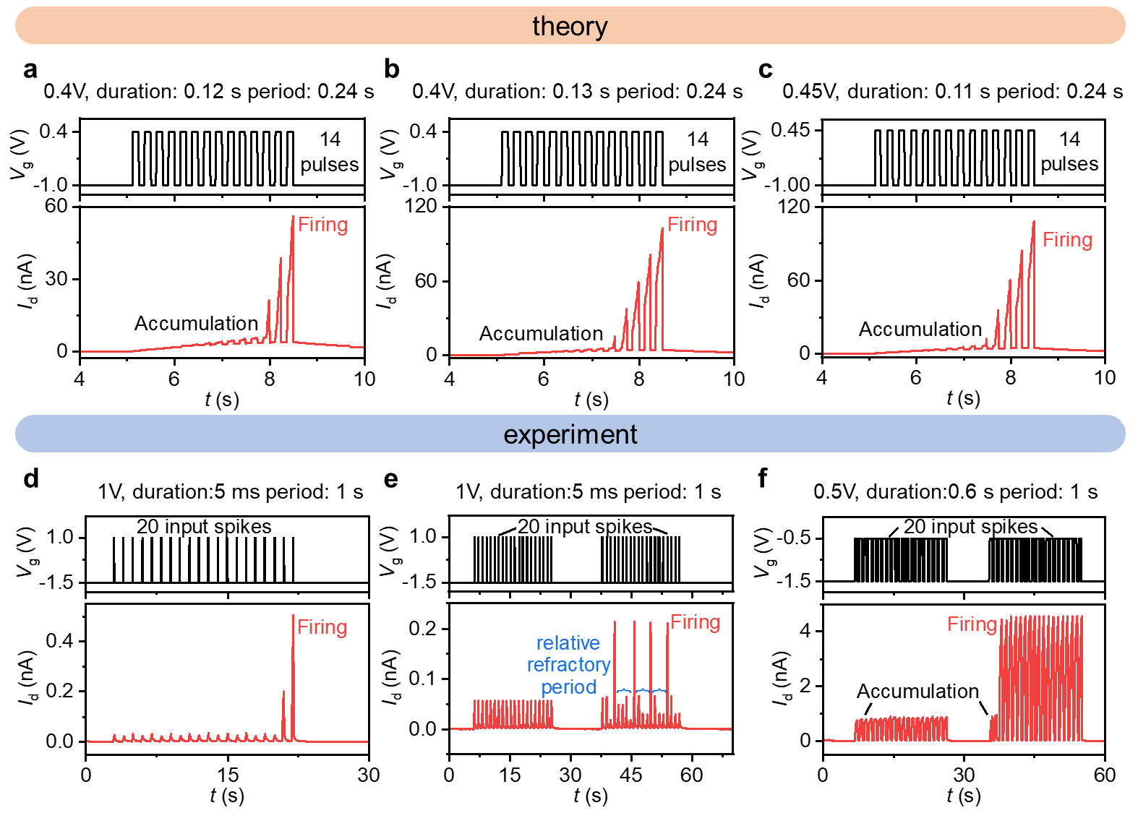
Supplementary Figure 26. The LIF behavior in theoretical calculation and experimental measurements. a-c The theoretical data of LIF generated by the Eq. 2-5 with various pulse width and pulse amplitude. d-f The experimental data of LIF obtained in the InO_{x}/AlO_{x} transistor with appropriate pulses. The relative refractory period is used to describe that the synapse undergoes a recovery period in which they transit to the active state.

Supplementary Note 9. Application by building neural network

ANN. An artificial neural network was established based on the STP characteristics measured in transistor experiments in CrossSim platform¹⁰. A three-layer back-propagation network with 784 input neurons, 300 hidden neurons and 10 output neurons was used for handwritten digit classification. Two data sets, small image (8×8 pixel) from UCI machine learning repository ¹¹ and large image (28×28 pixel) from Modified National Institute of Standards and Technology (MNIST) ¹² were used to train the network, and the datasets distribution of training and testing was shown in Supplementary Table 6.
RNN. Schematics of training process of RC system based on the LTP characteristics measured in transistor experiments is shown in Supplementary Fig. 27a. The original images were binarized first, then cut into 22 rows × 20 pixels to remove invalid pixels. Each row was divided into 4 groups with each group containing 5 pixels, and thus the image was converted into 88 pulse streams. The reservoir layer was simulated by the LTP device model. As for the read-out layer, we chose the SoftMax function $S(y_{i})=e^{y_{i}}/\sum_{k}{e^{y_{k}}}$ as the activation function, and cross-entropy $L=-1/N\sum_{i}{{\hat{y}}_{i}\log\left(S_{i}\right)}$ as the loss function.
SNN. Schematics of training process of the SNN is shown in Supplementary Fig. 27b. Each neuron of the SNN was inspired by spike inputs and would generate spike outputs based on LIF characteristics measured in transistor experiments. The loss function is the spike counts based cross-entropy that the spikes at each time step are accumulated and then passed through the cross-entropy loss function. The SNN work is simulated by Python package Pytorch and SNNtorch.
The source code is available at https://github.com/HuisheepLuo/Ion-transistor-network.

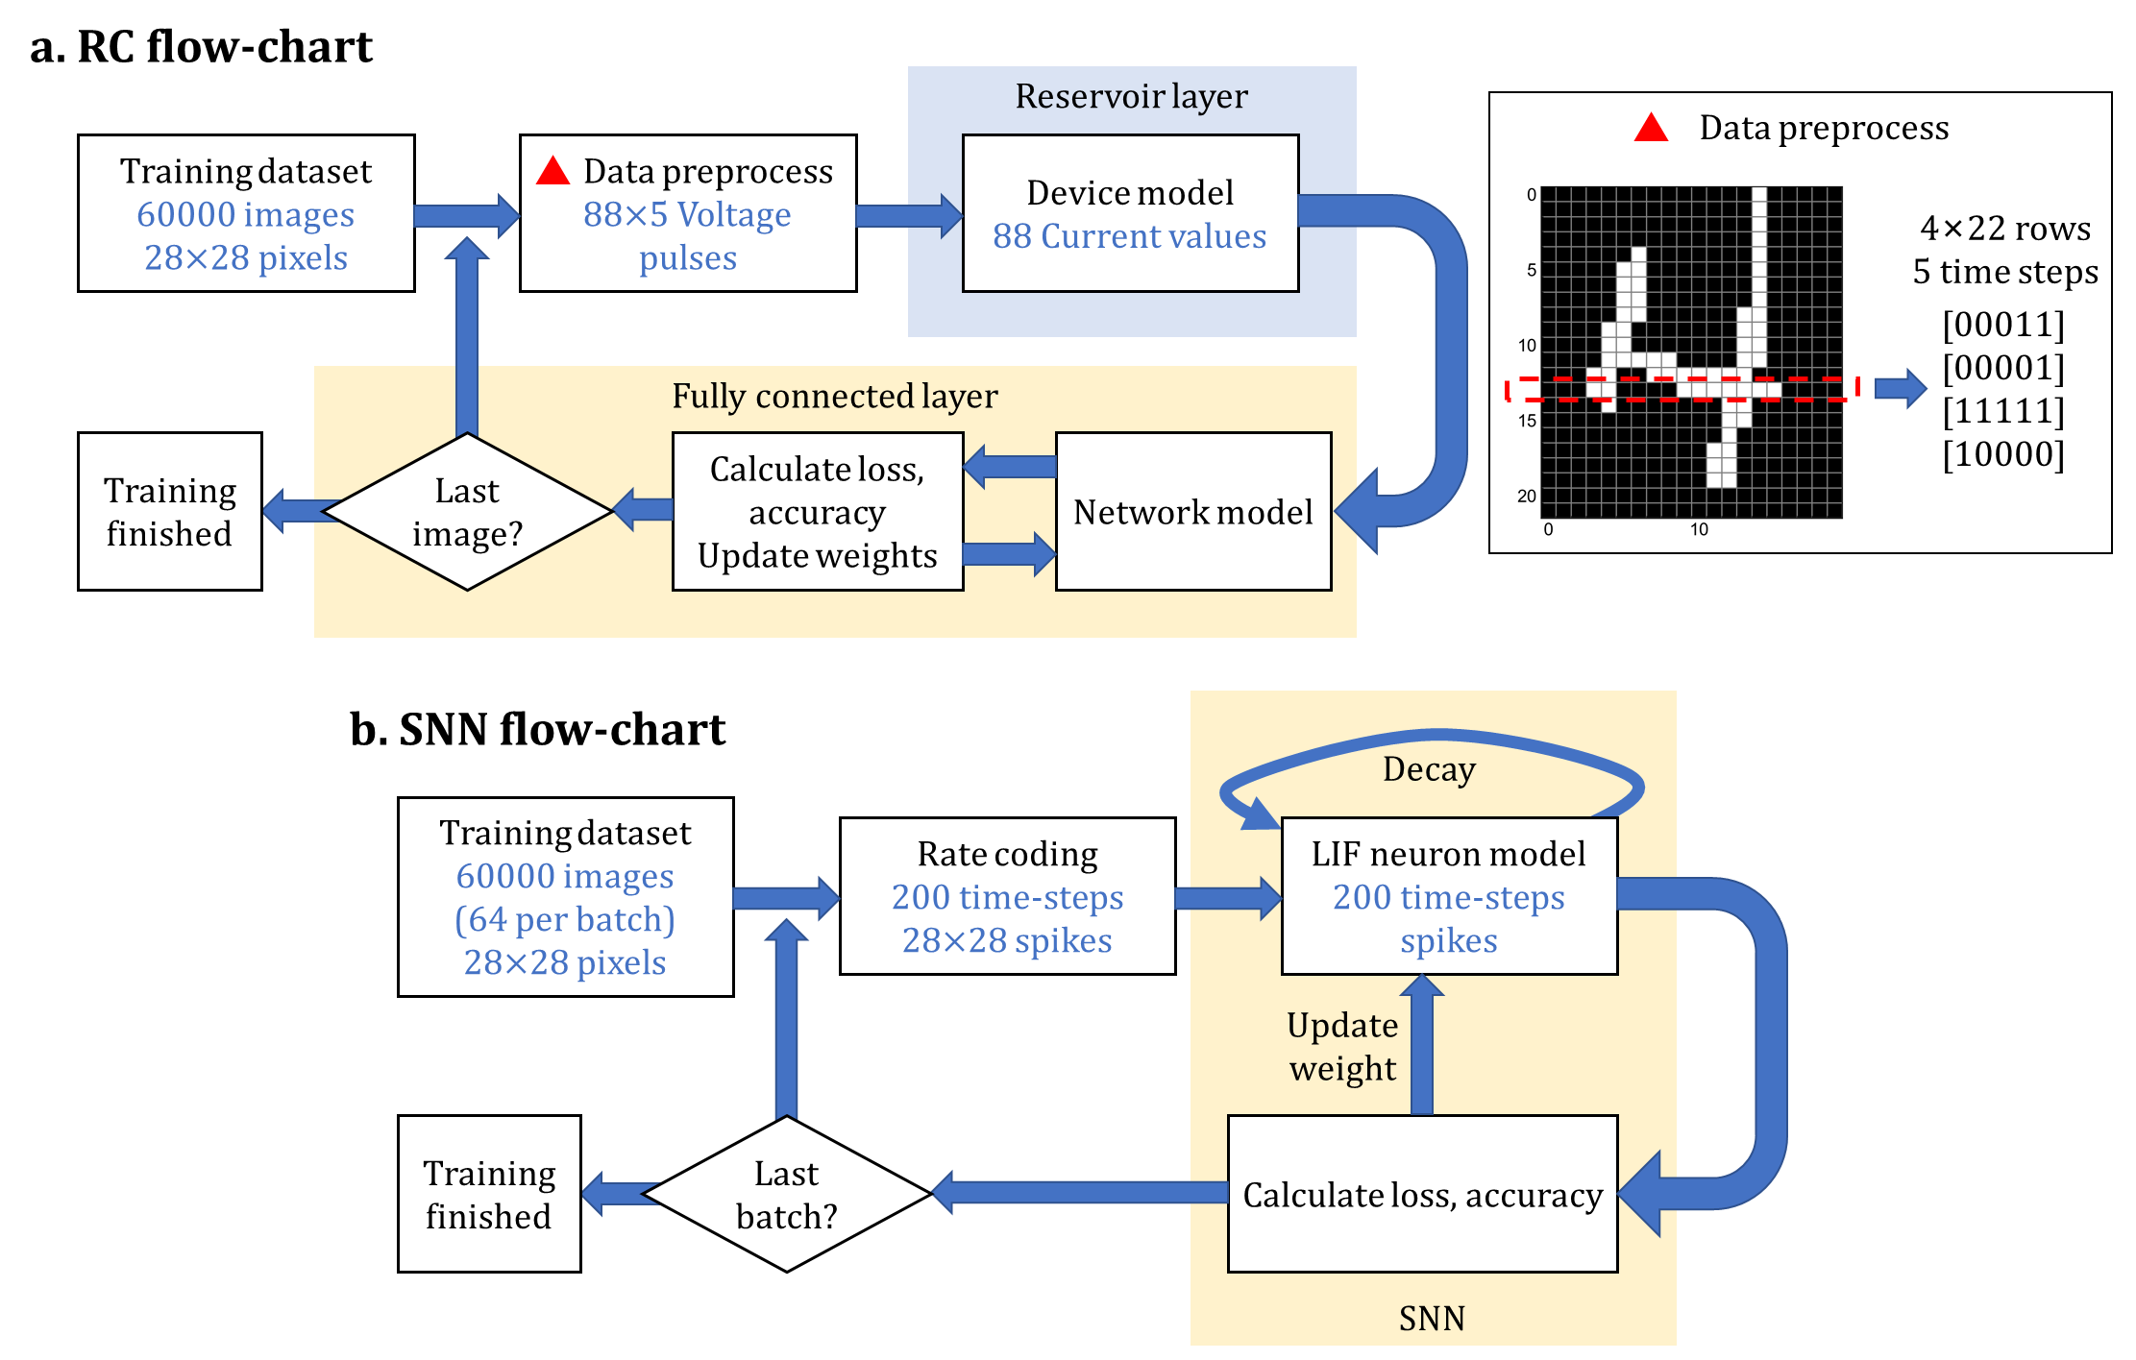
Supplementary Figure 27. The flowchart of RNN and SNN. a Flow chart of the training algorithm of RC system (blue words mean output). We chose the SoftMax function as the activation function, cross-entropy as the loss function, and learning rate 0.01. b Flow chart of the training algorithm of SNN (blue words mean output). The loss function is the spike counts based cross-entropy. The spikes at each time step are accumulated and then passed through the cross-entropy loss function.

Supplementary Figure 28. The simulation of neural network with various devices. ANN, RNN, SNN, and CNN are referred to artificial neural network, recurrent neural network, spiking neural network, and convolutional neural network, respectively. FeFET, PCM, and RRAM are referred to ferroelectric field-effect transistor, phase change memory, resistive memory, respectively.^{13–42}

Supplementary Table 6. The distribution of training/testing for two datasets and the network size.
dataset | Training example | Testing example | Network size
UCI Small images¹¹ | 3,823 | 1,797 | 64*36*10
MNIST large images¹² | 60,000 | 10,000 | 784*300*10

Supplementary Note 10. A multimode transistor calculator

The theory of the multimode transistor is encoded in an HTML file. The user interface shows a series of curves including the V_{g}-t, V_{g}-t, I_{d}-V_{g}, μ-V_{g}, and SS-V_{g}. By entering the main parameters, such as the dt, D_{i}/D_{i0}, and p_{i0}, or clicking the initialization button in the upper right of the page, the transistor can switch in various modes. More detailed results can be easily achieved by inputting desired parameters. More statements can be found in the README document.
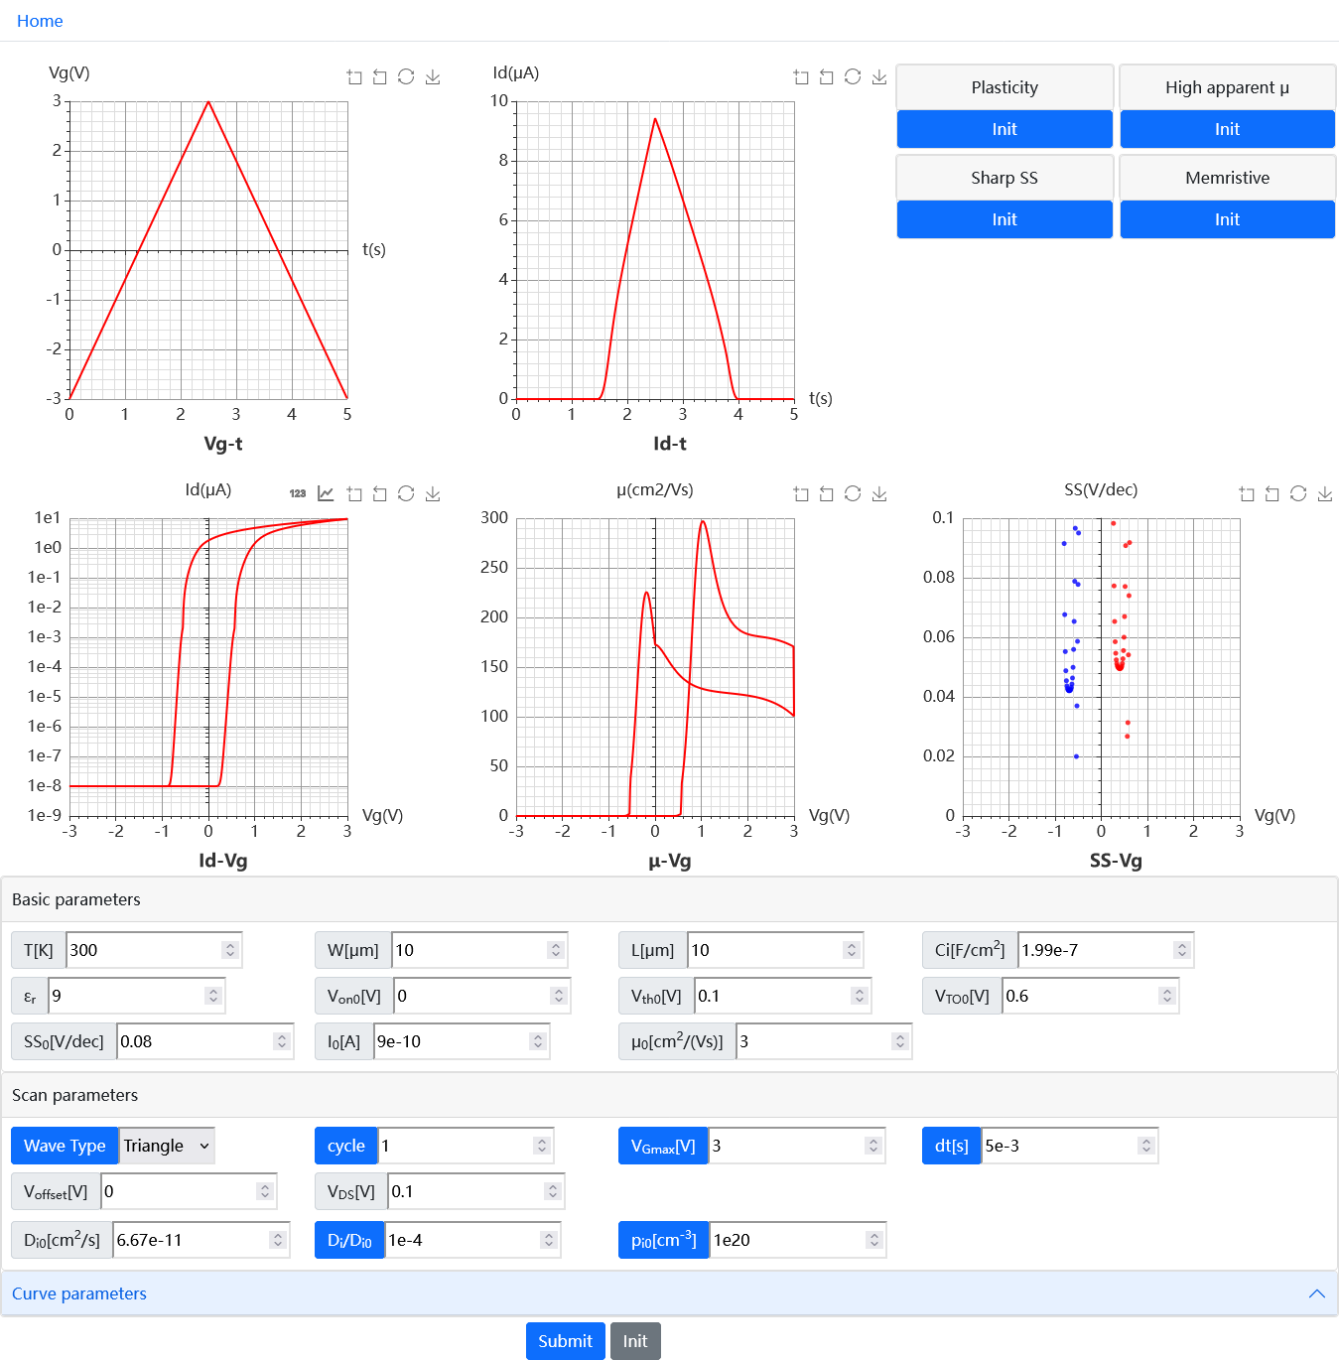
Supplementary Figure 29. User interface of the transistor calculator. By inputting appropriate parameters, the transistor can switch in various modes.

Supplementary Reference
1. Zhao, J. et al. Universal Compact Model for Thin-Film Transistors and Circuit Simulation for Low-Cost Flexible Large Area Electronics. IEEE Trans. Electron Devices 64, 2030–2037 (2017).
2. Conway, B. E. Electrochemical Supercapacitors, Scientific Fundamentals and Technological Applications. (Kluwer Academic/Plenum Press, New York, 1999).
3. Allen J. Bard & Faulkner, L. R. Electrochemical Methods; Fundamentals and Applications. (JOHN WILEY & SONS, INC.New York, 2001).
4. Liang, X. et al. Evidence for Pseudocapacitance and Faradaic Charge Transfer in High-Mobility Thin-Film Transistors with Solution-Processed Oxide Dielectrics. J. Phys. Chem. Lett. 11, 2765–2771 (2020).
5. Liang, X. et al. Artificial synaptic transistor with solution processed InOx channel and AlOx solid electrolyte gate. Appl. Phys. Lett. 116, 012102 (2020).
6. Belonoshko, A. B., Rosengren, A., Dong, Q., Hultquist, G. & Leygraf, C. First-principles study of hydrogen diffusion in α - Al2O3 and liquid alumina. Phys. Rev. B - Condens. Matter Mater. Phys. 69, 1–6 (2004).
7. Serra, E., Bini, A. C., Cosoli, G. & Pilloni, L. Hydrogen permeation measurements on alumina. J. Am. Ceram. Soc. 88, 15–18 (2005).
8. Wang, F., Lai, W., Li, R., He, B. & Li, S. Fast hydrogen diffusion along the Σ7 grain boundary of α-Al2O3: A first-principles study. Int. J. Hydrogen Energy 41, 22214–22220 (2016).
9. McGuire, F. A. et al. Sustained Sub-60 mV/decade switching via the negative capacitance effect in MoS2 Transistors. Nano Lett. 17, 4801–4806 (2017).
10. CrossSim Platform https://cross-sim.sandia.gov/ (accessed: July 2019).
11. Bache, K; Lichman, M. UCI Machine Learning Repository‏. (University of California, School of Information and Computer Science, 2016).
12. LeCun, Y., Bottou, L., Bengio, Y. & Haffner, P. Gradient-based learning applied to document recognition. Proc. IEEE 86, 2278–2323 (1998).
13. Xiong, X. et al. Reconfigurable Logic-in-Memory and Multilingual Artificial Synapses Based on 2D Heterostructures. Adv. Funct. Mater. 30, 2–7 (2020).
14. Seo, S. et al. Artificial optic-neural synapse for colored and color-mixed pattern recognition. Nat. Commun. 9, 1–8 (2018).
15. Wang, R. et al. Artificial Synapses Based on Lead-Free Perovskite Floating-Gate Organic Field-Effect Transistors for Supervised and Unsupervised Learning. ACS Appl. Mater. Interfaces 13, 43144–43154 (2021).
16. Yang, C. Sen et al. All-Solid-State Synaptic Transistor with Ultralow Conductance for Neuromorphic Computing. Adv. Funct. Mater. 28, 1–10 (2018).
17. Sun, J. et al. Optoelectronic Synapse Based on IGZO-Alkylated Graphene Oxide Hybrid Structure. Adv. Funct. Mater. 28, 1804397 (2018).
18. Fuller, E. J. et al. Li-Ion Synaptic Transistor for Low Power Analog Computing. Adv. Mater. 29, 1–8 (2017).
19. Qiu, W. et al. Optoelectronic In-Ga-Zn-O Memtransistors for Artificial Vision System. Adv. Funct. Mater. 30, 1–9 (2020).
20. Li, Y. et al. Oxide-Based Electrolyte-Gated Transistors for Spatiotemporal Information Processing. Adv. Mater. 32, 1–12 (2020).
21. Dalgaty, T. et al. In situ learning using intrinsic memristor variability via Markov chain Monte Carlo sampling. Nat. Electron. 4, 151–161 (2021).
22. Prezioso, M. et al. Training and operation of an integrated neuromorphic network based on metal-oxide memristors. Nature 521, 61–64 (2015).
23. Midya, R. et al. Reservoir Computing Using Diffusive Memristors. Adv. Intell. Syst. 1, 1900084 (2019).
24. Du, C. et al. Reservoir computing using dynamic memristors for temporal information processing. Nat. Commun. 8, 1–10 (2017).
25. Chen, H. et al. Logic gates based on neuristors made from two-dimensional materials. Nat. Electron. 4, 399–404 (2021).
26. Lin, P. et al. Three-dimensional memristor circuits as complex neural networks. Nat. Electron. 3, 225–232 (2020).
27. Burr, G. W. et al. Experimental Demonstration and Tolerancing of a Large-Scale Neural Network (165 000 Synapses) Using Phase-Change Memory as the Synaptic Weight Element. IEEE Trans. Electron Devices 62, 3498–3507 (2015).
28. Boybat, I. et al. Neuromorphic computing with multi-memristive synapses. Nat. Commun. 9, 1–12 (2018).
29. Sidler, S., Pantazi, A., Woźniak, S., Leblebici, Y. & Eleftheriou, E. Unsupervised learning using phase-change synapses and complementary patterns. in Lecture Notes in Computer Science (including subseries Lecture Notes in Artificial Intelligence and Lecture Notes in Bioinformatics) vol. 10613 LNCS 281–288 (2017).
30. Oh, S., Huang, Z., Shi, Y. & Kuzum, D. The Impact of Resistance Drift of Phase Change Memory (PCM) Synaptic Devices on Artificial Neural Network Performance. IEEE Electron Device Lett. 40, 1325–1328 (2019).
31. Woo, J. et al. Improved synaptic behavior under identical pulses using AlOx/HfO2 bilayer RRAM array for neuromorphic systems. IEEE Electron Device Lett. 37, 994–997 (2016).
32. Park, J. et al. TiOx-Based RRAM Synapse With 64-Levels of Conductance and Symmetric Conductance Change by Adopting a Hybrid Pulse Scheme for Neuromorphic Computing. IEEE Electron Device Lett. 37, 1559–1562 (2016).
33. Li, Z., Chen, P. Y., Xu, H. & Yu, S. Design of Ternary Neural Network with 3-D Vertical RRAM Array. IEEE Trans. Electron Devices 64, 2721–2727 (2017).
34. Lashkare, S. et al. PCMO RRAM for Integrate-and-Fire Neuron in Spiking Neural Networks. IEEE Electron Device Lett. 39, 484–487 (2018).
35. Garbin, D. et al. HfO2-Based OxRAM Devices as Synapses for Convolutional Neural Networks. IEEE Trans. Electron Devices 62, 2494–2501 (2015).
36. Luo, J. et al. Capacitor-less Stochastic Leaky-FeFET Neuron of Both Excitatory and Inhibitory Connections for SNN with Reduced Hardware Cost. Tech. Dig. - Int. Electron Devices Meet. IEDM 2019-Decem, 2019–2022 (2019).
37. Boyn, S. et al. Learning through ferroelectric domain dynamics in solid-state synapses. Nat. Commun. 8, 14736 (2017).
38. Kaneko, Y., Nishitani, Y. & Ueda, M. Ferroelectric artificial synapses for recognition of a multishaded image. IEEE Trans. Electron Devices 61, 2827–2833 (2014).
39. He, Y. et al. IGZO-based floating-gate synaptic transistors for neuromorphic computing. J. Phys. D. Appl. Phys. 53, 215106 (2020).
40. Fuller, E. J. et al. Parallel programming of an ionic floating-gate memory array for scalable neuromorphic computing. Science 364, 570–574 (2019).
41. Merrikh-Bayat, F. et al. High-Performance Mixed-Signal Neurocomputing with Nanoscale Floating-Gate Memory Cell Arrays. IEEE Trans. Neural Networks Learn. Syst. 29, 4782–4790 (2018).
42. Yang, X. et al. Mechanoplastic Tribotronic Floating-Gate Neuromorphic Transistor. Adv. Funct. Mater. 30, 1–10 (2020).

