Supplementary Materials for
Sustainable, high-performance ambient water harvesting via synergistic mechanisms and temperature-swing strategy

Table of content
Part I: Supplementary Discussions
Note S1. Material synthesis – dip coating
Note S2. Morphological characterization of cellulose-based textile
Note S3. Optical characterization
Note S4. Theoretical cooling power estimation
Note S5. Field test experiments (water uptake and temperature measurement)
Note S6. Field test experiments (cooling power measurement)
Note S7. Composite-water-energy interaction mechanism
Note S8. Lab-test experiments (water uptake measurement)
Note S9. Required humidity for water uptake.
Note S10. Field test of radiative cooling effect
Note S11. Sorption isotherm
Note S12. True density measurement
Note S13. BET equivalent specific surface area and porosity
Note S14. Desorption by solar heating
Note S15. Water quality test
Note S16. Lab-test experiments (desorption by solar heating)
Note S17. Global water production estimation
Note S18. Mechanical strain-stress curves

Part II: Supplementary Figures
Fig. S1. Synthesis of LiCl-cellulose composite.
Fig. S2. (A) Photo images of LiCl-cellulose composite and (B) SEM images of sample fiber.
Fig. S3. (A) Optical microscopic images of dry and wet cellulose samples. (B) The microscale fibers appear more transparent when water occupies the porous space.
Fig. S4. (A) SEM of 50 wt% LiCl-cellulose composite with some leakage of LiCl. (B) Zoom-in SEM (B) and corresponding EDX mapping (C) of the leaked LiCl region.
Fig. S5. SEM image and EDX mapping of LiCl-cellulose composite sample.
Fig. S6. Transmittance in the UV-VIS-NIR range and IR range for the LiCl-cellulose composite.
Fig. S7. Reflectance in the UV-VIS-NIR range and IR range for the LiCl-cellulose composite.
Fig. S8. The theoretical calculated radiative cooling power of the LiCl-cellulose composite in wet and dry conditions and cellulose in dry conditions.
Fig. S9. (A) Photo of temperature measurement setup in daytime for demonstration. (B) Schematic of temperature measurement setup.
Fig. S10. (A) Photo of cooling power setup in daytime for demonstration. (B) Schematic of cooling power measurement setup.
Fig. S11. Sorption isotherm of the average cellulose scaffold at different temperatures.
Fig. S12. Sorption isotherm of LiCl solution at different temperatures.
Fig. S13. Sorption isotherm of LiCl-cellulose composite sample at T_{a}=T_{s}=298 K.
Fig. S14. Schematic of water uptake characterization in an environmental chamber.
Fig. S15. Water uptake of LiCl-cellulose composite (10, 20, 30 wt%) under different RH with a 9 °C surface temperature drop.
Fig. S16. The experimental setup of field test with and without radiative cooling effects.
Fig. S17. Water uptake in a field test with and without radiative cooling effects.
Fig. S18. Water uptake vs. RH at 25 °C for 10, 20, 30 wt% LiCl-cellulose composites in a DDI method.
Fig. S19. Water uptake of cellulose scaffold, LiCl powder, and LiCl-cellulose composite in the DVS at increasing 0% RH, 30% RH, and 70% RH conditions (24 hours each at 25 °C).
Fig. S20. The true density of LiCl-cellulose composite as a function of LiCl mass fraction. The dashed line is a reference obtained by the rule of mixture.
Fig. S21. Water extraction by solar-driven vapor generation (A) after 1 min, (B) after 10 min.
Fig. S22. Water quality test of collected water.
Fig. S23. Desorption process by solar heating under 1 sun.
Fig. S24. (A) Desorption process by 1 sun under different RH with 9 °C surface temperatures drop. (B) Estimated water production under 1 sun for 24 hours
Fig. S25. Comparison of water production by solar lamp at 1 sun and hot plate.
Fig. S26. (A) Strain-stress curves of LiCl-cellulose composite and cellulose scaffold in both wet and dry conditions. The uncertainty of each test was caused by the sample variances of dimensions and random errors during the mechanical tests. (B) Tensile strength of cellulose scaffold and LiCl-cellulose composite samples in the dry and wet states.

Part III: Supplementary Tables
Table S1. GAB model parameters for textile samples.
Table S2. Parameters for solubility boundaries of LiCl.
Table S3. Empirical parameters for relative vapor pressure π as a function of mass fraction of the salt in solution ξ.
Table S4. Mass weight ratio of water harvesting mechanisms.
Table S5. Mass weight ratio of water harvesting mechanisms.

Material synthesis – dip coating
To prepare the different LiCl loadings on the cellulose sample, we dissolve LiCl crystals (Sigma Aldrich) into 200 ml deionized water to obtain 0.15, 0.3, and 0.5 mol L⁻¹ LiCl solutions. Cellulose samples are pre-dried at 80 °C for 30 minutes and the dry mass of the cellulose sample is measured. Then the sample is immersed into the LiCl solution and oven-dried at 80 °C for 20-40 minutes depending on the sample size (Fig. S1). The immersing-drying process is repeated three times. The final mass of the composite sample is measured and the LiCl loading weight percent (wt%) is obtained. The LiCl-cellulose composites are stored in sealed containers and dried for 5-10 minutes in an 80 °C oven just before testing.
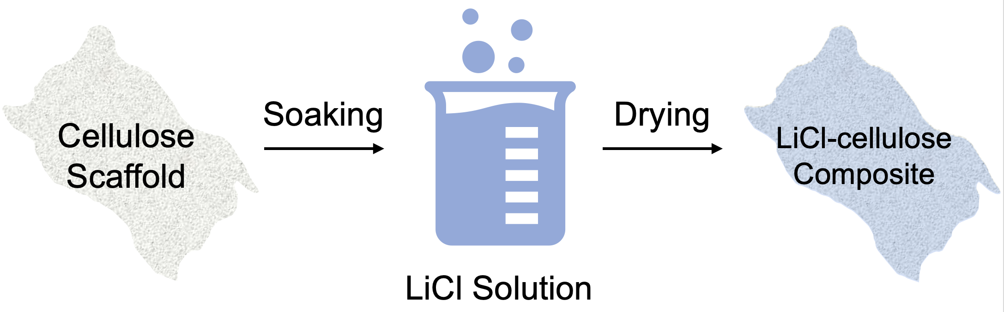
Fig. S1. Synthesis of LiCl-cellulose composite.

Morphological characterization of cellulose-based textile
Scanning Electron Microscopy (SEM, Quanta) and optical microscopy (OMAX, M837ZL-C180U3) was used to reveal the hierarchical fiber structures of the LiCl-cellulose composite (Fig.S2). Since non-woven cloth has strong mechanical strength and high-water adsorption capability, it is chosen to exemplify the cellulose-based textile and used as the scaffold.
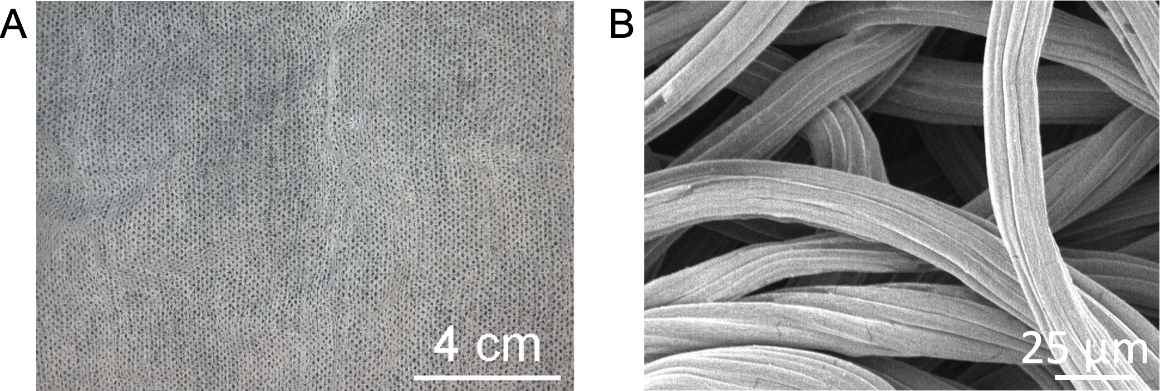
Fig. S2. (A) Photo images of LiCl-cellulose composite and (B) SEM images of sample fiber.
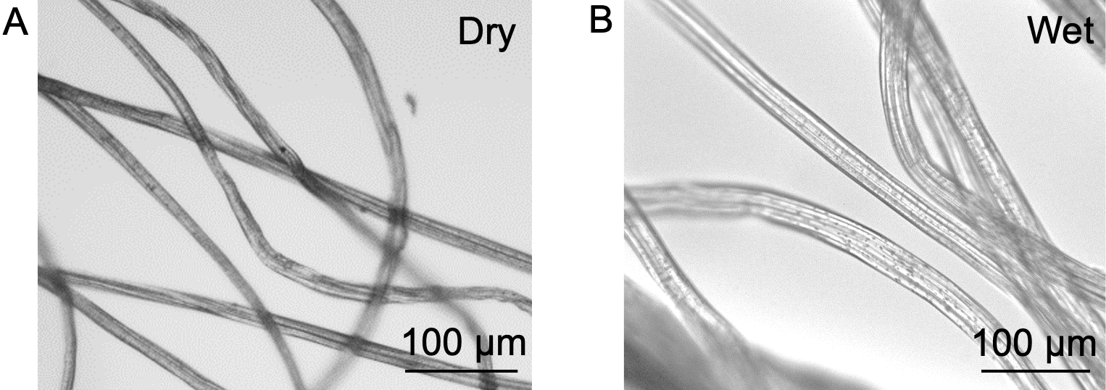
Fig. S3. (A) Optical microscopic images of dry and wet (at 167% water content) cellulose samples. (B) The microscale fibers appear more transparent when water occupies the porous space.
In Fig. S5, carbon and oxygen can be identified in the EDX mapping of the LiCl-cellulose composite since cellulose fibers are biopolymers. The mapped chlorine is mainly from LiCl coating on the fiber surface. Fig. S4 shows the SEM and EDX images of 50 wt% LiCl-cellulose composite. The LiCl leakage was found in the coating film. Higher LiCl content is desirable for the composite sorbent, while the risk of solution leakage may occur during the water sorption process. Thus, one of the challenges in making the stable composite is to choose the optimal LiCl content.
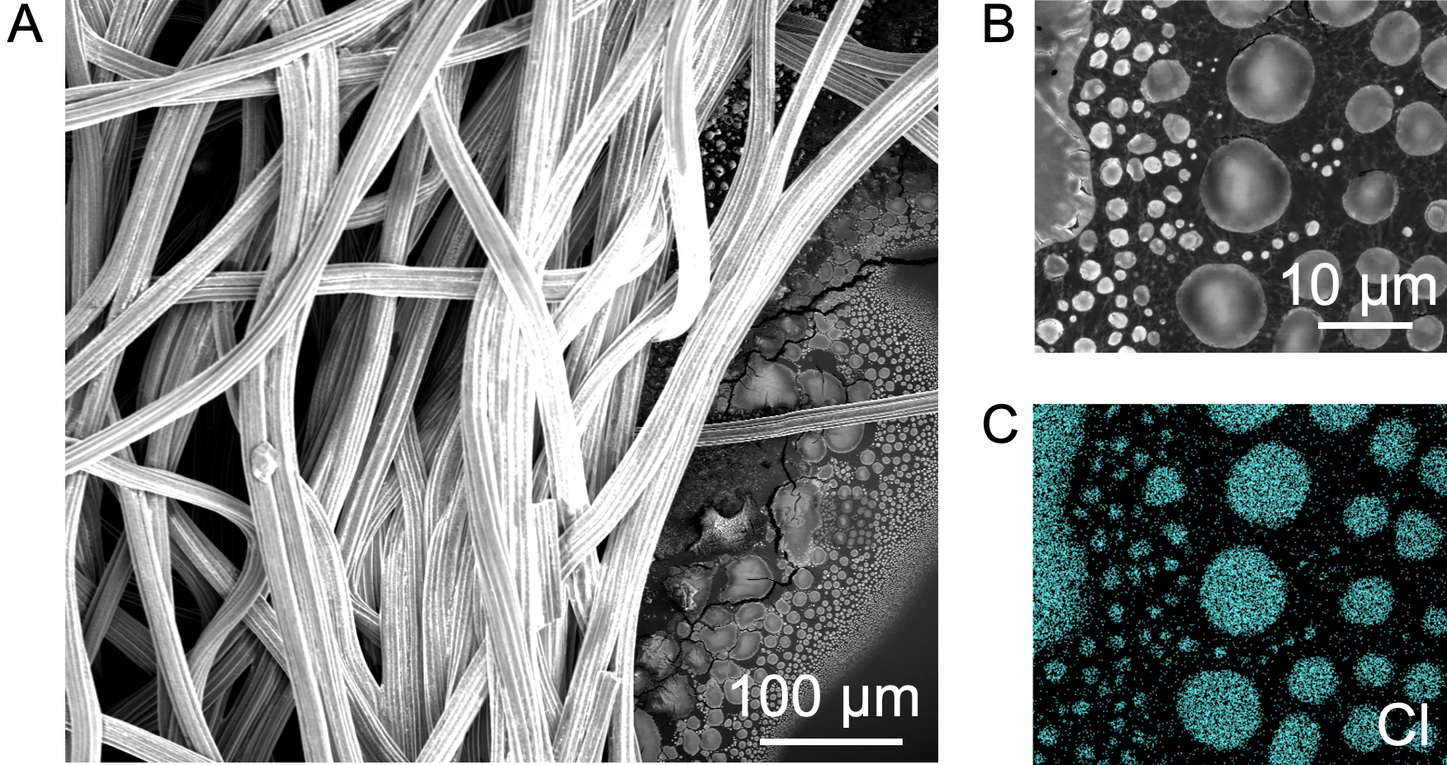
Fig. S4. (A) SEM of 50 wt% LiCl-cellulose composite with some leakage of LiCl. (B) Zoom-in SEM (B) and corresponding EDX mapping (C) of the leaked LiCl region.

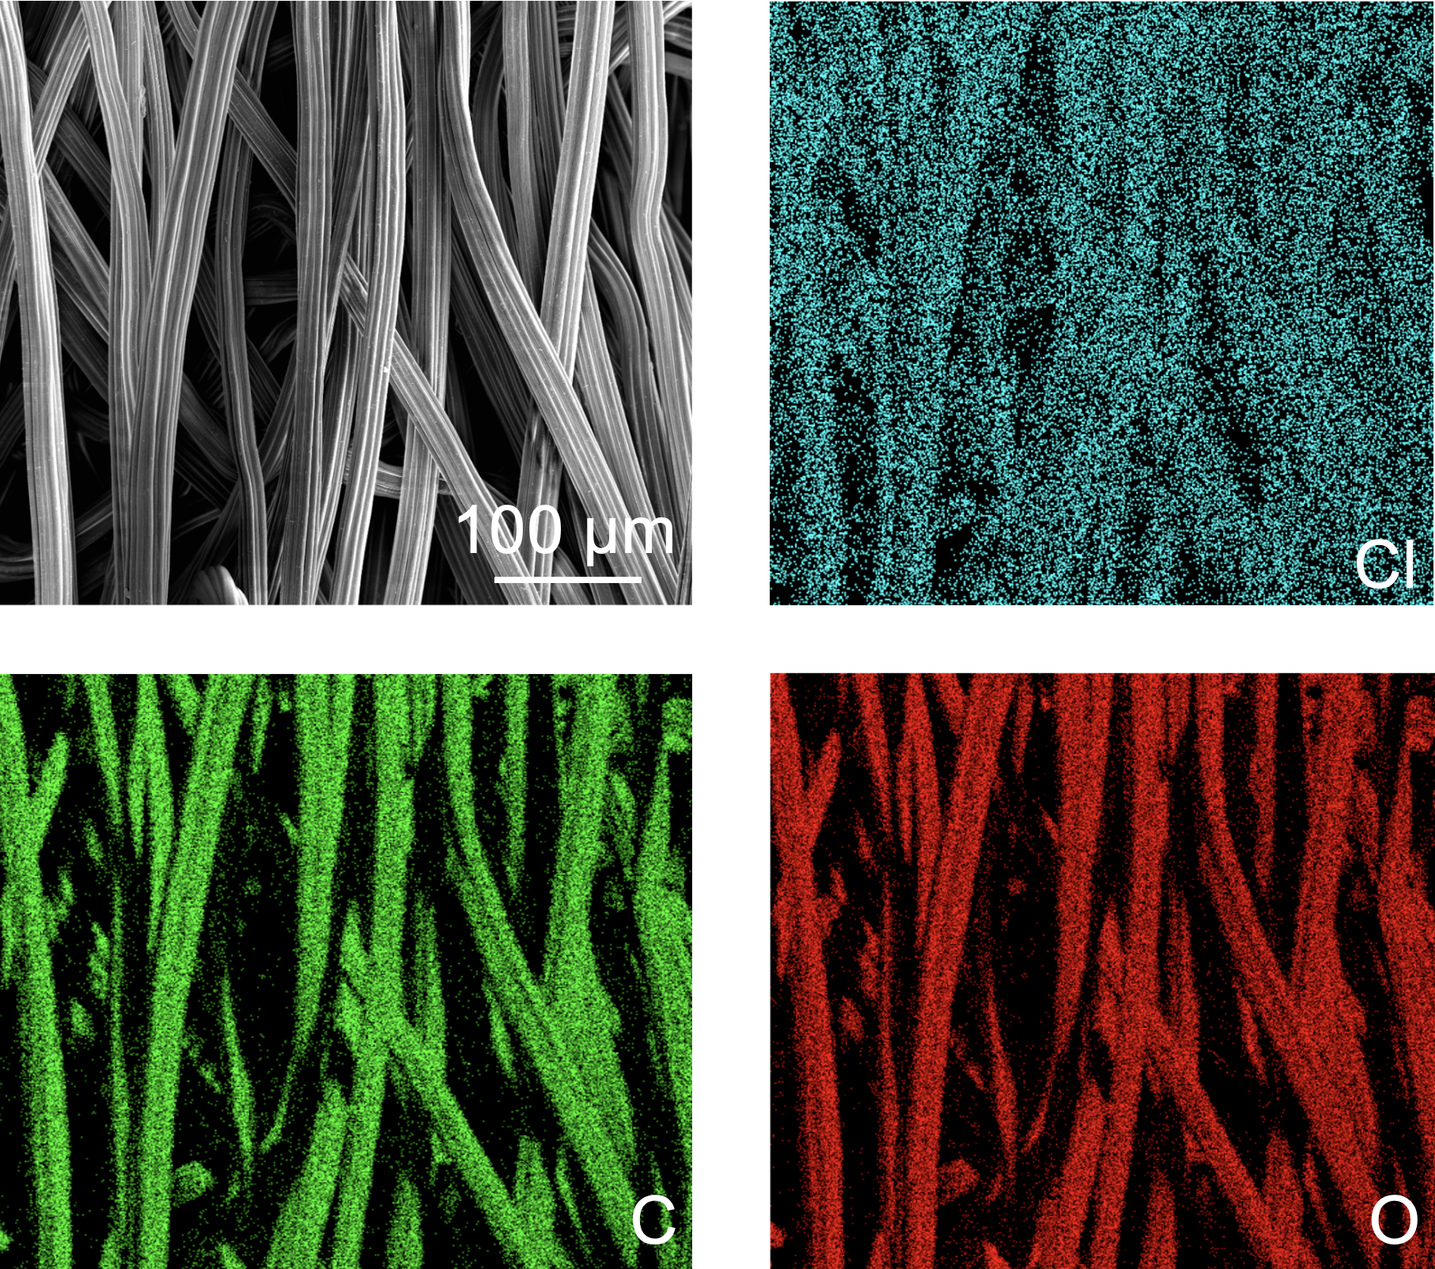
Fig. S5. SEM image and EDX mapping of LiCl-cellulose composite sample.

Optical characterization
By using a certified Spectralon diffuse reflectance standard, Perkin Elmer Lambda 950 UV-VIS-NIR spectrometer (± 0.02% uncertainty) with an integrating sphere, the total hemispheric transmittance and reflectance from 0.25-2.5 μm were measured. Additionally, a Nicolet iS50 FTIR spectrometer with a PIKE Technologies integrating sphere was used to measure the total hemispheric transmittance and reflectance between 3~20 μm with ± 0.5% uncertainty.
Kirchhoff’s law and the thermal equilibrium principle are used to derive the emissivity spectrum (Eq. S1).
(S1)
The transmittance of the LiCl-cellulose composite indicates 50.7% of solar radiation passes through the sample (Fig. S6), while the presence of water increases the transmittance of the LiCl-cellulose composite in the wet state by 13.5%. The other 45-47.1% of light is reflected by the dry cellulose scaffold and LiCl-cellulose composite (Fig. S7). The reflectance of the composite sample in the UV-VIS-NIR spectrum reduces to 17.3% when wet.
Fig. S6. Transmittance in the UV-VIS-NIR range and IR range for the cellulose scaffold and LiCl-cellulose composites.
Fig. S7. Reflectance in the UV-VIS-NIR range and IR range for the cellulose scaffold and LiCl-cellulose composites.

Theoretical cooling power estimation
The net cooling power (P_{net}) of the sample can be estimated from
P_{net} = P_{rad} – P_{conv} – P_{atm} (S2)
where,
P_{rad}: the power density of thermal radiation emitted by the sample,
P_{atm}: the power density of downward thermal radiation from the atmosphere,
P_{conv}: the effective power density loss including convection and conduction from the sample,
There is no power density of solar irradiation term as the experiments were done during the night. P_{rad} is the maximal cooling power available due to radiative cooling and can be derived from the emissivity spectrum of the sample by
(S3)
where I_{BB} is blackbody radiation intensity as a function of emitter temperature according to Planck’s law. P_{atm} can be calculated by the amount of power emitted from the atmosphere and absorbed by the sample where the atmospheric emissivity spectrum and the absorptivity spectrum of the cellulose sample are used (Eq. S4). The absorptivity spectrum of the sample equals the emissivity spectrum according to thermal equilibrium and Kirchhoff’s radiation law:
(S4)
where the angular part of the atmospheric emissivity can be obtained by (1) where τ(θ) is the angular atmospheric transmissivity.
The P_{conv} term of the top surface can be evaluated via the sample temperature, ambient temperature, and the effective heat transfer coefficient (Eq. S5):
P_{conv} = h(T-T_{amb}) (S5)
where h is the effective heat transfer coefficient and a common value of 15 W m⁻² K⁻¹ is used (2). The bottom surface of the sample was in contact with an insulated tabletop where its thickness is 35 mm.
Fig. S8. The theoretical calculated radiative cooling power of the LiCl-cellulose composite in wet and dry conditions and cellulose in dry conditions.

Field test experiments (water uptake and temperature measurement)
An insulated plastic table was used as a platform to support the samples with the length of 150 mm and the width of 130 mm. The sum of the dry mass of the cellulose scaffold and the LiCl powder is close to the dry mass of the LiCl-cellulose composite. The field tests were conducted during the winter and spring and the test location is 40.4237° N, 86.9212° W in West Lafayette, IN. To get the best radiative cooling effects and water uptake results, all of the field tests were done on selected days without or with few clouds. For each 2 hours, a balance with precision ±0.01 g was used to measure the mass of each sample. A local weather website provided the ambient conditions which were recorded as ambient temperature, relative humidity, wind speed, and dew point every 10 minutes during the field test. To reduce the convective heat loss, a windshield made of polyethylene foil was adopted. The ambient temperature was monitored by two thermocouples, while the sample temperature was monitored by two T-type thermocouples attached to the top surface of each sample.
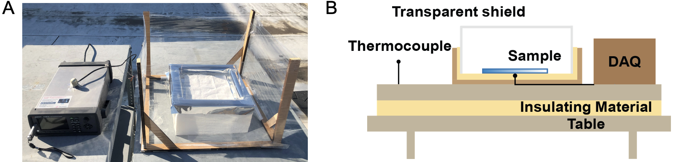
Fig. S9. (A) Photo of temperature measurement setup in daytime for demonstration. (B) Schematic of temperature measurement setup.

Field test experiments (cooling power measurement)
The cooling power measured in the field test was done by a feedback heater (a polyimide resistive heater) that locates under the sample and maintains at the ambient temperature (Fig. S10). A sample size of 50.8×50.8 mm was used. The power output of the heater will be the cooling power of the sample.
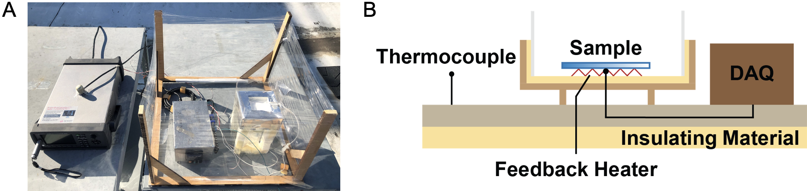
Fig. S10. (A) Photo of cooling power setup in daytime for demonstration. (B) Schematic of cooling power measurement setup.

Composite-water-energy interaction mechanism
The enhanced water capturing performance stems from four mechanisms: 1. Physisorption of cellulose; 2. Chemisorption of salt, forming salt hydrates; 3. Sorption of water vapor into salt solution (here called 1st condensation) if RH reaches the deliquescence point; 4. Condensation of water vapor due to vapor saturation (here called 2nd condensation).
The total water uptake m_{tot} is the sum of all four mechanisms:
(S6)
where ω_{i}, m_{i}(RH,T) are the mass ratio and water uptake of each mechanism, respectively. It is noted that the cellulose mass ratio is ω₁ = 1 – (ω₂ + ω₃ + ω_{intact_salt}). The value of m₄ can be very high because the saturation-induced condensation is only kinetically limited by the cooling power of the cellulose and the heat and mass transfer rate among sample, the air next to the sample, and the ambient environment.
The multiscale porous structure exposes a large surface area facilitating water harvesting kinetics. Given the thin thickness of the sample and fast sorption kinetics, the material system is assumed to be in equilibrium with the environment. It is also assumed that the air next to the sample has the same temperature as the sample, T_{s}.
Due to radiative cooling, the sample temperature is lower than the ambient temperature (T_{s} < T_{a}). Consequently, the saturation water vapor pressure near the sample is smaller than that of the ambient conditions, p_{s}*(T_{s}) < p_{a}*(T_{a}).
The water vapor pressure p_{wv} equals the product of RH and saturation vapor pressure p*:
(S7)
Therefore, the RH next to the sample is higher than that of the ambient RH, i.e. RH_{s} > RH_{a}.
For physisorption of cellulose (mechanism 1), we employ the Guggenheim-Anderson-de Boer (GAB) sorption model. The GAB model outperforms the BET model as it covers a wider water activity range (3). The GAB model successfully describes the sorption isotherm of cellulosic materials:
(S8)
where m is the moisture content (ratio of the mass of water to mass of dry material). The parameter a_{w} denotes the water activity or relative humidity. W₁ the moisture content corresponding to the monolayer on the whole free surface. C and K are related to temperature and the heat of adsorption (H) of the monolayer and intermediate layers, respectively. In general C and K should fulfill: 0 < K ≤ 1 and C > 0. For C ≥ 2, the sorption is of type II, i.e. with points of inflection (4).
(S9)
(S10)
Where H₁, H_{n}, and H_{L} are heat of sorption of the monolayer, multilayer, and latent heat, respectively. The H_{L} does not change much within the relevant temperature range. Therefore, a value of 2437 kJ mol⁻¹ is used here. Previous reports showed that H₁ – H_{n} ≈ 4.87 kJ mol⁻¹ (5). As multilayer adsorbed water resembles bulk liquid water, here we assume H_{n} ≈ H_{L} and therefore K ≈ K₀. The sorption isotherms of cellulose scaffolds are measured using a vapor sorption analyzer.
Table S1. GAB model parameters for textile samples.
Sample | W₁ | C | K
Cellulose scaffold 1 | 0.0666 | 9.8584 | 0.0080
Cellulose scaffold 2 | 0.0655 | 10.4217 | 0.0081
Cellulose scaffold 3 | 0.0692 | 9.5750 | 0.0076

It is noted that these values are very close to previous experimental reports of regenerated cellulose films, which had 0.0593, 11.00 and 0.88 for W₁, C and K, respectively (6).
The temperature effect can be manifested by the following figure, where lower temperature results in higher sorption amount m.
Fig. S11. Sorption isotherm of the average cellulose scaffold at different temperatures.
The LiCl salt adsorbs a large amount of moisture forming either hydrate or salt solution, as documented by the phase diagram of the LiCl-H₂O system (7) . The solubility boundaries define the conditions at which the crystals and solution co-exist. Above and below the solubility boundaries, the salt exists in solution and hydrate state, correspondingly. The salt hydrate under normal working conditions will be a mixture of LiCl, LiCl·H₂O and LiCl·2H₂O. Therefore, the moisture stored in the form of hydrate (mechanism 2) corresponds to a water uptake of 0.42 to 0.85. The water uptake of salt solution (mechanism 3) requires a rather complicated conversion from the phase diagram, as shown below.
The empirical formula of the solubility boundaries is:
(S11)
where θ and ξ are the reduced temperatures with respect to the critical temperature of water and the mass fraction of the salt in solution, respectively. is the critical temperature of water, i.e. 647.096 K.
Table S2. Parameters for solubility boundaries of LiCl.
 | ξ | A₀ | A₁ | A₂
Ice* | 0.000 ~ 0.253 | 0.422088 | -0.09041 | -2.93635
LiCl-5H₂O | 0.253 ~ 0.287 | -0.00534 | 2.01589 | -3.11459
LiCl-3H₂O | 0.287 ~ 0.369 | -0.56036 | 4.72308 | -5.81105
LiCl-2H₂O | 0.369 ~ 0.452 | -0.31522 | 2.88248 | -2.62433
LiCl-H₂O | 0.452 ~ 0.558 | -1.31231 | 6.17767 | -5.03479
LiCl | 0.558 ~ 1 | -1.3568 | 3.44854
*The ice line is θ = A₀ + A₁ξ + A₂ξ^{2.5}.
The relative vapor pressure π can be related to mass fraction of the salt in solution ξ using the following empirical formula:
(S12)
Where P_{solution}(ξ,T) and are the saturation pressure of salt solution and pure water. The empirical variables at the right-hand side of the equation are
f (ξ ,θ) = A + Bθ (S13)
where
(S14)
The corresponding parameters are given in Table S3.
Table S3. Empirical parameters for relative vapor pressure π as a function of mass fraction of the salt in solution ξ.
π₀ | π₁ | π₂ | π₃ | π₄ | π₅ | π₆ | π₇ | π₈ | π₉
0.28 | 4.30 | 0.60 | 0.21 | 5.10 | 0.49 | 0.362 | -4.75 | -0.40 | 0.03
Note that moisture content m and salt mass fraction ξ relate to each other by .
Using the equations above, the sorption isotherm of salt solution at different temperatures can be obtained, as shown in the figure below using 290 K and 300 K as examples.
Fig. S12. Sorption isotherm of LiCl solution at different temperatures.
It is evident that lower temperature facilitates water sorption. The theoretical limit of LiCl sorption can be more than ten times of its dry mass.
To validate the modeling, the sorption isotherms of the composites are measured (sample and ambient temperature both at 298 K, i.e. without radiative cooling). The model agrees with the DVS measurement. The deliquescence RH is set to be 11 %. The mass weight ratios of the mechanisms are summarized in Table S4.
Table S4. Mass weight ratio of water harvesting mechanisms.
LiCl-cellulose composite | ω₁ | ω₂ | ω₃ | ω_{intact_salt}
30 wt% | 0.7 | 0.2 to 0.02 | 0.01 to 0.24 | 0.09 to 0.04
20 wt% | 0.8 | 0.1 to 0.02 | 0.01 to 0.17 | 0.09 to 0.01
10 wt% | 0.9 | 0.08 to 0.001 | 0.01 to 0.099 | 0.01 to 0

Fig. S13. Sorption isotherm of LiCl-cellulose composite sample at T_{a}=T_{s}=298 K.
For the radiative cooling case, sample and ambient temperature are 292 K and 298 K, respectively. For ambient RH_{a} < 65%, i.e. RH_{s} < 100%, the water harvest is controlled by the first three mechanisms. The mass weight ratios of the three mechanisms are summarized in Table S5. For RH_{a} > 65%, the 2nd water condensation starts which is controlled by the cooling power. The m₄ is estimated to be a linear function of time because the cooling power is constant. It is also noted that, with higher salt content, the chemical potential gradient between the system and air is larger, and consequently the composite harvests water faster.
Table S5. Mass weight ratio of water harvesting mechanisms.
LiCl-cellulose composite | ω₁ | ω₂ | ω₃ | ω_{intact_salt} | dm₄/dRH
35 wt% | 0.65 | 0 | 0.25 to 0.35 | 0.1 to 0 | 42
25 wt% | 0.75 | 0 | 0.1 to 0.25 | 0.25 to 0 | 40
10 wt% | 0.9 | 0 | 0.09 to 0.1 | 0.01 to 0 | 35

Lab-test experiments (water uptake measurement)
The analogical experiments were conducted in an environmental chamber (ESPEC test chamber) with controlled temperature and relative humidity. A Laird thermoelectric (TE) device of 52×52 mm was used to simulate the radiative cooling effects by providing effective cooling to the composite. The TE module was used to maintain the composite temperature at 6 and 9 °C below the chamber temperature according to the results in the field tests shown in Fig. 3C. A 50×50 mm LiCl-cellulose composite sample (10, 20, or 30 wt% LiCl) was cropped and tested under 30%, 50%, 70%, and 90% RH at 25 °C ambient temperature, which covered most outdoor conditions. The LiCl-cellulose composite was weighed on a balance with a precision of ±0.01 g after a 2-hour water adsorption. The water uptakes were calculated based on the initial and final mass.
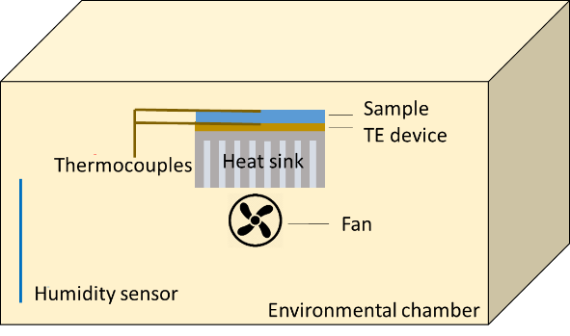
Fig. S14. Schematic of water uptake characterization in an environmental chamber.
Fig. S15 shows the water uptake profiles between 30-70% RH of the 10-30 wt% LiCl-cellulose samples with a constant 9 °C below the ambient temperature. The water uptake profile is overall higher as the radiative cooling effect enhances, which can be achieved by reducing the convection loss or adding an IR emissive substrate underneath that further maintains a lower sample surface temperature.
Fig. S15. Water uptake of LiCl-cellulose composite (10, 20, 30 wt%) under different RH with a 9 °C surface temperature drop.

Required humidity for water uptake.
The mechanism of water uptake is controlled by the LiCl loading and sub-ambient cooling relative to the dew-point temperature. In conditions where the surface temperature is above the dew-point temperature, the water uptake mechanism is dominated by adsorption into the LiCl-cellulose composite. The LiCl concentration largely controls the water uptake in the adsorption regime, while the temperature has only a small effect on the overall driving force. This effect can be described by the Polyani adsorption potential theory (8) at chemical equilibrium and is discussed further in methods (below). In conditions where the surface temperature is below the dew-point temperature, water is condensed by a cooling or “dewing” process.
Cooling-driven water uptake is primarily enhanced by the temperature difference between surface and the dewpoint temperature and the heat transfer coefficient. The heat transfer coefficient many depend on the fluid conductivity, enthalpy of vaporization, as well as geometric factors such as the surface energy (9). The cellulose loading refers to the amount mass of LiCl relative to the dry mass of the composite. The activity of water is a function of absolute temperature and salt concentration, as shown in section 3: Vapor Pressure, of Ref. (7). The ambient water vapor activity can be estimated as a function of the activity of water in the sorbent and the temperature ratio between the surface and the air
(S15)
The relationship above only considers the chemical potential for adsorption of a single component when sub-dewpoint condensation is not present. When dewing occurs, the total uptake of water is the combination of adsorption and cooling condensation.

Field test of radiative cooling effect
For the comparison of the significance of radiative cooling, the field test started at 12:31 AM and ended at 9:10 AM. A comparative field test was conducted to justify the radiative cooling effect on the AWH performance. A 30 wt% LiCl-cellulose composite sample was divided into two pieces. One piece is exposed to the sky (with radiative cooling) and the other is shielded by suspended cardboard that cut off the pathway of radiative cooling (Fig. S16). The 47.5% improvement of the water uptake profile by the radiative cooling further verifies the significance of removing heat for AWH (Fig. S17).
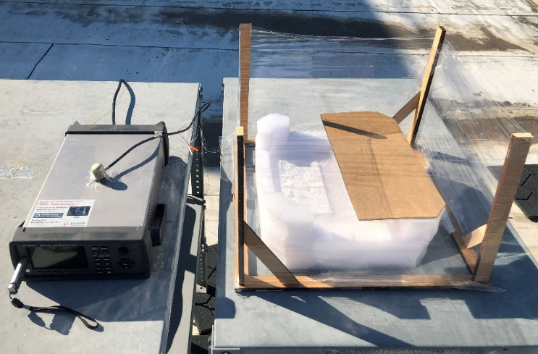
Fig. S16. The experimental setup of field test with and without radiative cooling effects.
Fig. S17. Water uptake in a field test with and without radiative cooling effects.

Sorption isotherm
DDI measurement
The sorption isotherms of LiCl-cellulose composite are characterized by the Vapor Sorption Analyzer (VSA). The equipment utilizes the Dynamic Dewpoint Isotherm (DDI) method for faster and robust data collections. The traditional dynamic vapor sorption (DVS) method is dependent on the moisture-sample equilibrium that requires the sample to stay at a preset RH for a preset time or until the sample weight change is within tolerance, which may take an infinitely long time. In practice, days and weeks are spent to ensure the equilibrium at each step of RH increment while reducing the time and speeding up may sacrifice measurement accuracy (10). In contrast, DDI measures the RH (with chilled mirror dewpoint sensor) and sample weight simultaneously. The RH in the sample chamber is always changing, thus the process is dynamic and has no dependence on the moisture-sample equilibrium (11). The DDI isotherm better resembles reality as the samples will be exposed to constantly changing ambient conditions. The results obtained by DDI will be similar to results from the DVS for the samples tested in this work as both cellulose and LiCl have fast vapor diffusion that allows moisture to penetrate the samples.
During the pre-test, the samples (~0.5 g) are maintained at below 5% RH for 6-14 hours before the measurement starts to remove excessive absorbed water in the samples. The weight at the end of the pre-test is regarded as the reference for water uptake calculation. At constant 25 °C, the RH is monitored when it rises from 5% to 90% dynamically and the sample weight is recorded by the internal high-precision balance. The water uptake vs. RH for 10-30 wt% LiCl-cellulose composite samples are plotted in Fig. S18.
Fig. S18. Water uptake vs. RH at 25 °C for 10, 20, 30 wt% LiCl-cellulose composites in a DDI method.
SPS measurement
The DVS method is useful to provide information on water absorption as a function of time under any specified RH and temperature. To analyze the material synergistic effect without radiative cooling, the cellulose, LiCl and LiCl-cellulose composite is tested simultaneously by the Projekt Messtechnik SPS moisture sorption analyzer. Similarly, all samples (each specimen is ~ 0.5 g) are kept at 0% RH for 24 hours to remove adsorbed/absorbed water from the samples and obtain the dry weight. Then, the samples are subject to 24-hour 30% RH and 24-hour 70% RH, all at a constant 25 °C. The two test conditions are selected to represent the lower and higher end of the operating condition for AWH. Measurement of the sample weights occurs every 15 minutes and each test condition is held 24 hours to ensure reaching equilibrium. The derivative of the curves in Fig. S19 gives the rate of the change of the water uptake in Fig. 4F.
Fig. S19. Water uptake of cellulose scaffold, LiCl powder, and LiCl-cellulose composite in the DVS at increasing 0% RH, 30% RH, and 70% RH conditions (24 hours each at 25 °C).

True density measurement
The true density of the LiCl-cellulose composite is measured by a gas displacement pycnometer (Micromeritics AccuPyc II 1340). The sample is sealed in a 3.5 cm³ instrument compartment. Helium gas is expanded into the compartment and rapidly fills pore volume including all the open and closed pores. The equilibrium pressures of filling the sample chamber and discharging into a second empty chamber allow the computation of the sample solid phase volume. The true density is then the sample mass divided by its solid phase volume.
Three LiCl-cellulose composite samples of different LiCl loadings are prepared using the dip coating. A pure nonwoven cloth sample is prepared to represent 0 wt% cases. All samples are cropped into small pieces of ~ 0.5x0.5 cm². Each sample of ~ 0.125 g is measured fives time and the result is summarized in Fig. S20. The dashed line is calculated based on the rule of mixture, i.e. ρ_{compsoite} = wt%_{cellulose} ρ_{cellulose} + wt%_{LiCl} ρ_{LiCl}, as a reference. The true density increases proportionally with the increase of LiCl mass fraction, and the trend well matches the rule of mixture. The measured true densities are used in specific surface characterization in the following section.
Fig. S20. The true density of LiCl-cellulose composite as a function of LiCl mass fraction. The dashed line is a reference obtained by the rule of mixture.

BET equivalent specific surface area and porosity
The specific surface area is characterized by gas adsorption with Micromeritics TriStar II 3020 to illustrate the impact of the additional LiCl on the effective sorption surface area. The principle of the instrument is by measuring the sorption isotherm of the material, various theories and models can be applied and fitted to generate specific surface area and porosity based on the amount of gas adsorbed on the specific surface. The samples are cooled to the boiling point (77.3 K) of the adsorbate (N₂) to ensure enough adsorption.
The pure nonwoven cloth and 24% LiCl-cellulose composite samples are loaded into 3/8 inches tubes to 0.25 ~ 0.4 g. The degassing process is kept at 90 ℃ for 13 hours to remove natively adsorbed water molecules. The sample mass is recorded with an accuracy of 0.0001g. After the tube is installed and sealed onto the instrument, the samples undergo another degassing and vacuum. The data points are taken for P/P₀ from 0.001 to 0.3 in a geometric series favoring the lower end of the relative pressure. The quantity of Nitrogen adsorption on the sample surface is recorded as the relative pressure ramps.
The Brunauer-Emmett-Teller (BET) method fits data in the range of 0.05-0.35 relative pressure, and the slope and intercept of fitting provide the amount of monolayer N₂ adsorption to derive the BET equivalent specific surface area. Therefore, the results are dependent on the data being fitted. The key criteria of data selection are intercept being greater than zero and the correlation coefficient R² being better than 0.999 for a valid BET fitting.

Desorption by solar heating
Fig. S21 shows the solar-assisted water harvesting device. As soon as the device is exposed to the sun, water extraction starts, and the condensed water vapor can be seen on the transparent wall. After 10 minutes, the condensed water accumulates and flows down for collection.
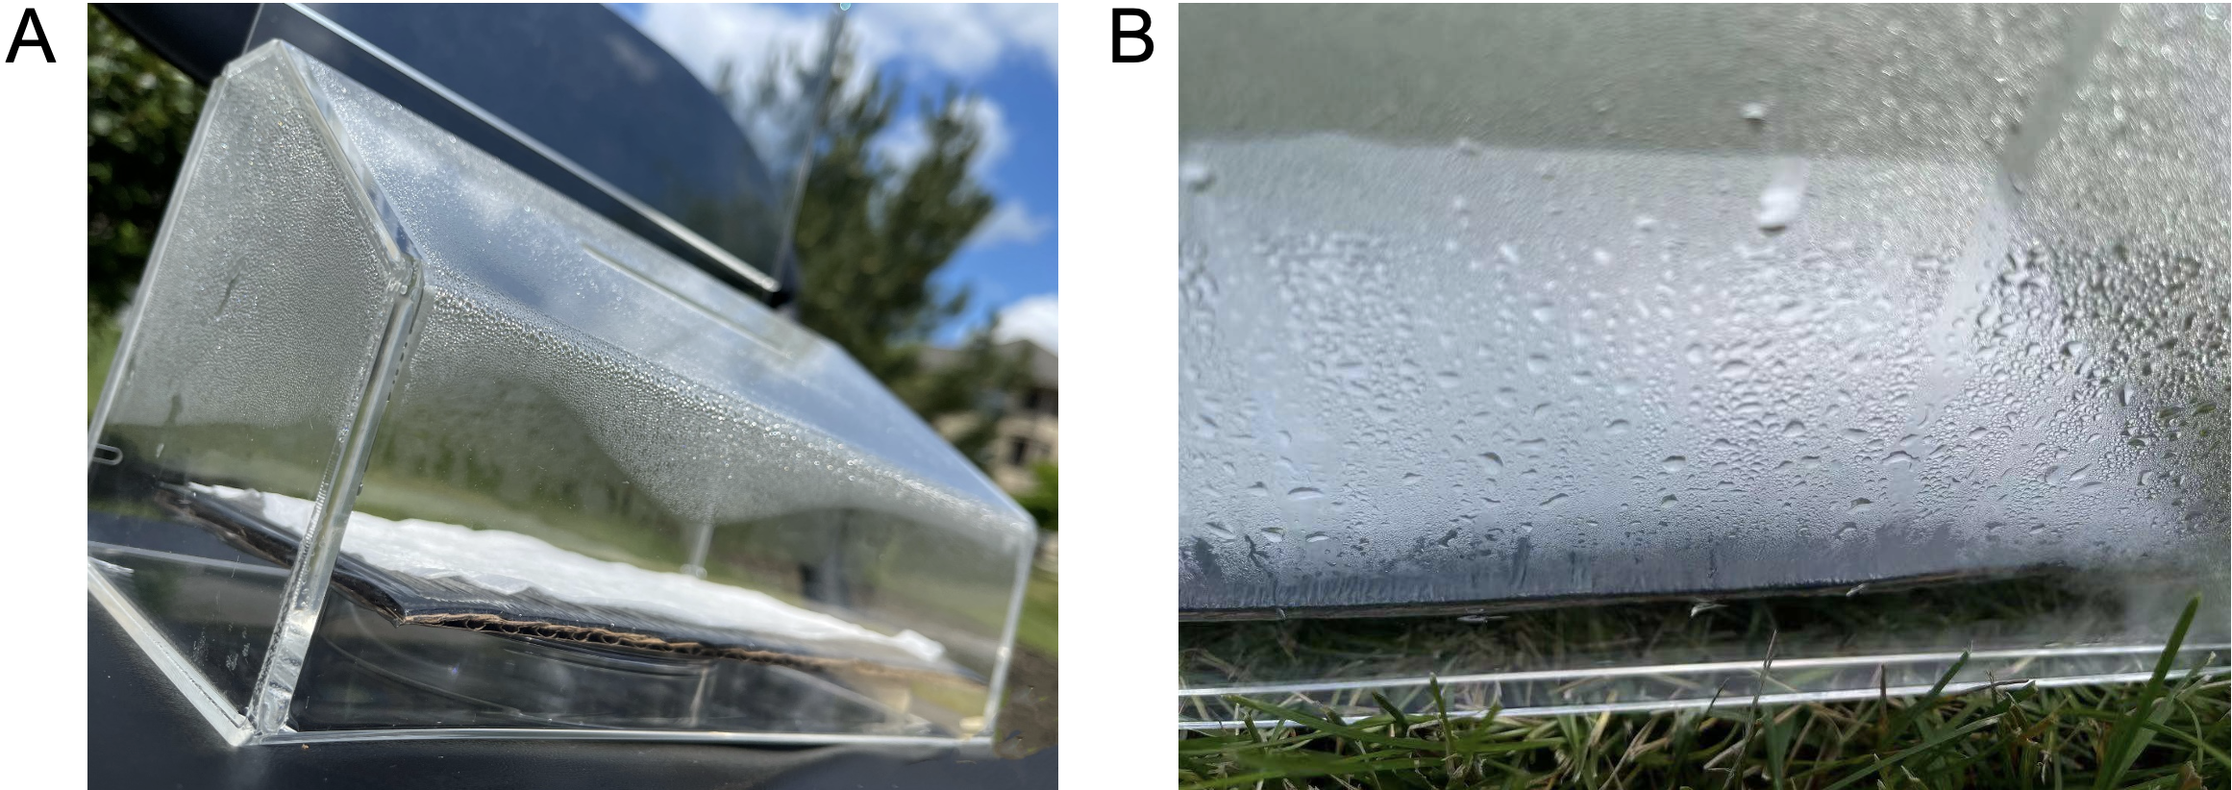
Fig. S21. Water extraction by solar-driven vapor generation (A) after 1 min, (B) after 10 min.

Water quality test
Water quality is crucial for the development of atmospheric water harvesting. The water extracted from the outdoor test was measured by ion conductivity to verify the water purification (a higher ion resistance demonstrated a high purity of the collected water). Fig. S22 shows the electrical resistance of water and the standard 18 MΩ purified water. Compared to the tap water, the water collected by the LiCl-cellulose composite has a 29% higher resistance. The precipitation droplets are made from nucleating around floating particles. Thus, rainwater presents the lowest ionic resistance. The comparable resistances to the highly purified standard 18 MΩ water indicate the cellulose material’s capability of generating safe and clean water regardless of the ambient air quality.
Fig. S22. Water quality test of collected water.

Lab-test experiments (desorption by solar heating)
Desorption kinetics and energy are also key factors that affect the ultimate performance of the AWH material in terms of water production.
The desorption process in the lab is simulated by a solar simulator with Xenon Arc Lamp (UXL-150, Newport 67005). After the adsorption process in the environmental chamber, the sorbent is transferred to a petri dish with the bottom covered by a dark substrate. The solar simulator emits 1 sun of irradiation, and the dark substrate absorbs the sunlight and generates heat and facilitates the removal of the moisture from the soaked sorbent. The mass of the sorbent is measured at a time interval between 5-15 minutes and the corresponding water uptake of the sorbent is shown in Fig. S23.
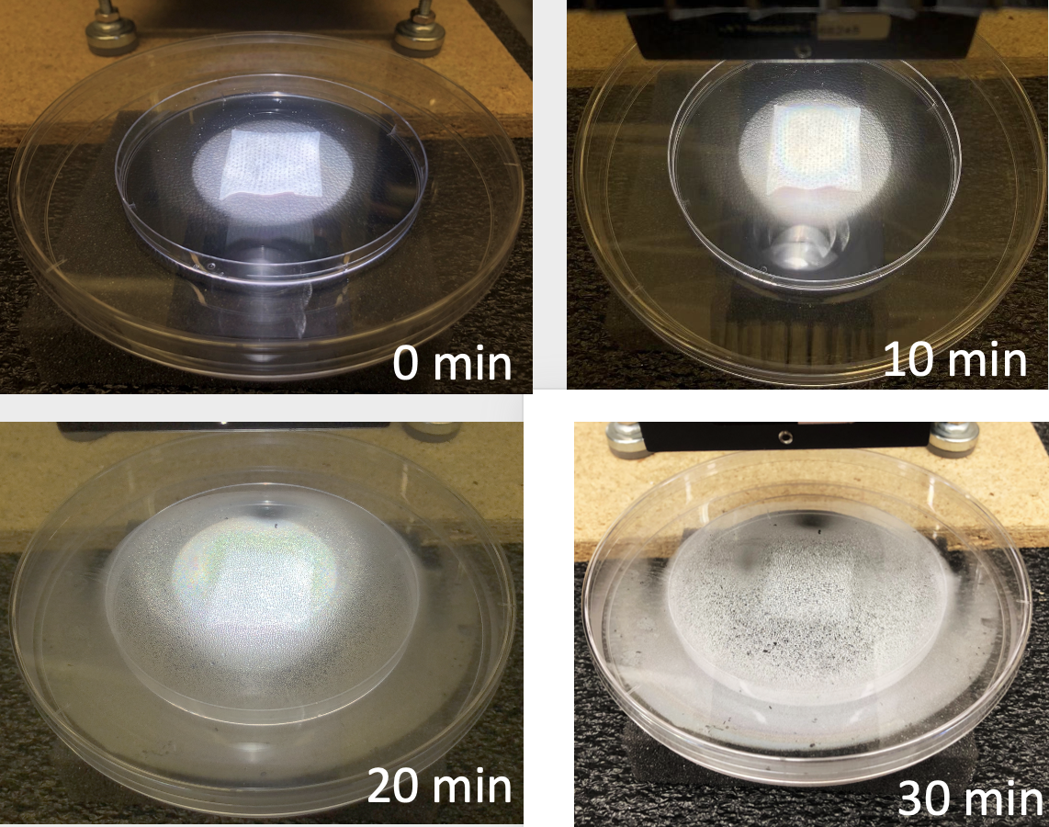
Fig. S23. Desorption process by solar heating under 1 sun.
The LiCl-cellulose composites with 30 wt% LiCl loading undergo water adsorption at 30-90% RH for 2 hours in the controlled chamber (dT = 9 °C) and then are exposed to 1 sun irradiation with a black substrate to determine the time required for the composite to desorb the water. Fig. S24 shows the water uptake profile during the desorption process for 30-90% RH.
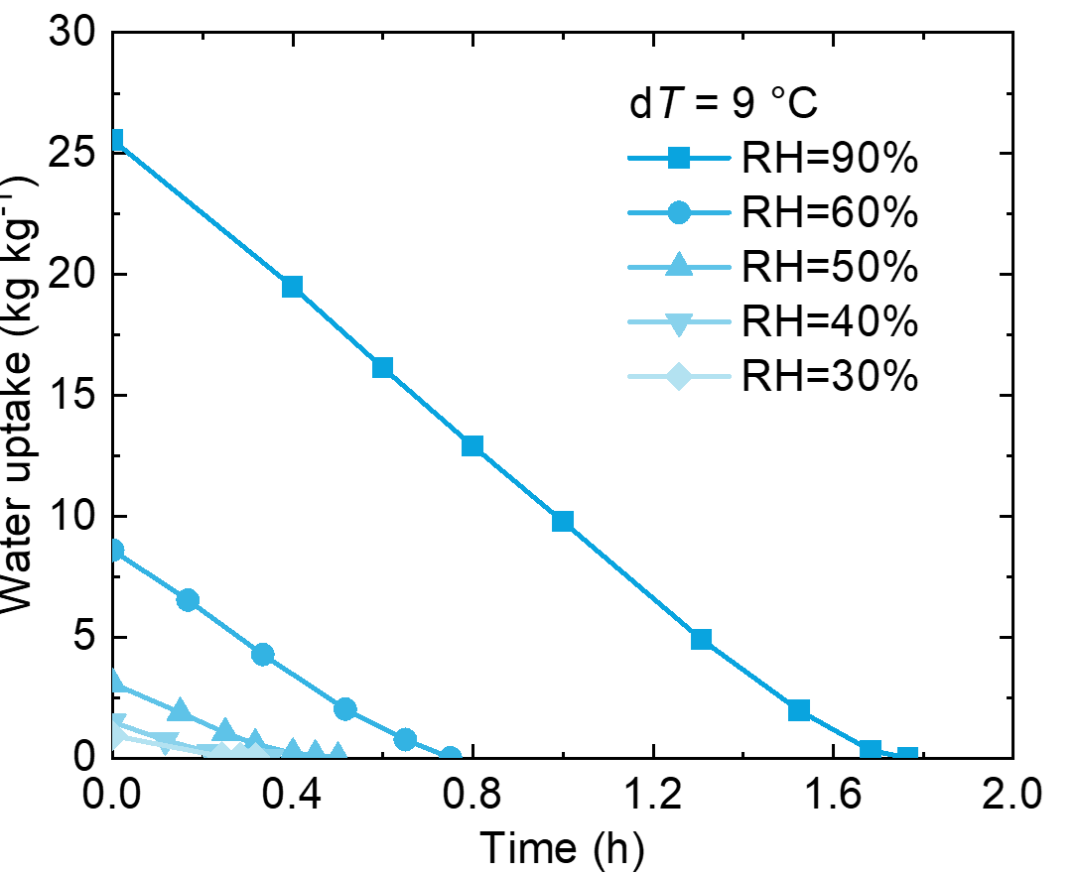
Fig. S24. Desorption process by 1 sun under different RH with 9 °C surface temperatures drop.
Alternatively, desorption can also be achieved by an active heat source. Here, we used a hotplate at 80 °C to release the absorbed water and compared the desorption kinetics between the LiCl-cellulose composite and LiCl powders. The two samples start with the same amount of absorbed water. The mass of each sample was recorded every ~10 minutes. The 24-hour water production curves are also estimated for comparison (Fig. S25).
The desorption rate by solar lamp at 1 sun is faster compared to the continuous water production by the hotplate. This is due to the direct heating by solar heating.
Fig. S25. Comparison of water production by solar lamp at 1 sun and hot plate.

Global water production estimation
The hourly relative humidity data for the year 2020 was collected from the National Centers for Environmental Prediction (NCEP). A RH data point for each day is represented by the relative humidity at 12 AM of that day. A linear interpolation of the 24 hours multicycle water collection rate for dT=9 °C between RH of 30-90% can be used to directly predict the maximum possible daily water collection as:
(S16)
Where RH is plugged in as percentage and M means the daily water collection rate in the unit of L kg⁻¹ day⁻¹.

Mechanical strain-stress curves
The MTS Criterion® Series 40 Electromechanical Universal Test Systems is used as a tensile meter to measure the mechanical tensile strength and toughness of the cellulose samples. The LiCl-cellulose composite and cellulose in both wet and dry states are cut into slices of 1x5 cm size.
A parallel load to the sample’s plane direction was applied, while the elongation was recorded at the same time during the test. The load over the cross-sectional area of each sample slice was used to calculate the nominal tensile stress. For each slide, optical microscopy was used to get the average width and the thickness to calculate the cross-sectional area. The displacement over the original length of the sample slice’s elongated part was used to calculate the strain. The maximum value of the strain-stress curve is considered as the strength. The average strength of three samples was calculated, and half of the data range of the sample strength is used to represent the uncertainties.
Representative strain-stress curves are plotted in Fig. S26A for LiCl-cellulose composite and cellulose in both wet and dry conditions. The wet samples have lower strength, but a better ultimate strain compared to the dry samples as the absorbed water plasticizes the sample. The addition of LiCl to the cellulose sample leads to higher strength in the dry state while yielding similar strength in the wet state.
The LiCl-cellulose composite exhibits higher mechanical strength than the cellulose scaffold in the dry condition in Fig. S6B, attributed to the fiber’s aggregation after the soaking and drying process, while the difference between their mechanical strengths is hardly observed in the wet condition.
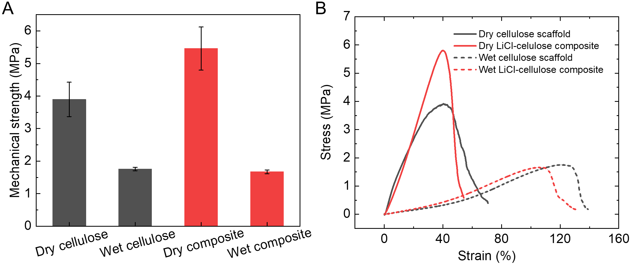
Fig. S26. (A) Strain-stress curves of LiCl-cellulose composite and cellulose scaffold in both wet and dry conditions. The uncertainty of each test was caused by the sample variances of dimensions and random errors during the mechanical tests. (B) Tensile strength of cellulose scaffold and LiCl-cellulose composite samples in the dry and wet states.

Reference
1. A. V. Tikhonravov, M. K. Trubetskov, G. W. DeBell, Application of the needle optimization technique to the design of optical coatings. Applied optics 35, 5493-5508 (1996).
2. C. Liu, J. Fan, H. Bao, Hydrophilic radiative cooler for direct water condensation in humid weather. Solar Energy Materials and Solar Cells 216, 110700 (2020).
3. E. O. Timmermann, Multilayer sorption parameters: BET or GAB values? Colloids and Surfaces A: Physicochemical and Engineering Aspects 220, 235-260 (2003).
4. J. Blahovec, Sorption isotherms in materials of biological origin mathematical and physical approach. Journal of Food Engineering 65, 489-495 (2004).
5. Y. B. Grunin, L. Y. Grunin, V. Y. Schiraya, M. S. Ivanova, D. S. Masas, Cellulose–water system’s state analysis by proton nuclear magnetic resonance and sorption measurements. Bioresources and Bioprocessing 7, 1-11 (2020).
6. P. Cazón, M. Vázquez, G. Velázquez, Regenerated cellulose films with chitosan and polyvinyl alcohol: Effect of the moisture content on the barrier, mechanical and optical properties. Carbohydrate polymers 236, 116031 (2020).
7. M. R. Conde, Properties of aqueous solutions of lithium and calcium chlorides: formulations for use in air conditioning equipment design. International Journal of Thermal Sciences 43, 367-382 (2004).
8. M. Dubinin, V. Astakhov. (ACS Publications, 1971).
9. S. Zheng, F. Eimann, C. Philipp, T. Fieback, U. Gross, Modeling of heat and mass transfer for dropwise condensation of moist air and the experimental validation. International Journal of Heat and Mass Transfer 120, 879-894 (2018).
10. B. Carter, A. Fontana, Dynamic dewpoint isotherm verses other moisture sorption isotherm methods. Application note. Decagon Devices, Pullman, WA 210, (2008).
11. S. J. Schmidt, J. W. Lee, Comparison between water vapor sorption isotherms obtained using the new dynamic dewpoint isotherm method and those obtained using the standard saturated salt slurry method. International Journal of Food Properties 15, 236-248 (2012).

