Supporting information for
The genome of rice planthopper egg parasitoid wasps Anagrus nilaparvatae (Hymenoptera: Mymaridae) casts light on the chemo- and mechano-sensing in parasitism

Ying Ma^{1, 2, *}, Zixiao Guo^{1, *}, Liyang Wang¹, Bingyang Wang ¹, Tingfa Huang ¹, Bingjie Tang ¹, Guren Zhang¹ and Qiang Zhou ¹
¹State Key Laboratory for Biocontrol, School of Life Sciences, Sun Yat-Sen University, Guangzhou 510275, China
²School of Agriculture, Sun Yat-Sen University, Guangzhou 510275, China
*These authors contributed equally to this work.
Correspondence: Qiang Zhou, State Key Laboratory for Biocontrol, School of Life Sciences, Sun Yat-Sen University, lsszhou@mail.sysu.edu.cn

This file contains:
Supplementary tables S1-S5
Supplementary figures S1-S13

Table S1 Statistics of PacBio SMRT sequencing data
Statistics | Anagrus nilaparvatae
Reads number | 1,646,365
Average reads length | 14,962 bp
Total bases | 24,632,913,130 bp
Average coverage | 55X

Table S2 Statistics of Illumina sequence data
Statistics | Anagrus nilaparvatae
Total reads | 140,760,170* 2
Read length | 150 bp
PE insert length | 350 bp
Total bases | 42,228,051,000 bp
Q20 (%) | 98.97%
Average coverage | 95X

Table S3 Results of the BUSCO assessment
Statistics | Number | Percentage (%)
Complete BUSCOs | 251 | 98.4
Complete and single-copy BUSCOs | 227 | 89.0
Complete and duplicated BUSCOs | 24 | 9.4
Fragmented BUSCOs | 3 | 1.2
Missing BUSCOs | 1 | 0.4
Total BUSCO groups searched | 255 | 100

Table S4 Classification of repeat sequences
Repeat elements | Number of elements | Length occupied (bp) | Percentage of  sequence (%)
Retroelements | 86998 | 49014319 | 9.22
SINEs | 129 | 6750 | 0.00
Penelope | 11867 | 4468853 | 0.84
LINEs | 57495 | 29825704 | 5.61
CRE/SLACS | 5 | 264 | 0.00
L2/CR1/Rex | 24372 | 9914426 | 1.86
R1/LOA/Jockey | 14786 | 12985460 | 2.44
R2/R4/NeSL | 1014 | 598445 | 0.11
RTE/Bov-B | 1936 | 1037724 | 0.20
L1/CIN4 | 1067 | 67945 | 0.01
LTR elements | 29374 | 19181865 | 3.61
BEL/Pao | 6697 | 5358154 | 1.01
Ty1/Copia | 4130 | 2923534 | 0.55
Gypsy/DIRS1 | 14307 | 9951981 | 1.87
Retroviral | 1301 | 56557 | 0.01
DNA transposons | 48636 | 12220847 | 2.30
hobo-Activator | 5648 | 651025 | 0.12
Tc1-IS630-Pogo | 4744 | 1044023 | 0.20
En-Spm | 0 | 0 | 0.00
MuDR-IS905 | 0 | 0 | 0.00
PiggyBac | 815 | 231430 | 0.04
Tourist/Harbinger | 1946 | 187788 | 0.04
Other (Mirage,P-element, Transib) | 1054 | 95250 | 0.02
Rolling-circles | 4219 | 1937665 | 0.36
Unclassified | 809243 | 217818304 | 40.97
Total interspersed repeats |  | 279053470 | 52.48
Small RNA | 1 | 138 | 0.00
Simple repeats | 1107 | 221550 | 0.04
Low complexity | 273 | 52492 | 0.01
Satellites | 1204 | 105787 | 0.02
Total tandem repeats |  | 379967 | 0.07
Bases masked |  | 281371102 | 52.92

Table S5 Functional annotation of Anagrus nilaparvatae genome.
Database | Gene number
Nr | 19088
GO | 12007
KOG | 16894
Kegg | 13079
Swissprot | 12805

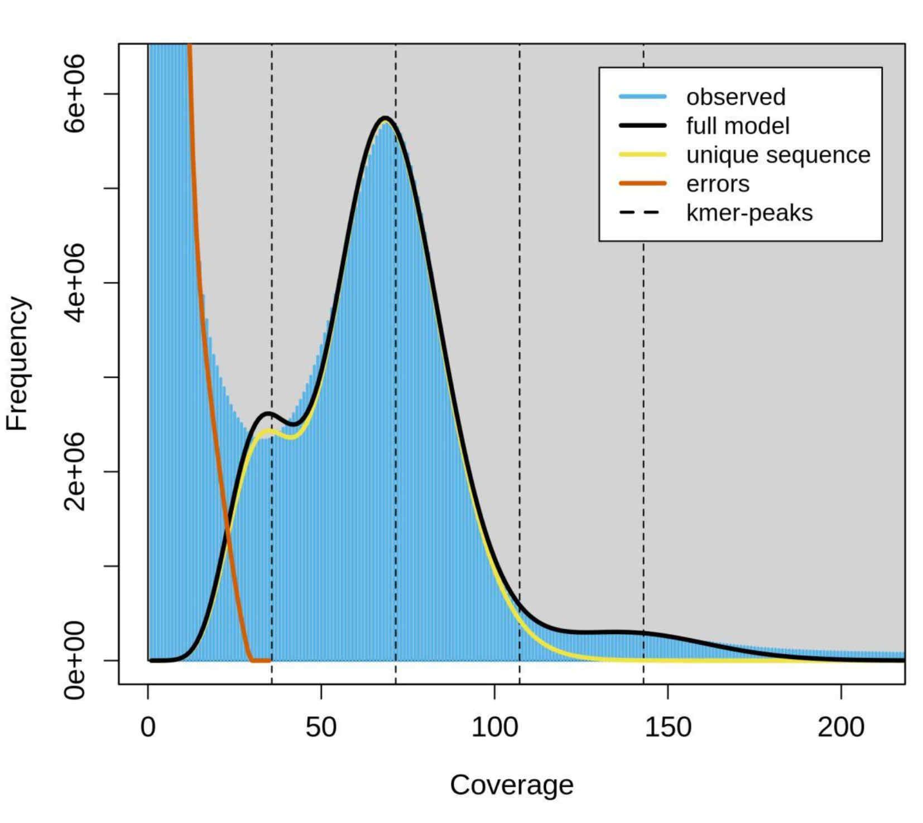
Fig. S1 Kmer Distribution of Anagrus nilaparvatae genome. The peak at ~40 corresponds to heterozygous sites, the peak at ~70 is the main peak, and the peak at ~140 corresponds to repeat sequences. protrusion at 1/2 position in front of the main peak is heterozygous peak, and the protrusion at 2 times after the main peak is the repetitive sequence peak. The analysis of the A. nilaparvatae genome sequencing data using 17-mer shows that the main peak corresponds to a depth of 70.

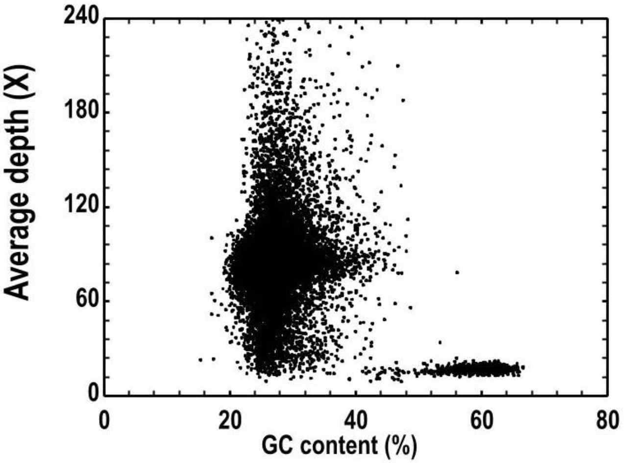

Fig. S2 GC-depth scatter map of the Anagrus nilaparvatae genome.

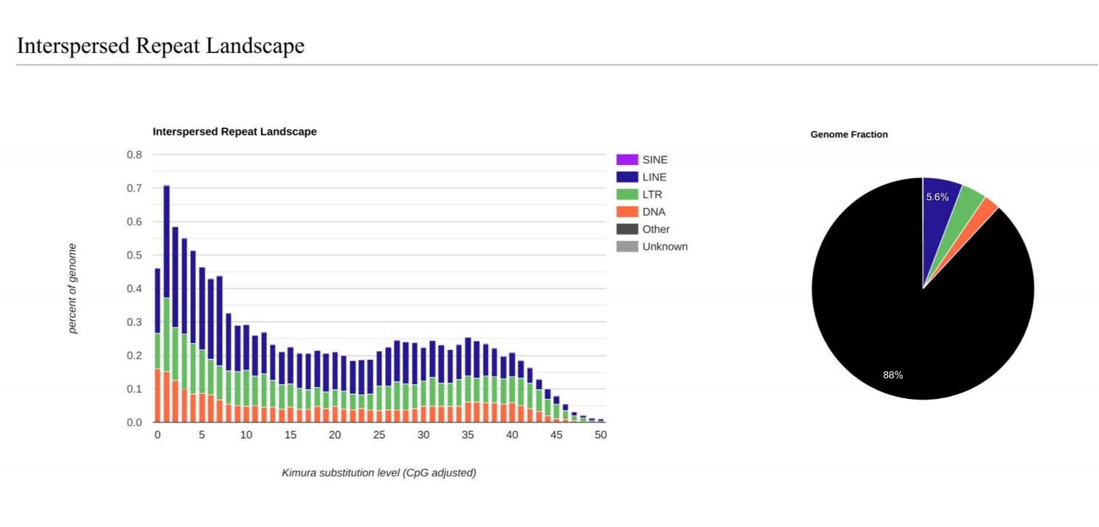
Fig. S3 Interspersed repeat landscape of the Anagrus nilaparvatae genome.

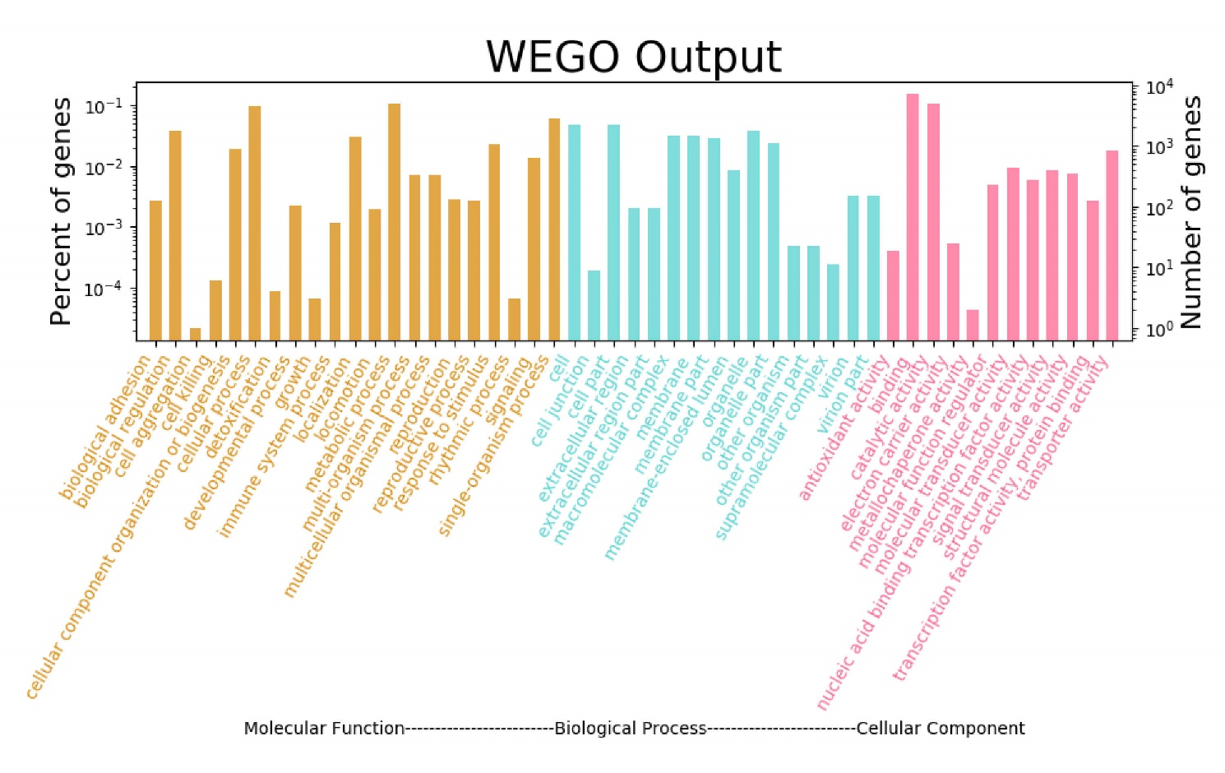
Fig. S4 GO functional classification of the Anagrus nilaparvatae predicted genes.

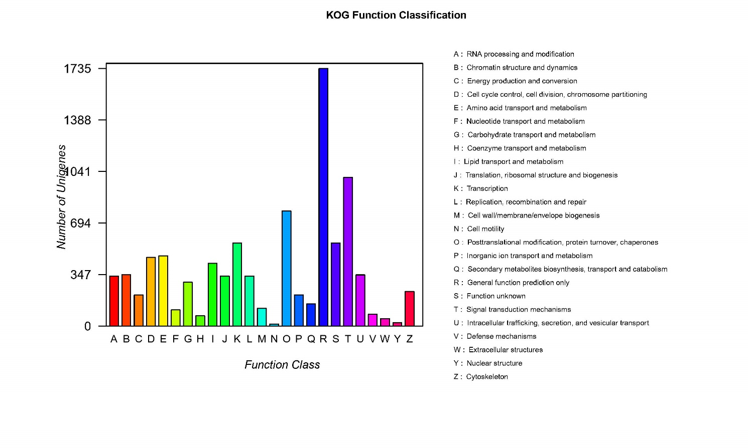
Fig. S5 KOG function classification of the predicted genes of Anagrus nilaparvatae.
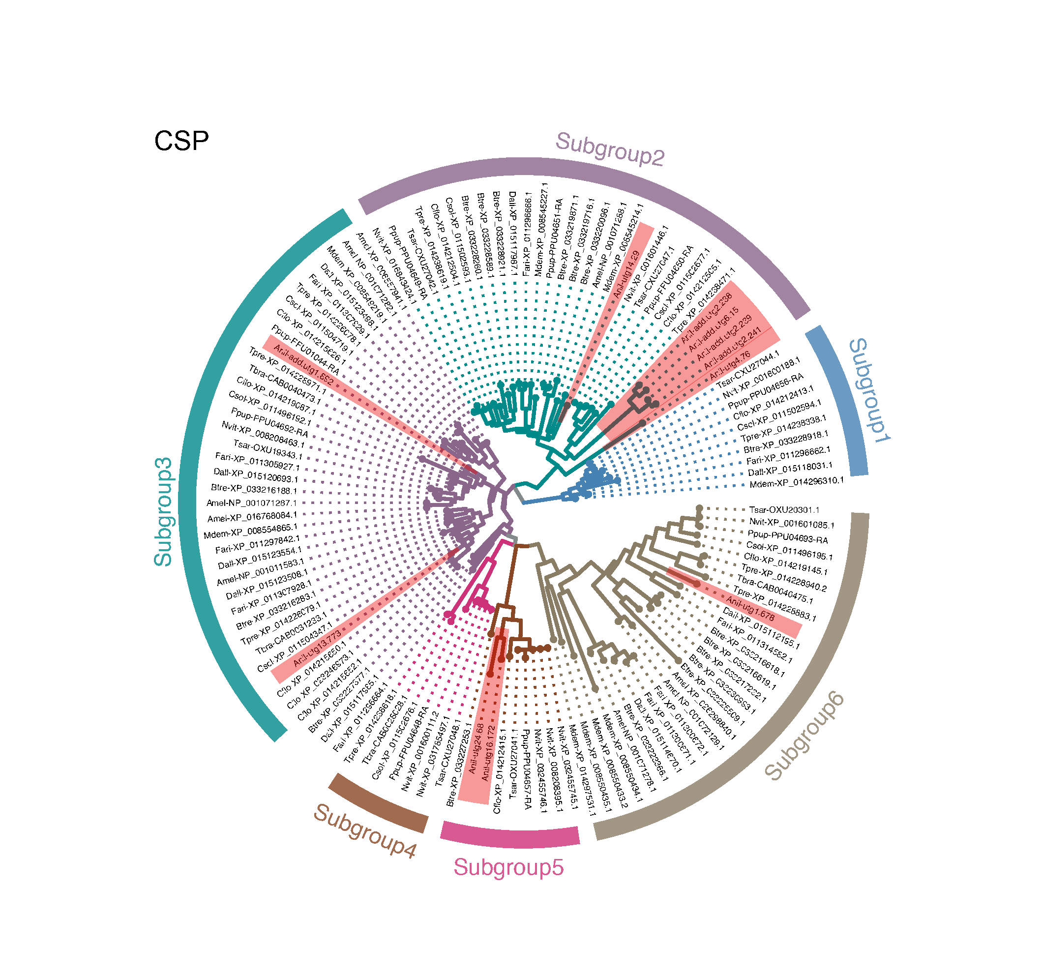
Fig. S6 Maximum-likelihood tree of CSPs of Anagrus nilaparvatae and other Hymenopteras. All gene names are the abbreviation of the species name plus the gene serial number, the gene serial number could be found in NCBI (https://www.ncbi.nlm.nih.gov/) or InsectBase 2.0 (http://v2.insect-genome.com/); Anil, Anagrus nilaparvatae; Amel, Apis mellifera; Btre, Belonocnema treatae; Cflo, Copidosoma floridanum; Csol, Ceratosolen solmsi; Dall, Diachasma alloeum; Fari, Fopius arisanus; Mdem, Microplitis demolitor; Nvit, Nasonia vitripennis; Ppup, Pteromalus puparum; Tbra, Trichogramma brassicae; Tpre, Trichogramma pretiosum; Tsar, Trichomalopsis sarcophagae.
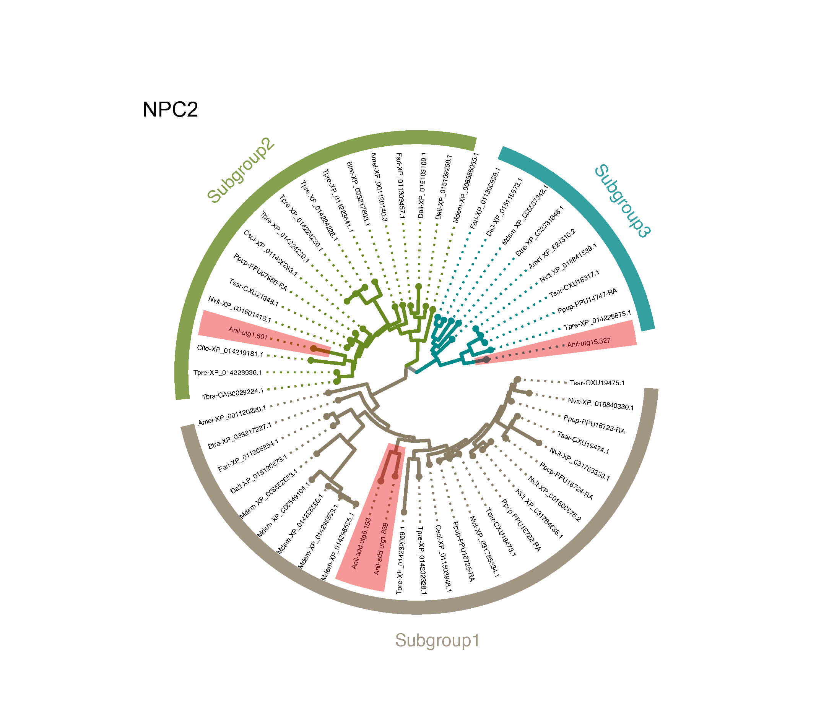
Fig. S7 Maximum-likelihood tree of NPC2s of Anagrus nilaparvatae and other Hymenopteras. Same as Fig. S6.
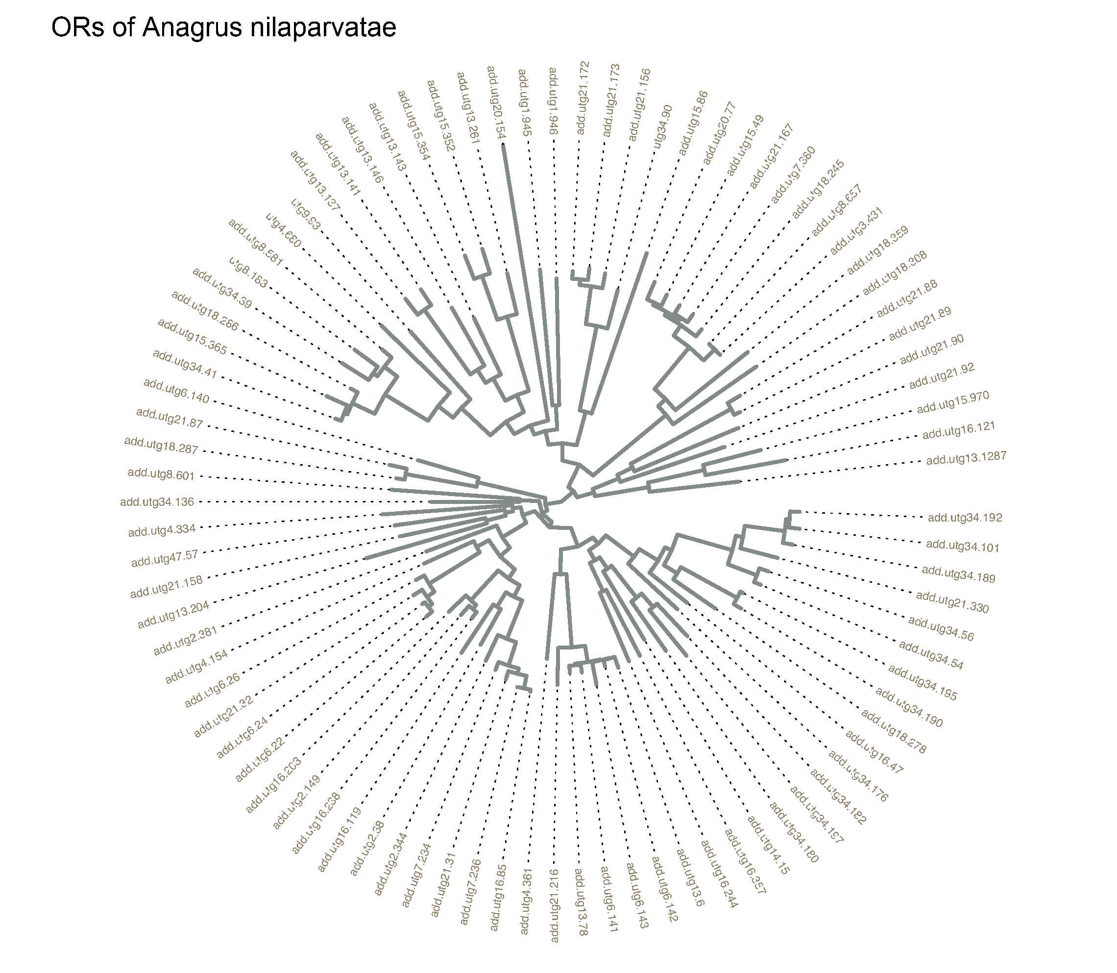
Fig. S8 Maximum-likelihood tree of ORs of Anagrus nilaparvatae and other Hymenopteras. Same as Fig. S6.
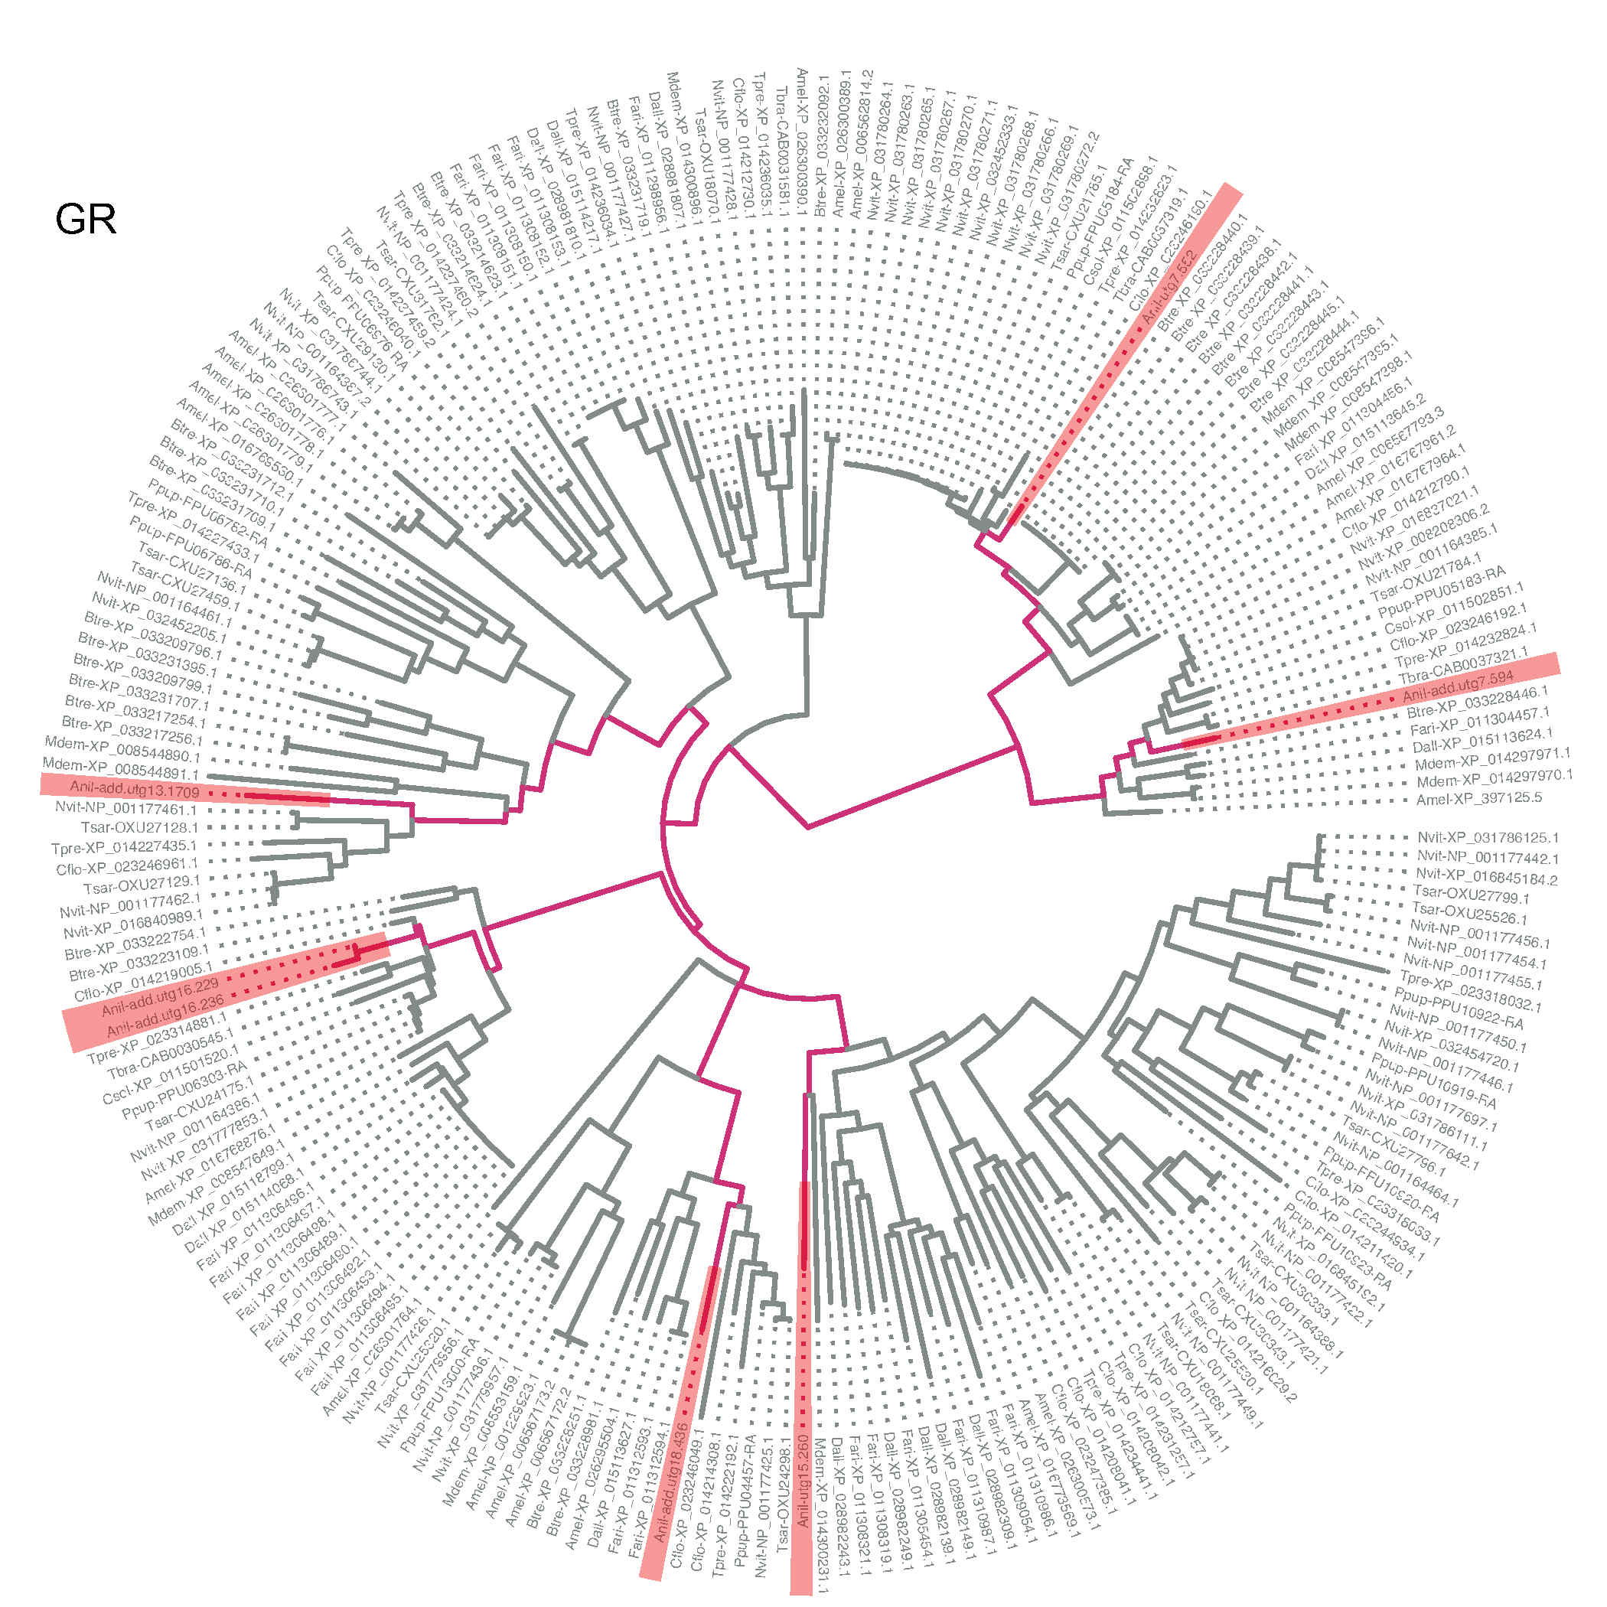
Fig. S9 Maximum-likelihood tree of GRs of Anagrus nilaparvatae and other Hymenopteras. Same as Fig. S6.
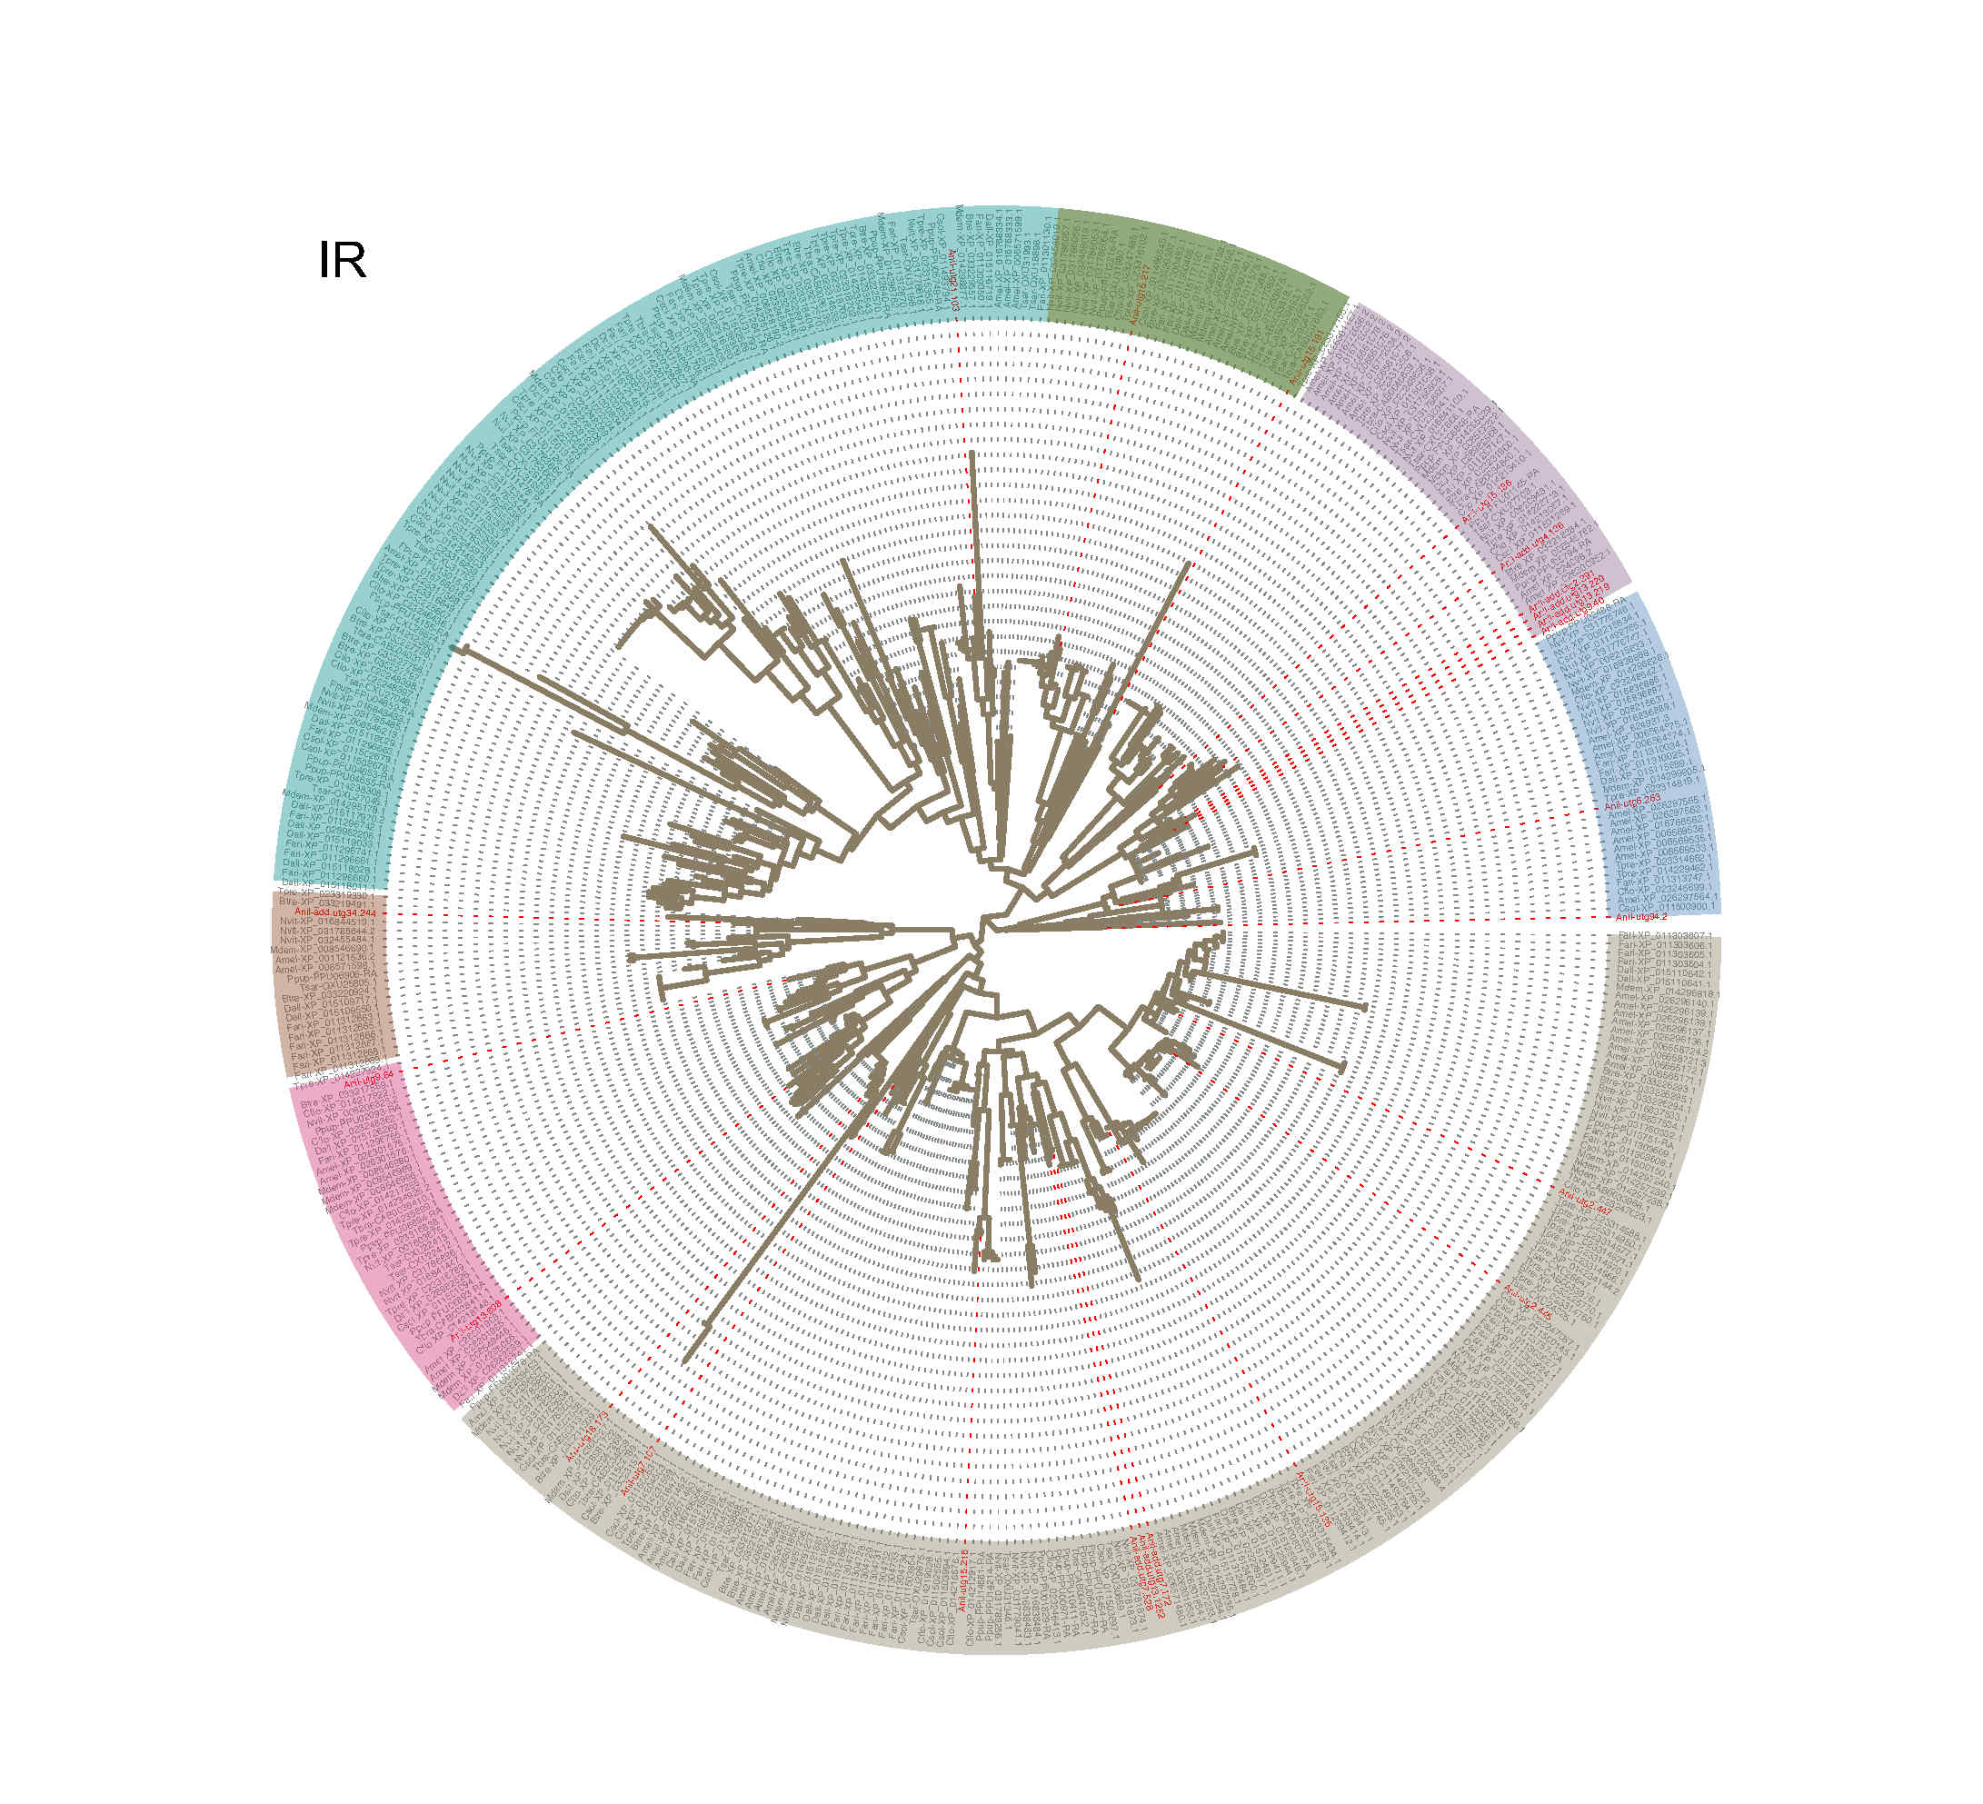
Fig. S10 Maximum-likelihood tree of IRs of Anagrus nilaparvatae and other Hymenopteras. Same as Fig. S6.
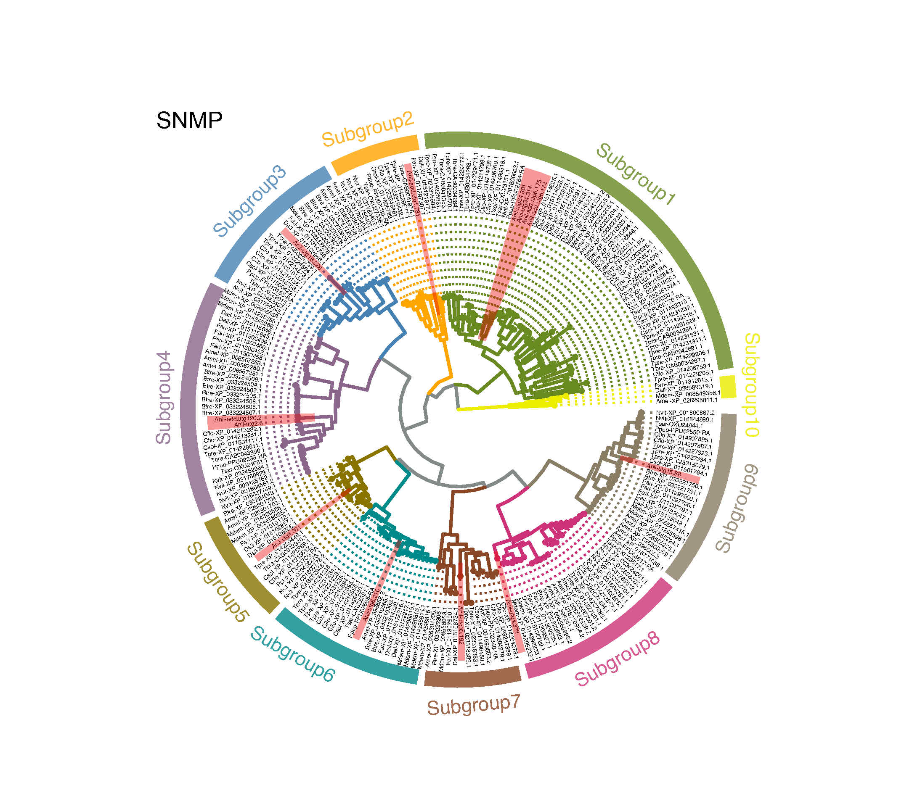
Fig. S11 Maximum-likelihood tree of SNMPs of Anagrus nilaparvatae and other Hymenopteras. Same as Fig. S6.

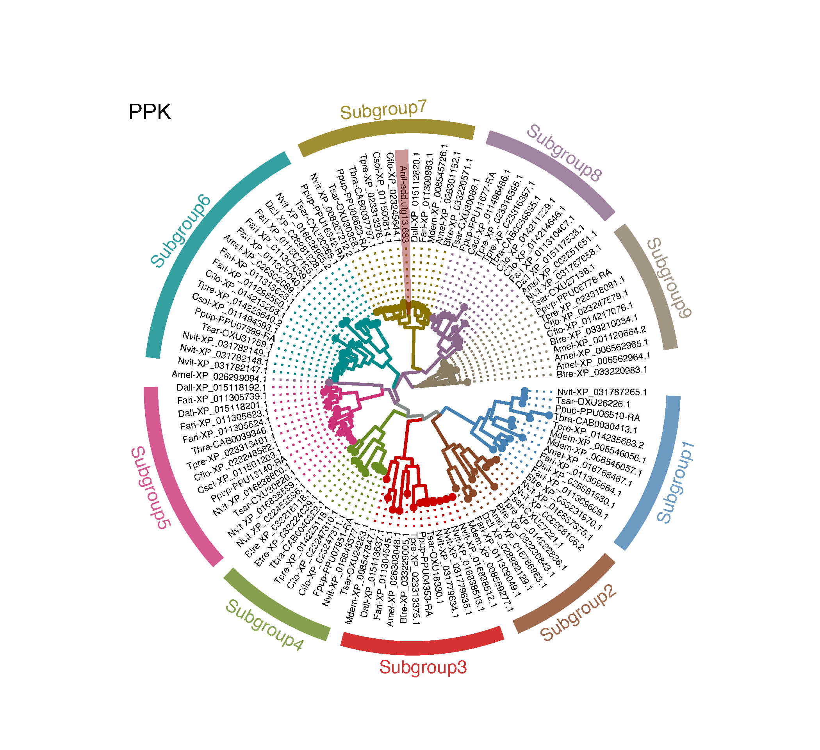
Fig. S12 Maximum-likelihood tree of PPKs of Anagrus nilaparvatae and other Hymenopteras. Same as Fig. S6.

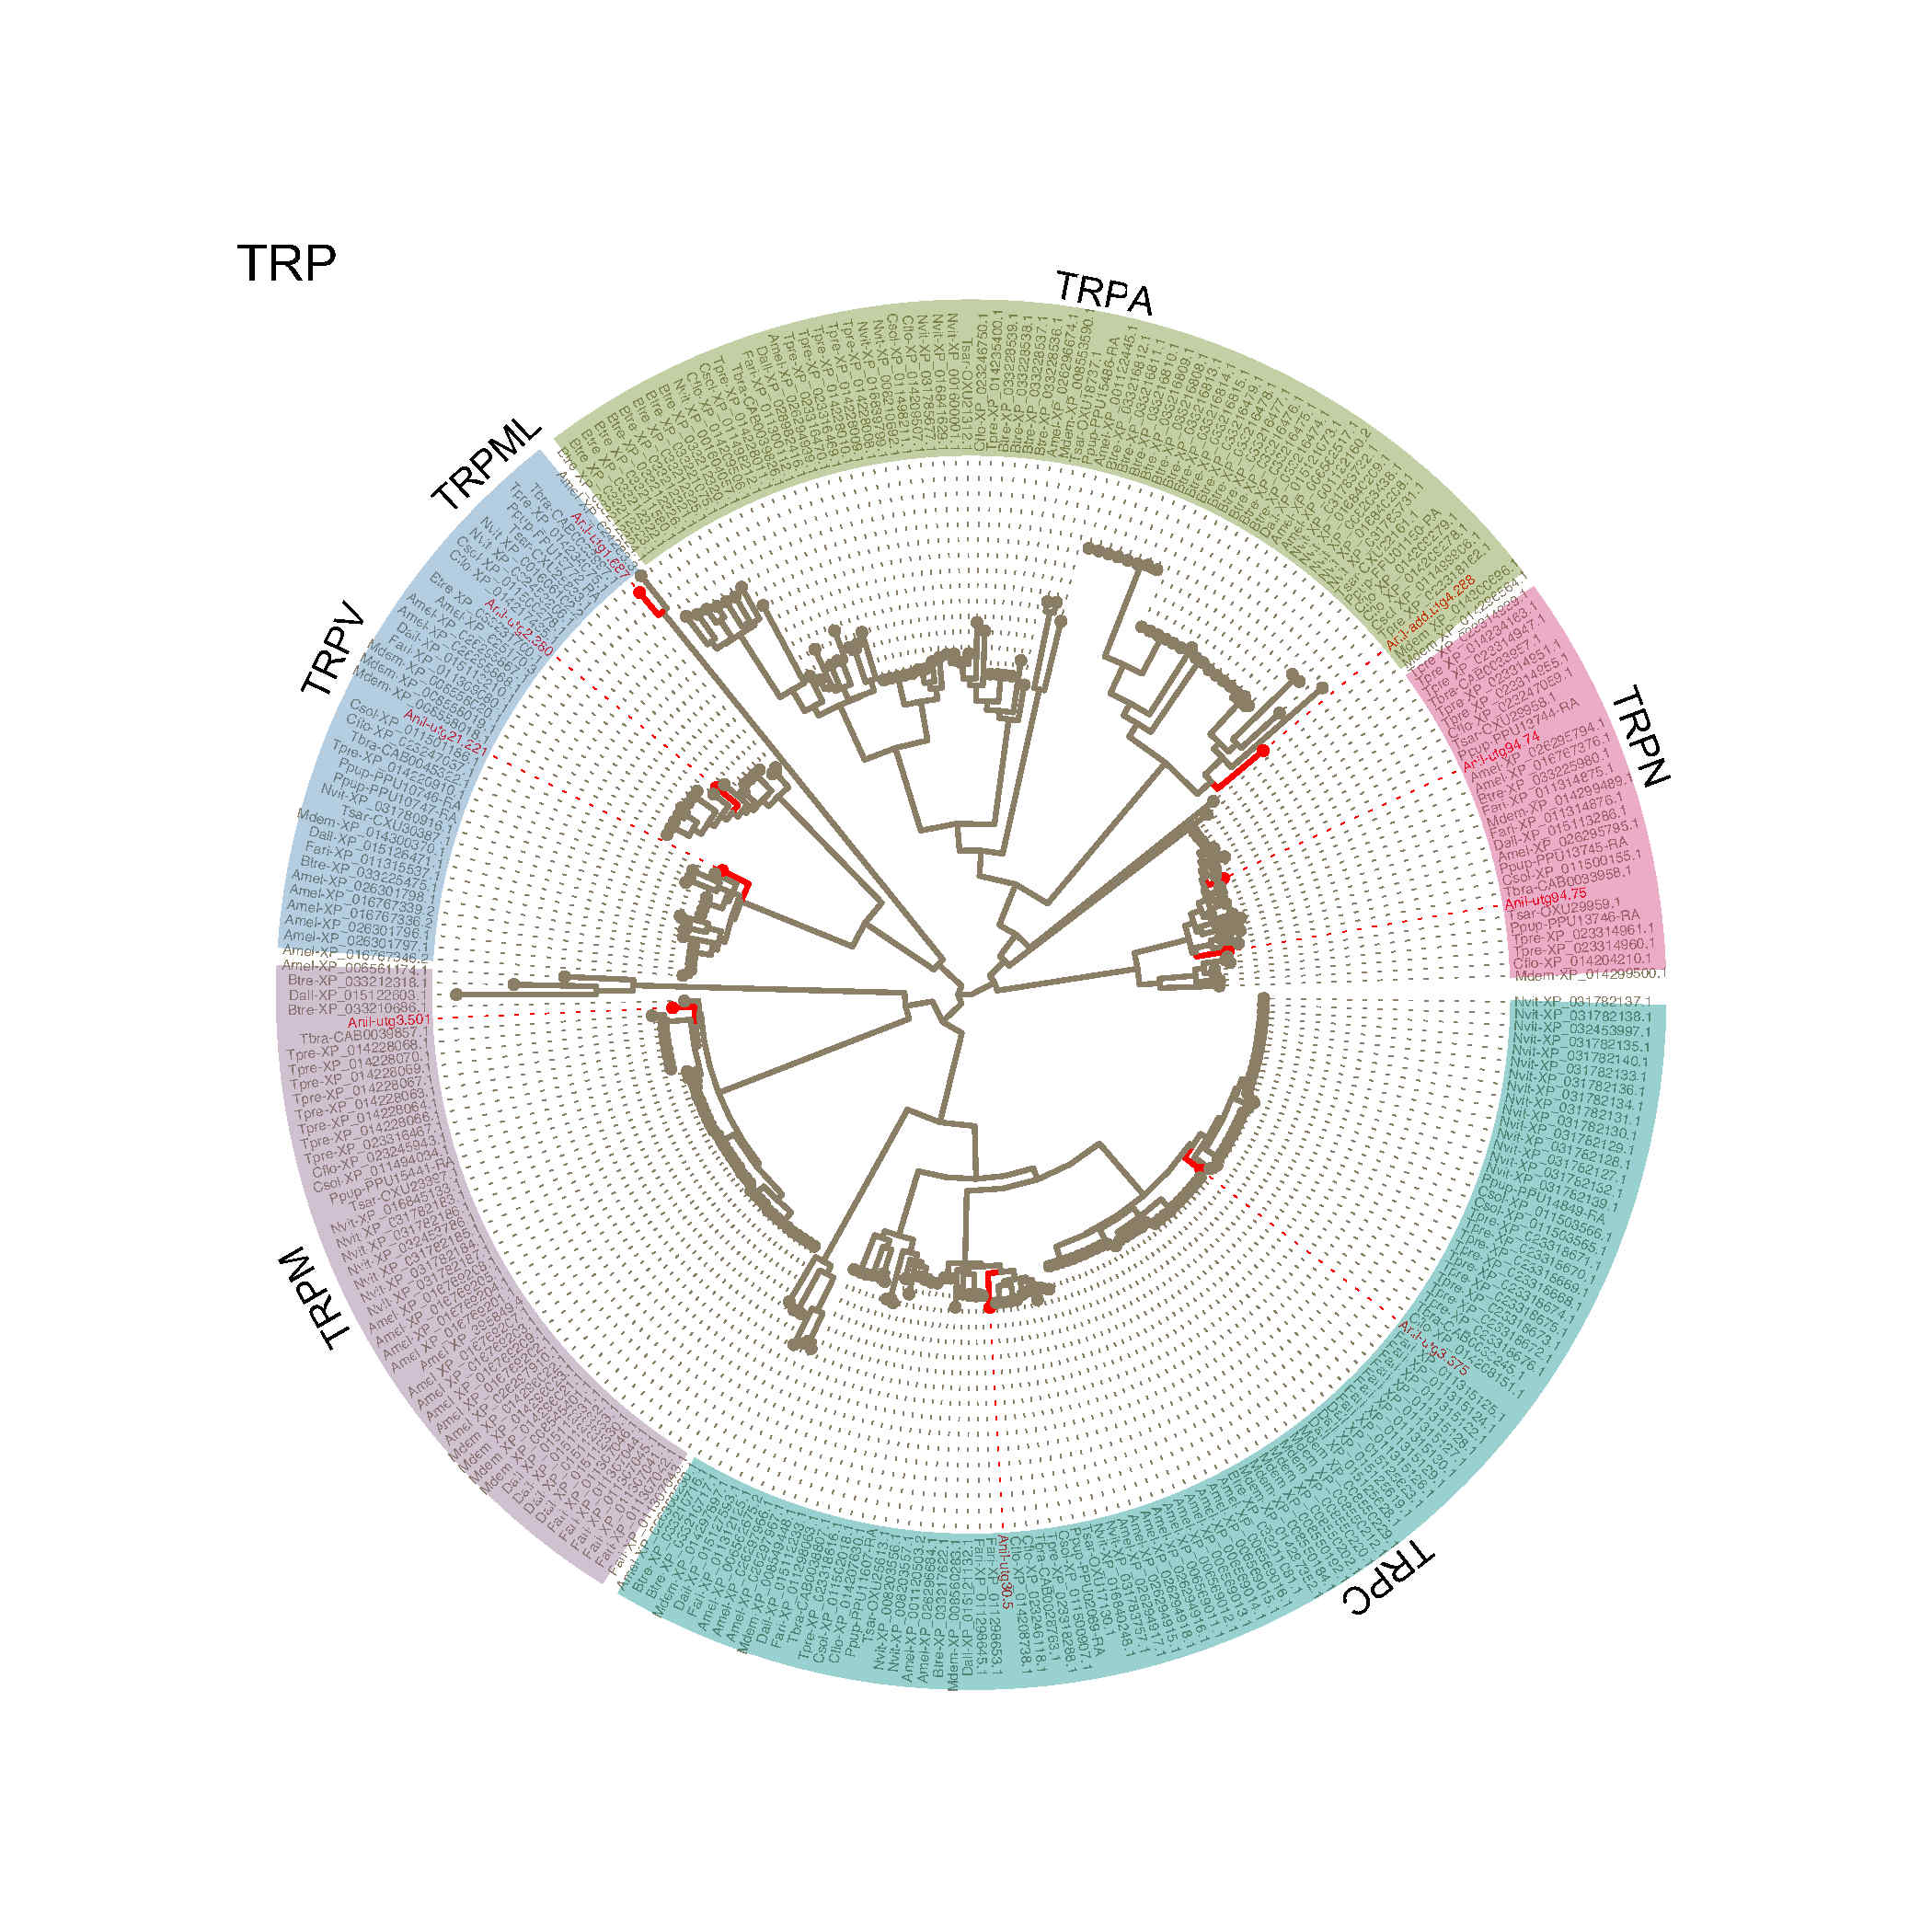
Fig. S13 Maximum-likelihood tree of TRPs of Anagrus nilaparvatae and other Hymenopteras. Same as Fig. S6.

