Supplementary Information for
GREM1/PPP2R3A expression in heterogeneous fibroblasts initiates pulmonary fibrosis

Xiaoni Shi, Shaoqi Yang, Wei Luo, Sha Wang, Jie Huang, Mengling Chen, Jing Wang, Yusi Cheng, Xinxin Zhang, and Jie Chao

Supplementary methods 2
Supplementary Figure S1 6
Supplementary Figure S2 8
Supplementary Figure S3 10
Supplementary Figure S4 11
Supplementary Figure S5 13
Supplementary Figure S6 15

Supplementary methods
Spatial transcriptomics (GSE183683)
1. Sample collection
For the model group, mice with obvious fibrotic lesions on CT scans were presumed to be a successful model. Lung tissues were trimmed near the hilum in the horizontal direction and then immediately frozen in OCT on dry ice. These samples were stored at -80°C before proceeding to the next step.
2. Spatial transcriptomics sequencing
2.1 Staining and imaging
Cryosections were cut at a 10 μm thickness with a cryostat (Leica, Germany) and mounted onto GEX arrays. The arrays were placed on a Thermocycler Adaptor with the active surface facing up and then incubated for 1 min at 37°C, fixed for 30 min with methyl alcohol at -20°C, and stained with H&E. Bright-field images of the whole slide were acquired with a Leica DMI8 whole-slide scanner at 10x resolution.
2.2 Permeabilization and reverse transcription
The spatial gene expression analysis was performed using the Visium Spatial Gene Expression Slide and Reagent Kit (10x Genomics, PN-1000184). For each well, a slide cassette was used to create leakproof wells for adding reagents. Then, 70 μl of permeabilization enzyme were added, and the samples were incubated at 37°C. For the NS-7 d, SiO₂-7 d and NS-56 d samples, the incubation time was 24 min. However, for the SiO₂-56 d group, because of severe lung fibrosis, a 30-min incubation time was used. Each well was washed with 100 μl of SSC, and 75 μl of RT master mix were added for cDNA synthesis (65°C, 15 minutes, hold at 4°C).
2.3 Preparation of the cDNA library for sequencing
At the end of first-strand synthesis, RT Master Mix was removed from the wells. Then, 75 μl of 0.08 M KOH were added and incubated for 5 min at room temperature. Next, KOH was removed from the wells, which were washed with 100 µl of EB buffer. Afterward, 75 μl of Second Strand Mix were added to each well for second-strand synthesis. The amplification of cDNAs (98°C 3 min; 98°C 15 s, 63°C 20 s, 72°C 1 min, 14 cycles; 72°C 1 min, hold at 4°C)
was performed using a S1000TM Touch Thermal Cycler (Bio-Rad). According to the manufacturer’s instructions, Visium spatial libraries were constructed using a Visium spatial library construction kit (10x Genomics, PN-1000184). The libraries were sequenced using an Illumina NovaSeq6000 sequencer with a sequencing depth of at least 100,000 reads per spot and a paired-end 150 bp (PE150) reading strategy (performed by CapitalBio Technology, Beijing).
3. Analysis of spatial transcriptomics data
10X Space Ranger software, which processes, summarizes and aligns unique molecular identifier (UMI) counts against the mmu10 mouse reference genome for each spot, was used to generate a feature-barcode matrix. Only spots overlaying tissue sections were retained for further analysis. The unsupervised clustering analysis was performed using a graph-based algorithm with 10 principal components. The t-distributed stochastic neighborhood embedding (t-SNE) method was used to visualize the spots in two-dimensional space. Spatial feature expression plots were generated using Loupe Browser 4.1.0.
Single-cell sequencing (GSE183682)
1. Sample collection
For the model group (mice instilled with SiO₂ suspension), mice with obviously high-density shadows on CT scans were included. Lung samples were collected from four mice for single-cell sequencing, namely, the NS-7 d, SiO₂-7 d, NS-56 d, and SiO₂-56 d samples. Whole lungs were removed from each mouse within 2 min of euthanasia and quickly washed with precooled PBS 3 times.
2. scRNA-seq
2.1 Cell capture and cDNA synthesis
Whole lung tissue was cut into small pieces (approximately 1 mm) and dissociated into single cells using a Lung Dissociation Kit (Miltenyi Biotech, 130-095-927, Germany). Using the Single-Cell 5' Library and Gel Bead Kit (10x Genomics, 1000169) and Chromium Single-Cell G Chip Kit (10x Genomics, 1000120), a cell suspension (300–600 living cells per microliter determined by CountStar) was loaded onto a Chromium single-cell controller (10x Genomics) to generate single-cell gel beads in emulsion (GEMs) according to the manufacturer’s protocol. Briefly, single cells were suspended in PBS containing 0.04% BSA. Approximately 20,000 cells were added to each channel, and the target cell recovery was estimated to be approximately 10,000 cells. Captured cells were lysed, and the released RNA was barcoded through reverse transcription in individual GEMs. Reverse transcription was performed on a S1000TM Touch Thermal Cycler (Bio-Rad) at 53°C for 45 min, followed by 85°C for 5 min and a hold at 4°C. The cDNA templates were generated and then amplified, and quality was assessed using an Agilent 4200 system (performed by CapitalBio Technology, Beijing).
2.2 scRNA-seq library preparation
The scRNA-seq libraries were constructed using the Single-Cell 5' Library and Gel Bead Kit, Single Cell V(D)J Enrichment Kit, Human T Cell (1000005) and Single Cell V(D)J Enrichment Kit according to the manufacturers’ instructions. The libraries were sequenced using an Illumina NovaSeq6000 sequencer with a sequencing depth of at least 100,000 reads per cell and a paired-end 150 bp (PE150) reading strategy (performed by CapitalBio Technology, Beijing).
3. Data preprocessing
3.1 Analysis of scRNA-seq data
Cell barcode filtering, alignment of reads and UMI counting were performed with Cell Ranger 4.0.0 software (https://www.10xgenomics.com/). The scRNA-seq data from four samples were combined using Cellranger aggr. Principal component analysis (PCA) was performed on the normalized data. An unsupervised clustering analysis was performed using Cellranger software with a graph-based algorithm. The top 10 principal components were used for clustering and t-SNE projections. The differential expression of genes between clusters was computed using sSEq- and edgeR-based methods. The GO and KEGG functional enrichment analyses of marker genes (FC≥2, P≤0.05) in Clusters 1 and 6 were performed using the R package Metascape.
3.2 Cell type annotation
Cell types were determined by clustering and marker gene expression.

Supplementary Figure S1
Fig. S1. Classification of fibroblasts using single-cell transcriptome sequencing. (A) Markers of myofibroblast differentiation. (B) GO enrichment analysis of the molecular functions of the top 50 genes in Cluster 6. (C) GO enrichment analysis of biological processes related to the top 50 genes in Cluster

Supplementary Figure S2
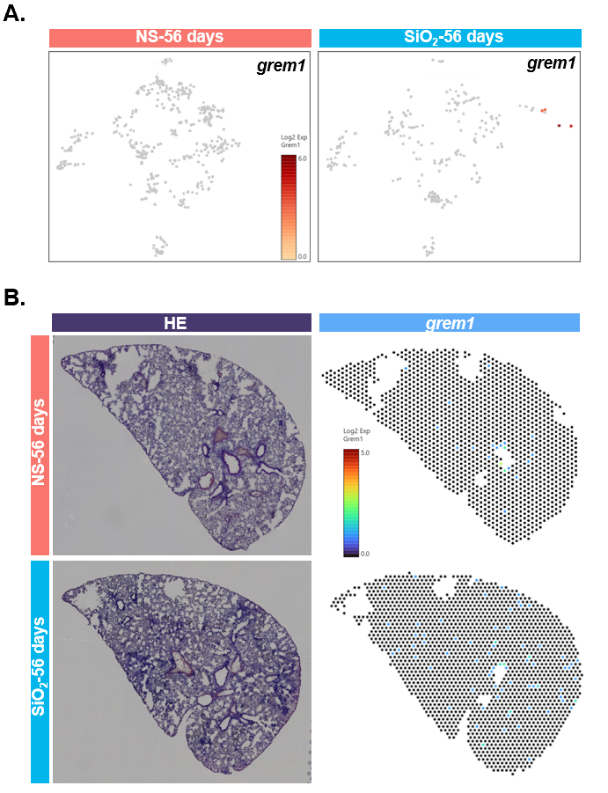
Fig. S2. Expression of grem1 in mice treated with saline and silica at 56 days determined using scRNA-seq and spatial transcriptome sequencing. (A) Compared with the normal saline group, grem1 expression in infla-pro fibroblasts was increased in the silica group but decreased compared with that at 7 days. (B) Compared with the normal saline group, the spatial localization of grem1 expression in the silica group increased but showed a decreasing trend at 7 days.

Supplementary Figure S3

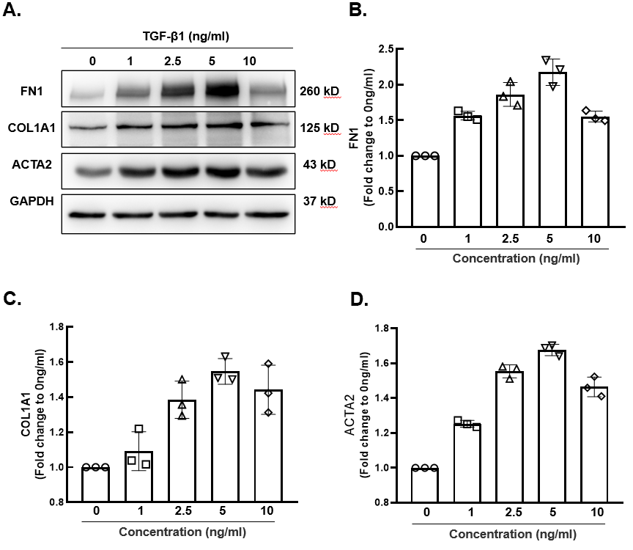
Fig. S3. The optimal concentration of TGF-β1 for treating cells. (A) A representative WB showed that when the concentration of TGF-β1 was 5 ng/ml, the highest expression of FN1, COL1, and α-SMA was detected. (B) The statistical analysis of three experiments shows the highest expression of FN1 in cells treated with 5 ng/ml TGF-β1 . (C) The statistical analysis of three experiments shows the highest expression of COL1 in cells treated with 5 ng/ml TGF-β1. (D) The statistical analysis of three experiments shows the highest expression of α-SMA in cells treated with 5 ng/ml TGF-β1.

Supplementary Figure S4

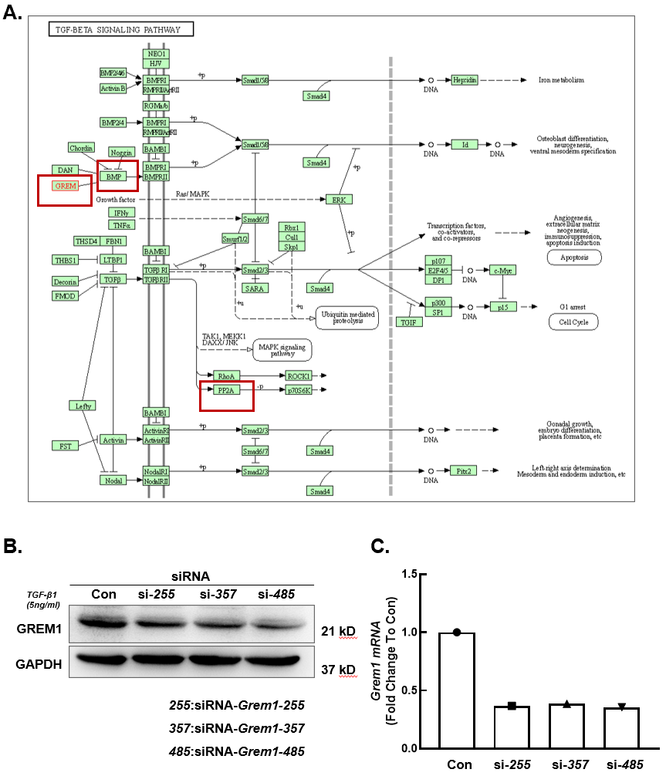
Fig. S4. Exploration of the downstream targets of GREM1 and verification of the Grem1 knockdown efficiency. (A) KEGG analysis showing that GREM1 is related to BMP and PP2A in the TGF-β signaling pathway; related research on PP2A is lacking. (B) The WB results show that among the three siRNAs, siRNA-Grem1-485 had the highest knockdown efficiency. (C) The qRT–PCR results showed that among the three siRNAs, siRNA-Grem1-485was the most efficient, achieving approximately 70% knockdown.

Supplementary Figure S5

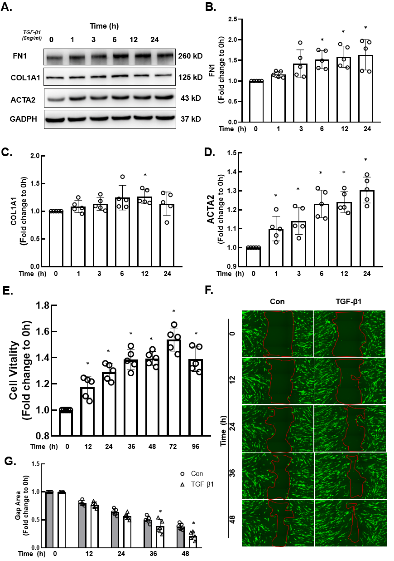
Fig. S5. Cells were treated with TGF-β1 to construct a cell model, and TGF-β1 increased cell viability and migration. (A) A representative WB shows that after treating cells with the optimal concentration of TGF-β1 at 5 ng/ml, the expression of the fibrosis-related markers FN1, COL1, and α-SMA increased in a time-dependent manner. (B) *p<0.05 indicates that the increase in FN1 expression between 0 h and the indicated time point was significant. (C) *p<0.05 indicates that the increase in COL1 expression between 0 h and the indicated time point was significant. (D) *p<0.05 indicates that the increase in α-SMA expression between 0 h and the indicated time point was significant. (E) The CCK-8 assay results show that after TGF-β1 treatment, cell viability increased in a time-dependent manner, peaking at 72 h. *p<0.05 indicates that the difference in cell viability between 0 h and the indicated time point was significant. (F) The results of the wound healing experiment show increased cell migration after TGF-β1 treatment. (G) *p<0.05 indicates that the difference in cell migration between the TGF-β1 treatment group and the control group was significant.

Supplementary Figure S6

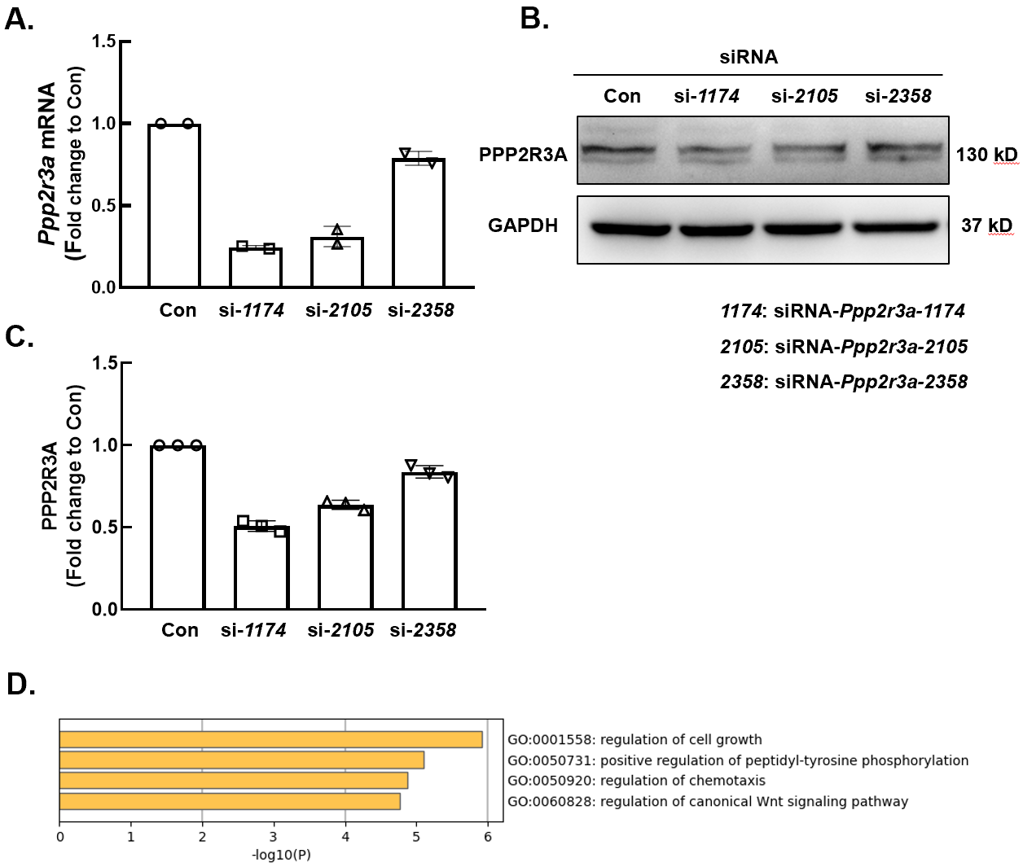
Fig. S6. Verification of the Ppp2r3a knockdown efficiency and GREM1 regulation of PPP2R3A through downstream signaling pathways. (A) The qRT–PCR results show that among the three siRNAs, siRNA-Ppp2r3a-1174 had the highest knockdown efficiency at approximately 70%. (B) The WB results show that among the three siRNAs, siRNA-Ppp2r3a-1174 had the highest knockdown efficiency. (C) The statistical analysis of three experiments shows that siRNA-Ppp2r3a-1174 had the highest knockdown efficiency. (D) GO analysis of the signaling pathways in which GREM1, PPP2R3A, FN1 and p53 were enriched. Combined with Table 2, GREM1 mainly regulates PPP2R3A through Wnt signaling pathway

