Impact of initial explants on in vitro propagation of native potato (Solanum tuberosum, Andigena group)

Plant Cell, Tissue and Organ Culture (PCTOC)

Lenny Yojana Correa Mora^{1,2} Daicy Yaneth Galvis Tarazona¹ María de los Angeles Bohórquez Quintero¹ Eyda Johanna Araque Barrera¹ Johan Sebastian Urquijo Ruíz³ Diana Marcela Arias Moreno¹* Zaida Zarely Ojeda Pérez¹

- Grupo de investigación BIOPLASMA, Facultad de Ciencias, Universidad Pedagógica y Tecnológica de Colombia. Avenida Central del Norte 39-115, Tunja, Boyacá, Colombia.
- Maestría en Ciencias Biológicas, Facultad de Ciencias, Universidad Pedagógica y Tecnológica de Colombia. Avenida Central del Norte 39-115, Tunja, Boyacá, Colombia.
- Maestría en Geomática, Facultad de Ciencias Agrarias, Universidad Nacional de Colombia. Carrera 30 # 45-03, Bld. 500, Bogotá, D.C., Colombia.

* Corresponding author. e-mail: diana.arias04@uptc.edu.co, +57-320-258-5856, +57-8-740-5626 ext 2432.

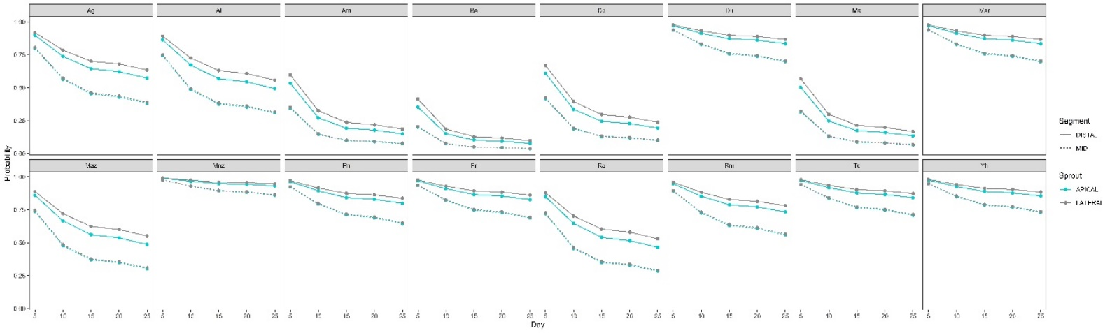

Fig. S1 Aseptic explants during the in vitro establishment stage for each of the native potato genotypes (predicted probability), according to the category of the initial explant: Apical-Distal (AD), Mid-Apical (MA), Lateral-Distal (LD), and Mid-Lateral (ML). Periodic evaluation for 25 days

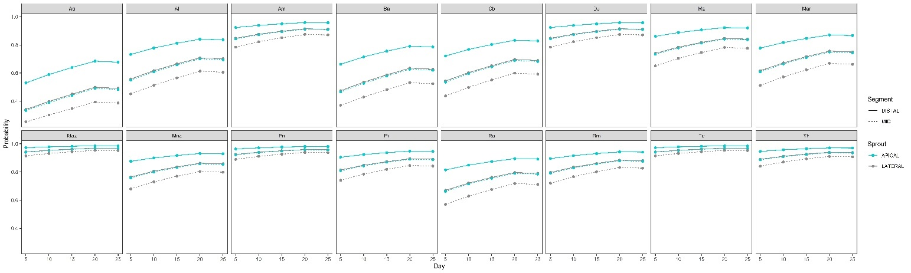
Fig. S2 Reactive explants during the in vitro establishment stage for each of the native potato genotypes (predicted probability), according to the category of the initial explant: Apical-Distal (AD), Mid-Apical (MA), Lateral-Distal (LD), and Mid-Lateral (ML). Periodic evaluation for 25 days

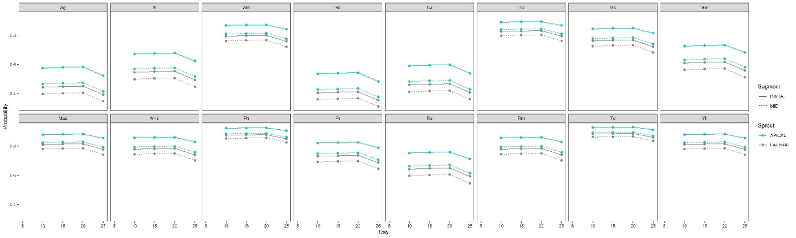
Fig. S3 Viable explants during the in vitro establishment stage for each of the native potato genotypes (predicted probability), according to the category of the initial explant: Apical-Distal (AD), Mid-Apical (MA), Lateral-Distal (LD), and Mid-Lateral (ML). Periodic evaluation for 25 days

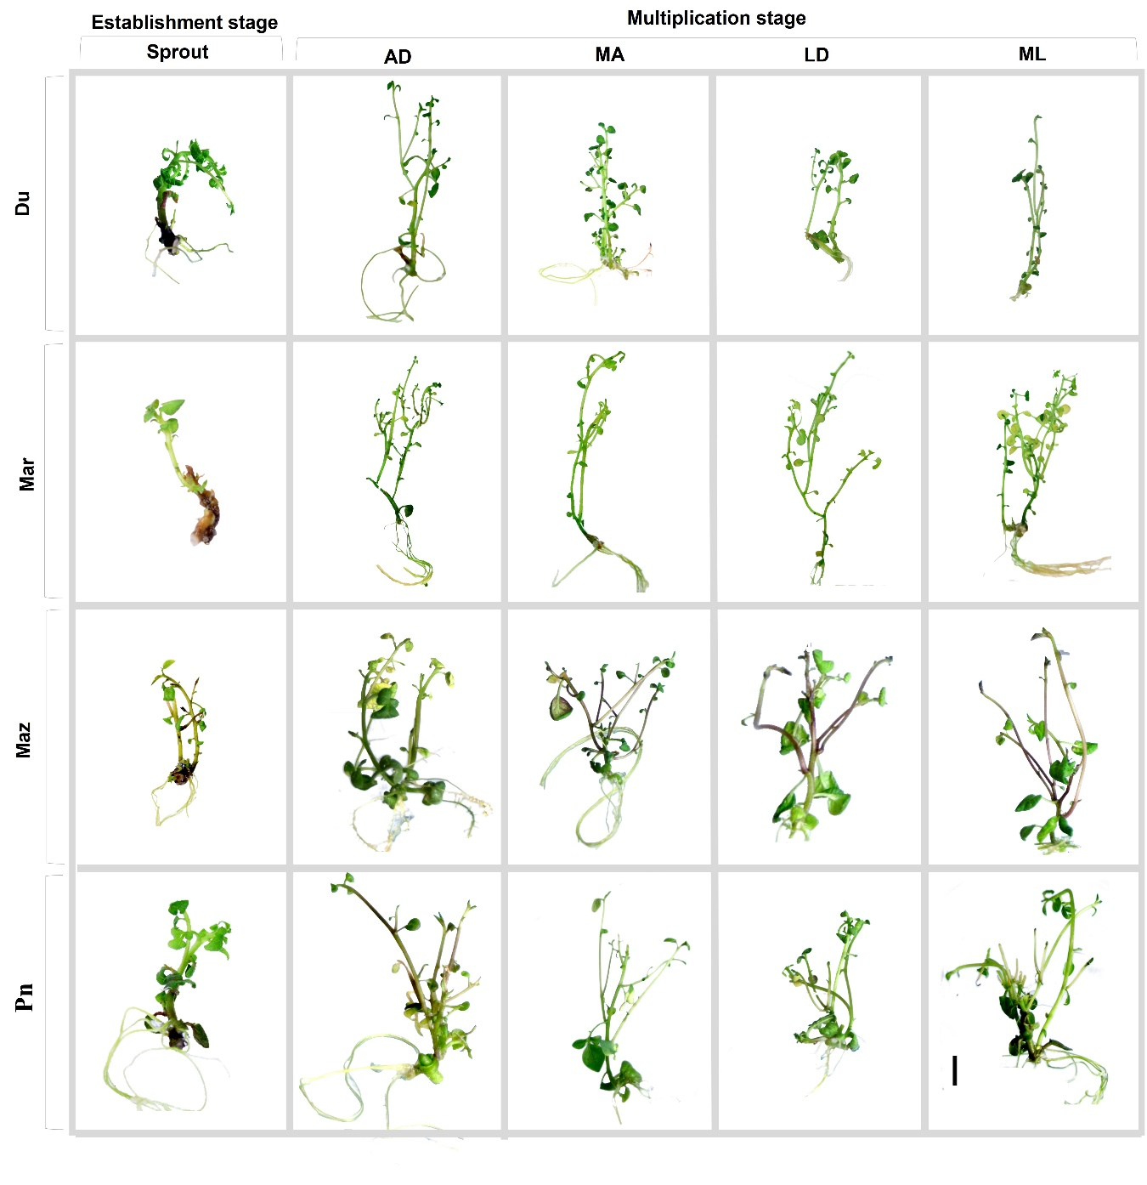
Fig. S4 Representative images of explant development by category of initial plant material: Apical-Distal (AD), Mid-Apical (MA), Lateral-Distal (LD), and Mid-Lateral (ML) (-: 1 cm). Du: Duraznillo, Mar: Maravillosa, Maz: Mortiña Azul, Pn: Pacha Negra.
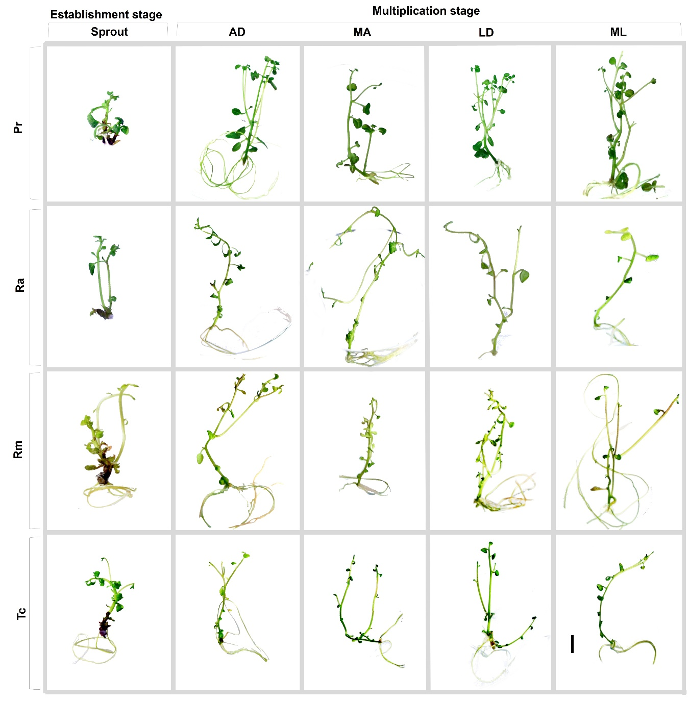
Fig. S4 Representative images of explant development by category of initial plant material: Apical-Distal (AD), Mid-Apical (MA), Lateral-Distal (LD), and Mid-Lateral (ML) (-: 1 cm). Pr: Pepina Rodeo, Ra: Rastrera, Rm: Ratona Morada, Tc: Tornilla Crema

