Supplemental Materials

Item | Title/Description
Supplemental Methods | quality control (QC) protocol
Supplemental Methods | computing tPRM
Supplemental Figure E1 | scatter plot of all COPDGene Phase 1 participants used for analysis in GOLD definitive plane
Supplemental Figure E2 | Scatter plot of V^{Norm} versus V^{fSAD} for all studied participants (n = 8,972)
Supplemental Figure E3 | Scatter plot of 𝜒^{fSAD} versus 𝜒^{Emph} for all studied participants (n = 8,972)
Supplemental Table E1 | table of tPRM descriptive statistics by GOLD
Supplemental Table E2 | Spearman’s rank correlation matrix between tPRM metrics and PFT measures
Supplemental Table E3 | Spearman’s rank correlation matrix between tPRM metrics and PFT measures/SGRQ total score
Supplemental Table E4 | Spearman’s rank correlation matrix between tPRM metrics and demographical/clinical measures
Supplemental Methods: quality control (QC) protocol

QC was performed in two steps (e.g. see 3 and 4 in exclusion diagram below), using GOLD grade, segmented lung volume change ($∆$V = inspiration volume – expiration volume, as a function of segmented voxels), and a correlation test metric (Q) defined as the absolute value of the difference between standard scores of FEV₁% predicted and %PRM^{Norm}, reported to be highly correlated in COPD studies*.
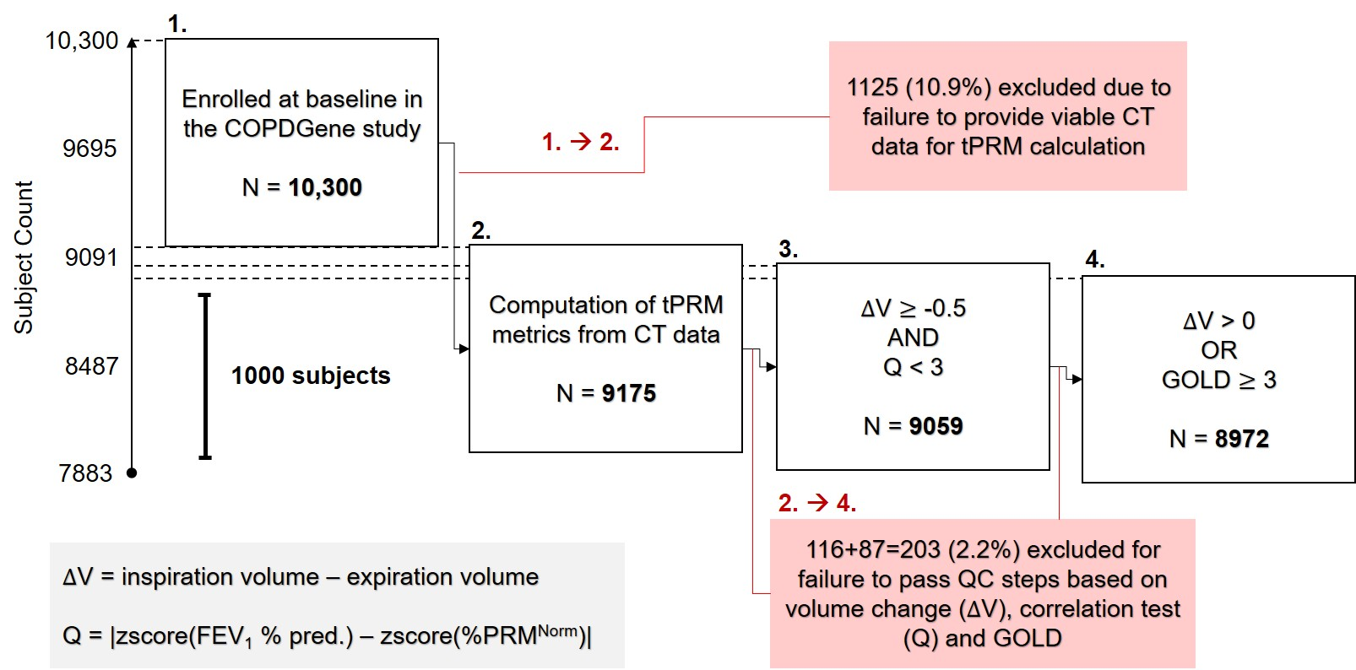
Specifically, QC tests for exclusion were applied consecutively as follows:

- ∆V < -0.5 L OR Q ≥ 3

A large negative volume change, here defined as greater than 0.5 L, often indicates transposition of intended respiratory stages (expiration/inspiration), due to faulty maneuver or data handling error. In addition, we test here if a deviation of equal to or greater than 3 standard deviations from the expected positive correlation between FEV₁% predicted and %PRM^{Norm} has occurred.

- ∆V ≤ 0 L and GOLD < 3

This second step goes on to test if a non-severe COPD participant (GOLD < 3) has zero or negative volume change. N.B. here and in step 1 we have considered that there may be participants with severe disease that have some abnormal volume changes (close to 0 due to very limited lung function).

* Galbán, C. J. et al. Computed tomography–based biomarker provides unique signature for diagnosis of COPD phenotypes and disease progression. Nature Medicine 18, 1711-1715, doi:10.1038/nm.2971 (2012).
Supplemental Methods: computing tPRM

The following describes the complete process of tPRM map computation, for an exemplar subject from the COPDGene cohort and a particular PRM class, from the raw CT data; i.e. given required inputs of i) thoracic CT scan at inspiration/TLC, and ii) thoracic CT scan at expiration/FRC.
1
- Segmentation

The lungs, minus major airways, are segmented at both inspiration and expiration; i.e. a binary map identifying voxels that belong to the lungs within each image deck is obtained.
2
- Registration (inspiration-to-expiration, I2E)

The inspiration lung is geometrically deformed to match the expiration frame; this is image registration, performed here using elastix (https://elastix.lumc.nl/). Thus we obtain the following three objects required for PRM (I2E): i) expiration CT image, ii) expiration segmentation map (binary, identifying lungs), iii) registered inspiration CT image, i.e. the inspiration CT image warped to fit the expiration spatial frame.
3
- PRM classification

Every voxel within the lungs (identified by ii) is classified as a function of its expiration HU (from 2-i above) and inspiration HU (from 2-iii above). In this study we used 4 classes based on thresholding about expiration HU = -856, inspiration HU = -950 and inspiration HU = -810; see diagram for classification based on regions defined by these three lines in the expiration HU – inspiration HU plane.
4
- tPRM mapping

For a given PRM class, a binary map is obtained (1 if that class, 0 otherwise), which defines a set of points in 3D space. This may be considered as a set of cubes (centered on the given points), and thus a 3D object for which topological properties (such as volume and surface area) can be calculated. tPRM is defined by the application of Minkowski functionals* to measure such properties from a binary map based on PRM classification; specifically, volume (V), surface area (S), mean breadth (B) and Euler-Poincaré characteristic (𝜒). To produce maps of these properties across an entire set of lung voxels in a reasonable amount of time, we compute functionals locally on a 21x21x21 set of voxels centered on a voxel from a grid of every 5th voxel (subsampling the complete set of segmented [lung] voxels). Values for all other voxels are then estimated rapidly via linear interpolation, producing a smooth tPRM map for each functional. In this study we used four PRM classes and four Minkowski functionals. Hence, 16 tPRM maps were computed for each subject (see metrics in Table E1).

* https://www.mathworks.com/matlabcentral/fileexchange/33690-imminkowski
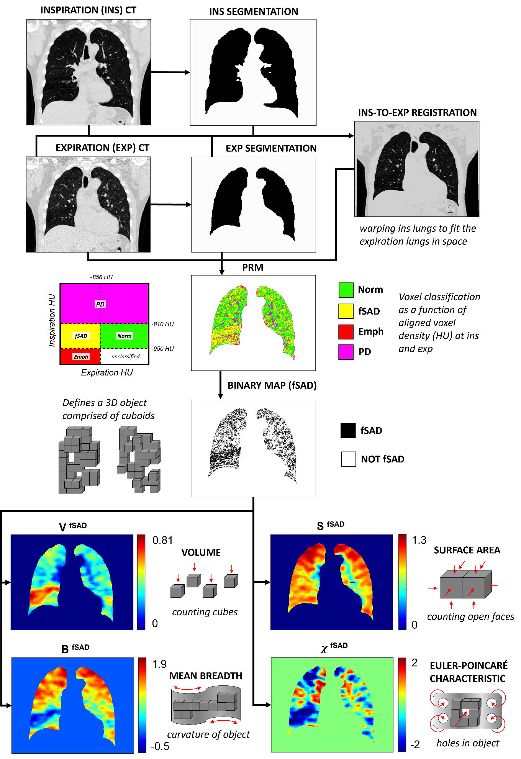
4
2
1
3
1
Figure E1: scatter plot of all study sample participants.
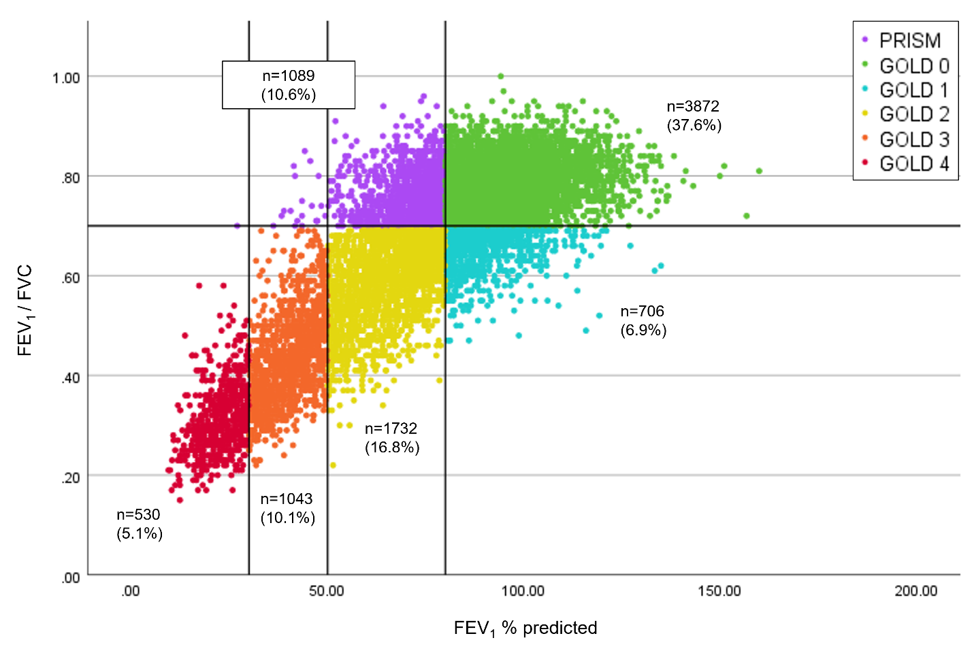
FEV₁ = forced expiratory volume in 1 second, FVC = forced vital capacity, GOLD = Global Initiative for Chronic Obstructive Lung Disease, PRISm = Preserved Ratio Impaired Spirometry. Horizontal line is plotted for FEV₁/FVC = 0.7. Vertical lines are plotted for FEV₁% predicted = 30, 50 and 80. Percentages are with respect to the total number of participants enrolled in Phase 1 of the COPDGene study (n = 10,300). Points are color-coded with respect to PRISM or GOLD grade class as specified in the legend top right.
Figure E2: scatter plot of all study sample participants (n = 8,972) for V^{Norm} versus V^{fSAD}.

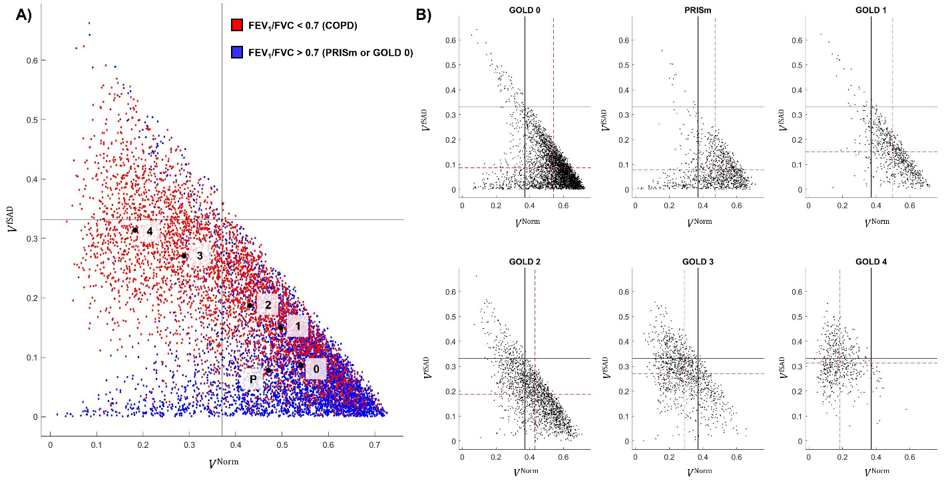
Scatter plot of all study sample participants (n = 8,972) for V^{Norm} versus V^{fSAD}. GOLD = Global Initiative for Chronic Obstructive Lung Disease, PRISm = Preserved Ratio Impaired Spirometry, FEV₁ = forced expiratory volume in 1 second, FVC = forced vital capacity, V = volume, Norm = normal, fSAD = functional small airways disease. (A) scatter plot of all participants color coded with respect to COPD classification, i.e. based on FEV₁/FVC threshold of 0.7. Plot annotated with mean points of subgroups (black dots) with subgroup labels (P = PRISm, otherwise number = GOLD class). (B) scatter plots with axes identical to that given in (A), showing point clouds and mean points (red dashed lines) for each subgroup. In all plots the black solid lines are plotted at the axes’ midpoints.
Figure E3: scatter plot of all study sample participants (n = 8,972) for χ^{Norm} versus χ^{fSAD}.
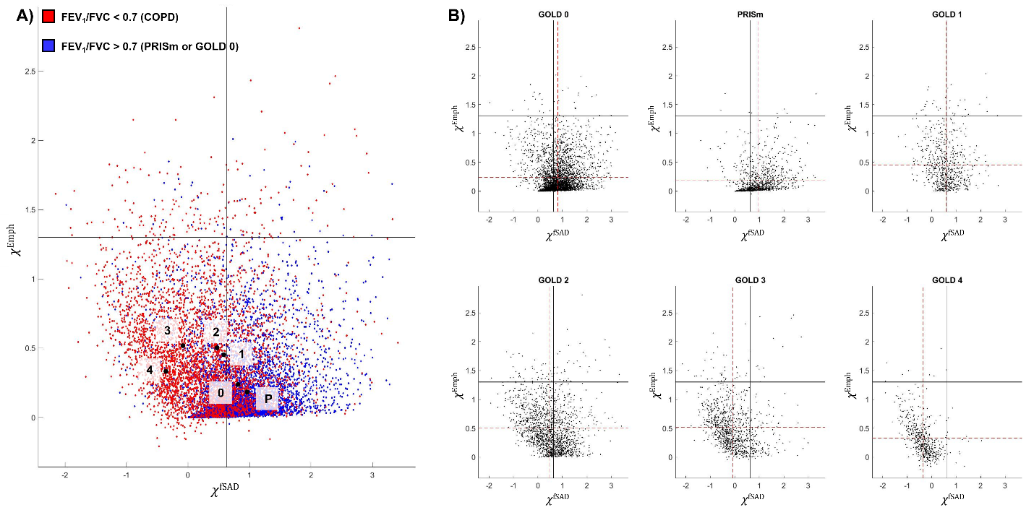
GOLD = Global Initiative for Chronic Obstructive Lung Disease, PRISm = Preserved Ratio Impaired Spirometry, FEV₁ = forced expiratory volume in 1 second, FVC = forced vital capacity, χ = Euler-Poincaré characteristic, Norm = normal, fSAD = functional small airways disease. (A) scatter plot of all participants color-coded with respect to COPD classification, i.e. based on FEV₁/FVC threshold of 0.7. Plot annotated with mean points of subgroups (black dots) with subgroup labels (P = PRISm, otherwise number = GOLD class). (B) scatter plots with axes identical to that given in (A), showing point clouds and mean points (red dashed lines) for each subgroup. In all plots the black solid lines are plotted at the value 0.
Table E1 – table of tPRM descriptive statistics by GOLD.

 | FEV₁/FVC > 0.7 |  | FEV₁/FVC < 0.7 (COPD)
tPRM Metric | GOLD 0 (n=3872) | PRISm (n=1089) | GOLD 1  (n=706) | GOLD 2 (n=1732) | GOLD 3 (n=1043) | GOLD 4 (n=530)
V^{Norm} | 0.54 (0.11) | 0.47 (0.13) | 0.50 (0.11) | 0.43 (0.12) | 0.29 (0.11) | 0.18 (0.08)
V^{fSAD} | 0.09 (0.08)_{P} | 0.08 (0.07)₀ | 0.15 (0.09) | 0.19 (0.10) | 0.27 (0.10) | 0.31 (0.08)
V^{Emph} | 0.01 (0.01) | 0.01 (0.02) | 0.03 (0.03) | 0.05 (0.06) | 0.13 (0.11) | 0.23 (0.12)
V^{PD} | 0.22 (0.11) | 0.30 (0.14) | 0.17 (0.07) | 0.18 (0.08) | 0.16 (0.08) | 0.13 (0.05)
S^{Norm} | 0.62 (0.13)₃ | 0.66 (0.13)₁ | 0.66 (0.11)_{P} | 0.69 (0.11) | 0.63 (0.15)₀ | 0.48 (0.15)
S^{fSAD} | 0.27 (0.17)_{P} | 0.26 (0.17)₀ | 0.40 (0.17) | 0.48 (0.18) | 0.61 (0.15)₄ | 0.64 (0.10)₃
S^{Emph} | 0.03 (0.04) | 0.02 (0.03) | 0.08 (0.09) | 0.12 (0.12) | 0.25 (0.14) | 0.34 (0.12)
S^{PD} | 0.40 (0.12) | 0.49 (0.13) | 0.33 (0.09)₂ | 0.34 (0.10)₁ | 0.29 (0.10) | 0.23 (0.06)
B^{Norm} | 0.08 (0.27) | 0.22 (0.31)₁ | 0.21 (0.27)_{P} | 0.36 (0.31) | 0.61 (0.24)₄ | 0.64 (0.16)₃
B^{fSAD} | 0.47 (0.24)_{P} | 0.49 (0.27)₀ | 0.58 (0.22)₃ | 0.64(0.23) | 0.61 (0.23)₁ | 0.53 (0.20)
B^{Emph} | 0.08 (0.11) | 0.06 (0.08) | 0.18 (0.17) | 0.23 (0.19) | 0.34 (0.18)₄ | 0.35 (0.13)₃
B^{PD} | 0.47 (0.13)_{P} | 0.47 (0.17)₀ | 0.41 (0.09)₂ | 0.40 (0.11)₁ | 0.32 (0.10) | 0.25 (0.06)
χ^{Norm} | -0.95 (0.63)_{P|1} | -0.95 (0.81)_{0|1} | -0.91 (0.55)_{0|P|2} | -0.84 (0.71)₁ | -0.17 (0.79) | 0.39 (0.55)
χ^{fSAD} | 0.81 (0.59) | 0.96 (0.65) | 0.58 (0.57) | 0.47 (0.74) | -0.08 (0.71) | -0.36 (0.49)
χ^{Emph} | 0.24 (0.30) | 0.18 (0.25) | 0.45 (0.39) | 0.50 (0.39)₃ | 0.52 (0.39)₂ | 0.33 (0.32)
χ^{PD} | 0.44 (0.33) | 0.28 (0.47) | 0.43 (0.18) | 0.40 (0.22) | 0.31 (0.18) | 0.24 (0.09)

Legend: tPRM features across the entire study population grouped by PRISm/GOLD grade. Values are displayed as mean (standard deviation). GOLD, Global Initiative for Chronic Obstructive Lung Disease; PRISm, preserved ratio impaired spirometry; Norm, normal; fSAD, functional small airways disease; Emph, emphysema; PD, parenchymal disease; V, volume density; S, surface area; B, mean breadth; χ, Euler-Poincaré characteristic. Multiple group comparisons were performed using the Kruskal-Wallis non-parametric test with Bonferroni post-hoc testing, at the 5% significance level. Groups with no significant difference indicated by subscripts and bold type.

Table E2 – Spearman’s rank correlation matrix between tPRM metrics and PFT measures.
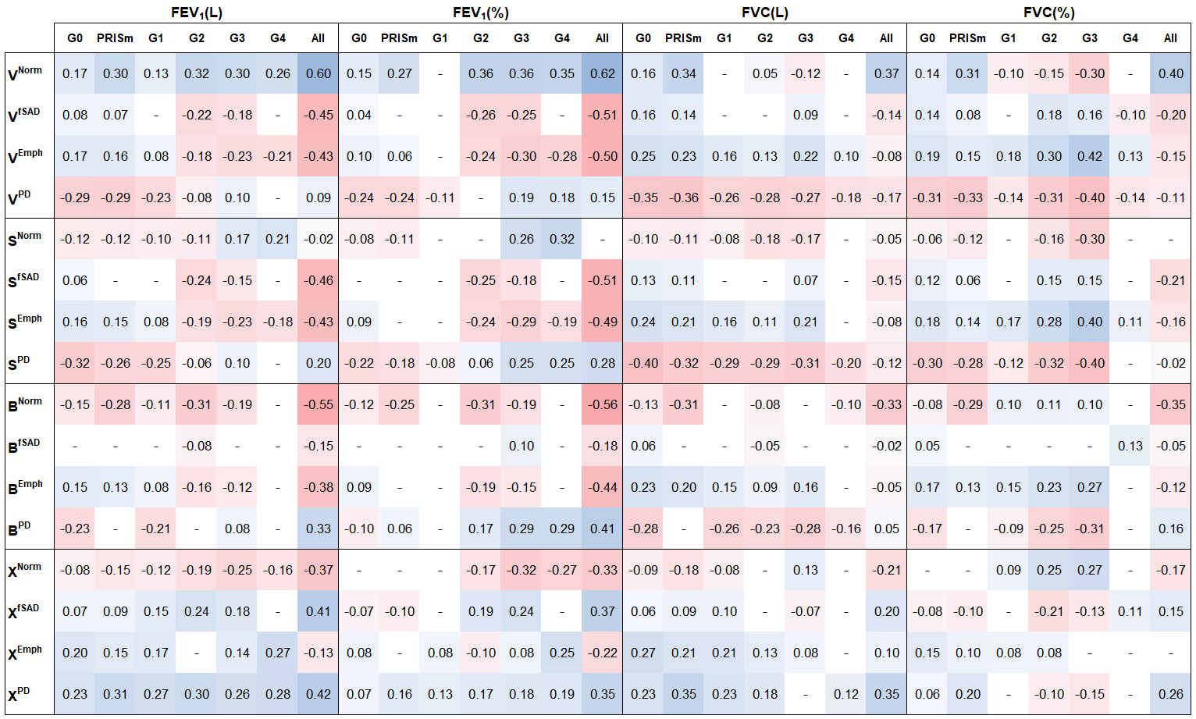
Legend: Correlations between tPRM and PFT measures. G, GOLD; PRISm, preserved ratio impaired spirometry; FEV₁, forced expiratory volume in one second; FVC, forced vital capacity; Norm, normal; fSAD, functional small airways disease; Emph, emphysema; PD, parenchymal disease; V, volume density; S, surface area; B, mean breadth; χ, Euler-Poincaré characteristic. Conditional formatting from red ($ρ$ = -1) to blue ($ρ$ = 1) through white ($ρ$ = 0) applied for every coefficient. Cells with statistically insignificant correlation (p > 0.05) are marked with a dash (-).

Table E3 – Spearman’s rank correlation matrix between tPRM metrics and PFT measures/SGRQ total score.
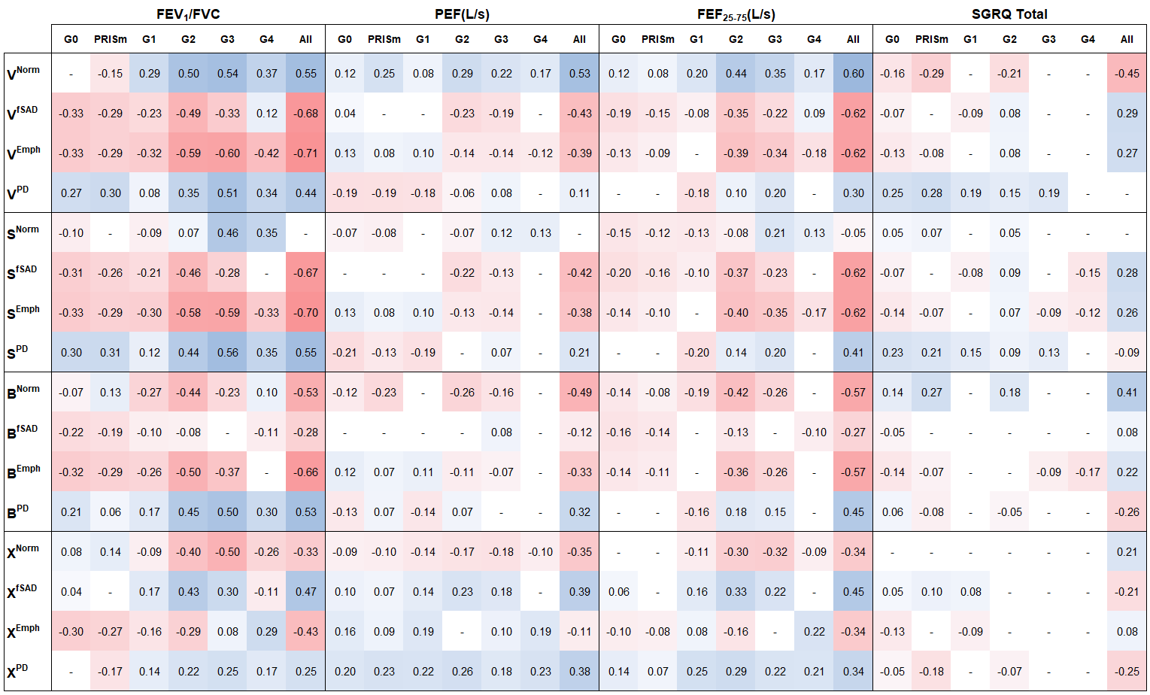Legend: Correlations between tPRM and PFT measures/SGRQ total score. G, GOLD; PRISm, preserved ratio impaired spirometry; FEV₁, forced expiratory volume in one second; FVC, forced vital capacity; PEF, peak expiratory flow; FEF, forced expiratory flow; SGRQ, St. George’s Respiratory Questionnaire; Norm, normal; fSAD, functional small airways disease; Emph, emphysema; PD, parenchymal disease; V, volume density; S, surface area; B, mean breadth; χ, Euler-Poincaré characteristic. Conditional formatting from red ($ρ$ = -1) to blue ($ρ$ = 1) through white ($ρ$ = 0) applied for every coefficient. Cells with statistically insignificant correlation (p > 0.05) are marked with a dash (-).
Table E4 – Spearman’s rank correlation matrix between tPRM metrics and demographical/clinical measures.
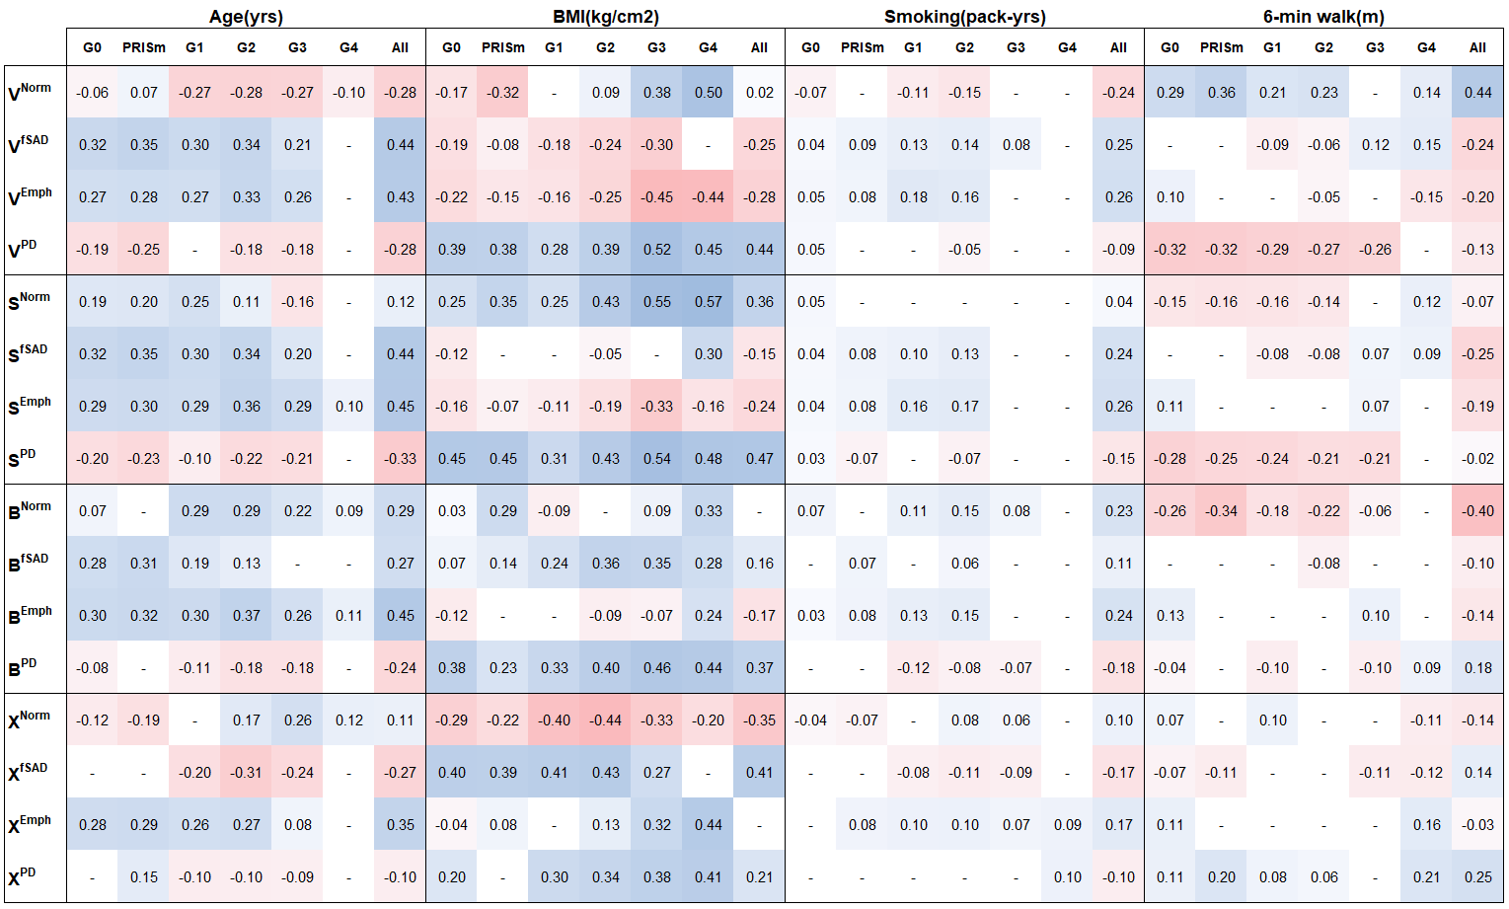
Legend: Correlations between tPRM and demographical/clinical measures. BMI, body mass index; G, GOLD; PRISm, preserved ratio impaired spirometry; Norm, normal; fSAD, functional small airways disease; Emph, emphysema; PD, parenchymal disease; V, volume density; S, surface area; B, mean breadth; χ, Euler-Poincaré characteristic. Conditional formatting from red ($ρ$ = -1) to blue ($ρ$ = 1) through white ($ρ$ = 0) applied for every coefficient. Cells with statistically insignificant correlation (p > 0.05) are marked with a dash (-).

