Supplementary Material
Table 1S: Demographic characteristics of small scale’s farmers
The demographic variable of respondents | Respondents (N) | Percentage (%)
Sex
Male | 206 | 98
Female | 4 | 2
Age group
18-30 | 86 | 41
31-54 | 106 | 50.5
>55 | 18 | 8.5
Education level
Illiterates | 87 | 41.4
1 to 8 grades | 108 | 51.4
9 to 12 grades | 13 | 6
College/University | 2 | 1
Farm sizes (ha)
< 1 ha | 126 | 60
> 1 ha | 84 | 40
Land tenure situation
landowners | 80 | 38
landholders | 130 | 61.9
Trend pesticide use past 5 years
Increasing | 172 | 81.9
Constant | 38 | 18
Farming experience
1-3 years | 26 | 12.4
5-10 years | 88 | 41.9
> 10 years | 96 | 45.7
Professional training
Yes | 9 | 4.3
No | 201 | 95.7

Table 2S: Farmers' knowledge, attitude, and understanding of pesticide (n = 210).
Variables | N | %
Do you think that pesticides affect human health?
yes | 187 | 89
No | 15 | 7.1
Don't know | 8 | 3.8
Do you think that pesticides affect the environment?
yes | 43 | 20
No | 145 | 69
Don't know | 22 | 10
Do you think pesticides are indispensable for high crop yield?
yes | 205 | 98
No | 1 | 0.5
Don't know | 4 | 1.9
Do you read, understand and follow pesticide labels
yes | 56 | 27
No | 154 | 73
How do pesticides enter the human body? (Multiple answers possible)
Dermal | 36 | 17
Inhalation | 106 | 50
Oral | 96 | 46
Eye contact | 97 | 46
Don't know | 36 | 17
Do you know the pesticides that are banned or restricted for use?
Yes | 16 | 7.6
No | 194 | 92.2
Do you know the reasons for banning or restricting pesticides? (n=16)
Highly toxic | 9 | 56
Not effective | 3 | 19
Expensive | 2 | 13
Don't know | 2 | 13
Aware of the toxicity color codes present on the pesticide containers
Yes | 10 | 4.8
No | 200 | 95

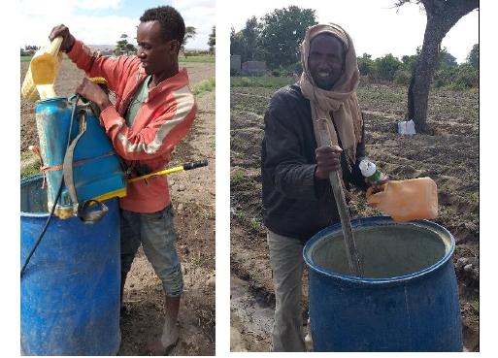
Figure 1S: Small scale framers mixing pesticides with bare hand and with a stick, but bare hands

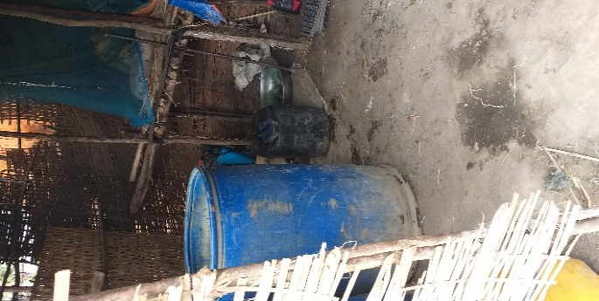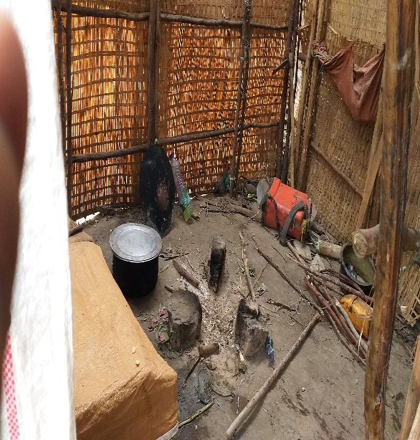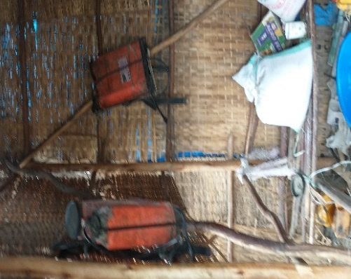
Figure 2S: Leftover pesticide, mixer tank, and Knapsacks (sprayer) in the kitchen (small huts for living and cooking)
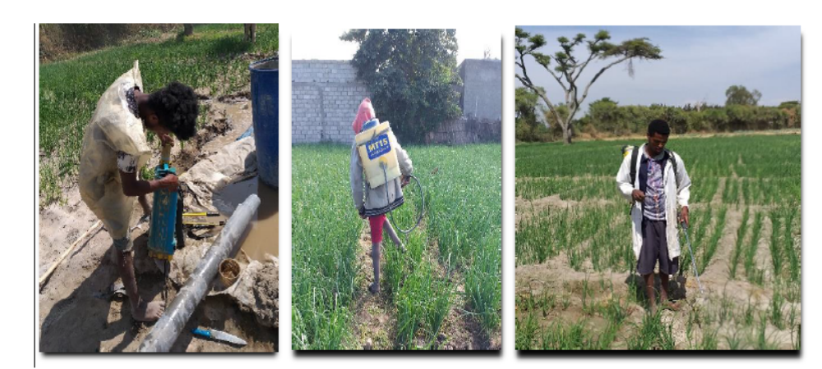
Figure 3S: Small farmers without improper PPE (bar foot, no facemask, and no glove) while spraying pesticides

