Appendix
Table 19:Trend of dam construction in Cauvery River Basin
Completed | Area (km²) | (%) area | No. of dams
1895 | 110 | 0.13 | 2
1906 | 2,444 | 3.01 | 9
1930 | 2,447 | 3.01 | 11
1940 | 42,220 | 52.0 | 18
1951 | 42,392 | 52.2 | 22
1961 | 47,257 | 58.2 | 30
1970 | 48,157 | 59.3 | 48
1980 | 49,039 | 60.4 | 61
1990 | 49,326 | 60.8 | 79
2001 | 51,585 | 63.6 | 84
2007 | 51,771 | 63.8 | 88
total | 52,189 | 64.3 | 96
Source: Catchments delineated by author using ArcGIS 10.
Table 20: Study catchments characteristics
Site | Name | Area (km²) | Elevation of the Gauge station (m) | Population | Density (persons/km²) | Forest Area (%) | Crop land (%) | Built-up Area (%) | Plantations (%) | Fallow Land (%)
1 | T. Bekuppe (TB) | 3,500 | 615 | 3,080,733 | 880 | 9.5 | 28.9 | 7 | 12.9 | 37.5
2 | M. H. Halli (MHH) | 3,050 | 844 | 972,312 | 318 | 0.7 | 20.5 | 1.3 | 40.3 | 31.6
3 | Chunchunkatte (Ch) | 2,995 | 757 | 628,429 | 209 | 7.4 | 7.8 | 0.8 | 43.7 | 36.2
4 | E. Managalam (EM) | 3,386 | 135 | 3,615,565 | 1067 | 5.7 | 34.6 | 11.8 | 3.5 | 35.1
 | Modelled catchment | 66,243 | 78 | 25,965,237 | 392 | 19.41 | 26 | 2.3 | 18 | 27.3
Source: (Census of India, 2011; Central Water Commission, 2014; Roy et al., 2016)
Table 21: Streamflow during dry and wet seasons as percentage of total annual streamflow at selected gauging stations
Station | Stream flow as % of total Annual discharge in Dec-May (dry season) | Stream flow as % of total Annual discharge in June-November (wet season)
Sakleshpur | 6.10% | 93.90%
M. H. Halli | 22.36% | 77.64%
Chunchunkatte | 5.48% | 94.52%
Kudige | 6.10% | 93.90%
T. Bekuppe | 35.59% | 64.41%
Biligundulu | 16.72% | 83.28%
E. Managalam | (Mar-Aug) 18.72% | (Sept-Feb)81.27%

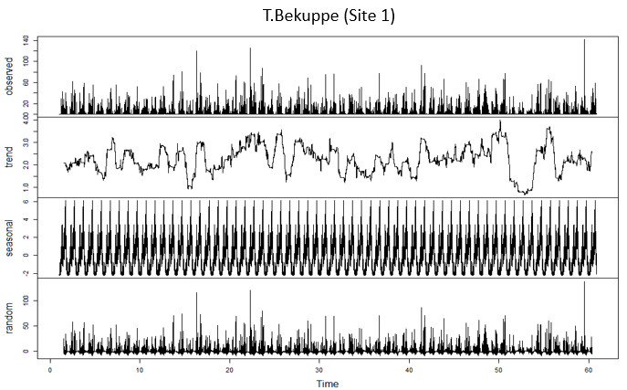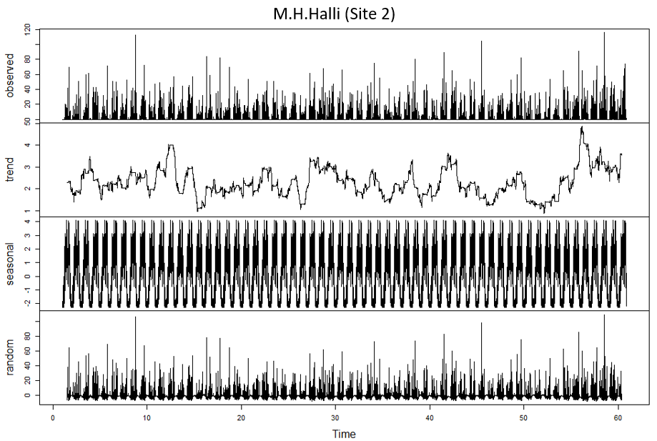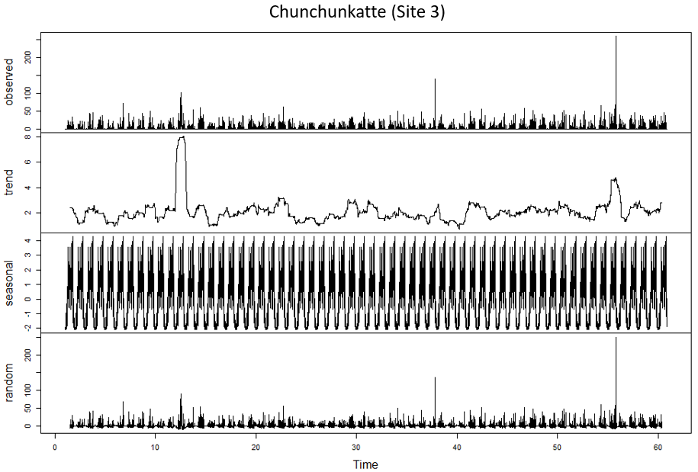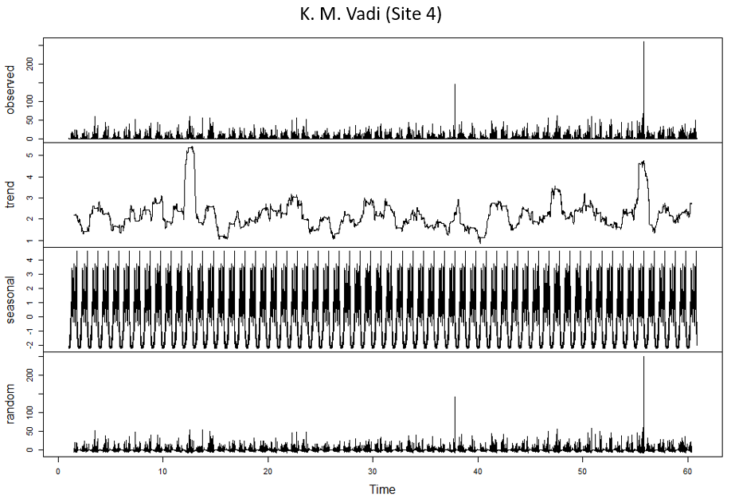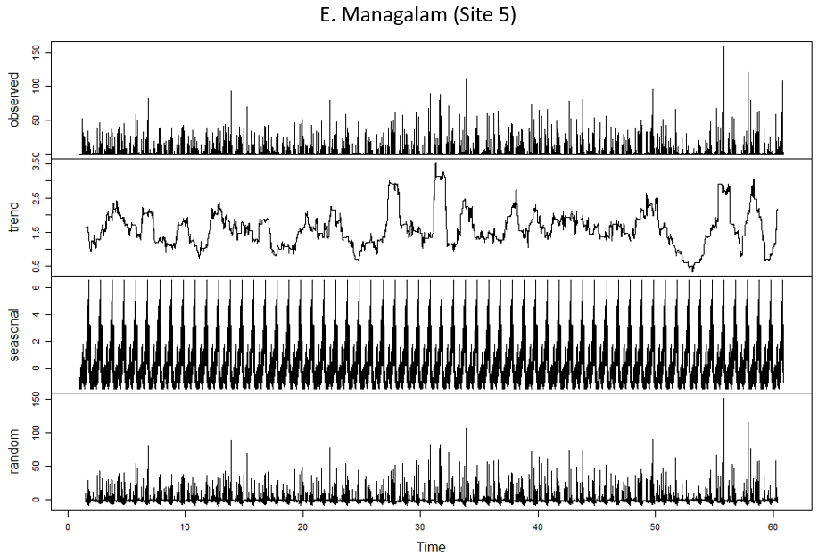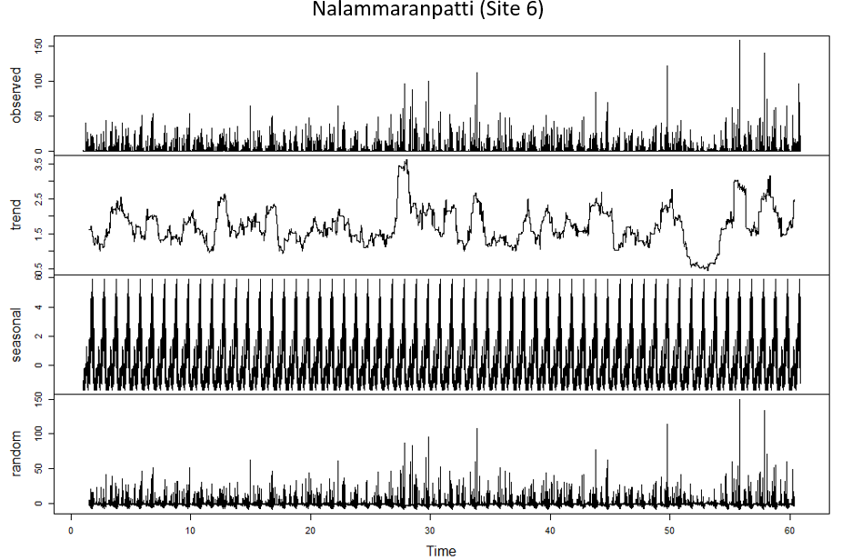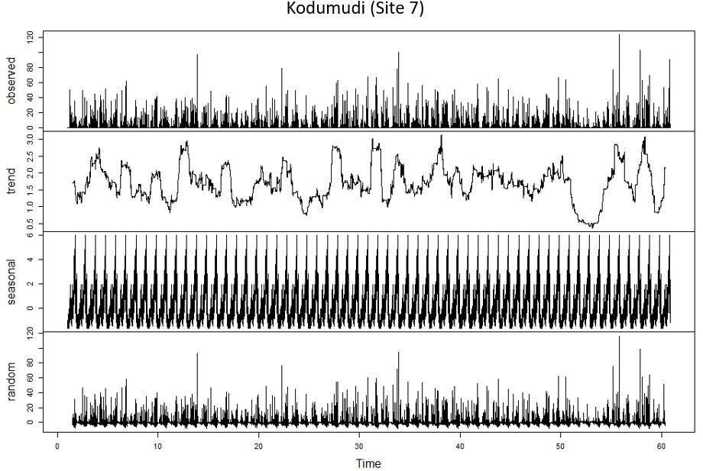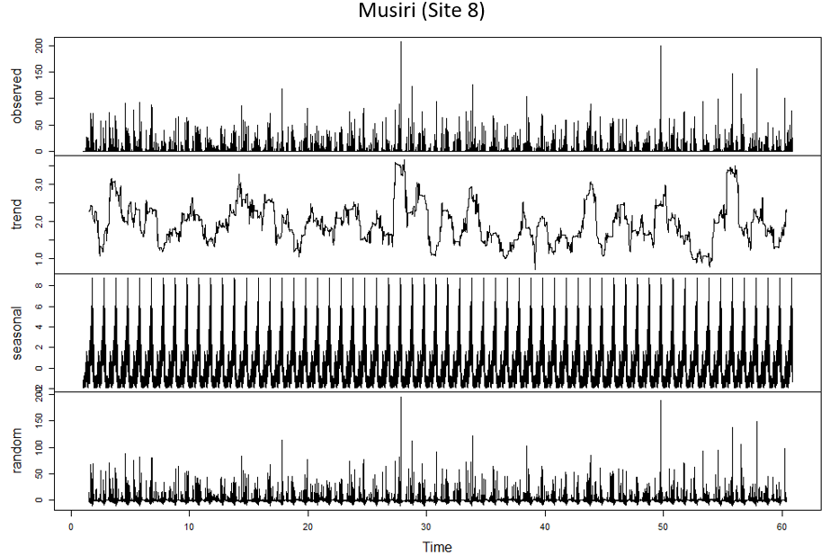
Figure 23: Trend graphs of daily rainfall time-series at selected meteorological stations (1951-2010)
Source: (Pai et al., 2014)

Table 22: Deviation (%) in Annual mean daily discharge in Baseline scenario and scenarios with improved IE and SL at four selected sites in Cauvery basin based on GWAVA simulations
Irrigation Efficiency (%) | Site 1 | Site 2 | Site 3 | Site 4
Baseline | 18 m³/s | 52 m³/s | 59 m³/s | 170 m³/s
50 | 0.014% | 0.03% | 0.01% | 0.02%
55 | 0.031% | 0.04% | 0.02% | 0.04%
60 | 0.05% | 0.05% | 0.02% | 0.05%
65 | 0.06% | 0.06% | 0.02% | 0.07%
70 | 0.07% | 0.07% | 0.02% | 0.08%
75 | 0.08% | 0.07% | 0.02% | 0.09%
80 | 0.09% | 0.08% | 0.03% | 0.1%
Water supply loss (%) | Site 1 | Site 2 | Site 3 | Site 4
20 | 0.01% | 0.02% | 0.01% | -0.001%
15 | 0.004% | 0.02% | 0.01% | -0.001%
10 | -0.0009% | 0.02% | 0.01% | -0.001%
5 | -0.007% | 0.01% | 0.01% | -0.002%

Table 23: Q10, Q50 and Q90 in Baseline and future scenarios
Sites | Exceedance (%) | BL | CC8.5 | SSP1+CC8.5 | SSP3+CC8.5
T. Bekuppe | 10% | 14.004 | 9.637 | 11.59 | 8.11
T. Bekuppe | 50% | 5.37 | 5.544562 | 5.822 | 5.502981
T. Bekuppe | 90% | 0 | 0 | 0 | 0
M. H. Halli | 10% | 36.234 | 22.089 | 29.448 | 20.635
M. H. Halli | 50% | 13.183 | 7.517 | 13.75 | 4.483
M. H. Halli | 90% | 3.853 | 3.963 | 2.409 | 2.409
Chunchunkatte | 10% | 178.9741 | 155.5924 | 147.6894 | 131.4727
Chunchunkatte | 50% | 23.34203 | 14.91818 | 14.71761 | 7.169035
Chunchunkatte | 90% | 0 | 0.26229 | 0.192454 | 0.152031
E. Managalam | 10% | 12.51 | 3.741 | 16.71 | 11.05
E. Managalam | 50% | 2.535 | 1.507 | 3.063 | 2.026
E. Managalam | 90% | 0.6 | 0.546 | 1.344 | 0.662
Biligundulu | 10% | 479.2 | 356.77 | 417.625 | 289.533
Biligundulu | 50% | 98.275 | 59.148 | 83.78 | 49.911
Biligundulu | 90% | 32.55 | 22.451 | 46.492 | 11.392

Table 24: Number of flow points showing significant deviation in High flow and Low flow indices.
Hydrological indices | CC8.5 | SSP1 | SSP3
HF1 | 70 | 65 | 77
HF2 | 54 | 45 | 64
HF3 | 29 | 26 | 28
HF4 | 62 | 38 | 63
HF5 | 46 | 49 | 52
LF1 | 84 | 82 | 84
LF2 | 47 | 45 | 54
LF3 | 13 | 14 | 17
LF4 | 84 | 81 | 84
LF5 | 49 | 54 | 61

