Supplemental material for
Mapping Algorithms for Predicting EQ-5D Utilities from the Assessment Test of chronic obstructive pulmonary disease
Chun-Hsiang Yu¹, Sheng-Mao Chang², Chih-Hui Hsu³, Sheng-Han Tsai⁴, Xin-Min Liao¹, Chian-Wei Chen¹, Ching-Hsiung Lin⁵, Jung-Der Wang⁶, Tzuen-Ren Hsiue¹, and Chiung-Zuei Chen¹*
Authors’ affiliation
1. Division of Pulmonary Medicine, Department of Internal Medicine, National Cheng Kung University Hospital, College of Medicine, National Cheng Kung University, Tainan, Taiwan
2. Department of Statistics, National Taipei University
3. Clinical Medicine Research Center, National Cheng Kung University Hospital, Tainan, Taiwan
4. Division of General Medicine, Department of Internal Medicine, National Cheng Kung University Hospital, College of Medicine, National Cheng Kung University, Tainan, Taiwan
5. Division of Chest Medicine, Changhua Christian Hospital, Changhua, Taiwan
6. Department of Public Health, College of Medicine, National Cheng Kung University, Tainan, Taiwan
Corresponding author full contact details:
Name: Chiung-Zuei Chen
Division of Pulmonary Medicine, Department of Internal Medicine, National Cheng Kung University Hospital, College of Medicine, National Cheng Kung University, Tainan, Taiwan
Email: chen96@mail.ncku.edu.tw
Supplementary Figure
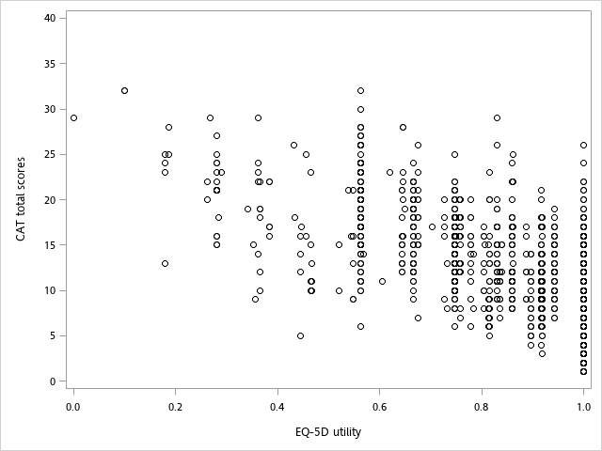
Supplementary Figure S1

Figure S1. Scatter graph of EQ-5D-3L utilities and CAT total scores. The darker circles represent higher data point density. A negative correlation (-0.69) between EQ-5D-3L utility and CAT total score was observed.

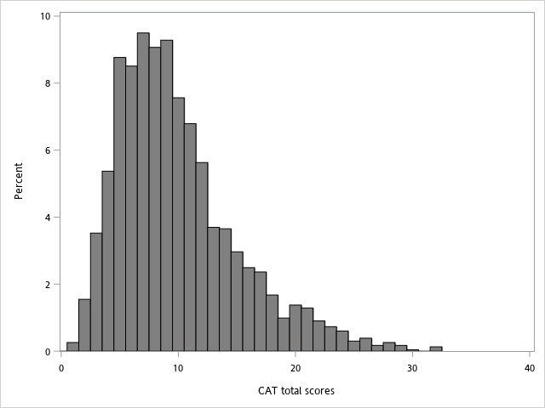
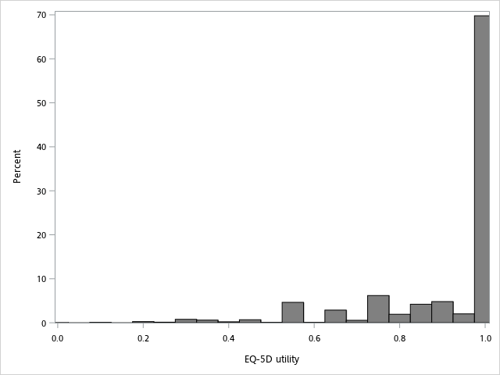
Supplementary Figure S2

Figure S2. Distributions of EQ-5D-3L utilities and CAT total scores. The largest cluster was located at EQ-5D utility=1: n=1624 (69.79% of observations). The other clusters were 0 ≤ EQ-5D < 0.5: n=65 (2.79%) and 0.5 ≤ EQ-5D < 1: n=638 (27.42%).
CAT, COPD assessment test; COPD, chronic obstructive pulmonary disease; EQ-5D, EuroQol five-dimensional questionnaire.

