SUPPLEMENTAL MATERIAL

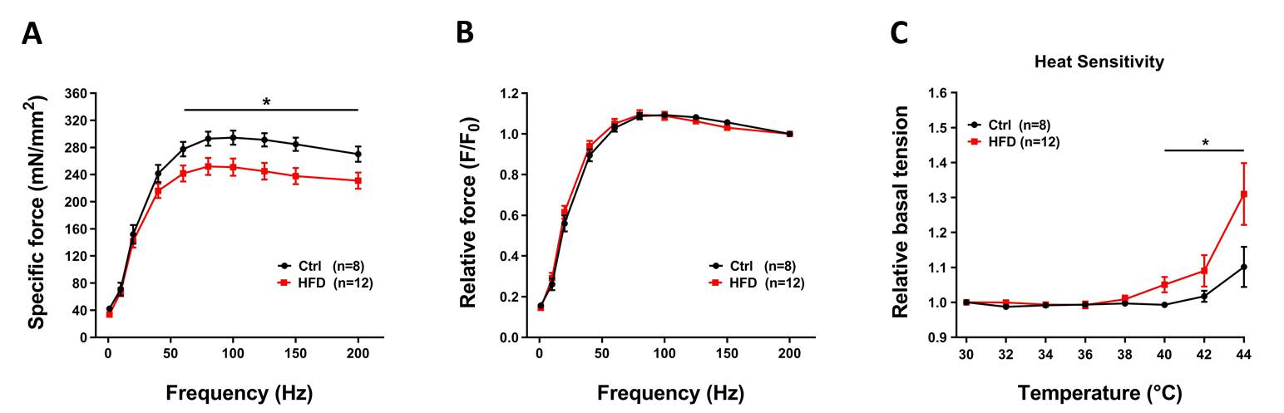

Figure S1. In vitro specific force and temperature dependence of basal tension in Soleus muscles. A and B) Force frequency (1-200Hz) curve of specific force (panel A) and relative force normalized to 200Hz (panel B) in isolated Soleus muscles. C) Relative basal tension (normalized to 30°C) during exposure to increasing temperature (from 30 to 44ºC). Data are shown as mean ± SEM (*p<0.05), as evaluated two-way ANOVA followed by Tukey´s post-hoc test. n = number of Soleus muscles tested.

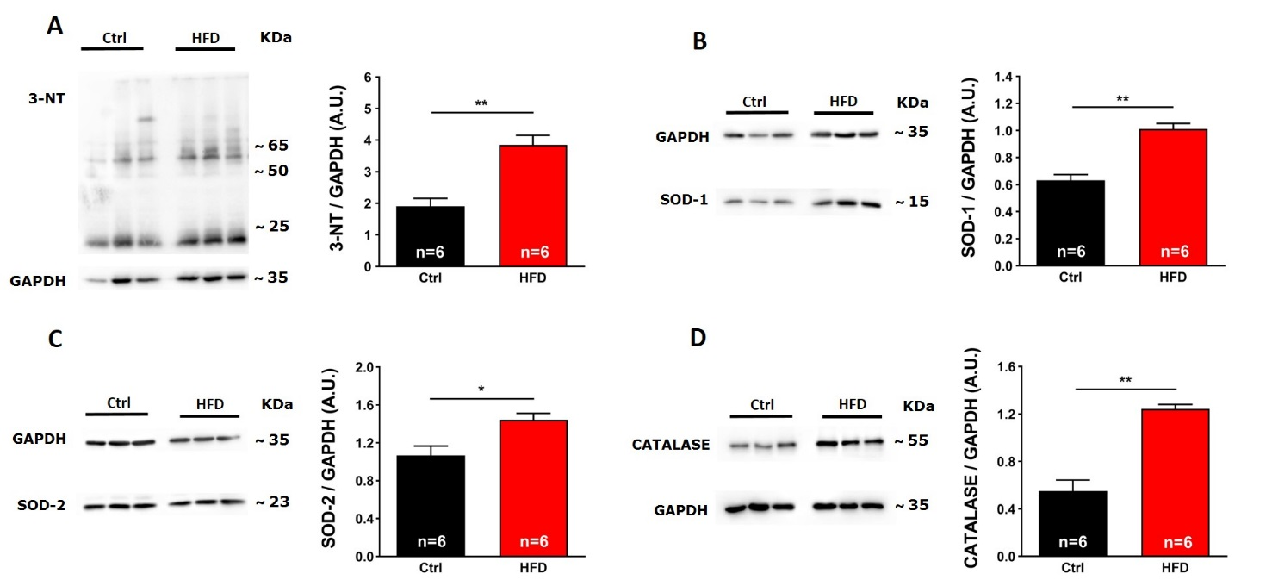

Figure S2. Markers of oxidative and nitrosilative stress in Soleus muscles. Representative immunoblots (left) and relative band densities normalized to GAPDH levels (right) of 3-NT (panel A), SOD-1 (panel B), SOD-2 (panel C), and Catalase (panel D) in Soleus muscle homogenates. Data are shown as mean ± SEM (*p<0.05 and **p<0.01), as evaluated by two-tailed unpaired Student’s t-test. n = number of mice tested.

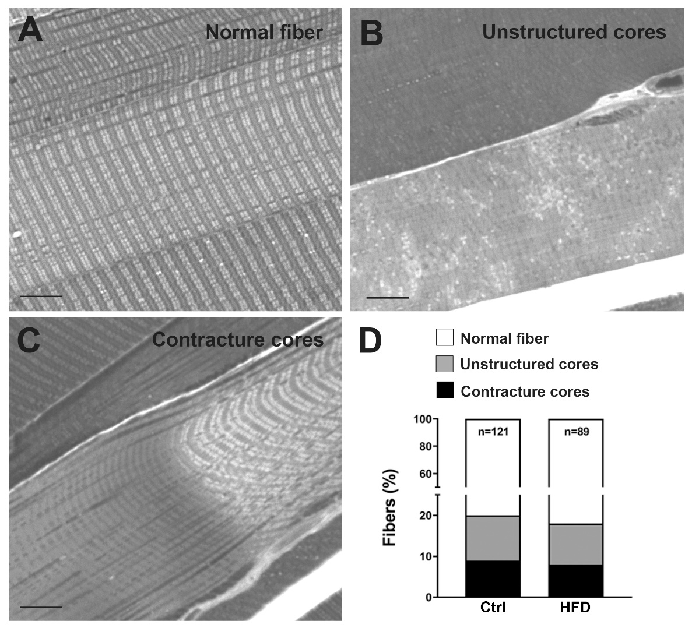

Figure S3. Muscle damage after the HS protocol evaluated by histological analysis. Quantitative analysis (panel D) in histological sections of EDL fibers, which were classified in three groups: presenting normal appearance (as in panel A), containing areas with loos of striation (as in panel B), or finally containing contracture cores (as in panel C). n = number of EDL fibers analyzed.

(Ctrl Diet)
Metabolized energy
Content | Value (Kcal/Kg) | Percentage (%)
Fat | 3.780 | 70
Protein | 842 | 16
Carbonhydrates | 766 | 14
Crude nutrients and moisture
Content | Value (mg/Kg) | Percentage (%)
Moisture | 44.328 | 4.4
Crude Ash | 61.481 | 6.1
Crude Fibre | 47.350 | 4.7
Crude Fat | 420.018 | 42.0
Crude Protein | 210.545 | 21.1
Nitrogenfree Extractives | 216.278 | 21.7

(HF Diet)
Metabolized energy
Content | Value (Kcal/Kg) | Percentage (%)
Fat | 358 | 10
Protein | 828 | 24
Carbonhydrates | 2.329 | 66
Crude nutrients and moisture
Content | Value (mg/Kg) | Percentage (%)
Moisture | 79.090 | 7.9
Crude Ash | 43274 | 4.3
Crude Fibre | 30.829 | 3.1
Crude Fat | 39.725 | 4.0
Crude Protein | 206.900 | 20.7
Nitrogenfree Extractives | 600.183 | 60

Table S1: Energetic and nutrients composition of the diets administrated to Ctrl and HFD mice.

