Supplementary materials

Towards a productivity-based management of tropical reefs in the Anthropocene

Detailed productivity framework to estimate growth rates, biomass production and productivity

Individual growth rates determine the energy flux at the community level, leading to changes in biomass production. Thus, scaling growth rates for individuals in order to establish predictions at ecosystem levels is crucial. Thus, scaling growth rates at individual level is the first step to estimate production and productivity and establish predictions at ecosystem levels. Here, we used the Metabolic Theory of Ecology (MTE)¹, linear mixed effect models (LME) and a growth rate database of 588 reef-associated fish species ² to estimate individual growth rate of any coral reef fish species at any temperature. Then, we used a series of formulas to combine fish size and abundance from dive surveys with growth rates from the MTE modeling to derive estimates of biomass production and productivity ³. The different methodological steps are described below, followed by outcomes of the modeling.

Growth modeling

The Metabolic Theory of Ecology ^{1,4} states that the joint effects of body size and temperature on any individual biological rate I such as metabolic rate, oxygen consumption rate or growth rate can be modeled using the following equation:
$I\left(M,T\right)=i_{0}·M^{α}·e^{\frac{-Ea}{k_{B}T}}$ (1)

Thus, the mass-specific rate, B, which is equal to I/M, scales as:

$B\left(M,T\right)=i_{0}·M^{-β}·e^{\frac{-Ea}{k_{B}T}}$ (2)

With I individual biological rate, M and T mass and temperature, i0 a normalization constant independent of body size and temperature, E_{a} the activation energy, k_{B} the Boltzmann's constant (8.62 10⁻⁵ eV·K⁻¹) , T absolute temperature in Kelvin, α and β=1-α mass scaling coefficients. This equation only holds within the temperature range of normal activity, which for most organisms lies between 0 and 40°C but varies between species or taxonomic groups. The mass scaling coefficients have a theoretical value of $α$ = ¾ and $β$ = ¼ due to fundamental constraints on metabolic rate and fractal-like design of exchange surfaces and distribution networks. The activation energy $E_{a}$ varies from 0.41 to 0.74 eV (average 0.62 eV) for aerobic organisms including an $E_{a}$ of 0.43 eV for fish ⁴.

In order to model fish growth, we used the Von Bertalanffy growth function (VBGF) which states that, as individuals grow larger, more energy will be used for organism maintenance and growth will slow down and eventually stop:
$L_{t}=L_{∞}·$ and $W_{t}=a·{L_{t}}^{b}$ (3,4)
where L_{t} and W_{t} are fish length and weight at a given time t, K is the growth coefficient, $t_{0}$ the hypothetical age at which L or W equals zero, a and b are the coefficients of the length-weight relationship. K is a relative, mass-specific growth rate and therefore follows the metabolic theory of ecology according to equation 2 which can be rewritten as follow ⁵:
$ln\left(K\right)=ln\left(K_{0}\right)-β·ln\left(M\right)-E_{a}·\frac{1}{k_{B}T}$ (6)
Using a growth rate and temperature database of 588 reef-associated fish species extracted from Fishbase by Morais and Bellwood, 2018, we fitted linear mixed effect models (LME) between ln(K), ln(M) and $\frac{1}{k_{B}T}$ to obtain $ln\left(K_{0}\right)$, $β$ and Ea of equation (6). The term “mixed-effect” refers to the fact that both fixed and random effects are incorporated into the model. Fixed effects correspond to the population level estimate of parameters, while random effects correspond to the variability of parameters among individuals relative to the population of species. We fitted different LME models with genus and family as random effects in order to obtain growth rate estimates at different taxonomic levels. In order to estimate the asymptotic length $L_{∞}$ of the LVB growth function, we fitted the proportionality relationship between $L_{∞}$ and species maximum length L_{max} by LME using genus, and then species as random effects:
$L_{∞}=A·L_{max}$ (7)
Best models were selected according to their lowest AIC. Their predictive capacity was estimated by cross-validation, randomly splitting the dataset into 100 different training (80% of data) and testing (20%) datasets and comparing growth rates K and $L_{∞}$ values predicted from the modeling of training datasets with observed values in testing datasets.

Outputs of K and $L_{∞}$ LME models were then used to estimate fish growth parameters of any species at any temperature T for the calculation of biomass production. For species for which we had no estimate of growth rate in our database, equation (5) and (7) were used to estimate species K and $L_{∞}$ at temperature T using parameters K₀, $β$, Ea and A estimated at genus level when possible (if a growth estimate was known for species of same genus), else at family level (if a growth estimate was known for species of same family), else using models’ fixed-effects (if no growth estimate was available for species of same genus or same family).
In order to estimate growth rate K at temperature T for species for which we already had an estimate of growth rate $K_{c}$and $L_{∞}$ at temperature $T_{c}$ in our database, we used $L_{∞}$ and the following equation derived from equation (5) to estimate a temperature-corrected K:
$K=K_{c}·e^{\frac{E_{a}}{k_{B}}×\left(\frac{1}{T_{c}}-\frac{1}{T}\right)}$ (8)
In the case where several growth rate estimates were available in our growth database for a given species, we selected the record with the closest temperature from our UVC data.

Biomass production
For each of the 2027 sites, we calculated standing biomass, yearly biomass production, and productivity as the ratio between biomass production and biomass by averaging each metric across all available transects surveyed at this site. Total biomass B_{t} of the assemblage of n individual fish of lengths L_{t,i} , length-weight coefficients a_{i}, b_{i}, and masses W_{t,i} surveyed along a given transect at time t was calculated using the following equation:
$B_{t}=\sum_{i=1}^{n}{}a_{i}L_{t,i}^{bi}=\sum_{i=1}^{n}{}W_{t,i}$ (9)
The projected size of each individual at age t + x days was calculated using a derivation of the VBGF, following the procedure in Depczynski et al., 2007;
$L_{t+x}=L_{∞}·\left(1-e^{-k\left(t+x-t_{0}\right)}\right)$ (10)
$t=\left(\frac{1}{K}\right)ln⁡\{\frac{\left(L_{∞}-L_{0}\right)}{\left[\left(1-\left(\frac{L_{t}}{L_{∞}}\right)\right)L_{∞}\right]}\}$ (11)
With t fish age corresponding to fish size L_{t} at time of census, and theoretical age at L=0 (t0) and theoretical length at t=0 (L0) set to zero since we only focused on growth trajectories of adult fish. Biomass production P and productivity P_{b} were then estimated using equation 12 and 13:
$P=B_{t+x}-B_{t}=\sum_{i=1}^{n}{}\left(-a_{i}L_{t,i}^{bi}\right)=\sum_{i=1}^{n}{}\left(W_{t+x,i}-W_{t,i}\right)$ (12)
$P_{b}=\frac{P}{B_{t}}$ (13)
With W_{t+x,i} the projected weight of an individual i calculated from its projected length L_{t+x,i} using Length-Weights coefficients a_{i} and b_{i}.

Growth estimations

Mixed-effect modeling of growth rates for 588 species with random effect at genus level revealed that the most parsimonious model included a random effect only for the mass scaling coefficient ß. The activation energy $E_{a}$ showed no significant variation between genus, with an estimated fixed-effect value of $E_{a}$= 0.38 eV for all genus. The mass scaling coefficient ß varied between 0.08 and 0.28 depending on genus, with a fixed-effect value of 0.19. The model with random effect at family level showed similar results, with ß ranging from 0.13 to 0.25 among families (fixed effect = 0.19) and no significant variation of $E_{a}$ among families (fixed effect = 0.5 eV).

For future analyses, our models will need to be improved, especially at family level, by using a larger database in order to better represent certain families/genus. Estimated values of ß, the mass scaling coefficient given by the slope between fish growth rates and the log of maximum mass, remained close to and within the confidence intervals of the theoretical value of 0.25 predicted by the metabolic theory of ecology (fixed effect = 0.19) ⁶. This value also remained close to those reported in fish ⁵. Our activation energy, given by the slope between fish growth rates and 1/kT, which had a fixed effect of 0.38 for the model at genus level, is close to the value of 0.43 eV reported for fish ⁴.

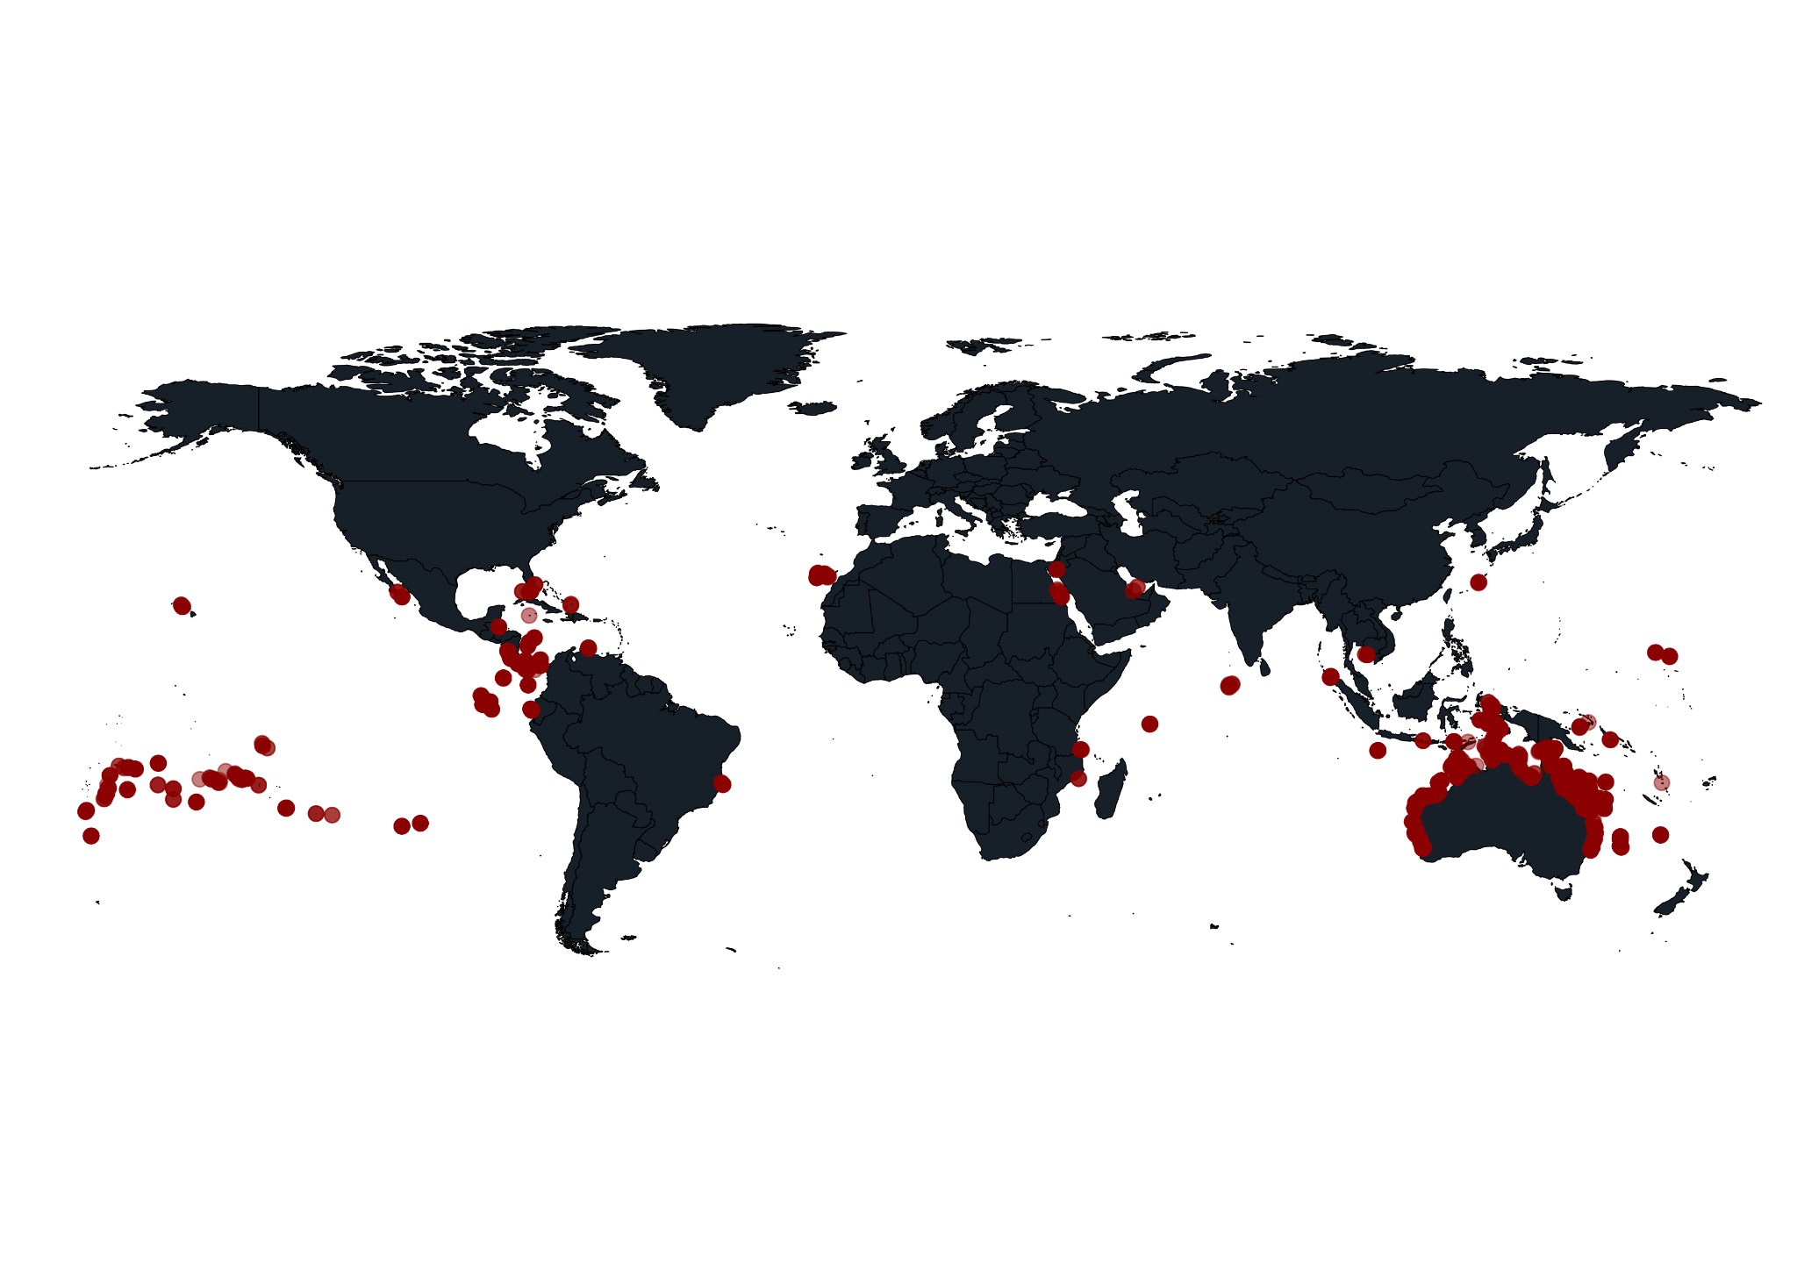

Supplementary Figure 1: Map of the 2027 sites used in the Reef Life Survey database, comprising 3719 over 39 countries.

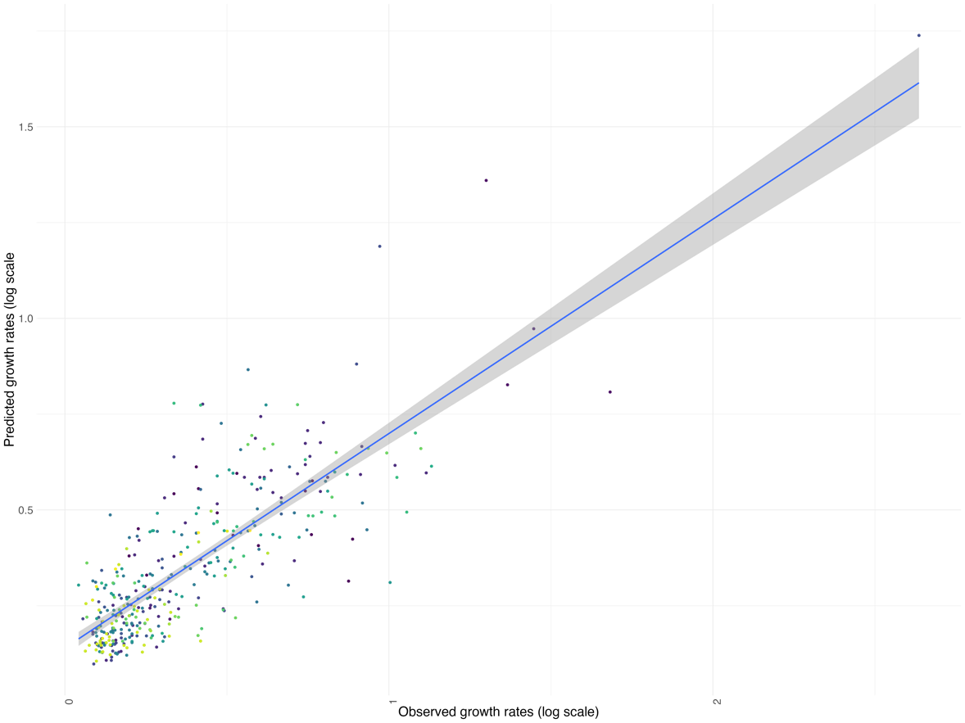
Supplementary Figure 2: Correlation between observed growth rates and predicted growth rates using MTE at family level. Mean performance over 100 cross-validation datasets was R2 = 0.58. Each color represents one of the 49 families in the reef fish growth dataset.

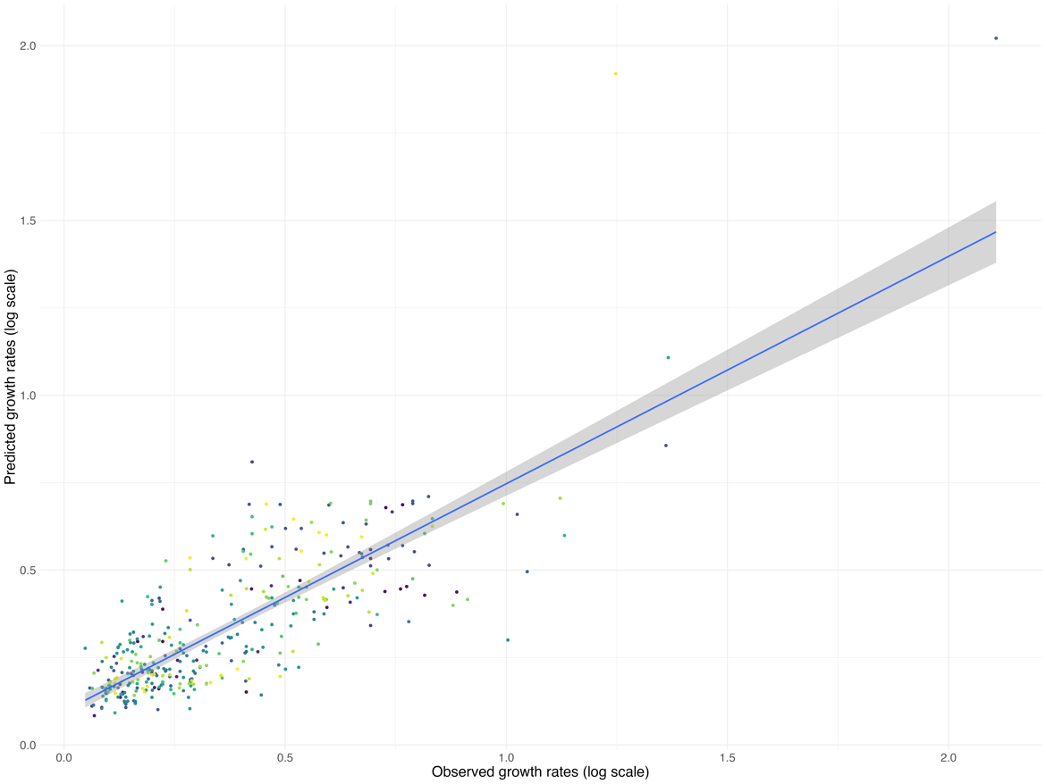
Supplementary Figure 3: Correlation between growth rates and predicted growth rates using MTE at genus level. Mean performance over 100 cross-validation datasets was R2 = 0.65. Each color represents one of the 215 genera in the reef fish growth dataset.

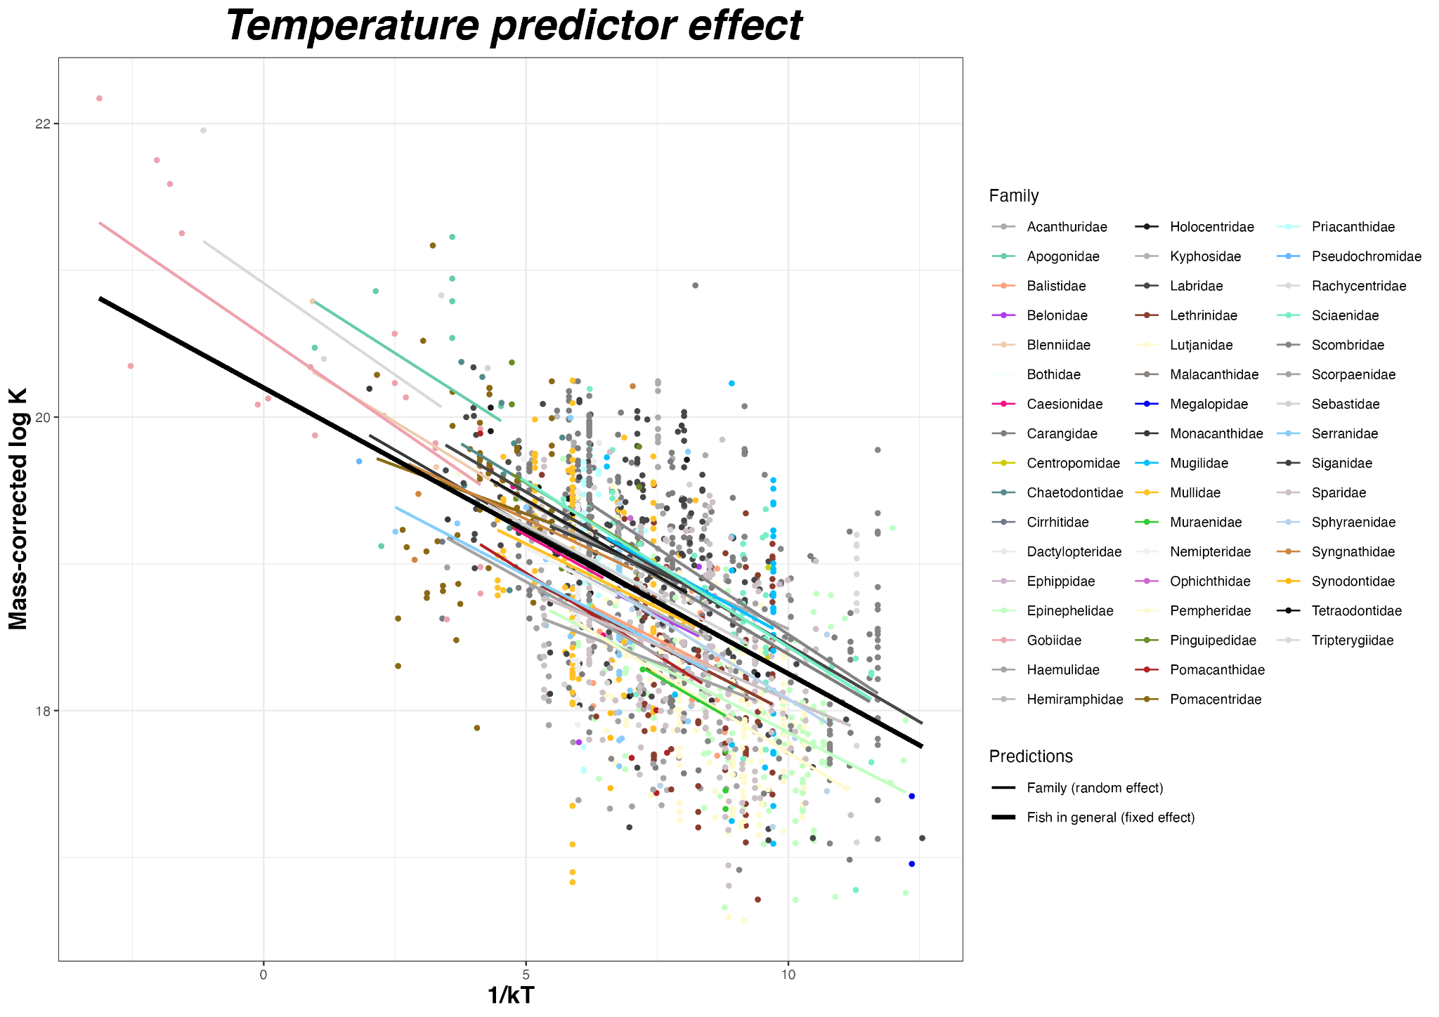
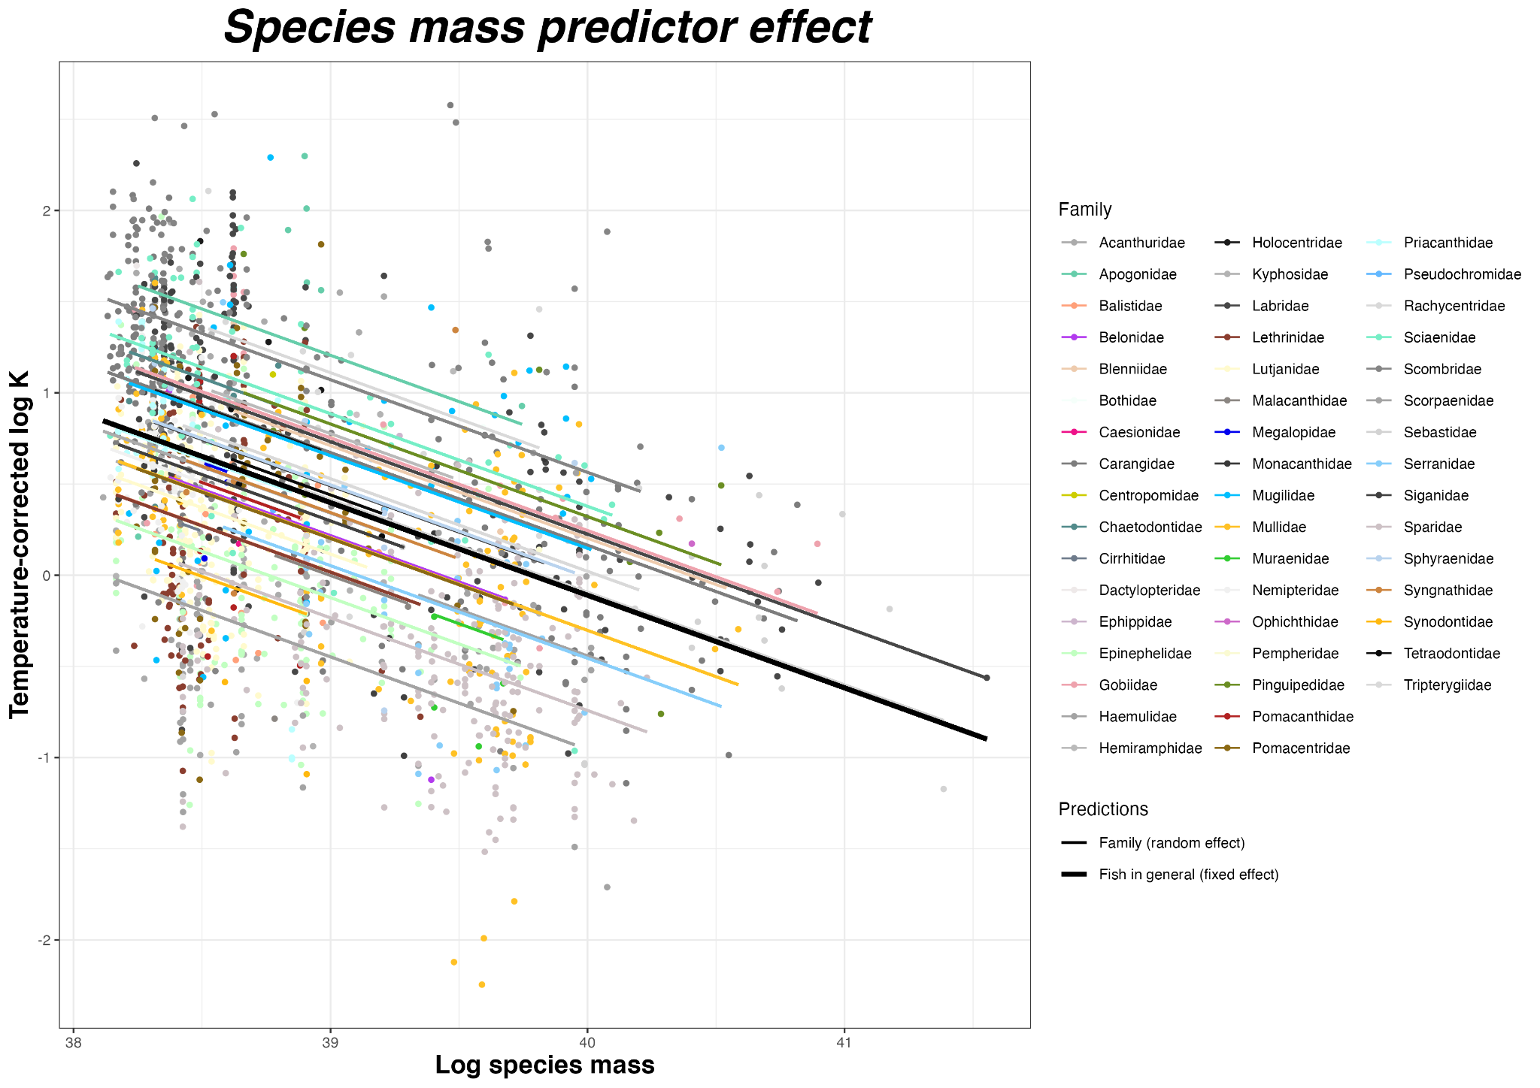

Supplementary Figure 4: A) Relationship between temperature corrected growth rates and species mass (slope is mass scaling coefficient 𝛽). (B) Relationship between the mass corrected growth rate and temperature (slope is negative activation energy -Ea). Relationships are represented for each family (random effect, coloured lines) and for the whole population (fixed effect, black slope).

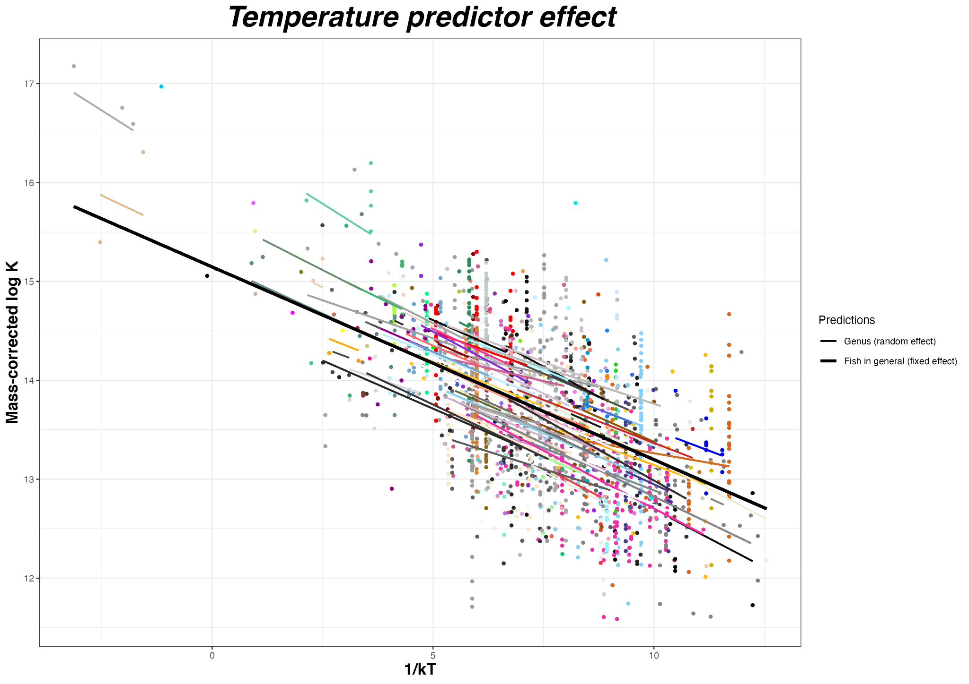
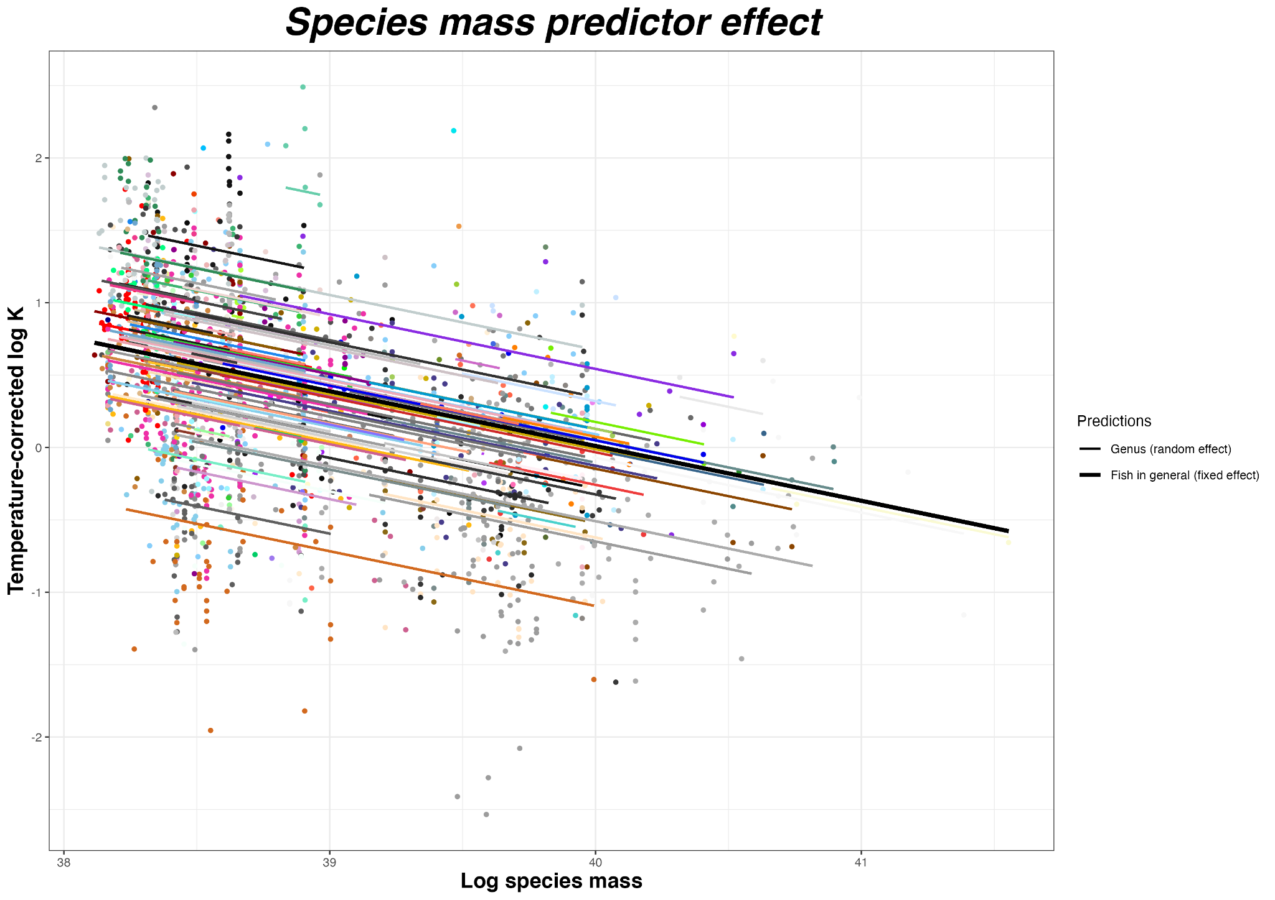

Supplementary Figure 5: A) Relationship between temperature corrected growth rates and species mass (slope is mass scaling coefficient 𝛽). (B) Relationship between the mass corrected growth rate and temperature (slope is negative activation energy -Ea). Relationships are represented for each genus (random effect, coloured lines) and for the whole population (fixed effect, black slope).

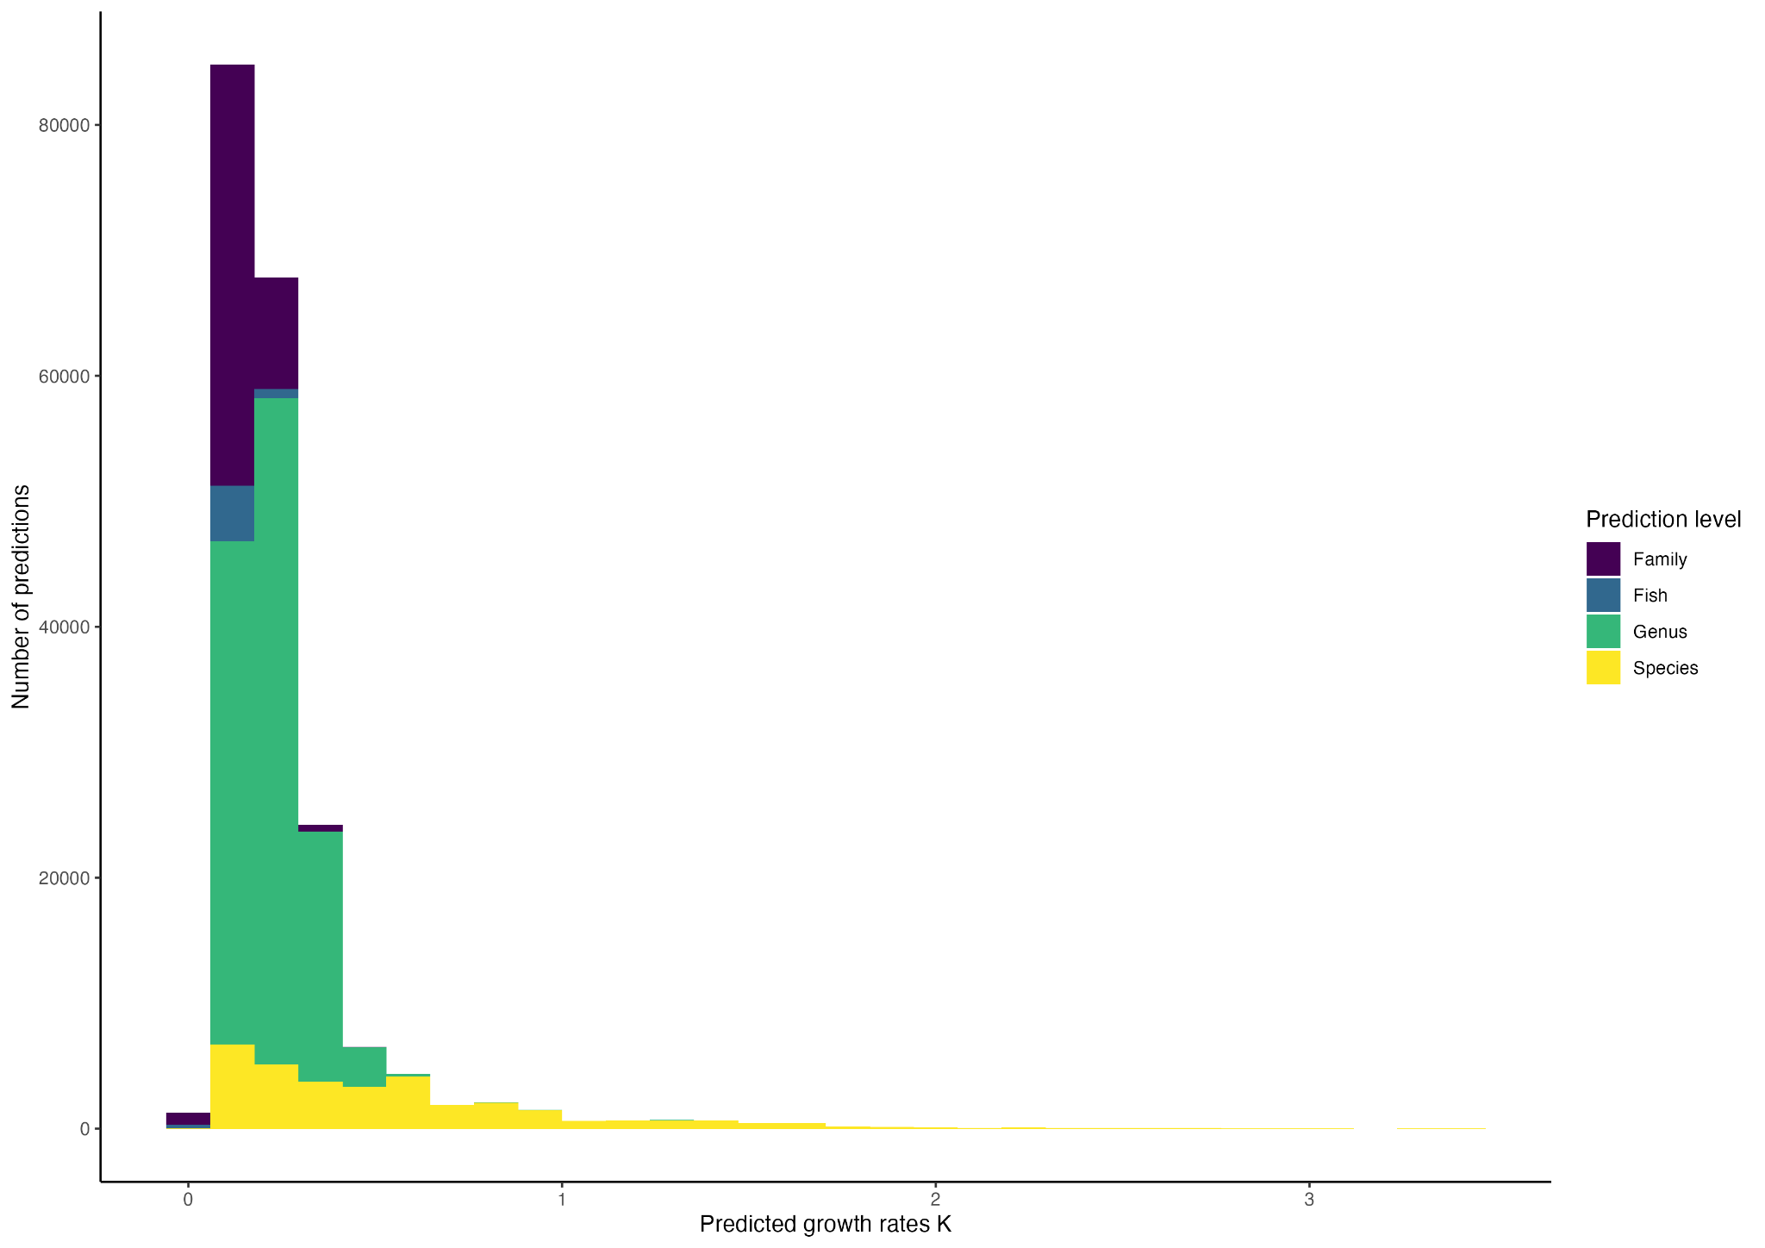

Supplementary Figure 6: Distributions of predicted growth rates for the 198385 reef fish observations across the 2027 Reef Life Survey sites, with the level of prediction in color. Growth rates were predicted at species level if information was already available for the species, else at genus (R2 = 0.66), family (R2 = 0.58), or fish level (fixed effects of the model). In total, 32410 growth rates were predicted at species level and 116548, 44035 and 5392 at genus, family and fish level respectively.

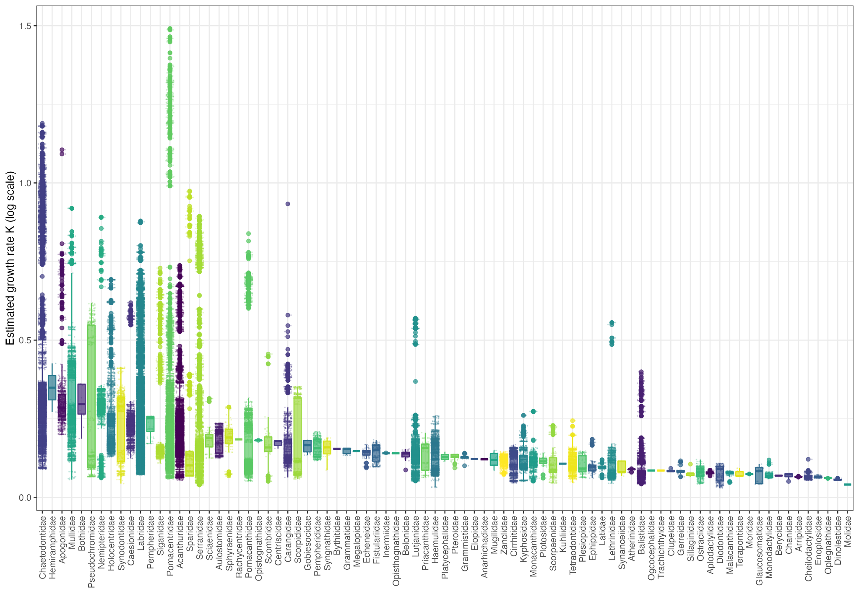

Supplementary Figure 7: Predicted growth rates for the 83 families.

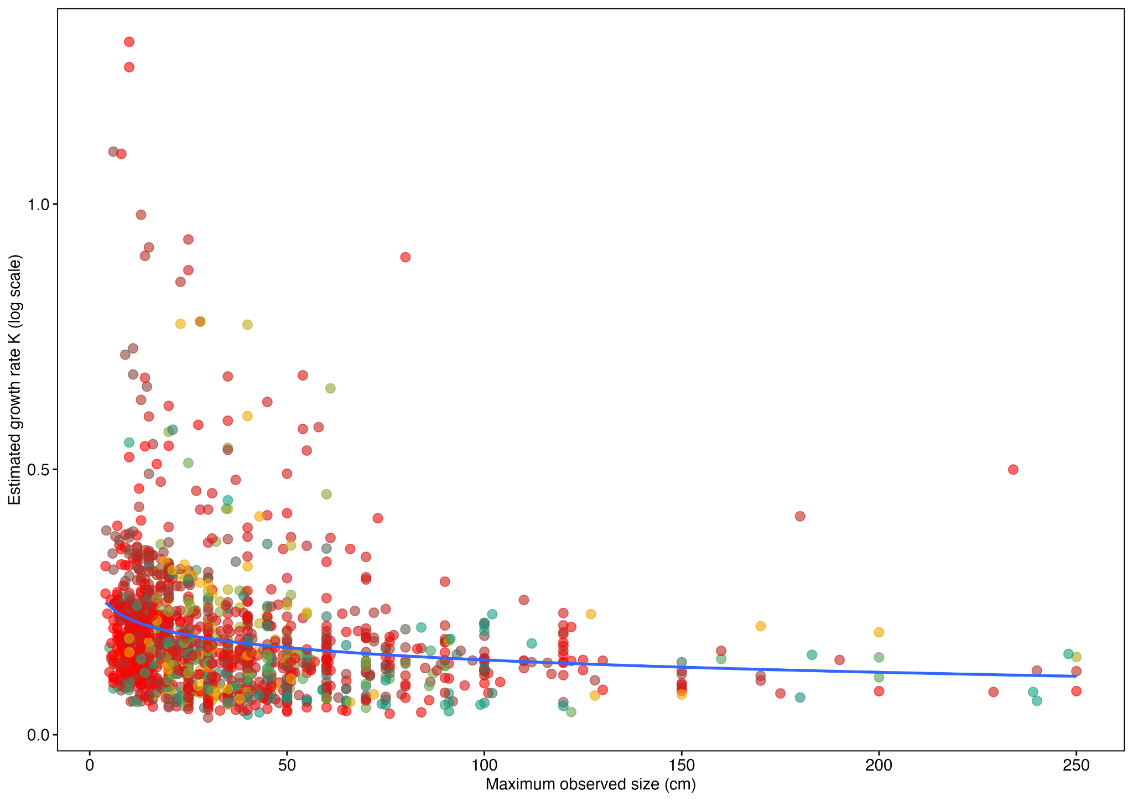
Supplementary Figure 8: Maximum observed size according to estimated growth rates for 83 families. These estimations are coherent with the theoretical relationship between growth rates and maximum size.
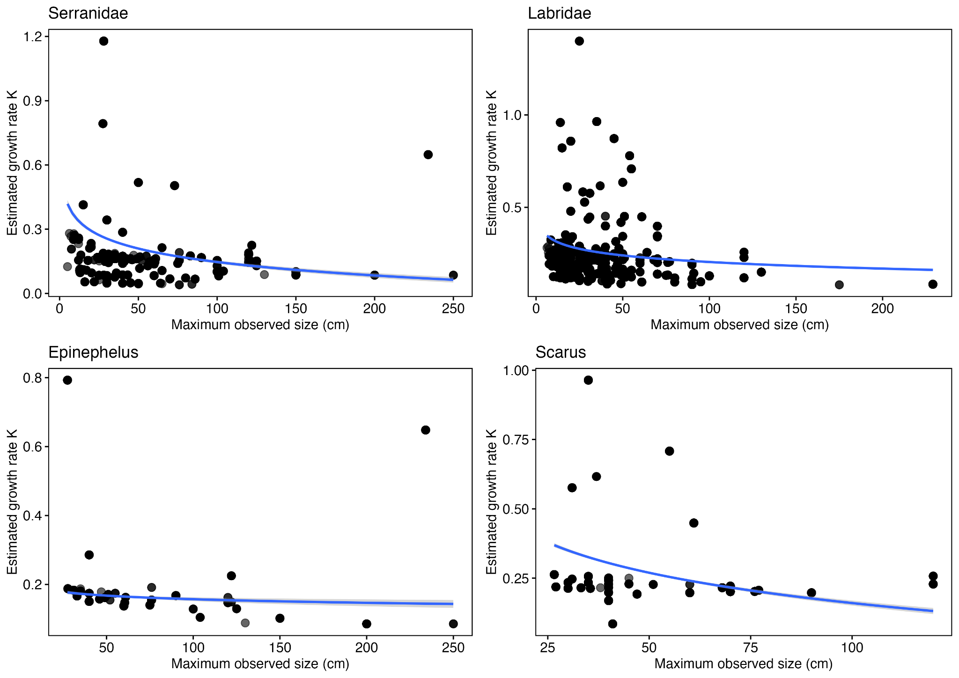
Supplementary Figure 9: Example of the relationship between maximum observed size (cm) according to estimated growth rates for two families (Lutjanidae and Labridae) and two genera (Lutjanus and Bodianus).
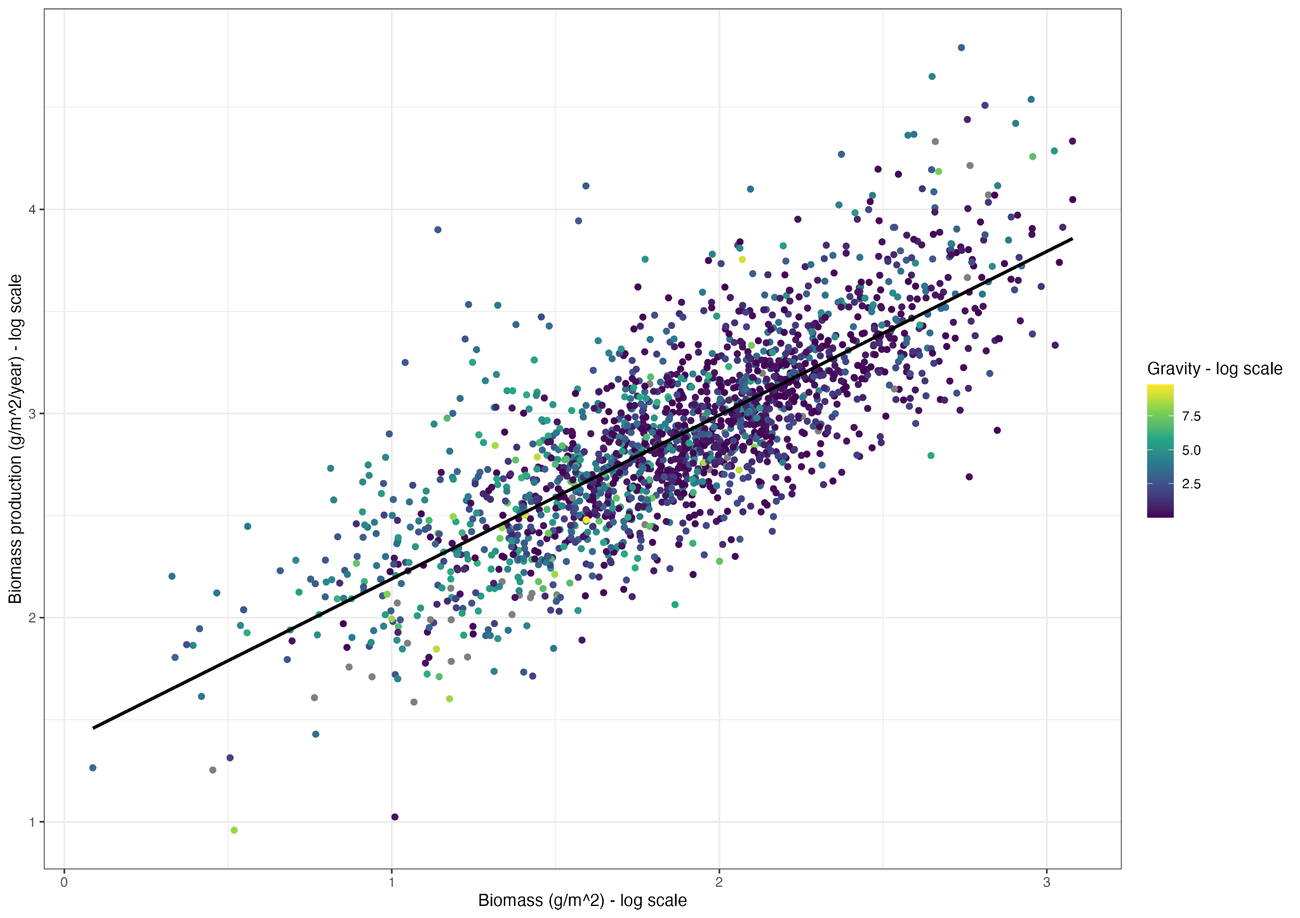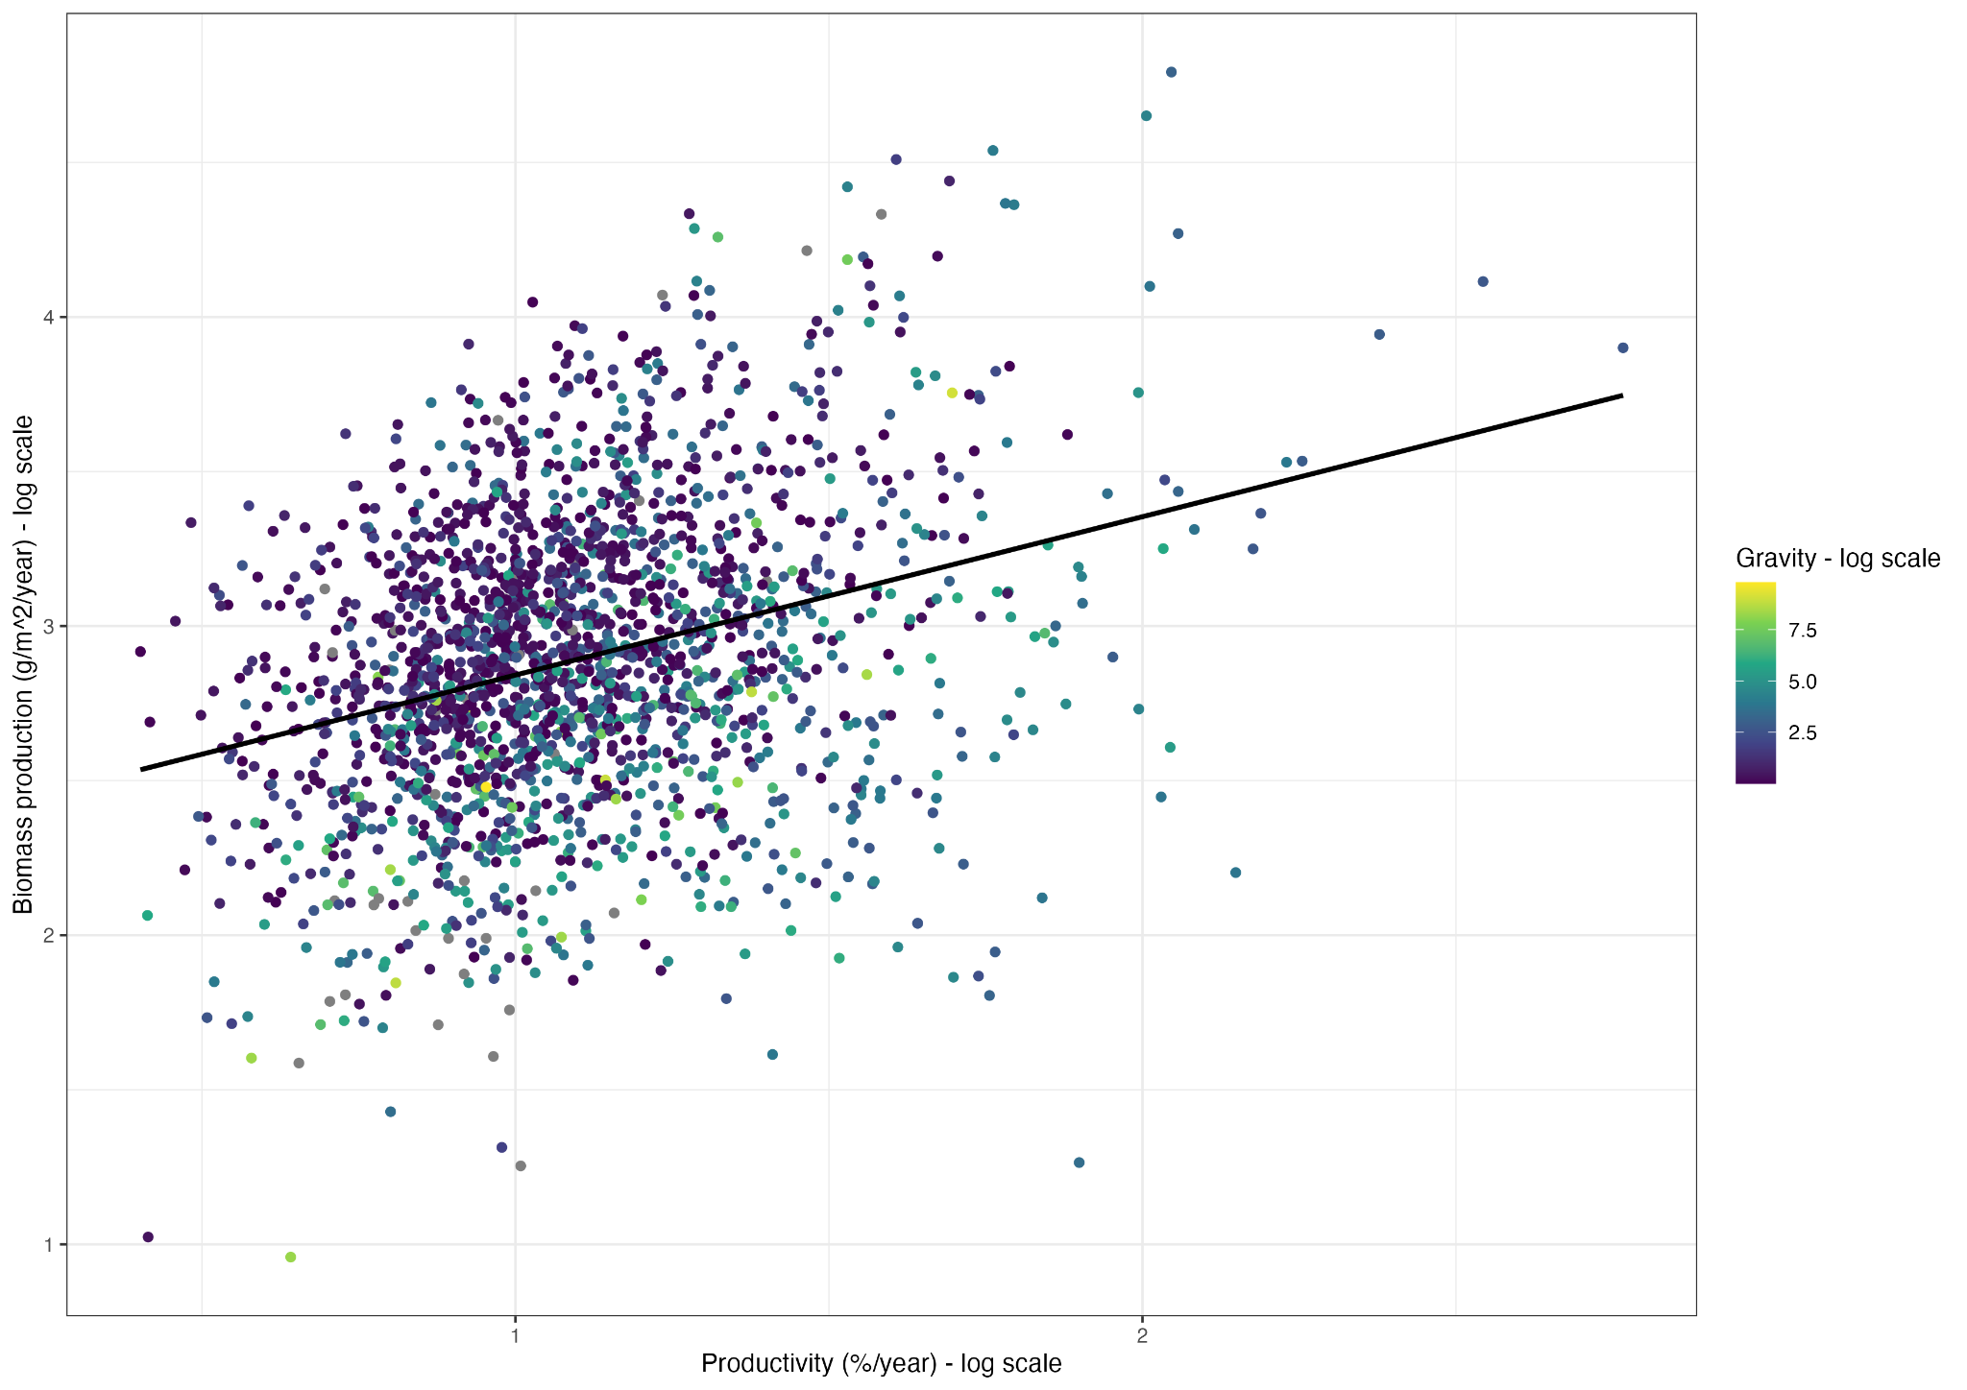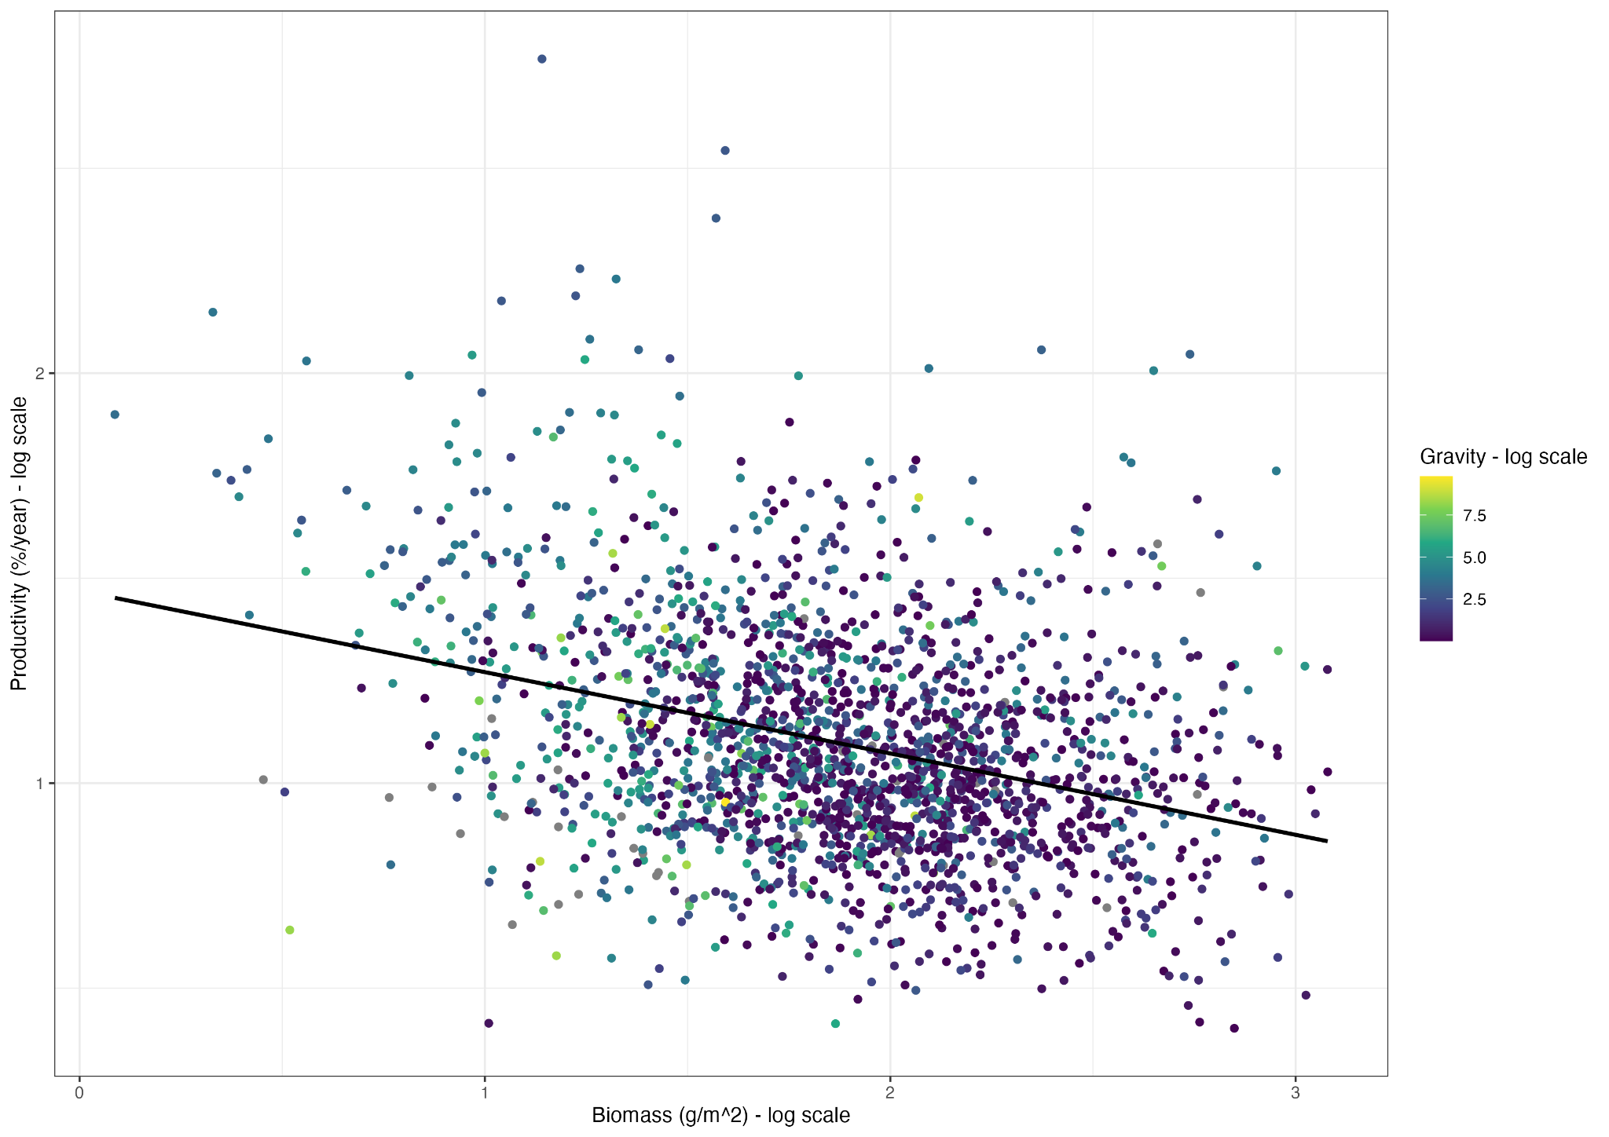

Supplementary Figure 10: Pearson correlation between standing biomass and biomass production (R = 0.79, P < 0.001), biomass production and productivity (R = 0.3, P<0.001) and productivity and biomass (R = -0.33, P<0.001).

Supplementary table 1 : Sensitivity analyses of our biomass/productivity thresholds. We ran the model for thresholds at +2.5%/5% and -2.5%/5% around the used thresholds in the study. Model performance remained stable across all chosen thresholds.

Thresholds | -5% | -2.5% | Used thresholds | +2.5% | +5% (99% for biomass)
Model performance (mean accuracy over 100 cross-validation folds) | 0.62 | 0.68 | 0.71 | 0.73 | 0.75

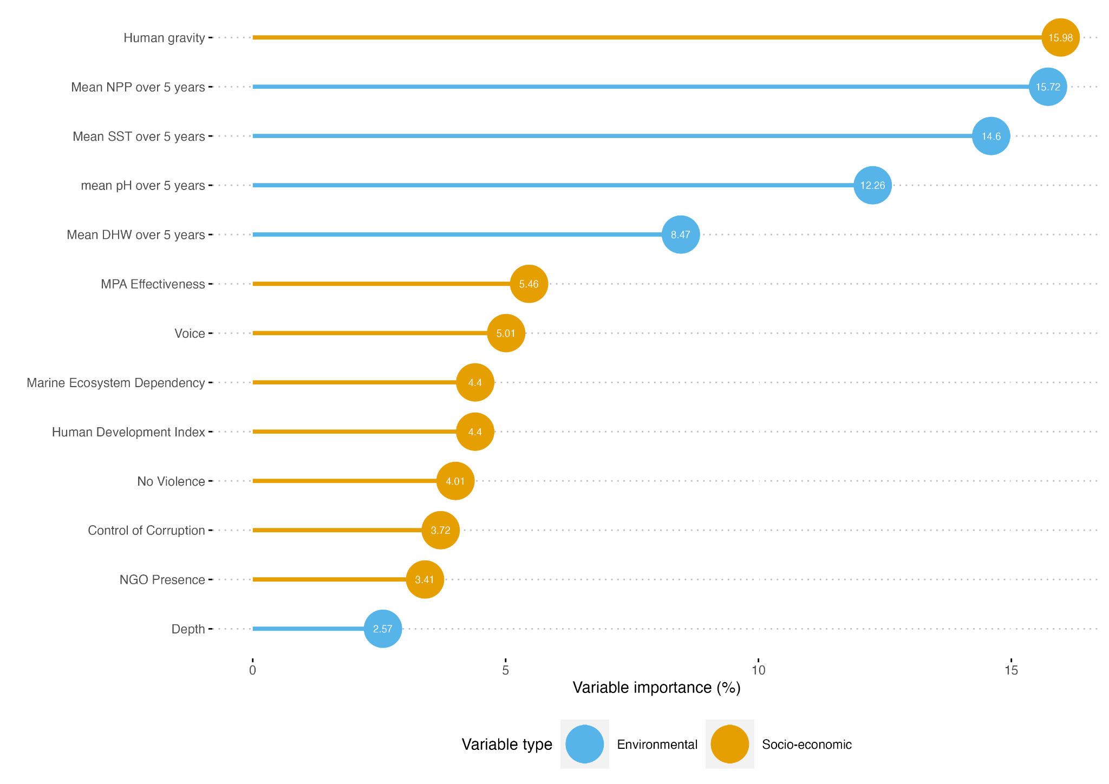
Supplementary Figure 11: Mean relative influence over 100 model iterations of our 13 environmental and socio-economic covariates on management classes using variable permutation. Sea surface temperature, primary productivity and human gravity (a proxy of human impact) had the strongest predictive capacity (relative contribution of 16.7%, 15.4% and 14.8% respectively).

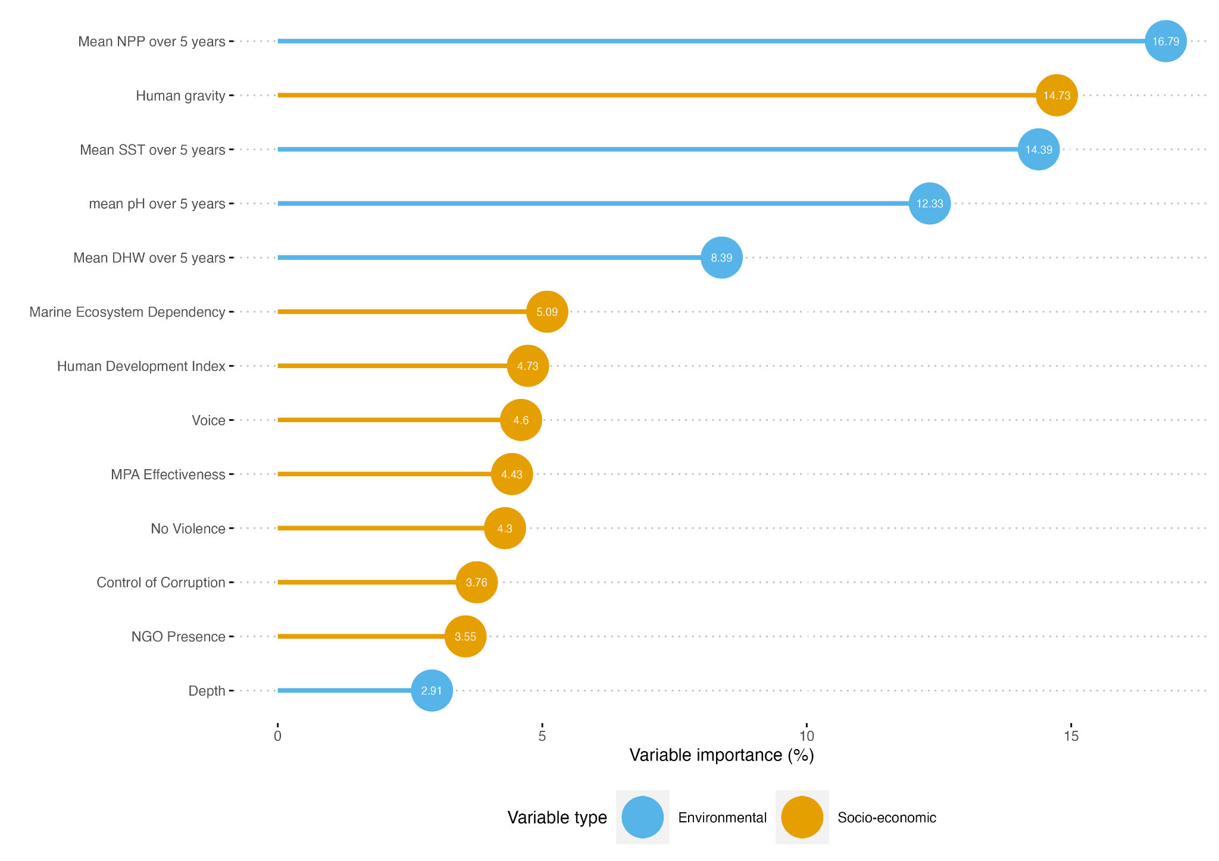

Supplementary figure 12: Mean relative influence over 100 model iterations of our 13 environmental and socio-economic covariates on management classes using variable permutation with thresholds at -2.5% of thresholds used in the study.

Supplementary figure 13: Mean relative influence over 100 model iterations of our 13 environmental and socio-economic covariates on management classes using variable permutation with thresholds at -5% of thresholds used in the study.

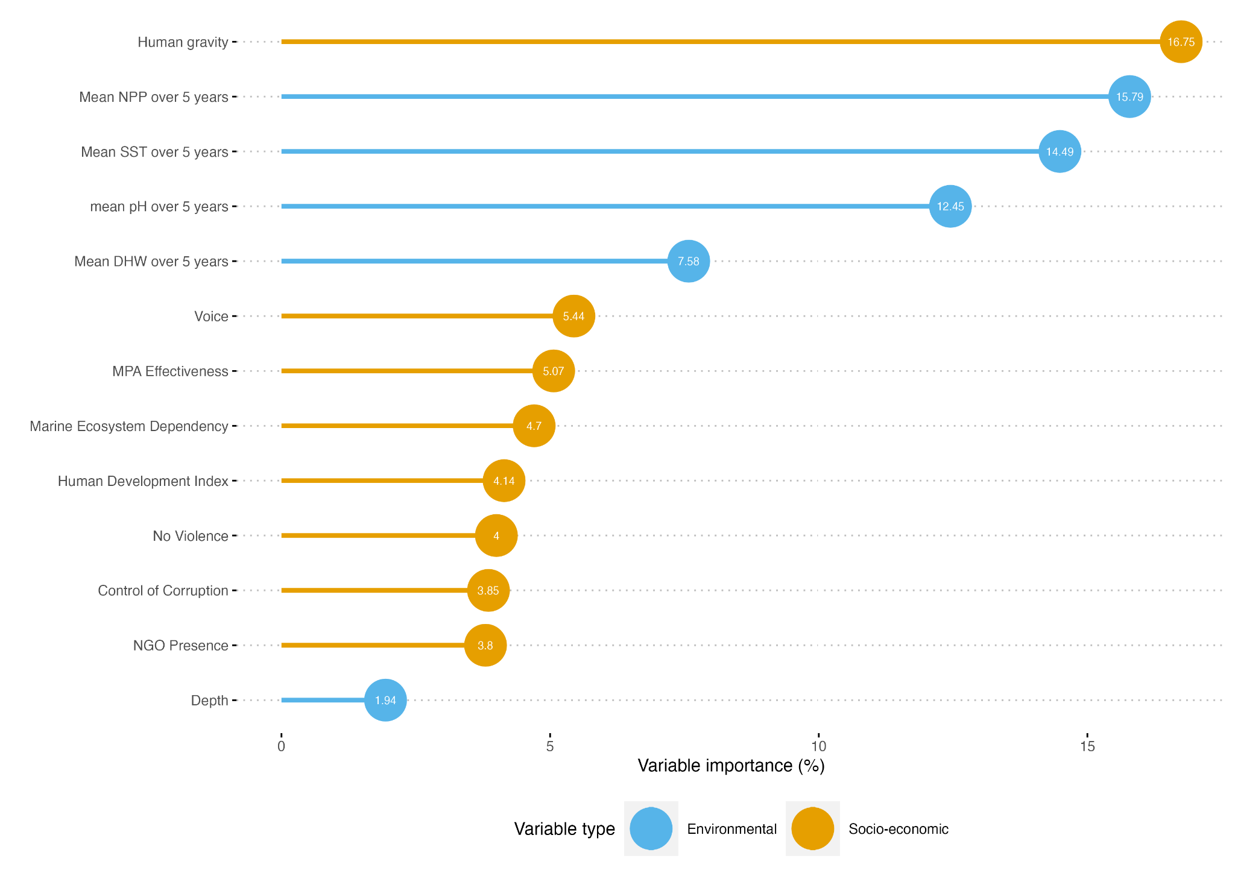
Supplementary figure 14: Mean relative influence over 100 model iterations of our 13 environmental and socio-economic covariates on management classes using variable permutation with thresholds at +2.5% of thresholds used in the study.
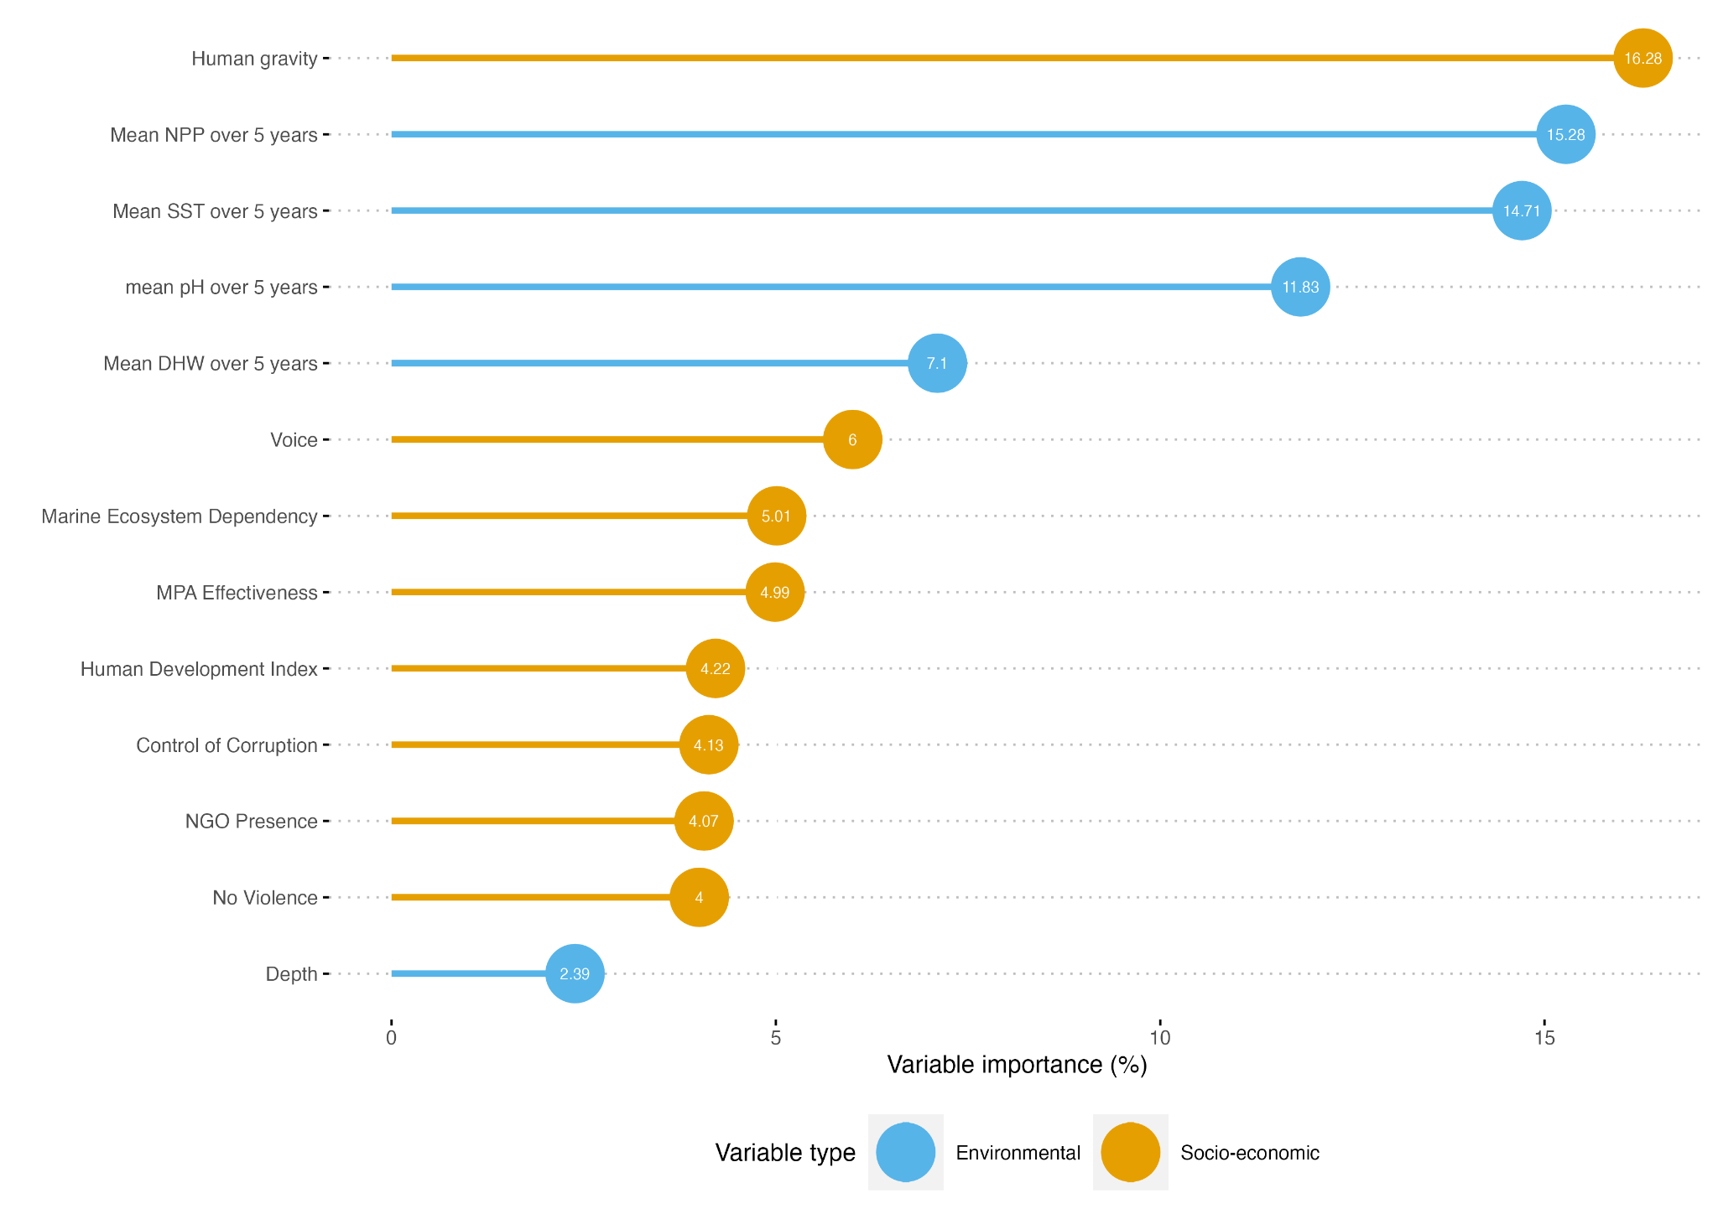
Supplementary figure 15: Mean relative influence over 100 model iterations of our 13 environmental and socio-economic covariates on management classes using variable permutation with thresholds at +5% of thresholds used in the study.
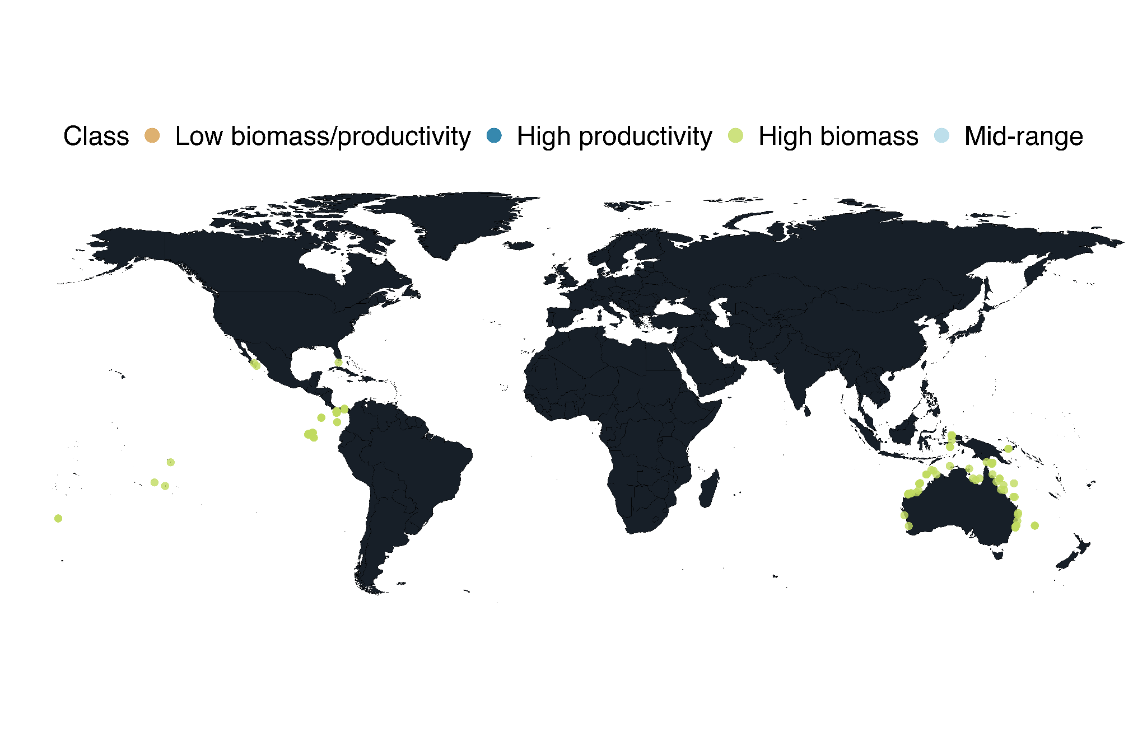
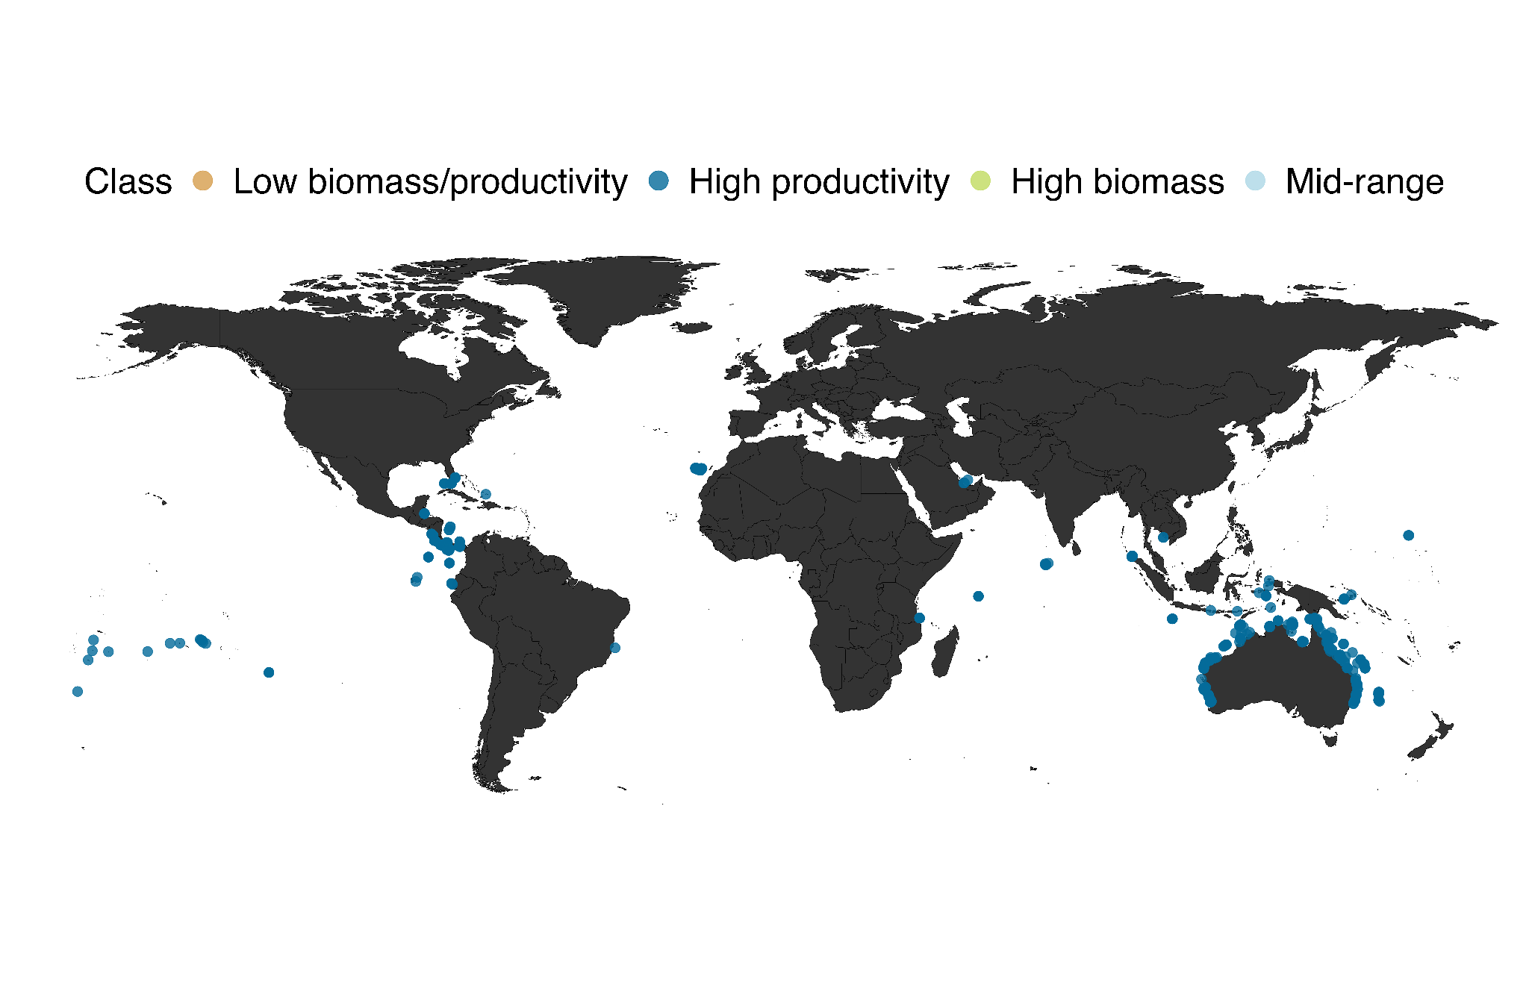

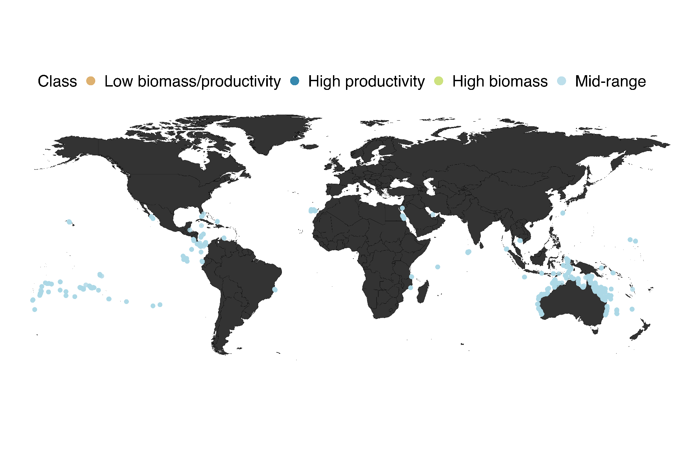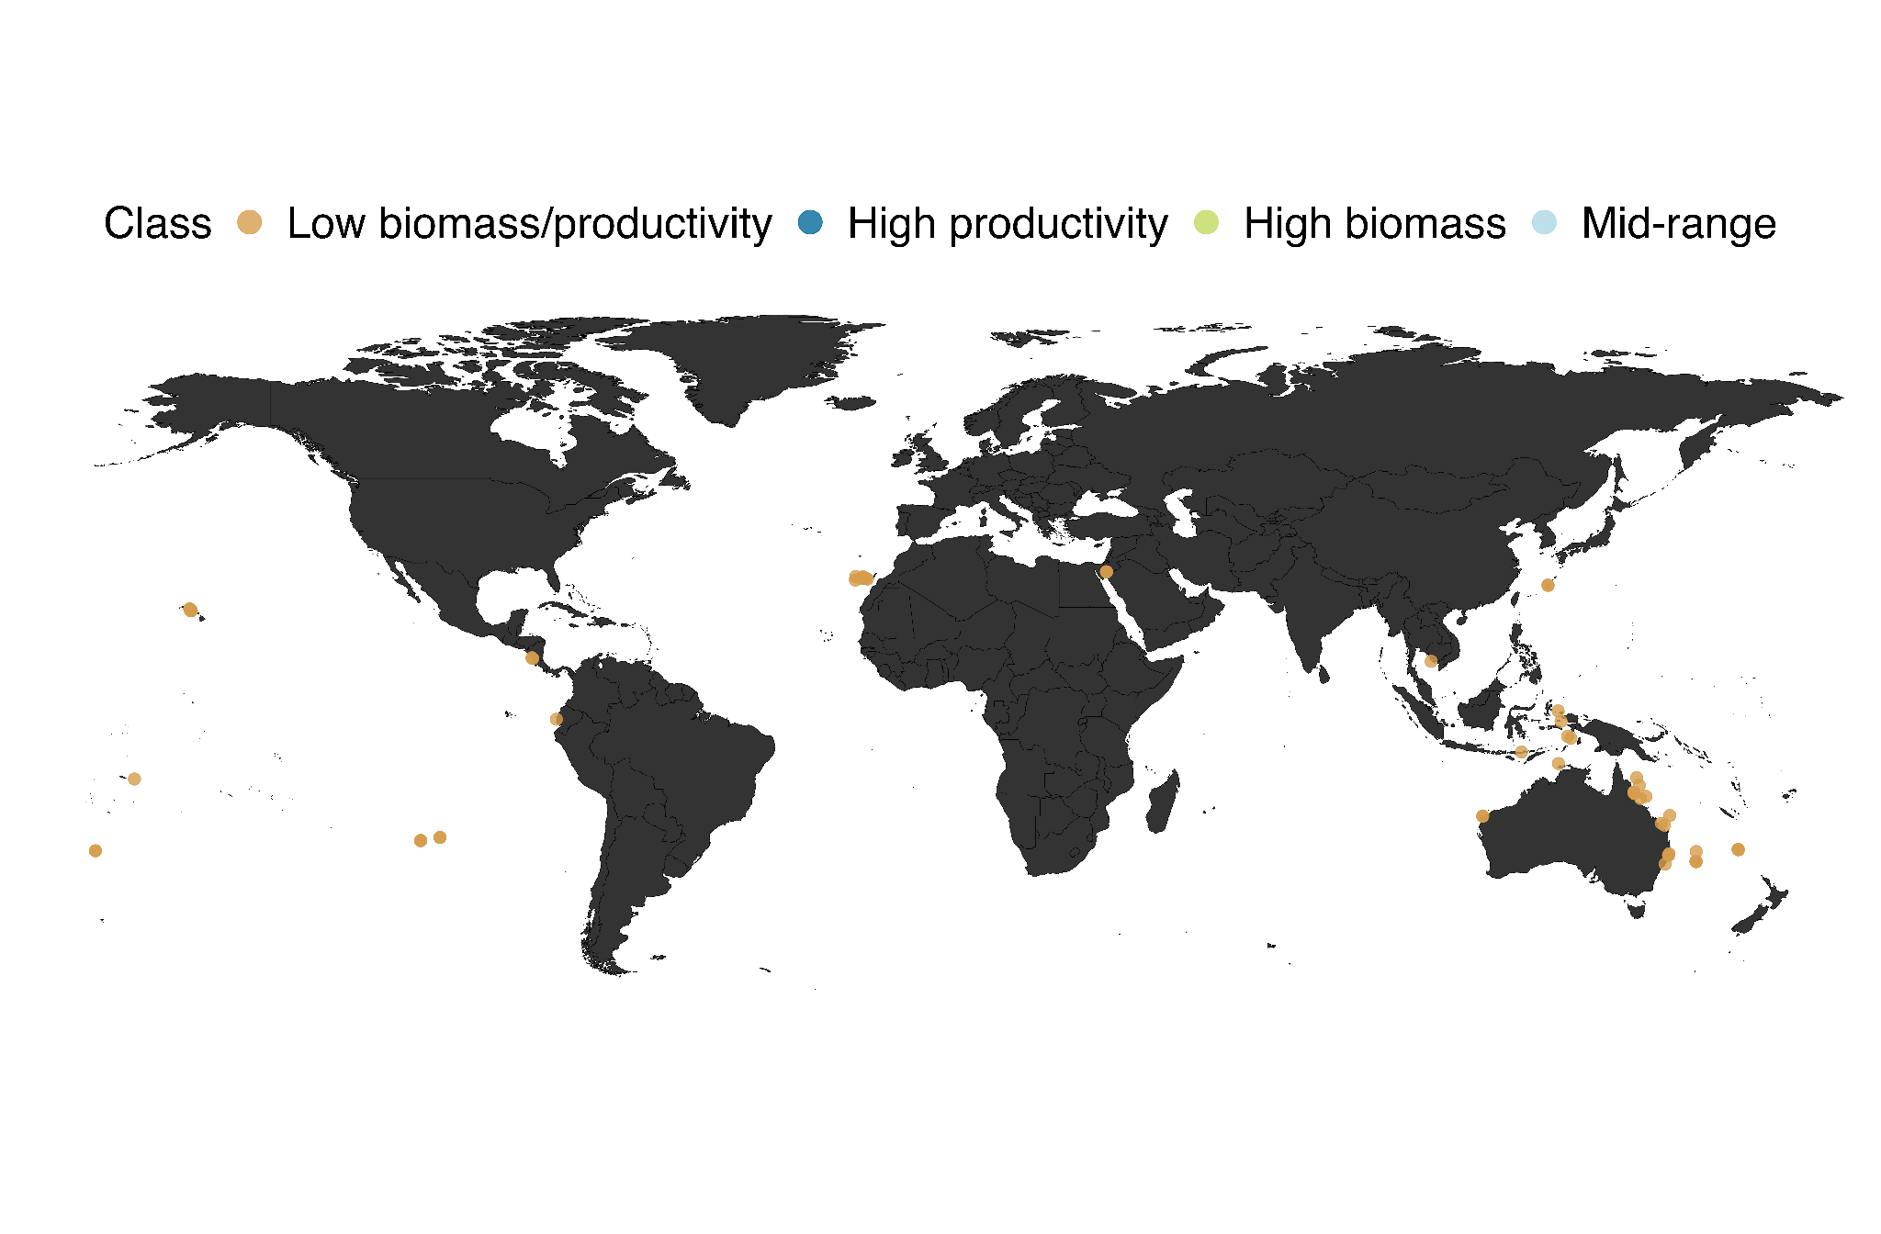

Supplementary Figure 16: World maps of the 102 sites classified as “High biomass”, characterized by high biomass (over 95% of observed values), 486 sites classified as “High productivity”, characterized by high productivity (over 75% of observed values), 72 sites classified as “Low biomass/productivity”, characterized by low biomass and productivity (over 25% of observed values for these two metrics), 1367 sites classified as “Mid-range”, which fit in neither of the three above categories.

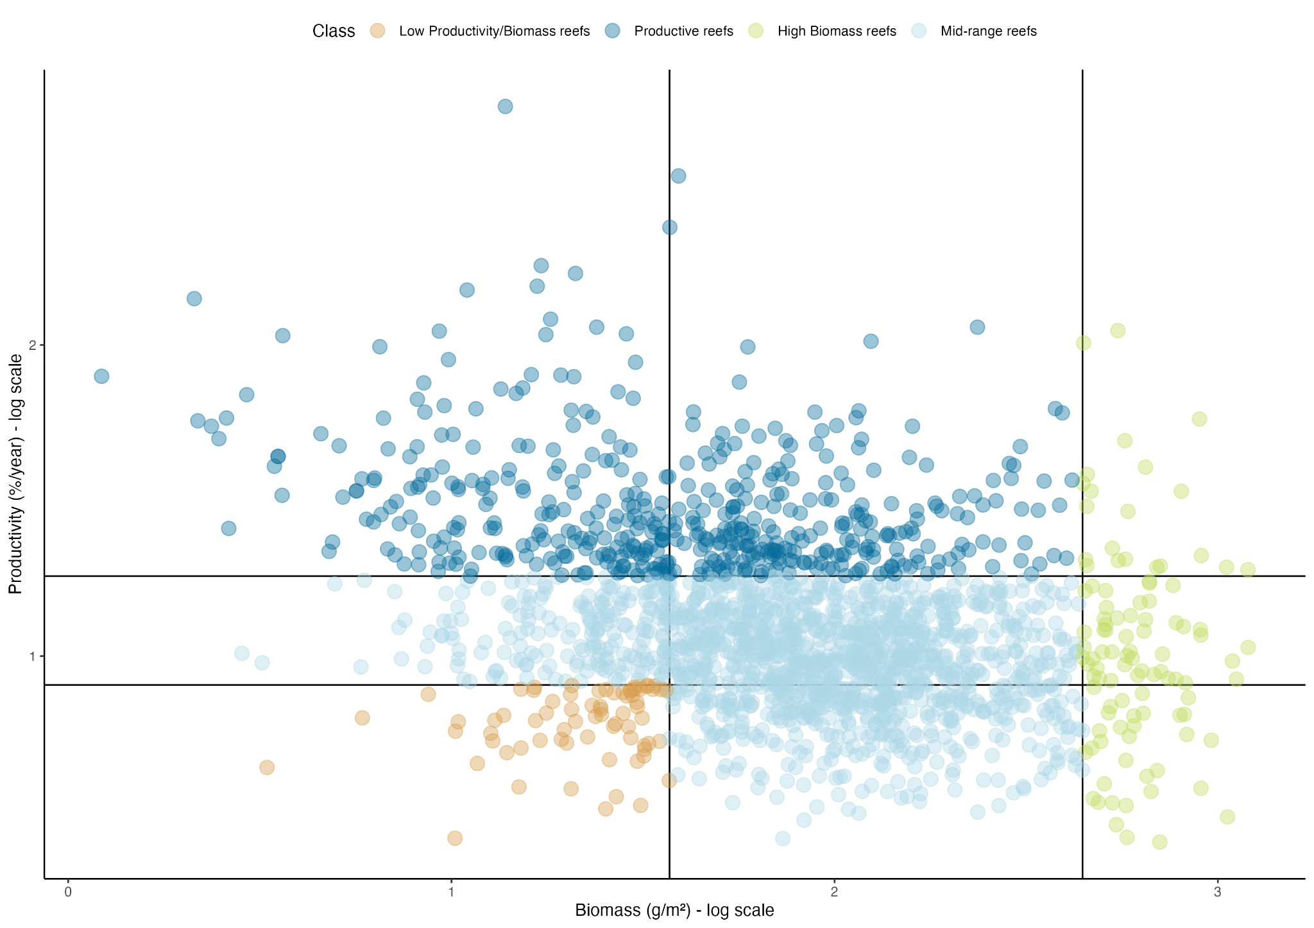
Supplementary Figure 17: Biplot of standing biomass and biomass productivity on the log scale, representing the four management classes defined on the 2027 tropical reef sites.

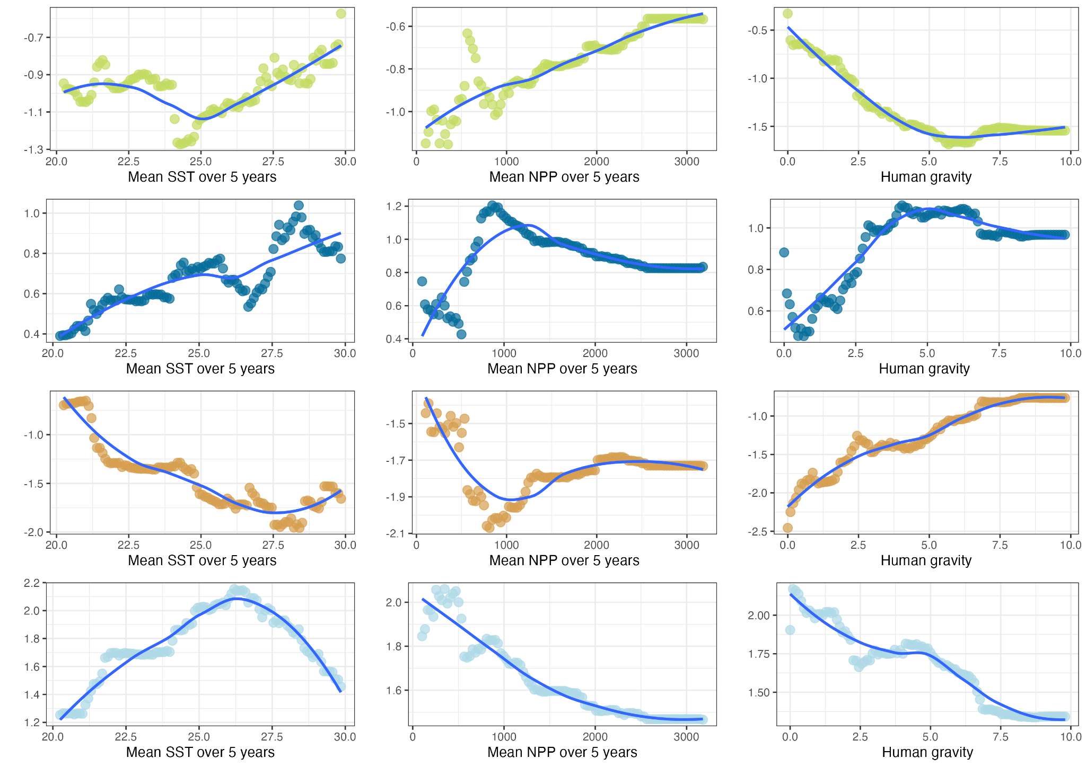

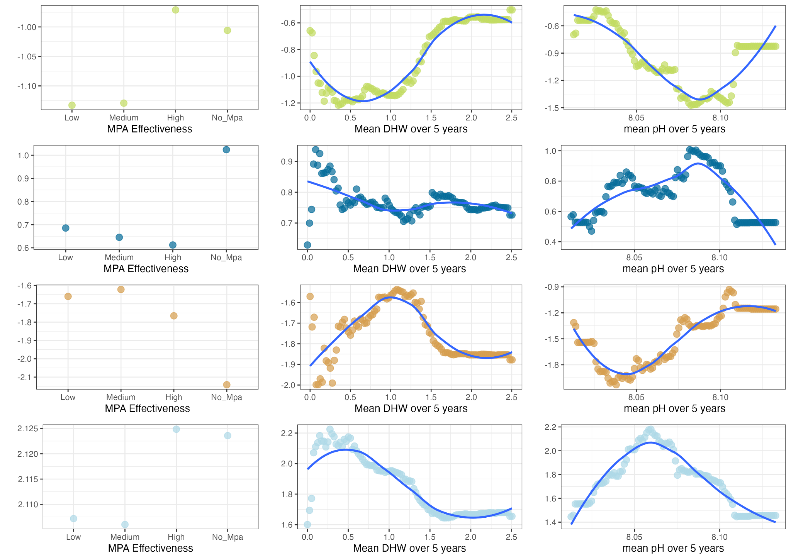

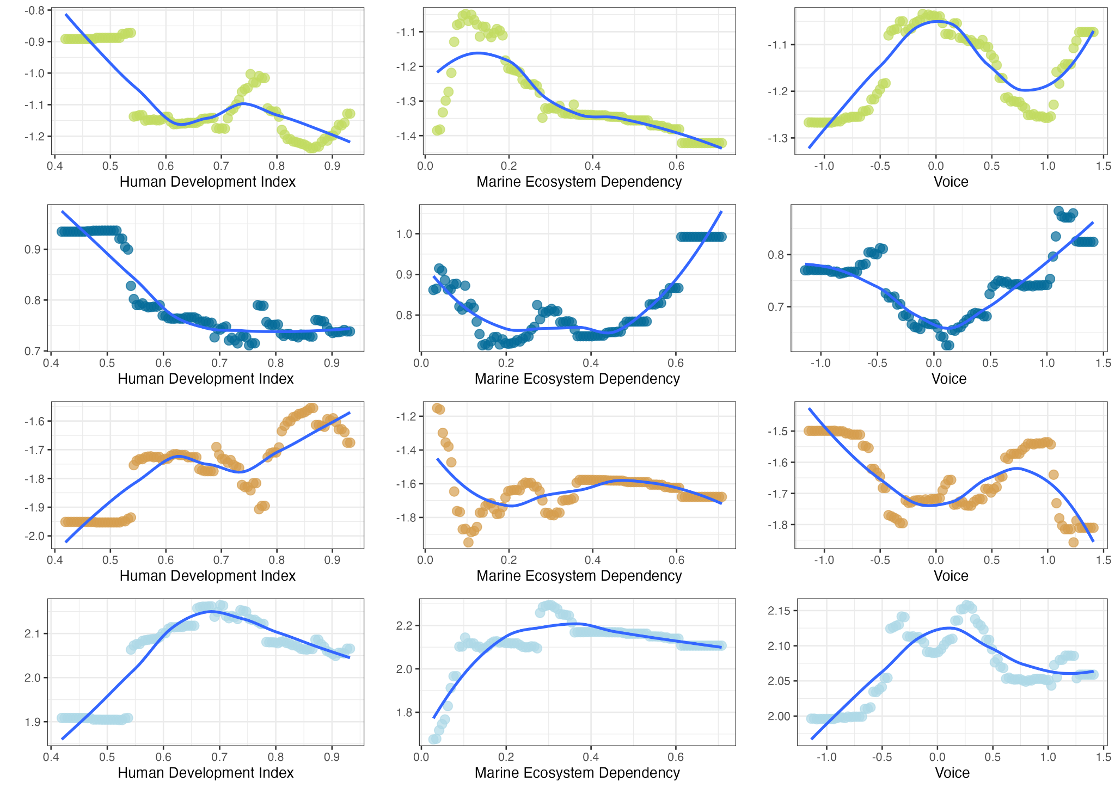

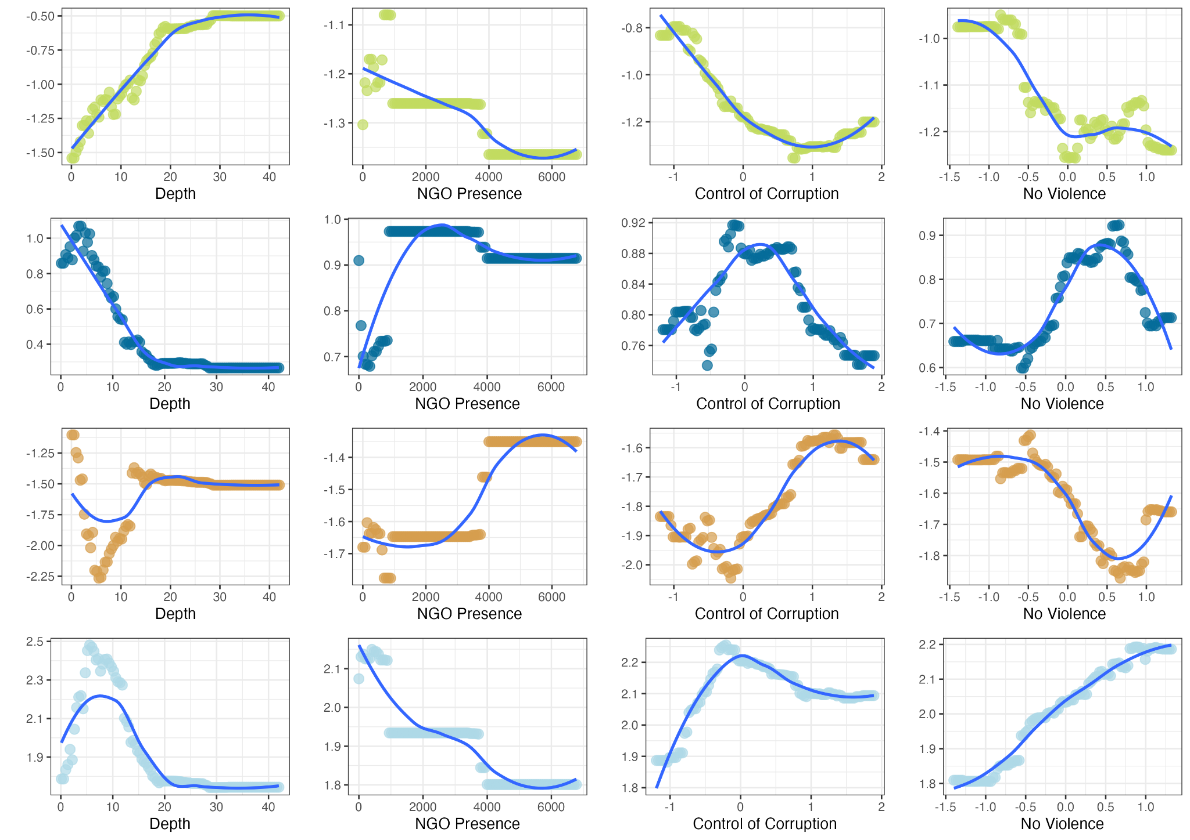

Supplementary Figure 18: Partial dependence plots showing relative contribution of the variable on the class probability from the perspective of the model for each environmental and socio-economic covariate, using the partial function from the pdp package, v.0.7.0.9000.

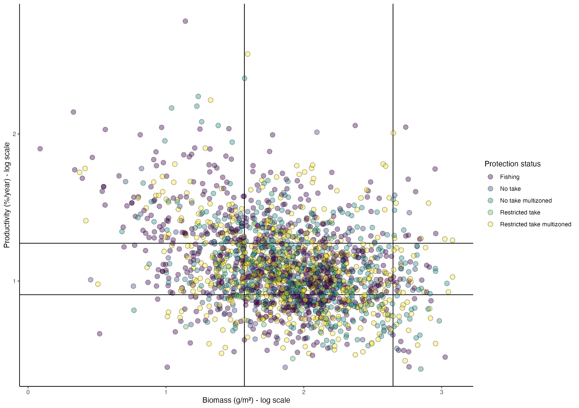

Supplementary Figure 19: Standing biomass and productivity biplot of the 2027 sites according to protection status – Fishing area, No-take area, Multizoned no-take area, Restricted take, Multizoned restricted take area. Lines represent Q25 and Q75. The second vertical line is the Q95 of the biomass distribution.

Supplementary Table 2: The 2027 sites comprised 1469 species, across 83 families and 317 genuses.

Family | Genus
Labridae | Sparisoma
Labridae | Halichoeres
Labridae | Thalassoma
Holocentridae | Holocentrus
Pomacentridae | Stegastes
Haemulidae | Haemulon
Lutjanidae | Lutjanus
Pomacentridae | Abudefduf
Acanthuridae | Acanthurus
Pomacentridae | Microspathodon
Labridae | Scarus
Chaetodontidae | Chaetodon
Pomacentridae | Chromis
Pomacanthidae | Holacanthus
Serranidae | Cephalopholis
Labridae | Bodianus
Ostraciidae | Lactophrys
Pomacanthidae | Pomacanthus
Tetraodontidae | Canthigaster
Haemulidae | Anisotremus
Sphyraenidae | Sphyraena
Labridae | Lachnolaimus
Diodontidae | Diodon
Lutjanidae | Ocyurus
Sciaenidae | Pareques
Serranidae | Epinephelus
Serranidae | Mycteroperca
Carangidae | Carangoides
Serranidae | Serranus
Ostraciidae | Acanthostracion
Kyphosidae | Kyphosus
Mullidae | Pseudupeneus
Aulostomidae | Aulostomus
Serranidae | Hypoplectrus
Ostraciidae | Rhinesomus
Mullidae | Mulloidichthys
Sparidae | Calamus
Ephippidae | Chaetodipterus
Scombridae | Scomberomorus
Synodontidae | Synodus
Sciaenidae | Odontoscion
Serranidae | Rypticus
Echeneidae | Echeneis
Balistidae | Canthidermis
Monacanthidae | Monacanthus
Scorpaenidae | Scorpaena
Sparidae | Diplodus
Priacanthidae | Heteropriacanthus
Labridae | Clepticus
Holocentridae | Myripristis
Holocentridae | Neoniphon
Scorpaenidae | Pterois
Grammatidae | Gramma
Gerreidae | Gerres
Balistidae | Melichthys
Inermiidae | Inermia
Carangidae | Caranx
Balistidae | Balistes
Malacanthidae | Malacanthus
Monacanthidae | Cantherhines
Apogonidae | Apogon
Diodontidae | Chilomycterus
Chaetodontidae | Prognathodes
Fistulariidae | Fistularia
Sciaenidae | Equetus
Monacanthidae | Aluterus
Tetraodontidae | Sphoeroides
Holocentridae | Sargocentron
Pempheridae | Pempheris
Mullidae | Parupeneus
Labridae | Coris
Scorpididae | Scorpis
Labridae | Ophthalmolepis
Pomacentridae | Parma
Serranidae | Hypoplectrodes
Cheilodactylidae | Cheilodactylus
Enoplosidae | Enoplosus
Labridae | Notolabrus
Monacanthidae | Meuschenia
Pomacentridae | Mecaenichthys
Acanthuridae | Prionurus
Cheilodactylidae | Nemadactylus
Sparidae | Rhabdosargus
Trachichthyidae | Trachichthys
Labridae | Suezichthys
Plesiopidae | Trachinops
Diodontidae | Dicotylichthys
Labridae | Achoerodus
Balistidae | Sufflamen
Labridae | Pseudolabrus
Zanclidae | Zanclus
Aplodactylidae | Aplodactylus
Serranidae | Pseudanthias
Scorpididae | Atypichthys
Serranidae | Acanthistius
Chaetodontidae | Heniochus
Carangidae | Pseudocaranx
Lutjanidae | Paracaesio
Acanthuridae | Paracanthurus
Scorpaenidae | Dendrochirus
Cirrhitidae | Cirrhitichthys
Sparidae | Acanthopagrus
Caesionidae | Caesio
Pomacentridae | Pomacentrus
Caesionidae | Pterocaesio
Siganidae | Siganus
Labridae | Stethojulis
Labridae | Macropharyngodon
Haemulidae | Plectorhinchus
Labridae | Labroides
Labridae | Hemigymnus
Apogonidae | Ostorhinchus
Pomacentridae | Dascyllus
Serranidae | Trachypoma
Labridae | Anampses
Pomacentridae | Amphiprion
Carangidae | Seriola
Moridae | Lotella
Mullidae | Upeneichthys
Monodactylidae | Schuettea
Labridae | Austrolabrus
Carangidae | Trachurus
Carangidae | Elagatis
Dinolestidae | Dinolestes
Glaucosomatidae | Glaucosoma
Ostraciidae | Anoplocapros
Labridae | Pseudocoris
Labridae | Olisthops
Acanthuridae | Naso
Pomacanthidae | Centropyge
Nemipteridae | Scolopsis
Labridae | Cirrhilabrus
Pomacentridae | Chrysiptera
Scorpididae | Microcanthus
Acanthuridae | Ctenochaetus
Terapontidae | Pelates
Pomacentridae | Amblyglyphidodon
Lethrinidae | Lethrinus
Serranidae | Diploprion
Balistidae | Rhinecanthus
Kyphosidae | Girella
Monodactylidae | Monodactylus
Labridae | Pictilabrus
Tetraodontidae | Tetractenos
Tetraodontidae | Arothron
Monacanthidae | Eubalichthys
Pomacanthidae | Chaetodontoplus
Labridae | Novaculichthys
Monacanthidae | Thamnaconus
Pomacentridae | Neoglyphidodon
Labridae | Gomphosus
Pomacentridae | Plectroglyphidodon
Mugilidae | Mugil
Hemiramphidae | Hyporhamphus
Cirrhitidae | Notocirrhitus
Ostraciidae | Ostracion
Labridae | Eupetrichthys
Plotosidae | Cnidoglanis
Labridae | Hologymnosus
Scorpaenidae | Scorpaenodes
Labridae | Labropsis
Chaetodontidae | Chelmon
Latidae | Psammoperca
Labridae | Choerodon
Haemulidae | Diagramma
Labridae | Epibulus
Pomacentridae | Dischistodus
Labridae | Oxycheilinus
Labridae | Cheilinus
Apogonidae | Cheilodipterus
Plesiopidae | Assessor
Serranidae | Plectropomus
Labridae | Labrichthys
Acanthuridae | Zebrasoma
Pomacentridae | Acanthochromis
Lethrinidae | Monotaxis
Labridae | Chlorurus
Pomacentridae | Neopomacentrus
Labridae | Pseudocheilinus
Pseudochromidae | Pseudochromis
Pseudochromidae | Pictichromis
Monacanthidae | Oxymonacanthus
Pseudochromidae | Ogilbyina
Balistidae | Balistapus
Pomacentridae | Cheiloprion
Pomacentridae | Premnas
Monacanthidae | Pervagor
Cirrhitidae | Paracirrhites
Serranidae | Chromileptes
Labridae | Dotalabrus
Balistidae | Pseudobalistes
Labridae | Pseudodax
Labridae | Hipposcarus
Lutjanidae | Macolor
Chaetodontidae | Forcipiger
Labridae | Cetoscarus
Pomacentridae | Hemiglyphidodon
Lutjanidae | Aphareus
Mugilidae | Crenimugil
Priacanthidae | Priacanthus
Carangidae | Scomberoides
Serranidae | Anyperodon
Ephippidae | Platax
Labridae | Cheilio
Nemipteridae | Pentapodus
Lutjanidae | Symphorichthys
Centriscidae | Aeoliscus
Synodontidae | Saurida
Carangidae | Gnathanodon
Carangidae | Trachinotus
Pseudochromidae | Oxycercichthys
Rachycentridae | Rachycentron
Scorpaenidae | Centropogon
Sillaginidae | Sillago
Chaetodontidae | Coradion
Carangidae | Ulua
Labridae | Pteragogus
Chaetodontidae | Chelmonops
Mullidae | Upeneus
Monacanthidae | Cantheschenia
Cirrhitidae | Cyprinocirrhites
Carangidae | Decapterus
Diodontidae | Cyclichthys
Synanceiidae | Synanceia
Labridae | Leptojulis
Synanceiidae | Inimicus
Scombridae | Scomber
Carangidae | Atule
Belonidae | Strongylura
Scombridae | Cybiosarda
Serranidae | Centrogenys
Lutjanidae | Symphorus
Plotosidae | Paraplotosus
Ostraciidae | Rhynchostracion
Carangidae | Selaroides
Labridae | Siphonognathus
Serranidae | Variola
Plesiopidae | Paraplesiops
Platycephalidae | Cymbacephalus
Pomacanthidae | Pygoplites
Scombridae | Grammatorcynus
Pseudochromidae | Labracinus
Labridae | Heteroscarus
Kyphosidae | Neatypus
Tetraodontidae | Torquigener
Gobiesocidae | Diademichthys
Labridae | Leptoscarus
Chaetodontidae | Parachaetodon
Chanidae | Chanos
Nemipteridae | Scaevius
Bothidae | Bothus
Tetraodontidae | Omegophora
Monacanthidae | Acanthaluteres
Serranidae | Epinephelides
Scorpididae | Tilodon
Arripidae | Arripis
Cheilodactylidae | Dactylophora
Serranidae | Gracila
Lutjanidae | Aprion
Cirrhitidae | Cirrhitus
Lethrinidae | Gnathodentex
Chaetodontidae | Hemitaurichthys
Balistidae | Balistoides
Pomacentridae | Lepidozygus
Serranidae | Luzonichthys
Belonidae | Tylosurus
Opisthognathidae | Opistognathus
Serranidae | Caesioscorpis
Sillaginidae | Sillaginodes
Atherinidae | Atherinomorus
Serranidae | Othos
Plotosidae | Plotosus
Monacanthidae | Scobinichthys
Berycidae | Centroberyx
Ostraciidae | Aracana
Serranidae | Aethaloperca
Labridae | Calotomus
Labridae | Larabicus
Plesiopidae | Calloplesiops
Monacanthidae | Amanses
Sparidae | Boops
Sparidae | Oblada
Sparidae | Sarpa
Labridae | Centrolabrus
Atherinidae | Atherina
Labridae | Xyrichtys
Belonidae | Belone
Mullidae | Mullus
Haemulidae | Pomadasys
Balistidae | Odonus
Pomacanthidae | Apolemichthys
Scorpaenidae | Scorpaenopsis
Syngnathidae | Corythoichthys
Apogonidae | Pristiapogon
Labridae | Diproctacanthus
Pomacanthidae | Paracentropyge
Haemulidae | Microlepidotus
Chaetodontidae | Johnrandallia
Serranidae | Paranthias
Serranidae | Dermatolepis
Balistidae | Xanthichthys
Echeneidae | Remora
Carangidae | Uraspis
Kyphosidae | Sectator
Lutjanidae | Hoplopagrus
Serranidae | Alphestes
Elopidae | Elops
Labridae | Iniistius
Scombridae | Euthynnus
Cirrhitidae | Oxycirrhites
Haemulidae | Orthopristis
Pomacentridae | Nexilosus
Haemulidae | Xenocys
Oplegnathidae | Oplegnathus
Labridae | Semicossyphus
Malacanthidae | Caulolatilus
Serranidae | Paralabrax
Labridae | Nicholsina
Syngnathidae | Hippocampus
Ogcocephalidae | Ogcocephalus
Molidae | Mola
Hemiramphidae | Hemiramphus
Kuhliidae | Kuhlia
Mugilidae | Neomyxus
Cirrhitidae | Isocirrhitus
Cirrhitidae | Neocirrhites
Grammistidae | Belonoperca
Pseudochromidae | Cypho
Monacanthidae | Paraluteres
Scombridae | Rastrelliger
Labridae | Bolbometopon
Caesionidae | Gymnocaesio
Cirrhitidae | Amblycirrhitus
Megalopidae | Megalops
Bythitidae | Stygnobrotula
Sparidae | Pagrus
Scombridae | Sarda
Haemulidae | Parapristipoma
Mugilidae | Chelon
Sparidae | Spondyliosoma
Monacanthidae | Stephanolepis
Sparidae | Pagellus
Chaetodontidae | Amphichaetodon
Pomacanthidae | Genicanthus
Labridae | Pseudojuloides
Serranidae | Grammistes
Scorpaenidae | Sebastapistes
Cirrhitidae | Cirrhitops
Lethrinidae | Gymnocranius
Carangidae | Alectis
Cirrhitidae | Itycirrhitus
Cheilodactylidae | Goniistius
Scorpaenidae | Taenianotus
Clupeidae | Sardinella
Ostraciidae | Lactoria
Scombridae | Gymnosarda
Gerreidae | Eucinostomus
Carangidae | Selar
Serranidae | Serranocirrhitus
Serranidae | Aulacocephalus
Mugilidae | Liza
Pomacentridae | Pomachromis
Pseudochromidae | Manonichthys
Anarhichadidae | Anarrhichthys
Scombridae | Thunnus
Clupeidae | Sardina
Monacanthidae | Chaetodermis
Apogonidae | Zoramia
Pempherididae | Parapriacanthus
Apogonidae | Rhabdamia
Terapontidae | Pelsartia

Bibliography

1. Brown, J. H., Gillooly, J. F., Allen, A. P., Savage, V. M. & West, G. B. TOWARD A METABOLIC THEORY OF ECOLOGY. Ecology 85, 1771–1789 (2004).
2. Morais, R. A. & Bellwood, D. R. Pelagic Subsidies Underpin Fish Productivity on a Degraded Coral Reef. Curr. Biol. 29, 1521-1527.e6 (2019).
3. Depczynski, M., Fulton, C. J., Marnane, M. J. & Bellwood, D. R. Life history patterns shape energy allocation among fishes on coral reefs. Oecologia 153, 111–120 (2007).
4. Gillooly, J. F., Brown, J. H., West, G. B., Savage, V. M. & Charnov, E. L. Effects of Size and Temperature on Metabolic Rate. Science 293, 2248–2251 (2001).
5. Sibly, R. M. et al. Fundamental insights into ontogenetic growth from theory and fish. Proc. Natl. Acad. Sci. 112, 13934–13939 (2015).
6. West, G. B., Brown, J. H. & Enquist, B. J. A General Model for the Origin of Allometric Scaling Laws in Biology. Science 276, 122–126 (1997).

