Supplementary Information

Multi-hazard risk to global port infrastructure and resulting trade and logistics losses
Jasper Verschuur, Elco E. Koks, Sihan Li, Jim W. Hall

*Corresponding author. Email: jasper.verschuur@keble.ox.ac.uk

This PDF file includes:

Supplementary Text
Supplementary Figures. 1 to 9
Supplementary Tables 1 to 4
References (1 to 35)

Supplementary Text

Port areas
The total port area mapped globally equals 4521 km². In Supplementary Figure 9, we have regrouped the 16 land-use classes into seven land-use classes and plotted the total area per continent. The Liquid (23.7%), Raw (15.4%) and Container (13.6%) land-use classes contribute most to the size of global port areas. The industry areas add an additional 4345 km² of port areas to the database. In Supplementary Figure 8, the Industry area per continent is shown. Most industry is concentrated in Europe, North-America and Asia, while the Middle-East also has a large number of industrial facilities in port areas (mainly oil facilities).

The mapped port area is considerably larger than previous estimates of global port areas that used a simple scaling relationship between throughput and port area ¹. For instance, Hanson and Nicholls ¹ predicted the global port area to be 1364 km². In their comparison of country-level port areas (Table 3 in (1)), they concluded that their estimates were overall lower than other studies. For comparison, we replicate this table and add the results of our mapping exercise to the table (see Supplementary Table 3). We compare the total port areas for 16 countries that includes (1) all land-use types, (2) all land-use types except ‘Industry’, (3) all land-use types except ‘Industry’, ‘Storage’, and ‘Other’ land-use areas . As can be seen from Supplementary Table 3, our estimates are considerably higher than all other studies, although it does depend on what land-use types are considered. Hence, comparison across studies is difficult and depends on the definition of port land-use included. Still, for the 16 countries considered, our estimates are 4.8, 2.5 and 2.1 times higher, respectively, compared to (1) for the three groups of land-use types. In particular, the discrepancies are larger for countries like China, the United States and Japan, underlining that simple scaling relationships across countries should be adopted with care.

Coastal structures database
We include three different types of coastal structures: (1) coastal breakwaters that function as an inlet (referred to as ‘inlet’), (2) coastal breakwaters that protect against waves (referred to as ‘breakwater’), and (3) coastal seawalls alongside port terminals that protect against waves and overtopping (referred to as ‘seawall’). To construct a geospatial database of coastal structures within port areas, we first extract data from OpenStreetMap under the tag ‘breakwater’. However, a lot of breakwaters are wrongly tagged (e.g. coastal groynes, revetment, etc.). Therefore, we manually checked all tagged breakwaters and remove wrongly tagged ones, while supplementing missing coastal structures (adding ‘inlet’ and ‘seawall’ structures). This new geospatial dataset consists of 1410 coastal structures, represented as either lines or polygons.

Wave height operational threshold
We derive wave parameters (significant wave height, wave period and wave direction) from ERA5 global reanalysis wave data at 6h interval from 1979-2018 ². For every port, we extract data at the closest grid cell and create a daily time series by selecting the wave parameters concurrent with the daily maximum wave height.

To estimate the wave height at the entrance channel and in front of the coastal protection works, we propagate the wave parameters at the grid cell to the entrance of the channel and the coastal protection works. The wave height and direction change as they propagate from the deep sea towards the coast (wave period is assumed to be constant) owing to the influence of shoaling and refraction ³. Under the assumption of a straight and parallel offshore bathymetry, we can use the Snell’s law to propagate wave height and wave direction from the deep sea depth towards any other depth and orientation ³. A similar assumption was adopted in previous work ⁴, as it was recognized that it is the only approach feasible given available global input.

The depth at the grid cell and at the coastal protection works are taken from the GEBCO 2020 global bathymetry data ⁵. For the coastal protection works, we assume the design depth to be the deepest point along a 15m buffer around the coastal structure. To check whether the estimated design depths approximate the design depths of existing breakwaters, we match our breakwater database with breakwaters included in the ‘International Breakwater Directory’ ⁶. We find 42 overlapping breakwaters with a design depth input in the database. We find that the estimated and observed design depths correspond well (Pearson correlation coefficient of 0.54), keeping in mind that the GEBCO dataset has a 450m resolution. For the navigation channel we assume the depth to be equal to 1.2 times the draft of the largest vessel entering the port (dredged channel), except if the natural bathymetry is deeper than the design depth of the navigation channel. In that case we adopt the natural bathymetry depth. To obtain the orientation of the coastal protection work/navigation channel, we find the orthogonal angle of the orientation of the coastline, which is taken from the global, self-consistent, hierarchical, high-resolution shoreline database (GSHHG) ⁷ (which in some cases includes the breakwaters as part of the coastline). We use this data in combination with Snell’s law (see ³ for formulation) to find the wave height and wave angle in the navigation channel and at the toe of the coastal protection works. Wave propagation is constrained by wave breaking (when waves reach shallow water) using a wave breaking criteria (H_{b} = d_{b}/1.28) with H_{b} the wave breaking height and d_{b} the depth at breaking.

Based on the critical wave threshold adopted per port, we find the number of days the wave height exceeds this threshold over the historical time period. We use this to estimate the annual frequency of exceedance per port.

Overtopping operational threshold
Overtopping is a complex phenomenon driven by the interaction of waves and surges on a coastal structure ^{8,9}. Most ports have breakwaters that protect the port basin from unwanted wave transmission into the harbor. Ports without a breakwater often have seawalls alongside the port terminals to minimize the probability of wave overtopping and resulting impacts on goods and operations. The design of breakwaters and other coastal protection works vary considerably globally and are dependent, among others, on the local hydrodynamic conditions, the type of structure (e.g. caisson, rubble mound), type of armor layer (e.g. rock, Tetrapods, Xbloc), inclusion of a berm, and the lifetime and importance of the coastal protection work ⁸. Given that this type of data is not readily available globally, we propose an alternative way to evaluate the risk of overtopping for coastal protection works. For every coastal structure exposed to overtopping in our database, we first create a standard design (in particular the design freeboard) based on engineering design principles given the wave and surge inputs. We then re-evaluate the risk of overtopping to the design structure for the combined wave and surge time series.

The wave data, propagated to the coastal structures, are taken similar as described in the derivation of the wave height operational thresholds. We add surge and tide data to the wave time series, obtained from latest Global Tide and Surge Reanalysis (GTSR) model data ¹⁰, which is a global reanalysis product of extreme water levels (EWL, tide+surge) for 1979-2018. Wave set-up/run-up is not added to the EWL data, as this is implicitly included in wave overtopping formulas ¹¹.

As described above, instead of obtaining information on the dimensions of all coastal protection works, we construct a hypothetical design based on engineering principles and the local hydrodynamic input. This also prevents introducing errors due to bias in the input parameters (wave and surge data). We distinguish between two types of structures: an armored breakwater (‘breakwater’ type) and an armored seawall (‘seawall’ type), which have similar design principles except that in the case of a breakwater an additional correction factor is added for the presence of a permeable crest berm.

Wave height is the major design parameter for overtopping of coastal structures. A number of assumptions are made. First, all coastal structures are assumed to have a 50 year lifetime with a 10% probability of failure over this lifetime, which is a common value for breakwaters protecting commercial ports ¹². This implies a design wave height with a 475 year return period (following a standard Poisson distribution). To find the design wave height, we fit an extreme value distribution to the annual maxima of wave height at the toe of the coastal structure. We decided to use a Gumbel distribution, after also testing a Weibull distribution, and both distributions with a Peak over Threshold (PoT) method (with the threshold at the 99th percentile). The annual maxima method in combination with the Gumbel distribution results in design wave heights that are closest to design wave height of 37 georeferenced breakwaters included in the ‘International Breakwater Directory’ ⁶. To find the corresponding wave period, we fit a regression model between wave period and the square root of the wave height (Tm ~ H^{0.5}) and use this to extrapolate the wave period. The design wave direction is set to the median wave direction associated with the annual maximum wave events. The design storm surge is set to be the maximum storm surge observed during any of the annual maximum wave events.

To estimate the freeboard height of the structure (main design parameter), we use the overtopping formulas used in the HR Wallingford design manual of wave overtopping ¹³. These formulas are similar as the more recent formulas adopted in the Eurotop manual ¹¹, except that the Eurotop formulas use spectral wave height as design parameter (instead of significant wave height), which is not available in the wave model output. All structures are assumed to have a 1:2 slope and breakwater have a crest width/design wave height ratio of 1.7. These design criteria are obtained after inspecting known breakwater designs that are included in the ‘International Breakwater Directory’ ⁶. We include a surface roughness of 0.5 to the design, which corresponds to having an armor layer composed of rock (with permeable core), cubes, Cubipods or HARO’s ¹¹. Moreover, the correction factor due to oblique waves is based on the EurOtop manual, given that this formula is considered to be superior (the formula in Wallingford 1999 was based on limited research).

Based on the design wave conditions and design parameters, we find the design freeboard for wave overtopping, after which we add the design surge to this freeboard. We use this design freeboard to estimate daily overtopping volumes using the combined wave and surge time series and estimate the exceedance of the tolerable overtopping threshold. The frequency of yearly exceedance is adopted to assess the number of downtime days.

Sensitivity analysis global estimates
Supplementary Table 4 summarizes the results of the variance-based sensitivity analysis for the global port-specific and trade risk estimates. The top10 most sensitive model parameters are highlighted in bold. As can be seen, the uncertainty in the cyclone fragility curve is by far the leading uncertainty parameter for both metrics, although less important for trade risk compared to port-specific. As expected, the recovery duration curves and maximum recovery values contribute more to the variance of trade risk, as they directly influence downtime, compared to port-specific, for which they indirectly contribute to logistics losses. The maximum damage values are negligible for trade risk, as it does not affect downtime, but it is important for the variance in port-specific, in particular General Cargo and Industry maximum damage values.

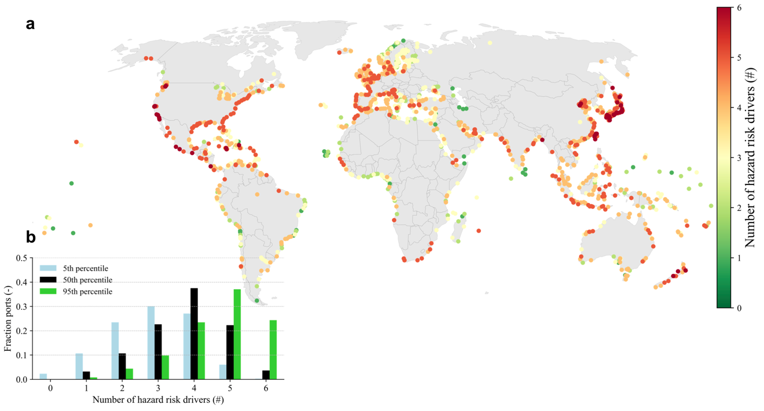

Supplementary Figure 1. The hazard exposure of ports. (A) The number of hazards that contribute to risk of a given port (median port-specific > 0) out of the six hazards considered (cyclone wind, coastal flooding, river flooding, pluvial flooding, earthquakes, operational). (B) A histogram of the fraction of ports exposed, grouped by the number of hazards for the median (black), 5th percentile (light blue, exposed if 5th percentile of port-specific > 0) and 95th percentile (green, exposed if 95th percentile of port-specific > 0) port-specific.

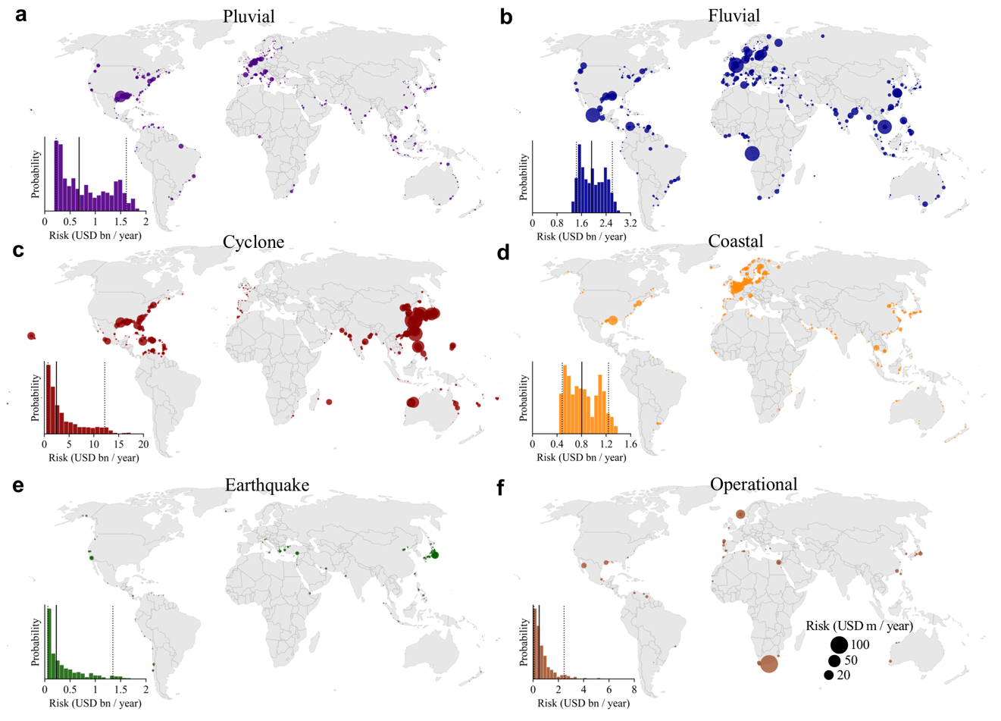

Supplementary Figure 2. The global footprint of port-specific per hazard. The size of the marker indicates the magnitude of port-specific, whereas the histogram shows the global aggregated port-specific across the 10,000 samples with the black line indicating the median and the dashed lines indicating the 5th and 95th percentile. Results are shown for Pluvial (A), Fluvial (B), Cyclone wind (C), Coastal (D), Earthquake (E) and Operational (F) hazard risk driver, respectively.

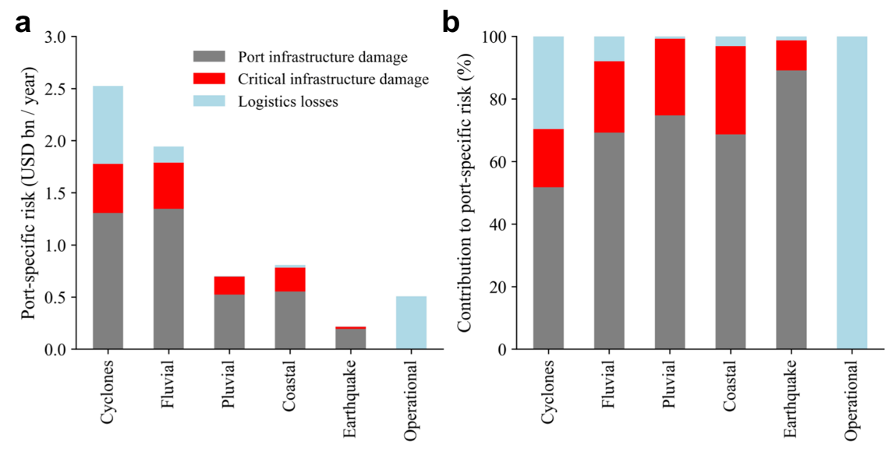

Supplementary Figure 3. Contribution of different hazard risk factors to the total port-specific by hazard type. (A) The absolute contribution to the median port-specific per hazard type. (B) Same as (A) but expressed in relative terms.

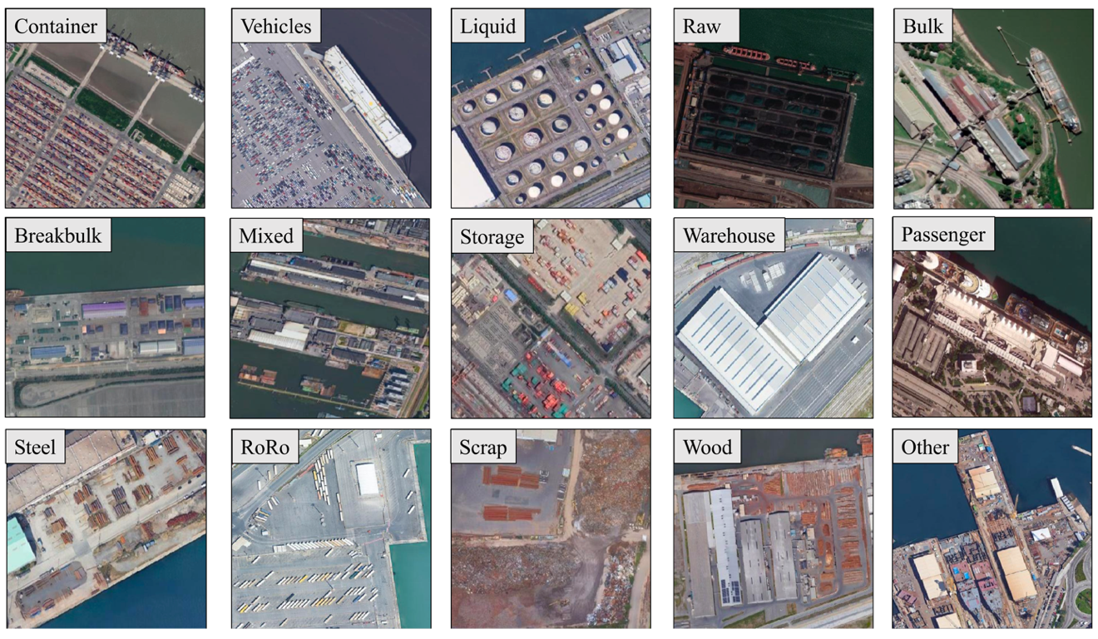

Supplementary Figure 4. The 15 different port land-use types considered in this study when mapping port areas.

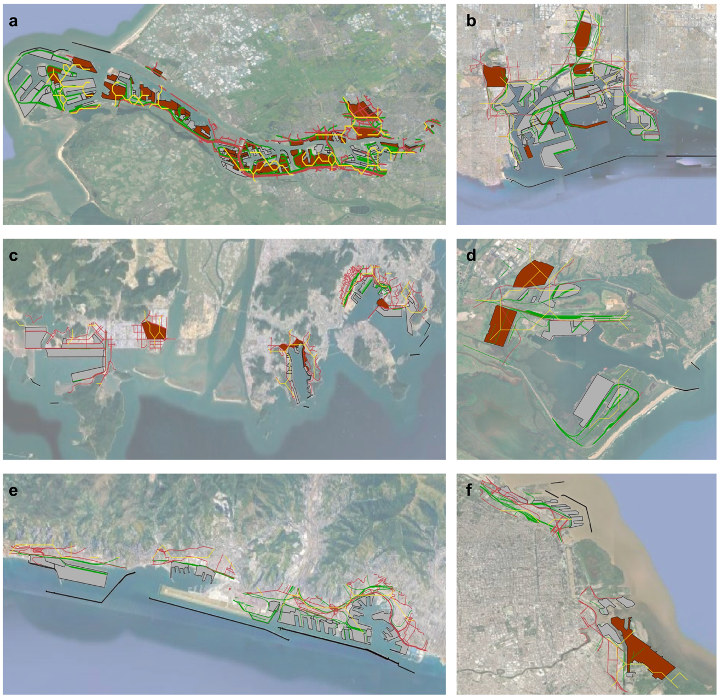

Supplementary Figure 5. Examples of port and critical infrastructure database for six ports. The figures show the port terminals (grey areas), industry (brown areas), roads (red lines), railway (green lines), electricity transmission (yellow lines) and breakwaters (black lines). The ports depicted are the port of Rotterdam (A), the ports of Los Angeles-Long Beach (B), the port of Busan (C), Richards Bay coal terminal (D), the port of Genoa (E) and the port of Buenos Aires (F).

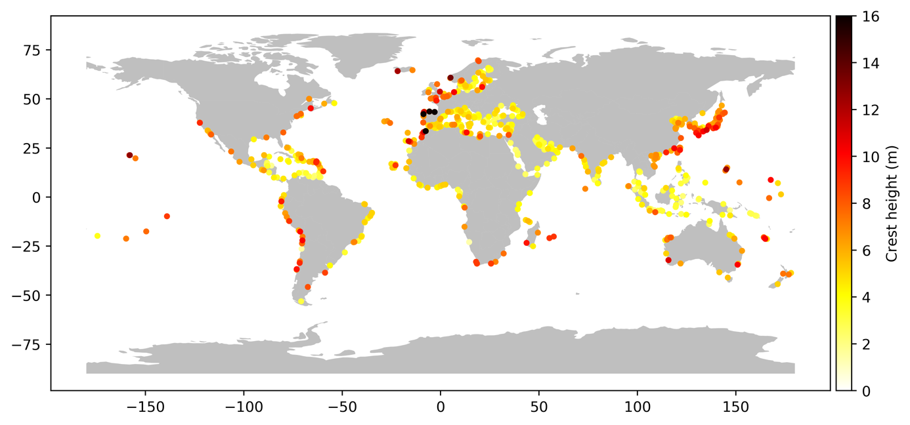

Supplementary Figure 6. The global distribution of breakwater crest heights modelled using the synthetic breakwater design methodology.

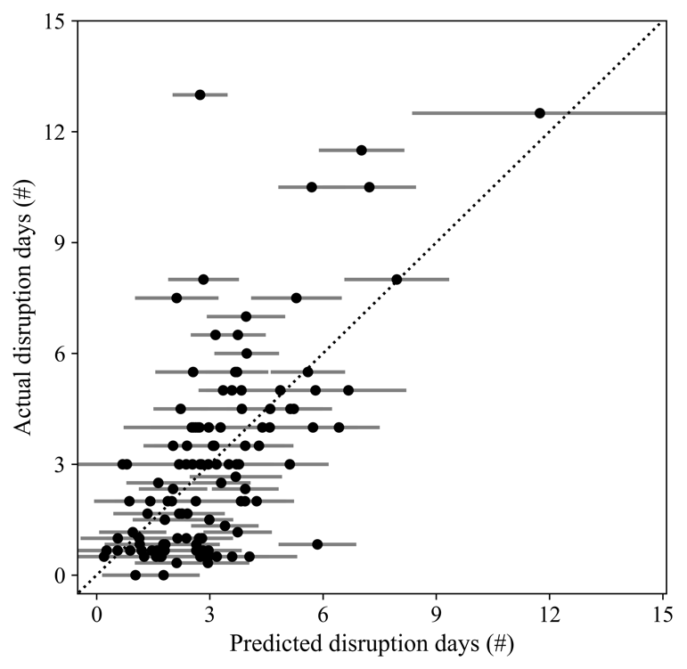

Supplementary Figure 7. The predicted versus observed number of disruption days of the cyclone-induced downtime regression model. The dot indicates the mean result of the regression whereas the error bar shows the 5-95th percentile of the regression model.

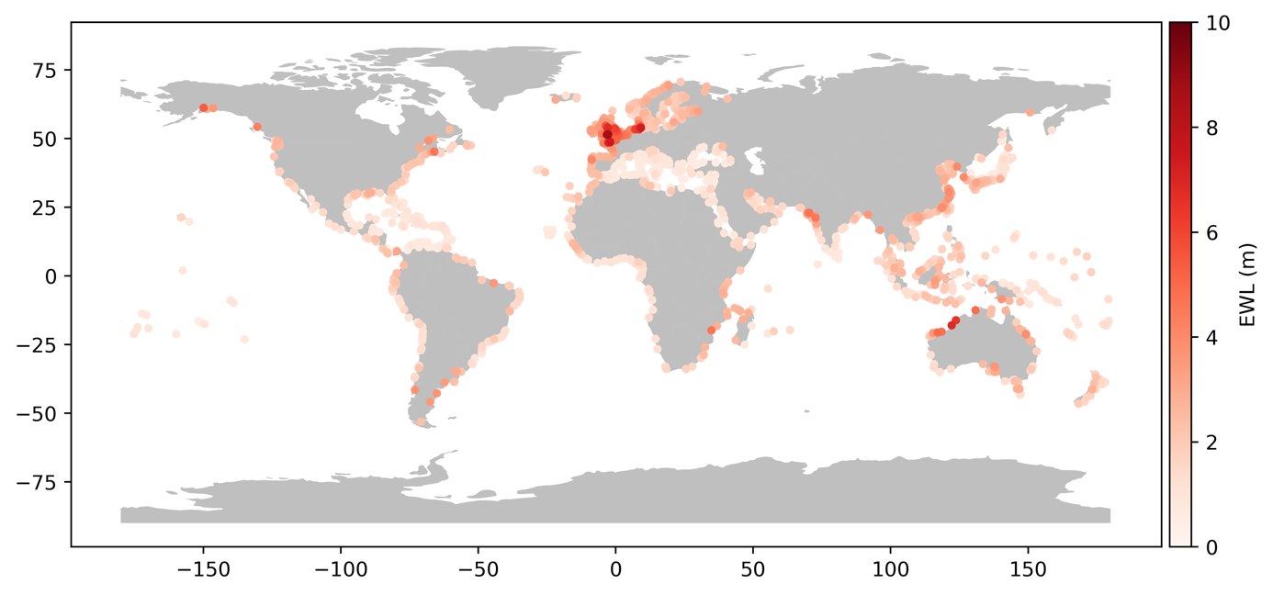

Supplementary Figure 8. The modelled 1 in 100 year extreme water level (EWL) at the port boundary used for the coastal flood risk modelling. Extreme water levels consist of storm surges, tides, sea-level anomalies and wave set-up for those ports that are exposed to wave set-up.

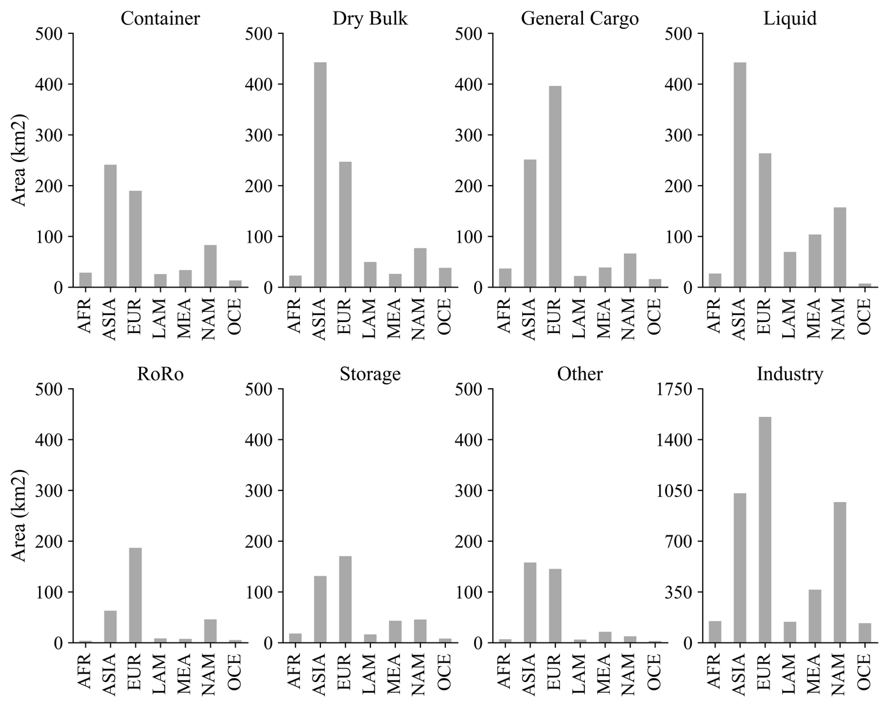

Supplementary Figure 9. The aggregated area of port infrastructure per region and land-use type, grouped into seven port land-use types (Container, Dry Bulk, General Cargo, Liquid, RoRo, Storage and Other, see Supplementary Table 2) and an industrial land-use type. Note the different y-axis scale of the Industry chart. AFR = Africa, ASIA = Asia, EUR = Europe, LAM = Latin America, MEA = Middle-East, NAM = North-America, OCE = Oceania.

Supplementary Table 1. An overview of the model parameters used in this study and the adopted values. The lower and upper range of the values reflect the respective lower and upper range of the uniform distribution used in the sensitivity analysis. *Values are scaled from 1998 values to 2018 values using yearly inflation rates and converted from euro to dollar.

Category | Parameter | Description | Value | Lower | Upper | Source
Operational | Wave threshold | The wave height threshold used (m) (ME|HE) | 4.0|5.0 | 3|4 | 5|6 | Expert Judgment
 | Temperature threshold | The temperature threshold used (Celsius) (Rest of world | Middle-East) | 35|45 | 32|42 | 38|48 | ⁴, Expert Judgment
 | Wind speed threshold | The wind speed empirical function used | 17 | 13 | 21 | ⁴, Expert Judgment
 | Overtopping threshold | The overtopping threshold used (l/s/m) (coastal breakwater | seawall) | 1.0|0.4 |  |  | ¹¹
 | Breakwater design | The design breakwater conditions | 1 | 0.5 | 1.5 | Expert judgment
 | Design wave height breakwater | The design wave height return period for breakwater design (years) | 475 | 100 | 1000 | Expert Judgment
Equipment | Number of cranes | Number of cranes on a container terminal per vessel | 3 | 2 | 4 | Scaling relationship
Cost scaling | Scaling factor Europe, North-America, Australia | The scaling factor applied for the port land-use damage values | 1 |  |  | Expert judgment, ¹⁴
 | Scaling factor Africa | The scaling factor applied for the port land-use damage values | 1.1 |  |  | Expert judgment, ¹⁴
 | Scaling factor Middle-East | The scaling factor applied for the port land-use damage values | 0.6 |  |  | Expert judgment, ¹⁴
 | Scaling factor Asia | The scaling factor applied for the port land-use damage values | 0.5 |  |  | Expert judgment, ¹⁴
 | Scaling factor South America, Caribbean, Pacific | The scaling factor applied for the port land-use damage values | 0.8 |  |  | Expert judgment, ¹⁴
Reconstruction costs | Maximum damage General cargo | Maximum damage value used in risk analysis (USD/m2) | 1000* | 700 | 1300 | ¹⁵, ¹⁴
Port land-use | Maximum damage RoRo | Maximum damage value used in risk analysis (USD/m2) | 750* | 500 | 1000 | (15), ¹⁴
 | Maximum damage Liquid | Maximum damage value used in risk analysis (USD/m2) | 1000* | 500 | 1500 | (15), ¹⁴
 | Maximum damage Container | Maximum damage value used in risk analysis (USD/m2) | 800* | 600 | 1000 | ¹⁵, ¹⁴
 | Maximum damage Bulk | Maximum damage value used in risk analysis (USD/m2) | 550* | 400 | 700 | ¹⁵, ¹⁴
 | Maximum damage Raw | Maximum damage value used in risk analysis (USD/m2) | 550* | 400 | 700 | ¹⁵, ¹⁴
 | Maximum damage Refinery | Maximum damage value used in risk analysis (USD/m2) | 1800* | 1500 | 2100 | ¹⁵, ¹⁴
 | Maximum damage Industry | Maximum damage value used in risk analysis (USD/m2) | 400 | 300 | 500 | ¹⁶
 | Maximum damage Warehouse | Maximum damage value used in risk analysis (USD/m2) | 600 | 400 | 800 | ¹⁷
 | Maximum damage Ship to Shore crane | Maximum damage value used in risk analysis (MUSD) | 9 | 7 | 11 | Expert Judgment, ¹⁸
Reconstruction costs | Construction costs Road | Maximum damage value used in risk analysis (MUSD/km) | 3 | 1.5 | 4.5 | ¹⁹
Infrastructure | Construction costs Rail | Maximum damage value used in risk analysis (MUSD/km) | 17 | 14 | 20 | ²⁰
 | Construction costs Transmission | Maximum damage value used in risk analysis (MUSD/km) | 1.1 | 0.7 | 1.5 | ^{14,21}
 | Construction costs Power plant | Maximum damage value used in risk analysis (MUSD) | 300 | 100 | 900 | ^{14,22}
 | Ratio reconstruction/ construction costs | The ratio between reconstruction costs and total construction costs | 0.6 | 0.5 | 0.7 | Expert Judgment
Depth-damage curve | Uncertainty fragility flood | Uncertainty in the fragility curves adopted (m) | 0 | -0.5 | 0.5 | Expert Judgment
Flooding | Fragility Breakbulk flooding | Fragility curve used in risk analysis |  |  |  | ¹⁵
 | Fragility RoRo flooding | Fragility curve used in risk analysis |  |  |  | ¹⁵
 | Fragility Raw flooding | Fragility curve used in risk analysis |  |  |  | ¹⁵
 | Fragility Liquid flooding | Fragility curve used in risk analysis |  |  |  | ¹⁵
 | Fragility Container flooding | Fragility curve used in risk analysis |  |  |  | ¹⁵
 | Fragility Bulk flooding | Fragility curve used in risk analysis |  |  |  | ¹⁵
 | Fragility Refinery flooding | Fragility curve used in risk analysis |  |  |  | ¹⁵
 | Fragility Warehouse flooding | Fragility curve used in risk analysis |  |  |  | ²³
 | Fragility Industry flooding | Fragility curve used in risk analysis |  |  |  | ¹⁶
 | Fragility Road/rail | Fragility curve used in risk analysis |  |  |  | ²⁴
 | Fragility Electricity | Fragility curve used in risk analysis | Unaffected
 | Fragility Power | Fragility curve used in risk analysis |  |  |  | ²⁵
Depth-damage curve | Uncertainty fragility earthquake | Uncertainty in the fragility curves adopted (PGA) | 0 | -0.2 | 0.2 | Expert Judgment
Earthquake | Fragility Liquid earthquake | Fragility curve used in risk analysis |  |  |  | ²⁶
 | Fragility Bulk earthquake | Fragility curve used in risk analysis |  |  |  | ²⁷
 | Fragility Warehouse earthquake | Fragility curve used in risk analysis |  |  |  | ²⁶
 | Fragility Quay walls earthquake | Fragility curve used in risk analysis |  |  |  | ²⁸
 | Fragility Road earthquake | Fragility curve used in risk analysis |  |  |  | ²⁹
 | Fragility Rail earthquake | Fragility curve used in risk analysis |  |  |  | ²⁶)
 | Fragility Electricity earthquake | Fragility curve used in risk analysis |  |  |  | ²⁵
 | Fragility Power | Fragility curve used in risk analysis |  |  |  | ²⁵
Depth-damage curve | Uncertainty fragility TC | Uncertainty in the fragility curves adopted (m/s) | 0 | -10 | 10 | Expert Judgment
Tropical cyclones | Fragility Liquid TC | Fragility curve used in risk analysis |  |  |  | ³⁰
 | Fragility Bulk TC | Fragility curve used in risk analysis |  |  |  | ³⁰
 | Fragility Warehouse TC | Fragility curve used in risk analysis |  |  |  | ³¹
 | Fragility Quay walls TC | Fragility curve used in risk analysis | Unaffected
 | Fragility Road TC | Fragility curve used in risk analysis | Unaffected
 | Fragility Rail TC | Fragility curve used in risk analysis | Unaffected
 | Fragility Electricity TC | Fragility curve used in risk analysis
 | Fragility Power TC | Fragility curve used in risk analysis |  |  |  | ²⁵
 | Fragility Container crane TC | Fragility curve used in risk analysis |  |  |  | ³²
Recovery | Recovery duration flooding | Recovery curve used for damage essential port land use |  |  |  | Expert Judgment
Flooding | Uncertainty recovery curve | Uncertainty in the recovery curves adopted (%) | 0 | -10 | 10 | Expert Judgment
 | Maximum recovery port flooding | Maximum downtime when a port is flooded (#days) | 120 | 90 | 150 | Expert Judgment
 | Maximum recovery road flooding | Maximum downtime when a road is flooded (#days) | 45 | 30 | 60 | Expert Judgment
 | Maximum recovery rail flooding | Maximum downtime when a rail is flooded (#days) | 45 | 30 | 60 | Expert Judgment
 | Maximum recovery power flooding | Maximum downtime when power is flooded (#days) | 50 | 40 | 60 | Expert Judgment
Recovery | Recovery duration earthquake | Recovery curve used for damage essential port land use |  |  |  | ³³
Earthquake | Uncertainty recovery curve | Uncertainty in the recovery curves adopted (%) | 0 | -10 | 10 | Expert Judgment
 | Maximum recovery port earthquake | Maximum downtime when a port is hit by earthquake (#days) | 300 | 250 | 350 | ³³
 | Maximum recovery road earthquake | Maximum downtime when a road is hit by earthquake (#days) | 90 | 60 | 120 | ³³
 | Maximum recovery rail earthquake | Maximum downtime when a rail is hit by earthquake (#days) | 90 | 60 | 120 | ³³
 | Maximum recovery electricity earthquake | Maximum downtime when a transmission line is hit by earthquake (#days) | 30 | 25 | 35 | ³³
 | Maximum recovery power earthquake | Maximum downtime when power plants is hit by earthquake (#days) | 100 | 80 | 120 | ³³
Recovery | Recovery duration TC | Duration downtime when a TC hits a port (#days) | Empirical |  |  | ³⁴
Tropical cyclones | Uncertainty recovery curve | Uncertainty in the recovery curves adopted (%) | 0 | -10 | 10 | Expert Judgment
 | Maximum recovery cranes TC | Maximum downtime when cranes are destroyed by TC (#days) | 200 | 150 | 250 | Expert Judgment
 | Maximum recovery electricity TC | Maximum downtime when transmission lines are destroyed by TC (#days) | 30 | 25 | 35 | Expert Judgment
 | Maximum recovery power plant TC | Maximum downtime when power plants are destroyed by TC (#days) | 50 | 40 | 60 | Expert Judgment
Logistics losses | Freight rate | Freight rate in USD per tonnes | 1.0 | 0.5 | 1.5 | ³⁵
 | Port charge | Port charge to load/unload freight in USD per tonnes | 5.5 | 1.0 | 10.0 | ³⁵
 | Inventory | Inventory costs to store freight in USD per tonnes | 0.5 | 0.1 | 0.9 | ³⁵
 | Value of time | Value of time for delay of goods in USD per tonnes per day | 5.5 | 1.0 | 10.0

Supplementary Table 2. The 15 types of port land-use types used in the port mapping exercise together with description and the group they belong to.

Subgroup | Group | Description
Container | Container | Dedicated terminal for the loading/offloading and storage of containers
Vehicles | RoRo | Dedicated terminal for the loading/offloading and storage of vehicles
Liquid | Liquid | Dedicated terminal for the loading/offloading and storage of oil and gas-related products
Raw | Dry Bulk | Open terminals for the loading/offloading and storage raw materials such as iron ore, coal, alumina, phosphate etc.
Bulk | Dry Bulk | Closed terminals (silos, warehouses) for the loading/offloading and storage of raw materials such as grains, cement etc.
Breakbulk | General Cargo | Breakbulk terminals and storage areas. Handling of cargo in unitized form such as pallets, bags, creates etc.
Mixed | General Cargo | A mix of various types, but predominantly breakbulk goods
Storage | Storage | A dedicated storage space located not part of the port terminals. Can be used for the storage of all type of goods (containers, breakbulk)
Warehouse | Storage | A warehouse used for the storage and distribution of goods
Passenger | Other | A passenger terminal used for mooring of passenger vessels, ferries and cruise ships
Steel | General Cargo | A dedicated terminal for the loading/offloading and storage of steel products
RoRo | RoRo | A roll on roll off terminal used for the movement of trucks on dedicated RoRo vessels
Scrap | General Cargo | A dedicated terminal for the loading/offloading and storage of scrap products
Wood | General Cargo | A dedicated terminal for the loading/offloading and storage of wood and paper products
Other | Other | Other land-use types not mentioned above. In particular shipyards and land under construction

Supplementary Table 3. A comparison of country-wide port areas (in km²) across studies as presented in Table 3 of Hanson and Nicholls (2020) ¹. Columns 2-5 are directly adopted from Hanson and Nicholls (2020) (please refer to this study for details) whereas columns (6-8) are based on the port area mapping performed in this study as described above. ‘All land-use’ includes all land-use types, including ‘Industry’. ‘No industry’ includes all port land-use types but not ‘Industry’. ‘Select land-use’ includes all port-land use types (no industry), except land-use classified as ‘Industry’, ‘Storage’ or ‘Other’ (see Supplementary Table 2).
Country | Hanson and Nicholls (2020) | Dronkers et al. (1990) | Lloyds List (2009) | AAPA (2014) | This study - all land-use | This study - no industry | This study - selected land-use
Australia | 63.84 | 75.6 | 65.22 | 98.94 | 145.99 | 53.33 | 47.16
Belgium | 13.01 | 25.3 | 24.53 | 19.82 | 86.58 | 38.75 | 28.08
Bulgaria | 1.59 | 9.7 | 0.55 | 1.22 | 3.13 | 2.27 | 1.71
China | 171.77 | 26.8 | 406.63 | 547.42 | 764.01 | 614.87 | 514.80
Finland | 6.41 | 12 | 6.97 | 3.21 | 53.66 | 26.36 | 22.71
France | 19.78 | 44.7 | 31.29 | 25.35 | 122.27 | 53.26 | 41.41
Germany | 29.33 | 38.1 | 32.88 | 26.5 | 82.13 | 45.10 | 34.88
Ireland | 3.68 | 4.1 | 4.87 | 2.67 | 13.25 | 6.83 | 5.78
Italy | 25.21 | 42.9 | 32.94 | 23.44 | 109.97 | 41.60 | 33.33
Japan | 89.17 | 199.1 | 72.99 | 79.03 | 416.47 | 254.84 | 214.28
Netherlands | 24.85 | 75.9 | 36.94 | 47.05 | 131.57 | 50.93 | 34.40
Poland | 3.96 | 16.3 | 3.92 | 5.32 | 18.40 | 12.60 | 9.81
Romania | 3.71 | 9.5 | 4.96 | 4.57 | 11.10 | 5.22 | 4.81
Spain | 23.14 | 39.7 | 39.74 | 24.98 | 112.82 | 50.54 | 38.44
United Kingdom | 32.79 | 64.4 | 38.05 | 19.79 | 113.52 | 56.54 | 47.10
United States | 112.7 | 138.7 | 144.9 | 160.26 | 808.96 | 255.82 | 230.23
Total | 624.94 | 822.8 | 947.38 | 1089.57 | 2993.83 | 1568.86 | 1308.93

Supplementary Table 4. Result of the variance-based sensitivity analysis for global aggregated economic and trade risk. The values indicate to what extent a parameter contribute to the variance of the results. The top-10 most important parameters are highlighted in bold.
Category | Variable | Port-specific risk | Trade risk
Operational | Wave threshold | 0.024 | 0.115
 | Temperature threshold | 0.000 | 0.038
 | Wind speed threshold | 0.000 | 0.000
 | Breakwater design | 0.000 | 0.000
 | Design wave height breakwater | 0.000 | 0.000
Equipment | Number of cranes | 0.001 | 0.000
Reconstruction costs | Maximum damage General cargo | 0.005 | 0.000
 | Maximum damage RoRo | 0.000 | 0.000
 | Maximum damage Liquid | 0.000 | 0.000
 | Maximum damage Container | 0.002 | 0.000
 | Maximum damage Bulk | 0.000 | 0.000
 | Maximum damage Raw | 0.000 | 0.000
 | Maximum damage Refinery | 0.000 | 0.000
 | Maximum damage Industry | 0.004 | 0.000
 | Maximum damage Warehouse | 0.000 | 0.000
 | Maximum damage Ship to Shore crane | 0.000 | 0.000
 | Construction costs Road | 0.000 | 0.000
 | Construction costs Rail | 0.003 | 0.000
 | Construction costs Transmission | 0.000 | 0.000
 | Construction costs Power plant | 0.000 | 0.000
 | Ratio reconstruction/ construction costs | 0.002 | 0.000
Depth-damage curve | Uncertainty fragility flood | 0.060 | 0.016
 | Uncertainty fragility cyclone | 0.929 | 0.772
 | Uncertainty fragility earthquake | 0.006 | 0.002
Recovery | Recovery duration flooding | 0.000 | 0.022
 | Recovery duration cyclone | 0.010 | 0.027
 | Recovery duration earthquake | 0.000 | 0.000
 | Maximum recovery port flooding | 0.000 | 0.000
 | Maximum recovery road flooding | 0.000 | 0.000
 | Maximum recovery rail flooding | 0.000 | 0.000
 | Maximum recovery power flooding | 0.000 | 0.002
 | Maximum recovery port earthquake | 0.000 | 0.000
 | Maximum recovery road earthquake | 0.000 | 0.000
 | Maximum recovery rail earthquake | 0.000 | 0.000
 | Maximum recovery electricity earthquake | 0.000 | 0.000
 | Maximum recovery power earthquake | 0.000 | 0.000
 | Recovery duration TC | 0.001 | 0.009
 | Maximum recovery cranes TC | 0.000 | 0.000
 | Maximum recovery electricity TC | 0.000 | 0.000
 | Maximum recovery power plant TC | 0.000 | 0.000
Logistics losses | Freight rate | 0.001 | 0.000
 | Port charge | 0.000 | 0.000
 | Inventory | 0.000 | 0.000
 | Value of time | 0.029 | 0.000

References

1. Hanson, S. E. & Nicholls, R. J. Demand for Ports to 2050: Climate Policy, Growing Trade and the Impacts of Sea‐Level Rise. Earth’s Futur. 8, (2020).
2. Hersbach, H. et al. The ERA5 Global Reanalysis. Q. J. R. Meteorol. Soc. n/a, qj.3803 (2020).
3. Dean, R. G. & Dalrymple, R. A. Coastal Processes with Engineering Applications. (Cambridge University Press, 2001). doi:10.1017/CBO9780511754500
4. Izaguirre, C., Losada, I. J., Camus, P., Vigh, J. L. & Stenek, V. Climate change risk to global port operations. Nat. Clim. Chang. 11, 14–20 (2021).
5. Weatherall, P. et al. A new digital bathymetric model of the world’s oceans. Earth Sp. Sci. 2, 331–345 (2015).
6. Allsop, N. W. H., Cork, R. S. & Verhagen, ir. H.-J. A Database of Major Breakwaters Around the World. in Coasts, marine structures and breakwaters: Adapting to change 2, 2: 676-679 (Thomas Telford Ltd, 2010).
7. Wessel, P. & Smith, W. H. F. A global, self-consistent, hierarchical, high-resolution shoreline database. J. Geophys. Res. Solid Earth 101, 8741–8743 (1996).
8. van der Meer, J. Design aspects of breakwaters and sea defences. 5th Int. Short Conf. Appl. Coast. Res. 1–32 (2011).
9. van der Meer, J. W. Stability of the seaward slope of berm breakwaters. Coast. Eng. 16, 205–234 (1992).
10. Muis, S. et al. A High-Resolution Global Dataset of Extreme Sea Levels, Tides, and Storm Surges, Including Future Projections. Front. Mar. Sci. 7, 1–15 (2020).
11. EurOtop. Manual on wave overtopping of sea defences and related structures. An overtopping manual largely based on European research, but for worldwide application. (2018).
12. Falk, H. & Dalsgaard, J. Aalborg Universitet Choice of Safety Levels for Conventional Breakwaters. (2005).
13. Wallingford, H. Wave Overtopping of Seawalls: Design and Assessment Manual. R&D technical report W178 (1999).
14. World Bank. Private Participation in Infrastructure Database. Port Sector Snapshot (2021). Available at: https://ppi.worldbank.org/en/snapshots/sector/ports. (Accessed: 4th June 2021)
15. Snuverink, M. A. M., van den Berg, K., Sluijs, L. & van Proosdij, E. Schade bij inundatie van buitendijkse industrie. Inundatierisico’s buitendijkse gebieden (1998).
16. Huizinga, J., De Moel, H. & Szewczyk, W. Global flood depth-damage functions. Methodology and the database with guidelines. (2017). doi:10.2760/16510
17. ARE. Climate Costs for Asia Pacific Ports. (2018).
18. Kox, S. A. J. A Tool for Determining Marine Terminal Dimensions and Costs in a Project’s Feasibility Phase. 203 (2016).
19. van Ginkel, K., Dottori, F., Alfieri, L., Feyen, L. & Koks, E. Direct flood risk assessment of the European road network: an object-based approach. Nat. Hazards Earth Syst. Sci. Discuss. 1–22 (2020). doi:10.5194/nhess-2020-104
20. Attina, M. et al. Assessment of unit costs (standard prices) of rail projects (CAPital EXpenditure). (2018).
21. Mason, T., Curry, T. & Wilson, D. Captial costs for Transmission and Subsations. (2012).
22. FEMA. Hazus-MH Technical Manual Flood Model. Washington D.C: Department of Homeland Security (2020).
23. Pitilakis, K. et al. Application of stress test concepts for port infrastructures against natural hazards. The case of Thessaloniki port in Greece. Reliab. Eng. Syst. Saf. 184, 240–257 (2019).
24. Koks, E. E. et al. A global multi-hazard risk analysis of road and railway infrastructure assets. Nat. Commun. 10, 2677 (2019).
25. Miyamoto International. Overview of Engineering Options for Increasing Infrastructure Resilience. (2019).
26. Kaynia, A. M. Guidelines for deriving seismic fragility functions of elements at risk: Buildings, lifelines, transportation networks and critical facilities, SYNER-G Reference Report 4. JRC Scientific and Policy Reports (2013). doi:10.2788/19605
27. Guo, K., Zhou, C., Meng, L. & Zhang, X. Seismic vulnerability assessment of reinforced concrete silo considering granular material-structure interaction. Struct. Des. Tall Spec. Build. 25, 1011–1030 (2016).
28. Na, U. J. & Shinozuka, M. Simulation-based seismic loss estimation of seaport transportation system. Reliab. Eng. Syst. Saf. 94, 722–731 (2009).
29. Argyroudis, S. & Kaynia, A. M. Fragility Functions of Highway and Railway Infrastructure. in (eds. Pitilakis, K., Crowley, H. & Kaynia, A. M.) 299–326 (Springer Netherlands, 2014). doi:10.1007/978-94-007-7872-6_10
30. Kameshwar, S. & Padgett, J. E. Fragility and Resilience Indicators for Portfolio of Oil Storage Tanks Subjected to Hurricanes. J. Infrastruct. Syst. 24, 04018003 (2018).
31. Lee, S., Ham, H. J. & Kim, H. J. Fragility assessment for cladding of industrial buildings subjected to extreme wind. J. Asian Archit. Build. Eng. 12, 65–72 (2013).
32. Gur, S. & Ray-Chaudhuri, S. Vulnerability assessment of container cranes under stochastic wind loading. Struct. Infrastruct. Eng. 10, 1511–1530 (2014).
33. FEMA. Hazus Earthquake Model Technical Manual. HAZUS 4.2 SP3 (2020).
34. Verschuur, J., Koks, E. E. & Hall, J. W. Port disruptions due to natural disasters: Insights into port and logistics resilience. Transp. Res. Part D Transp. Environ. 85, 102393 (2020).
35. Zhang, Y. et al. Economic impact of typhoon-induced wind disasters on port operations: A case study of ports in China. Int. J. Disaster Risk Reduct. 50, 101719 (2020).

