Supplementary Information
Table A.1 Target organisms and reference stains used to test specificity of FISH probes.
Organisms and Strains | Source* | Hybridization results from the following FISH probes
 |  | BAC303 | FUSO | STRC493 | HAEinf | PSE277
 |  | ⁹ | ¹⁰ | ¹¹ | ¹² | ¹³
Acinetobacter sp. | RA3957 | - | - | - | - | N
Actinobacillus actinomycetemcomitans | ATCC 43718 | - | N | - | - | -
Alcaligenes faecalis | DSM 30030 | - | - | - | N | -
Alcaligenes xylosoxidans | CF (4×) | - | - | - | N | -
Bacteroides distasonis | DSM 20701 | - | - | N | - | -
Bacteroides distasonis | ATCC 8503^{T} | P | - | - | - | -
Bacteroides eggerthii | DSM 20697 | - | - | N | - | -
Bacteroides eggerthii | ATCC 27754 ^{T} | P | - | - | - | -
Bacteroides fragilis | DSM 2151 | - | - | N | - | -
Bacteroides fragilis | ATCC 25285 ^{T} | P | - | - | - | -
Bacteroides fragilis | DSM 1396 | - | - | - | - | -
Bacteroides ovatus | ATCC 8483 ^{T} | P | - | - | - | -
Bacteroides thetaiotaomicron | ATCC 2914g ^{T} | P | - | - | - | -
Bacteroides vulgatus | DSM 1447 | - | - | N | - | -
Bacteroides vulgatus | ATCC 8482 ^{T} | P | - | - | - | -
Bergeyella zoohelcum | LMG 8351 ^{T} | N | - | - | - | -
Bergeyella zoohelcum | LMG 8352 | N | - | - | - | -
Bifidobacterium infantis | ATCC 15697 | - | - | N | - | -
Bordetella pertussis | DSM 5571 | - | - | - | N | -
Burkholderia andropogonis | DSM 9511 | - | - | - | N | -
Burkholderia caryophilli | DSM 50341 | - | - | - | N | -
Burkholderia cepacia | ATCC 25416 | - | - | - | N | -
Burkholderia cepacia | CF (10×) | - | - | - | N | -
Burkholderia gladioli | DSM 4285 | - | - | - | N | -
Burkholderia vietnamiensis | LMG 10929 | - | - | - | N | -
Campylobacter rectus | ATCC 33238 ^{T} | - | N | - | - | -
Candida glabrata | ATCC 90030 | - | - | - | - | -
Candida krusei | ATCC 6258 | - | - | - | - | -
Candida parapsilosis | DSM 70125 | - | - | - | - | -
Capnocytophaga gingivalis | MCCM 00858 | - | N | - | - | -
Carnobacterium divergens | DSM 20623 | - | - | N | - | -
Chryseobacterium gleum | LMG 8334 | N | - | - | - | -
Chyseobacterium indologenes | LMG 8336 | N | - | - | - | -
Chyseobacterium indologenes | LMG 8337 ^{T} | N | - | - | - | -
Citrobacter freundii | ATCC 6750 | - | - | - | - | -
Citrobacter freundii | ATCC 8090 | - | - | - | - | -
Clostridium bifermentans | NIZO B529 | - | - | N | - | -
Clostridium difficile | ATCC 9688 | - | - | N | - | -
Clostridium histolyticum | DSM 2158 | - | - | N | - | -
Clostridium oroticum | DSM 1287 | - | - | N | - | -
Cytophaga hutchinsonii | LMG 10844 ^{T} | N | - | - | - | -
Cytophaga johnsonae | LMG 1341 ^{T} | N | - | - | - | -
Cytophaga johnsonae | LMG 1342 | N | - | - | - | -
Cytophaga uliginosa | LMG 3809 ^{T} | N | - | - | - | -
Cytophaga xylanolytica | DSM 6779 | - | - | N | - | -
Empedobacter brevis | LMG 4011 ^{T} | N | - | - | - | -
Empedobacter brevis | LMG 4012 | N | - | - | - | -
Enterobacter aerogenes | ATCC 13048 | - | - | - | - | -
Enterobacter cloacae | ATCC 13047 | - | - | - | - | -
Enterococcus faecalis | DSM 20478 | - | - | N | - | -
Enterococcus faecalis | ATCC 29212 | - | - | - | - | -
Enterococcus faecium | ATCC 29213 | - | - | - | - | -
Escherichia coli | ATCC 25922 | - | - | - | N | -
Escherichia coli | DSM 25922 | - | - | N | - | -
Escherichia coli | ATCC 35218 | - | - | - | - | -
Escherichia coli | DSM 682 | - | - | - | - | -
Eubacterium plautii | DSM 4000 | - | - | N | - | -
Eubacterium tenue | DSM 20695 | - | - | N | - | -
Flavobacterium aquatile | LMG 400g ^{T} | N | - | - | - | -
Flavobacterium ferrugineum | LMG 4021 ^{T} | N | - | - | - | -
Flavobacterium odoratum | LMG 4028 | N | - | - | - | -
Flavobacteriztm odoratum | LMG 1233 ^{T} | N | - | - | - | -
Flexibacter columnaris | LMG 13035 | N | - | - | - | -
Flexitbrix dorotheae | DSM 6795 ^{T} | N | - | - | - | -
Fusobacterium nucleatum subsp. polymorphum | DSM 20482 | - | - | N | - | -
Fusobacterium nucleatum subsp. nucleatum | ATCC 25586 ^{T} | - | P | - | - | -
Haemophilus influenzae | ATCC 3391 | - | - | - | Y | -
Haemophilus influenzae | CF (5×) | - | - | - | Y | -
Haemophilus influenzae | Clinical isolate | - | N | - | - | -
Haemophilus parainfluenzae | DSM 8978 | - | - | - | N | -
Haliscomenobacter hydrossis | DSM llOO^{T} | N | - | - | - | -
Klebsiella pneumoniae | DSM 3104 | - | - | - | - | -
Klebsiella oxytoca | Clinical isolate | - | - | - | - | -
Lactobacillus acidophilus | NIZO B228 | - | - | N | - | -
Lactococcus lactis subsp. cremoris | DSM 20069 | - | - | P | - | -
Leuconostoc lactis | NIZO B630 | - | - | P | - | -
Porphyromonas gingivalis | ATCC 33277 ^{T} | - | N | - | - | -
Prevotella intermedia | ATCC 25611 ^{T} | - | N | - | - | -
Prevotella loescheii | ATCC 15930 ^{T} | N | - | - | - | -
Propionibacterium propionicus | DSM 43307 | - | - | - | - | -
Proteus mirabilis | ATCC 43071 | - | - | - | - | -
Proteus vulgaris | Clinical isolate | - | - | - | - | -
Pseudomonas aeruginosa | DSM 50071 | - | - | - | N | -
Pseudomonas aeruginosa | ATCC 25853 | - | - | - | N | -
Pseudomonas aeruginosa | ATCC 10145 | - | - | - | - | -
Pseudomonas aeruginosa | CF (10×) | - | - | - | N | -
Pseudomonas alcaligenes | DSM 50342 | - | - | - | N | -
Pseudomonas chlororaphis | DSM 50083 | - | - | - | N | -
Pseudomonas fluorescens | DSM 50090 | - | - | - | N | -
Pseudomonas putida | DSM 291 | - | - | - | N | -
Pseudomonas spp. | SS266 | - | - | - | - | Y
Pseudomonas spp. | SS51 | - | - | - | - | Y
Pseudomonas stutzeri | DSM 5190 | - | - | - | N | -
Riemerella anatipestifer | LMG 11054 ^{T} | N | - | - | - | -
Riemerella anatipestifer | LMG 11602 | N | - | - | - | -
Saprospira grandis | DSM 2844 | N | - | - | - | -
Serratia spp. | SS301 | - | - | - | - | N
Serratia spp. | SS305 | - | - | - | - | N
Sphingobacterium heparinum | LMG 4024 ^{T} | N | - | - | - | -
Sphingobacterium mizutae | LMG 8340 ^{T} | N | - | - | - | -
Sphingobacterium spiritivorum | LMG 8347 ^{T} | N | - | - | - | -
Sphingobacterium spiritivorum | LMG 8348 | N | - | - | - | -
Sporocytophaga myxococcoides | LMG 8393 ^{T} | N | - | - | - | -
Staphylococcus aureus | ATCC 25923 | - | - | - | - | -
Staphylococcus aureus | ATCC 25423 | - | - | - | - | -
Staphylococcus aureus | ATCC 29213 | - | - | - | - | -
Staphylococcus aureus | ATCC 33862 | - | - | - | - | -
Staphylococcus aureus | DSM 346 | - | - | - | - | -
Staphylococcus cohnii | ATCC 35662 | - | - | - | - | -
Staphylococcus epidermidis | ATCC 12228 | - | - | - | - | -
Staphylococcus epidermidis | ATCC 14990 | - | - | - | - | -
Staphylococcus haemolyticus | DSM 20264 | - | - | - | - | -
Staphylococcus schleiferi | DSM 4807 | - | - | - | - | -
Staphylococcus schleiferi | DSM 6628 | - | - | - | - | -
Staphylococcus sciuri | DSM 20345 | - | - | - | - | -
Stenotrophomonas maltophilia | DSM 50170 | - | - | - | N | -
Stenotrophomonas maltophilia | CF (10×) | - | - | - | N | -
Stenotrophomonas maltophilia | ATCC 13637 | - | - | - | - | -
Stenotrophomonas maltophilia | DSM 50170 | - | - | - | - | -
Streptococcus agalactiae | DSM 2134 | - | - | - | - | -
Streptococcus bovis | MMB | - | - | P | - | -
Streptococcus equi subsp.equi | MMB | - | - | P | - | -
Streptococcus equinus | MMB | - | - | P | - | -
Streptococcus intermedius | DSM 20573 | - | - | P | - | -
Streptococcus mitis | MMB | - | - | P | - | -
Streptococcus mutans | DSM 20523 | - | - | P | - | -
Streptococcus mutans | DSM 20662 | - | - | - | - | -
Streptococcus mutans | ATCC 35668 | - | - | - | - | -
Streptococcus oralis | DSM 20627 | - | - | P | - | -
Streptococcus pneumonia | DSM 20566 | - | - | - | N | -
Streptococcus pyogenes | MMB | - | - | P | - | -
Streptococcus pyogenes | DSM 2071 | - | - | - | N | -
Streptococcus pyogenes | DSM 20565 | - | - | - | - | -
Streptococcus pyogenes | ATCC 19615 | - | - | - | - | -
Streptococcus salivarius | DSM 20560 | - | - | - | - | -
Streptococcus salivarius | MMB | - | - | P | - | -
Streptococcus sanguis | DSM 20567 | - | - | P | - | -
Streptococcus sanguis | MMB | - | - | P | - | -
Streptococcus viridans | Clinical isolate | - | N | - | - | -
Tannerella forsythensis | ATCC 43037 ^{T} | - | N | - | - | -
Taxeobacter ocellatus | GBF Txol | N | - | - | - | -
Treponema denticola | ATCC 35405 | - | N | - | - | -
Treponema maltophilum | ATCC 51939 ^{T} | - | N | - | - | -
Treponema socranskii subsp. buccale | ATCC 35534 ^{T} | - | N | - | - | -
Treponema socranskii subsp. socranskii | ATCC 35536 ^{T} | - | N | - | - | -
Treponema vincentii | ATCC 35580 | - | N | - | - | -
Vagococcus fluvialis | DSM 5731 | - | - | N | - | -
Veillonella dispar | ATCC 17748 | - | N | - | - | -
Veillonella parvula | ATCC 10790 ^{T} | - | N | - | - | -
Weeksella virosa | LMG 8350 | N | - | - | - | -
Weeksella virosa | LMG 8349 | N | - | - | - | -
Weissella kandleri | DSM 20593 | - | - | N | - | -
Abbreviations: P = Positive hybridization signal, N = No hybridisation signal, - = not tested, * superscript T denotes a type strain

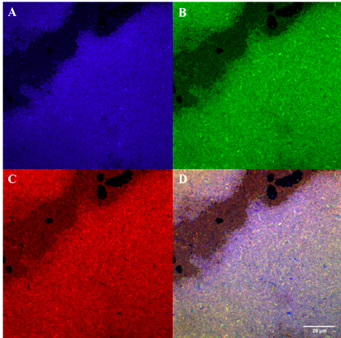
Figure A.1 Fluorescence in situ hybridisation staining of pure P. aeruginosa ATCC BAA-47 pure cells from broth culture with Pseudomonas spp. probe. (A) Nucleic material/DAPI in blue, (B) Eubacterial probe (EUB) in green, (C) Pseudomonas spp. specific probe (PSE277) in red, (D) composite image of (A), (B), (C). Images at 60x magnification.

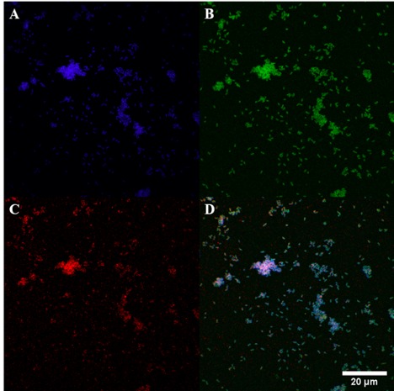
Figure A.2 Fluorescence in situ hybridisation staining of B. Fragilis ATCC 25285 pure cells from broth culture with Bacteroides spp. probe. (A) Nucleic material/DAPI in blue, (B) Eubacterial probe (EUB) in green, (C) Bacteroides spp. specific probe (BAC303) in red, (D) composite image of A, B & C. Images at 60x magnification.

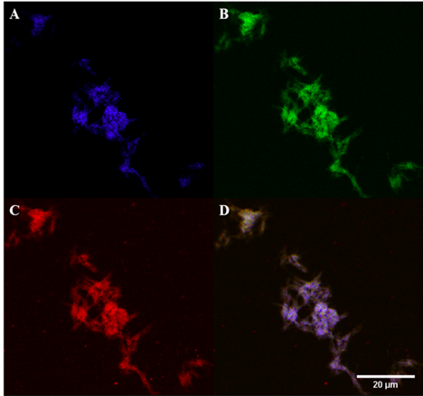
Figure A.3 Fluorescence in situ hybridisation staining of F. nucleatum ATCC 25586 pure cells from broth culture with Fusobacterium spp. probe. (A) Nucleic material/DAPI in blue, (B) Eubacterial probe (EUB) in green, (C) Fusobacterium spp. specific probe (FUSO) in red, (D) composite image of A, B & C. Images at 100x magnification.
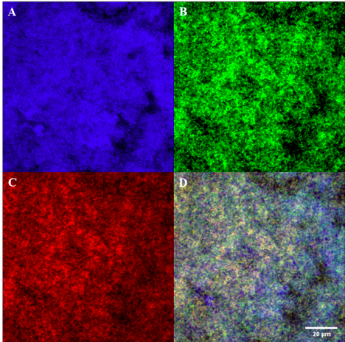
Figure A.4 Fluorescence in situ hybridisation staining of pure Haemophilus influenzae ATCC 10211 type b cells from broth culture. (A) Nucleic material/DAPI in blue, (B) Eubacterial probe (EUB) in green, (C) H. influenzae specific probe (Haeinf) in red, (D) composite image of A, B & C. Images at 60x magnification.

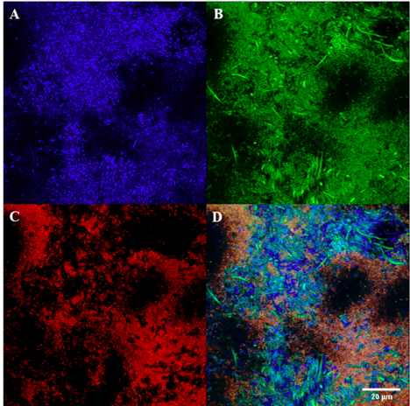
Figure A.5 Fluorescence in situ hybridisation staining of P. aeruginosa ATCC BAA-47 and E. coli K-12 DH5 alpha, ATCC PTA-4079 mixed cells from broth culture with Pseudomonas spp. probe. (A) Nucleic material/DAPI in blue, (B) Eubacterial probe (EUB) in green, (C) Pseudomonas spp. specific probe (PSE277) in red, (D) composite image of A, B & C. Images at 60x magnification.
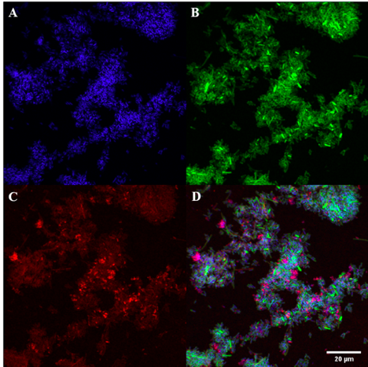
Figure A.6 Fluorescence in situ hybridisation staining of B. fragilis ATCC 25285 and E. coli K-12 DH5 alpha, ATCC PTA-4079 mixed cells from broth culture with Bacteroides spp. probe. (A) Nucleic material/DAPI in blue, (B) Eubacterial probe (EUB) in green, (C) Bacteroides spp. specific probe (BAC303) in red, (D) composite image of A, B & C. Images at 60x magnification.

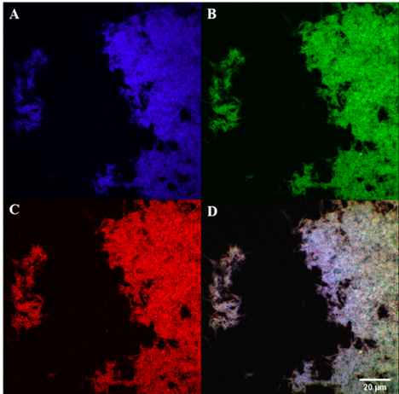
Figure A.7 Fluorescence in situ hybridisation staining of F. nucleatum ATCC 25586 and E. coli K-12 DH5 alpha, ATCC PTA-4079 mixed cells from broth culture with Fusobacterium spp. probe. (A) Nucleic material/DAPI in blue, (B) Eubacterial probe (EUB) in green, (C) Fusobacterium spp. specific probe (FUSO) in red, (D) composite image of A, B & C. Images at 60x magnification.
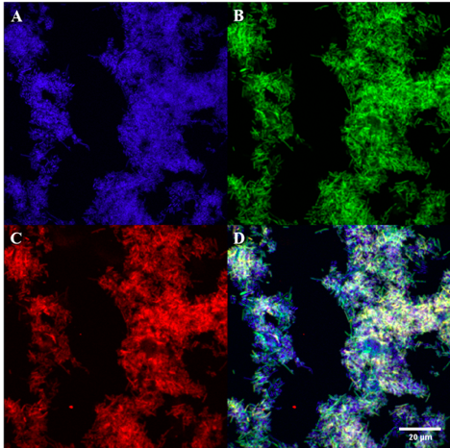
Figure A.8 Fluorescence in situ hybridisation staining of mixed Haemophilus influenzae ATCC 10211 type b and E. coli K-12 DH5 alpha, ATCC PTA-4079 mixed cells from broth culture with Haemophilus influenzae species-specific probe. (A) Nucleic material/DAPI in blue, (B) Eubacterial probe (EUB) in green, (C) H. influenzae species-specific probe (Haeinf) in red, (D) composite image of A, B & C. Images at 60x magnification.

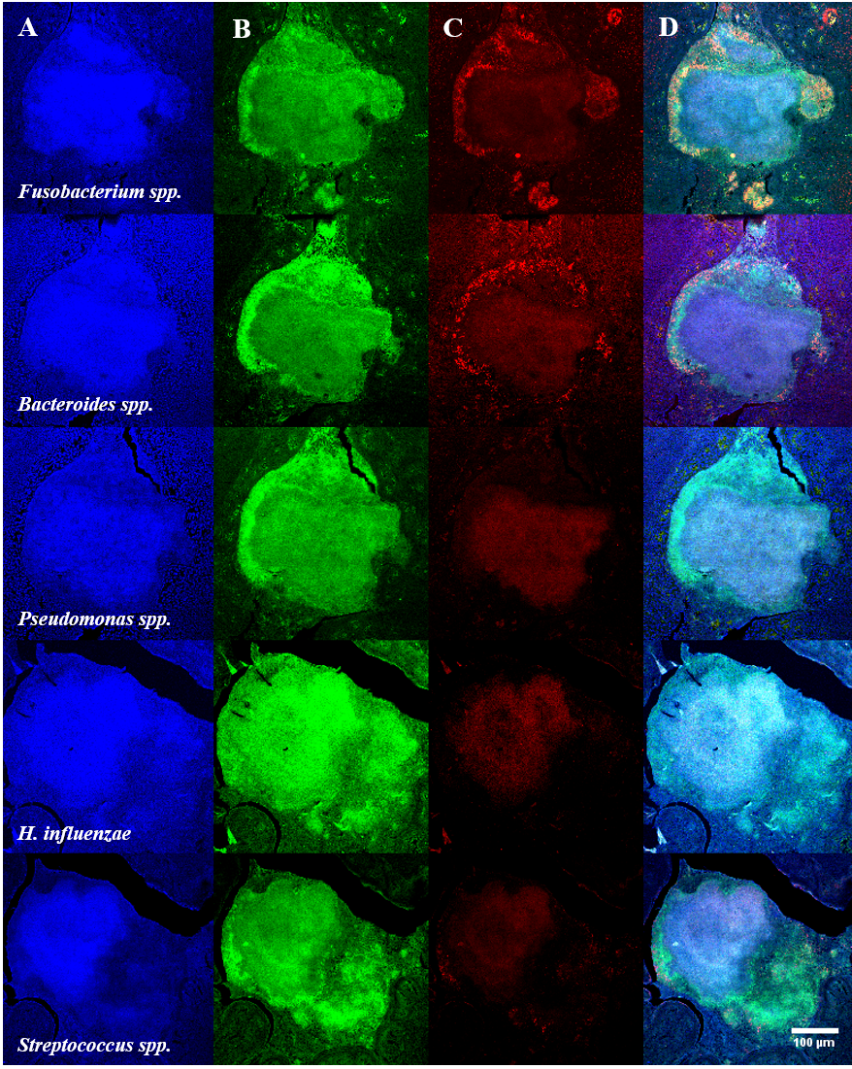
Figure A.9 Fluorescence in situ hybridisation staining of Fusobacterium spp., Bacteroides spp., Pseudomonas spp., H. influenzae and Streptococcus spp. specific probes in the same bacterial microcolony in a child with RT.
Rows: Fusobacterium spp., Bacteroides spp., Pseudomonas spp., H. influenzae and Streptococcus spp. specific probes. Columns: (A) Nucleic material/DAPI in blue, (B) Eubacterial probe (EUB) in green, (C) Specific bacterial taxa probe in red, (D) composite image of (A), (B), (C). Images at 10x magnification.

