Supplemental information for:

Enhanced correlation-based linking of biosynthetic gene clusters to their metabolic products through chemical class matching
  - Joris J. R. Louwen¹, Marnix H. Medema¹, Justin J. J. van der Hooft^{1,2*}
1. Bioinformatics Group, Wageningen University, 6708PB Wageningen, The Netherlands
2. Department of Biochemistry, University of Johannesburg, Johannesburg, South Africa
* Corresponding author - justin.vanderhooft@wur.nl

Figure S1. MIBiG classes matched to ClassyFire superclasses.
Figure S2. antiSMASH-predicted classes matched to NPClassifier superclasses, where matches with counts above five are shown.
Figure S3. antiSMASH predicted classes matched to ClassyFire classes, where matches with counts above five are shown.
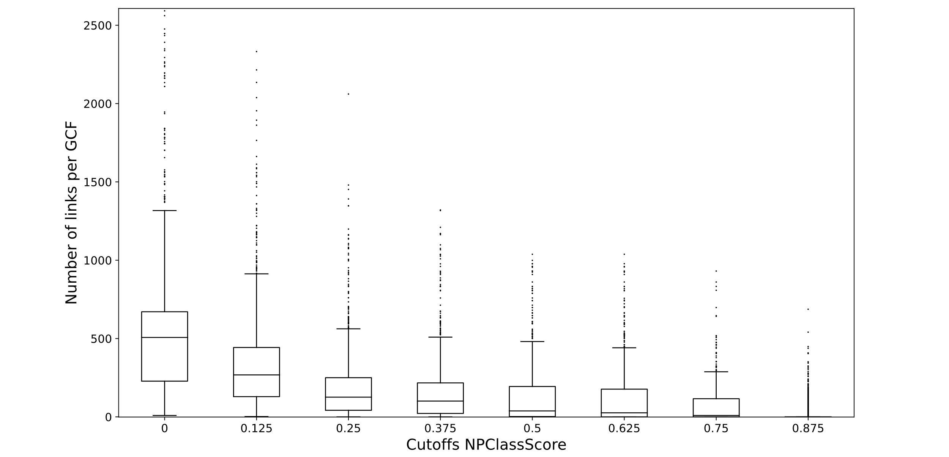
Figure S4. Number of links per GCF for all the GCFs in the Streptomyces/Salinispora dataset after using standardised Metcalf scoring in combination with NPClassScore filtering at varying cut-offs for the NPClassScore. The standardised Metcalf score cut-off was 2.5.
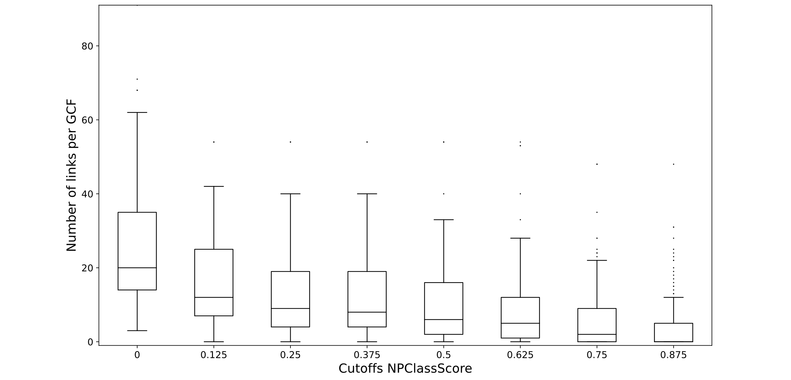
Figure S5. Number of links per GCF for all the GCFs in the Cyanobacteria dataset after using standardised Metcalf scoring in combination with NPClassScore filtering at varying cut-offs for the NPClassScore. The standardised Metcalf score cut-off was 2.5.

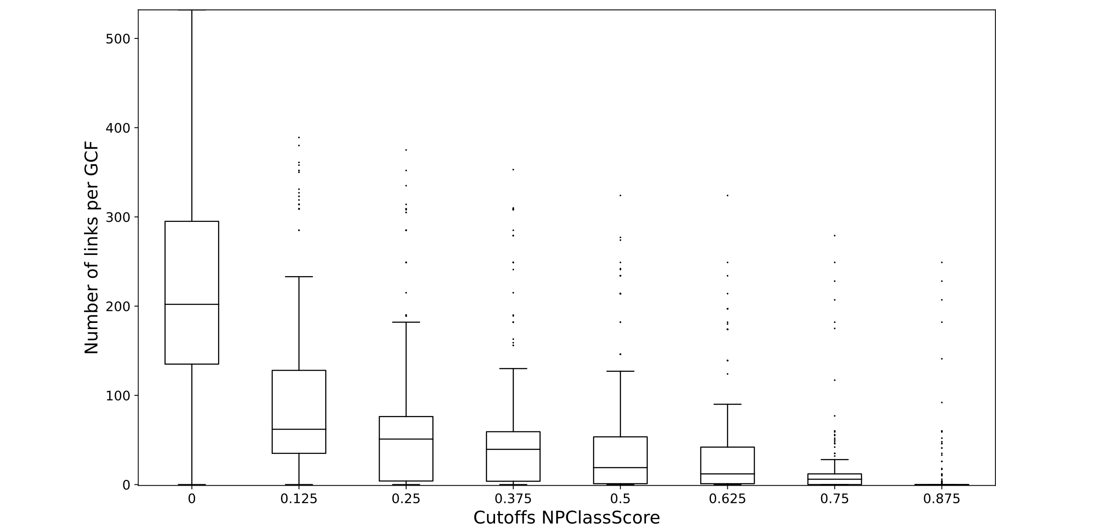
Figure S6. Number of links per GCF for all the GCFs in the Nocardia dataset after using standardised Metcalf scoring in combination with NPClassScore filtering at varying cut-offs for the NPClassScore. The standardised Metcalf score cut-off was 2.5.

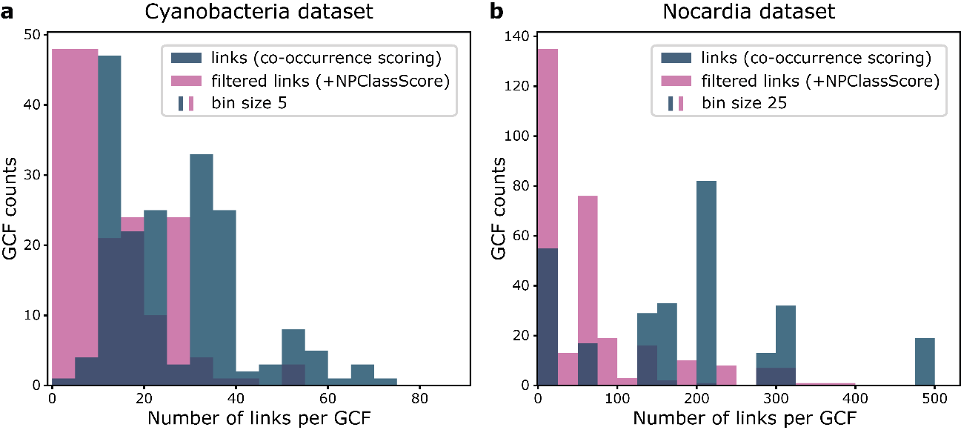
Figure S7. Histograms showing the number of candidate links per GCF in the (a) Cyanobacteria dataset and (b) Nocardia dataset after co-occurrence scoring (standardised Metcalf), and after NPClassScore filtering with a cut-off of 0.25. The bin sizes are 5 in (a) and 25 in (b). The results highlight how NPClassScore narrows down the number of candidate links for most GCFs.
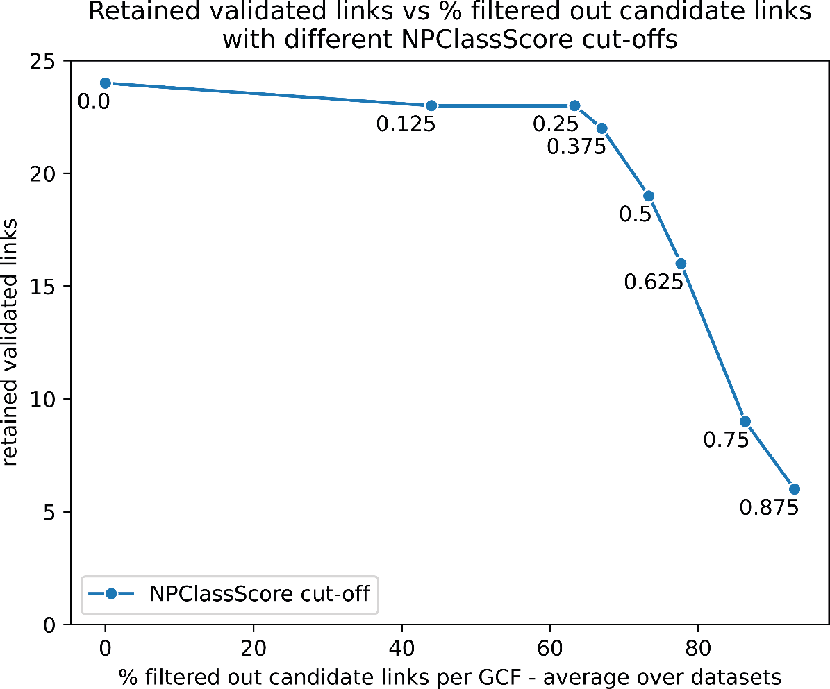
Figure S8. Number of retained validated links versus the percentage of filtered out candidate links per GCFs with different NPClassScore cut-offs. The percentage of filtered out candidate links is an average over the three datasets.
Table S1. Scoring table from NPClassScore showing the scores from MIBiG classes to NPClassifier pathways.
 | Polyketide | Other | Saccharide | Terpene | PKS-NRP_Hybrids | NRP | RiPP
Polyketides | 0.759 | 0.088 | 0.457 | 0.091 | 0.400 | 0.208 | 0.034
Shikimates and Phenylpropanoids | 0.028 | 0.051 | 0.021 | 0.005 | 0.014 | 0.016 | 0.000
Alkaloids | 0.100 | 0.471 | 0.000 | 0.236 | 0.131 | 0.179 | 0.017
Amino acids and Peptides | 0.033 | 0.220 | 0.064 | 0.010 | 0.422 | 0.579 | 0.950
Terpenoids | 0.048 | 0.012 | 0.029 | 0.654 | 0.005 | 0.000 | 0.000
Fatty acids | 0.019 | 0.046 | 0.000 | 0.000 | 0.027 | 0.004 | 0.000
Carbohydrates | 0.012 | 0.112 | 0.429 | 0.005 | 0.002 | 0.014 | 0.000

Table S2. Translation of BiG-SCAPE to MIBiG classes.
BiG-SCAPE class | MIBiG class
PKSI | Polyketide
PKSother | Polyketide
NRPS | NRP
RiPPs | RiPP
Saccharides | Saccharide
Others | Other
Terpene | Terpene
PKS-NRP_Hybrids | PKS-NRP_Hybrids

Table S3. Translation of antiSMASH classes from all other versions to match antiSMASH v5 classes.
original antiSMASH class | antiSMASH v5 class
NAGGN | other
NAPAA | other
RRE-containing | bacteriocin
RiPP-like | bacteriocin
cf_fatty_acid | fatty_acid
cf_putative | other
cf_saccharide | saccharide
guanidinotides | fused
lanthipeptide-class-i | lanthipeptide
lanthipeptide-class-ii | lanthipeptide
lanthipeptide-class-iii | lanthipeptide
lanthipeptide-class-iv | lanthipeptide
lanthipeptide-class-v | lanthipeptide
lantipeptide | lanthipeptide
linaridin | lanthipeptide
lipolanthine | lanthipeptide
nrps | NRPS
otherks | hglE-KS
prodigiosin | other
pyrrolidine | other
ranthipeptide | bacteriocin
redox-cofactor | other
t1pks | T1PKS
t2pks | T2PKS
t3pks | T3PKS
thioamide-NRP | other
thioamitides | bacteriocin
transatpks | transAT-PKS

Table S4. Information about the contents of the three datasets. We included the number of spectra in our versions of the datasets separately as some spectra present in the molecular networks occurred in, for example, control samples or samples we did not use.
# | Streptomyces/Salinispora | Cyanobacteria | Nocardia
strains | 154 | 24 | 11
BGCs | 5869 | 301 | 367
GCFs | 1581 | 184 | 300
spectra | 13667 | 729 | 11464
MFs | 8346 | 341 | 10458
spectra in our version of the data | 13381 | 707 | 3080
spectra without structure-based class prediction | 1145 | 34 | 809

Table S5. The average number of links per GCF for each dataset after NPClassScore filtering with different cut-offs, along with the percentual decrease in the number of links. In this case, the MS/MS spectra without structure-based predictions are automatically excluded.
NPClassScore cutoff | Streptomyces/Salinispora |  | Cyanobacteria |  | Nocardia
NPClassScore cutoff | Number of links | Change | Number of links | Change | Number of links | Change
0 | 549.85 | 0 | 26.98 | 0 | 206.33 | 0
0.125 | 332.96 | -39 | 15.81 | -41 | 98.27 | -52
0.25 | 177.00 | -68 | 12.61 | -53 | 64.35 | -69
0.375 | 149.46 | -73 | 11.78 | -56 | 58.24 | -72
0.5 | 115.89 | -79 | 9.88 | -63 | 45.85 | -78
0.625 | 105.10 | -81 | 8.42 | -69 | 35.17 | -83
0.75 | 64.19 | -88 | 6.20 | -77 | 13.03 | -94
0.875 | 23.13 | -96 | 3.82 | -86 | 6.31 | -97

Table S6. Counts for the number of spectra with certain ClassyFire superclasses as predicted by MolNetEnhancer (MNE), MNE for spectra below 850 Da, and CANOPUS. Counts are coloured from white to red, white being the lowest count and red being the highest count for each column.
CF superclasses | MNE predicted spectra | MNE predicted spectra <850Da | CANOPUS predicted spectra
Alkaloids and derivatives | 173 | 150 | 9
Benzenoids | 281 | 263 | 522
Hydrocarbon derivatives | 17 | 14 | 13
Hydrocarbons | 0 | 0 | 1
Lignans, neolignans and related compounds | 61 | 60 | 3
Lipids and lipid-like molecules | 4597 | 3603 | 1647
Nucleosides, nucleotides, and analogues | 18 | 18 | 136
Organic 1,3-dipolar compounds | 0 | 0 | 30
Organic Polymers | 105 | 10 | 2
Organic acids and derivatives | 2437 | 1865 | 4057
Organic nitrogen compounds | 79 | 78 | 280
Organic oxygen compounds | 231 | 209 | 882
Organohalogen compounds | 16 | 16 | 0
Organoheterocyclic compounds | 1013 | 981 | 731
Organophosphorus compounds | 0 | 0 | 2
Organosulfur compounds | 1 | 1 | 29
Phenylpropanoids and polyketides | 1528 | 1373 | 202
Total | 10557 | 8641 | 8546

Table S7. Counts of the ClassyFire superclass predictions for the 6,606 spectra that could be predicted by both MolNetEnhancer (MNE), and CANOPUS, showing the MNE predictions and CANOPUS predictions. Counts are coloured from white to red, white being the lowest count and red being the highest count for each column.
CF superclasses | MNE predictions | CANOPUS predictions
Alkaloids and derivatives | 119 | 7
Benzenoids | 203 | 338
Hydrocarbon derivatives | 8 | 13
Hydrocarbons | 0 | 1
Lignans, neolignans and related compounds | 33 | 3
Lipids and lipid-like molecules | 2686 | 1301
Nucleosides, nucleotides, and analogues | 16 | 81
Organic 1,3-dipolar compounds | 0 | 16
Organic Polymers | 10 | 1
Organic acids and derivatives | 1553 | 3229
Organic nitrogen compounds | 72 | 243
Organic oxygen compounds | 165 | 700
Organohalogen compounds | 16 | 0
Organoheterocyclic compounds | 773 | 534
Organophosphorus compounds | 0 | 2
Organosulfur compounds | 1 | 24
Phenylpropanoids and polyketides | 951 | 113
Total | 6606 | 6606

Table S8. The average number of candidate links per GCF for each dataset after NPClassScore filtering with different cut-offs, along with the percentual decrease in the number of links. In this case, the MS/MS spectra without structure-based predictions are automatically included.
NPClassScore cutoff | Streptomyces/Salinispora |  | Cyanobacteria |  | Nocardia
NPClassScore cutoff | Number of links | Change | Number of links | Change | Number of links | Change
0 | 549.85 | 0 | 26.98 | 0 | 206.33 | 0
0.125 | 372.64 | -32 | 17.32 | -36 | 158.98 | -23
0.25 | 216.68 | -61 | 14.12 | -48 | 125.05 | -39
0.375 | 189.14 | -66 | 13.29 | -51 | 118.95 | -42
0.5 | 155.57 | -72 | 11.39 | -58 | 106.56 | -48
0.625 | 144.78 | -74 | 9.93 | -63 | 95.88 | -54
0.75 | 103.87 | -81 | 7.71 | -71 | 73.73 | -64
0.875 | 62.81 | -89 | 5.33 | -80 | 67.01 | -68

