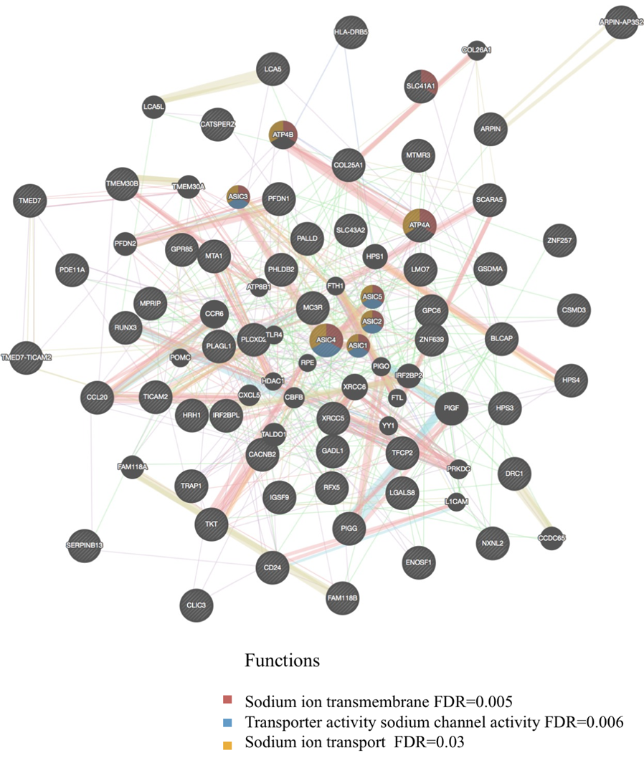
Figure S1: Network analysis for genes with hypomethylated DMPs identified for the vitamin D and high exercise group, extracted from GeneMania. Significant biological pathways (FDR < 0.05) associated with the input genes and related genes are described in the legend. The input genes are indicated with stripes.

Table S9: Top 8 vitamin D genes (r2 ≥ 0.2) associated with the study factors.
Gene name | Number of CpGs | Factor | Correlation coefficient (r2) | P-value
RXRA | 1 | Age | -0.22 | 0.00023
PNPLA1 | 1 | Physical activity-summer | 0.21 | 0.00059
PNPLA1 | 1 | Physical activity-winter | 0.22 | 0.00042
SERINC2 | 1 | Alcohol (SD/week) | -0.22 | 0.00025
SOAT1 | 1 | Physical activity-summer | 0.20 | 0.00081
 | 1 | Age | 0.20 | 0.00093
SMARCA4 | 1 | Age | -0.21 | 0.00080
PPARGC1B | 3 | Age | -0.27  -0.20  0.20 | 0.000009  0.00098  0.00100
ACSL1 | 1 | Age | 0.20 | 0.00083
SMARCC1 | 1 | Age | -0.21 | 0.00080

