Supplementary Material

Supplementary Notes
1. Salmonella infection
1.1. ST infection 1
In generation 10, selection line and non-selection line chicks were obtained from the Changping Experimental Base of Institute of Animal Sciences (Beijing, China). A total of 146 one-day-old chicks (Table 1) were raised in separate cages at the experimental center of China Agricultural University (Beijing, China) with free access to feed and water. Salmonella typhimurium (ST, 21484 standard strain) was purchased from China Industrial Microbial Culture Preservation Center (Beijing, China). The bacteria were resuscitated overnight in Luria–Bertani (LB) broth (Amresco, Washington, DC, USA) at 37 °C in an orbital shaking incubator at 150 rpm. After recovery, the bacteria were cultured for 12 h and concentrated in a centrifuge. The final number of colony forming units (CFUs) was determined by plating serial dilutions. At seven days of age, the chicks were orally inoculated with 1 mL culture containing 2.5×10¹⁰ CFU Salmonella typhimurium. Blood samples, livers, spleen, cecum, and cecal tonsils were collected at three days post infection.
1.2. ST infection 2
In generation 12, selection line and non-selection line chicks were obtained from the Changping Experimental Base of Institute of Animal Sciences (Beijing, China). A total of 180 one-day-old chicks were raised in separate cages at the experimental center of China Agricultural University (Beijing, China) with free access to feed and water. Salmonella typhimurium (ST, 21484 standard strain) was purchased from China Industrial Microbial Culture Preservation Center (Beijing, China). The bacteria were resuscitated overnight in Luria–Bertani (LB) broth (Amresco, Washington, DC, USA) at 37 °C in an orbital shaking incubator at 150 rpm. After recovery, the bacteria were cultured for 12 h and concentrated in a centrifuge. The final number of colony forming units (CFUs) was determined by plating serial dilutions. At seven days of age, the chicks were orally inoculated with 1 mL culture containing 8.97×10¹¹ CFU Salmonella typhimurium. The mortality rate and heterophil and leukocyte counts in peripheral blood were determined at 24 hours days post infection, Counts were compared with non-infected chicks and between selection and non-selection lines.
1.3. ST infection 3
In the F2 population, extreme individuals among the high and low H/L groups were selected and mated to two F3 populations (high H/L group and low H/L group). A total of 60 one-day-old chicks from these crosses were raised in separate cages at the experimental center of China Agricultural University (Beijing, China) with free access to feed and water. Salmonella typhimurium (ST, 21484 standard strain) was purchased from China Industrial Microbial Culture Preservation Center (Beijing, China). The bacteria were resuscitated overnight in Luria–Bertani (LB) broth (Amresco, Washington, DC, USA) at 37 °C in an orbital shaking incubator at 150 rpm. After recovery, the bacteria were cultured for 12 h and concentrated in a centrifuge. The final number of colony forming units (CFUs) was determined by plating serial dilutions. At seven days of age, the chicks were orally inoculated with 1 mL culture containing 5.27×10¹⁰ CFU Salmonella typhimurium. The mortality rate and heterophils in blood were determined at 24 hours days post infection.

2. Transcriptome sequencing and analysis
Total RNA was extracted from multiple tissues (liver, spleen, cecum, and cecal tonsils) using a QIAGEN kit (Qiagen, Hilden, Germany). Quality and quantity of the extracted RNA were assessed using a 2100 Bioanalyzer and RNA 6000 Nano kit (Agilent, Santa Clara, CA, USA). For mRNA library construction and deep sequencing, 3 µg of RNA was prepared using the TruSeq RNA Sample Preparation Kit (Illumina, San Diego, CA, USA) to capture the coding transcriptome. After purification, the RNA was fragmented using divalent cations at 95 °C. The cleaved fragments were reverse transcribed using the TruSeq RNA Library Preparation Kit for first-strand synthesis, followed by second-strand cDNA synthesis. After purification and adaptor ligation of the cDNA fragments, sequencing was performed on the HiSeq X Ten platform (Illumina, San Diego, CA, USA). Reads were analyzed for quality control purposes using the software FastQC (v0.10.1). Sequence adapters and low-quality reads were eliminated. Clean reads were mapped to the chicken reference genome (Gallus gallus 5.0) using Hisat2. Mapped transcripts were quantified using Htseq. Analysis to identify differentially expressed genes (DEGs) was conducted by DESeq2. Those with fold-change ≥2 and Padj <0.5 were considered to be DEGs.

3. Single-cell RNA-seq and gene expression analysis
Heterophils were collected from the F3 population after ST infection using a single-cell collection solution that contained cell lysis components and RNase inhibitors. Reverse transcription was performed with oligo(dT) to form first-strand cDNA. PCR amplification was then used to enrich the cDNA, and the amplified product was purified before being used to construct the library, including the steps of DNA fragmentation, end repair, adding "A" plus linker, PCR amplification, and library quality control. The constructed library was then sequenced as 150-bp paired-end (PE) reads using the Illumina platform. In order to guarantee data quality, a Perl script was used to filter the original reads (Raw Data). The script employed the following steps: 1) Trim Smart-seq2 public primer sequence from reads (trimmed reads with length less than 30 bp were discarded); 2) Remove reads contaminated by adapters (reads were defined as contaminated if they contained more than 5 bp of adapter sequence); 3) Remove low-quality reads (reads were defined as low-quality if more than 15% of bases had phred quality value less than or equal to 19); 4) Remove reads in which N bases comprise more than 5% of the total bases. At every step, if one read in a pair was discarded, the other was also.
The reference genome and annotation file were downloaded from the ENSEMBL database (http://www.ensembl.org/index.html). Bowtie2 v2.2.3 was used to build the genome index, and filtered reads (Clean Data) were then aligned to the reference genome using HISAT2 v2.1.0. The count of reads in each gene for each sample was determined by HTSeq v0.6.0, and the fragments per kilobase million mapped reads (FPKM) was then calculated to estimate expression in each sample. Differential gene expression analysis was conducted using DESeq2 v1.6.3, which estimates the expression level of each gene on a per-sample basis by linear regression, then calculates the associated P-value using the Wald test. Genes with P≤0.05 and |log2_ratio|≥1 were identified as differentially expressed genes (DEGs).

4. Mutation function prediction
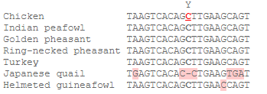
According to the reference genome annotation, rs736799474 is located downstream of the PTPRJ gene. Multi-species sequence alignment indicates that the region containing it is conserved.
According to the Genecard entry for PTPRJ (https://www.genecards.org/cgi-bin/carddisp.pl?gene=PTPRJ&keywords=PTPRJ), the human PTPRJ gene features a132-Kb enhancer region located 61.7 Kb downstream. Alignment of this region with the sequence around the chicken SNP revealed that a 10-bp sequence including the rs736799474 mutation site is highly conserved. Therefore, we speculate that the sequence near rs736799474 has enhancer activity.
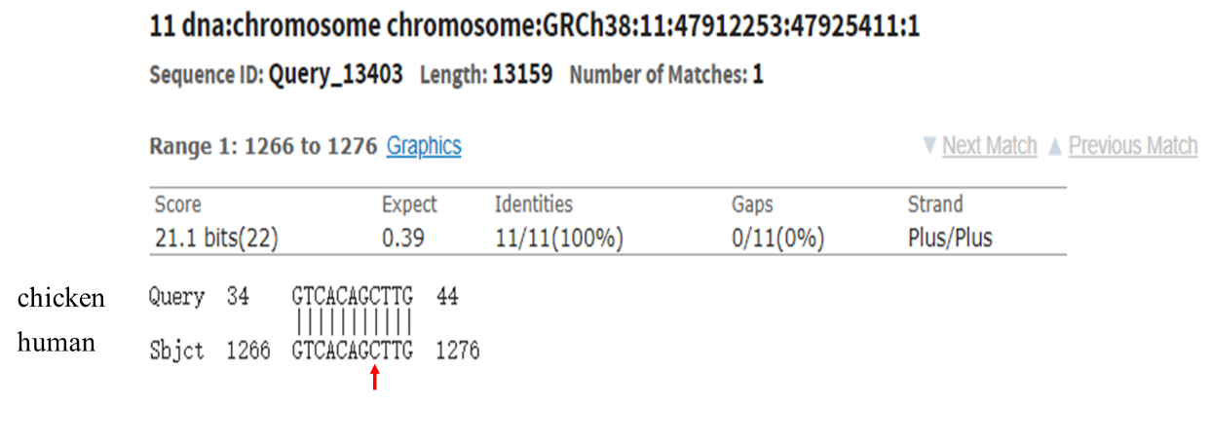

Supplementary Figures

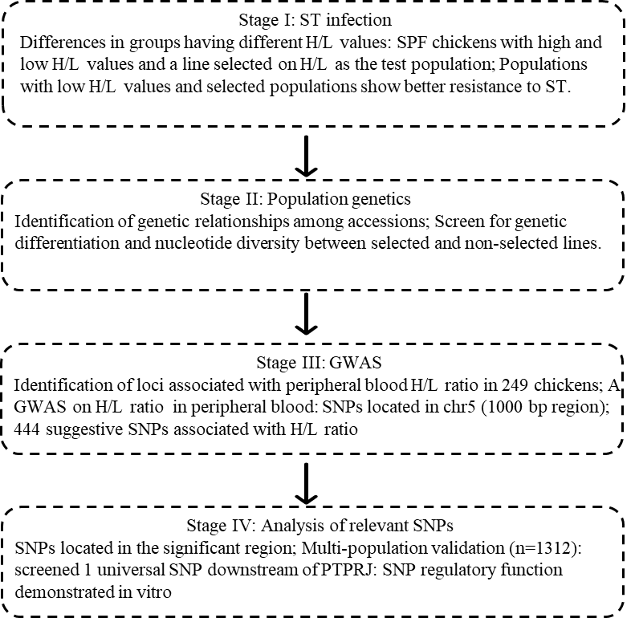

Supplementary Figure S1. Graphic representation of study design. ST: Salmonella typhimurium. H/L: Heterophil to lymphocyte ratio. GWAS: Genome-wide association study. SNPs: Single nucleotide polymorphisms. LD: Linkage disequilibrium (LD). PTPRJ: Protein tyrosine phosphatase, receptor type J.

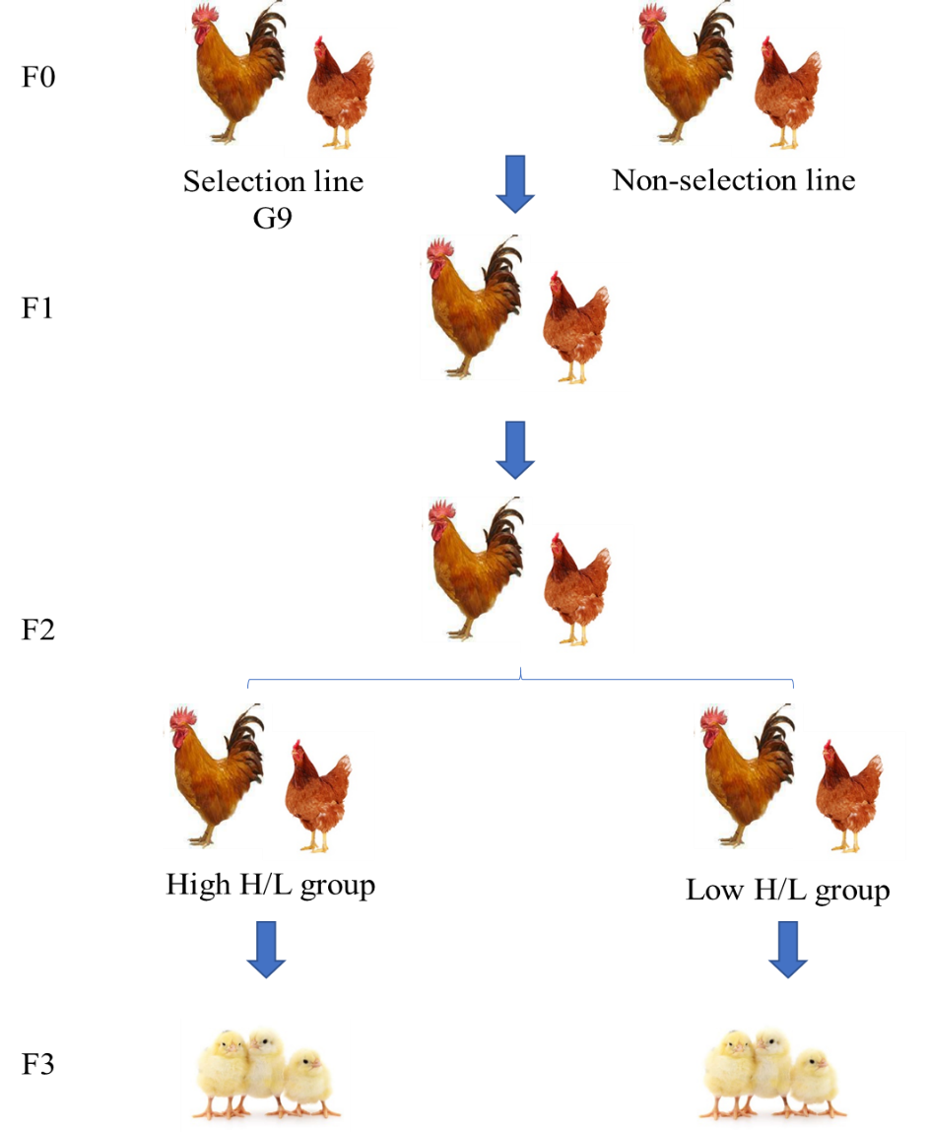

Supplementary Figure S2. Diagram of F3 population intercross between the selection and non-selection lines.

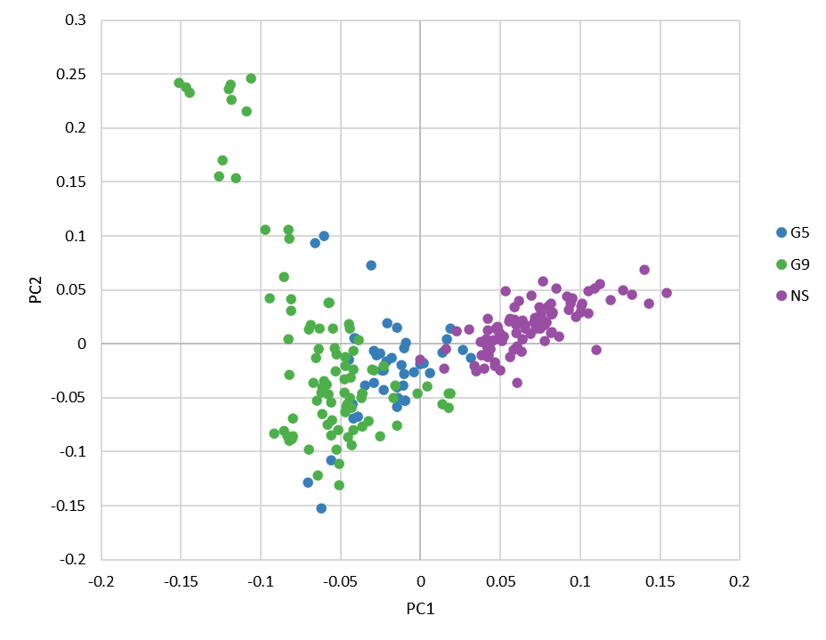

Supplementary Figure S3. Principal component analysis.

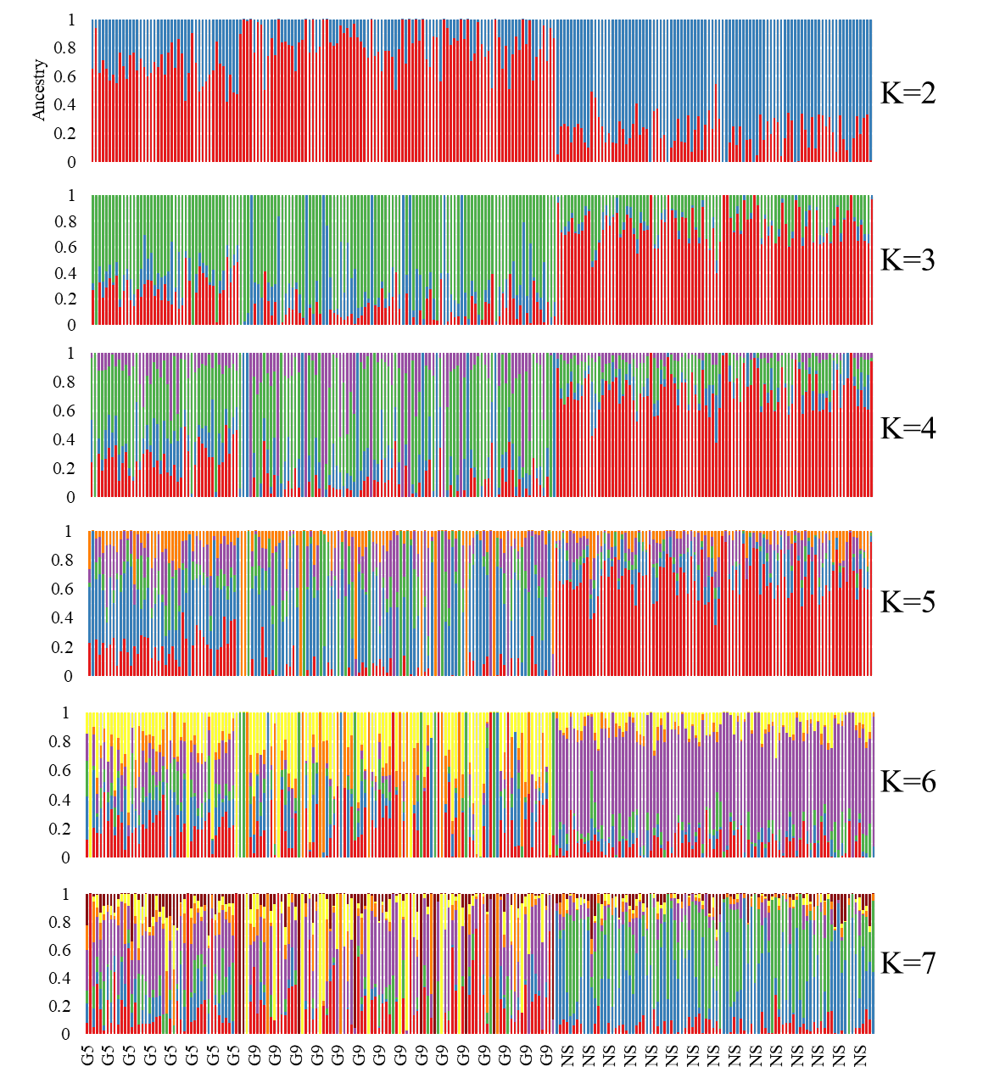

Supplementary Figure S4. Genome-wide admixture analyses inferred from SNPs analyzed with ADMIXTURE 1.3. At K = 2, 3, and 4, the three populations (non-selection line, generation 5, and generation 9) separate into three groups, which indicates a potential slight gene differentiation between the selection and non-selection lines.

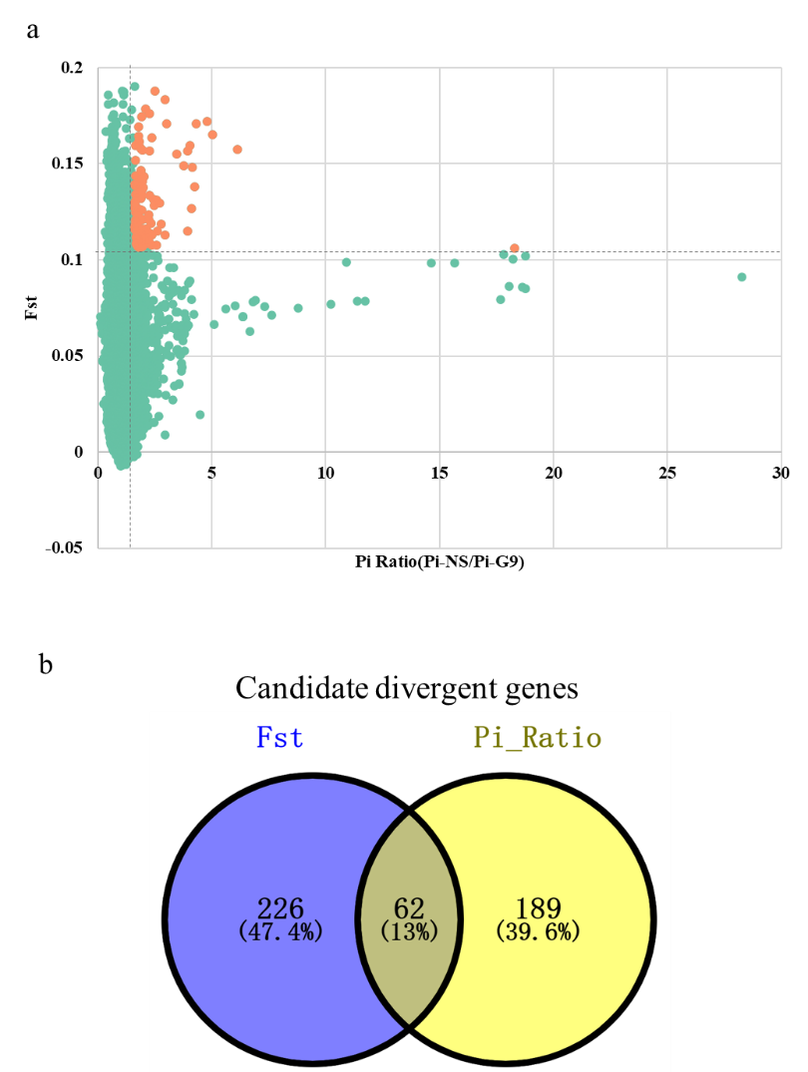

Supplementary Figure S5. Genome-wide distribution of the Pi ratio and FST, determined across all autosomes using 40-kb windows with 10-kb steps. (a) Comparison of generation 9 and non-selection breeds. Red dots represent windows fulfilling the requirement for selected regions. The gray vertical dashed line indicates the pi ratio threshold, and the gray horizontal dashed line the FST threshold, pi_ratio=(pi_G9/pi_NS). (b) Intersection of the candidate divergent gene sets identified by FST and Pi ratio.

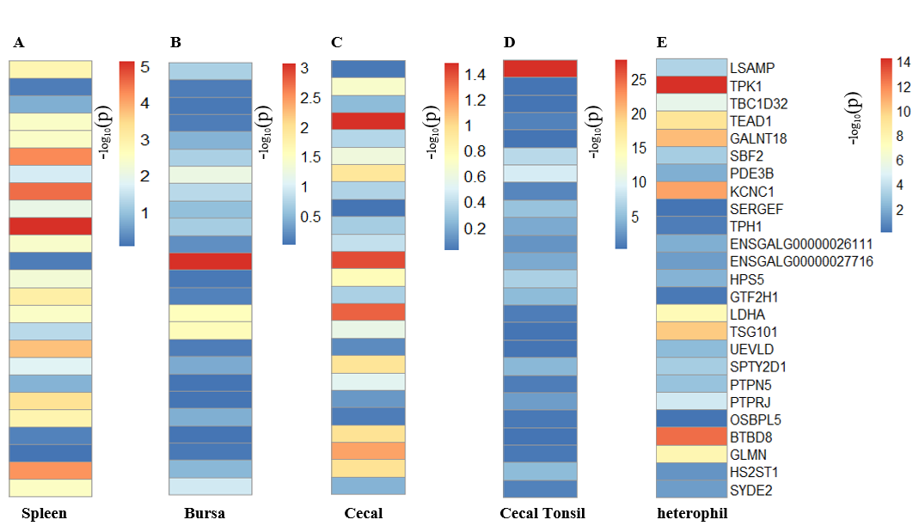

Supplementary Figure S6. Differential gene expression between selection and non-selection lines or high and low H/L groups in multiple tissues. (a) Spleen, (b) bursa, (c) cecum, (d) cecal tonsils, and (e) heterophils. P-values are for the comparison of selection line vs. non-selection line chickens (for heterophils, P-values compare the high H/L group vs. low H/L group) based on RNA-seq data and obtained using Fisher’s exact test via Deseq2. Values shown are -log (P).

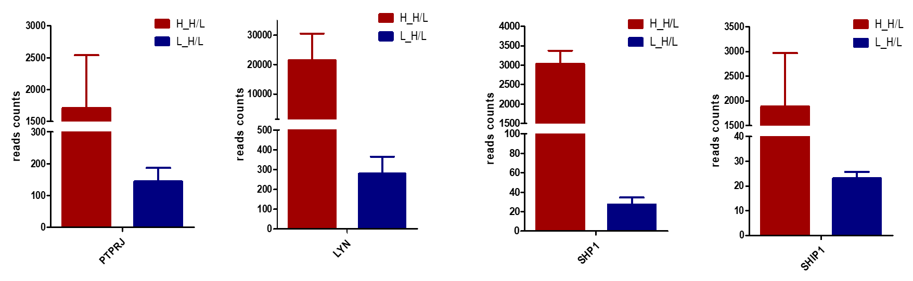

Supplementary Figure S7. Gene expression of PTPRJ, LYN, SHP-1, and SHIP-1 in individuals from the F3 population with high and low H/L.

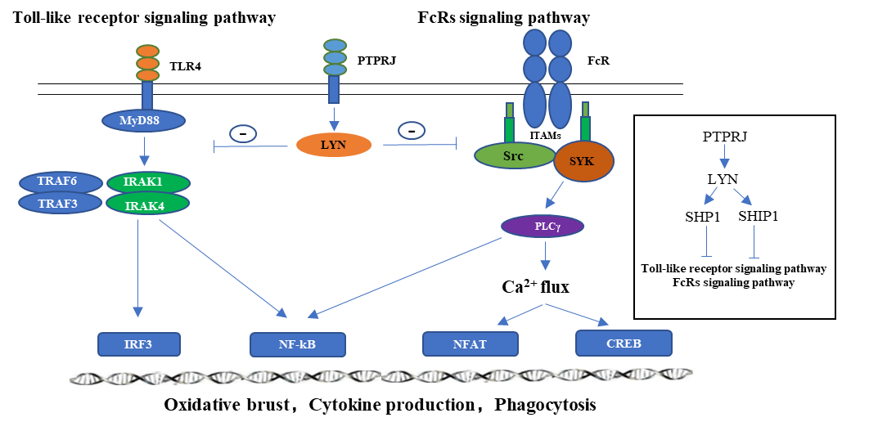
Supplementary Figure S8. PTPRJ exerts an inhibitory effect on the Toll-like receptor and FcγRs signaling pathways through the LYN gene. Bacterial factors such as lipopolysaccharides (LPS) activate innate immunity as well as stimulate the antigen-specific immune response and trigger the inflammatory response. Members of the Toll-like receptor (TLR) gene family convey signals stimulated by these factors, activating signal transduction pathways that result in transcriptional regulation and stimulate immune function. TLR4 is activated by LPS. The downstream signaling pathways used by these receptors activate IL-1 receptor associated kinase (IRAK) through the MyD88 adaptor protein, and subsequent signaling through TRAF-6 and protein kinase cascades activates NF-kB. NF-kB then activates transcription of genes such as those encoding the proinflammatory cytokines IL-1 and IL-12. When Fcγ receptors are involved in binding, the γ chain of FcγR and the ITAM tyrosine of FcγRIIA are rapidly phosphorylated. The two Src homology domains in the tyrosine kinase Syk bind to ITAM, leading to formation of signal complexes on the cell membrane. Within those complexes, Syk-mediated phosphorylation of effector proteins activates downstream signaling pathways that can culminate in cell phagocytosis, degranulation, and cytokine and peroxide release.

