Supplement figure
Supplementary Figure 1 The picture of Pengyuan crabs
Supplementary Figure 2(a) Surface topography with and without crab disturbance. (No crabs (left), crabs (right))
Figure 2(b) Surface topography variation with crabs in summer and winter
Supplementary Figure 3 Experimental setup
Supplementary Figure 4 SRQ100 soil solution sampler

Supplementary Figure 1 The picture of Pengyuan crabs
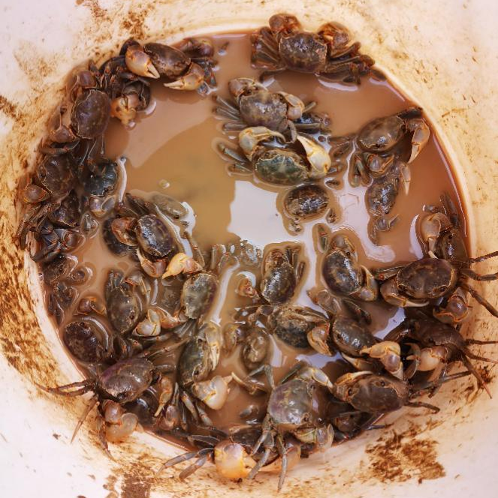

Supplementary Figure 2(a) Surface topography with and without crab disturbance. (No crabs (left), crabs (right))
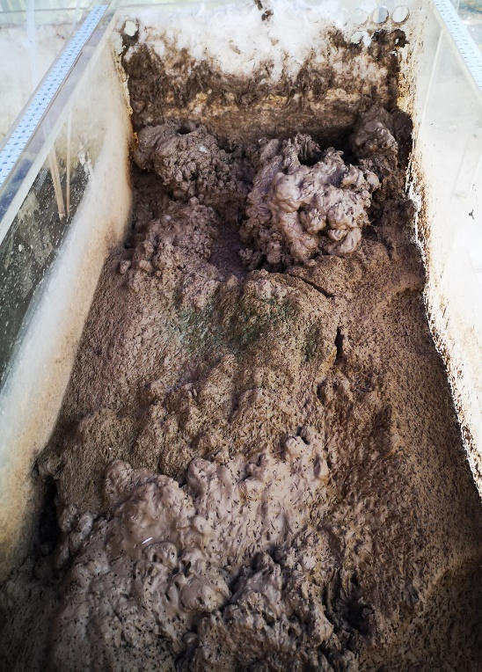
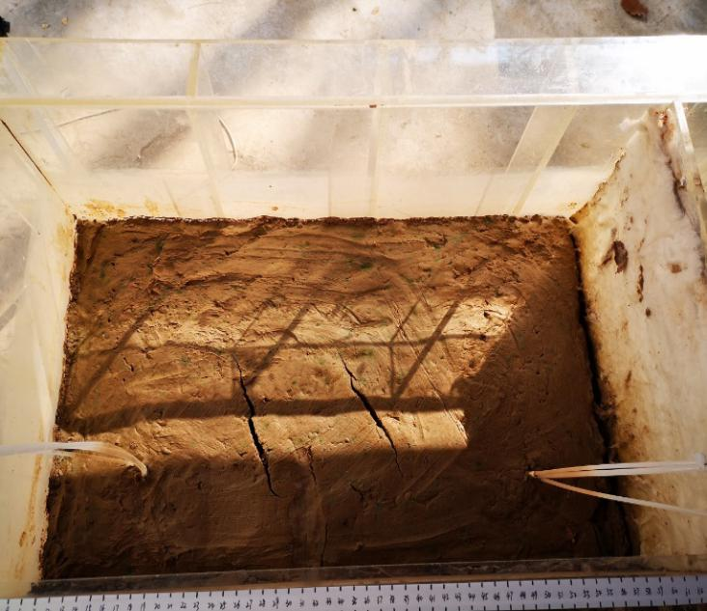

Figure 2(b) Surface topography variation with crabs in summer and winter
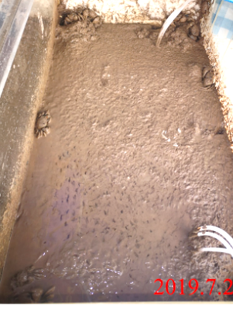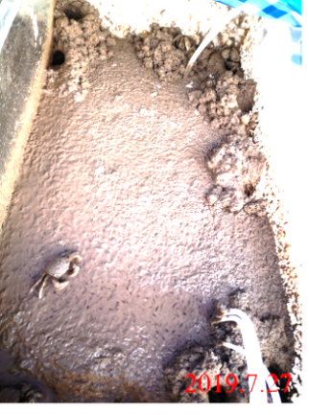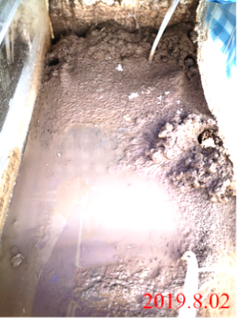
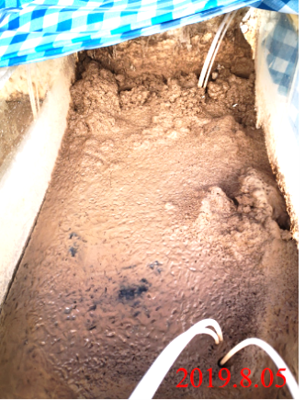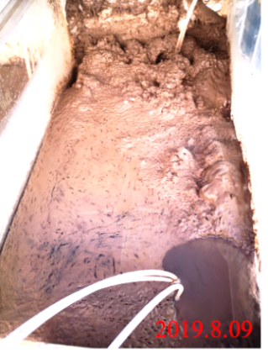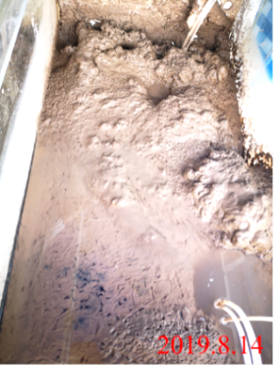
in summer
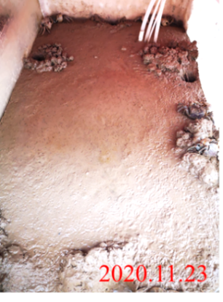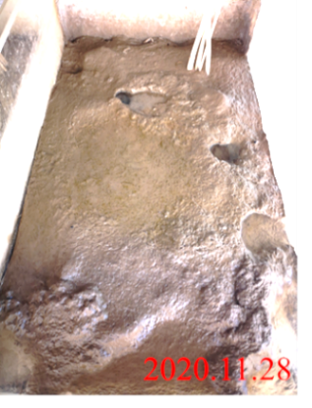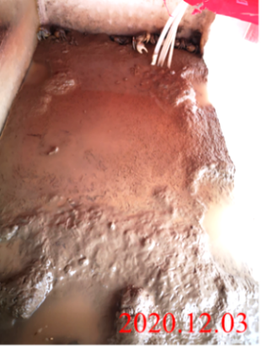
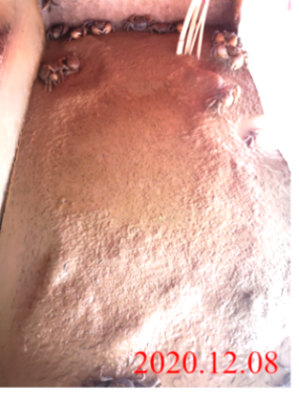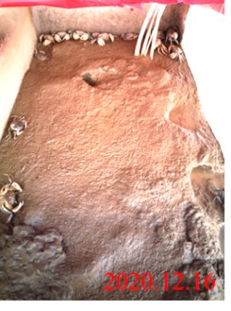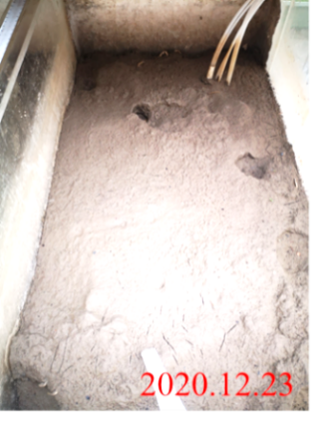
in winter
Supplementary Figure 3 Experimental setup
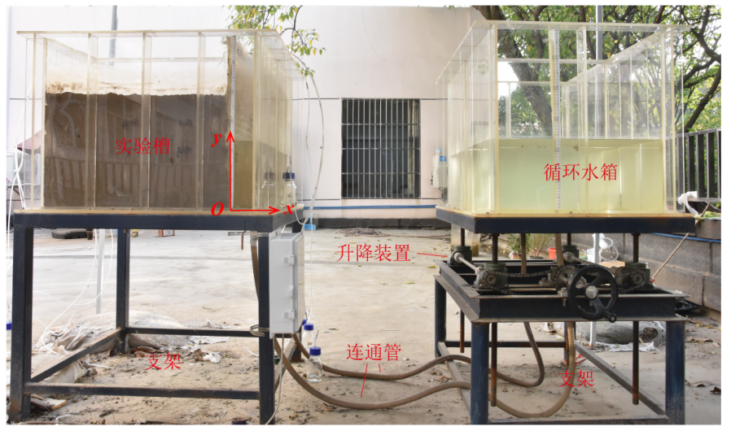
Support holder
Support holder
Lifting gear
Connecting pipe
Experiment box
Experiment box
Supplementary Figure 4 SRQ100 soil solution sampler
