Supplementary Figure S1: Failure to Enroll Rate (FTE) for different enrollment ages and minimum number of fingers enrolled using a quality score of 40 as the enrollment threshold score

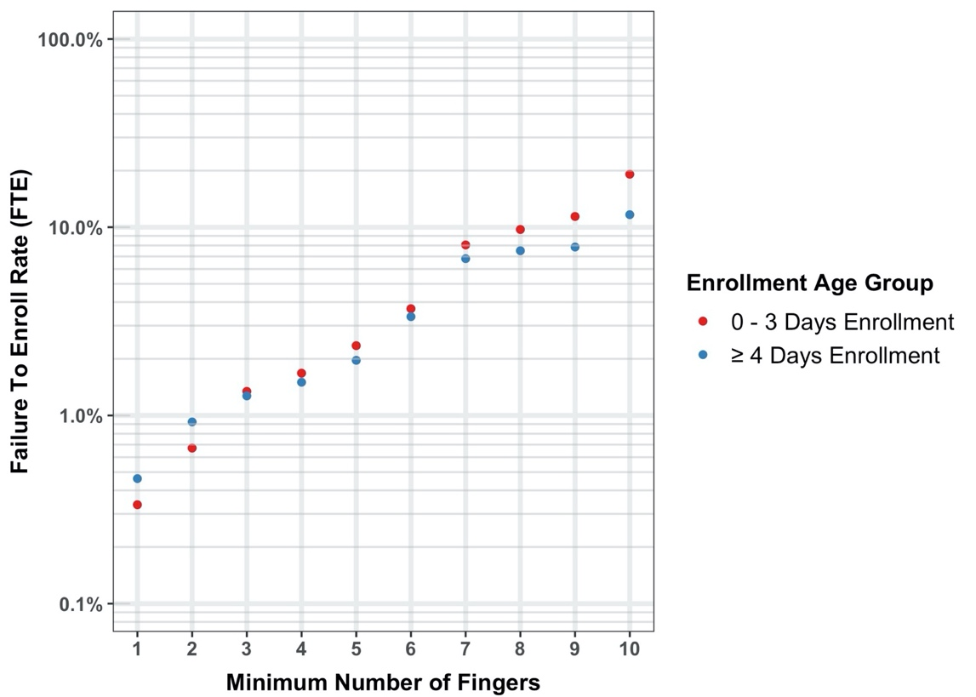

Supplementary Table S1: Comparison of different biometric traits and their compatibility for infant identification based on information from [19,23] and the authors' perception.
Biometric  Trait | Required Degree of Subject Cooperation | Persistence | Parental Concerns | Primary Failure Modes | Examples for Attempt with Infants
Face | Moderate (Stare towards camera with neutral expression) | Low (Facial Aging) | Minor | Facial aging, trauma | Singh et al. (20)
Fingerprint | High (Allow the operator to hold the child’s finger) | Potentially high | Moderate | Sloughing, worn prints | Francis Galton et al. (26), Jain et al. (27)
Iris | High (Open eyes and stare towards camera) | Potentially high | Major | Eye condition, behavior | Corby et al. (28)
Palm-print | Moderate (Open fist and allow operator to hold the palm) | Potentially high | Moderate | Sloughing, worn prints | Weingaertner, D et al. (21)
Footprint | Moderate (Removal of shoes and allow operator to hold foot) | Unknown | Minor | Sloughing, worn prints | Weingaertner, D et al. (21)
Ear | Low (Keep head steady) | Potentially high | Minor | Aging, specificity | Fields, C et al. (29)
Palm Vein  Pattern | Moderate (Open fist and allow the operator to hold the palm) | Potentially high | Moderate | Thin, obscured vasculature in infants, fat, hair in adults | Cao, J et al. (30)

