Supporting Information for

Nano zero-valent iron assisted microbial electrosynthesis for medium-chain fatty acids production

Ping Wu ¹, Jie Zhang ¹, Jing Li ¹, Yan Zhang ^{1, 2, 3}, Bo Fu ^{1, 2, 3}, Mingyi Xu ⁴,
Yifeng Zhang ⁴, He Liu ^{1, 2, 3, *}

¹ School of Environmental and Civil Engineering, Jiangnan University, Wuxi 214122, China;
² Jiangsu Key Laboratory of Anaerobic Biotechnology, Wuxi 214122, China;
³ Jiangsu Collaborative Innovation Center of Water Treatment Technology and Material, Suzhou 215011, China;
⁴ Department of Environmental Engineering, Technical University of Denmark, DK-2800 Lyngby, Denmark.
* Corresponding author:
He Liu, E-mail: liuhe@jiangnan.edu.cn
Number of pages: 6
Number of figures: 3
Number of tables: 1
Number of references: 5

Figure.S1 (a) Online monitoring of cathode potential for all reactors during the entire operation; (b1-b4) Online monitoring of all closed-circuit reactor cathode currents (R2-R5) during the entire operation, (c) pH change of each reactor catholyte during the operation.
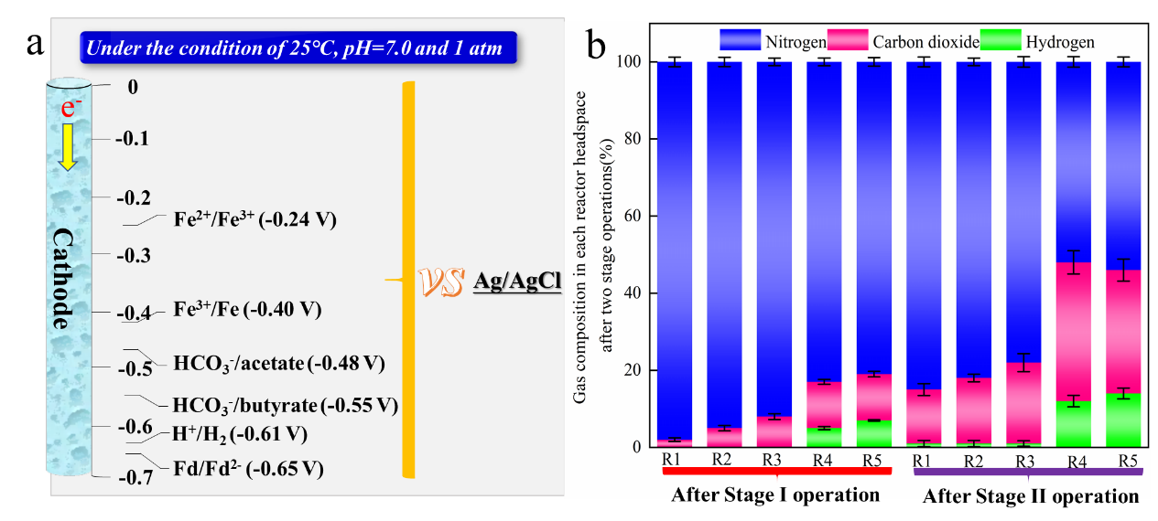
Figure.S2 (a)The theoretical cathode potentials of critical reactions in MES under standard condition; (b) The gas composition of reactor headspace in R1-R5.

Figure.S3 Cyclic voltammogram of the fresh carbon felt without inoculum in 50 mM PBS solution.

Table.S1 Summary of bioproducts production performance from CO₂ or HCO₃⁻ feedstocks in bioelectrochemical system.
Feedstock | Cathode | Working volume | Applied voltage | Electron donor | Maximum production rate (g/L/d), concentration  (g/L), or yield | Reference
CO₂: N₂ (V: V=3:7),  feed batch and continuously feed. | Carbon felt (19.8 cm²) | 0.36 L | −0.85 V vs SHE  constant potential | Electrode | 9.8 g/L/d acetate; 3.2 g/L/d butyrate; 0.95 g/L/d caproate. | 1
CO₂ (99%) + Ethanol,  feed batch. | Carbon felt  (7 cm²) | 0.095 L | 10 A/cm²  constant current density | Electrode +  5 g/L Ethanol | 2.41 g/L/d caproate. | 2
CO₂ + CO,  feed batch. | Carbon felt  (7 cm²) | 0.095 L | 10 A/cm²  constant current density | Electrode + CO | 5.47 g/L acetate; <2 g/L butyrate; <1 g/L caproate. | 3
HCO₃⁻,  feed batch. | Graphite  (30.0 cm²) | 0.65 L | −0.8 V vs SHE  constant potential | Electrode | 5.45 g/L acetate. | 4
HCO₃⁻,  continuously feed. | Graphite felt  (4.9 cm²) | 0.07 L | −1.0 V vs SHE  constant potential | Electrode | 4.5 g/L acetate; trace amounts of formate, ethanol, butanol, butyrate, etc. | 5
HCO₃⁻,  feed batch and continuously feed. | Carbon felt (15 cm²) | 0.17 L | 1.2 V | Electrode +  5 g/ L NZVI | 1.6 g/L acetate, 1.1 g/L butyrate, and 0.7 g/L caproate. | This study

Reference
- Jourdin L, Raes SMT, Buisman CJN, Strik DPBTB. Critical biofilm growth throughout unmodified carbon felts allows continuous bioelectrochemical chain elongation from CO₂ up to caproate at high current density. Front. Energy Res. 2018;6:00007.
- Jiang Y, Chu N, Qian DK, Zeng JX. Microbial electrochemical stimulation of caproate production from ethanol and carbon dioxide. Bioresour. Techno. 2020; 295:122266.
- Chu N, Liang QJ, Zhang W, Ge Z, Hao W, Jiang Y, Zeng RJ. Waste C1 gases as alternatives to pure CO₂ improved the microbial electrosynthesis of C4 and C6 carboxylates. ACS Sustain Chem Eng. 2020;8:8773−8782.
- Mohanakrishna G, Karolien V, Pant D. Imperative role of applied potential and inorganic carbon source on acetate production through microbial electrosynthesis. J CO₂ Util. 2016;15:57−64.
- Izadi P, Fontmorin JM, Godain A, Yu EH, Head IM. Parameters influencing the development of highly conductive and efficient biofilm during microbial electrosynthesis: the importance of applied potential and inorganic carbon source. NPJ Biofilms Microbi. 2020;6:40.

