Screening and understanding Li adsorption on 2-dimensional metallic materials by learning physics
Sheng Gong^{1,*}, Shuo Wang^{2,*}, Taishan Zhu^{1,*}, Xi Chen¹ and Jeffrey C. Grosmman^{1,†}

¹Department of Materials Science and Engineering, Massachusetts Institute of Technology, MA 02139, USA
²Department of Materials Science and Engineering, University of Maryland, MD 20742, USA

- Details of machine learning models
In this work, we choose Crystal Graph Convolutional Neural Networks (CGCNN)¹ as the architecture for building graph convolution network potentials for Li adsorption. Li adsorption sites are sampled randomly within 5 Å above the plane of the given 2D material. As shown in Figure 1c in the main text, in each batch we randomly sample 10 symmetrically inequivalent adsorption sites from each material, and we iteratively sample batches until convergence.
For the random forest models, we use the code from Scikit Learn². For the descriptors used for the random forest models, we add three features (thickness, number of atom per area, number of atom per volume) to the ones generated from the Matminer³ platform. The modules used to generate features in this work are: Element Property (magpie), Oxidation States, Electron Affinity, Band Center, Cohesive Energy, Miedema, TMetal Fraction, Valence Orbital, Yang Solid Solution, Global Symmetry Features, Structural Complexity, Chemical Ordering, Global Instability Index, Maximum Packing Efficiency, Minimum Relative Distances, Structural Heterogeneity, Average Bond Length, Average Bond Angle, Bond Orientational Parameter and Coordination Number.
- Details of DFT calculations
All first-principle calculations, including Li adsorption site optimization, site energy and work function calculation and charge transfer are carried out using density functional theory (DFT) by employing the Vienna Ab initio Simulation Package (VASP).⁴ The projector augmented wave (PAW) method⁵ is used with a kinetic energy cutoff of 500 eV. The first Brillouin zone is sampled by the Monkhorst–Pack scheme⁶ with a grid density of KSPACING = 0.4 Å^{–1}. The exchange-correlation interactions are treated using Perdew−Burke−Ernzerh functional (PBE) within the generalized gradient approximation (GGA).⁷ Convergence criteria are set to be 10⁻⁴ eV for the total energy and < 10⁻² eV/Å for atomic forces, respectively. To avoid Li-Li interactions between periodic images, supercells with lattice parameters larger than 7 Å⁸ are used for all Li-contained calculations.

- Discussion about learning E_{ads}, E_{cp} and Ф by random forest.
As discussed in the main text, learning E_{ads} is essentially learning E_{cp} and Ф at the same time, making learning E_{ads} more challenging than learning E_{cp} or Ф alone. In addition to the MAEs as shown in the paper, here we plot the feature importance from learning E_{ads}, E_{cp} and Ф in Figure S1, from which we can see that the top features from learning E_{ads} are almost equally composed of top features from learning E_{cp} and Ф, showing that when learning E_{ads}, the random forest model is trying to simultaneously learn E_{cp} and Ф.
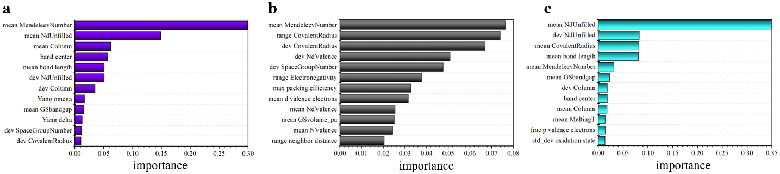
Figure S1. a, b and c Feature importance from random forest models for learning E_{ads}, E_{cp} and Ф, respectively. Only features with high importance are plotted.

- Standard deviation of covalent radius versus adsorption height.

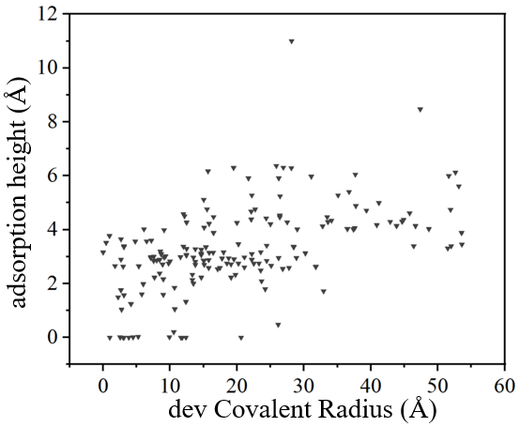
Figure S2. Adsorption height versus standard deviation of covalent radius of components in 2D materials.

- Enhancing Li adsorption ability of graphene

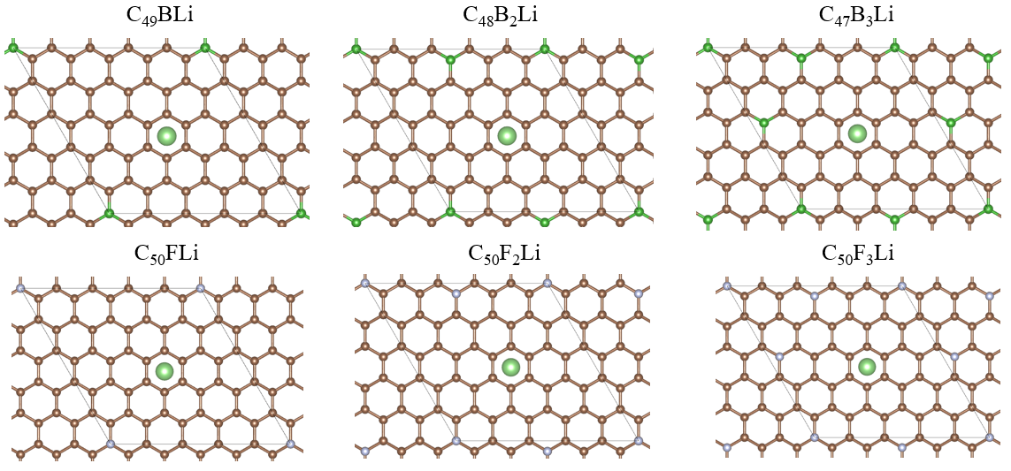
Figure S3. Structures of B-doped graphene and F-functionalized graphene, respectively.

REFERENCE
1. Xie, T.; Grossman, J. C., Crystal Graph Convolutional Neural Networks for an Accurate and Interpretable Prediction of Material Properties. Phys Rev Lett 2018, 120 (14), 145301.
2. <scikit learn.pdf>.
3. Ward, L.; Dunn, A.; Faghaninia, A.; Zimmermann, N. E. R.; Bajaj, S.; Wang, Q.; Montoya, J.; Chen, J.; Bystrom, K.; Dylla, M.; Chard, K.; Asta, M.; Persson, K. A.; Snyder, G. J.; Foster, I.; Jain, A., Matminer: An open source toolkit for materials data mining. Computational Materials Science 2018, 152, 60-69.
4. Kresse, G.; Furthmuller, J., Efficient iterative schemes for ab initio total-energy calculations using a plane-wave basis set. Physical Review B 1996, 54 (16), 11169-11186.
5. Blochl, P. E., Projector Augmented-Wave Method. Physical Review B 1994, 50 (24), 17953-17979.
6. Monkhorst, H. J.; Pack, J. D., Special Points for Brillouin-Zone Integrations. Physical Review B 1976, 13 (12), 5188-5192.
7. Perdew, J. P.; Burke, K.; Ernzerhof, M., Generalized gradient approximation made simple. Physical review letters 1996, 77 (18), 3865-3868.
8. Khantha, M.; Cordero, N. A.; Alonso, J. A.; Cawkwell, M.; Girifalco, L. A., Interaction and concerted diffusion of lithium in a (5,5) carbon nanotube. Physical Review B 2008, 78 (11).

