Supplementary Information
Advances of isomerizing-hydrogenating properties of CoMo catalysts supported on ASA-Al₂O₃
E.A. Avdeenko, K.A. Nadeina*, A.E. Lushchikova, T.V. Larina, V.P. Pakharukova, E.Yu. Gerasimov, I.P. Prosvirin, A.A. Gabrienko, Yu.V. Vatutina, O.V. Klimov, A.S. Noskov
Boreskov Institute of Catalysis SB RAS, Lavrentiev Ave. 5, Novosibirsk, Russia, 630090

* Corresponding author.
E-mail address: lakmallow@catalysis.ru (Nadeina K.A.)

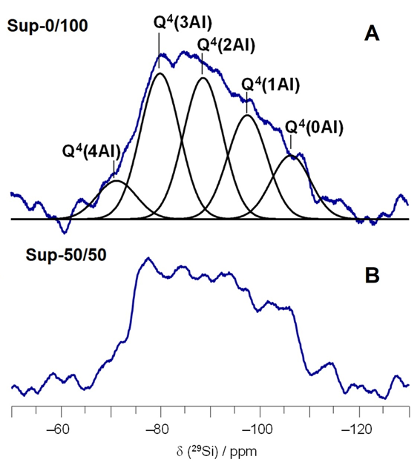
Figure SI1 – ²⁹Si MAS NMR spectra of the samples a) Sup-0/100 and b) Sup-50/50. Black lines represent the signals from Si atoms of Q⁴(nAl) framework units, n = 0÷4, in the aluminosilicate structure.
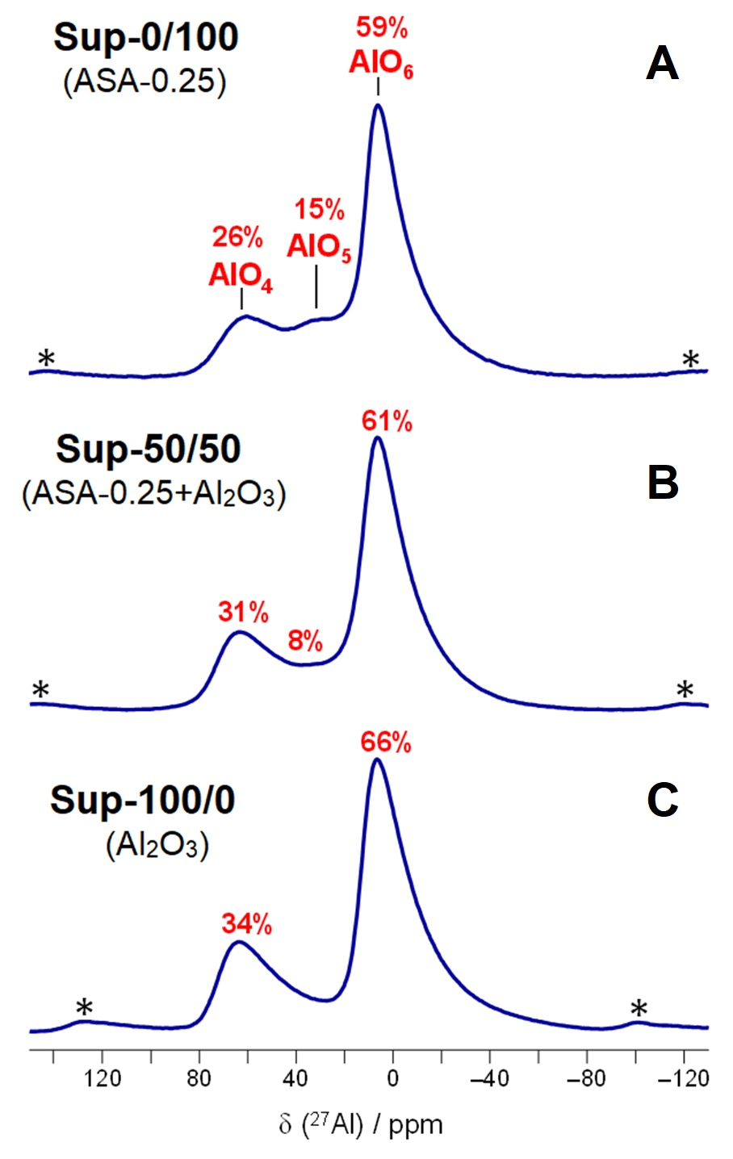
Figure SI2 – 2⁷Al MAS NMR spectra of the samples a) Sup-0/100, b) Sup-50/50 and c) Sup-100/0. The signals at about 70, 30 and 13 ppm belong to four-, five- and sixfold coordinated aluminium atoms in AlO₄, AlO₅ and AlO₆ units, respectively. Asterisks denote spinning sidebands.
Figure SI3 – X-ray diffraction patterns of the supports. Characteristic bands and relative intensities of the peaks of γ-Al₂O₃ phase are shown as black lines.
Table SI4 – Textural properties of ASA and Al2O3 powders, supports and catalysts
Al₂O₃/ASA ratio | Sample | SSA, m²/g | V, cm³/g | D, Å | Pore portion, %
 |  |  |  |  | <50 Å | 50-100 Å | 100-200 Å | >200 Å | 70-130 Å
initial ASA |  | 479 | 1.60 | 134 | 12 | 42 | 23 | 22 | 38
initial Al₂O₃ |  | 227 | 0.55 | 97 | 11 | 53 | 31 | 3 | 50
100/0 | Sup | 216 | 0.45 | 84 | 20 | 58 | 19 | 2 | 44
100/0 | CoMo | 184 | 0.42 | 73 | 21 | 56 | 19 | 2 | 43
90/10 | Sup | 271 | 0.55 | 81 | 18 | 50 | 25 | 5 | 40
90/10 | CoMo | 231 | 0.46 | 80 | 18 | 47 | 28 | 5 | 40
70/30 | Sup | 328 | 0.78 | 95 | 14 | 42 | 32 | 10 | 40
70/30 | CoMo | 271 | 0.66 | 98 | 13 | 38 | 34 | 12 | 39
50/50 | Sup | 397 | 1.08 | 109 | 12 | 36 | 31 | 20 | 35
50/50 | CoMo | 323 | 0.88 | 109 | 11 | 32 | 34 | 21 | 35
30/70 | Sup | 417 | 1.17 | 112 | 12 | 35 | 28 | 23 | 34
30/70 | CoMo | 345 | 0.96 | 116 | 10 | 34 | 32 | 22 | 36
10/90 | Sup | 429 | 1.26 | 121 | 11 | 34 | 26 | 28 | 32
10/90 | CoMo | 364 | 1.06 | 126 | 11 | 35 | 30 | 22 | 37
0/100 | Sup | 443 | 1.30 | 117 | 15 | 36 | 25 | 22 | 33
0/100 | CoMo | 381 | 0.94 | 124 | 12 | 34 | 28 | 23 | 35

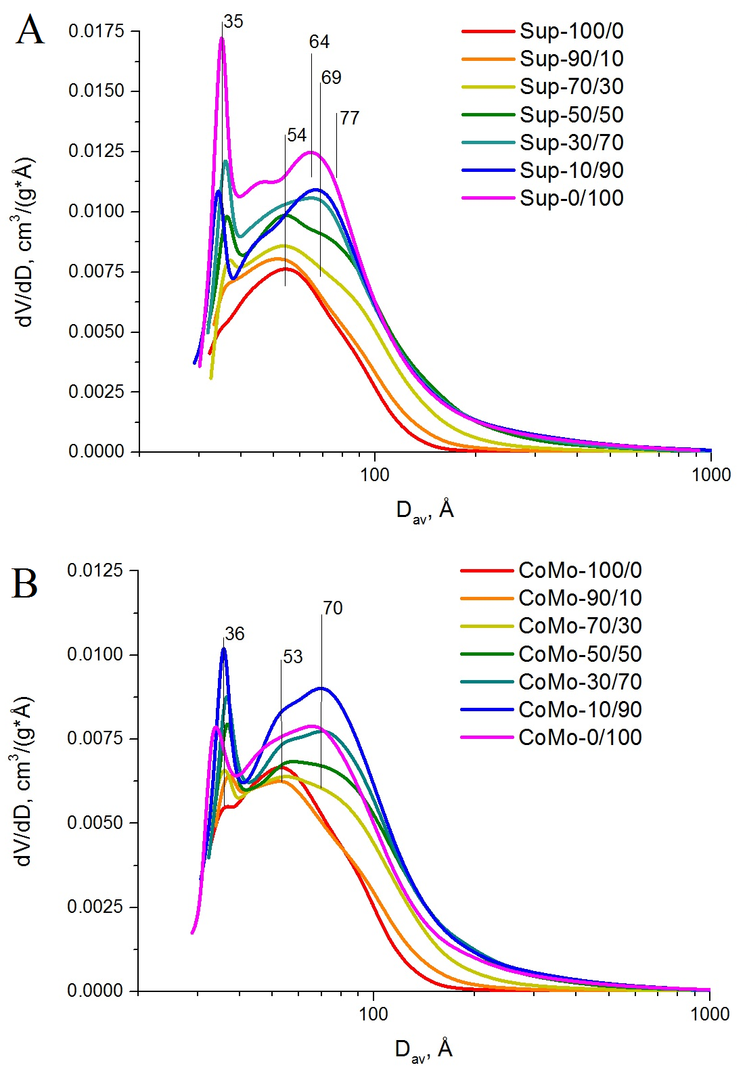
Figure SI5 – Pore size distributions of supports and catalysts.
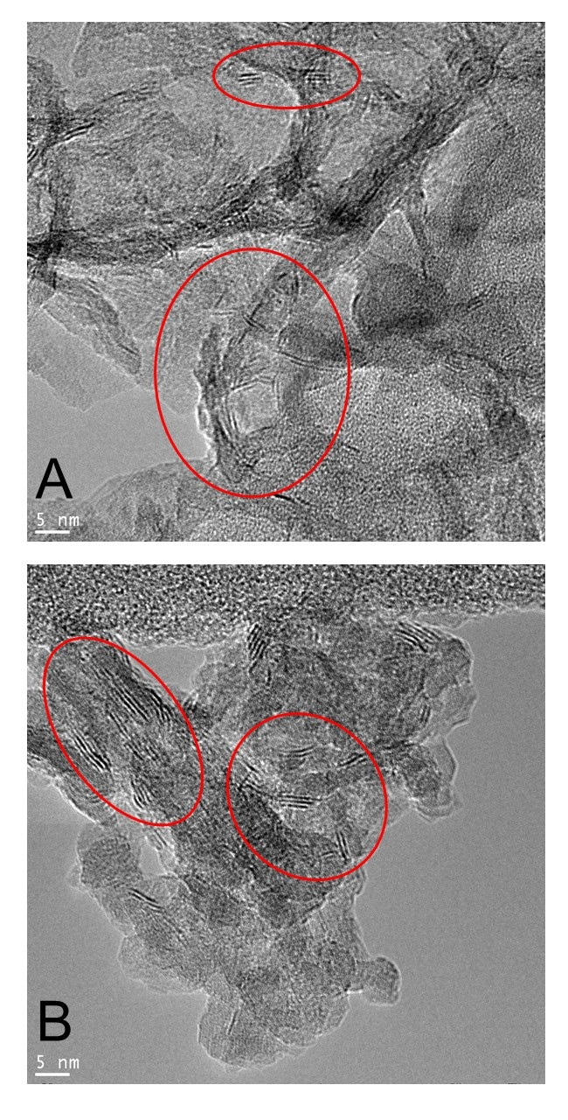
Figure SI6 – HRTEM images of active component particles located on a) ASA and b) alumina in CoMo-50/50. Red circles point out typical CoMoS particles.

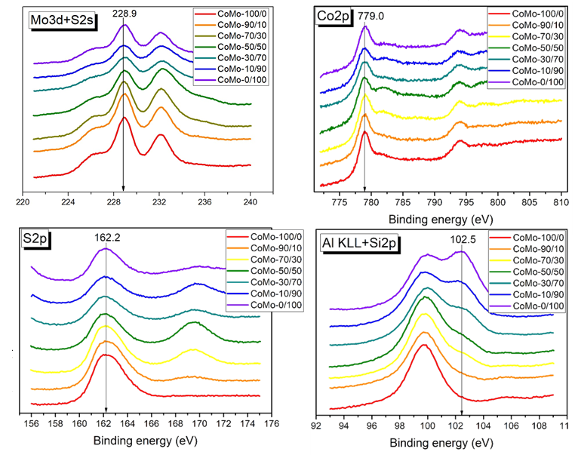
Figure SI7 – Mo3d, Co2p, S2s, S2p, Al KLL and Si2p XPS spectra of sulfide catalysts

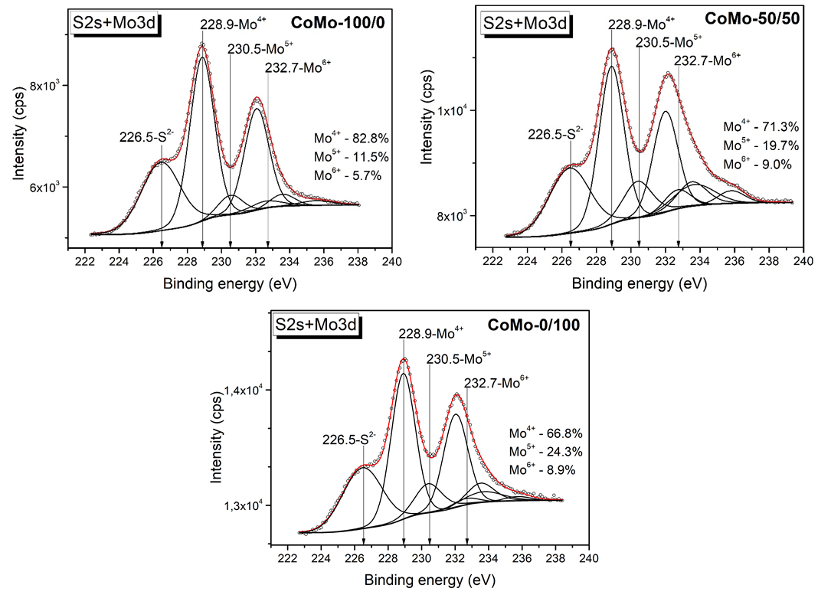
Figure SI8 – Deconvolution of Mo3d+S2s XPS spectra of CoMo-100/0, CoMo-50/50 and CoMo-0/100 sulfide catalysts

