Supporting Information
Table S1. List of the 9 temperate species selected from the PEP725 phenological network. Successional type means species which appear in different periods of community development. A species appeared in earlier stages of community succession was defined as early successional species, and vice versa¹⁰⁶.
Number | Latin name | Successional type
1 | Aesculus hippocastanum L. | Early
2 | Betula pendula Roth | Early
3 | Alnus glutinosa (L.) Gaertn. | Early
4 | Ribes grossularia L. | Early
5 | Fraxinus excelsior L. | Late
7 | Fagus sylvatica L. | Late
7 | Quercus robur L. | Late
8 | Tilia cordata Mill. | Late
9 | Tilia platyphyllos Scop. | Late

Table S2. Statistics of the piecewise structural equation model (SEM) contains direct effect of climatic factors only and indirect effect of including GPP_{max}. We calculated the adjusted coefficients of predictors (R²). *P<0.05, **P<0.01, ***P<0.001
Overall fit | Response | Predictor | Standardized direct effect
R² = 0.33 | GPP_{max} | Temperature | 0.27 | ***
R² = 0.33 | GPP_{max} | Radiation | -0.09 | *
R² = 0.33 | GPP_{max} | Precipitation | 0.32 | ***
R² = 0.33 | GPP_{max} | CO₂ | 0.30 | ***
R² = 0.34 | SOS | GPP_{max} | -0.68 | ***
R² = 0.34 | SOS | Temperature | -0.18 | *
R² = 0.34 | SOS | Radiation | 0.24 | ***
R² = 0.34 | SOS | Precipitation | 0.11 | *
R² = 0.34 | SOS | CO₂ | 0.05

Table S3. Statistics of the piecewise structural equation model (SEM) contains direct effect of climatic factors only and indirect effect of including GPP. We calculated the adjusted coefficients of predictors (R²). *P<0.05, **P<0.01, ***P<0.001.
Overall fit | Response | Predictor | Standardized direct effect
R² = 0.34 | GPP | Temperature | 0.22 | ***
R² = 0.34 | GPP | Radiation | -0.19 | ***
R² = 0.34 | GPP | Precipitation | 0.36 | ***
R² = 0.34 | GPP | CO₂ | 0.29 | ***
R² = 0.24 | SOS | GPP | -0.44 | ***
R² = 0.24 | SOS | Temperature | -0.27 | **
R² = 0.24 | SOS | Radiation | 0.23 | **
R² = 0.24 | SOS | Precipitation | 0.06
R² = 0.24 | SOS | CO₂ | -0.02

Table S4. List of detailed information of the datasets used in this study.
Number | Variable | Dataset | Time resolution | Time series | Link
1 | SOS | PEP725 | yearly | 1951-2015 | http://www.pep725.eu/
2 | EOS | PEP725 | yearly | 1951-2015 | http://www.pep725.eu/
3 | SOS | PhenoCam | yearly | 2000-2018 | https://phenocam.sr.unh.edu/
4 | SOS | GIMMS NDVI_{3g} | yearly | 1982-2014 | http://ecocast.arc.nasa.gov
5 | SOS | FLUXNET | yearly | 1992-2014 | https://fluxnet.org/data/
6 | Temperature | FLUXNET | daily | 1992-2014 | https://fluxnet.org/data/
7 | Radiation | FLUXNET | daily | 1992-2014 | https://fluxnet.org/data/
8 | CO2 | FLUXNET | daily | 1992-2014 | https://fluxnet.org/data/
9 | Precipitation | FLUXNET | daily | 1992-2014 | https://fluxnet.org/data/
10 | GPP_{max} | FLUXNET | yearly | 1992-2014 | https://fluxnet.org/data/
11 | GPP | FLUXNET | daily | 1992-2014 | https://fluxnet.org/data/
12 | Temperature | E-OBS | daily | 1950-2014 | http://www.ecad.eu/
13 | Precipitation | E-OBS | daily | 1983-2014 | http://www.ecad.eu/
14 | Radiation | E-OBS | daily | 1983-2014 | http://www.ecad.eu/
15 | Air humidity | E-OBS | daily | 1983-2014 | http://www.ecad.eu/
16 | Temperature | Climate Research Unit | monthly | 1981-2017 | https://crudata.uea.ac.uk/cru/data/hrg/cru_ts_4.04/cruts.2004151 855.v4.04/
17 | Soil moisture | World Meteorological Organization | monthly | 1983-2014 | http://climexp.knmi.nl/select.cgi?id=someone@ somewhere&field=clm_wfdei_soil01

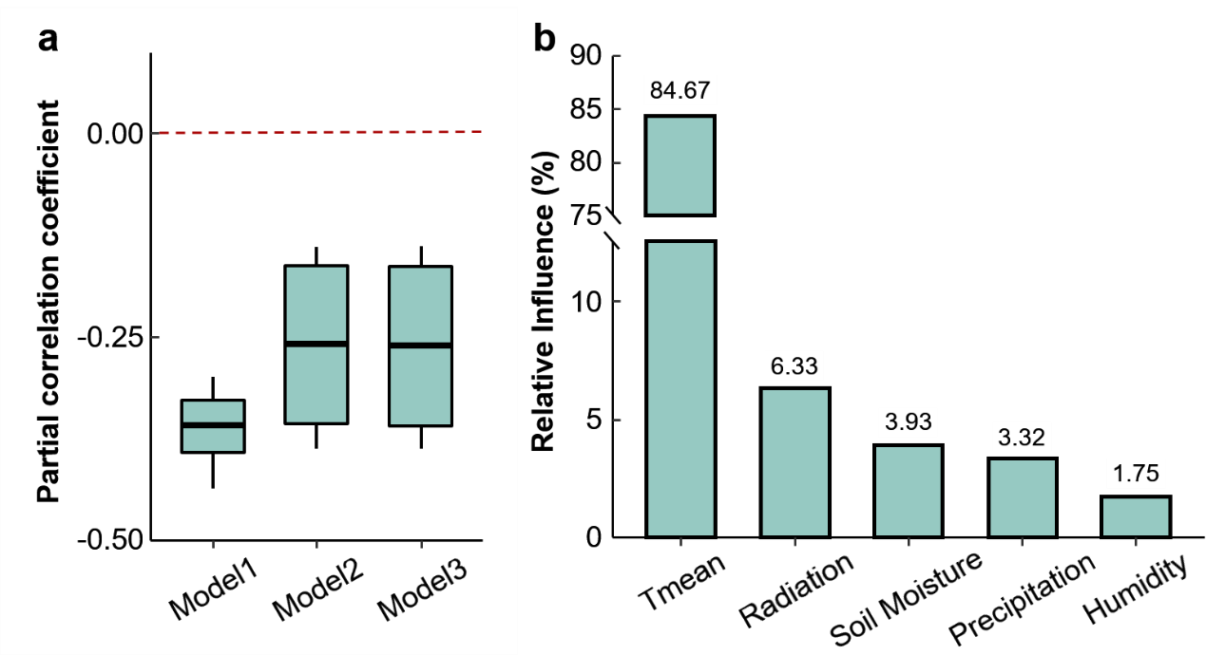
Fig. S1 (a) Partial correlation coefficients between leaf unfolding date and temperature during previous growing season after excluding covariates and (b) the relative influence of climatic factors during previous growing season on spring leaf unfolding between 1984 and 2015 obtained from the PEP725 database. The covariates included climate factors (radiation, precipitation, soil moisture, humidity) in growing season, autumn leaf senescence date, chilling and forcing in winter and spring. Climate factors were excluded in Model1, climatic factors and autumn phenology were excluded in Model2, climatic factors, autumn leaf senescence date and chilling and forcing were excluded in Model3.

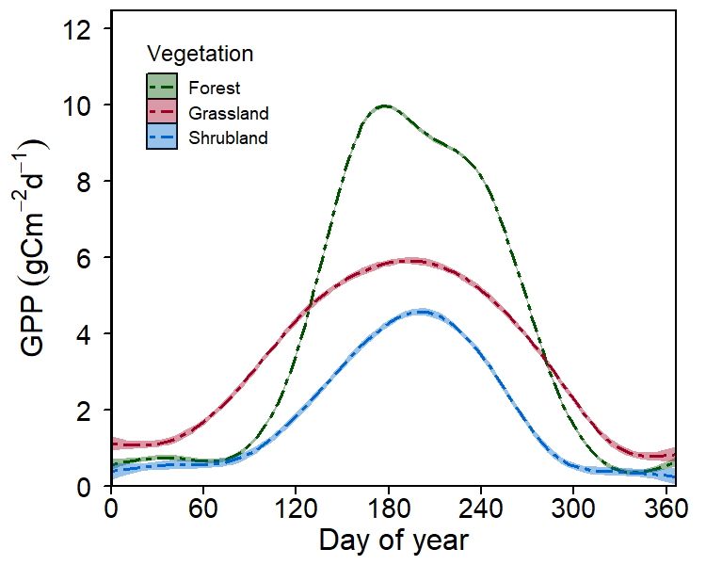
Fig. S2 Daily gross primary productivity (GPP) changes in three vegetation types based on 39 FLUXNET sites between 1992 and 2014.

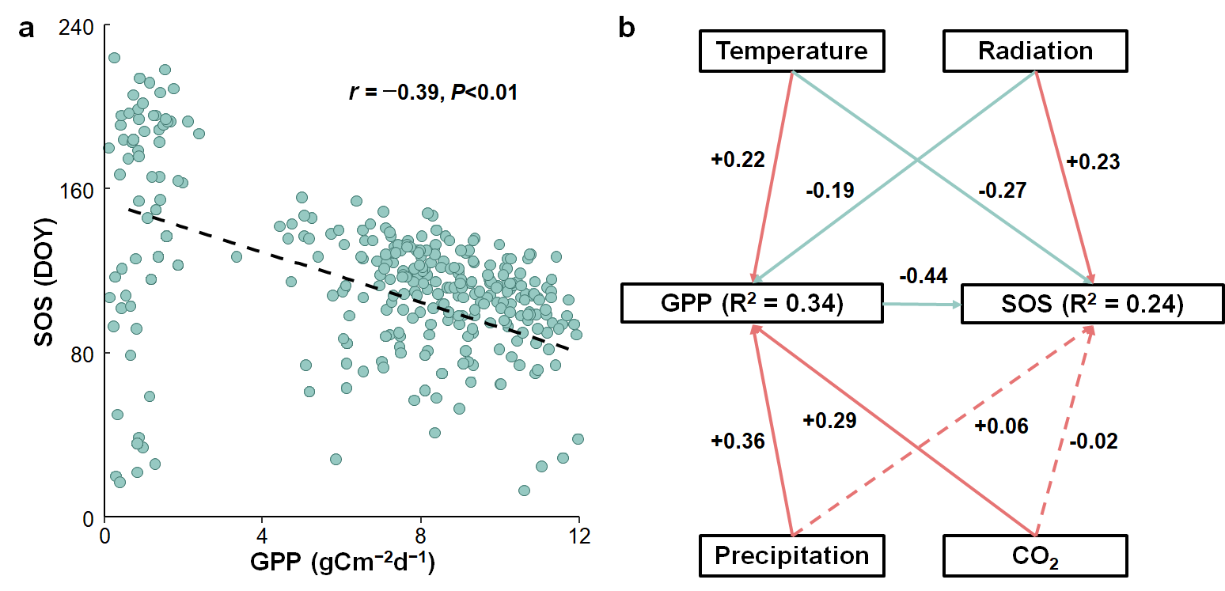

Fig. S3 (a) Relationship between spring phenology (SOS) and GPP and (b) the piecewise structural equation model using the data of 39 FLUXNET sites between 1992 and 2014. In (a), black dash line represents the fitted linear regression line, r value represents the correlation coefficient between SOS and GPP. (b)The model includes climate factors (temperature, radiation, precipitation and CO₂) and GPP to explore the direct (arrows from each climate factor directly point to the SOS) or indirect (arrows from each climate factor firstly directly point to GPP then to the SOS) effects of climate factors on spring phenology. Standardized coefficients between variables are shown next to lines, blue lines indicate a negative effect while red lines indicate a positive effect. The solid lines represent significant (P<0.05) relationships between variables, and dashed lines represent no significant (P>0.05) relationships between variables. R² values represent the goodness of fits of the responses.

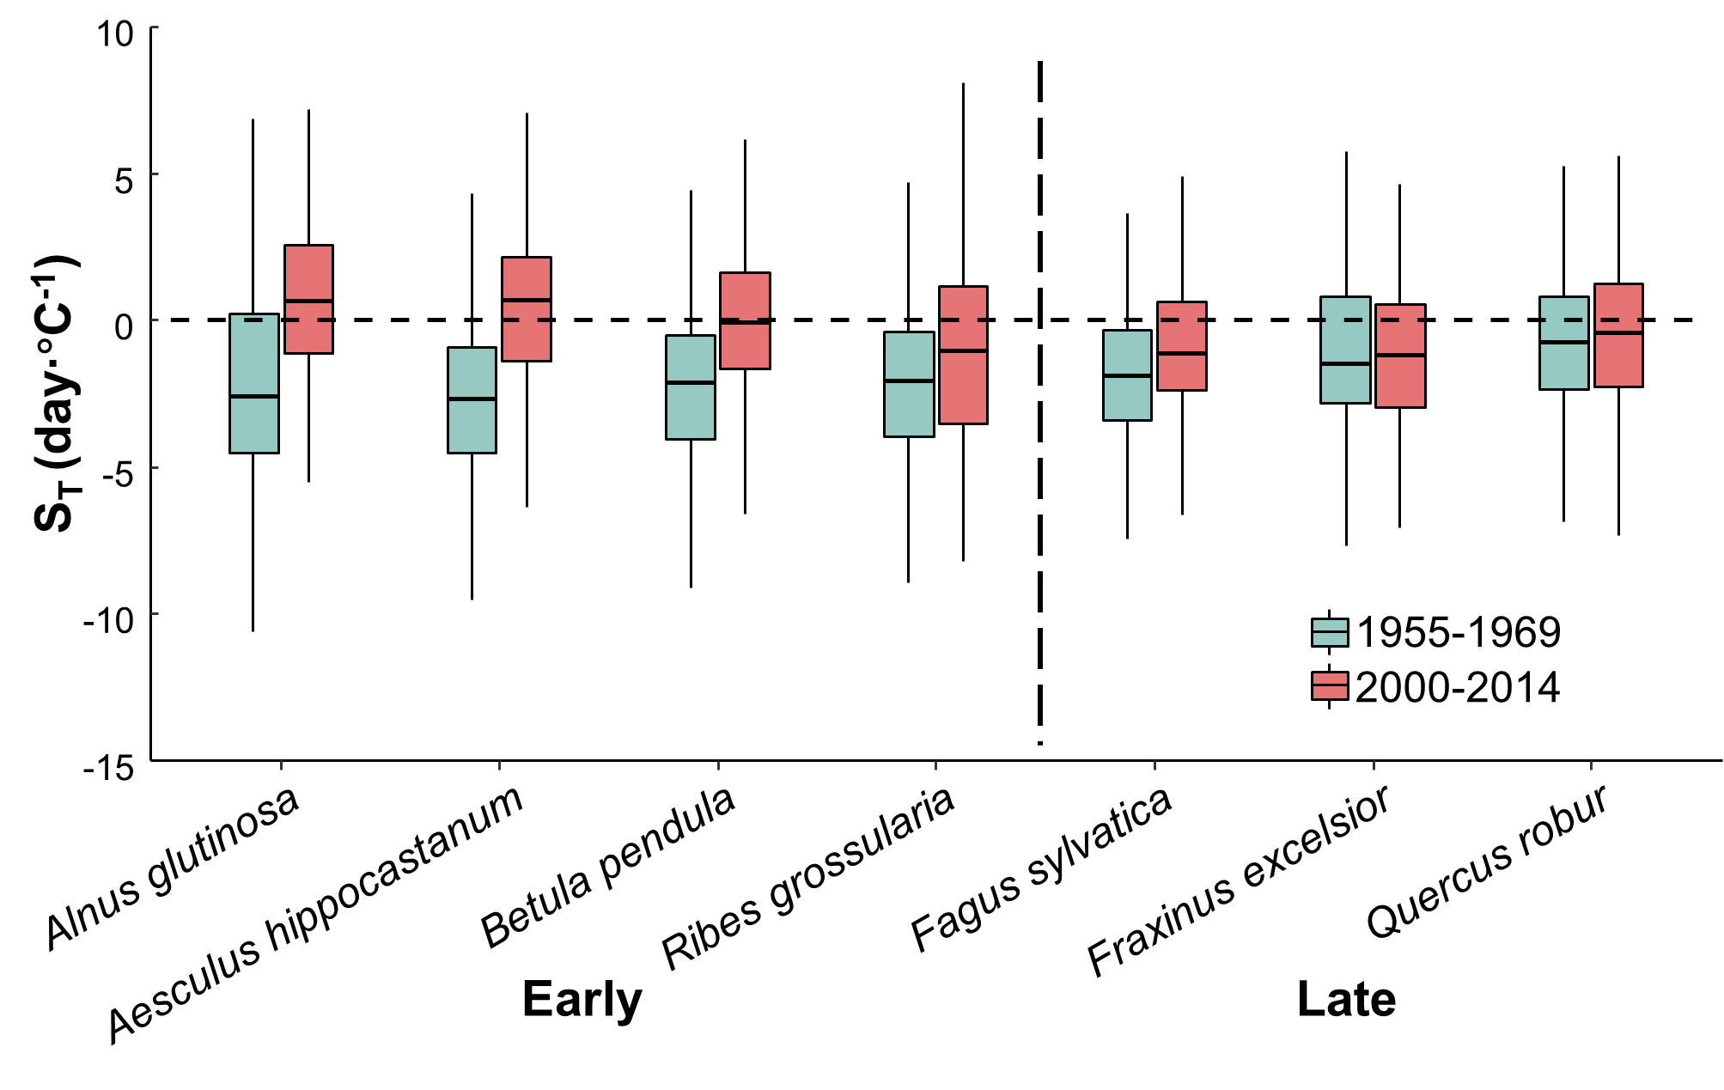
Fig. S4 Temperature sensitivities (S_{T}, change in days per degree Celsius) of leaf unfolding in early- and late-successional species during 1955-1969 and 2000-2014. The calculated S_{T} was based on the temperature during previous growing season and leaf unfolding dates obtained from the PEP725 database. The length of each box indicates the interquartile range, the horizontal line inside each box the median, and the bottom and top of the box the first and third quartiles respectively. The black dashed horizontal line indicates when the S_{T} is equal to zero.

