Supplementary material

Characterization of NPs
Size of NPs
Mean diameter and size distribution were measured by photon correlation spectroscopy (DLS) with a Brookheaven BI-9000AT instrument (Brookheaven Instruments Corporation, USA). Zeta potential was measured by the laser Doppler anemometry (Zeta Plus, Zeta Potential Analyzer, Brookhaven Instruments Corporation, USA). All measurements were performed at 25℃. The reported values were determined from at least three measurements.

Morphology Studies
Morphological examination of the nanoparticles was conducted using JEM-100S (Japan) transmission electron microscope (TEM). One drop of nanoparticle suspension was placed on a copper grid covered with nitrocellulose membrane and air-dried before observation.

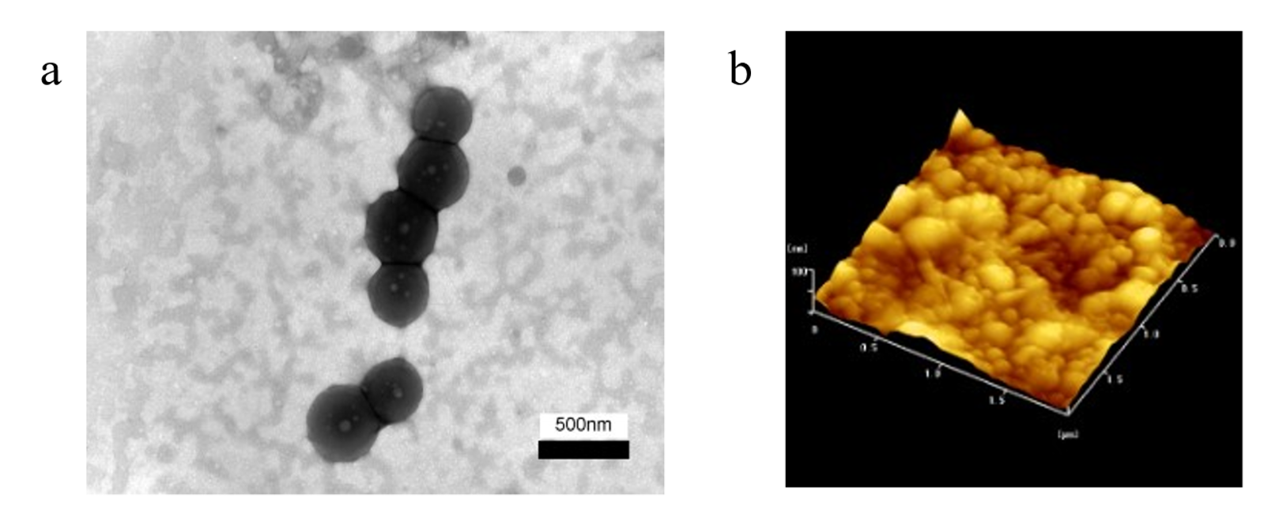
FigS1. a.Transmission electron microscope images of CDDP-Tet NPs b. Atomic force microscopy images of CDDP-Tet NPs

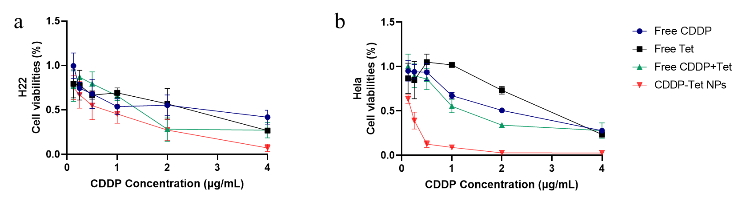
Fig S2. In vitro cytotoxicity of the nanoparticles. a. Cell viabilities of H22 after being co-cultured with drugs for 48 hours. The concentration of Tet was 2.4 times as much as the concentration of CDDP. b. Cell viabilities of Hela after being co-cultured with drugs for 48 hours. The concentration of Tet was 2.4 times as much as the concentration of CDDP.

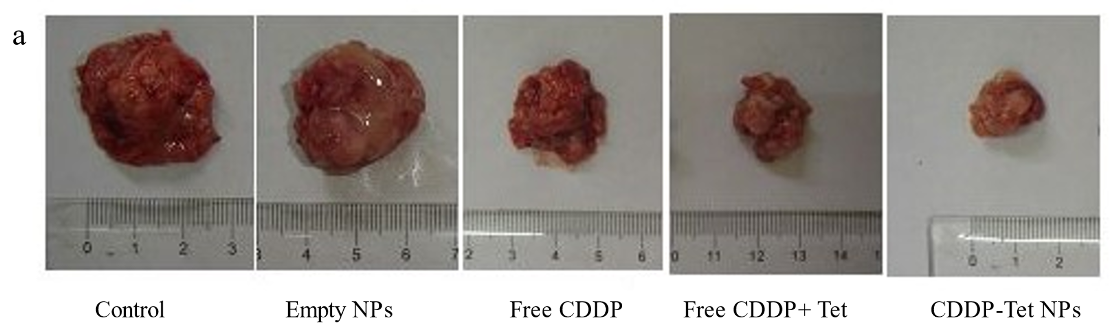
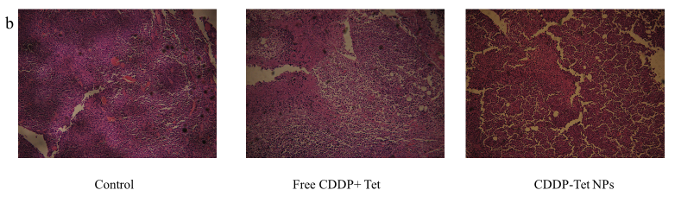
Fig S3. a The specimens of tumors on murine models at the endpoint of the experiment. b Tumor specimens stained HE were on light microscopic observation (200X).

Table S1 Characteristics of the optimal CDDP-Tet loaded PEG-PCL copolymeric NPs
NPs | Mn | Hydrophobic ratio (%) | Diameter (nm) | Polydispersity
mPEG-PCL | 25826 | 83.11 | 285.8±4.2 | 0.054±0.085
HO-PCL | 21038 | / | / | /
CDDP-Tet loaded NPs | / | / | 359.1±5.3nm | 0.231±0.00
NPs = Nanoparticles; Mn = Number-average molecular weight measured by gel permeation chromatography

Table S2. Drug loading content and loading efficiency of CDDP-Tet loaded PEG-PCL copolymeric NPs
Drug | Drug loading content | Loading efficiency
CDDP | 3.32% | 65.3%
Tet | 7.45% | 27.9%

