Discovering molecular regulators of ageing using mixture models with RNA-sequencing data
Supplementary Figures and Tables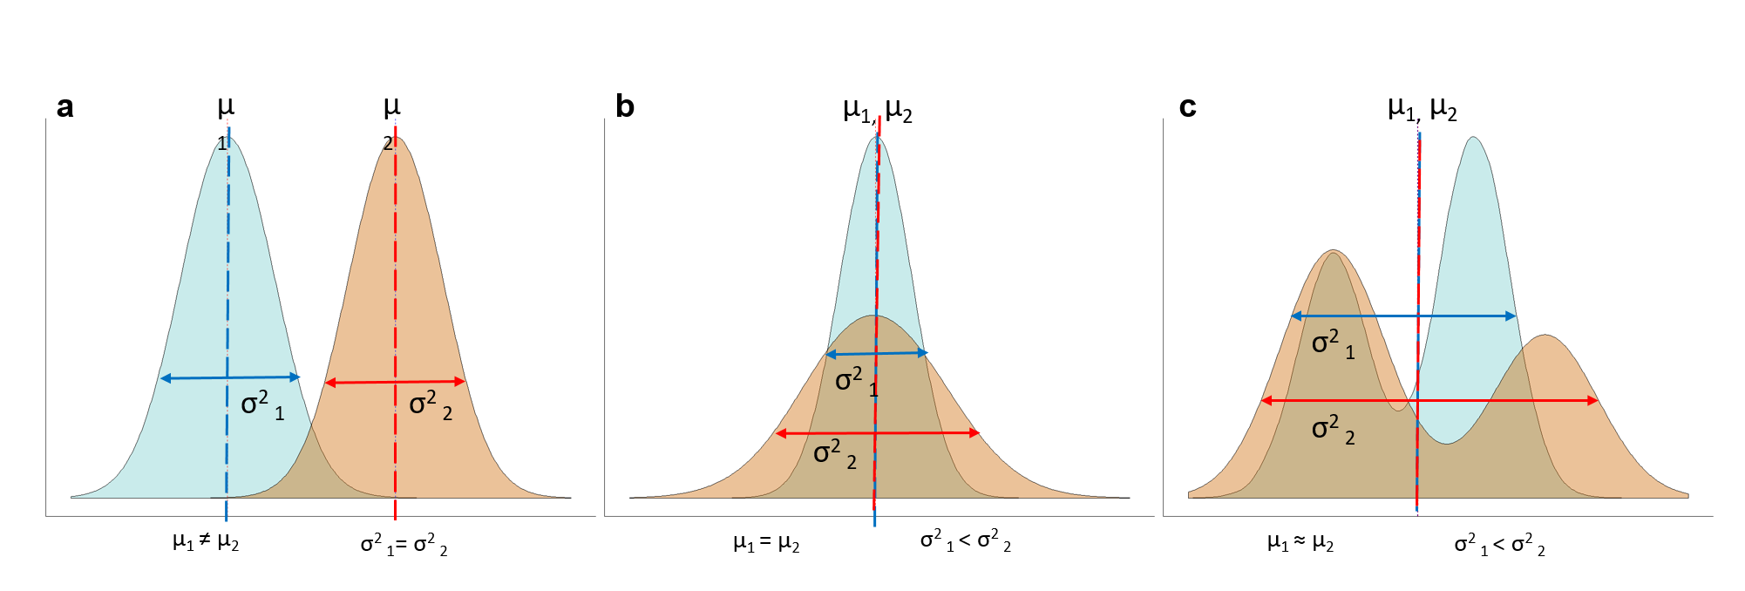
Supplementary Figure S1. Diagram of gene expression distributions, with each phenotype (blue and orange distributions). (a) Standard gene differential analysis were the mean (μ) transcript count for each phenotype (blue (μ₁) and red (μ₂) dotted line) are different, while the variance is the same σ² (blue (σ² ₁) and red (σ² ₂) line). (b) Single mode gene expression distributions with the same μ₁ = μ₂ but different σ² (σ² ₁ < σ² ₂). (c) Bimodal gene expression with similar μ₁ ≈ μ₂ but with very different σ² (σ² ₁ < σ² ₂) .

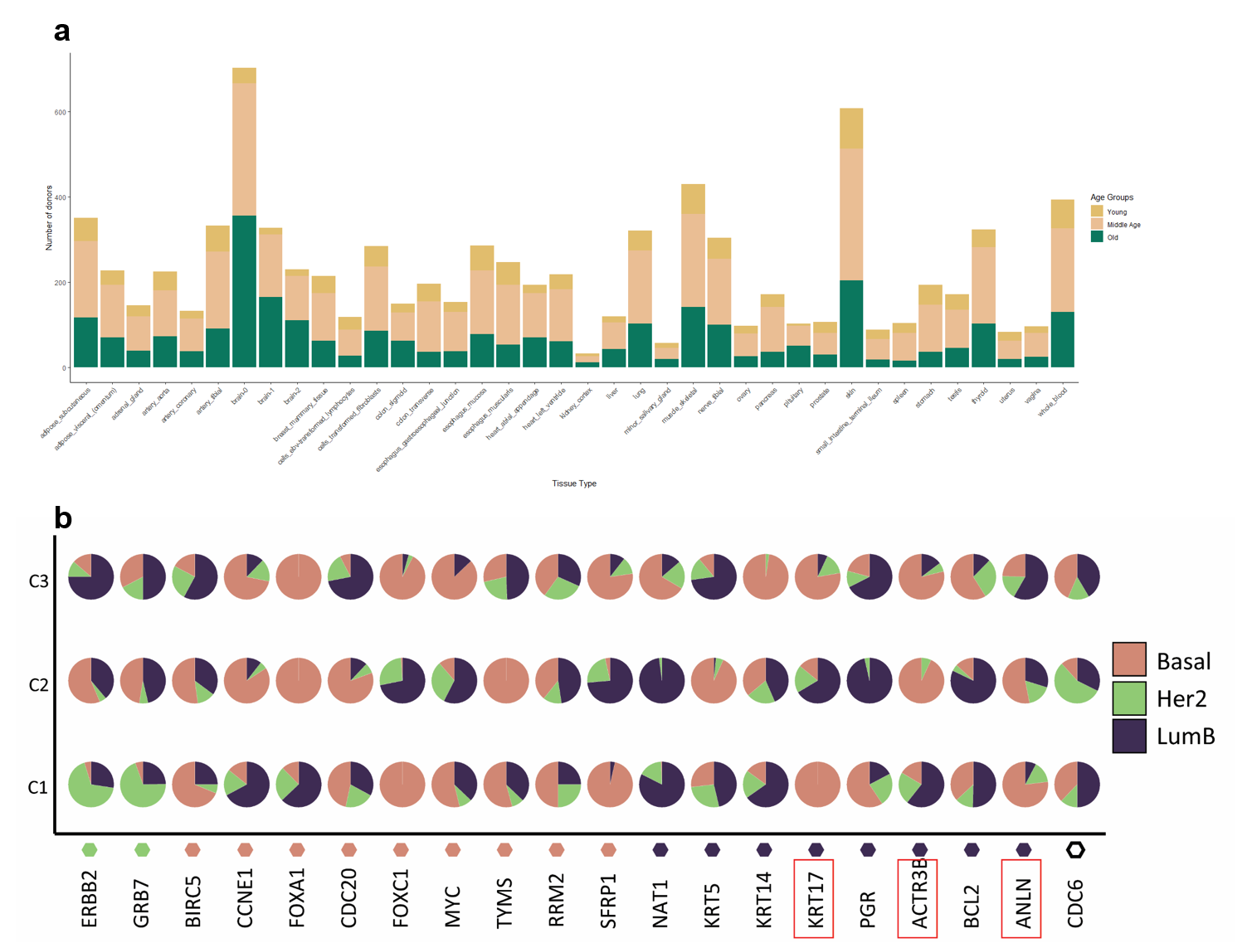
Supplementary Figure S2. (a) Distribution of age groups after merging the six age groups into 3 age groups. (b) Mixture model clustering of 20 out of 46 PAM50 genes for three cancer subtypes (Basal, Her2, LumB).Genes in red boxes can potentially be classified by mixture models into a different cancer subtype in addition to their initial cancer subtypes.

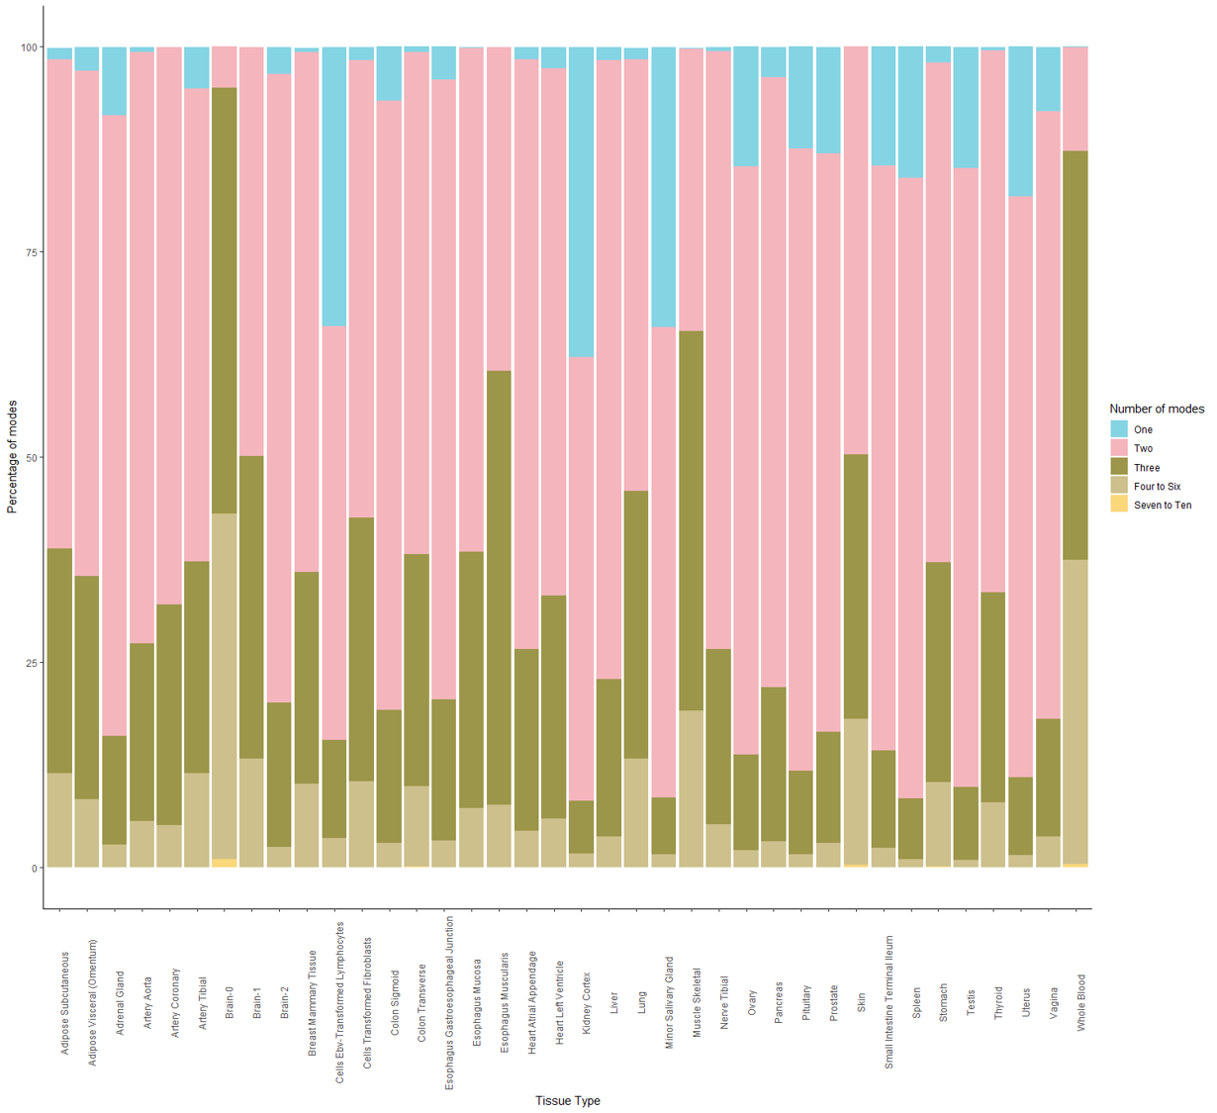

Supplementary Figure S3. Percentage of modes across all 38 tissues using mclust. Modes were set to one and ten modes. Modes one to three make up the majority of modes. Brain-0 and whole blood had the highest number of modes that were four to six. But modes one to three still made up the largest majority.

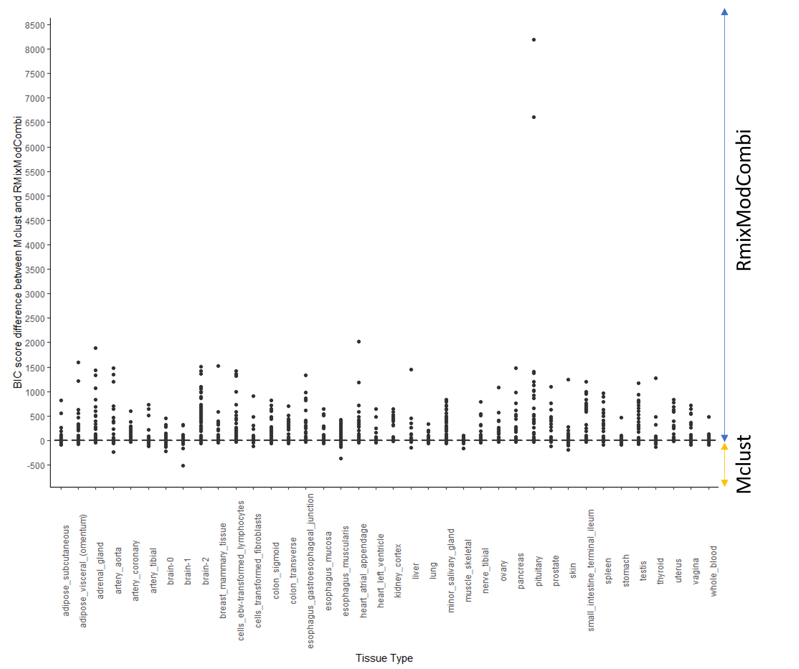
Supplementary Figure S4: Boxplot of BIC score difference between Mclust clustered genes and RmixModCombi genes. To ensure a fair comparison only genes that have been clustered into the same number of modes are compared to each other. The mean difference of the BIC scores between the two packages is 0.

Supplementary Table S1: Total number of pathways detected in the three databases (GO, Hallmark & wikiPathways), by mixture models, edgeR and total number of pathways that are common between the pathways detected by mixture models and edgeR
 | GO database |  |  | HallMark Database |  |  | wikiPathways
Tissue | Mixture Model Pathways | EdgeR Pathways | Mixture model Common Pathways | Mixture Model Pathways | EdgeR Pathways | Mixture model Common Pathways | Mixture Model Pathways | EdgeR Pathways | Mixture model Common Pathways
adrenal_gland | 10 | 6 | 0 | 0 | 0 | 0 | 0 | 0 | 0
brain-0 | 716 | 131 | 20 | 1 | 5 | 0 | 0 | 0 | 0
brain-1 | 70 | 127 | 5 | 0 | 0 | 0 | 0 | 0 | 0
brain-2 | 18 | 383 | 5 | 2 | 5 | 0 | 0 | 0 | 0
colon_sigmoid | 6 | 1 | 0 | 0 | 0 | 0 | 0 | 0 | 0
colon_transverse | 254 | 239 | 8 | 7 | 5 | 1 | 0 | 0 | 0
esophagus_mucosa | 15 | 9 | 0 | 3 | 1 | 1 | 0 | 0 | 0
esophagus_muscularis | 2 | 22 | 0 | 0 | 0 | 0 | 0 | 0 | 0
heart_atrial_appendage | 81 | 83 | 0 | 1 | 3 | 0 | 0 | 0 | 0
heart_left_ventricle | 109 | 45 | 0 | 0 | 0 | 0 | 0 | 0 | 0
lung | 246 | 239 | 17 | 12 | 3 | 1 | 0 | 3 | 0
muscle_skeletal | 27 | 28 | 0 | 1 | 3 | 0 | 0 | 0 | 0
nerve_tibial | 24 | 58 | 6 | 0 | 0 | 0 | 0 | 0 | 0
testis | 18 | 41 | 0 | 0 | 0 | 0 | 0 | 0 | 0
thyroid | 5 | 421 | 0 | 2 | 4 | 1 | 0 | 0 | 0
vagina | 49 |  | 0 | 0 | 0 | 0 | 0 | 0 | 0
whole_blood | 248 | 184 | 14 | 6 | 6 | 0 | 0 | 1 | 0
adipose_subcutaneous | 0 | 765 | 0 | 0 | 0 | 0 | 0 | 0 | 0
adipose_visceral_(omentum) | 0 | 314 | 0 | 0 | 0 | 0 | 0 | 0 | 0
artery_aorta | 0 | 292 | 0 | 0 | 0 | 0 | 0 | 0 | 0
artery_coronary | 0 | 40 | 0 | 0 | 0 | 0 | 0 | 0 | 0
artery_tibial | 0 | 474 | 0 | 1 | 2 | 0 | 0 | 0 | 0
breast_mammary_tissue | 0 | 1568 | 0 | 0 | 0 | 0 | 0 | 0 | 0
cells_ebv-transformed_lymphocytes | 0 | 5 | 0 | 0 | 0 | 0 | 0 | 0 | 0
kidney_cortex | 0 | 66 | 0 | 0 | 0 | 0 | 0 | 0 | 0
liver | 0 | 7 | 0 | 0 | 0 | 0 | 0 | 0 | 0
minor_salivary_gland | 0 | 6 | 0 | 0 | 0 | 0 | 0 | 0 | 0
ovary | 0 | 139 | 0 | 0 | 0 | 0 | 0 | 0 | 0
pancreas | 0 | 8 | 0 | 0 | 0 | 0 | 0 | 0 | 0
prostate | 0 | 331 | 0 | 0 | 0 | 0 | 0 | 0 | 0
skin | 0 | 799 | 0 | 1 | 3 | 0 | 0 | 0 | 0
small_intestine_terminal_ileum | 0 | 12 | 0 | 0 | 0 | 0 | 0 | 0 | 0
stomach | 0 | 11 | 0 | 0 | 0 | 0 | 0 | 0 | 0
uterus | 0 | 73 | 0 | 0 | 0 | 0 | 0 | 0 | 0

Supplementary Table S2: Reference list for the 14 common pathways in whole blood
 | Pathway | References
1 | Proteasomal protein catabolic process | Vilchez et al. 2014¹
2 | Positive regulation of I-kappaB kinase/NF-kappaB signaling | Garcia-Garica et al. 2021²
 | I-kappaB kinase/NF-kappaB signaling | Tilstra et al. 2011³
4 | Positive regulation of cytokine production | Rea et al. 2018⁴
5 | Regulation of I-kappaB kinase/NF-kappaB signaling | Garcia-Garica et al. 2021²
6 | Regulation of leukocyte mediated immunity | Desai et al. 2011⁵
7 | ncRNA processing | Jin et al. 2019⁶
8 | Regulation of protein complex assembly | Koga et al. 2011⁷
9 | Positive regulation of immune effector process | Weyand & Goronzy 2016⁸
10 | T cell activation | Li et al. 2019⁹
11 | Positive regulation of leukocyte cell-cell adhesion | Anisimova et al. 2018¹⁰
12 | Regulation of DNA-templated transcription in response to stress | Lans et al. 2019¹¹
13 | Positive regulation of protein transport | Anisimova et al. 2020¹²
14 | Regulation of T cell activation | Weyand & Goronzy 2016⁸

Full references
1 Vilchez, D., Saez, I. & Dillin, A. The role of protein clearance mechanisms in organismal ageing and age-related diseases. Nature Communications 5, 5659, doi:10.1038/ncomms6659 (2014).
2 García-García, V. A., Alameda, J. P., Page, A. & Casanova, M. L. Role of NF-κB in Ageing and Age-Related Diseases: Lessons from Genetically Modified Mouse Models. Cells 10, 1906 (2021).
3 Tilstra, J. S., Clauson, C. L., Niedernhofer, L. J. & Robbins, P. D. Aging Dis 2, 449-465 (2011).
4 Rea, I. M. et al. Age and Age-Related Diseases: Role of Inflammation Triggers and Cytokines. Frontiers in Immunology 9, doi:10.3389/fimmu.2018.00586 (2018).
5 Desai, A., Grolleau-Julius, A. & Yung, R. Leukocyte function in the aging immune system. J Leukoc Biol 87, 1001-1009, doi:10.1189/jlb.0809542 (2010).
6 Jin, L., Song, Q., Zhang, W., Geng, B. & Cai, J. Roles of long noncoding RNAs in aging and aging complications. Biochimica et Biophysica Acta (BBA) - Molecular Basis of Disease 1865, 1763-1771, doi:https://doi.org/10.1016/j.bbadis.2018.09.021 (2019).
7 Koga, H., Kaushik, S. & Cuervo, A. M. Protein homeostasis and aging: The importance of exquisite quality control. Ageing research reviews 10, 205-215, doi:10.1016/j.arr.2010.02.001 (2011).
8 Weyand, C. M. & Goronzy, J. J. Aging of the Immune System. Mechanisms and Therapeutic Targets. Ann Am Thorac Soc 13 Suppl 5, S422-S428, doi:10.1513/AnnalsATS.201602-095AW (2016).
9 Li, M. et al. Age related human T cell subset evolution and senescence. Immunity & Ageing 16, 24, doi:10.1186/s12979-019-0165-8 (2019).
10 Anisimova, A. S., Alexandrov, A. I., Makarova, N. E., Gladyshev, V. N. & Dmitriev, S. E. Protein synthesis and quality control in aging. Aging (Albany NY) 10, 4269-4288, doi:10.18632/aging.101721 (2018).
11 Lans, H., Hoeijmakers, J. H. J., Vermeulen, W. & Marteijn, J. A. The DNA damage response to transcription stress. Nature Reviews Molecular Cell Biology 20, 766-784, doi:10.1038/s41580-019-0169-4 (2019).
12 Anisimova, A. S. et al. Multifaceted deregulation of gene expression and protein synthesis with age. Proceedings of the National Academy of Sciences 117, 15581-15590, doi:10.1073/pnas.2001788117 (2020).

Supplementary Table S3: Unique genes detected by mixture models that are common with the external ageing databases
 | artery_aorta | artery_tibial | brain-0 | brain-1 | brain-2 | colon_sigmoid | colon_transverse | esophagus_mucosa | esophagus_muscularis | lung | muscle_skeletal | uterus | whole_blood | Total by gene
AIFM1 | 0 | 0 | 0 | 0 | 0 | 0 | 0 | 0 | 0 | 1 | 0 | 0 | 0 | 1
APP | 0 | 0 | 1 | 1 | 0 | 0 | 0 | 0 | 0 | 0 | 0 | 0 | 0 | 2
ARNTL | 0 | 0 | 1 | 1 | 0 | 0 | 0 | 0 | 0 | 0 | 0 | 0 | 0 | 2
BSCL2 | 0 | 0 | 0 | 0 | 0 | 0 | 0 | 0 | 0 | 1 | 1 | 0 | 0 | 2
C1QA | 0 | 0 | 1 | 0 | 0 | 0 | 0 | 0 | 0 | 0 | 0 | 0 | 0 | 1
CDKN1A | 0 | 0 | 0 | 0 | 0 | 0 | 0 | 0 | 0 | 0 | 0 | 1 | 0 | 1
CDKN2A | 0 | 0 | 0 | 0 | 0 | 1 | 1 | 0 | 1 | 0 | 0 | 0 | 0 | 3
CDKN2B | 0 | 0 | 0 | 0 | 0 | 0 | 0 | 0 | 0 | 0 | 0 | 0 | 1 | 1
CEBPA | 1 | 0 | 1 | 0 | 0 | 0 | 1 | 0 | 0 | 1 | 0 | 0 | 1 | 5
CEBPB | 0 | 0 | 0 | 1 | 0 | 0 | 0 | 0 | 0 | 0 | 0 | 0 | 0 | 1
EFEMP1 | 0 | 0 | 0 | 0 | 0 | 0 | 1 | 0 | 0 | 0 | 0 | 0 | 0 | 1
EP300 | 0 | 0 | 0 | 1 | 0 | 0 | 0 | 0 | 0 | 0 | 0 | 0 | 0 | 1
FAS | 0 | 1 | 0 | 0 | 0 | 0 | 0 | 0 | 0 | 0 | 0 | 0 | 0 | 1
FLT1 | 0 | 0 | 1 | 0 | 0 | 0 | 0 | 0 | 0 | 0 | 0 | 0 | 0 | 1
FOXO1 | 0 | 0 | 0 | 0 | 0 | 0 | 1 | 0 | 0 | 0 | 0 | 0 | 0 | 1
GPX4 | 0 | 0 | 1 | 0 | 0 | 0 | 0 | 0 | 0 | 0 | 0 | 0 | 0 | 1
HMGB2 | 0 | 0 | 1 | 0 | 0 | 0 | 0 | 0 | 0 | 0 | 0 | 0 | 0 | 1
HSF1 | 0 | 0 | 0 | 0 | 0 | 0 | 0 | 1 | 0 | 0 | 0 | 0 | 0 | 1
HSPA8 | 0 | 0 | 1 | 0 | 0 | 0 | 0 | 0 | 0 | 0 | 0 | 0 | 0 | 1
IGF1 | 0 | 0 | 0 | 1 | 0 | 0 | 0 | 1 | 0 | 0 | 0 | 0 | 0 | 2
IKBKB | 0 | 0 | 1 | 0 | 0 | 0 | 0 | 0 | 0 | 0 | 0 | 0 | 0 | 1
IL6 | 0 | 0 | 1 | 0 | 0 | 0 | 0 | 1 | 0 | 0 | 0 | 0 | 0 | 2
IL7 | 0 | 0 | 0 | 0 | 1 | 0 | 0 | 0 | 0 | 0 | 0 | 0 | 0 | 1
INSR | 0 | 0 | 0 | 0 | 0 | 0 | 0 | 1 | 0 | 0 | 0 | 0 | 0 | 1
IRS1 | 0 | 0 | 1 | 0 | 0 | 0 | 0 | 0 | 0 | 0 | 0 | 0 | 0 | 1
JUND | 0 | 0 | 0 | 0 | 0 | 0 | 0 | 0 | 0 | 0 | 1 | 0 | 0 | 1
KL | 0 | 0 | 1 | 0 | 0 | 0 | 1 | 0 | 0 | 0 | 0 | 0 | 1 | 3
LEPR | 0 | 0 | 1 | 0 | 0 | 0 | 1 | 1 | 0 | 0 | 0 | 0 | 0 | 3
MAPK3 | 0 | 0 | 1 | 0 | 0 | 0 | 0 | 0 | 0 | 0 | 0 | 0 | 1 | 2
MAPK9 | 0 | 0 | 1 | 0 | 0 | 0 | 0 | 0 | 0 | 0 | 0 | 0 | 0 | 1
MAPT | 0 | 0 | 1 | 0 | 0 | 0 | 0 | 0 | 0 | 1 | 1 | 0 | 0 | 3
MAX | 0 | 0 | 0 | 0 | 0 | 0 | 0 | 1 | 0 | 0 | 0 | 0 | 0 | 1
MLH1 | 0 | 0 | 1 | 0 | 0 | 0 | 0 | 0 | 0 | 0 | 0 | 0 | 0 | 1
MSRA | 0 | 0 | 1 | 0 | 0 | 0 | 0 | 0 | 0 | 0 | 0 | 0 | 0 | 1
MT1E | 0 | 0 | 1 | 0 | 0 | 0 | 0 | 0 | 0 | 0 | 0 | 0 | 1 | 2
MTOR | 0 | 0 | 1 | 1 | 0 | 0 | 0 | 0 | 0 | 1 | 0 | 0 | 0 | 3
NCOR2 | 0 | 0 | 1 | 0 | 0 | 0 | 1 | 0 | 0 | 0 | 0 | 0 | 0 | 2
PARP1 | 0 | 0 | 1 | 0 | 0 | 0 | 0 | 0 | 0 | 1 | 0 | 0 | 0 | 2
PCMT1 | 0 | 0 | 1 | 1 | 0 | 0 | 0 | 0 | 0 | 0 | 0 | 0 | 0 | 2
PLAU | 0 | 0 | 1 | 0 | 0 | 0 | 0 | 0 | 0 | 0 | 0 | 0 | 1 | 2
PPARG | 0 | 1 | 0 | 0 | 0 | 0 | 1 | 0 | 0 | 0 | 0 | 0 | 0 | 2
RELA | 0 | 0 | 0 | 0 | 0 | 0 | 1 | 0 | 0 | 0 | 0 | 0 | 0 | 1
RET | 0 | 0 | 1 | 0 | 0 | 0 | 0 | 0 | 0 | 0 | 0 | 0 | 0 | 1
RGN | 0 | 0 | 0 | 0 | 0 | 0 | 0 | 1 | 0 | 0 | 0 | 0 | 0 | 1
RICTOR | 0 | 0 | 0 | 0 | 0 | 0 | 1 | 0 | 0 | 0 | 0 | 0 | 0 | 1
S100B | 0 | 0 | 0 | 0 | 0 | 0 | 1 | 0 | 0 | 0 | 0 | 0 | 1 | 2
SDHC | 0 | 0 | 1 | 0 | 0 | 0 | 0 | 0 | 0 | 1 | 0 | 0 | 1 | 3
SOD2 | 0 | 0 | 0 | 0 | 0 | 0 | 0 | 0 | 0 | 0 | 1 | 0 | 1 | 2
SST | 0 | 0 | 1 | 0 | 0 | 0 | 1 | 0 | 0 | 0 | 0 | 0 | 0 | 2
TP53 | 0 | 0 | 0 | 0 | 0 | 0 | 0 | 0 | 0 | 1 | 0 | 0 | 0 | 1
UCP2 | 0 | 0 | 1 | 0 | 0 | 0 | 0 | 0 | 0 | 0 | 0 | 0 | 0 | 1
YWHAZ | 0 | 0 | 1 | 1 | 0 | 0 | 0 | 0 | 0 | 0 | 0 | 0 | 0 | 2
Total by Tissue | 1 | 2 | 29 | 8 | 1 | 1 | 12 | 7 | 1 | 8 | 4 | 1 | 9

Supplementary Table S4: Genes detected by edgeR that are common with the external ageing databases
 | adipose_subcutaneous | adipose_visceral_(omentum) | adrenal_gland | artery_aorta | artery_tibial | brain-0 | brain-1 | brain-2 | breast_mammary_tissue | cells_transformed_fibroblasts | colon_sigmoid | colon_transverse | esophagus_mucosa | heart_atrial_appendage | heart_left_ventricle | liver | lung | muscle_skeletal | nerve_tibial | ovary | pancreas | pituitary | prostate | skin | spleen | stomach | testis | thyroid | uterus | whole_blood | Total by gene
AIFM1 | 1 | 1 | 0 | 0 | 1 | 0 | 0 | 1 | 1 | 0 | 0 | 0 | 0 | 0 | 0 | 0 | 0 | 0 | 0 | 0 | 0 | 0 | 1 | 1 | 0 | 0 | 0 | 0 | 0 | 0 | 7
APOE | 0 | 0 | 0 | 0 | 0 | 0 | 0 | 0 | 0 | 0 | 0 | 0 | 0 | 0 | 0 | 0 | 0 | 0 | 0 | 0 | 0 | 0 | 1 | 1 | 0 | 0 | 0 | 0 | 1 | 1 | 4
APP | 0 | 0 | 0 | 0 | 0 | 0 | 0 | 0 | 1 | 0 | 0 | 0 | 0 | 0 | 0 | 0 | 0 | 0 | 0 | 0 | 0 | 0 | 0 | 0 | 0 | 0 | 0 | 0 | 1 | 0 | 2
ARNTL | 1 | 0 | 0 | 0 | 0 | 0 | 0 | 0 | 0 | 0 | 0 | 0 | 0 | 0 | 0 | 0 | 0 | 0 | 0 | 0 | 0 | 0 | 0 | 1 | 0 | 0 | 0 | 0 | 0 | 0 | 2
BSCL2 | 0 | 1 | 0 | 0 | 0 | 0 | 0 | 0 | 0 | 0 | 0 | 0 | 0 | 0 | 0 | 0 | 0 | 0 | 0 | 0 | 0 | 0 | 0 | 0 | 0 | 0 | 0 | 0 | 0 | 0 | 1
C1QA | 0 | 0 | 0 | 0 | 0 | 0 | 1 | 0 | 1 | 0 | 0 | 0 | 0 | 0 | 0 | 0 | 0 | 0 | 0 | 0 | 0 | 0 | 0 | 1 | 0 | 0 | 0 | 1 | 0 | 1 | 5
CDKN1A | 0 | 1 | 0 | 0 | 0 | 1 | 1 | 0 | 1 | 0 | 0 | 0 | 0 | 0 | 0 | 0 | 1 | 0 | 0 | 0 | 0 | 0 | 0 | 0 | 0 | 0 | 0 | 1 | 0 | 1 | 7
CDKN2A | 1 | 1 | 0 | 1 | 1 | 1 | 0 | 0 | 1 | 0 | 0 | 0 | 1 | 0 | 1 | 0 | 1 | 0 | 1 | 0 | 1 | 0 | 1 | 1 | 0 | 0 | 0 | 1 | 1 | 1 | 16
CDKN2B | 1 | 0 | 0 | 0 | 1 | 0 | 0 | 0 | 1 | 0 | 0 | 0 | 0 | 0 | 0 | 0 | 0 | 1 | 0 | 0 | 0 | 0 | 0 | 1 | 0 | 0 | 0 | 0 | 0 | 0 | 5
CEBPA | 1 | 0 | 0 | 0 | 1 | 0 | 1 | 0 | 1 | 0 | 0 | 0 | 0 | 0 | 0 | 0 | 0 | 0 | 0 | 0 | 0 | 0 | 0 | 0 | 0 | 0 | 0 | 1 | 0 | 0 | 5
CEBPB | 1 | 1 | 0 | 0 | 0 | 1 | 0 | 0 | 1 | 0 | 0 | 0 | 0 | 0 | 0 | 0 | 0 | 0 | 0 | 0 | 0 | 0 | 0 | 0 | 0 | 0 | 0 | 0 | 0 | 0 | 4
CLU | 0 | 0 | 0 | 0 | 0 | 1 | 1 | 0 | 1 | 1 | 0 | 0 | 0 | 0 | 1 | 0 | 0 | 0 | 1 | 0 | 0 | 0 | 0 | 0 | 0 | 0 | 0 | 0 | 0 | 0 | 6
DBN1 | 1 | 1 | 0 | 0 | 0 | 0 | 0 | 0 | 1 | 0 | 0 | 0 | 0 | 0 | 0 | 0 | 0 | 0 | 0 | 0 | 0 | 0 | 0 | 1 | 0 | 0 | 0 | 0 | 1 | 0 | 5
EFEMP1 | 0 | 0 | 0 | 1 | 0 | 1 | 1 | 1 | 1 | 0 | 0 | 0 | 0 | 0 | 0 | 0 | 0 | 0 | 0 | 0 | 0 | 0 | 1 | 1 | 0 | 0 | 0 | 0 | 0 | 1 | 8
EGF | 0 | 0 | 0 | 0 | 0 | 0 | 0 | 0 | 1 | 0 | 0 | 0 | 0 | 0 | 0 | 0 | 0 | 1 | 0 | 0 | 0 | 0 | 1 | 0 | 0 | 0 | 0 | 0 | 1 | 0 | 4
EGFR | 0 | 1 | 0 | 1 | 1 | 0 | 0 | 0 | 0 | 0 | 0 | 0 | 0 | 0 | 0 | 0 | 0 | 0 | 0 | 0 | 0 | 0 | 0 | 0 | 0 | 0 | 0 | 0 | 0 | 1 | 4
EP300 | 0 | 0 | 0 | 0 | 1 | 0 | 0 | 0 | 0 | 0 | 0 | 0 | 1 | 0 | 0 | 0 | 0 | 0 | 0 | 0 | 0 | 0 | 0 | 0 | 0 | 0 | 0 | 0 | 0 | 0 | 2
ERCC1 | 0 | 1 | 0 | 0 | 0 | 1 | 0 | 0 | 0 | 0 | 0 | 0 | 0 | 0 | 1 | 0 | 0 | 0 | 0 | 0 | 0 | 0 | 0 | 0 | 0 | 0 | 0 | 0 | 1 | 1 | 5
ERCC5 | 0 | 1 | 0 | 0 | 0 | 0 | 0 | 0 | 0 | 0 | 0 | 0 | 1 | 0 | 0 | 0 | 0 | 0 | 0 | 0 | 0 | 0 | 0 | 0 | 0 | 0 | 0 | 0 | 0 | 1 | 3
FAS | 1 | 0 | 0 | 0 | 0 | 0 | 0 | 1 | 1 | 0 | 0 | 0 | 0 | 0 | 0 | 0 | 0 | 0 | 0 | 0 | 0 | 0 | 1 | 0 | 1 | 0 | 0 | 1 | 1 | 1 | 8
FLT1 | 0 | 0 | 0 | 0 | 0 | 0 | 0 | 1 | 1 | 0 | 0 | 0 | 0 | 0 | 0 | 0 | 0 | 0 | 0 | 0 | 0 | 0 | 0 | 0 | 0 | 0 | 0 | 0 | 0 | 1 | 3
FOXO1 | 1 | 1 | 0 | 0 | 1 | 0 | 0 | 1 | 1 | 0 | 0 | 0 | 0 | 0 | 0 | 0 | 0 | 0 | 0 | 0 | 0 | 0 | 0 | 1 | 0 | 0 | 0 | 0 | 1 | 0 | 7
GH1 | 0 | 1 | 0 | 0 | 0 | 0 | 0 | 0 | 0 | 0 | 0 | 0 | 0 | 0 | 0 | 0 | 0 | 0 | 1 | 0 | 0 | 0 | 0 | 0 | 0 | 0 | 0 | 0 | 0 | 0 | 2
GPX4 | 1 | 0 | 0 | 0 | 0 | 0 | 1 | 0 | 1 | 0 | 0 | 0 | 0 | 0 | 1 | 0 | 0 | 0 | 0 | 0 | 0 | 0 | 0 | 0 | 0 | 0 | 0 | 0 | 0 | 0 | 4
HMGB2 | 0 | 0 | 0 | 0 | 0 | 0 | 1 | 1 | 0 | 0 | 0 | 0 | 0 | 0 | 0 | 0 | 0 | 0 | 0 | 0 | 0 | 0 | 1 | 0 | 0 | 0 | 0 | 0 | 1 | 1 | 5
HOXB7 | 0 | 0 | 0 | 0 | 0 | 0 | 0 | 0 | 1 | 0 | 0 | 0 | 1 | 0 | 0 | 0 | 0 | 0 | 0 | 0 | 0 | 0 | 0 | 0 | 0 | 0 | 0 | 0 | 0 | 0 | 2
HOXC4 | 1 | 0 | 0 | 0 | 0 | 0 | 0 | 0 | 0 | 0 | 0 | 0 | 1 | 0 | 0 | 0 | 0 | 0 | 0 | 0 | 0 | 0 | 0 | 0 | 0 | 0 | 1 | 0 | 0 | 0 | 3
HSF1 | 0 | 0 | 0 | 0 | 1 | 1 | 0 | 1 | 1 | 0 | 0 | 0 | 0 | 0 | 1 | 0 | 1 | 0 | 0 | 0 | 0 | 0 | 0 | 0 | 0 | 0 | 0 | 0 | 0 | 1 | 7
HSPA8 | 0 | 1 | 0 | 0 | 1 | 0 | 0 | 0 | 1 | 0 | 0 | 0 | 0 | 0 | 0 | 0 | 0 | 0 | 0 | 0 | 0 | 0 | 0 | 0 | 0 | 0 | 0 | 0 | 0 | 0 | 3
IGF1 | 1 | 1 | 0 | 0 | 0 | 1 | 0 | 0 | 1 | 0 | 0 | 0 | 0 | 0 | 0 | 0 | 0 | 0 | 1 | 0 | 0 | 0 | 1 | 0 | 0 | 0 | 0 | 0 | 0 | 0 | 6
IKBKB | 1 | 0 | 0 | 1 | 0 | 0 | 0 | 1 | 0 | 0 | 0 | 0 | 1 | 0 | 0 | 0 | 0 | 1 | 0 | 0 | 0 | 0 | 0 | 0 | 1 | 0 | 0 | 0 | 1 | 0 | 7
IL6 | 0 | 1 | 0 | 0 | 1 | 0 | 0 | 0 | 1 | 0 | 0 | 1 | 0 | 0 | 0 | 1 | 0 | 1 | 1 | 0 | 0 | 0 | 1 | 0 | 0 | 0 | 0 | 1 | 0 | 1 | 10
IL7 | 0 | 0 | 0 | 0 | 1 | 1 | 1 | 0 | 1 | 0 | 0 | 0 | 0 | 0 | 0 | 0 | 0 | 0 | 0 | 0 | 0 | 0 | 0 | 1 | 0 | 0 | 0 | 0 | 1 | 0 | 6
INSR | 1 | 0 | 0 | 1 | 0 | 1 | 0 | 0 | 0 | 0 | 0 | 0 | 0 | 0 | 0 | 0 | 0 | 0 | 0 | 0 | 0 | 0 | 0 | 1 | 0 | 0 | 0 | 0 | 0 | 0 | 4
IRS1 | 1 | 1 | 0 | 0 | 1 | 0 | 0 | 0 | 1 | 0 | 0 | 0 | 0 | 0 | 0 | 0 | 1 | 1 | 0 | 0 | 0 | 0 | 0 | 1 | 0 | 0 | 0 | 0 | 0 | 1 | 8
JUND | 0 | 1 | 0 | 0 | 0 | 1 | 0 | 0 | 0 | 0 | 0 | 0 | 0 | 0 | 0 | 0 | 0 | 0 | 0 | 0 | 0 | 0 | 0 | 0 | 0 | 0 | 0 | 1 | 0 | 1 | 4
KL | 0 | 1 | 0 | 1 | 0 | 0 | 0 | 0 | 1 | 0 | 0 | 0 | 0 | 0 | 0 | 1 | 0 | 0 | 0 | 1 | 0 | 1 | 1 | 0 | 0 | 0 | 0 | 0 | 0 | 0 | 7
LEPR | 0 | 1 | 0 | 0 | 1 | 0 | 1 | 1 | 1 | 0 | 0 | 0 | 0 | 0 | 0 | 0 | 0 | 0 | 1 | 0 | 0 | 0 | 0 | 0 | 0 | 0 | 0 | 0 | 0 | 1 | 7
MAP3K5 | 1 | 1 | 0 | 0 | 1 | 0 | 0 | 0 | 0 | 0 | 0 | 0 | 0 | 0 | 0 | 0 | 0 | 0 | 0 | 0 | 0 | 0 | 0 | 0 | 0 | 0 | 0 | 0 | 0 | 1 | 4
MAPK3 | 0 | 1 | 0 | 1 | 0 | 0 | 1 | 0 | 1 | 0 | 0 | 0 | 0 | 0 | 0 | 0 | 0 | 0 | 0 | 0 | 0 | 0 | 0 | 0 | 0 | 0 | 0 | 0 | 0 | 0 | 4
MAPK9 | 0 | 1 | 0 | 0 | 0 | 0 | 0 | 1 | 1 | 0 | 0 | 0 | 0 | 0 | 0 | 0 | 0 | 1 | 0 | 0 | 0 | 0 | 0 | 1 | 0 | 0 | 0 | 1 | 0 | 0 | 6
MAPT | 1 | 0 | 0 | 1 | 1 | 0 | 0 | 0 | 1 | 0 | 0 | 0 | 0 | 0 | 0 | 0 | 0 | 0 | 0 | 0 | 0 | 0 | 1 | 0 | 0 | 0 | 0 | 0 | 0 | 0 | 5
MAX | 0 | 1 | 0 | 0 | 0 | 1 | 0 | 0 | 1 | 0 | 0 | 0 | 0 | 0 | 0 | 0 | 0 | 0 | 0 | 0 | 0 | 0 | 1 | 0 | 0 | 0 | 0 | 0 | 0 | 0 | 4
MLH1 | 0 | 1 | 0 | 0 | 0 | 0 | 0 | 0 | 0 | 0 | 0 | 0 | 0 | 0 | 0 | 0 | 0 | 0 | 0 | 0 | 0 | 0 | 0 | 1 | 1 | 0 | 0 | 0 | 0 | 0 | 3
MSRA | 1 | 0 | 0 | 0 | 1 | 0 | 0 | 0 | 1 | 0 | 0 | 0 | 0 | 0 | 0 | 0 | 0 | 0 | 0 | 0 | 0 | 0 | 0 | 0 | 0 | 0 | 0 | 0 | 0 | 0 | 3
MT1E | 0 | 1 | 0 | 0 | 0 | 0 | 0 | 0 | 0 | 0 | 0 | 0 | 0 | 0 | 0 | 0 | 0 | 1 | 0 | 0 | 0 | 0 | 1 | 1 | 0 | 0 | 0 | 0 | 0 | 0 | 4
NCOR2 | 0 | 1 | 1 | 0 | 0 | 0 | 0 | 0 | 0 | 0 | 0 | 0 | 0 | 0 | 0 | 0 | 0 | 0 | 0 | 0 | 0 | 0 | 0 | 1 | 0 | 0 | 0 | 0 | 0 | 1 | 4
NGF | 0 | 0 | 0 | 0 | 0 | 1 | 0 | 0 | 1 | 0 | 0 | 0 | 0 | 0 | 0 | 0 | 0 | 0 | 0 | 0 | 0 | 0 | 0 | 0 | 0 | 0 | 0 | 0 | 0 | 0 | 2
PARP1 | 1 | 0 | 0 | 1 | 1 | 0 | 0 | 1 | 0 | 0 | 0 | 0 | 0 | 0 | 0 | 0 | 0 | 0 | 1 | 0 | 0 | 0 | 0 | 1 | 0 | 0 | 0 | 0 | 0 | 0 | 6
PCMT1 | 0 | 0 | 0 | 0 | 1 | 0 | 0 | 1 | 1 | 0 | 0 | 0 | 0 | 0 | 0 | 0 | 0 | 0 | 0 | 0 | 0 | 0 | 0 | 0 | 0 | 0 | 0 | 0 | 0 | 1 | 4
PLAU | 0 | 0 | 0 | 0 | 1 | 0 | 0 | 0 | 0 | 0 | 0 | 0 | 0 | 1 | 0 | 0 | 0 | 1 | 0 | 0 | 0 | 0 | 0 | 1 | 0 | 1 | 0 | 1 | 1 | 0 | 7
PPARG | 1 | 0 | 0 | 1 | 0 | 0 | 0 | 0 | 1 | 0 | 0 | 0 | 0 | 0 | 0 | 0 | 0 | 0 | 0 | 1 | 0 | 0 | 0 | 0 | 0 | 0 | 0 | 0 | 0 | 0 | 4
RELA | 0 | 0 | 0 | 0 | 1 | 0 | 0 | 0 | 1 | 0 | 0 | 0 | 0 | 0 | 0 | 0 | 1 | 0 | 0 | 0 | 0 | 0 | 0 | 0 | 0 | 0 | 0 | 0 | 0 | 1 | 4
RET | 0 | 0 | 0 | 0 | 0 | 0 | 0 | 0 | 1 | 0 | 0 | 0 | 0 | 0 | 1 | 0 | 0 | 1 | 0 | 0 | 0 | 0 | 0 | 0 | 0 | 0 | 0 | 1 | 0 | 0 | 4
RGN | 0 | 0 | 0 | 0 | 0 | 1 | 0 | 0 | 0 | 0 | 0 | 0 | 0 | 0 | 0 | 0 | 0 | 0 | 0 | 0 | 0 | 0 | 0 | 0 | 0 | 0 | 0 | 0 | 0 | 0 | 1
RICTOR | 0 | 0 | 0 | 0 | 0 | 0 | 0 | 0 | 1 | 0 | 0 | 0 | 0 | 0 | 0 | 0 | 0 | 0 | 0 | 0 | 0 | 0 | 0 | 0 | 0 | 0 | 0 | 0 | 0 | 0 | 1
S100B | 1 | 0 | 0 | 1 | 0 | 0 | 0 | 0 | 1 | 0 | 0 | 0 | 0 | 0 | 0 | 0 | 0 | 0 | 0 | 0 | 0 | 0 | 0 | 0 | 0 | 0 | 0 | 0 | 0 | 0 | 3
SDHC | 1 | 1 | 0 | 0 | 1 | 0 | 0 | 0 | 1 | 0 | 0 | 0 | 0 | 0 | 0 | 0 | 0 | 1 | 0 | 0 | 0 | 0 | 0 | 1 | 0 | 0 | 0 | 0 | 0 | 0 | 6
SIRT1 | 0 | 1 | 0 | 0 | 1 | 0 | 0 | 0 | 0 | 0 | 0 | 0 | 0 | 0 | 0 | 0 | 0 | 0 | 0 | 0 | 0 | 0 | 0 | 1 | 0 | 0 | 0 | 0 | 0 | 0 | 3
SOD2 | 0 | 1 | 0 | 0 | 1 | 1 | 0 | 0 | 0 | 0 | 0 | 0 | 0 | 0 | 0 | 0 | 0 | 0 | 0 | 0 | 0 | 0 | 0 | 0 | 0 | 0 | 0 | 0 | 0 | 0 | 3
SST | 0 | 0 | 0 | 0 | 0 | 0 | 0 | 0 | 0 | 0 | 1 | 0 | 0 | 0 | 0 | 0 | 0 | 0 | 0 | 1 | 0 | 0 | 0 | 0 | 0 | 0 | 0 | 0 | 0 | 0 | 2
TNF | 0 | 1 | 0 | 0 | 0 | 0 | 0 | 0 | 1 | 0 | 0 | 1 | 0 | 0 | 0 | 0 | 0 | 0 | 0 | 0 | 0 | 0 | 0 | 1 | 0 | 0 | 0 | 1 | 0 | 1 | 6
TP53 | 0 | 0 | 0 | 1 | 0 | 0 | 0 | 1 | 1 | 0 | 0 | 0 | 0 | 0 | 0 | 0 | 0 | 0 | 0 | 0 | 0 | 0 | 0 | 1 | 0 | 0 | 0 | 0 | 0 | 0 | 4
UCP2 | 1 | 0 | 0 | 0 | 0 | 0 | 0 | 1 | 1 | 0 | 0 | 0 | 0 | 0 | 0 | 0 | 0 | 0 | 0 | 0 | 0 | 0 | 0 | 1 | 0 | 0 | 0 | 0 | 0 | 0 | 4
WRN | 0 | 1 | 0 | 0 | 0 | 1 | 1 | 1 | 0 | 0 | 0 | 0 | 0 | 0 | 0 | 0 | 0 | 1 | 0 | 0 | 0 | 0 | 0 | 0 | 0 | 0 | 0 | 0 | 0 | 0 | 5
YWHAZ | 0 | 1 | 0 | 0 | 1 | 0 | 0 | 0 | 0 | 0 | 0 | 0 | 0 | 0 | 1 | 0 | 0 | 0 | 0 | 0 | 0 | 0 | 0 | 0 | 0 | 0 | 0 | 0 | 0 | 0 | 3
Total by Tissue | 23 | 31 | 1 | 12 | 24 | 16 | 11 | 15 | 41 | 1 | 1 | 2 | 6 | 1 | 7 | 2 | 5 | 11 | 7 | 3 | 1 | 1 | 13 | 23 | 3 | 1 | 1 | 11 | 12 | 21

Supplementary Table S5: Table of total number genes detected by mixture models and edgeR by tissues, as well as mode information for mixture models
Tissue | Genes detected by mixture models | Number of genes modeled by Mclust | Number of two modes (Mclust) | Number of three modes (Mclust) | Number of genes modeled by RmixmodCombi | Number of two modes (RmixModCombi) | Number of three modes (RmixModCombi) | Genes detected by EdgeR | Mixture model Unique Genes | Number of genes modeled by Mclust | Number of two modes (Mclust) | Number of three modes (Mclust) | Number of genes modeled by RmixmodCombi | Number of two modes (RmixModCombi) | Number of three modes (RmixModCombi)
adipose_subcutaneous | 367 | 6 | 0 | 6 | 361 | 56 | 305 | 5532 | 67 | 3 | 0 | 3 | 64 | 10 | 54
adipose_visceral_(omentum) | 627 | 1 | 0 | 1 | 626 | 221 | 405 | 4978 | 286 | 1 | 0 | 1 | 285 | 94 | 191
adrenal_gland | 3 | 0 | 0 | 0 | 3 | 1 | 2 | 74 | 3 | 0 | 0 | 0 | 3 | 1 | 2
artery_aorta | 1689 | 8 | 0 | 8 | 1681 | 823 | 858 | 2052 | 1349 | 8 | 0 | 8 | 1341 | 671 | 670
artery_coronary | 0 | 0 | 0 | 0 | 0 | 0 | 0 | 205 | 0 | 0 | 0 | 0 | 963 | 0 | 0
artery_tibial | 1345 | 15 | 0 | 15 | 1330 | 370 | 960 | 5544 | 973 | 10 | 0 | 10 | 963 | 275 | 688
brain-0 | 9102 | 82 | 0 | 82 | 9019 | 110 | 8909 | 4536 | 8258 | 78 | 0 | 78 | 8180 | 93 | 8087
brain-1 | 4124 | 32 | 0 | 32 | 4092 | 1169 | 2923 | 3587 | 3965 | 30 | 0 | 30 | 3935 | 1138 | 2797
brain-2 | 1379 | 5 | 0 | 5 | 1374 | 769 | 605 | 3458 | 1305 | 5 | 0 | 5 | 1300 | 730 | 570
breast_mammary_tissue | 0 | 0 | 0 | 0 | 0 | 0 | 0 | 8344 | 0 | 0 | 0 | 0 | 0 | 0 | 0
cells_ebv-transformed_lymphocytes | 0 | 0 | 0 | 0 | 0 | 0 | 0 | 62 | 0 | 0 | 0 | 0 | 0 | 0 | 0
cells_transformed_fibroblasts | 0 | 0 | 0 | 0 | 0 | 0 | 0 | 269 | 0 | 0 | 0 | 0 | 0 | 0 | 0
colon_sigmoid | 84 | 0 | 0 | 0 | 84 | 31 | 53 | 93 | 84 | 0 | 0 | 0 | 84 | 31 | 53
colon_transverse | 3583 | 55 | 0 | 55 | 3528 | 992 | 2536 | 200 | 3581 | 55 | 0 | 55 | 3526 | 992 | 2534
esophagus_gastroesophageal_junction | 0 | 0 | 0 | 0 | 0 |  | 0 | 493 | 0 | 0 | 0 | 0 | 0 | 0 | 0
esophagus_mucosa | 1237 | 8 | 0 | 8 | 1229 | 349 | 880 | 1869 | 1205 | 8 | 0 | 8 | 1197 | 341 | 856
esophagus_muscularis | 9 | 0 | 0 | 0 | 9 | 0 | 9 | 396 | 9 | 0 | 0 | 0 | 9 | 0 | 9
heart_atrial_appendage | 5 | 0 | 0 | 0 | 5 | 1 | 4 | 253 | 5 | 0 | 0 | 0 | 5 | 1 | 4
heart_left_ventricle | 6 | 0 | 0 | 0 | 6 | 2 | 4 | 957 | 5 | 0 | 0 | 0 | 5 | 2 | 3
kidney_cortex | 0 | 0 | 0 | 0 | 0 | 0 | 0 | 20 | 0 | 0 | 0 | 0 | 0 | 0 | 0
liver | 0 | 0 | 0 | 0 | 0 | 0 | 0 | 108 | 0 | 0 | 0 | 0 | 0 | 0 | 0
lung | 3855 | 20 | 0 | 20 | 3835 | 1176 | 2659 | 844 | 3823 | 18 | 0 | 18 | 3805 | 1174 | 2631
minor_salivary_gland | 0 | 0 | 0 | 0 | 0 | 0 | 0 | 32 | 0 | 0 | 0 | 0 | 0 | 0 | 0
muscle_skeletal | 620 | 6 | 0 | 6 | 614 | 36 | 578 | 2545 | 601 | 4 | 0 | 4 | 597 | 34 | 563
nerve_tibial | 169 | 3 | 0 | 3 | 166 | 39 | 127 | 1145 | 161 | 3 | 0 | 3 | 158 | 38 | 120
ovary | 91 | 1 | 0 | 1 | 90 | 36 | 54 | 822 | 15 | 0 | 0 | 0 | 15 | 6 | 9
pancreas | 0 | 0 | 0 | 0 | 70 | 0 | 0 | 227 | 0 | 0 | 0 | 0 | 0 | 0 | 0
pituitary | 0 | 0 | 0 | 0 | 84 | 0 | 0 | 371 | 0 | 0 | 0 | 0 | 0 | 0 | 0
prostate | 71 | 1 | 0 | 1 | 70 | 36 | 34 | 1988 | 10 | 0 | 0 | 0 | 10 | 2 | 8
skin | 86 | 2 | 0 | 2 | 84 | 7 | 77 | 4003 | 81 | 2 | 0 | 2 | 79 | 7 | 72
small_intestine_terminal_ileum | 0 | 0 | 0 | 0 | 0 | 0 | 0 | 30 | 0 | 0 | 0 | 0 | 0 | 0 | 0
spleen | 0 | 0 | 0 | 0 | 0 | 0 | 0 | 214 | 0 | 0 | 0 | 0 | 0 | 0 | 0
stomach | 0 | 0 | 0 | 0 | 0 | 0 | 0 | 80 | 0 | 0 | 0 | 0 | 0 | 0 | 0
testis | 13 | 0 | 0 | 0 | 13 | 7 | 6 | 298 | 6 | 0 | 0 | 0 | 6 | 0 | 2
thyroid | 209 | 1 | 0 | 1 | 208 | 33 | 175 | 2176 | 200 | 1 | 0 | 1 | 199 | 0 | 168
uterus | 259 | 1 | 0 | 1 | 258 | 119 | 139 | 3146 | 87 | 1 | 0 | 1 | 86 | 0 | 56
vagina | 2 | 0 | 0 | 0 | 2 | 0 | 2 | 102 | 2 | 0 | 0 | 0 | 2 | 0 | 2
whole_blood | 4556 | 80 | 0 | 80 | 4476 | 194 | 4282 | 3002 | 4492 | 79 | 0 | 79 | 4413 | 0 | 4220

