Development of species/genus specific primers for identification of three Trichoderma species and for detection of Trichoderma genus

You Zhou¹, Jun Wang¹, Laying Yang¹, Lijia Guo¹, Shuting He², Wei Zhou³, Junsheng Huang ^{1,}*

¹ Environment and Plant Protection Institute, Chinese Academy of Tropical Agricultural Sciences, Haikou 571101, Hainan, People’s Republic of China
² Qiongzhong Lvyuan Ecological Agriculture Development Co., Ltd., Qiongzhong 572900, Hainan, People’s Republic of China
³ Biotechnology Research Institute, Guangxi Academy of Agricultural Sciences, Nanning 530007, Guangxi, People’s Republic of China

* To corresponding author: h888111@126.com

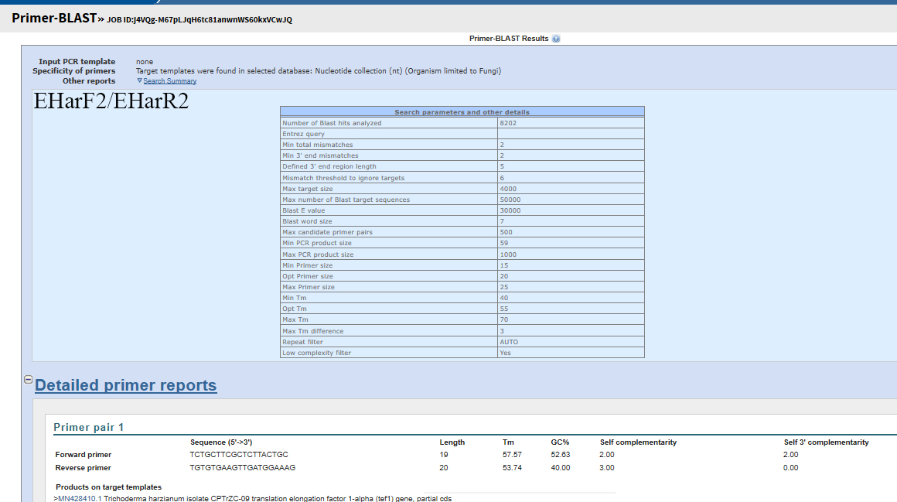

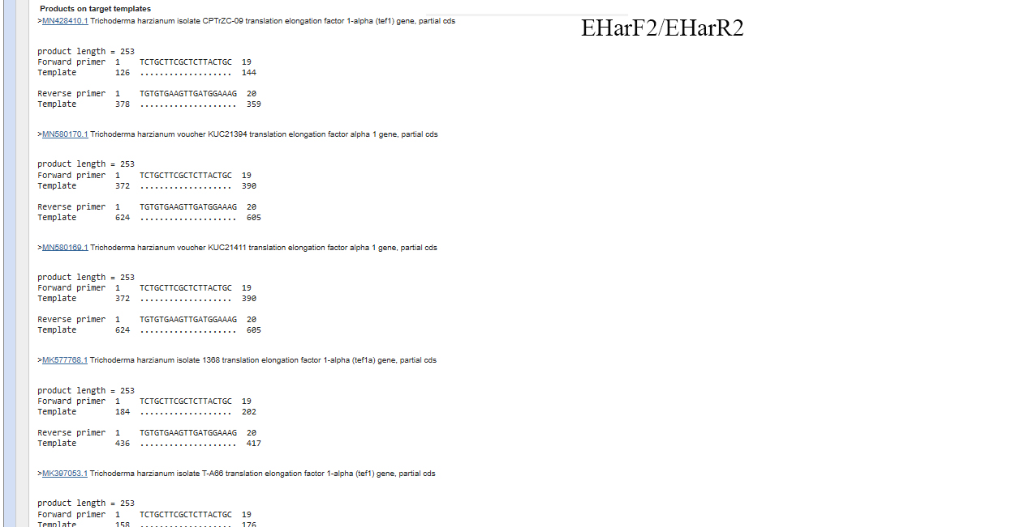
Fig. S1 Cross reactivity analysis of EHarF2/EHarR2 using Primer-BLAST
EHarF2/EHarR2: TCTGCTTCGCTCTTACTGC/ TGTGTGAAGTTGATGGAAAG

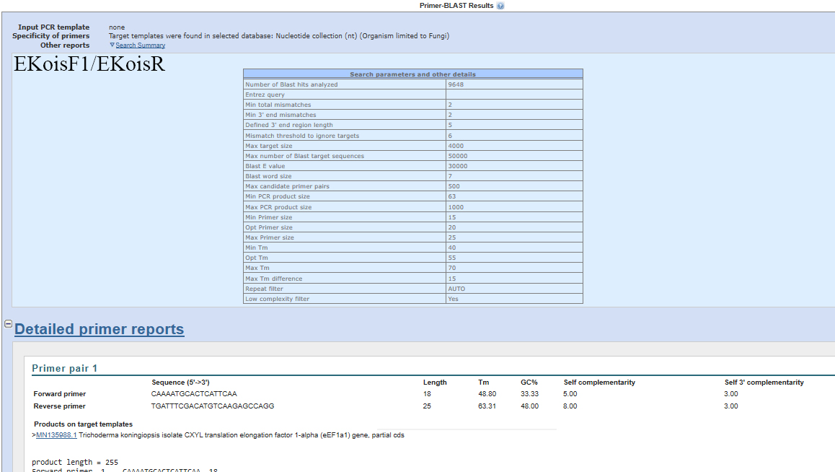

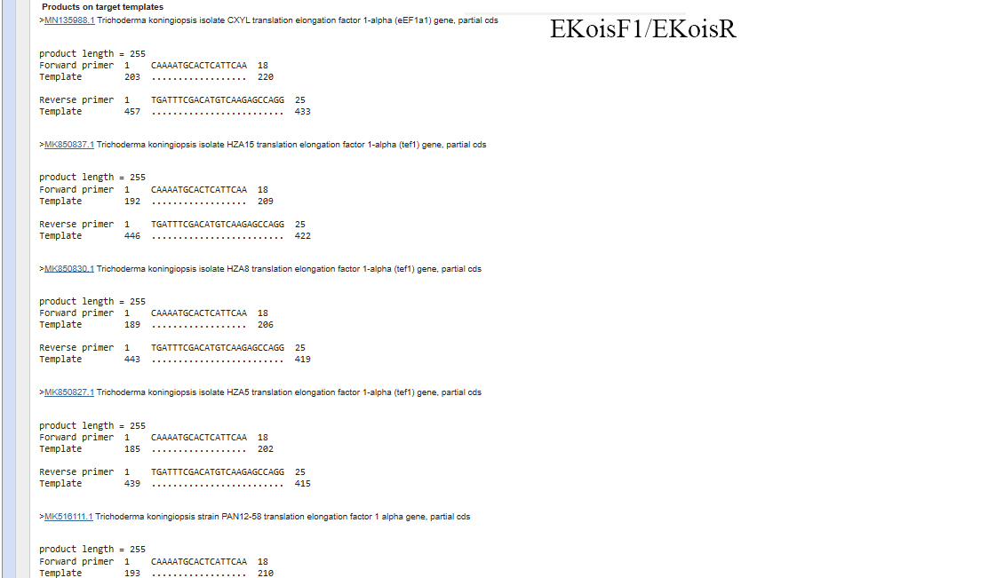

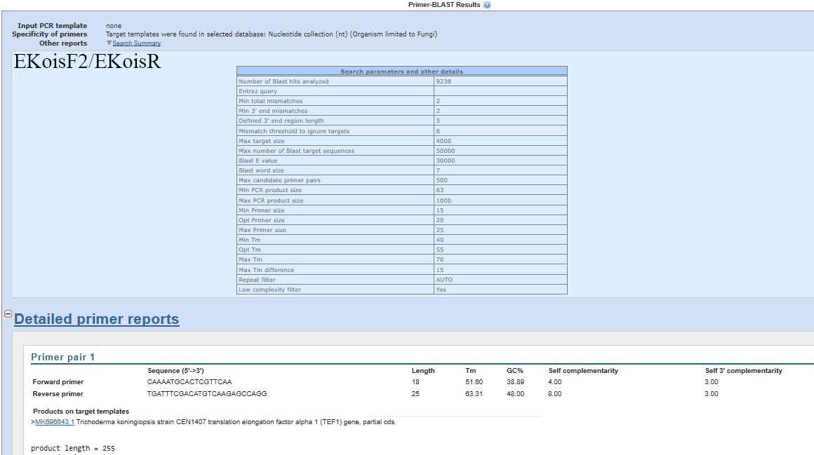

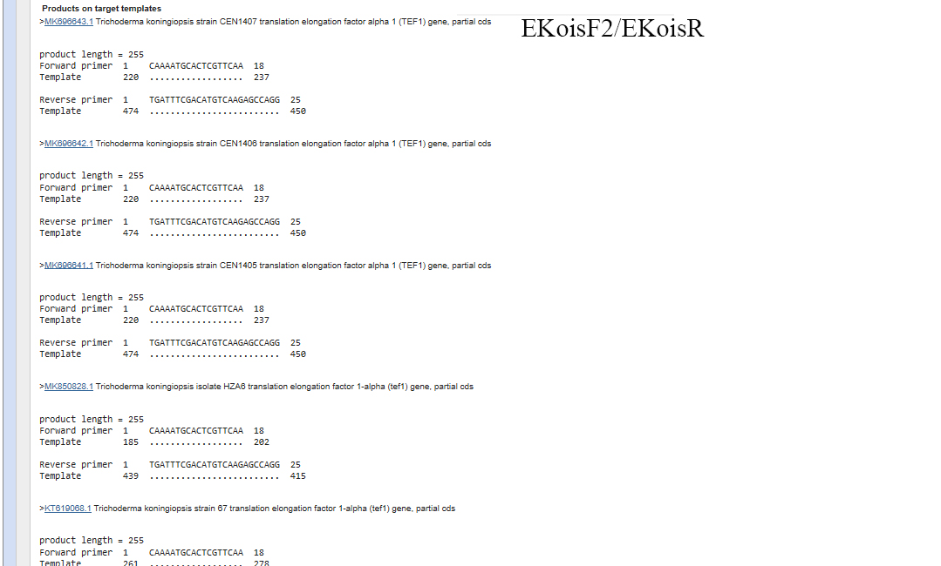
Fig. S2 Cross reactivity analysis of EKoisF/EKoisR using Primer-BLAST
Because the primers containing degenerate bases cannot use for cross reactivity analysis in Primer-BLAST tool, the primer with degenerate bases was split into primers without degenerate bases for cross reactivity analysis. (R=A/G)
EKoisF/EKoisR: CAAAATGCACTCRTTCAA/ TGATTTCGACATGTCAAGAGCCAGG
EKoisF/EKoisR= EKoisF1/EKoisR, EKoisF2/EKoisR
EKoisF1/EKoisR: CAAAATGCACTCATTCAA/TGATTTCGACATGTCAAGAGCCAGG
EKoisF2/EKoisR: CAAAATGCACTCGTTCAA/ TGATTTCGACATGTCAAGAGCCAGG

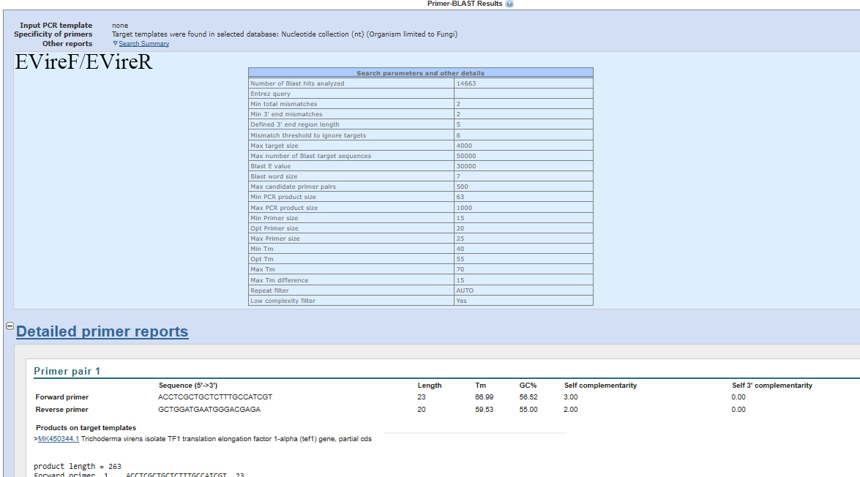

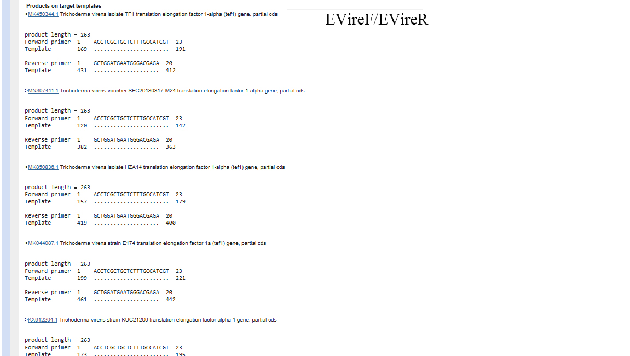
Fig. S3 Cross reactivity analysis of EVireF/EVireR using Primer-BLAST
EVireF/EVireR: ACCTCGCTGCTCTTTGCCATCGT/GCTGGATGAATGGGACGAGA

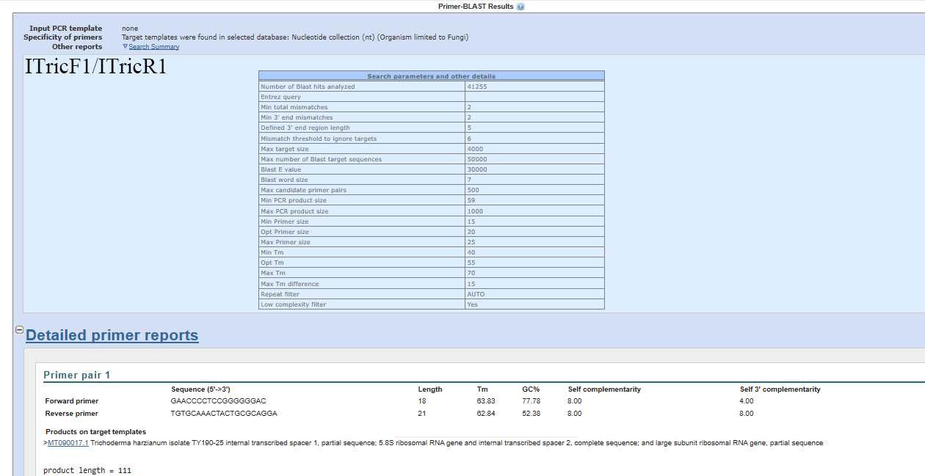

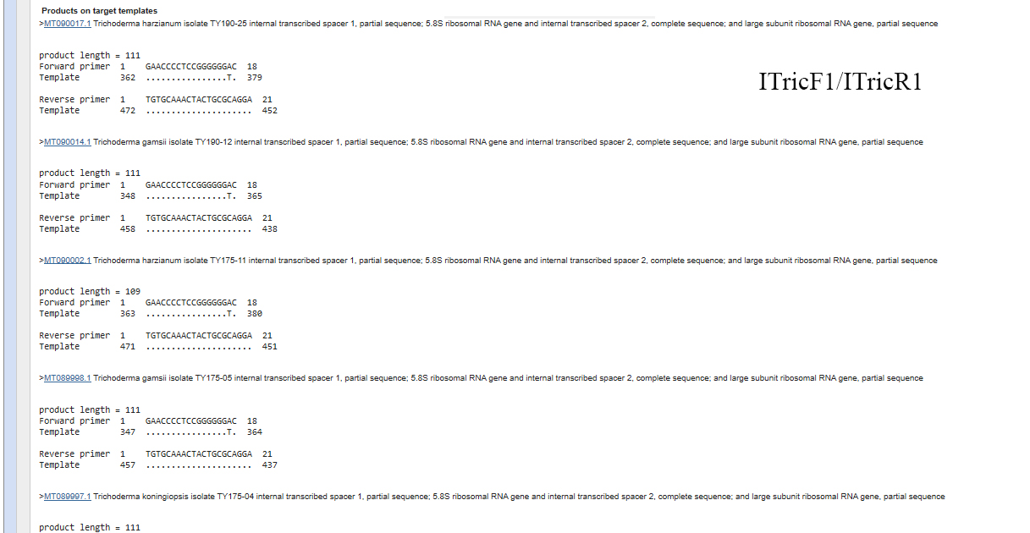
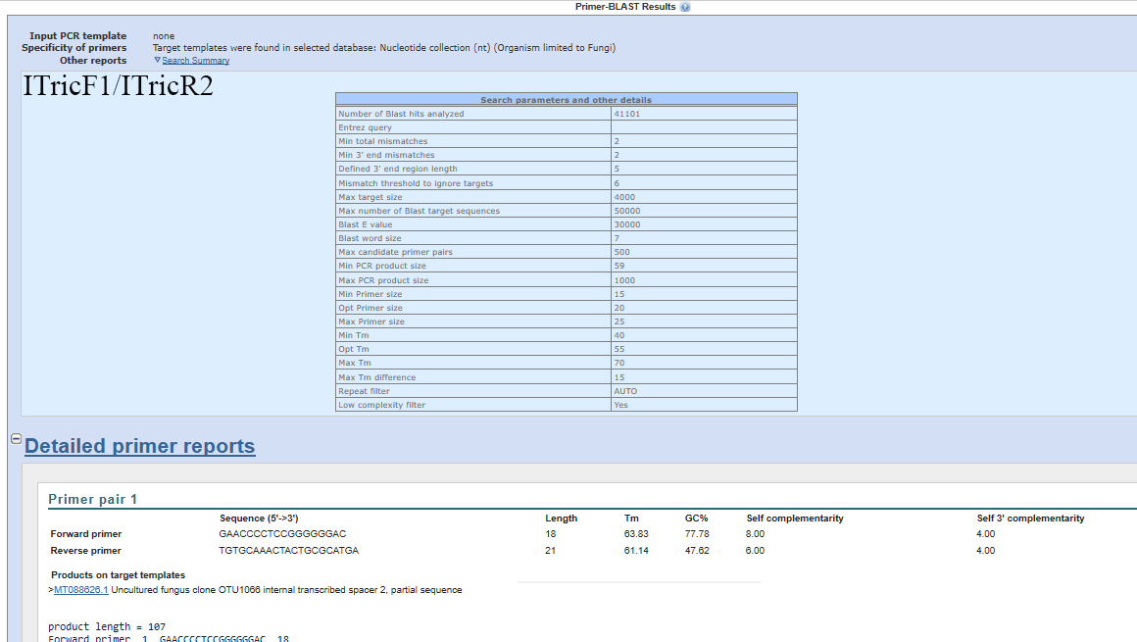
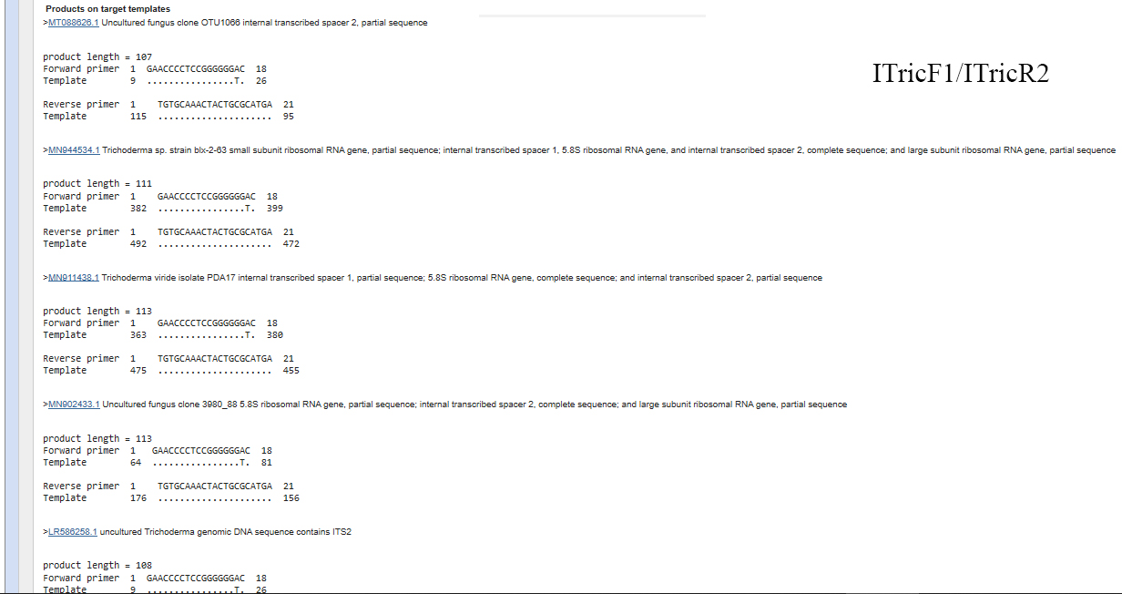

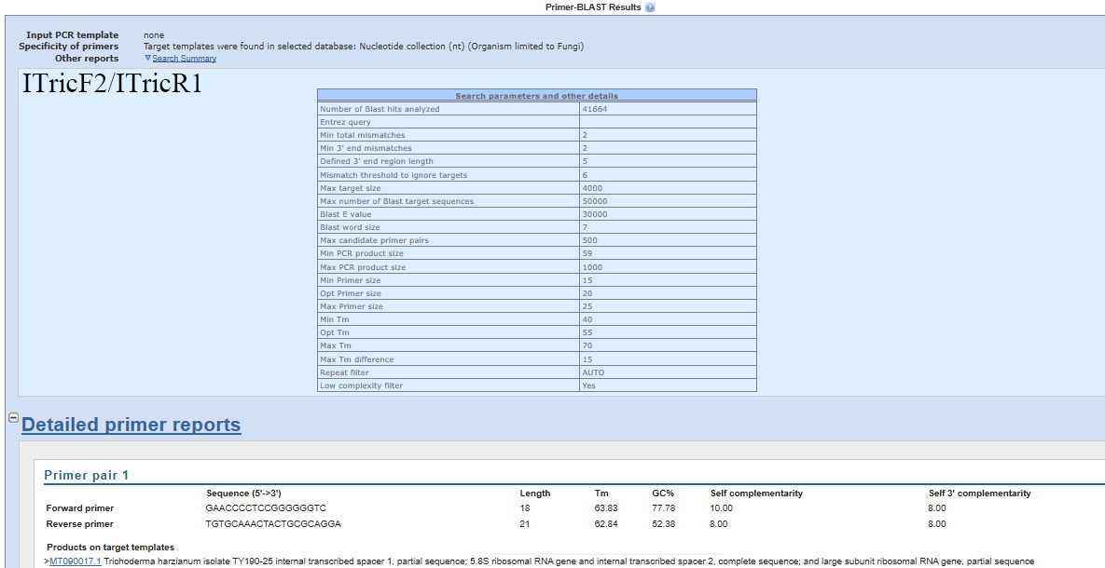

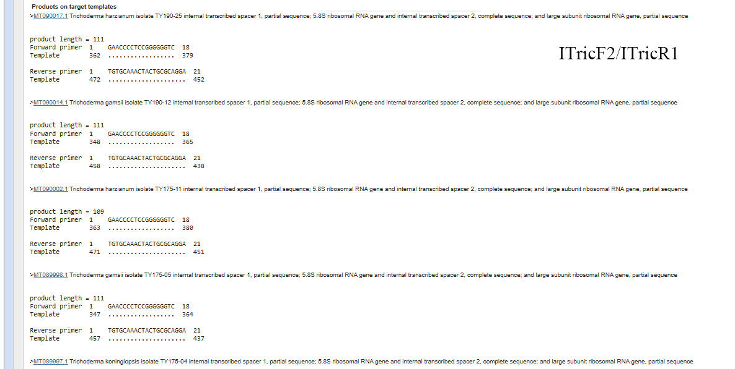

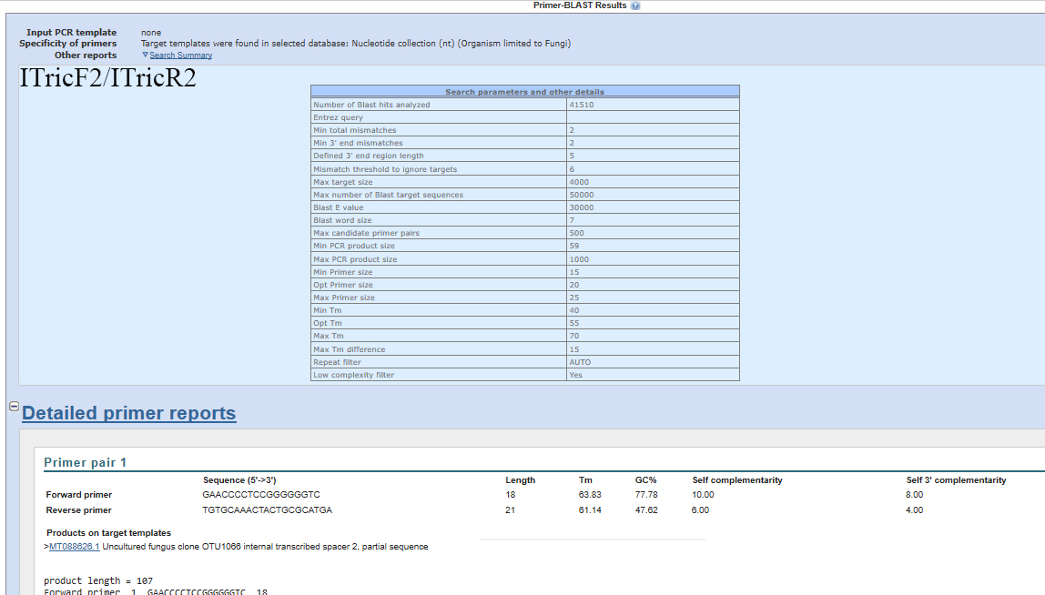

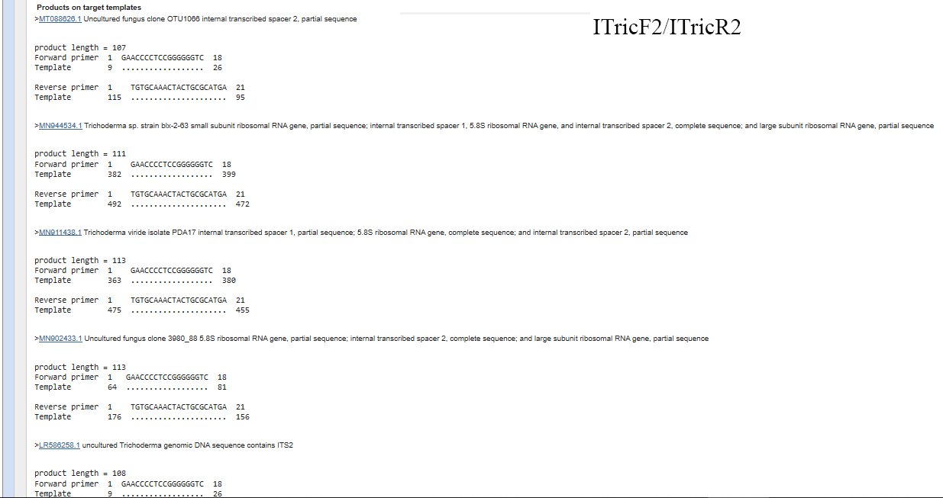

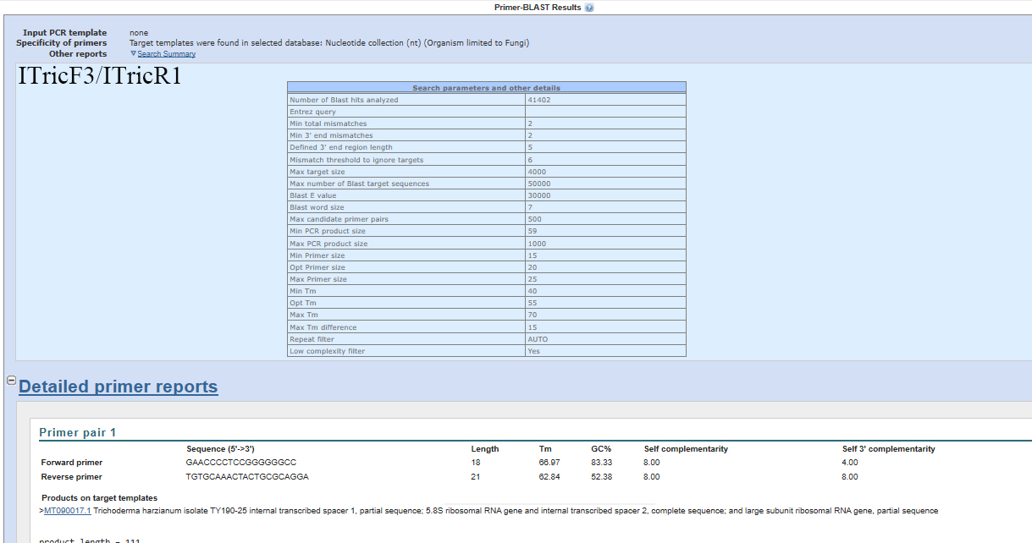

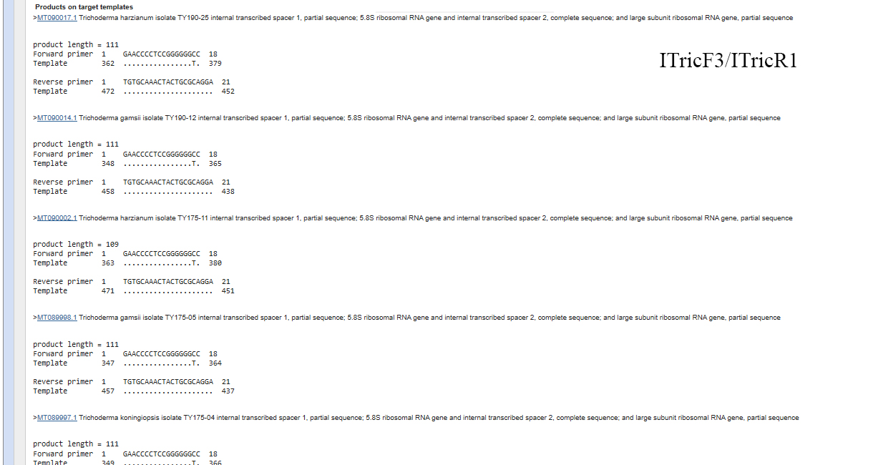
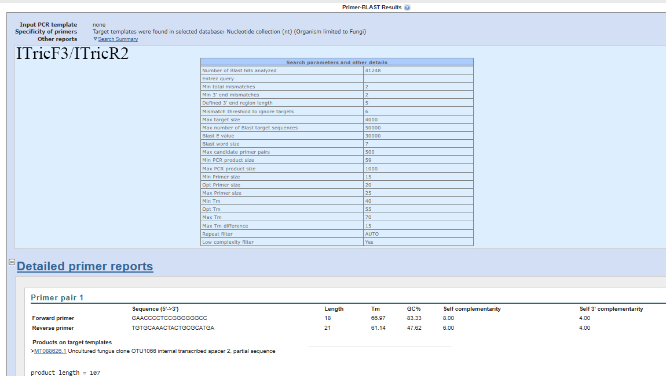
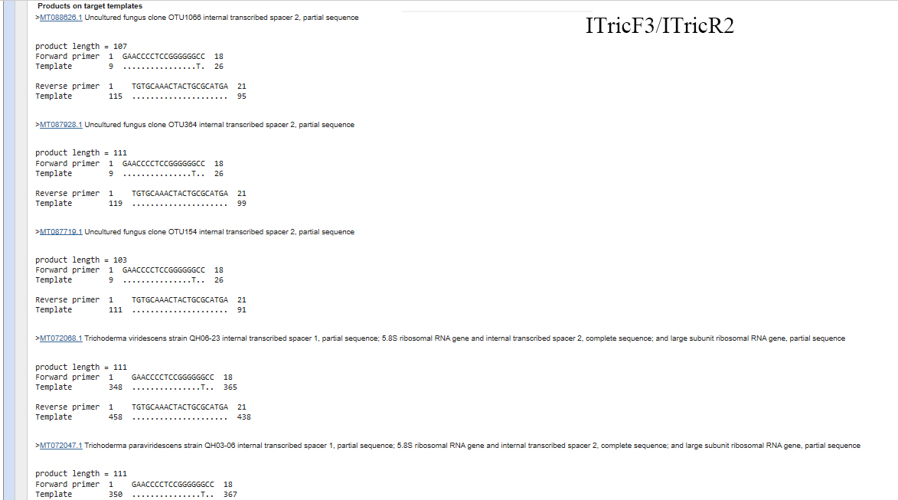
Fig. S4 Cross reactivity analysis of ITricF/ITricR using Primer-BLAST
Because the primers containing degenerate bases cannot use for cross reactivity analysis in Primer-BLAST tool, the primers with degenerate bases were split into primers without degenerate bases for cross reactivity analysis. (H=A/T/C; K=G/T)
ITricF/ITricR: GAACCCCTCCGGGGGGHC/TGTGCAAACTACTGCGCAKGA
ITricF/ITricR= ITricF1/ITricR1, ITricF1/ITricR2, ITricF2/ITricR1, ITricF2/ITricR2, ITricF3/ITricR1, ITricF3/ITricR2
ITricF1/ITricR1: GAACCCCTCCGGGGGGAC/TGTGCAAACTACTGCGCAGGA
ITricF1/ITricR2: GAACCCCTCCGGGGGGAC/TGTGCAAACTACTGCGCATGA
ITricF2/ITricR1: GAACCCCTCCGGGGGGTC/TGTGCAAACTACTGCGCAGGA
ITricF2/ITricR2: GAACCCCTCCGGGGGGTC/TGTGCAAACTACTGCGCATGA
ITricF3/ITricR1: GAACCCCTCCGGGGGGCC/TGTGCAAACTACTGCGCAGGA
ITricF3/ITricR2: GAACCCCTCCGGGGGGCC/TGTGCAAACTACTGCGCATGA

