Supplementary Figures

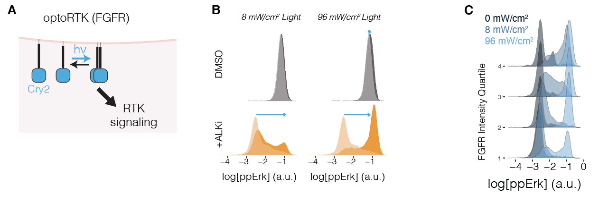
Supplementary Figure 1. OptoFGFR functional profiling of STE-1 cancer cells. A) optoFGFR comprises the intracellular domain of FGFR1 fused to the PHR domain from Arabidopsis Cryptochrome 2, which clusters under blue light stimulation⁵⁵. The construct is anchored in the membrane through N-terminal myristoylation. B) Single cell distributions of ppErk intensity in STE-1 cells stimulated by the indicated intensity of blue light in the presence (orange) or absence (grey) of ALKi (2 hr pre-incubation of 1µM crizotinib). Strong ppErk response at low light intensity in the presence, but not the absence, of ALKi suggests that ALKi hypersensitizes cells to RTK stimulation. C) The magnitude of ppErk response in optoFGFR STE-1 cells is a function of both light intensity and optoFGFR expression levels. Results are presented by binning optoFGFR-mCh expression by quartiles. ( 1<25%, 25% < 2 < 50%, 50% <3 < 75%, 4 > 75%).

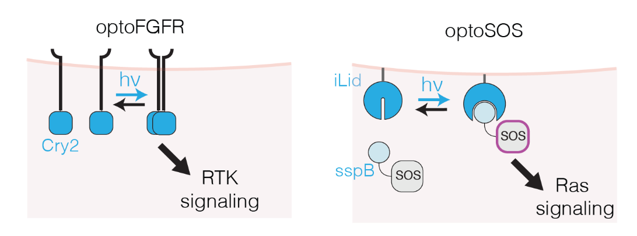
Supplementary Figure 2. Schematics of the optoFGFR and optoSOS tools used in Figure 3. optoFGFR²⁷ allows optogenetic stimulation of the FGFR receptor using light-induced clustering of the Cryptochrome 2 protein⁵⁵. OptoSOS allos Ras activation through membrane recruitment of the SOS2 catalytic domain (SOS2_{cat}). Membrane recruitment is achieved through blue light dimerization of sspB to the iLid protein⁵⁶ which is anchored to the membrane through a CAAX motif.

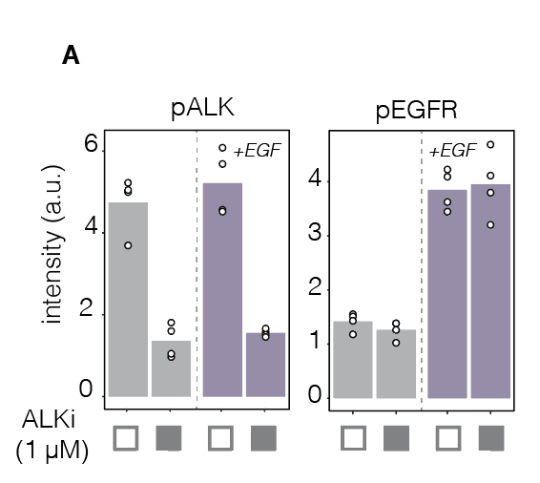

Supplementary Figure 3. EGFR signal suppression does not result from decreased EGFR phosphorylation. Following overnight starvation, STE-1 cells were pretreated with ALKi or DMSO for 2 hrs. Cells were then stimulated with either EGF (50 ng/mL) for 15 min and then were fixed and immunostained for ppErk. ALKi pretreatment did not alter pEGFR (Y1068) levels in either the presence or absence of EGF, whereas pALK (Y1507) decreased. Thus EML4-ALK does not modulate EGFR signaling through changes in EGFR phsophorylation. Data points represent mean intensity of 3000-5000 cells.

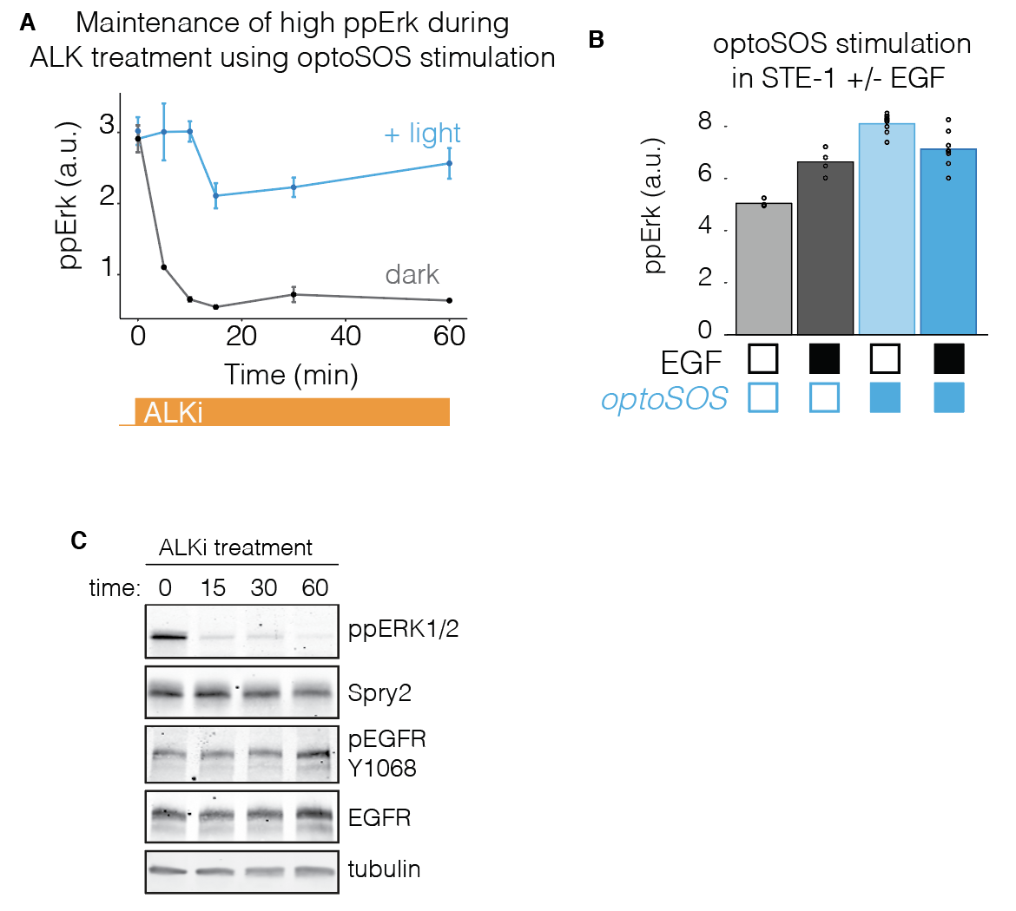
Supplementary Figure 4. Determining the role of Erk-dependent negative feedback on RTK suppression. A) Demonstration that optoSOS can maintain high Erk levels (comparable to those from the uninhibited oncogene) during ALKi pre-treatment. Optogenetic stimulation of Ras/Erk was used to decouple ALK inhibition from loss of Erk signaling in Figure 3G-J. B) ppErk levels after 15 min of EGF stimulation in the presence or absence of optoSOS activation. Maintenance of optoSOS activation during EGF stimulation did not result in elevated Erk signaling in the absence of ALKi (as seen in Figure 3J). Data in A) and B) represent signal from top 25% of optoSOS-expressing cells. Data points represent mean ± SEM of 200-600 cells per condition. C) Western blot showing levels of negative regulator Spry2 over the first hour of ALKi treatment. Despite loss of Erk activity, Spry2 levels remain unchanged over this time period.

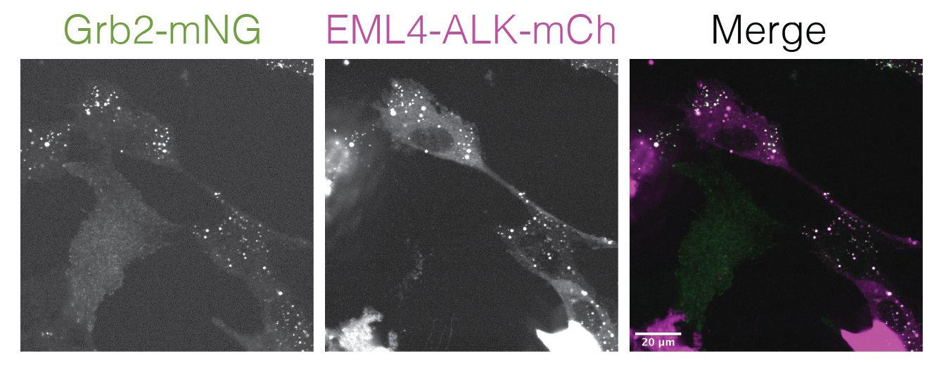

Supplementary Figure 5. EML4-ALK condensates colocalize with Grb2 puncta. Beas2B cells that harbored endogenously tagged Grb2 (Grb2:mNG) were transfected with EML4-ALK-mCh. In transfected cells, EML4-ALK co-localized with Grb2. In untransfected cells, Grb2 was diffuse.

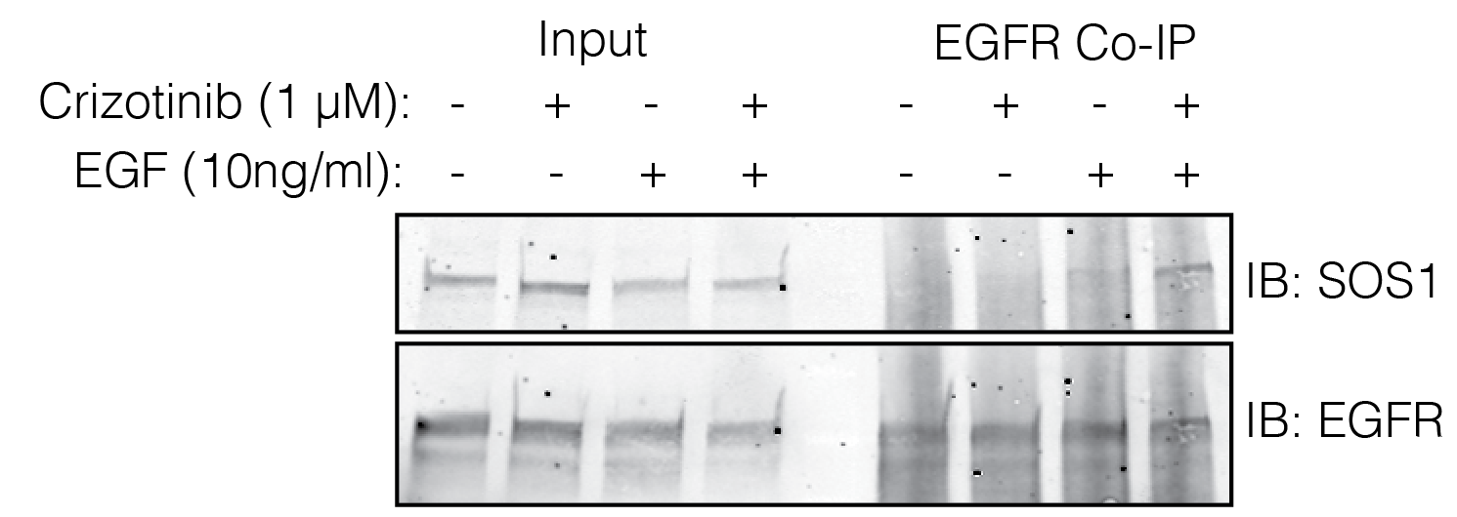
Supplementary Figure 6. Co-immunoprecipitation of EGFR with SOS1. H3122 cells were starved overnight, pretreated with crizotinib (2 hr), and were stimulated with EGF for 2 minutes before lysis and immunoprecipitation. Right 4 lanes are reproduced from Figure 4J.

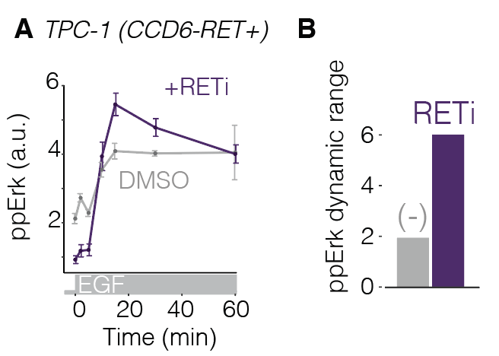
Supplementary Figure 7. CCDC6-RET+ cancer cells show dynamic suppression of EGFR through RTK fusion activity. TPC-1 cells harbor CCDC6-RET, a distinct RTK fusion that forms condensates. We tested the extent to which CCDC6-RET could modulate EGFR dynamic range as observed for EML4-ALK. A) Plot shows ppErk response to EGF stimulation after 2 hr pre-treatment with DMSO (grey) or 100 nM BLU-667 (purple), a RET inhibitor. Data represent mean ± SEM of triplicates, each of which represents ~1000 cells. B) Quantification of ppErk dynamic range shows that oncogene inhibition enhances signaling through EGFR. Thus, multiple RTK fusions that form condensates dynamically suppress EGFR signaling.

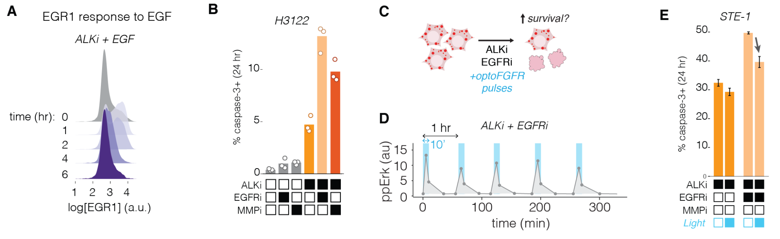
Supplementary Figure 8. RTK/Erk pulses activate transcription and promote cell survival during ALKi treatment. A) Adaptive response of EGR1 expression in STE-1 cells treated with ALKi and 50 ng/mL of EGF. EGR1 peaks at 1 hr after stimulation and then adapts to near baseline expression. EGR response is stronger and earlier than observed in Figure 6B because here all cells were stimulated at t = 0, whereas in 6B only individual cells were stimulated sporadically through paracrine signals starting 1-2 hrs after ALK treatment. B) Blockade of EGFR or MMPs accelerates cell death in H3122 in response to ALKi, as shown STE-1 cells in Figure 6G. C) We tested whether optoFGFR stimulation could reduce the enhanced cell death response in STE-1 cells co-treated with ALKi and EGFRi. D). A 10 min pulse of blue light (96 mW/cm²) every hour produced strong, periodic ppErk levels. Data points represent mean of three replicates, each representing ~2000 cells. E) Hourly pulses of optoFGFR/Erk (10 min of 96 mW/cm²) reduced cell death in both ALKi and ALKi/EGFRi treated cells. Data points represents the mean +/- SEM of three replicates, each representing ~10,000 cells.

