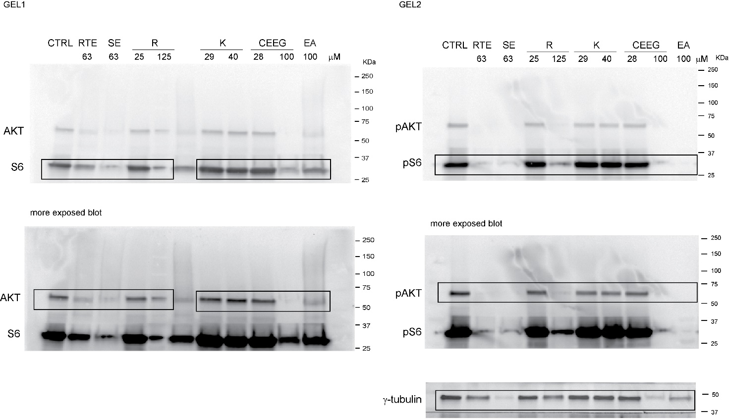

Supplementary Figure 1. Full-length blots from the two gels used for figure 4. Gel 1 was used to develop AKT and S6, Gel 2 was used to develop the phosphtylated forms of AKT and S6 (pAKT and pS6 respectively). Boxes indicate the cropped areas used in figure 4. Different exposures are indicated.

