Supplementary Table 1. Datasets included in the study. P, postnatal day; MI, myocardial infarction; cHF, heart failure caused by ischaemic cardiomyopathy; dHF, heart failure caused by dilated cardiomyopathy; ECs, endothelial cells; LV, left ventricle; LA, left atrium.

Species | Repository | Repository accession number | Injury/Disease status | Age | Number of ECs post-filtering | References
Mouse | GEO | GSE117893 | 21 days post-MI | Neonatal (P2) | 270 | Li et al., Development 2018⁵³
Mouse | GEO | GSE118545 | Healthy | Neonatal (P6) | 1510 | Hu et al, Genes & Development 2018⁵⁴
 |  |  |  | Neonatal (P10) | 1211 | Hu et al, Genes & Development 2018⁵⁴
Mouse | ArrayExpress | E-MTAB-7376 | 3 days post-MI | Adult | 519 | Farbehi et al., eLife 2019¹⁹
Mouse | GEO | GSE132880 | Healthy | Adult | 2747 | Li et al., EHJ 2019¹⁵
Mouse | GEO | GSE132880 | 7 days post-MI | Adult | 5168 | Li et al., EHJ 2019¹⁵
Mouse | GEO | GSE136088 | 14 days post-MI | Adult | 285 | DePasquale et al., Nuclei acids research 2019¹⁷
Mouse | ArrayExpress | E-MTAB-9816 | 1 day post-MI | Adult | 59 | Tombor et al., Nature Communications 2021¹⁸
Mouse | ArrayExpress | E-MTAB-9816 | 3 days post-MI | Adult | 116 | Tombor et al., Nature Communications 2021¹⁸
Mouse | ArrayExpress | E-MTAB-9816 | 14 days post-MI | Adult | 169 | Tombor et al., Nature Communications 2021¹⁸
Mouse | ArrayExpress | E-MTAB-9816 | 28 days post-MI | Adult | 177 | Tombor et al., Nature Communications 2021¹⁸
Human | GEO | GSE106118 | Healthy | Fetal  5 - 25 weeks | 240 | Cui et al., Cell reports 2019⁵⁵
Human | GEO | GSE134355 | Healthy | Fetal 11 - 12 weeks | 532 | Han et al., Nature 2020⁵⁶
 |  |  |  | Adult | 165 | Han et al., Nature 2020⁵⁶
Human | SRA | SRP234812 | Healthy | Fetal  19 - 22 weeks | 532 | Suryawanshi et al., Cardiovascular research 2020⁵⁷
Human | GEO | GSE109816 | Healthy | Adult | 386 | Wang et al., Nature cell biology 2020²⁰
Human | GEO | GSE121893 | cHF | Adult | 132 | Wang et al., Nature cell biology 2020²⁰
Human | GEO | GSE121893 | dHF | Adult | 264 | Wang et al., Nature cell biology 2020²⁰

Supplementary Table 2. Details of patients included in the KLF4 validation study.
 | Age | Sex | Cause of death
Healthy subjects  (n = 5) | 25 | Male | 1a - Suspension by ligature
Healthy subjects  (n = 5) | 52 | Male | 1a Chest injuries, 1b Road traffic collision (cyclist)
Healthy subjects  (n = 5) | 29 | Male | 1a - Suspension by ligature
Healthy subjects  (n = 5) | 53 | Male | 1a - Suspension by ligature
Healthy subjects  (n = 5) | 63 | Male | 1a - Ruptured atherosclerotic abdominal aortic aneurysm
 |  |  | Diagnosis
Patients  (n = 5) | 45 | Female | Ischaemic cardiomyopathy
Patients  (n = 5) | 70 | Male | Ischaemic cardiomyopathy
Patients  (n = 5) | 52 | Male | Ischaemic cardiomyopathy
Patients  (n = 5) | 55 | Male | Ischaemic cardiomyopathy
Patients  (n = 5) | 57 | Female | Ischaemic cardiomyopathy

Supplementary Table 3. Details of ZFP36 siRNA oligonucleotides.
siRNAs | Sequence (5’ -> 3’)
siRNAs | Sense | Antisense
s14977 | UCUGUCUCCUAGAAUCUUAtt | UAAGAUUCUAGGAGACAGAtt
s14978 | AGACGGAACUCUGUCACAAtt | UUGUGACAGAGUUCCGUCUtg
s14979 | CUUUAUUUAUGACGACUUUtt | AAAGUCGUCAUAAAUAAAGgg

Supplementary Table 4. Top marker and GO term analyses of mouse coronary endothelial cell clusters. Genes enriched in individual clusters were identified as the cluster markers. The markers were ranked by the adjusted P values and average log2FC and the top 20 markers that satisfied adjusted P < 0.05 were listed below.
Cluster | Top markers | Top GO terms
0 | Rps6, Rpl18a, Rps28, Rpl13a, Rps7, Rps8, Rps23, Rpl34, Rpl37, Rps27, Rps4x, Rpl26, Rps12, Ttn, Id3, Hsp90aa1, Rps21, Tm4sf1, Cyyr1 | Positive regulation of inflammatory response, regulation of transcription involved in cell fate commitment, protein transport from ciliary membrane to plasma membrane
1 | Actb, Trp53i11, Mest, Tmsb10, Prnd, Sparcl1, Tmsb4x, Ptp4a3, Pfn1, Tpm4, Myl6, Actg1, Csrp1, Ppp1r2, Msn, Bst2, Ubb, Mall, Ly6a, Hspa1a | Cytoplasmic translation, ribosomal small subunit assembly, sequestering of actin monomers
2 | Cxcl12, Aqp7, Cd300lg, Btnl9, Cd36, Sept4, Slc6a6, Cdkn1c, Oaz2, Glul, Car4, Clec14a, Flt1, Tubb2a, Gas6, App, Morf4l1, Eva1b, Dazap2 | Cell adhesion, positive regulation of angiogenesis, regulation of endothelial cell proliferation
3 | Aqp1, Igfbp5, Cd9, Rassf9, Rhoj, Fabp4, Slc26a10, Anxa2, Adgrf5, Ptrf, Dstn, Crip2, Rras, Lmo2, Prr13, Aplp2 | Positive regulation of fibroblast proliferation, negative regulation of epithelial cell apoptotic process, negative regulation of developmental process
4 | Jun, Btg2, Klf4, Klf2, Dusp1, Jund, Cdkn1a, Ubc, Apold1, Sgk1, Irf1, Hspb1, Plk2, Pnrc1, Atp2a2, Wsb1, Dusp3, Plat | Negative regulation of apoptotic process, regulation of cell cycle, positive regulation of nitric oxide biosynthetic process
5 | Fbln5, Gja5, Hey1, Sox17, Ltbp4, Efnb2, Rbp7, Ly6c1, Depp1, Cyb5r3, Nudt4, Cd81, Emp2, Serinc3, Id2, Eif1, My12a | Angiogenesis, positive regulation of epithelial cell proliferation, cell adhesion
6 | Stmn1, Hmgb2, Cdc20, Cenpf, Top2a, Ube2c, Hist1h2ae, Cenpa, Selenoh, Dek, Ube2s, Tuba1b, Tubb5, Calm2, Arl6ip1, Tubb4b, Ptma, H10, Ctla2a, Gm42418 | Regulation of alternative mRNA splicing, via spliceosome, mitotic sister chromatid segregation, mismatch repair
7 | Tmem59, Hspg2, Rabac1, Pdgfb, Scp2, Dusp3, Notch4, Itpkb | Branching involved in blood vessel morphogenesis, angiogenesis, positive regulation of angiogenesis
8 | Cox6a2, Ankrd1, Tnni3, Pln, Actc1, Myl2, Tnnt2, Slc25a4, Tpm1, Timp3, Gm10250, Mdh1, Atp5g1, Heg1, Rps26, Romo1 | Cytoplasmic translation, ribosomal small subunit assembly, sequestering of actin monomers
9 | Plvap, Lrg1, Tmem176a, Tmem176b, Cpe, Cfh, Socs3, Selenop, Rplp0, Rps2, Rpl15, Ifitm2, Scarb1, Itm2b, Slc25a5, Ebf1, Rgcc, Igfbp7, Fos | Cytoplasmic translation, ribosomal small subunit assembly, positive regulation of angiogenesis
10 | Rbm20, Slc8a1, Ctnna3, Myocd, Gm26561, RP24-559D16.1, Ryr2, Palld, Fhl2, Ccdc141, Chrm2, Dmd, Kcnd2, Pde4d, Pip5k1b, Sorbs2, Tbc1d4, Lmo7, Sorbs1, Klf6 | Regulation of inflammatory response, sequestering of metal ion, negative regulation of platelet-derived growth factor receptor-beta signalling pathway
11 | Col3a1, Col1a1, Dcn, Col1a2, Postn, Lum, Mfap5, Htra3, Gsn, Gpx3, Rarres2, Serping1, Rcn3, Pi16, Aebp1, Eef1a1, Mgp, Ncl, Crip1 | Cellular modified amino acid metabolic process, intrinsic apoptotic signalling pathway in response to DNA damage, small molecule biosynthetic process
12 | Ifit2, Cxcl10, Isg15, Gbp2, Gbp5, Gbp3, Rsad2, Oasl2, Iigp1, Isg20, Samhd1, Ifitm3, AW112010, Cd47, Plscr2, H2-D1, Chmp4b, Upp1, Clic4, Timp4 | Defence response to virus, cellular response to interferon-beta, positive regulation of T cell mediated cytotoxicity
13 | Ctss, Wfdc17, Cd14, C1qc, C1qa, Ccl4, C1qb, Lyz2, Cxcl2, Spp1, Pf4, Apoe, Cd74, H2-Aa, Ctsb, Fth1, H2-Ab1, Cst3, Ftl1, Srgn | Cytoplasmic translation, positive regulation of signal transduction by p53 class mediator, immune system process
14 | Rgs4, Myh11, Higd1b, Gucy1a3, Vtn, Steap4, Ndufa4l2, Kcnj8, Gm13889, Rasl11a, Tpm2, Rgs5, Abcc9, Cox4i2, Myl9, Cox4i2, Myl9, Colec11, Axl, Lbh | Transmembrane receptor protein serine/threonine kinase signalling pathway, hepatocyte proliferation, circadian behaviour

Supplementary Table 5. Common upregulated DEGs across all timepoints post-MI in adult mouse cardiac ECs compared to uninjured adult mouse cardiac ECs. Differentially expressed genes (DEGs) were ranked according to the adjusted P values and the average log2 fold change.
DEGs | Average log2 fold change
DEGs | 1 day | 3 days | 7 days | 14 days | 28 days
Cebpd | 2.69 | 2.65 | 1.63 | 2.34 | 3.58
Elob | 2.66 | 2.76 | 2.77 | 1.49 | 2.76
Gas5 | 3.77 | 2.74 | 2.50 | 3.22 | 3.50
Rack1 | 3.22 | 2.75 | 2.49 | 1.95 | 2.99
Selenof | 2.70 | 2.79 | 3.03 | 1.64 | 2.62
Selenok | 2.38 | 2.43 | 2.37 | 1.63 | 2.89
Selenom | 2.39 | 1.93 | 2.02 | 1.40 | 2.35
Selenop | 3.65 | 3.16 | 2.99 | 2.73 | 4.47
Selenow | 3.04 | 2.92 | 3.36 | 2.20 | 3.28
Sem1 | 2.93 | 3.02 | 3.05 | 1.63 | 2.72
Atp6v0c | 3.02 | 2.40 | 2.14 | 1.84 | 2.11
Vps28 | 1.15 | 1.51 | 1.57 | 1.19 | 1.30
Nme2 | 2.81 | 2.62 | 2.51 | 1.79 | 2.90
Lgals1 | 2.65 | 0.95 | 0.87 | 2.26 | 1.73
Socs3 | 1.99 | 1.17 | 0.76 | 1.87 | 3.16
Tmem176b | 1.42 | 0.70 | 0.75 | 1.45 | 0.99
Emp1 | 1.22 | 1.19 | 1.18 | 1.44 | 2.43
Capg | 1.40 | 1.16 | 1.15 | 0.46 | 0.87
Ndfip1 | 0.76 | 1.51 | 1.41 | 0.55 | 1.30

Supplementary Table 6. Top marker and GO term analyses of human coronary endothelial cell clusters. Genes enriched in individual clusters were identified as the cluster markers. The markers were ranked by the adjusted P values and average log2FC and the top 20 markers that satisfied adjusted P < 0.05 were listed below.
Cluster | Top markers | Top GO terms
0 | CDH11, POSTN, COL3A1, CGNL1, LEPR, SAT1, CLU, PROCR, FBLN2, CCDC80, NPR3, TIMP1, COLEC11, LTC4S, SLC6A4, FN1, APCDD1, CTHRC1, INHBA, NPPC | Translational initiation, viral transcription, nuclear-transcribed mRNA catabolic process, nonsense-mediated decay, SRP-dependent cotranslational protein targeting to membrane, cytoplasm translation, ribosomal large subunit assembly, maturation of SSU-rRNA from tricistronic rRNA transcript, ribosomal small subunit assembly, heterophilic cell-cell adhesion via plasma membrane cell adhesion, calcium-dependent cell-cell adhesion via plasma membrane cell adhesion molecule
1 | A2M, CD36, TMSB4XP4, AC104389.1, FABP4, MTATP6P1, H19, FABP5P7, IGF2, RGCC, COL4A1, COL15A1, RP5-857K21.11, FMO2, KDR, MGLL, COL4A2, ITGA6 | Angiogenesis, maintenance of blood-brain barrier, vesicle transport along actin filament, negative regulation of dendrite development, negative regulation of endothelial cell proliferation, platelet aggregation, protein localisation to adherens junction, antigen processing and presentation of exogenous peptide antigen via MHC class I, TAP-independent, positive regulation of endothelial cell proliferation, positive regulation of GTPase activity
2 | COL15A1, IL32, CLDN5, TM4SF18, CAV1, COL4A1, GNG11, CA4, FABP5, LGALS1, IGFBP7, COL4A2, TNNT3, C1orf54, S100A16, GYPC, IGFBP2, IGFBP3, FABP4, CCND1 | Positive regulation of cell migration, angiogenesis, Fc-gamma receptor signalling pathway involved in phagocytosis, negative regulation of endothelial cell proliferation, vascular endothelial growth factor receptor signalling pathway, interleukin-12-mediated signalling pathway, basement membrane organisation, regulation of cell shape, postsynaptic actin cytoskeleton organisation, negative regulation of blood vessel endothelial cell migration
3 | MYL7, CSRP3, AcTC1, TNNT2, CKM, TPM1, MYL2, MYH7, CRYAB, TNNI3, NPPA, TNNC1, HSPB7, TTN, MB, COX6A2, ANKRD1, COX7A1, MYH6, AP000251.3 | Muscle filament sliding, cardiac myofibril assembly, sarcomere organisation, cardiac muscle contraction, mitochondrial ATP synthesis coupled electron transport, regulation of cardiac muscle contraction by regulation of the release of sequestered calcium ion, skeletal muscle thin filament assembly, cellular response to caffeine, atrial cardiac muscle cell action potential, membrane depolarisation during cardiac muscle cell action potential
4 | GJA5, FBLN5, TSPAN2, SEMA3G, SERPINE2, PCSKS, CLDN5, SRGN, JAG1, HEY1, CXCL12, MECOM, JAM2, CLEC14A, PPA1, IGFBP3, DKK2, KCTD12, ELN, SULF1 | Negative regulation of protein binding, platelet degranulation, extracellular matrix organisation, positive regulation of cell differentiation, heart trabecula formation, negative regulation of cell migration, protein localisation to bicellular tight junction, response to interferon-alpha, negative regulation of phosphoprotein phosphatase activity, blood vessel remodelling
5 | TYROBP, LAPTM5, C1QB, FCER1G, ALAS2, S100A9, LYZ, S100A8, PLAUR, CXCL8, DUSP2, HBM | Neutrophil degranulation, respiratory burst, positive regulation of tumour necrosis factor production, innate immune response, positive regulation of interleukin-4 production, positive regulation of interleukin-6 production, microglial cell activation, positive regulation of interferon-gamma production, cytokine-mediated signalling pathway, neutrophil chemotaxis
6 | NDP, IGFL2, F5, KISS1, NTRK2, SELL, TFPI2, HAPLN1, PTHLH, PLAT, CD55, SERPINB1, AKR1B1, DKK2, CD9, S100A6, CRIP1, DKK3, IGFBP5 | Nuclear-transcribed mRNA catabolic process, nonsense-mediated decay, translational initiation, SRP-dependent cotranslational protein targeting to membrane, viral transcription, neutrophil degranulation, cytoplasmic translation, antigen processing and presentation of exogenous peptide antigen via MHC class I, TAP-dependent, antigen processing and presentation of exogenous peptide antigen via MHC class I, TAP-independent, positive regulation of translation, antigen processing and presentation of endogenous peptide antigen via MHC class I via ER pathway, TAP-independent
7 | TBX2, EGFLAM, CYGB, AGT, P2RY14, ITGB1P1, MYLK, PDGFRB, STEAP4, RGSS, SCN4B, NOTCH3, THBS4, FAT1, KLHL23, ABCC9 | Brain development, negative regulation of blood vessel endothelial cell migration, positive regulation of signal transduction by p53 class mediator, endothelial cell differentiation, peptide hormone processing, muscle contraction, branching morphogenesis of an epithelial tube, epithelial cell development, negative regulation of cellular process, negative regulation of cell-substrate adhesion

Supplementary Table 7. Upregulated DEGs in human fetal coronary ECs compared to adult ECs. DEGs were ranked according to both the adjusted P values and the average log2 fold change.
Comparison | Upregulated (log2 fold change)
Uninjured fetal vs uninjured adult | HBG2 (6.24), EEF1A1 (2.89), RPL10 (2.77), HBA1 (5.14), HBA2 (5.25), MDK (3.47), RPL15 (2.13), RPS23 (2.31), RPS26 (2.44), GAPDH (2.38), RPS15A (2.85), RAMP2 (2.72), RPL13(2.34), COL3A1 (3.88), RPS7 (2.37), RPS3A (2.30), RPL26 (2.55), RPL39 (2.61), RPLP0 (2.22), RPL28 (2.67)

Supplementary Table 8. Gene expression in cardiac ECs from patients with heart failure, compared to those from the healthy adult human heart. Differentially expressed genes (DEGs) were ranked according to the adjusted P values and the average log2 fold change. cHF, heart failure caused by ischaemic cardiomyopathy; dHF, heart failure caused by dilated cardiomyopathy.
Groups | Upregulated (log2 fold change)
Groups | Specific | Common (cHF/dHF)
cHF | TRMT61A (0.38), RNY4 (1.12), TTN (0.63), ANKRD1 (0.63), PDK4 (1.00), DNAJC6 (0.67), PCNXL3 (0.40), TCEB2P2 (0.60), ANKRD36C (1.34), RN7SKP71 (1.16) | MSRB3 (1.18/1.04), MYH6 (0.68/0.26), MTATP8P1 (1.11/1.19), SMARCA4 (0.83/1.06), KANK2 (0.89/0.61), MYL7(0.52/0.39), DOCK6 (0.74/0.85), NOTCH3 (0.39/0.28), SYNE3 (0.37/0.48), CANX (0.45/0.38), GAS5 (0.29/0.43), ONECUT3 (0.58/0.35), PTMAP5 (0.75/0.89), MALAT1 (0.41/0.38), UACA (0.80/0.32), SCN5A (0.44/0.35), NBL1 (0.92/0.84), WDR31 (0.49/0.66)
dHF | ITLN1 (2.38), RP11-475J5.10 (1.01), HP (1.20), FOSB (1.09), MTND4P12 (0.90), RP11-475J5.6 (0.84), MTRNR2L7, RP5-857K21.6, MTRNR2L13, JUN

Supplementary Table 9. Common upregulated DEGs in fetal and dHF adult heart ECs compared to the uninjured adult heart. DEGs were ranked according to both the adjusted P values and the average log2 fold change.
Comparison | Upregulated (log2 fold change, dHF/fetal)
Common DEGs between healthy fetal and dHF adult (vs uninjured adult) | RPL39 (0.35/2.61), RPL11 (0.36/1.91), PTMA (0.40/1.16), RPS11 (0.37/1.19), FN1 (0.25/2.23), NAP1L1 (0.37/0.93), EFNB2 (0.47/0.63), RPL10AP6 (0.51/0.25), LTBP4 (0.55/1.02), CCDC80 (0.33/1.03), SOX4 (1.08/0.63), EEF2 (0.61/1.01), HSPA5 (0.40/0.86), FUS (0.76/0.77), PABPC1 (0.75/0.58), RTF1 (0.27/0.43), TIMP2 (0.39/0.29)

Supplementary Table 10. Common and species-specific upregulated genes in injured mouse and human cardiac ECs. DEGs were ranked according to the adjusted P values and the average log2 fold change.
 | Upregulated DEGs (log2 fold change, mouse/human)
 | Common | Species-specific
Mouse injured vs uninjured | Cebpd(1.75) /CEBPD (0.90), Fos (1.54)/FOS (0.52), Jund (0.82)/JUND (0.56), Jun (1.09)/JUN (1.62), Rps4x (0.69)/RPS4Y1 (0.57), Lgals3bp (0.90)/LGALS3BP (0.35), Cd74 (0.92)/CD74 (0.66), B2m (0.67)/B2M (0.54), Dnaja1 (0.75)/DNAJB1 (1.15), Zfp36 (1.20)/ZFP36 (0.77), Zfp36l2 (0.80)/ZFP36L2 (0.79), Adamts1 (1.05)/ADAMTS1 (0.69), Hes1 (0.84)/HES1 (0.88), Ubc (0.70)/UBC (0.46), Rhob (0.75)/RHOB (0.26), Egr1 (1.11)/EGR1 (1.47), Nfkbia (0.91)/NFKBIA (0.64), Klf2 (0.81)/KLF2 (0.75), Cdkn1a (0.94)/CDKN1A (0.38), Fosb (1.06)/FOSB (1.23), Gimap4 (0.56)/GIMAP4 (0.76), Ier5 (0.68)/IER5 (0.92), Tsc22d1 (0.53)/TSC22D1 (0.65), Tmod3 (0.41)/TMOD3 (0.78), Hsp90aa1 (0.61)/HSP90AA1 (0.87), Apold1 (0.51)/APOLD1 (0.53), Dnajb1 (0.77)/DNAJB1 (0.60), Nedd9 (0.35)/NEDD9 (0.62), Gimap6 (0.39)/GIMAP6 (0.47), Tsc22d3 (0.35)/TSC22D3 (0.73), Gas6 (0.45)/GAS6 (0.60), Itga6 (0.32)/ITGA6 (1.29), Ddx3y (0.27)/DDX3Y (0.93), Tinagl1 (0.35)/TINAGL1 (0.39), Ets1 (0.28)/ETS1 (0.66), Timp3 (0.44)/TIMP3 (0.57), Slfn5 (0.34)/SLFN5 (0.75), Sparcl1 (0.47)/SPARCL1 (1.04), Klf4 (0.49)/KLF4 (1.12), Sgk1 (0.28)/SGK1 (0.81) | Cavin1 (3.95), Nme2 (2.53), Cavin3 (2.43), Selenow (2.36), Ccn1 (2.27), Nop53 (2.21), Selenop (2.18), Atp6v0c (2.13), Depp1 (2.13), Tcim (2.09)  (889 in total)
Human injured vs uninjured |  | AP000251.3 (3.19), MTRNR2L12 (3.04), RP11-777B9.5 (2.96), MTRNR2L8 (2.93), MTND6P3 (2.61), CH507-513H4.5 (2.60), MSRB3 (2.44), MTRNR2L10 (2.35), RP11-475J5.4 (2.32), AC002075.4 (2.30)  (645 in total)

Supplementary Figures
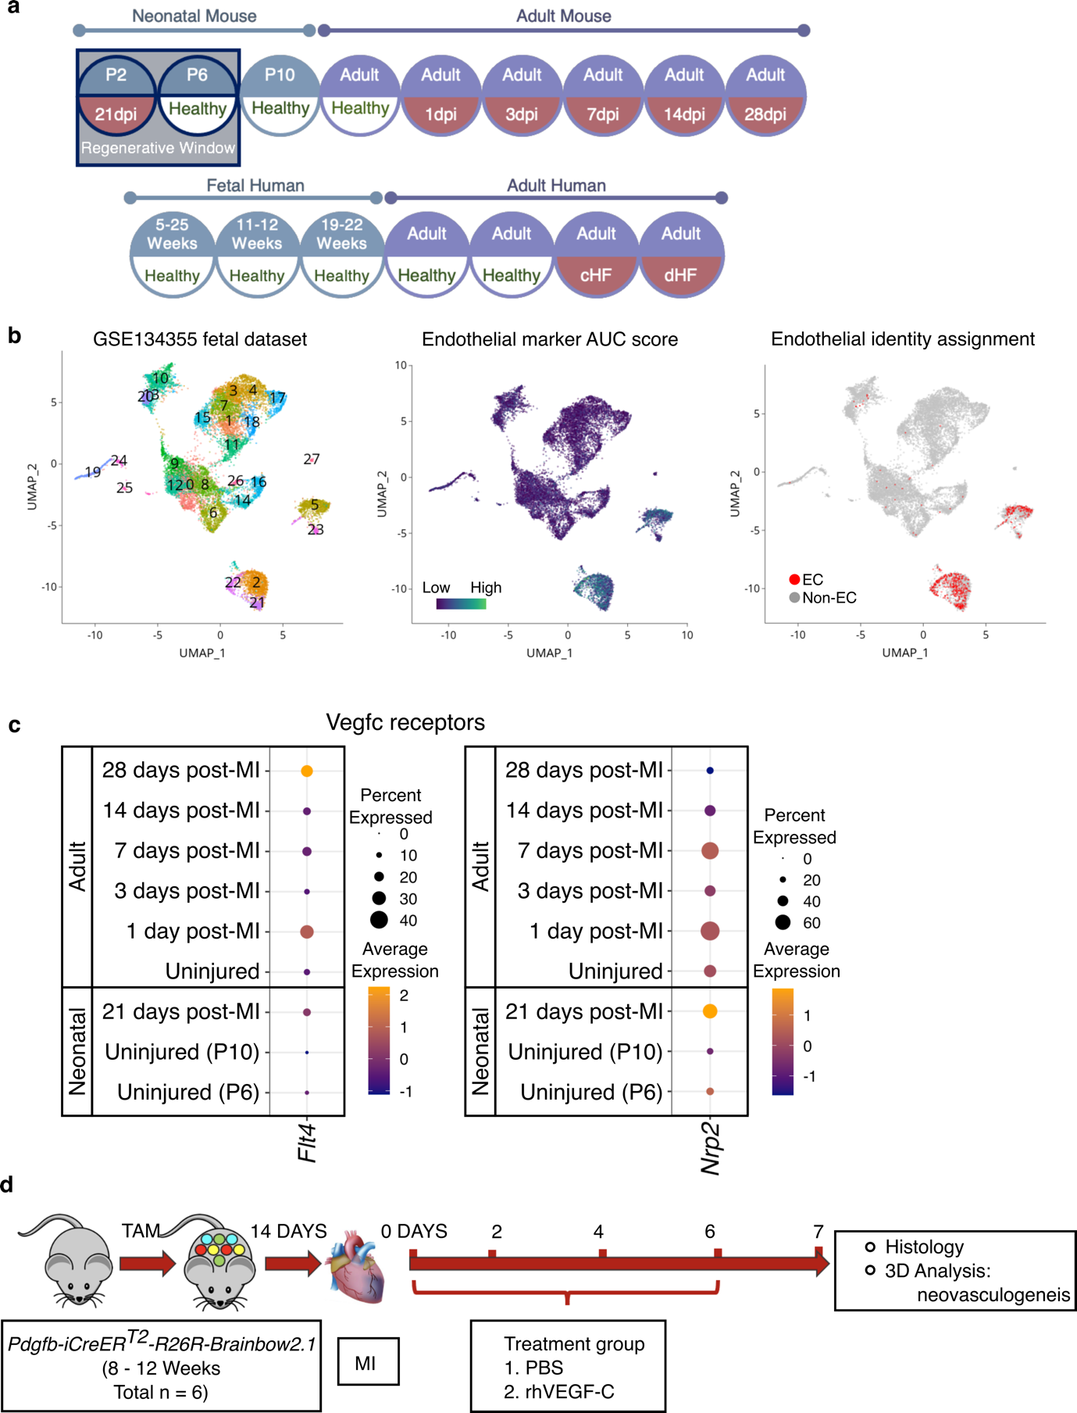
Supplementary Fig. 1 a. Groups included in the meta-analysis of mouse and human coronary EC scRNA-seq data. b. An example of EC enrichment using AUCell package. Left, the Seurat object generated from GSE134255 was subject to endothelial cell enrichment based on the expression of a panel of 45 endothelial markers¹³. Middle, all cells were scored for the expression of the endothelial markers and ranked using the AUCell package¹⁴ (version 1.13.3). Right, cells that passed the calculated threshold were assigned as endothelial cells. Endothelial cells were subset from the original Seurat object to generate a new endothelial-specific Seurat object, containing all the raw counts and metadata for the selected cells. c. Dot plots shows the expression level of Vegfc receptors Flt4 and Nrp2 in mouse coronary ECs. d. Workflow of the in vivo study using exogenous rhVEGF-C treatment to augment endogenous neovascularisation via endothelial cell clonal proliferation in the adult mouse heart. Pdgfb-iCreER^{T2}-R26R-Brainbow2.1 mice underwent permanent coronary artery ligation and were administered either recombinant human (rh)VEGF-C or PBS control at days 0, 2 4 and 6 post-surgery. Hearts were collected at 7 days for histological profiling and 3D clonal proliferation analysis.
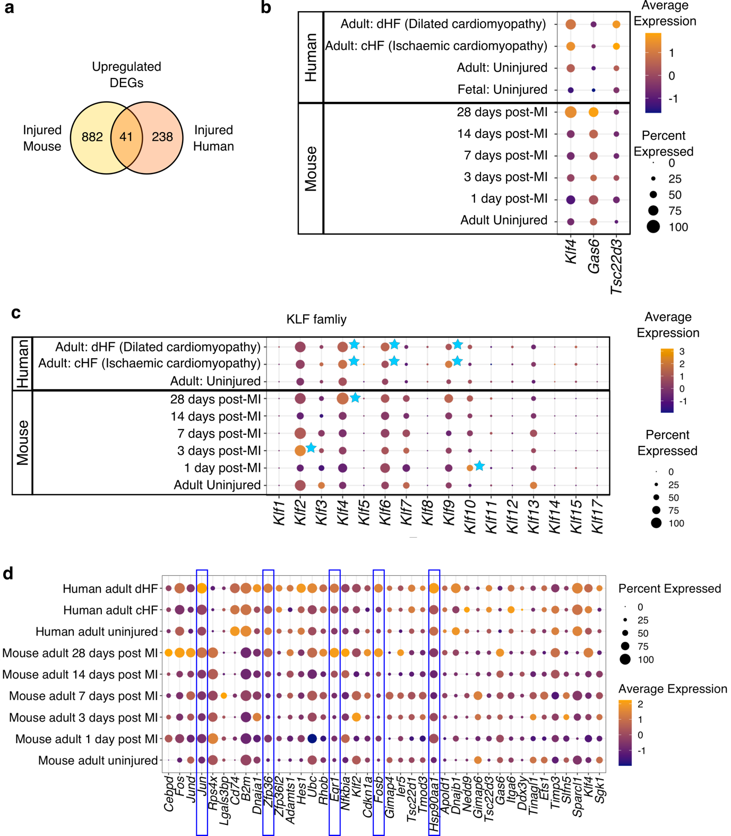
Supplementary Fig. 2 a. All mouse and human coronary EC scRNA-seq data was integrated to identify conserved mechanisms underpinning vascular responses between the two species. 41 upregulated DEGs were shared by coronary ECs in the injured mouse and human heart compared to the healthy hearts. However, many DEGs were specific to one species (882 and 238 genes, respectively). b. Expression of Klf4, Gas6 and Tsc22d3 was upregulated across all time-points in the injured mouse hearts and in both types of human heart failure. cHF, heart failure caused by ischaemic cardiomyopathy; dHF, heart failure caused by dilated cardiomyopathy. c. Dot plot shows the expression of Klf family members in human and mouse adult coronary ECs. Blue stars indicate enriched expression in coronary ECs in response to injury e.g., KLF4, KLF6 and KLF9 in human heart failure and Klf2, Klf4 and Klf10 in mice post-MI. d. Dot plot of 41 genes that were upregulated in both mouse and human cardiac ECs after ischaemic injury, compared to healthy heart coronary ECs. The greatest fold-change in expression in the highest percentage of cells was observed in Jun, Zfp36, Egr1, Fosb, and Hsp90aa1 (blue boxes).

