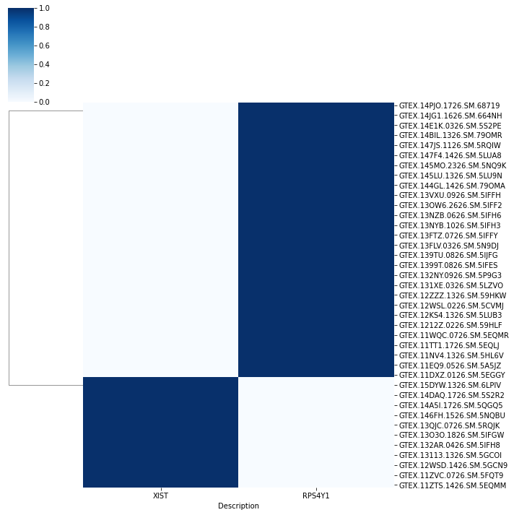
Figure S1. XIST and RPS4Y1 were used to distinguish between women and men in GTEx liver database.

Figure S2. The expression of 14 obesity-related genes/ GAPDH in GTEx liver, TCGA LIHC normal samples and TCGA LIHC tumor samples in female. (A) The expression of 14 obesity-related genes/ GAPDH in GTEx liver and TCGA LIHC normal samples in female. (B) The expression of 14 obesity-related genes/ GAPDH in GTEx liver and TCGA LIHC tumor samples in female. (C) The expression of 14 obesity-related genes/ GAPDH in TCGA LIHC normal and tumor samples in female.

Figure S3. Thirty three genes were screened out to explore the relationship with the occurrence and development of HCC. MFN2, OGDH and MMAA were key proteins related to mitochondria, and the 5-year survival curves were generated in MFN2 and OGDH in female and male respectively.

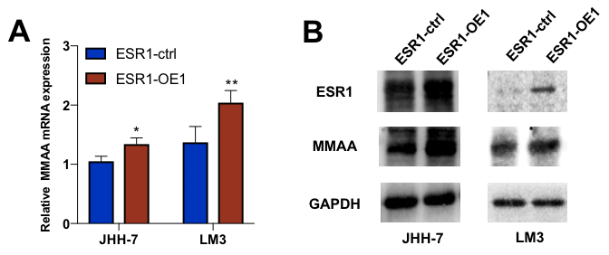
Figure S4. MMAA was upregulated with the overexpression of ESR1. (A) The relative MMAA mRNA expression was promoted in two cell lines as the ESR1 was overexpressed. (B) The MMAA expression was increased in two cell lines as the ESR1 was overexpressed in protein level.

Supplementary table 1. Baseline information for HCC patients from TCGA database.
Characteristics | Total | Female (n=120) | Male (n=249) | P value
Age
NA | 1 | 0 | 1 | 0.2228
< 60 | 169 | 48 | 121
≥ 60 | 199 | 72 | 127
AJCC T stage
NA | 2 | 1 | 1 | 0.2623
T1-2 | 275 | 87 | 188
T3-4 | 92 | 32 | 60
AJCC stage
NA | 24 | 10 | 14 | 0.7442
I-II | 257 | 77 | 180
III-IV | 88 | 33 | 55
Grade
NA | 5 | 3 | 2 | 0.296
G1-2 | 232 | 71 | 161
G3-4 | 132 | 46 | 86
BMI
NA | 34 | 14 | 20 | 0.5133
< 25 | 177 | 55 | 122
≥ 25 | 158 | 51 | 107

Supplementary table 2. Detail information for the primers we used in our study. F, forward; R: reverse.
Gene names | Sequences (5′-3′)
MMAA-F | AGAGCACCTTTCCGATGTTACC
MMAA-R | AGTCCTTCTGTGTGGTCCTTTA
GCLC-F | GTGGTACTGCTCACCAGAGTG
GCLC-R | AGCTCCGTGCTGTTCTGGGCCTT
GCLM-F | ATCTTGCCTCCTGCTGTGTGATGC
GCLM-R | CAATGACCGAATACCGCAGTAGCC
ME1-F | CTGCTGACACGGAACCCTC
ME1-R | GATCTCCTGACTGTTGAAGGAAG
TXNIP-F | GGTCTTTAACGACCCTGAAAAGG
TXNIP-R | ACACGAGTAACTTCACACACCT
HMOX1-F | AAGACTGCGTTCCTGCTCAAC
HMOX1-R | AAAGCCCTACAGCAACTGTCG
FOXM1-F | CGTCGGCCACTGATTCTCAAA
FOXM1-R | GGCAGGGGATCTCTTAGGTTC
NRF2-F | CCAATTCAGCCAGCCCAGCACAT
NRF2-R | CAGGTGACTGAGCCTGATTAGTAG
ESR1-F | CCCACTCAACAGCGTGTCTC
ESR1-R | CGTCGATTATCTGAATTTGGCCT
ACTB-F | CATGTACGTTGCTATCCAGGC
ACTB-R | CTCCTTAATGTCACGCACGAT

Supplementary table 3. Detail information for the primers we used in ChIP. F, forward; R: reverse.
Fragments | Sequences (5′-3′)
P1-F | CAAAGGCCAAATTCCTTTCA
P1-R | CAGCTGATCAAGGCTGTGTG
P2-F | AGACAGTGGGGTCATGGGTA
P2-R | TCAGTGGCTCAGTTGCTGAC
P3-F | CATGGTCCCCACTTTAGGAA
P3-R | GATGCAACAGGAAGGCTCTC

