SUPPLEMENTARY MATERIAL for: “Glacier fluctuations in the northern Patagonian Andes (44°S) imply wind-modulated interhemispheric in phase paleoclimates during Termination 1” by R.L. Soteres et al.

Table 1s. Geographic and ¹⁰Be analytical data sorted into moraine complexes with outliers (*). Boron-corrected ¹⁰Be/⁹Be values were measured against the 07KNSTD AMS standard with reported ¹⁰Be/⁹Be value of 2.85x10¹² ([50]; ¹⁰Be half-life = 1.36 Myr.). 1σ analytical or internal AMS uncertainties are shown. ¹⁰Be concentrations are corrected for ¹⁰Be in process blanks run with each sample batch. Density = 2.65 g/cm³. Erosion correction = 0 mm/kyr. Carrier concentrations in ppm as follows, with the ¹⁰Be/⁹Be ratios measured in the process blanks in each sample batch: (ª) 1031.92; 9.348 x 10⁻¹⁷; (^{b}) 1032; 2.51655 x 10⁻¹⁶; (^{c}) 1037.83; 6.21585 x 10⁻¹⁶; (^{d}) 1029.5; 9.94 x 10⁻¹⁶; (^{e}) 1030; 1.06362 x 10⁻¹⁵.
ID Sample | Latitude | Longitude | Elev. | Thickness | Shielding | Quartz | ⁹Be Carrier | ¹⁰Be/⁹Be | ¹⁰Be
 | (DD) | (DD) | (m. asl.) | (cm) |  | (g) | (g) | (10⁻¹⁴) | (10⁴ atoms/g)
PV6
LVM17-19 | -43.95039 | -71.47274 | 966 | 1.5 | 0.99999 | 10.0587 | 0.1827 ^{d} | 13.3693 ± 0.2753 | 16.7204 ± 0.3451
LVM17-20 | -43.96147 | -71.48231 | 986 | 1.46 | 0.99999 | 10.0695 | 0.1824 ^{d} | 14.9934 ± 0.2778 | 18.7157 ± 0.3475
LVM17-21 | -43.96136 | -71.48222 | 987 | 2.12 | 0.99999 | 10.2666 | 0.1825 ^{d} | 14.2141 ± 0.4076 | 17.4056 ± 0.4997
LVM17-23 | -43.95932 | -71.48016 | 988 | 1.73 | 0.99999 | 10.2027 | 0.1828 ^{d} | 14.5319 ± 0.4113 | 17.9385 ± 0.5082
CR1
LV17-15 | -43.95631 | -71.63477 | 989 | 0.83 | 0.99561 | 10.0593 | 0.1810 ^{b} | 11.9671 ± 0.2223 | 14.7759 ± 0.2754
LV17-17 | -43.95763 | -71.63805 | 1028 | 0.92 | 0.99436 | 7.3368 | 0.1811 ^{b} | 8.4723 ± 0.1780 | 14.3194 ± 0.3024
LV17-18 | -43.95779 | -71.63845 | 1033 | 0.66 | 0.98835 | 8.5175 | 0.1824 ª | 11.9671 ± 0.2223 | 14.8313 ± 0.2852
LV17-34 | -43.95681 | -71.63554 | 999 | 1.66 | 0.99431 | 10.0111 | 0.1817 ^{b} | 10.0501 ± 0.1932 | 13.8238 ± 0.3937
LV17-35 | -43.95674 | -71.63504 | 991 | 2.03 | 0.99035 | 10.0145 | 0.1804 ^{b} | 11.9671 ± 0.2223 | 13.4924 ± 0.3087
LV17-36 | -43.95656 | -71.63422 | 977 | 1.89 | 0.99531 | 10.0420 | 0.1810 ^{b} | 10.8833 ± 0.2483 | 14.6171 ± 0.3836
LV17-41 | -43.95595 | -71.63452 | 993 | 1.44 | 0.99553 | 10.0267 | 0.1818 ^{c} | 11.4006 ± 0.2171 | 14.1814 ± 0.2710
CR2
LV17-20 | -43.95951 | -71.64014 | 1057 | 1.49 | 0.99168 | 9.8171 | 0.1806 ^{b} | 9.5606 ± 0.2271 | 12.1003 ± 0.2883
LV17-21 | -43.959 | -71.6394 | 1051 | 0.99 | 0.99415 | 10.6714 | 0.1824 ^{b} | 11.0940 ± 0.1887 | 13.0509 ± 0.2231
LV17-23 | -43.95738 | -71.63653 | 1016 | 1.47 | 0.99672 | 10.0129 | 0.1817 ^{c} | 9.9408 ± 0.1855 | 12.3656 ± 0.2318
LV17-24 | -43.95723 | -71.63578 | 1007 | 1.25 | 0.99564 | 7.7729 | 0.1798 ^{b} | 9.5606 ± 0.2271 | 12.3310 ± 0.2849
LV17-25 | -43.95721 | -71.63571 | 1006 | 0.96 | 0.99536 | 10.0773 | 0.1817 ^{c} | 7.7533 ± 0.1782 | 11.9031 ± 0.2277
LV17-27 | -43.9569 | -71.63461 | 987 | 1.12 | 0.99631 | 10.5152 | 0.1811 ^{b} | 9.7772 ± 0.1833 | 11.5858 ± 0.2183
CR3
LV17-03 | -43.95847 | -71.63325 | 1000 | 0.98 | 0.99529 | 9.4877 | 0.1823 ª | 9.1395 ± 0.1725 | 12.1005 ± 0.2285
LV17-04 | -43.95846 | -71.63338 | 1003 | 1.71 | 0.99529 | 6.3327 | 0.1822 ª | 5.8934 ± 0.1295 | 11.6772 ± 0.2569
LV17-05 | -43.95816 | -71.6346 | 997 | 0.91 | 0.9947 | 10.0425 | 0.1818 ª | 9.1985 ± 0.2390 | 11.4743 ± 0.2982
LV17-06 | -43.95891 | -71.63708 | 1034 | 0.99 | 0.99307 | 10.0736 | 0.1811 ^{c} | 9.5331 ± 0.1876 | 11.7448 ± 0.2321
LV17-07 | -43.95936 | -71.63822 | 1060 | 2.53 | 0.99282 | 7.1468 | 0.1801 ^{b} | 6.9884 ± 0.1533 | 12.1040 ± 0.2675
LV17-08 | -43.95942 | -71.63835 | 1066 | 0.99 | 0.99467 | 5.4946 | 0.1823 ª | 5.3347 ± 0.1266 | 12.1869 ± 0.2895
LV17-12 | -43.96037 | -71.64056 | 1076 | 1.61 | 0.99337 | 10.3945 | 0.1822 ª | 10.0876 ± 0.1887 | 12.1851 ± 0.2281
CR4
LV17-29 | -43.9607 | -71.63497 | 1017 | 0.83 | 0.98634 | 10.0145 | 0.1825 ª | 9.1901 ± 0.1884 | 11.5402 ± 0.2367
LV17-30* | -43.9607 | -71.63545 | 1014 | 1.18 | 0.99355 | 11.0143 | 0.1818 ^{c} | 8.3826 ± 0.1910 | 94.735 ± 0.2168
LV17-37 | -43.96248 | -71.63354 | 1030 | 1.36 | 0.98865 | 15.0622 | 0.1818 ^{c} | 14.6167 ± 0.2916 | 12.1180 ± 0.2422
CR5
LV17-38 | -43.9689 | -71.64705 | 1048 | 1 | 0.93103 | 14.0461 | 0.1821 ^{c} | 12.9493 ± 0.2468 | 10.7591 ± 0.2056
LV17-39 | -43.9688 | -71.64677 | 1050 | 1.66 | 0.93104 | 12.0197 | 0.1817 ^{e} | 10.4793 ± 0.1950 | 10.7913 ± 0.2020
Perched boulder
LV17-42 | -43.95883 | -71.62435 | 962 | 1.56 | 0.99333 | 10.0267 | 0.1825 ^{c} | 11.3490 ± 0.2922 | 14.1715 ± 0.3656

Figure 1s. Kernel density diagrams of ¹⁰Be for the sequence of moraine ridges at Lago Palena/General Vintter and in the Cerro Riñón valley. Red lines are Gaussian curves of individual ages. Thick black line is the sum of all samples in each moraine ridge. Blue line is the mean age. Yellow bar and green lines represent the 1σ and 2σ uncertainty ranges, respectively. In the text, aritmethic means are shown with 1σ and standard error of the mean (SEM) including 3% propagated production rate uncertainty. Chi square value is shown as Rχ2.
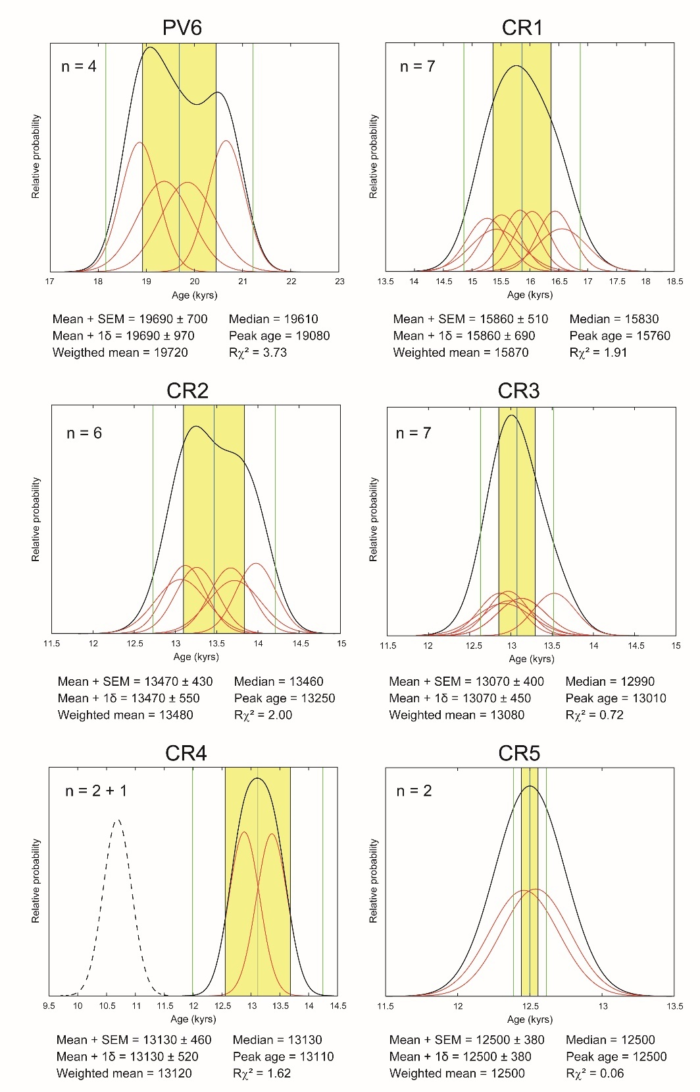

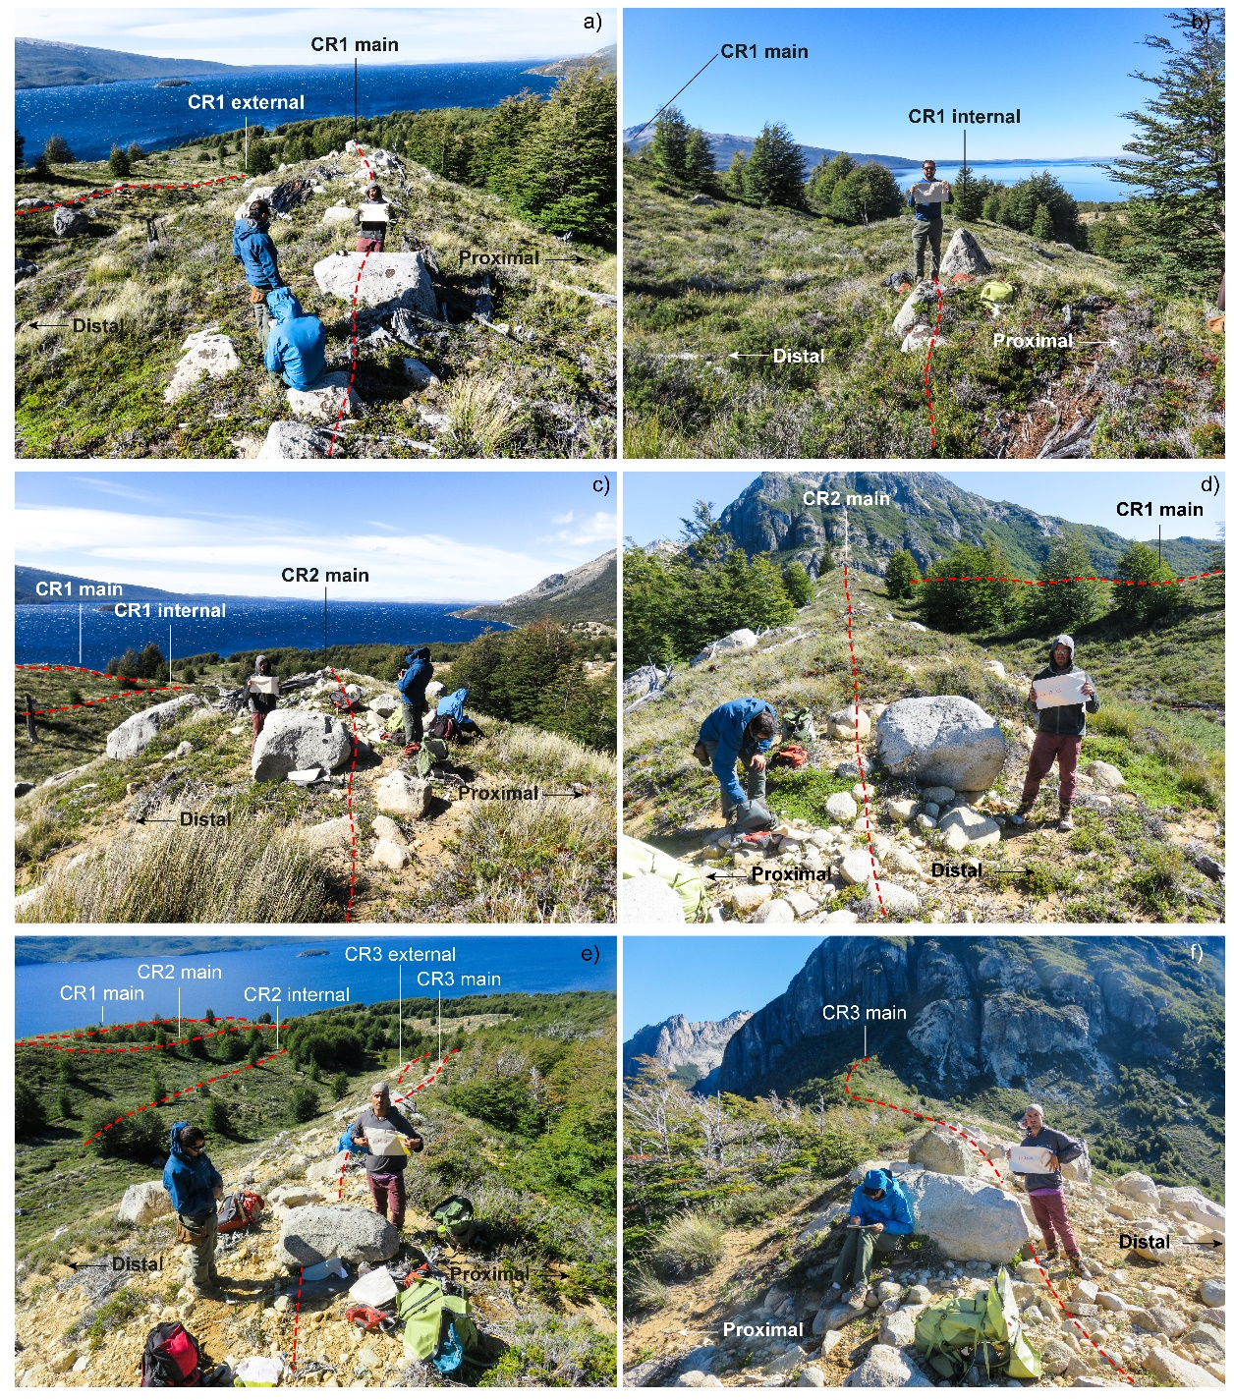
Figure 2s. Overview of the main moraine complexes in the Cerro Riñón valley and examples of boulders sampled for surface exposure dating. a) and b) The CR1 moraine complex; c) and d) The CR2 moraine complex; e) and f) The CR3 moraine complex.

Figure 3s: Globaly distributed glacier chronologies spanning T1. Circles correspond to mean moraine ¹⁰Be ages accompanied by ±1σ range. Squares denote ¹⁰Be ages from erratics and bedrock outcrops (±1σ ). Triangles are bracketing radiocarbon ages with 2σ calibrated uncertainty. a) Glacier fluctuations in Patagonia [*this study,14,21,22,23,24,25,26]. b) Glacier fluctuations in the Southern Alps of New Zealand [28,29,30,31]. c) Glacier fluctuations in high latitudes of the Northern Hemisphere including Artic Norway [5], Alaska [6], Highland Scotland [7] and south Greenland [44,46]. d) Glacier fluctuations in Western United States [43,45]. e) Glacier fluctuations in the European Alps [40,41,42,47,48,49,50,51]. f) CO₂ record from WAIS ice core [38]. Blue bars highlight cold/wet interval and yellow bars demote warm/dry periods inferred from palinological analyses.
