

Supplementary information for

Evidence for New Enantiospecific Interaction Force in Chiral Biomolecules

Yael Kapon,⁺¹ Abhijit Saha,⁺² Tal Duanias-Assaf,² Thijs Stuyver,² Amir Ziv,¹ Tzuriel Metzger,¹ Shira Yochelis,¹ Sason Shaik,*² Ron Naaman,*³ Meital Reches,*² and Yossi Paltiel*¹

Correspondence to: paltiel@mail.huji.ac.il

This PDF file includes:

Materials and Methods
Figures S1 to S8

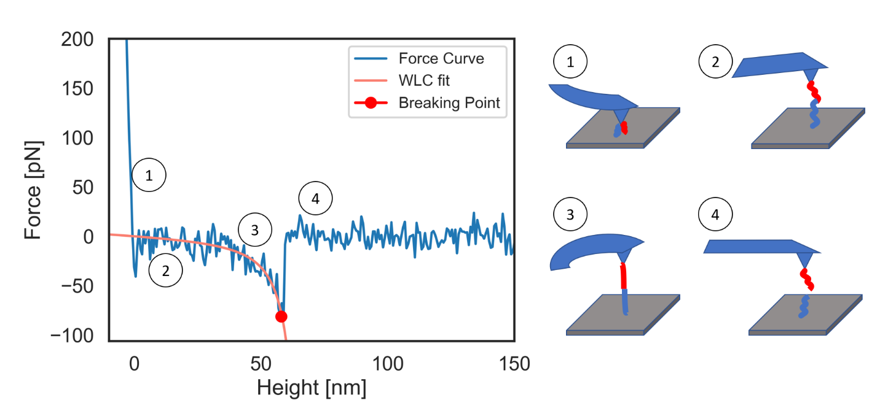
Force curves examples
Figure S1: A force vs. distance curve example. (1) The cantilever is in contact with the sample’s substrate. (2) As the cantilever retracts the helical peptide on the tip captures a molecule from the surface and (3) both molecules stretch and align, this is the pulling event. (4) At the breaking point, the molecules break apart and the cantilever sensed force is back to zero.
To extract the pulling force a worm like chain (WLC) extension model is fitted to the relevant pulling event. The breaking point is the point in which the curve diverts from the WLC model. The pulling force is the force at the breaking point.
The pulling energy is extracted by integrating the force curve from the breaking point to the point in which the force is back to zero.

Energy analysis

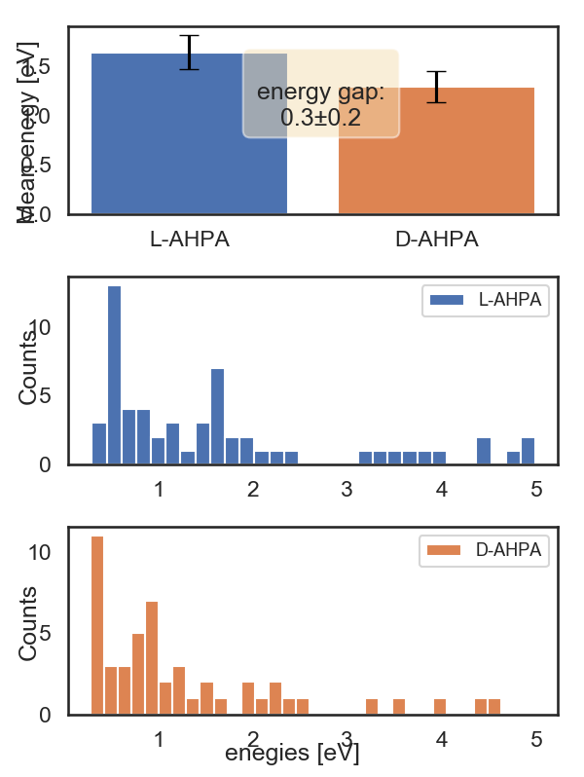

Figure S2: Energy analysis of L to L interaction (blue) of AHPA and D to L AHPA interaction (orange). The energy of a single pulling event is retrieved by integrating over the force curve from the rupture point to the end of the pulling event. The energy attributed to a sample is the mean energy of all the pulling events in that sample.
Top: the mean energy for L-L and D-L interaction of AHPA. The energy gap between same and opposite enantiomers' interaction is $0.3±0.2 eV$.Bottom: the energies’ distributions.

Statistical comparison of the MPF presented in the paper
A one-way analysis of variance test (ANOVA) was used to determine whether the four samples measured and presented in Figure 1 (L&L, D&L, non-chiral molecule &L, gold substrate &L) had a significant statistical difference.
The one-way ANOVA test gave a p-value of 0.0001, which means there was a significant difference between the four samples. Next, a Tukey test was preformed to determine whether there was a difference between each pair of the four samples. The results are presented in Supplementary table S3.
The results of this test show a clear difference between samples L and D (homo vs. heterochiral interactions) and between samples L and N (homochiral vs. non-chiral interactions). It seems sample G (gold substrate) has too little data for this test. The similarities between D and N can be explained by the suppression of the exchange interaction.

Multiple Comparison of Means - Tukey HSD, FWER=0.05
group1 | group2 | mean diff | adj | lower | upper | reject
D | G | 0.0 | 0.7382 | -0.0 | 0.0 | False
D | L | 0.0 | 0.0067 | 0.0 | 0.0 | True
D | N | -0.0 | 0.8531 | -0.0 | 0.0 | False
G | L | 0.0 | 0.1826 | -0.0 | 0.0 | False
G | N | -0.0 | 0.2802 | -0.0 | 0.0 | False
L | N | -0.0 | 0.001 | -0.0 | -0.0 | True
\
Table S3: Multiple Comparison of Means - Tukey HSD. Presented are the results of a Tukey test between the following samples (groups): L-AHPA (L), D-AHPA (D), non-chiral peptide (N), clean gold substrate (G). There is a clear statistical difference between samples L and D (homo vs. heterochiral interactions) and between samples L and N (homochiral vs. non-chiral interactions). It seems sample G (gold substrate) has too little data for this test. The similarities between D and N can be explained by the suppression of the exchange interaction.

For the results in Figure 3 (measurements with magnetic field and samples with spacers) a t-test was performed. For the magnetic field results (Figure 3A) the p-value was 0.0021 and for the separated chiral layer (Figure 3B) a p-value of 2.134e-105 was calculated. Both are very good results showing significant difference.
The quality of the fit
This indicates for which data we have good statistic or poor ones. The Gaussian fit was assigned in the article to the red and purple data (spaced monolayers) where the test score was over 95%.
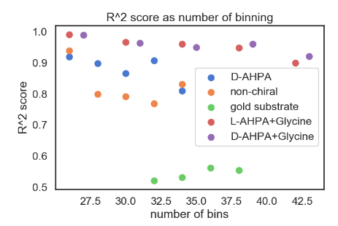
Figure S4: Fit quality for the Gaussian force histograms fit. Presented is $R^{2}$ test vs. number of bins for the sum-of-Gaussian fit of the force histograms.

Interactions under magnetic field
Figure S5 presents single molecule force spectroscopy results under a constant magnetic field.
A reference non-helical peptide (PEG-6-Ahx-K) was synthesized and attached to a gold coated AFM cantilever. The functionalized cantilever was used in Force spectroscopy to measure the interaction force between the reference peptide and a L-AHPA monolayer under a constant magnetic field applied by an external magnet. There is no difference between the mean pulling force (over the margin of error) measured for opposite magnetic field. Since the reference peptide does not create a spin dipole, there is no specific symmetry for the exchange interaction and therefore there is no difference between the magnetizations. This supports the argument that the strength of the interaction is determined by the exchange interaction. 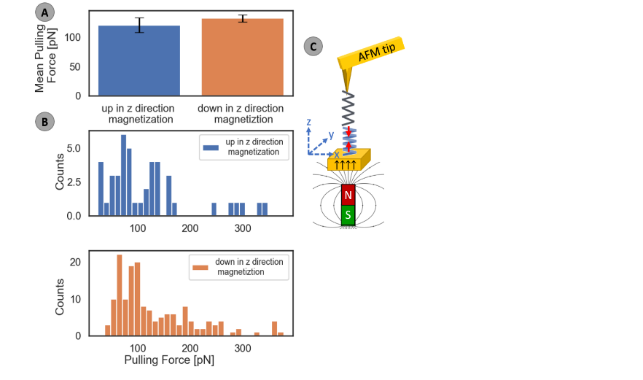
Figure S5: Force spectroscopy results for interactions under magnetic field.
A) Mean pulling force (MPF) between the non-helical reference molecule on the tip and chiral monolayer. No difference is measured between the different magnetization suggesting the spin dependency we presented in Figure 3 is in fact due to exchange interactions between the peptides. B) The force distributions. C) Experimental setup: a reference peptide was used to functionalize gold coated AFM cantilever. Force Spectroscopy probes the interaction between the peptide on the cantilever and a L-AHPA monolayer under a constant magnetic field.
Spaced mono layers
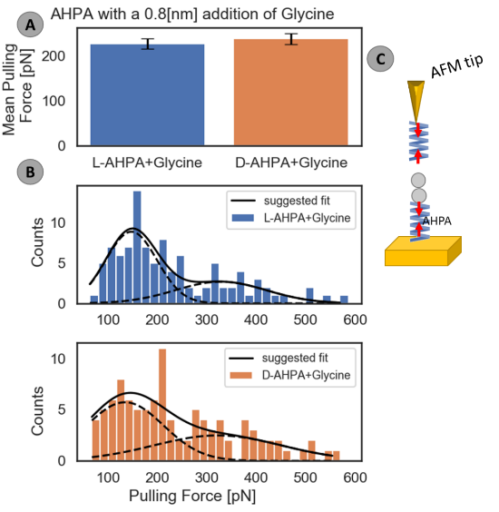
Figure S6: Force spectroscopy results for spaced chiral monolayer. A) Mean pulling force (MPF) between the molecule on the tip (L-AHPA) and the monolayer. In this case (unlike Figure 2.) no difference is measured between the monolayers suggesting the exchange interaction decays due to the additional nonchiral layer. B) The force distributions. The D monolayer matches a single Gaussian fit and the L monolayer has a very small amplitude for the second gaussian suggesting the exchange interaction nearly extinguishes. C) Two glycine layers were added to an adsorbed AHPA monolayer.
The glycine's carboxyl group is facing up. The overall thickness of the non-chiral layer is $8Å$.

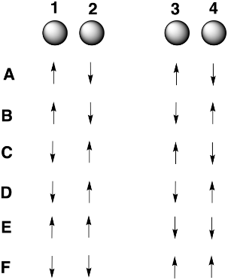
Figure S7: The different (covalent) distributions of 2 alpha and 2 beta electrons in the 4 orbitals making up the model system. Note that we do not consider ionic structures here explicitly.

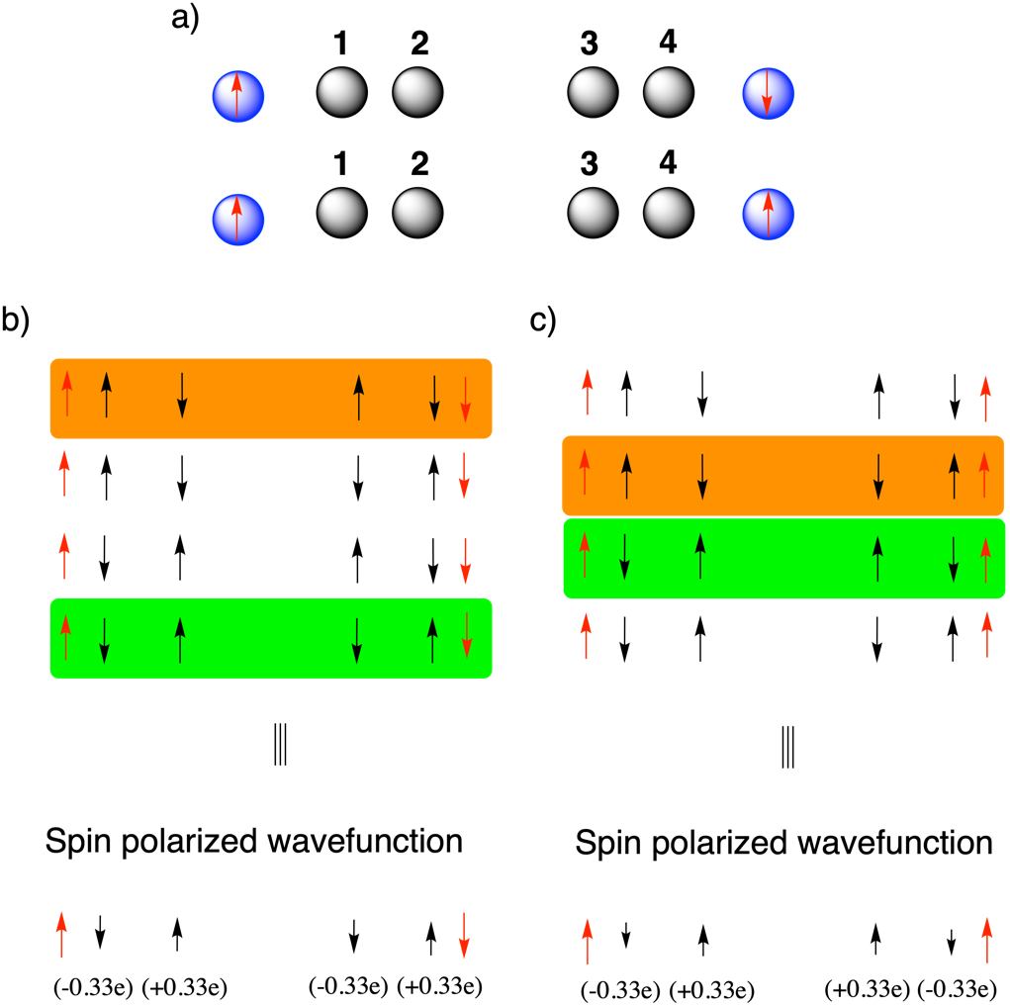

Figure S8: a) The model system with the “spin-polarization sources” included. b) The different covalent determinants contributing to the wave-function in the dissociation limit for opposite spins on the source sites and c) the different determinants for parallel spins on the source sites. The determinants denoted in green are the most favorable under the considered situation; the orange determinants are the least favorable whereas the remaining two determinants remain degenerate. As a result of the increase in the weight of the green determinant in the wavefunction, the overall wavefunction polarizes accordingly (cf. the bottom of panel b and c; the spin densities shown were obtained for a distance of 1Å between the spin-polarization sources and the actual molecules).

