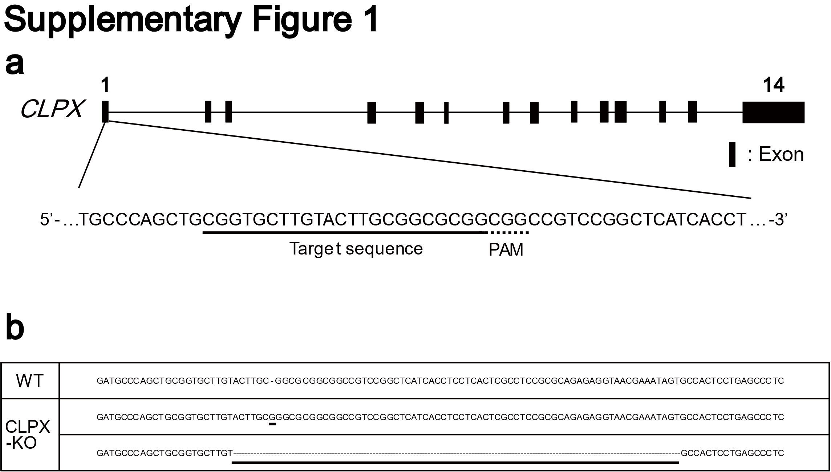
Supplementary Figure 1. Genotyping of CLPX-KO HepG2 cells.
a Schematic presentation of the human CLPX. A portion of exon 1 of CLPX was enlarged to indicate the Cas9 target sequence and the protospacer adjacent motif (PAM). The underlined and dotted underlined sequences indicate the Cas9 target sequence and PAM, respectively. b DNA sequences of mutant clones. Insertion of guanine (NC_000015.10:g.65185126_65185127insC (NM_006660.5:c.216_217 insG)) or 71 base pairs of deletion (NC_000015.10:g.65185062_65185132del) are indicated by bold underlining. The hyphens in the sequences of the mutant clones indicate the deleted sequences.

Supplementary Methods
For the genotyping of CLPX-KO cells, the locus targeted by Cas9 in CLPX-KO cells was amplified by PCR (KOD -Multi & Epi-, TOYOBO), and the PCR products were ligated with pGEM-T Easy vector (Promega). The ligation mixture was used to transform E. coli, and the independent colonies were picked up for the colony PCR. The colony PCR products were used as a template for the Sanger sequencing reaction, and the sequence was determined by an ABI3500 Genetic analyzer (Applied Biosystems, Waltham, MA). The sequences of the primer set for PCR were as follows: 5’-GTGAACTCTCCACGGGGTCTA-3’ and 5’-ACAGGAGCATTTTGTGCCTTTC-3’. For the colony PCR and Sanger sequencing reaction, T7 (5’-TAATACGACTCACTATAGGG-3’) and SP6 (5’-ATTTAGGTGACACTATAGAA-3’) primers were used. PCR products were purified using the Monarch DNA Gel Extraction Kit (New England Biolabs, Ipswich, MA).

