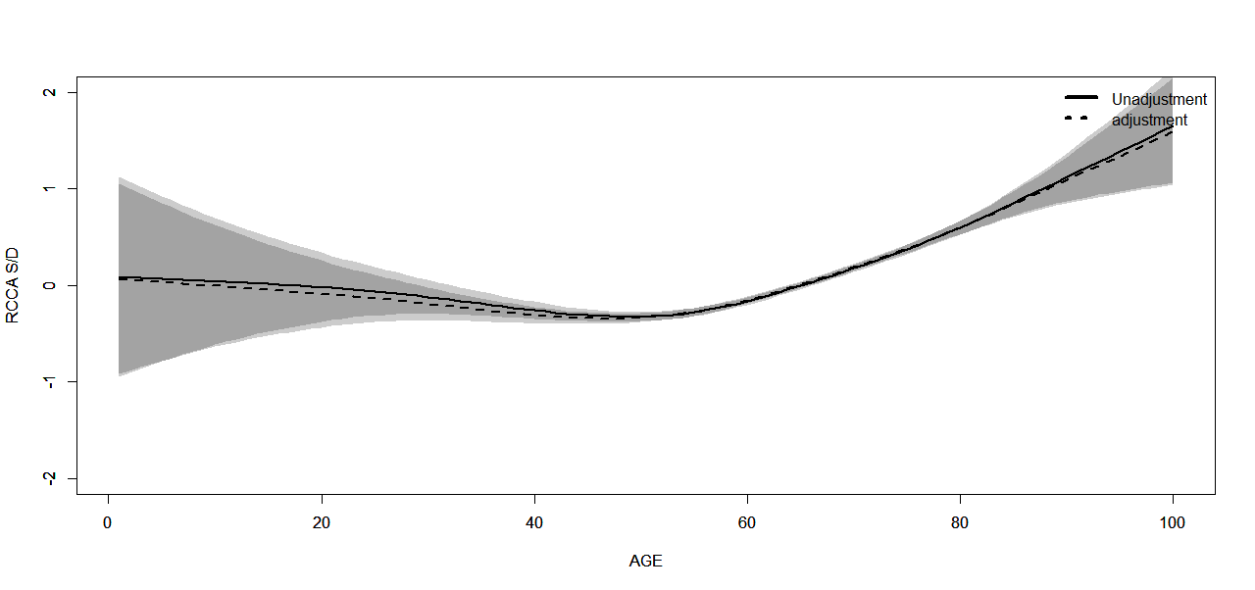
Supplementary 1 Generalized smoothing splines for RCCA S/D and AGE. Horizontal coordinates represent diferent ages, while vertical coordinates represent residuals of RCCA S/D. Solid line: no adjustment; dashed line: adjusted for gander, BMI, CHD, HBP, diabetes mellitus, dyslipidemia, smoking and alcohol. Shaded area shows the 95% confdence interval.
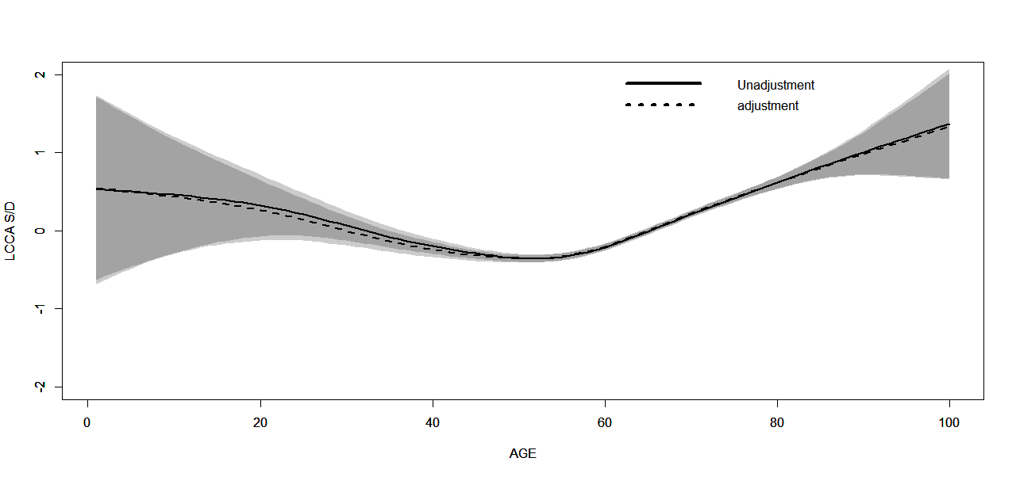
Supplementary 2 Generalized smoothing splines for LCCA S/D and AGE. Horizontal coordinates represent diferent ages, while vertical coordinates represent residuals of LCCA S/D. Solid line: no adjustment; dashed line: adjusted for gander, BMI, CHD, HBP, diabetes mellitus, dyslipidemia, smoking and alcohol. Shaded area shows the 95% confdence interval.
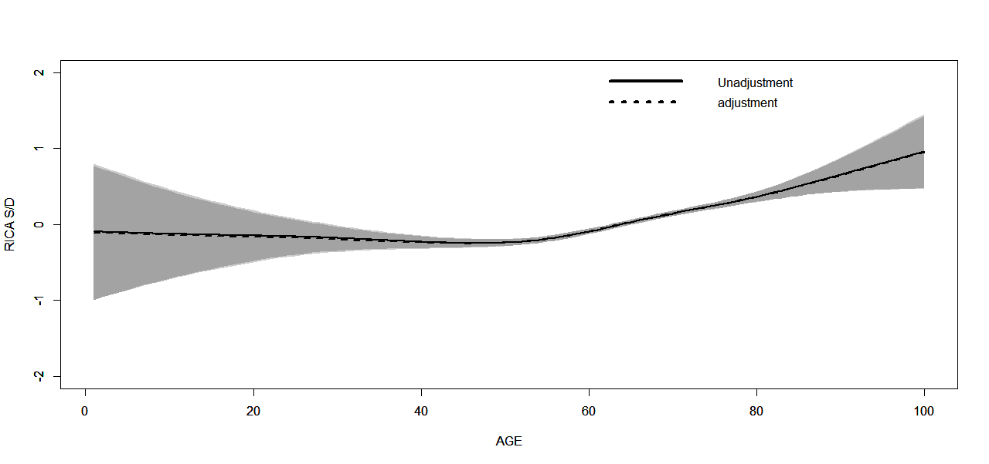
Supplementary 3 Generalized smoothing splines for RICA S/D and AGE. Horizontal coordinates represent diferent ages, while vertical coordinates represent residuals of RICA S/D. Solid line: no adjustment; dashed line: adjusted for gander, BMI, CHD, HBP, diabetes mellitus, dyslipidemia, smoking and alcohol. Shaded area shows the 95% confdence interval.

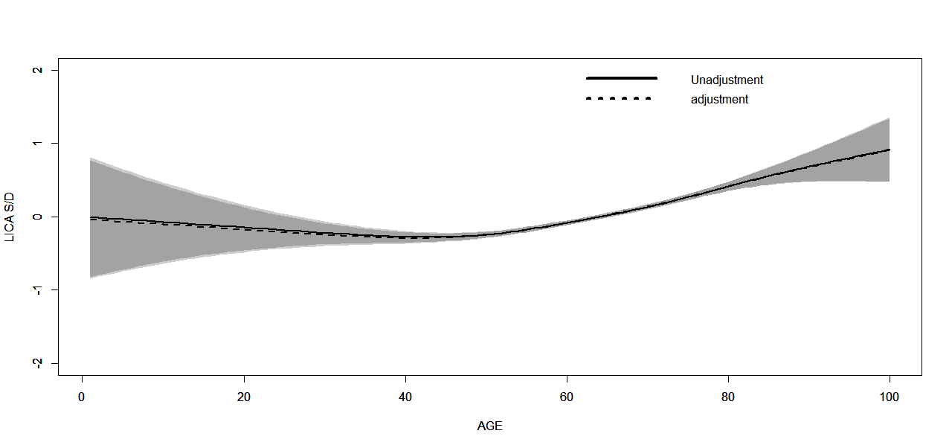
Supplementary 4 Generalized smoothing splines for LICA S/D and AGE. Horizontal coordinates represent diferent ages, while vertical coordinates represent residuals of LICA S/D. Solid line: no adjustment; dashed line: adjusted for gander, BMI, CHD, HBP, diabetes mellitus, dyslipidemia, smoking and alcohol. Shaded area shows the 95% confdence interval.

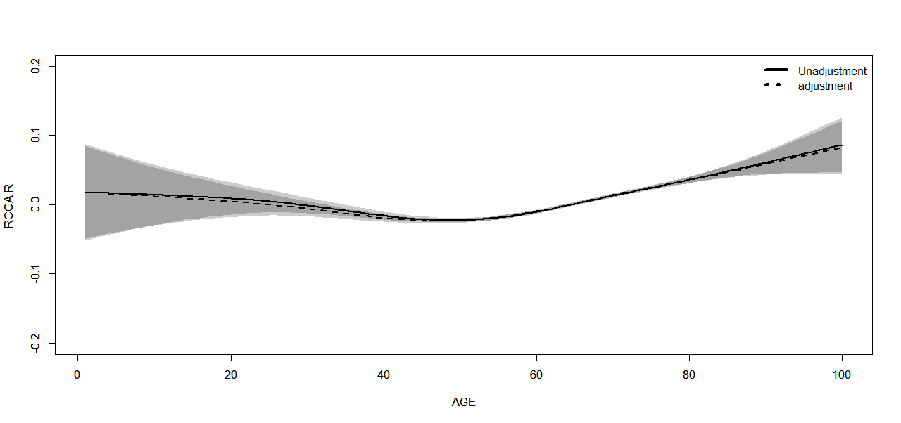
Supplementary 5 Generalized smoothing splines for RCCA RI and AGE. Horizontal coordinates represent diferent ages, while vertical coordinates represent residuals of RCCA RI. Solid line: no adjustment; dashed line: adjusted for gander, BMI, CHD, HBP, diabetes mellitus, dyslipidemia, smoking and alcohol. Shaded area shows the 95% confdence interval.

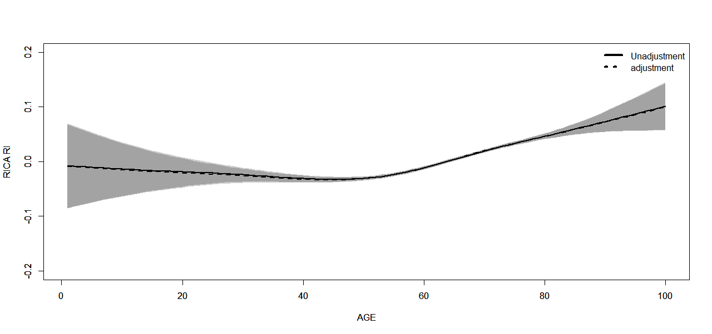
Supplementary 6 Generalized smoothing splines for RICA RI and AGE. Horizontal coordinates represent diferent ages, while vertical coordinates represent residuals of RICA RI. Solid line: no adjustment; dashed line: adjusted for gander, BMI, CHD, HBP, diabetes mellitus, dyslipidemia, smoking and alcohol. Shaded area shows the 95% confdence interval.

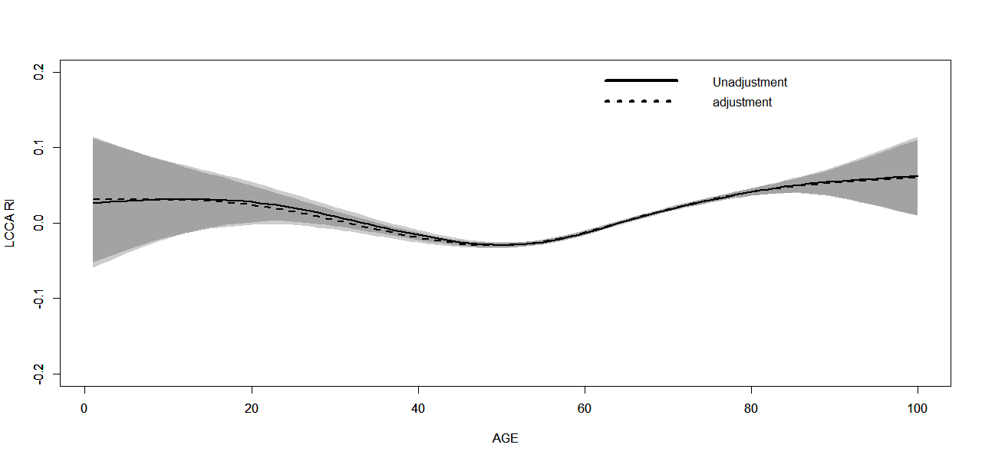
Supplementary 7 Generalized smoothing splines for LCCA RI and AGE. Horizontal coordinates represent diferent ages, while vertical coordinates represent residuals of LCCA RI. Solid line: no adjustment; dashed line: adjusted for gander, BMI, CHD, HBP, diabetes mellitus, dyslipidemia, smoking and alcohol. Shaded area shows the 95% confdence interval.

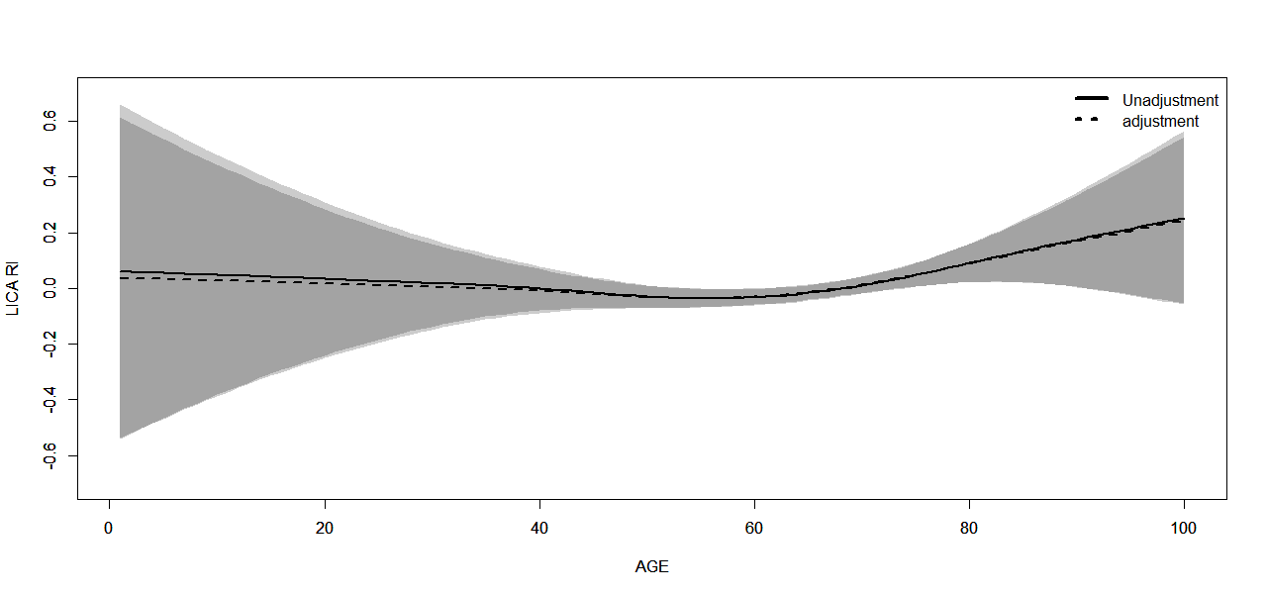
Supplementary 8 Generalized smoothing splines for LICA RI and AGE. Horizontal coordinates represent diferent ages, while vertical coordinates represent residuals of LICA RI. Solid line: no adjustment; dashed line: adjusted for gander, BMI, CHD, HBP, diabetes mellitus, dyslipidemia, smoking and alcohol. Shaded area shows the 95% confdence interval.

