Supporting Information

Advanced Cu-free Bipolar Solid-state Lithium-ion Battery Promoted by Li⁺ Conductive Matrix Enabled Excellent Iron Oxide Anode

Wujie Dong,¹ Yantao Zhao,² Mingzhi Cai,² Chenlong Dong,² Wenqin Ma,¹ Jun Pan,¹ Zhuoran Lv, ¹ Hang Dong, ¹ Yufeng Tang¹*, Fuqiang Huang¹*

¹State Key Laboratory of High Performance Ceramics and Superfine Microstructure, Shanghai Institute of Ceramics, Chinese Academy of Sciences, Shanghai 200050, P. R. China
²State Key Laboratory of Rare Earth Materials Chemistry and Applications, College of Chemistry and Molecular Engineering, Peking University, Beijing 100871, P.R. China

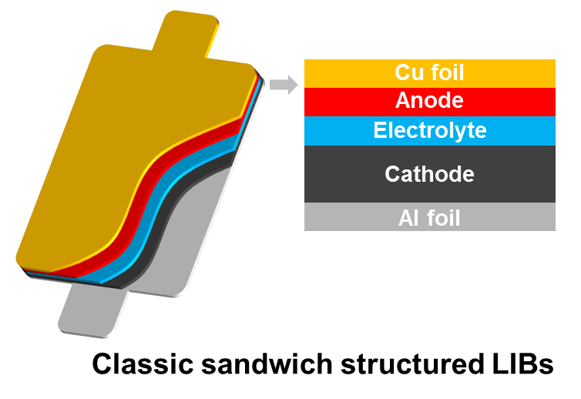
Figure S1. Schematic images of classic LIBs.

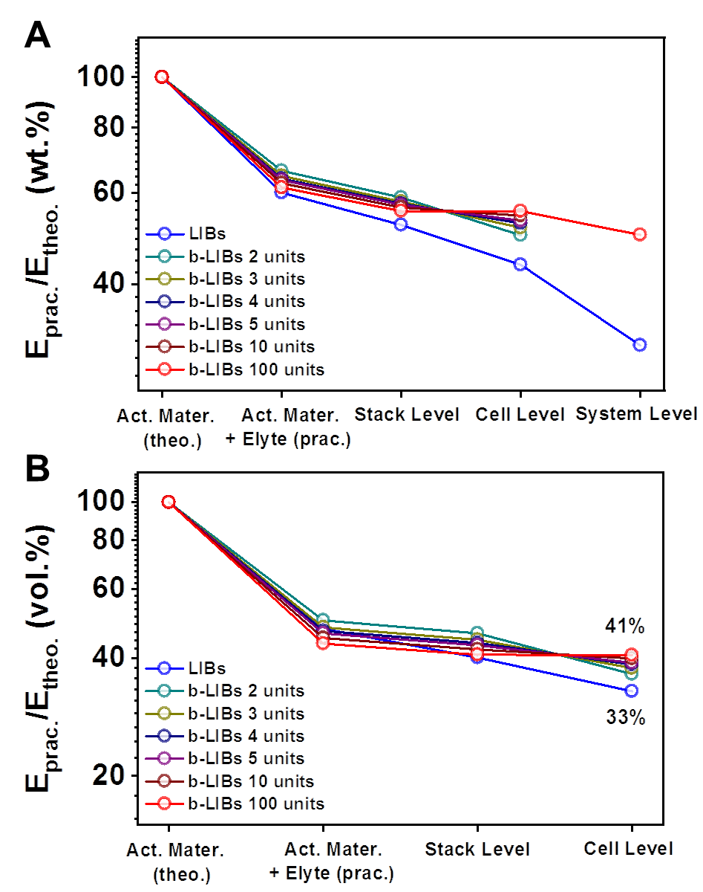

Figure S2. Conversion rate from theoretical (A) gravimetric and (B) volumetric energy density to practical values.

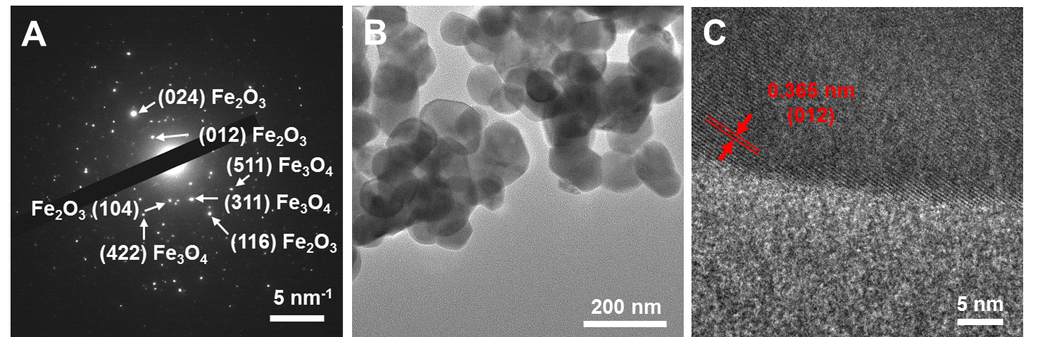
Figure S3. (A) Selected area electron diffraction of FeO_{x}-LFBO sample. (B) TEM and (C) HRTEM images of FeO_{x} sample.

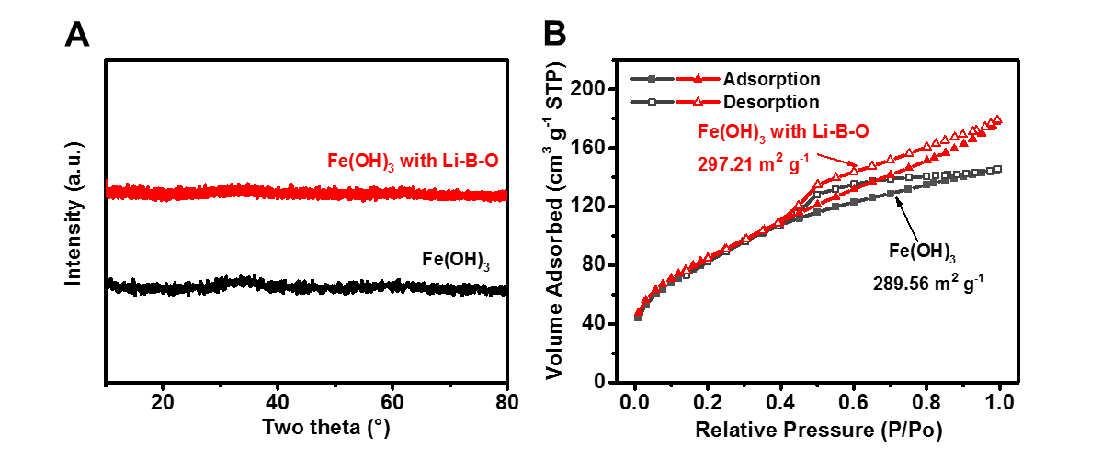
Figure S4. (A) XRD patterns and (B) N₂ adsorption-desorption isotherms of unannealed Fe(OH)₃ and Fe(OH)₃-LFBO.

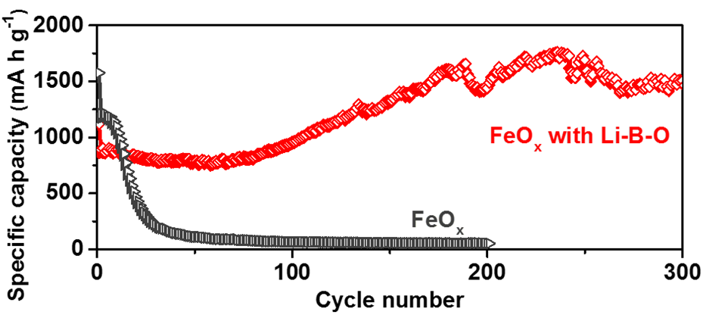
Figure S5. Cycling performance of FeO_{x}-LFBO and bare FeO_{x} at 0.1 A g^{–1}.

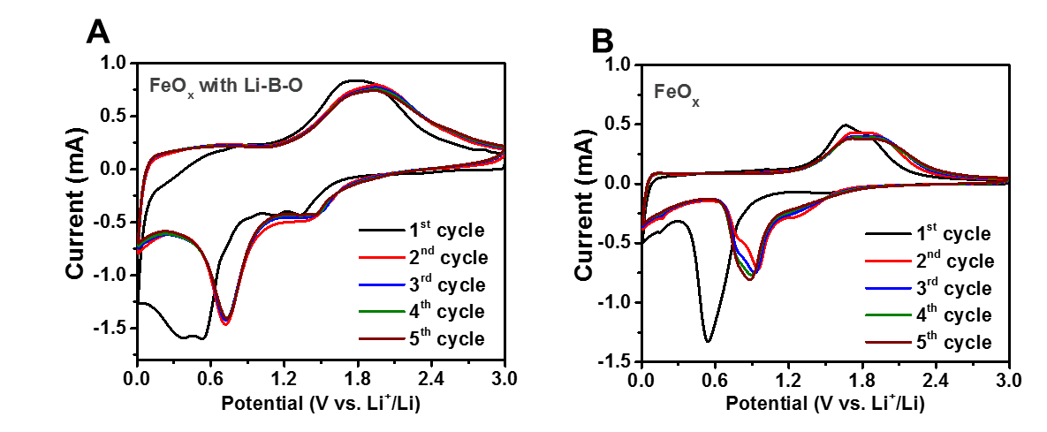
Figure S6. CV curves of (A) FeO_{x}-LFBO and (B) FeO_{x} at 0.3 mV s^{–1}.

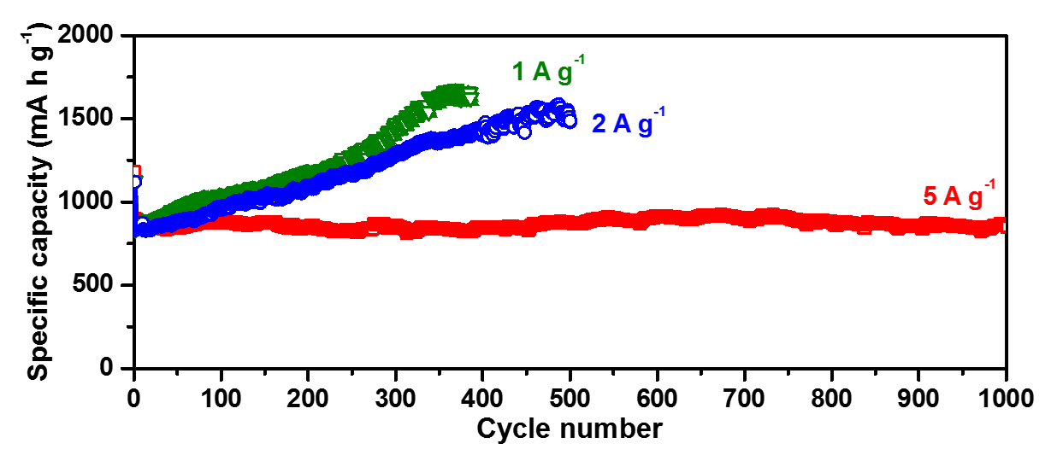
Figure S7. Long-term cycling of FeO_{x}-LFBO at 1 A^{–1} − 10 A^{–1}.

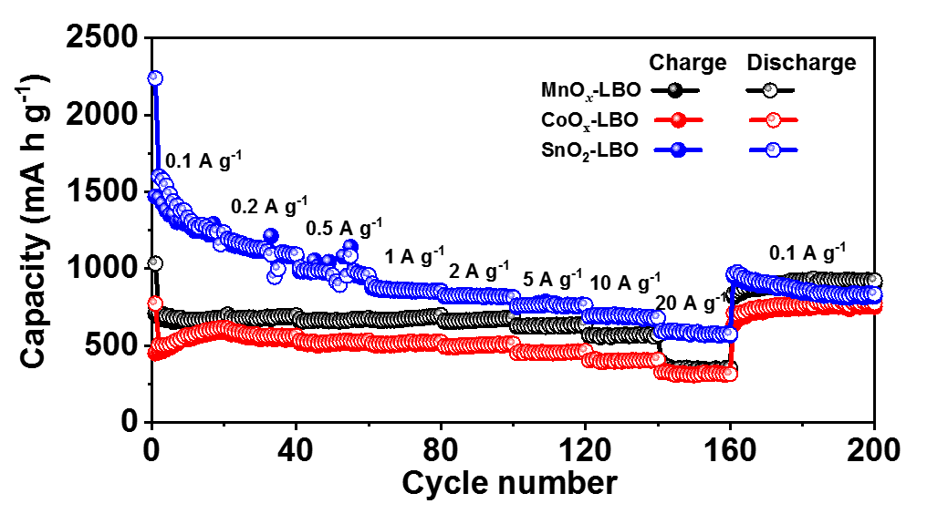
Figure S8. Rate capability of MnO_{x}-LBO, CoO_{x}-LBO, and SnO₂-LBO electrodes at 1 A^{–1} − 20 A^{–1}.

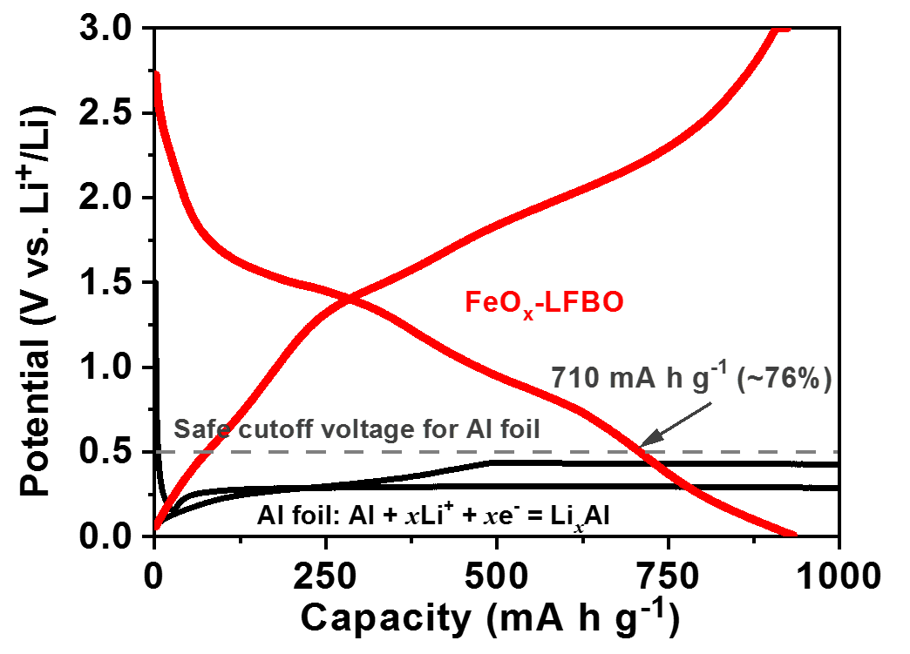
Figure S9. GCD curves of FeO_{x}-LFBO electrode and Al foil.

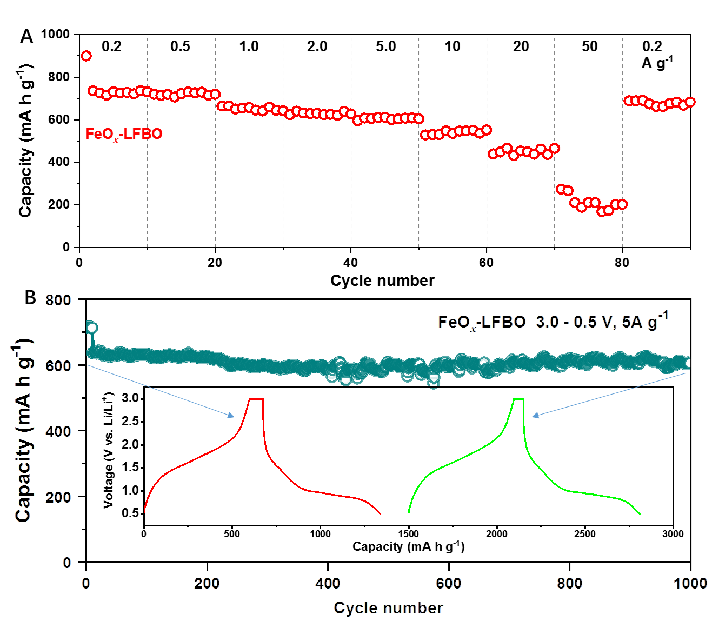

Figure S10. (A) Rate capability of FeO_{x}-LFBO electrode under the voltage range of 3.0 - 0.5 V. (B) Long-term cycling of FeO_{x}-LFBO electrode at 5 A g⁻¹ under the voltage range of 3.0 - 0.5 V. Inset: GCD curves of FeO_{x}-LFBO anodes before and after 1000 cycles.

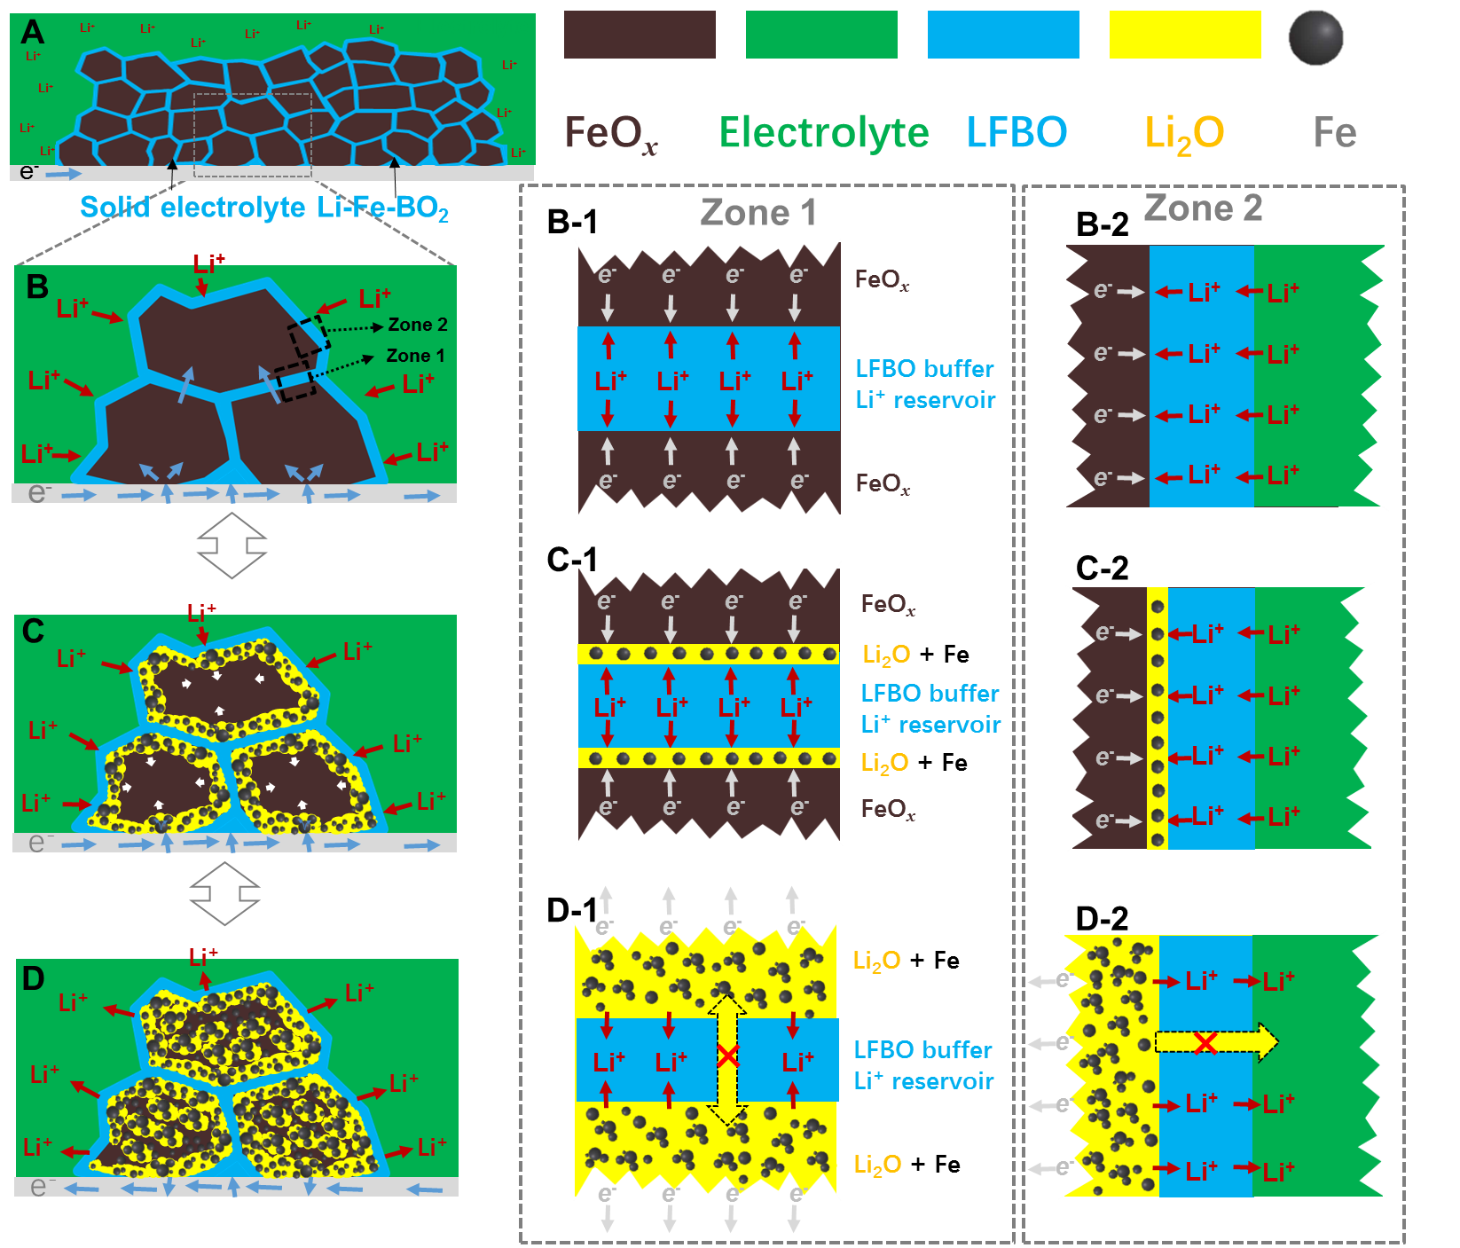
Figure S11. Schematic microstructure evolves during charging/discharging process of FeO_{x}-LFBO anode. (A) The initial electrode and (B) the partial enlarged view of FeO_{x}-LFBO anode; (B-1) and (B-2) are the enlarged interface of FeO_{x}/LFBO/FeO_{x} and FeO_{x}/LFBO/electrolyte; (C) Lithiation reaction begins and form Fe+Li₂O precipitates uniformly, (C-1) and (C-2) are the enlarged interface of FeO_{x}/Fe+Li₂O/LFBO/Fe+Li₂O/FeO_{x} and FeO_{x}/Fe+Li₂O/LFBO/electrolyte; (D) Lithiation reaction completes in the whole FeO_{x}-LFBO electrode to form isolated small Fe+Li₂O precipitates in LFBO matrix, (D-1) and (D-2) are the enlarged interface of Fe+Li₂O/LFBO/Fe+Li₂O and Fe+Li₂O/LFBO/electrolyte.

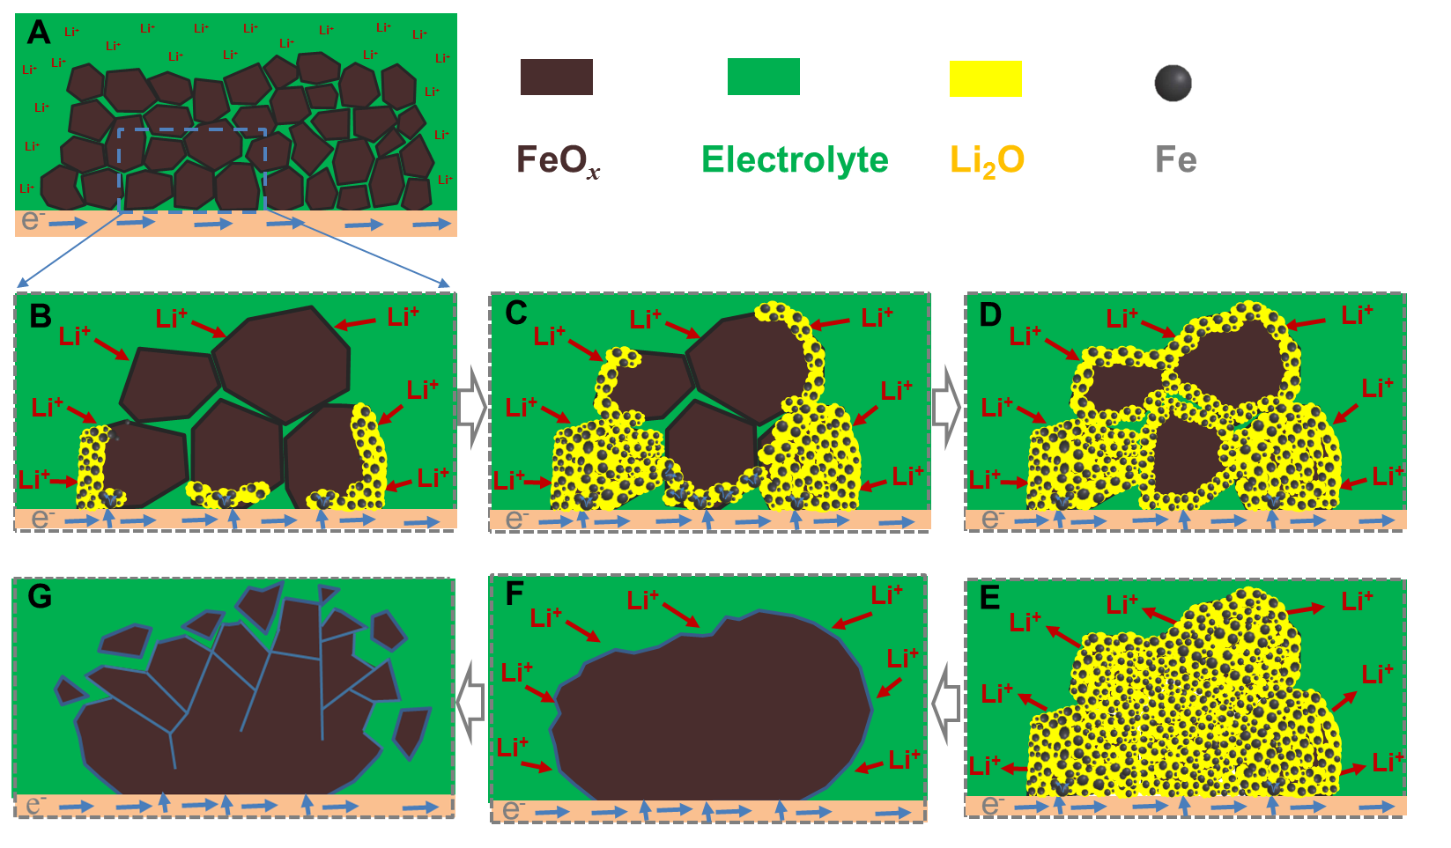
Figure S12. Schematic microstructure evolves during charging/discharging process of common FeO_{x} anode. (A) The initial FeO_{x} electrode; (B) The partial enlarged view of FeO_{x} electrode when lithiation reaction begin and form Fe + Li₂O precipitates; (C-D) Lithiation reaction completes in the initial FeO_{x} particles and extends to neighboring particles; (E) Lithiation reaction completes in the whole FeO_{x} electrode to form aggregated Fe + Li₂O precipitates, when delithiation reaction starts; (F) Delithiation reaction completes to form a much bigger aggregated FeO_{x} particle; (G) Huge FeO_{x} particle cracks into fragments after some cycles.

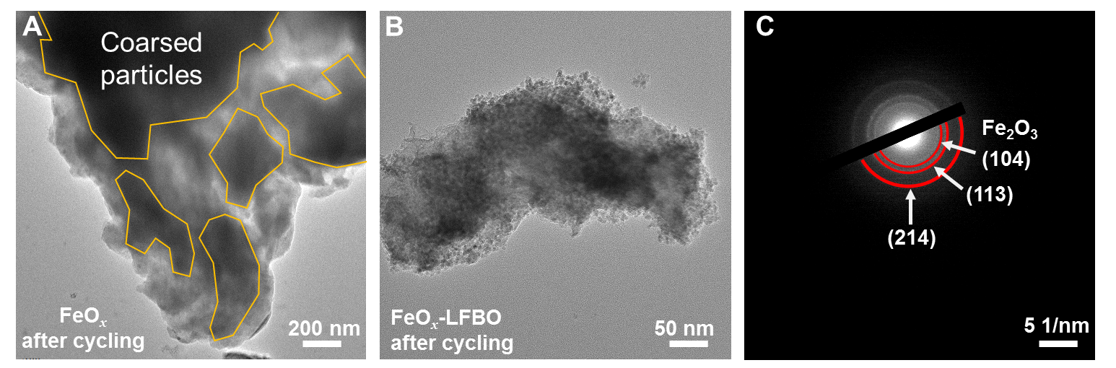
Figure S13. TEM images of (A) FeO_{x} after 100 cycles and (B) FeO_{x}-LFBO electrodes after 500 cycles at 2 A g⁻¹.

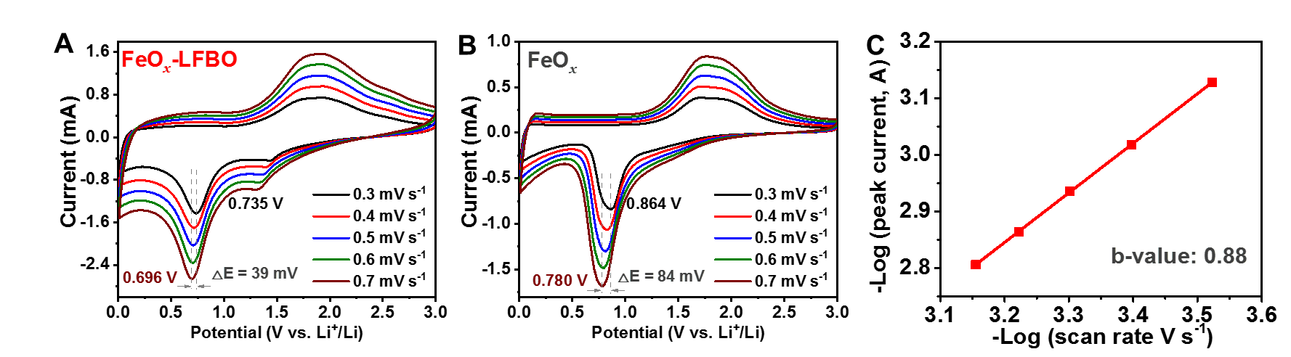
Figure S14. CV curves of (A) FeO_{x}-LFBO and (B) FeO_{x} electrodes at the scan rate spanning over 0.3 - 0.7 mV s⁻¹. (C) Logarithmic relationship between the peak current and scan rates of FeO_{x}-LFBO, the red line is obtained by linear fitting with the shope (b-value) of 0.88.

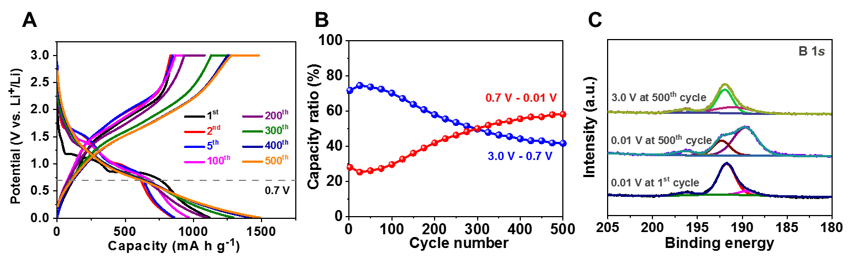
Figure S15. (A) GDC curves FeO_{x}-LFBO electrode after different cycles at 2 A g⁻¹, and (B) the relevent capacity contribution vs. cycle number in different votage ranges of 3.0 - 0.7 V and 0.7 - 0.01 V. (C) Ex-situ B 1s XPS spectrums of FeO_{x}-LFBO electrodes after first discharge to 0.01 V and 0.01 V/3.0 V at 500th cycle.

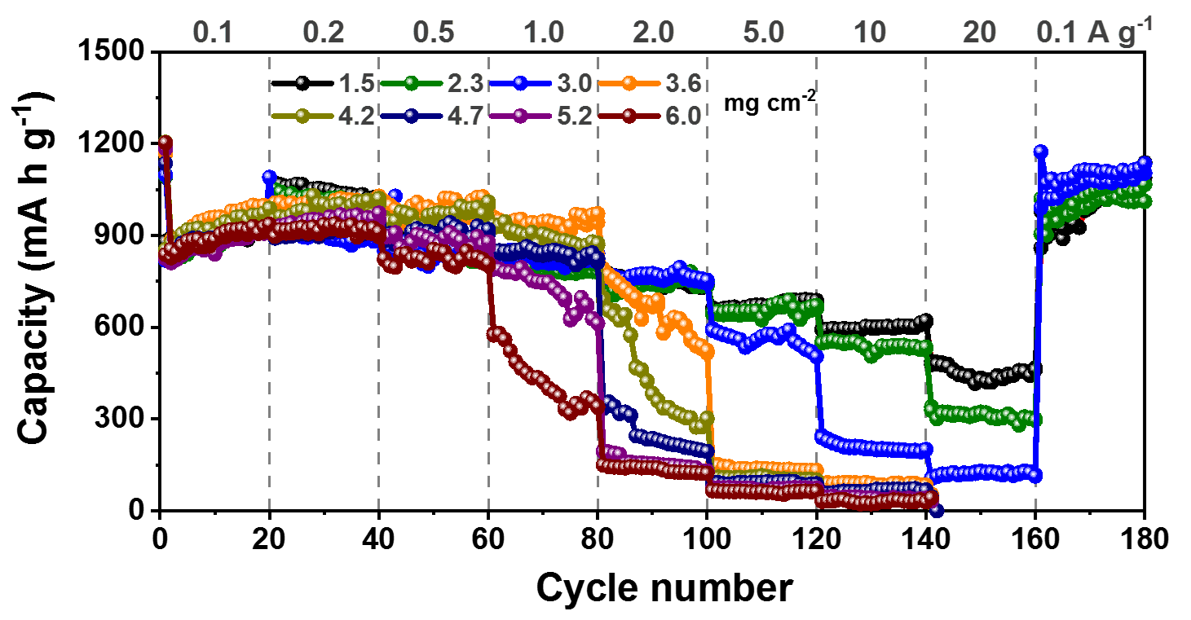
Figure S16. Rate capabilities of FeO_{x}-LFBO electrodes with different loading mass spanning over 1.5 – 6 mg cm⁻² at the current density of 0.1 – 20 A g⁻¹.

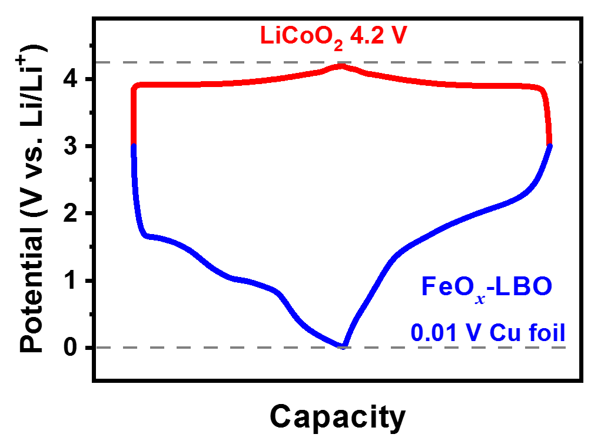
Figure S17. Theoretical GDC curves of perfectly matched LiCoO₂ cathode (red line, 3.0 – 4.2 V) and FeO_{x}-LFBO (blue line, 3.0 – 0.01 V).

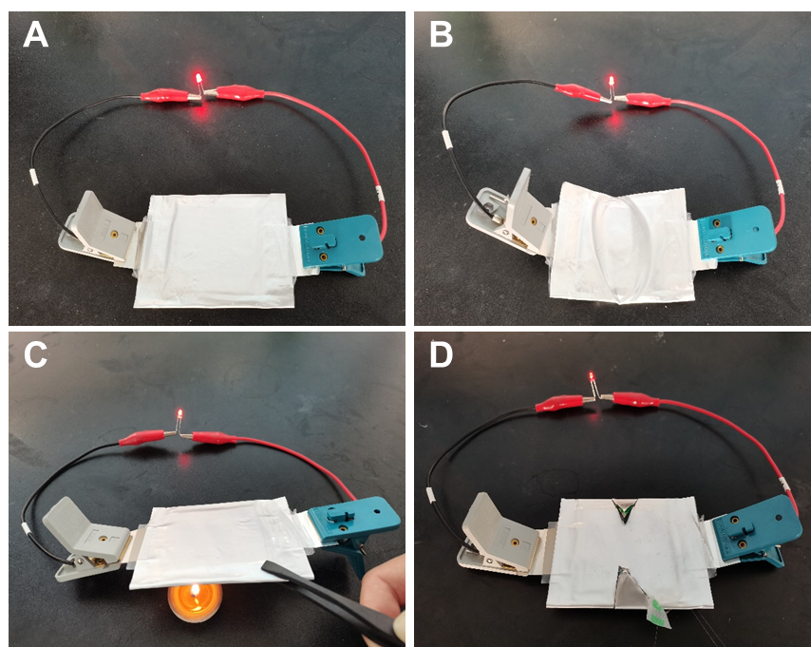
Figure S18. The digital image of pouch-type bipolar solid-state cell, which can light a red LED bulbs at (A) normal, (B) bended, (C) heated, and (D) cut conditions.

