Additional file 1
Discovering hair biomarkers of Alzheimer’s disease using high resolution mass spectrometry-based untargeted metabolomics
Chih-Wei Chang ¹, Shih-Wen Li ¹, Pi-Shan Sung ², Ru-Hsueh Wang ³, Chih-Hsing Wu ³, Yuan-Chi Chen ¹, Pao-Chi Liao ^{1, 4,} *

- Department of Environmental and Occupational Health, College of Medicine, National Cheng Kung University, Tainan, Taiwan
- Department of Neurology, National Cheng Kung University Hospital, College of Medicine, National Cheng Kung University, Tainan, Taiwan
- Department of Family Medicine, National Cheng Kung University Hospital, College of Medicine, National Cheng Kung University, Tainan, Taiwan
- Department of Food Safety/Hygiene and Risk Management, College of Medicine, National Cheng Kung University, Tainan, Taiwan

*Corresponding author:
Dr. Pao-Chi Liao
Department of Environmental and Occupational Health, College of Medicine, National Cheng Kung University, 138 Sheng-Li Road, Tainan, 704, Taiwan,
Tel: 886-6-2353535 ext 5566
Fax: 886-6-2752484
Email: liaopc@mail.ncku.edu.tw
2 supplementary figures and 2 supplementary table

Figure S1. Quality control (QC) of the analytical method. (A) RSD distribution of all the detected peak features in the QC samples. Red line represents the 85% of all detected peaks. (B) RSD distribution in the QC sample of the discriminatory peak features between AD and controls. Red line represents 90% of the discriminatory peak features.

Figure S2. Correlations between normalize abundance of 10 metabolites and MoCA score. (A) acetyl-L-carnitine, (B) propionylcarnitine, (C) butyrylcarnitine, (D) O-valeroyl-L-carnitine, (E) 6-O-methylnorlaudanosoline, (F) PC (16:0/0:0), (G) LPC 18:1, (H) pyridoxal, (I) hydroxyprolyl-leucine, and (J) piperine.

Table S1. The 72 discriminatory peak features analyzed by fold change and Student's t test.

Table S2 Chemical structures annotated by MS-FINDER and MoNA within MS-DIAL.

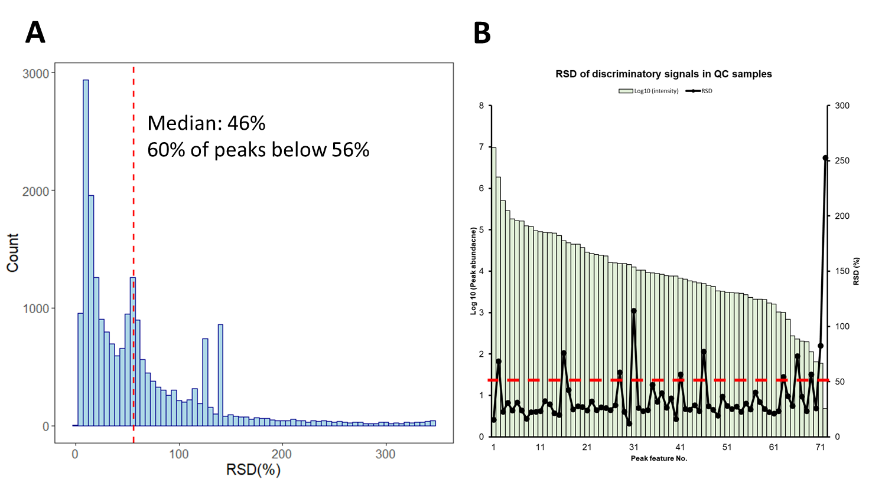
Figure S1. Quality control (QC) of the analytical method. (A) RSD distribution of all the detected peak features in the QC samples. A calculated median RSD of 46% while 60% of the total detected peaks had RSD values below 56% during the measurement. (B) The 61 discriminatory peak features had RSD values below 50%, suggesting that they were subjected to tandem mass spectrometry (MS/MS) analysis for chemical structure identification.
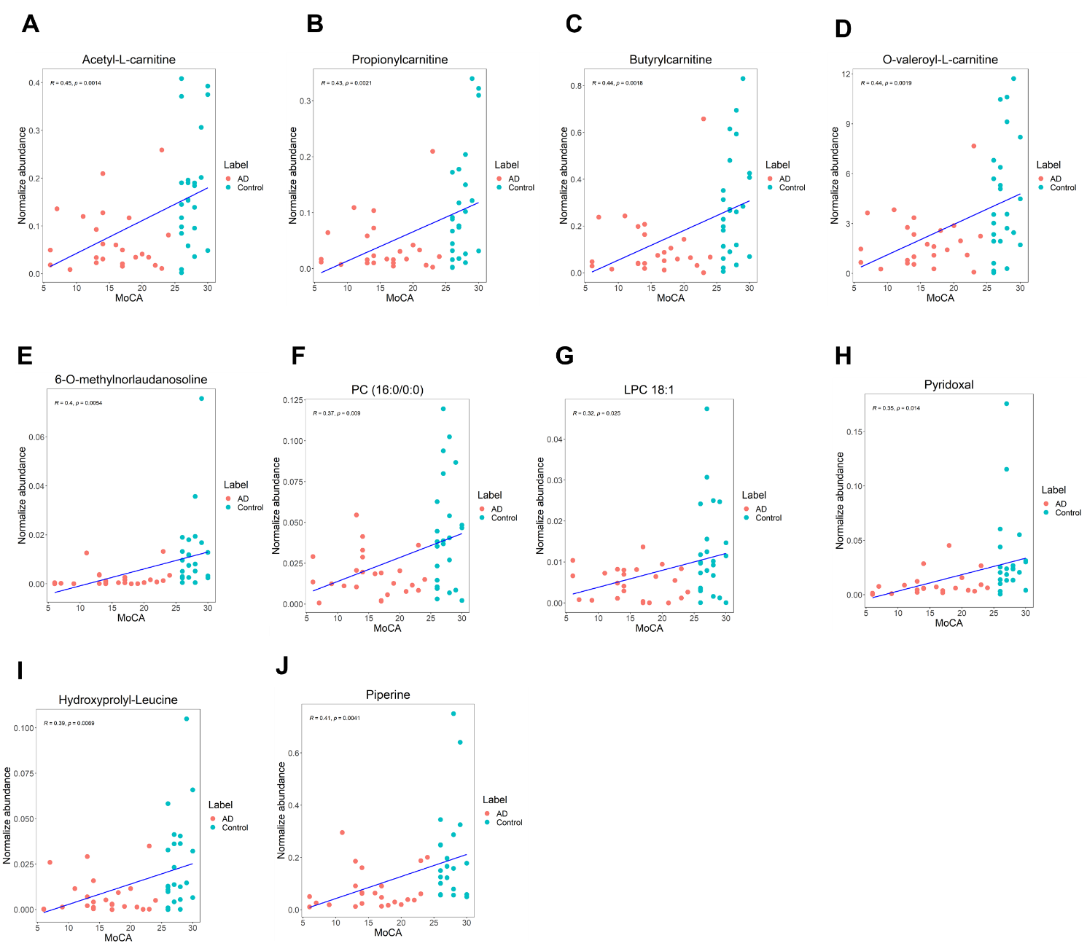
Figure S2. Correlations between normalize abundance of 10 metabolites and MoCA score. (A) acetyl-L-carnitine, (B) propionylcarnitine, (C) butyrylcarnitine, (D) O-valeroyl-L-carnitine, (E) 6-O-methylnorlaudanosoline, (F) PC (16:0/0:0), (G) LPC 18:1, (H) pyridoxal, (I) hydroxyprolyl-leucine, and (J) piperine.

Table S1. The 72 discriminatory peak features analyzed by fold change and Student's t test.
Peak No. | Retention time (min) | m/z | AD / Control | P
#01 | 0.81 | 134.0762 | 0.49 | 0.0091
#02 | 7.89 | 145.0647 | 12.46 | 0.0095
#03 | 0.84 | 149.5973 | 0.38 | 0.0050
#04 | 1.74 | 150.0549 | 0.28 | 0.0077
#05 | 1.25 | 198.037 | 0.47 | 0.0039
#06 | 4.68 | 199.0865 | 0.48 | 0.0010
#07 | 0.98 | 204.1228 | 0.40 | 0.0005
#08 | 4.43 | 213.1231 | 0.33 | 0.0084
#09 | 1.90 | 218.1384 | 0.35 | 0.0035
#10 | 1.08 | 218.1385 | 0.30 | 0.0028
#11 | 2.52 | 229.1178 | 0.31 | 0.0036
#12 | 4.47 | 232.1541 | 0.38 | 0.0019
#13 | 4.43 | 235.1072 | 0.30 | 0.0089
#14 | 9.63 | 240.1955 | 0.24 | 0.0058
#15 | 1.04 | 245.1493 | 0.30 | 0.0041
#16 | 5.12 | 246.1593 | 0.42 | 0.0077
#17 | 5.11 | 246.1696 | 0.43 | 0.0019
#18 | 1.57 | 247.1284 | 0.46 | 0.0093
#19 | 7.89 | 247.1437 | 16.98 | 0.0100
#20 | 5.11 | 248.1749 | 0.41 | 0.0020
#21 | 8.71 | 261.1458 | 0.34 | 0.0031
#22 | 4.07 | 267.0953 | 0.40 | 0.0080
#23 | 6.39 | 268.1151 | 6.75 | 0.0097
#24 | 8.44 | 272.1276 | 0.26 | 0.0010
#25 | 1.26 | 272.1963 | 0.44 | 0.0069
#26 | 4.50 | 274.1756 | 0.41 | 0.0094
#27 | 5.07 | 276.1589 | 7.19 | 0.0074
#28 | 2.32 | 281.1126 | 4.75 | 0.0051
#29 | 8.93 | 286.1431 | 0.35 | 0.0020
#30 | 9.06 | 286.1431 | 0.37 | 0.0020
#31 | 9.14 | 286.1431 | 0.34 | 0.0018
#32 | 5.71 | 288.1590 | 10.12 | 0.0021
#33 | 5.56 | 290.1745 | 179.00 | 0.0030
#34 | 5.56 | 292.1807 | 10.67 | 0.0075
#35 | 7.15 | 302.1379 | 0.17 | 0.0042
#36 | 7.28 | 302.1379 | 0.21 | 0.0044
#37 | 7.28 | 303.1415 | 0.10 | 0.0059
#38 | 6.24 | 304.1538 | 6.47 | 0.0087
#39 | 9.77 | 312.1586 | 0.26 | 0.0093
#40 | 6.25 | 327.1368 | 6.48 | 0.0099
#41 | 10.90 | 329.2467 | 0.39 | 0.0082
#42 | 4.98 | 344.1233 | 4.86 | 0.0070
#43 | 6.68 | 353.2216 | 0.39 | 0.0000
#44 | 7.34 | 364.2262 | 18.06 | 0.0097
#45 | 6.69 | 365.1974 | 11.61 | 0.0046
#46 | 6.21 | 366.2056 | 77.20 | 0.0065
#47 | 11.21 | 366.2994 | 0.39 | 0.0010
#48 | 9.04 | 367.2374 | 0.45 | 0.0011
#49 | 6.61 | 378.2056 | 17.77 | 0.0054
#50 | 6.69 | 379.9793 | 87.88 | 0.0047
#51 | 6.42 | 380.2211 | 24.93 | 0.0074
#52 | 6.69 | 380.2211 | 58.60 | 0.0030
#53 | 5.69 | 382.2005 | 18.49 | 0.0065
#54 | 5.95 | 382.2005 | 17.46 | 0.0084
#55 | 6.69 | 382.2274 | 69.98 | 0.0032
#56 | 6.51 | 382.2368 | 89.53 | 0.0040
#57 | 9.14 | 385.2473 | 0.35 | 0.0018
#58 | 8.94 | 385.2474 | 0.32 | 0.0005
#59 | 6.13 | 396.2161 | 135.20 | 0.0051
#60 | 6.51 | 396.2162 | 123.54 | 0.0064
#61 | 6.13 | 398.2222 | 17.78 | 0.0082
#62 | 5.56 | 407.2531 | 43.01 | 0.0056
#63 | 6.01 | 412.2109 | 68.92 | 0.0029
#64 | 6.45 | 414.2266 | 94.70 | 0.0069
#65 | 6.18 | 424.2583 | 252.94 | 0.0024
#66 | 8.80 | 481.3044 | 0.34 | 0.0081
#67 | 10.66 | 496.3388 | 0.42 | 0.0013
#68 | 6.70 | 497.2996 | 10.55 | 0.0028
#69 | 10.66 | 497.3419 | 0.38 | 0.0056
#70 | 6.13 | 513.2948 | 664.05 | 0.0044
#71 | 10.92 | 522.3543 | 0.40 | 0.0046
#72 | 6.71 | 795.4117 | 270.16 | 0.0032

Table S2 Chemical structures annotated by MS-FINDER and MoNA within MS-DIAL.
Compound name | Formula | m/z | Retention time (min) | ID method | MS-DIAL match score | MS-FINDER Formula score | MS-FINDER structure score
L-Acetylcarnitine | C9H17NO4 | 204.1228 | 0.98 | MoNA/MS-Finder | 71.8 | 3.66 | 6.21
Hydroxyprolyl-Leucine | C11H20N2O4 | 245.1493 | 1.04 | MS-Finder |  | 3.6
Pyridoxal | C8H9NO3 | 150.0549 | 1.74 | MoNA | 79.3
Propionylcarnitine | C8H17NO4 | 218.1384 | 1.90 | MS-Finder |  | 3.93 | 6.7
Butyryl-carnitine | C11H21NO4 | 232.1541 | 4.47 | MoNA/MS-Finder | 95.6 | 3.55 | 5.91
Valeryl-carnitine | C12H23NO4 | 246.1696 | 5.11 | MoNA/MS-Finder | 90.8 | 3.55 | 5.99
Hyoscyamine | C17H23NO3 | 290.1745 | 5.56 | MoNA/MS-Finder | 81.8 | 3.61 | 6.98
Cyrmenin A | C22H34N2O5 | 407.2531 | 5.56 | MS-Finder |  | 3.42
Galantamine | C17H21NO3 | 288.1590 | 5.71 | MS-Finder |  | 3.54
Sacubitril | C24H29NO5 | 412.2109 | 6.01 | MS-Finder |  | 3.85
 | C24H29NO4 | 396.2161 | 6.13 | MS-Finder |  | 3.7
 | C25H33N3O3 | 424.2583 | 6.18 | MS-Finder |  | 3.02
6-O-Desmethyldonepezil | C23H27NO3 | 366.2056 | 6.21 | MS-Finder |  | 4.05 | 7.18
Scopolamine | C17H21NO4 | 304.1538 | 6.24 | MS-Finder |  | 3.74 | 7.19
 | C24H31NO5 | 414.2266 | 6.45 | MS-Finder |  | 3.77
2-benzoyl-1-(2,5-dimethoxyphenyl)-decahydroisoquinolin-4a-ol | C24H29NO4 | 396.2162 | 6.51 | MS-Finder |  | 3.69
 | C24H27NO3 | 378.2056 | 6.61 | MS-Finder |  | 3.58
 | C21H28NO3 | 365.1974 | 6.69 | MS-Finder |  | 3.23
Donepezil | C24H29NO3 | 380.2211 | 6.69 | MoNA/MS-Finder | 92.1 | 3.83 | 7.25
6-O-methylnorlaudanosoline | C17H19NO4 | 302.1379 | 7.15 | MS-Finder |  | 3.78
 | C24H29NO2 | 364.2262 | 7.34 | MS-Finder |  | 3.26
Lenticin | C14H18N2O2 | 247.1437 | 7.89 | MoNA/MS-Finder | 95.8 | 3.36 | 5.71
Piperine | C17H19NO3 | 286.1431 | 9.14 | MoNA/MS-Finder | 94.8 | 3.69 | 6.59
PC(16:0/0:0) | C24H50NO7P | 496.3388 | 10.66 | MoNA | 88.6
LPC 18:1 | C26H52NO7P | 522.3543 | 10.92 | MoNA | 75.2

