Additional Figures

Figure S1. The distribution and functional classification of the detected single-nucleotide polymorphisms (SNPs)
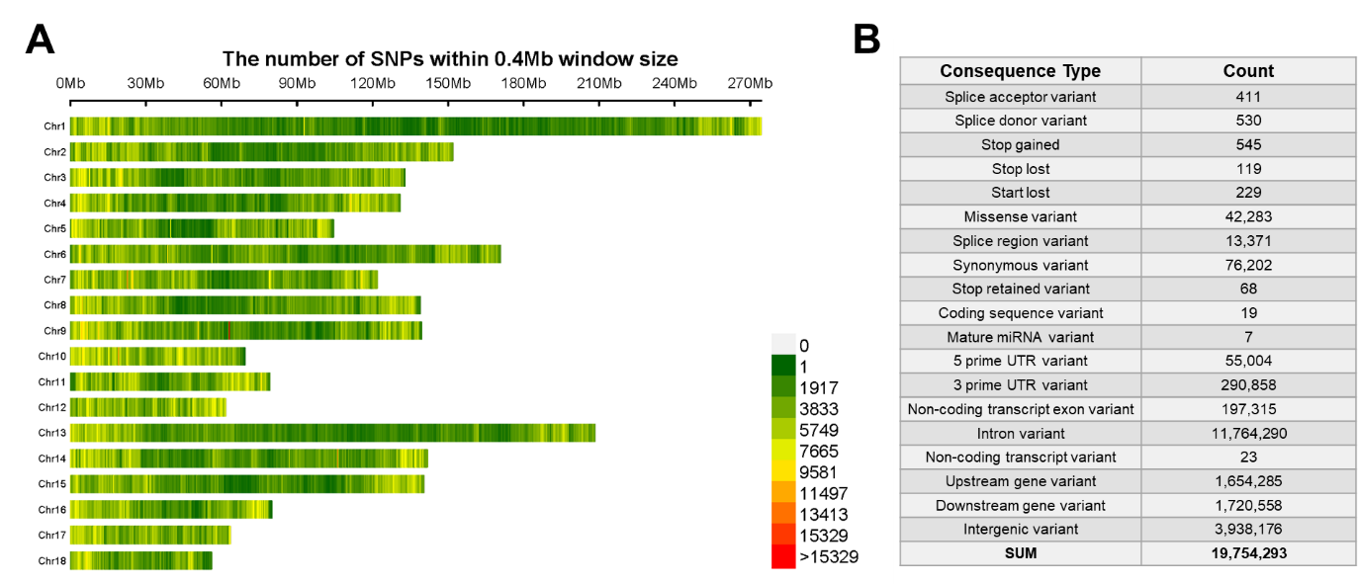

Figure S2. The distribution and functional classification of the Imputed single-nucleotide polymorphisms (SNPs)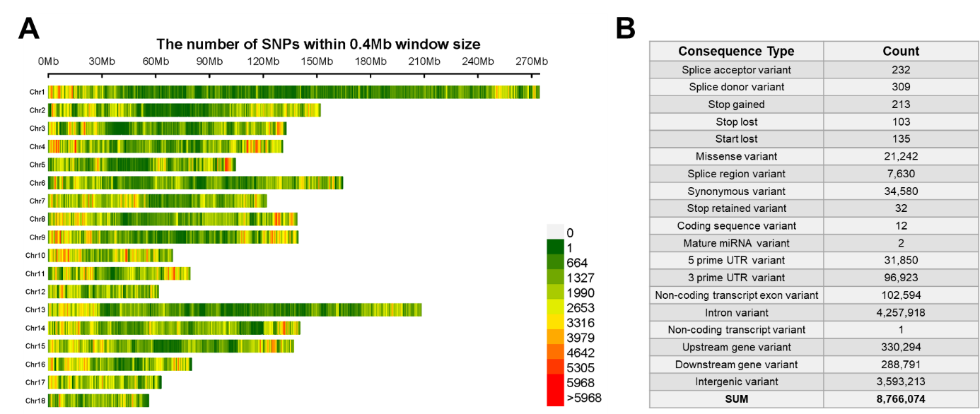

Figure S3. The venn diagram of the putative loci that associated with the number of left teats, right teats, and total teats
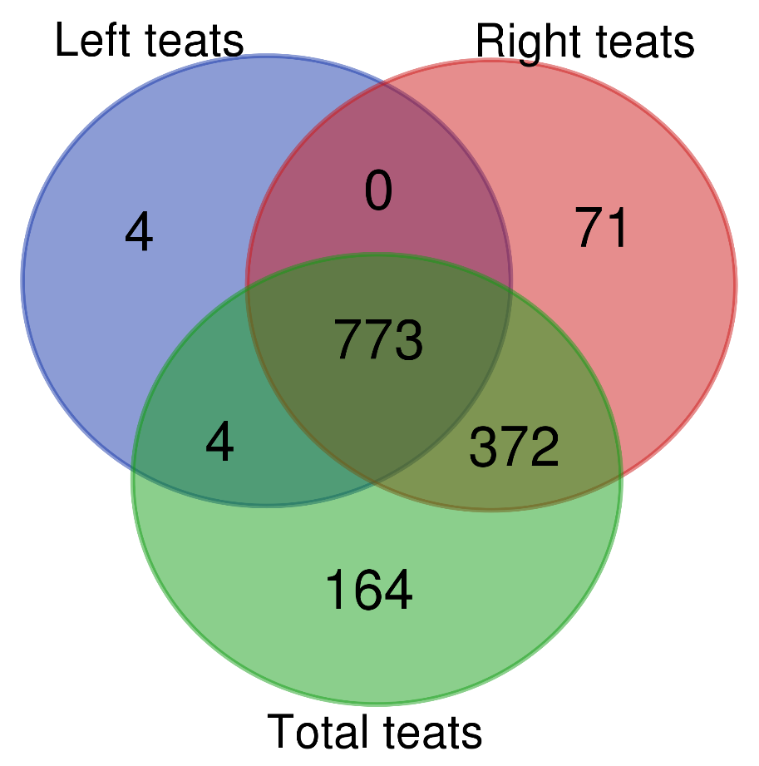

Figure S4. QTL enrichment results of GWAS on teat number relevant traits

Figure S5. Regional association plots around rs322980623. (A) GWAS result around rs322980623. (B) The θπ ratio around rs322980623. (C) pCADD values around rs322980623.
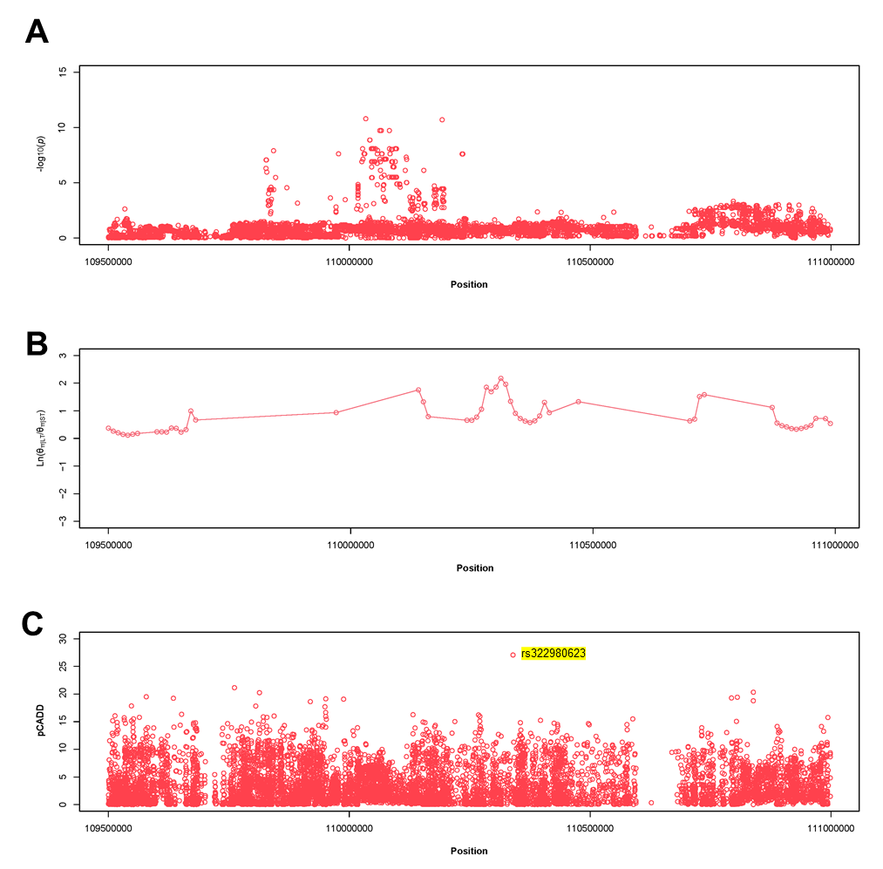

Figure S6. Regional association plots around rs324534752. (A) GWAS result around rs324534752. (B) The θπ ratio around rs324534752. (C) pCADD values around rs324534752.
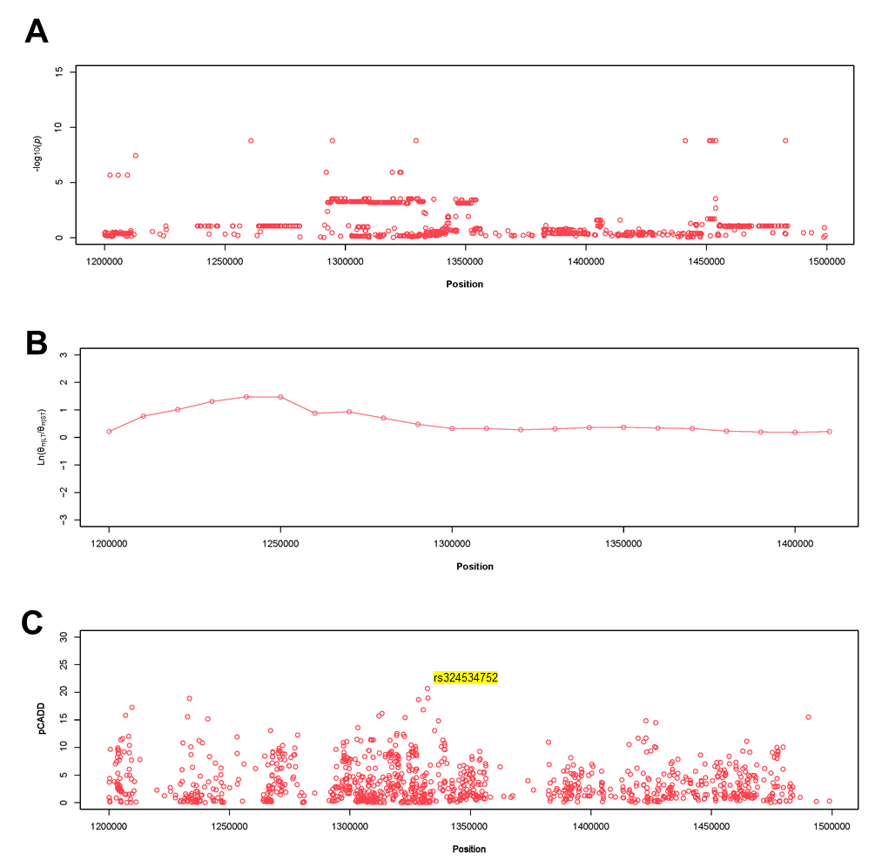

Figure S7. QTL enrichment results of the potential selection regions around rs346331089 (A), rs322980623 (B), and rs324534752 (C).
