Genetic polymorphisms impact response to clopidogrel in feline hypertrophic cardiomyopathy

Yu Ueda¹, Ronal H.L. Li², Nghi Nguyen², Eric S. Ontiveros³, Samantha L. Fousse³, Maureen S Oldach², Karen M. Vernau², Michael H. Court⁴, Joshua A. Stern³

- North Carolina State University, College of Veterinary Medicine, Department of Clinical Sciences, Raleigh, NC, USA
- University of California – Davis, School of Veterinary Medicine, Department of Veterinary Surgical and Radiological Sciences, Davis, CA, USA
- University of California – Davis, School of Veterinary Medicine, Department of Medicine and Epidemiology, Davis, CA, USA
- Washington State University, College of Veterinary Medicine, Department of Veterinary Clinical Sciences, Pullman, WA, USA

Supplement Table 1. Correlation analyses between platelet function tests and clopidogrel and clopidogrel metabolite concentrations measured after the 10-14 days of clopidogrel therapy in cats with HCM are listed as correlation coefficient (r) and the corresponding p-value. The values with a significant correlation (p < 0.05) are shown with asterisks.

 |  | Clopidogrel (ng/mL) | Clopidogrel acid (ng/mL) | CAM-D (ng/mL) | CAM-D metabolic ratio
Multiplate AUC % inhibition | r | -0.0039 | 0.15 | 0.24 | 0.088
 | p-value | 0.98 | 0.34 | 0.12 | 0.58
Multiplate AUC post-clopidogrel | r | -0.016 | -0.2 | -0.2 | 0.063
 | p-value | 0.92 | 0.19 | 0.18 | 0.69
Multiplate Aggregation % inhibition | r | 0.0067 | 0.15 | 0.22 | 0.1
 | p-value | 0.97 | 0.35 | 0.15 | 0.51
Multiplate Aggregation post-clopidogrel | r | 0.017 | -0.15 | -0.16 | 0.024
 | p-value | 0.91 | 0.32 | 0.32 | 0.88
Multiplate Velocity % inhibition | r | -0.074 | 0.055 | 0.14 | 0.1
 | p-value | 0.64 | 0.73 | 0.37 | 0.51
Multiplate Velocity post-clopidogrel | r | 0.19 | -0.26 | -0.2 | 0.63*
 | p-value | 0.2 | 0.07 | 0.17 | 0.0001
PVASP PRI % inhibition | r | 0.14 | 0.24 | 0.033 | -0.13
 | p-value | 0.39 | 0.14 | 0.84 | 0.41
PVASP MFI post-clopidogrel | r | -0.18 | -0.35* | -0.078 | 0.27
 | p-value | 0.23 | 0.0015 | 0.6 | 0.061
P-selectin % change of % change | r | -0.1 | 0.075 | 0.0063 | 0.31*
 | p-value | 0.53 | 0.65 | 0.97 | 0.046
P-selectin % change post-clopidogrel | r | 0.15 | 0.12 | -0.13 | 0.31*
 | p-value | 0.36 | 0.45 | 0.43 | 0.046

Supplement Figure 1. The means and 95% confidence intervals of (a) P-selectin percent change and (b) PRI derived from phosphorylated vasodilator-stimulated phosphoprotein (P-VASP) expression before and after 10-14 day course of clopidogrel treatment are noted with a blue solid line for cats with P2RY12:V34I wildtype (g/g) and a red solid lie for the P2RY12: V34I variants (g/a and a/a).

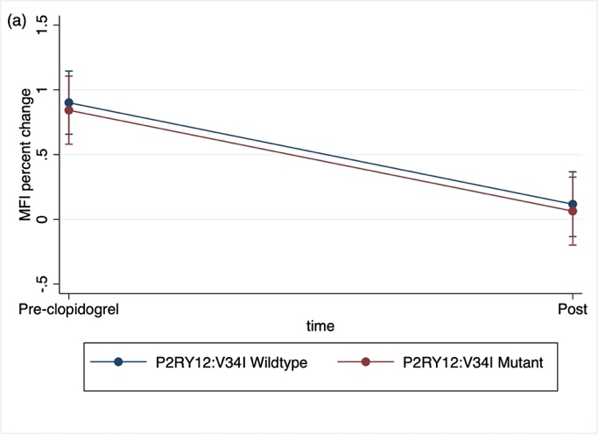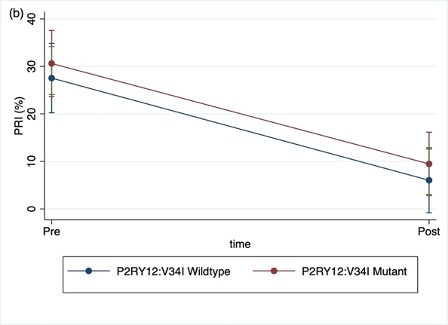

Supplement Figure 2. Comparison of (a) plasma derivatized clopidogrel active metabolite (CAM-D) concentrations and (b) calculated CAM-D metabolic ratio between different variants for the CYP2C41:H231R. The horizontal line represents the median, the box the 25th and 75th percentile, the whiskers the 1.5 times interquartile range, and the points outside the whiskers are outliers.

