APPENDIX A

CHROMATOGRAM OF EXTRACTS OF TWO SPECIESE OF HEDYSARUM
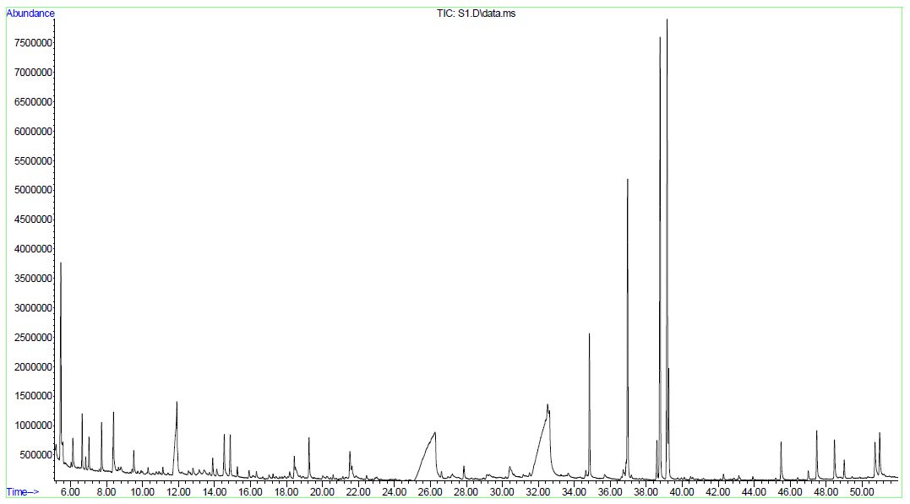
Figure - 1. Chromatogram of root extract of the Hedysarum neglectum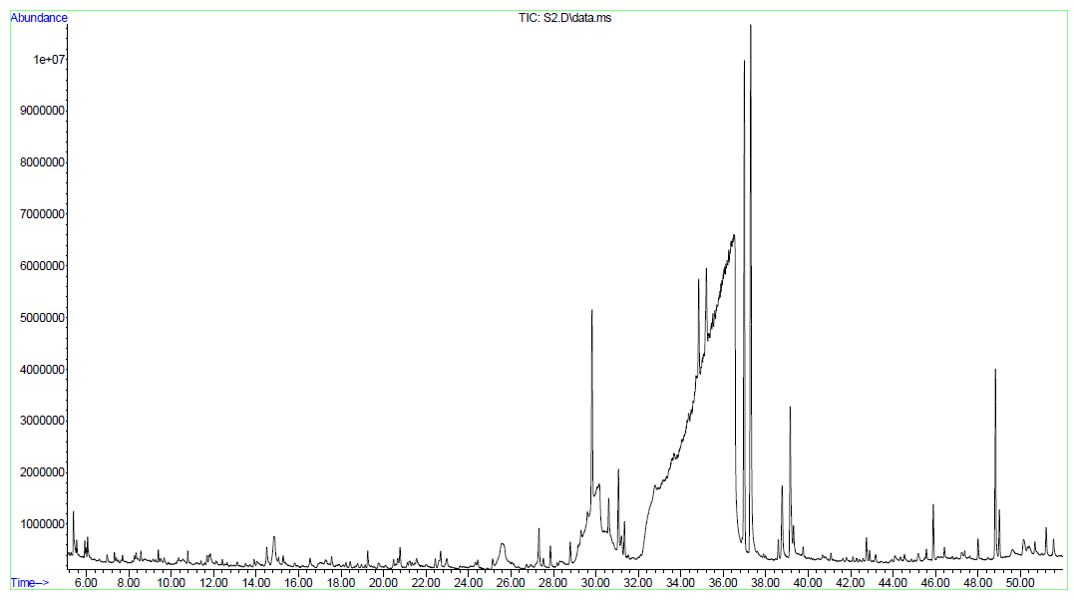
Figure - 2. Chromatogram of the extract of the aboveground parts of the Hedysarum neglectum
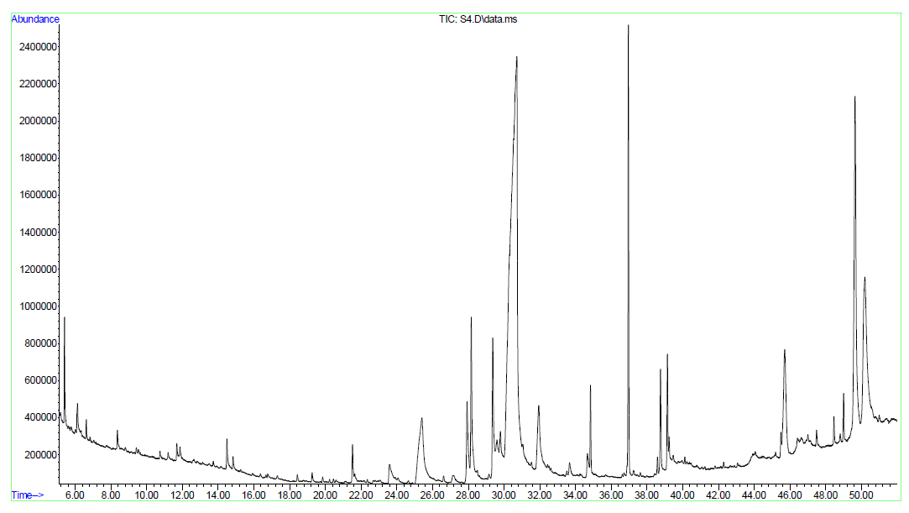
Figure - 3. Chromatogram of root extract of Hedysarum theinum
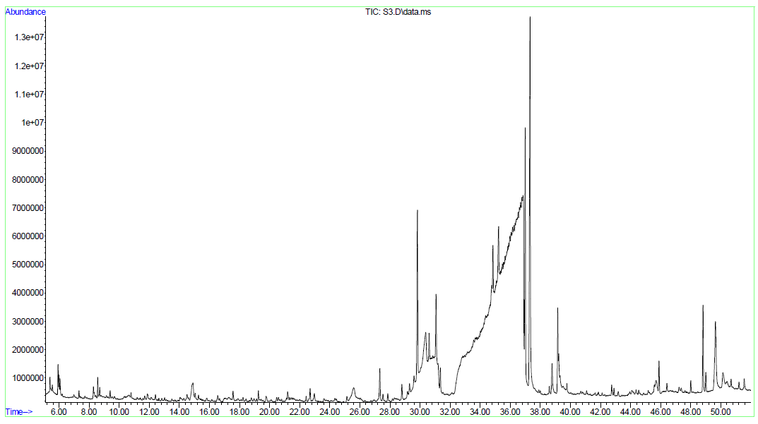
Figure - 4. Chromatogram of the extract of the aboveground parts of Hedysarum theinum

APPENDIX B
PHYLOGENETIC TREE OF NEIGHBOR-JOINING OF TWO TYPES OF HEDYSARUM BASED ON ITS SEQUENCING
– denotes Hedysarumspecies collected in Kazakhstan

Figure 1 - Phylogenetic tree of NJ species H. theinum and H. neglectum based on ITS sequencing

