Cover sheet for supplementary material for publication

Manuscript title: The contribution of atmospheric deposition to cadmium and lead accumulation in rice grains
Number of pages: 2
Number of tables: 1
Number of figure: 1

Tab. S1. Biomass of shoots and roots of rice at different growth stages
Fig. S1. Photosynthetic parameters of rice leaves at tillering and heading stage.

Shoot | Tillering Stage |  | Heading Stage |  | Ripening Stage
Shoot | XT | ZZ | XT | ZZ | XT | ZZ
T1-1 | 7.93±1.70 ab | 4.70±0.76 ab | 39.64±6.90 a | 36.01±6.98 a | 39.34±6.16 ab | 31.55±6.66 b
T2-1 | 9.15±0.71 a | 6.49±2.01 a | 28.01±7.62 b | 27.98±3.10 ab | 39.47±5.14 ab | 35.20±1.69 b
T3-1 | 7.56±1.89 ab | 6.01±1.58 ab | 30.45±4.71 ab | 30.17±5.12 ab | 46.51±6.25 a | 35.51±0.95 b
T4-1 | 6.11±0.46 b | 4.12±0.31 b | 39.89±1.62 a | 26.61±2.81 b | 36.78±2.87 b | 43.25±3.60 a

Root | Tillering Stage |  | Heading Stage |  | Ripening Stage
Root | XT | ZZ | XT | ZZ | XT | ZZ
T1-1 | 2.96±0.04 a | 1.74±0.08 b | 20.20±0.73 b | 17.55±0.40 b | 18.02±2.12 a | 21.13±1.22 a
T2-1 | 4.28±0.32 a | 4.24±1.04 a | 16.61±0.43 c | 18.41±0.66 ab | 16.88±0.63 a | 17.45±0.49 b
T3-1 | 3.19±1.33 a | 3.50±0.56 a | 22.54±1.45 a | 18.86±0.86 a | 18.82±0.16 a | 20.58±0.62 a
T4-1 | 3.57±0.97 a | 1.70±0.67 b | 19.12±1.00 b | 17.43±0.16 b | 17.24±0.91 a | 20.32±1.36 a
Table S1 Biomass (g plant⁻¹) of shoots and roots of rice at different growth stages

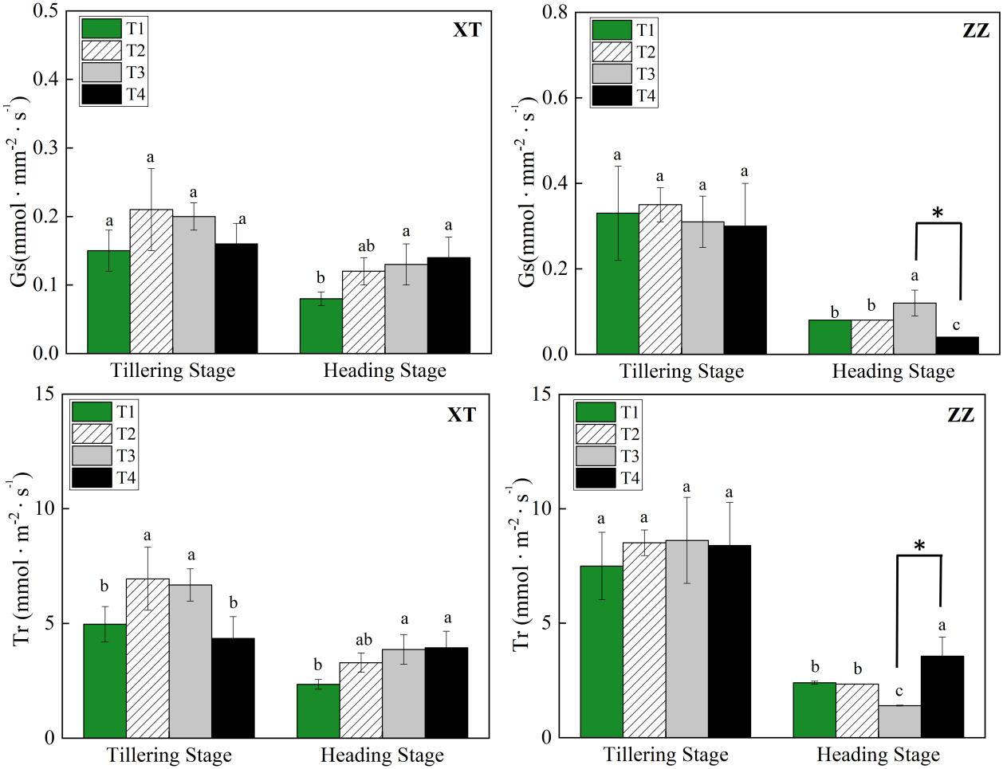
Fig. S1 Gs (stomatal conductance) and Tr (Transpiration rate) of rice leaves at tillering and heading stage. (data are means±SE, n=4). Lowercase letters indicate significant differences (p< 0.05) between the four exposure treatments in each growth stage.

