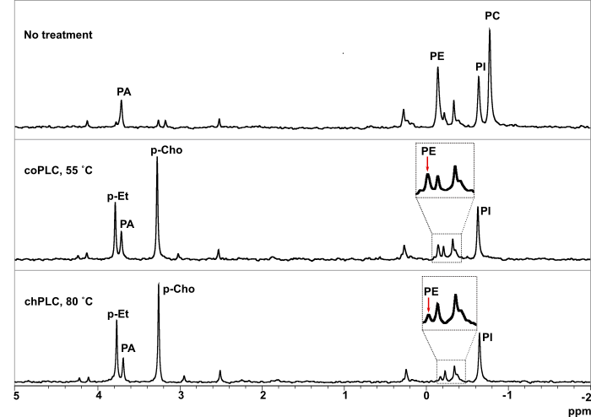
Supplementary Figure 1. ³¹P NMR analysis of crude oil treated with coPLC and 55 C and chPLC at 80 C. As observed, the peaks corresponding to PE and phosphoethanolamine indicate that the hydrolysis of this PL by chPLC is higher.

Enzyme cost | coPLC 55C | chPLC 80C | Incremental benefit
$ 8,00 | $ 5,49 | $ 11,64 | 112%
$ 6,70 | $ 6,79 | $ 12,42 | 83%
$ 5,00 | $ 8,49 | $ 13,44 | 58%
$ 3,30 | $ 10,19 | $ 14,46 | 42%
$ 2,00 | $ 11,49 | $ 15,24 | 33%

Supplementary Table 1. Sensitivity of enzymatic degumming net profit to variations in enzyme cost for a plant with a capacity of 100 thousand MT per year. Oil prices considered is $822.

Oil price | coPLC 55C | chPLC 80C | Incremental benefit | coPLC 55C FAS | chPLC 80C FAS | Incremental benefit
$ 1.500 | $ 22,05 | $ 27,00 | 22% | $ 12,45 | $ 17,40 | 40%
$ 1.300 | $ 18,05 | $ 23,00 | 27% | $ 9,73 | $ 14,68 | 51%
$ 1.100 | $ 14,05 | $ 19,00 | 35% | $ 7,01 | $ 11,96 | 71%
$ 900 | $ 10,05 | $ 15,00 | 49% | $ 4,29 | $ 9,24 | 115%
$ 822 | $ 8,49 | $ 13,44 | 58% | $ 3,23 | $ 8,18 | 153%
$ 700 | $ 6,05 | $ 11,00 | 82% | $ 1,57 | $ 6,52 | 315%
$ 500 | $ 2,05 | $ 7,00 | 241% | $ (1,15) | $ 3,80 | -

Supplementary Table 2. Sensitivity of enzymatic degumming net profit to variations in soybean oil price for a plant with a capacity of 100 thousand MT per year. Enzyme cost considered is $5 per MT dose.

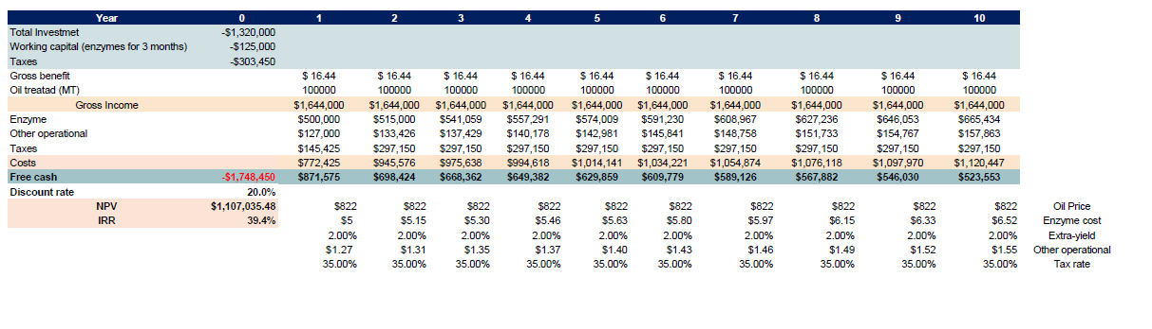
Supplementary Table 3. NPV and IRR analysis for the base scenario.

