Mesenchymal stromal cells in the bone marrow niche consist of multi-populations with distinct transcriptional and epigenetic properties

Sanshiro Kanazawa, Hironori Hojo, Shinsuke Ohba, Junichi Iwata, Makoto Komura, Atsuhiko Hikita, Kazuto Hoshi

Supplementary Figure 1
Graph-based Top Genes by Cluster.
Supplementary Figure 2
A comparison between cluster 4 and 1 in open chromatin signals.
Supplementary Figure 3
A comparison between cluster 4 and 5 in open chromatin signals.
Supplementary Table
Primers sequences for RT-PCR.

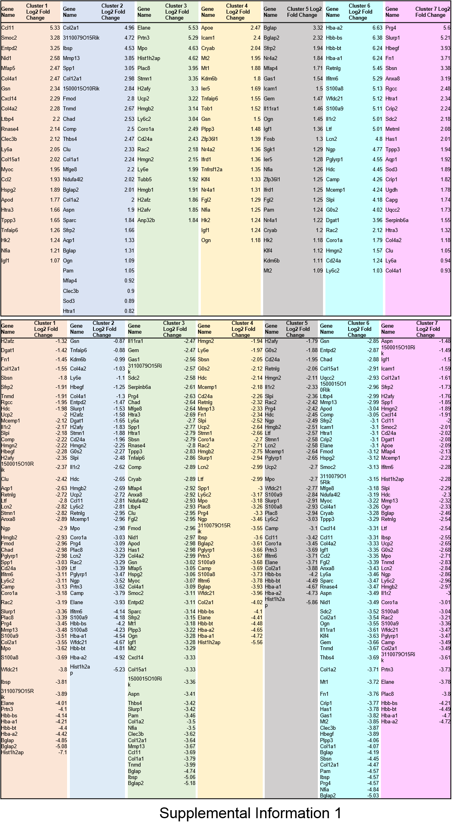
Supplementary Figure 1
Graph-based Top Genes by Cluster. These contains the union of the top 20 up and downregulated and differentially expressed genes for each cluster.

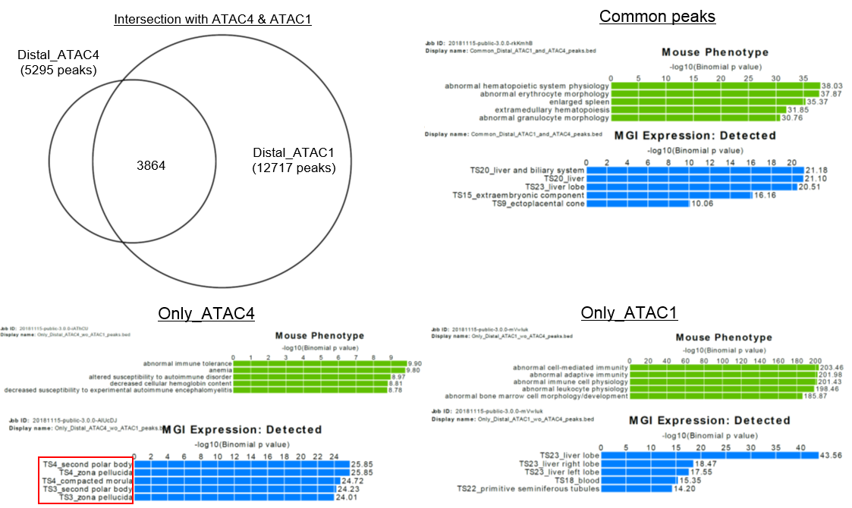
Supplementary Figure 2
A comparison between cluster 4 and 1 in open chromatin signals. In the ATAC-seq analysis, focusing on regions common to clusters 4 and 1, genes listed as genes associated with terms obtained by GREAT analysis and their expression were listed.

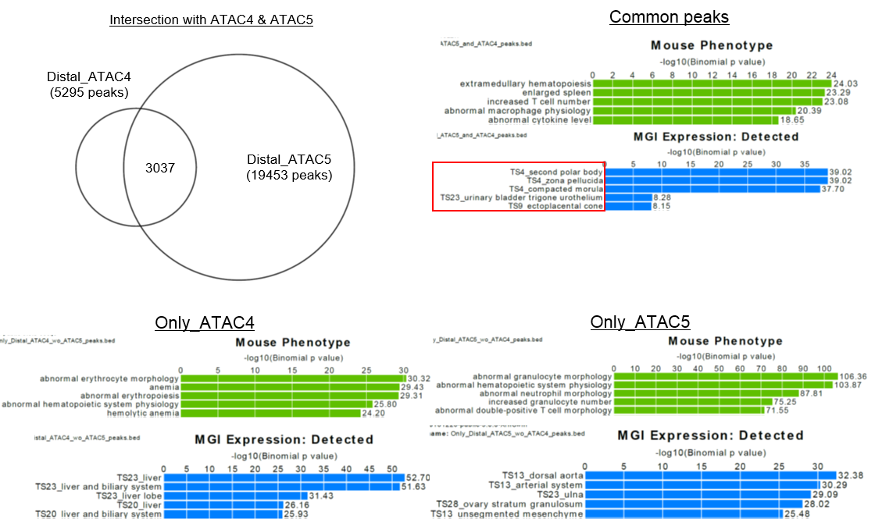
Supplementary Figure 3
A comparison between cluster 4 and 5 in open chromatin signals. In the ATAC-seq analysis, focusing on regions common to clusters 4 and 5, genes listed as genes associated with terms obtained by GREAT analysis and their expression were listed.

Gene name |  | Sequence
Gapdh | FW | 5'- CCACTAACATCAAATGGGGTGAGG -3'
 | RV | 5'- TACTTGGCAGGTTTCTCCAGGC -3'
Hprt | FW | 5'- TCAGTCAACGGGGGACATAAA -3'
 | RV | 5'- GGGGCTGTACTGCTTAACCAG -3'
Col2a1 | FW | 5'- TTGAGACAGCACGACGTGGAG -3'
 | RV | 5'- AGCCAFFTTGCCATCGCCATA -3'
Sox9 | FW | 5'- TCTCCTAATGCTATCTTCAAGGCG -3'
 | RV | 5'- TGCTCAGTTCACCGATGTCCAC -3'
Alp | FW | 5'- CACAATATCAAGGATATCGACGTGA -3'
 | RV | 5'- ACATCAGTTCTGTTCTTCGGGTACA -3'
Bglap | FW | 5'- GGGCAATAAGGTAGTGAACAG -3'
 | RV | 5'- GCAFCACAFFTCCTAAATAGT -3'
Adipoq | FW | 5'- TGTTCCTCTTAATCCTGCCCA -3'
 | RV | 5'- CCAACCTGCACAAGTTCCCTT -3'
Pparg | FW | 5'- ACCACTCGCATTCCTTTGAC -3'
 | RV | 5'- TGGGTCAGCTCTTGTGAATG -3'

Supplementary Table
Primers sequences for RT-PCR.

