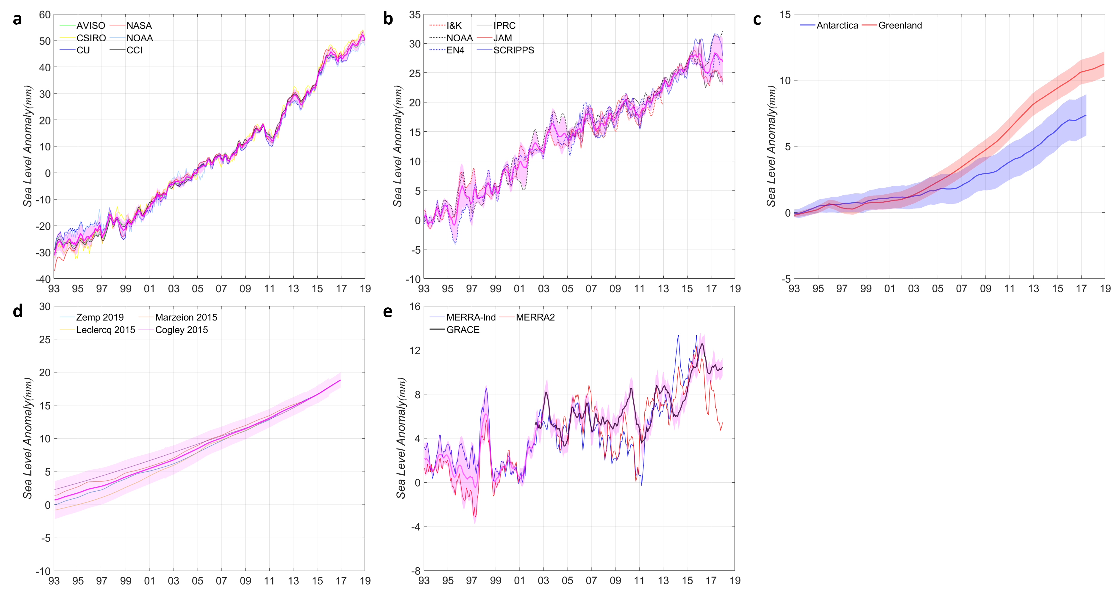
Supplementary Figure. 1 | GMSL changes. a-e, Each component of GMSL budget for satellite altimetry (a), steric (b), Antarctica and Greenland Ice Sheets (c), Glacier (d), and land water storage (e). The uncertainties of each component are shown in coloured shades (see Methods).

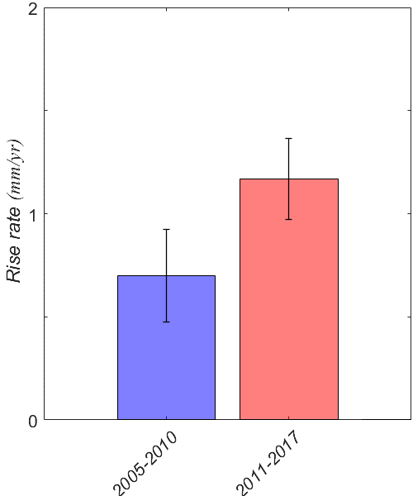
Supplementary Figure. 2 | Argo-derived steric sea level trends. Steric sea level trends based on averaged three Argo products over 2005-2010 (Left) and 2011-2017 (Right). Error bars represent 95% confidence intervals estimated from slopes of uncertainty.

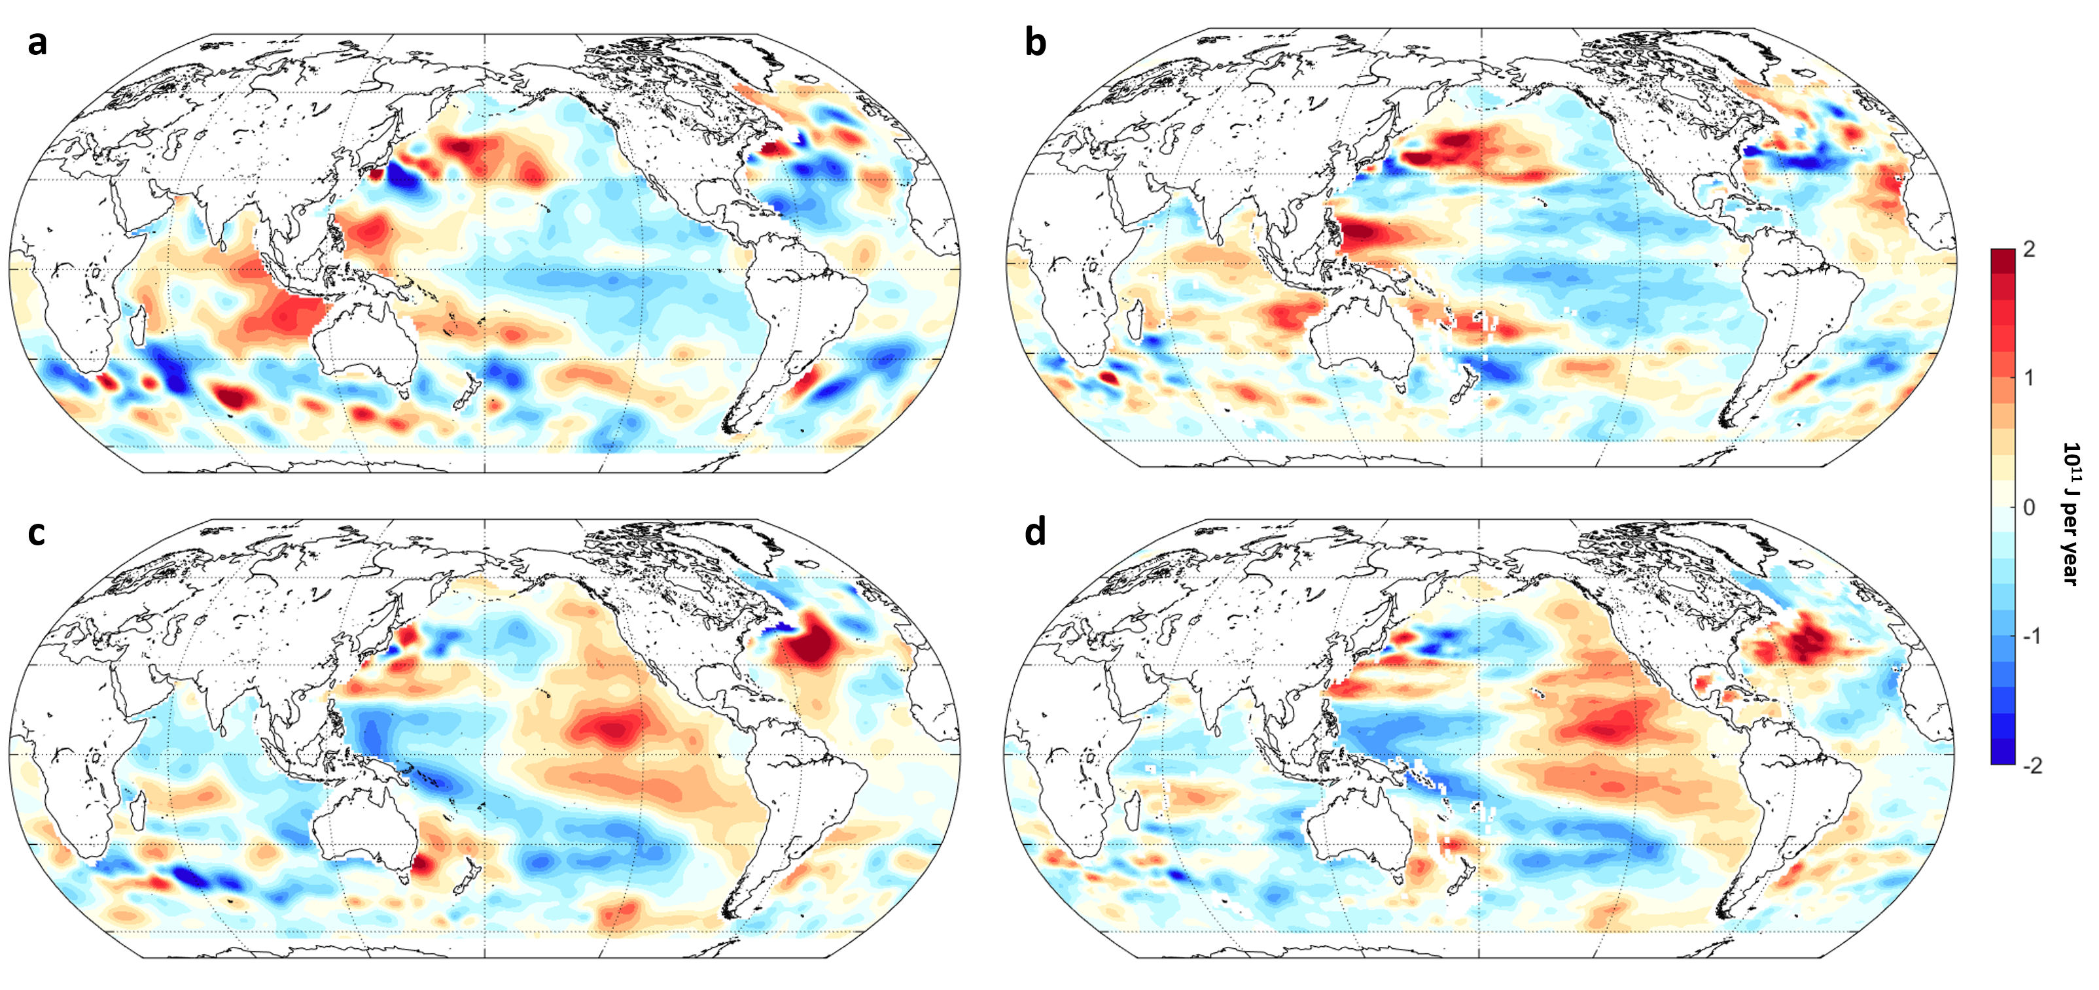
Supplementary Figure. 3 | Argo-derived OHC trends. (a, b) 2005-2010. (c, d) 2011-2017. Global maps of upper-2000 m OHC trends based on IPRC (a, c) and JAMSTEC (b, d).

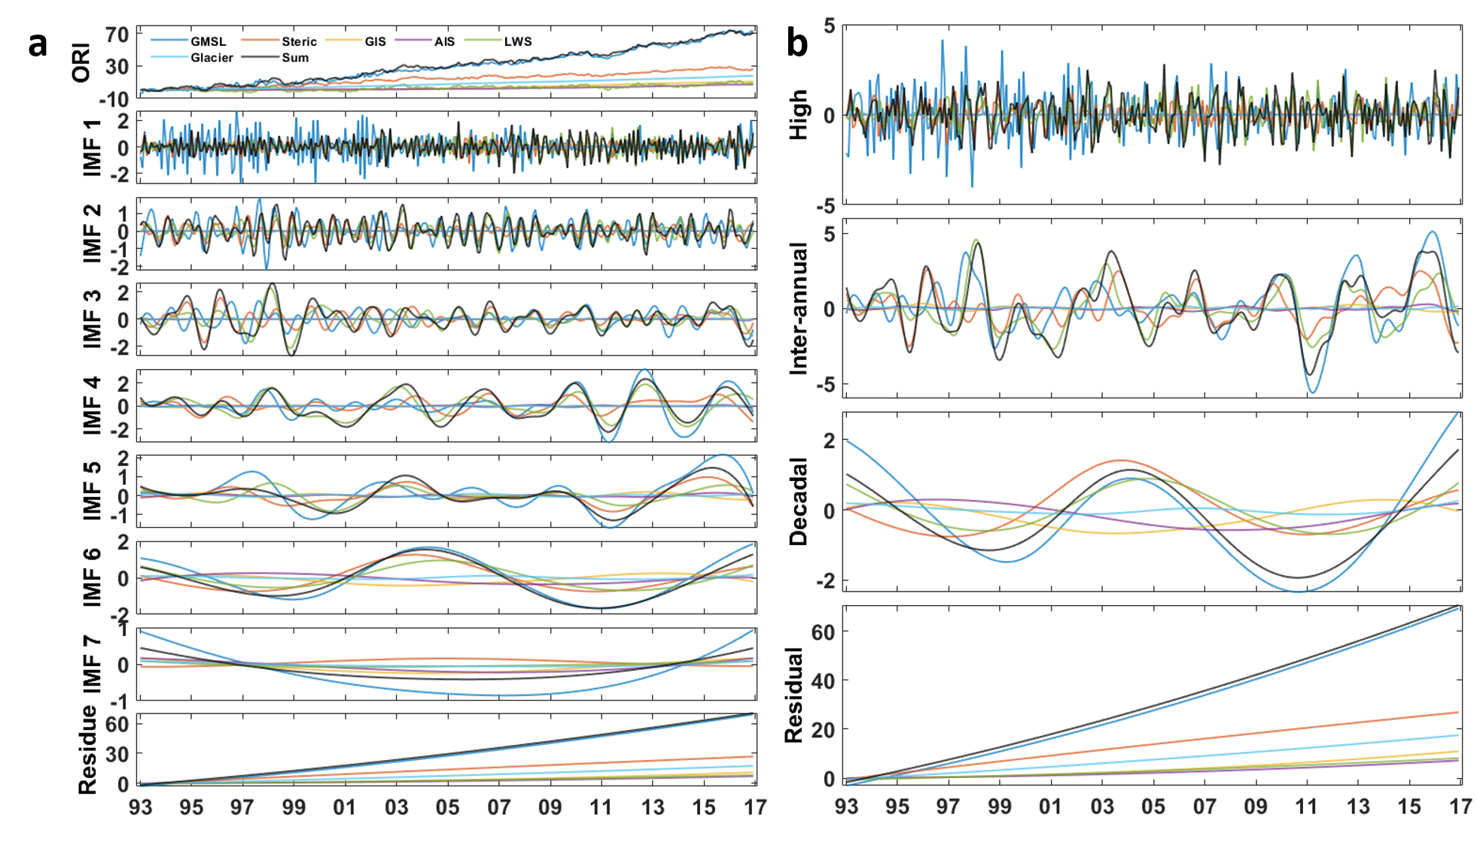
Supplementary Figure. 4 | EEMD results for all components of sea-level budget. (a) All of the original monthly data (top) are decomposed into seven intrinsic mode functions (IMFs) and the resulting trends (bottom) in ascending order. (b) Four major time-scale components representing high-frequency (IMFs 1–2), ENSO-scale frequency (IMFs 3–5), decadal-scale frequency (IMFs 6–7), and residual.

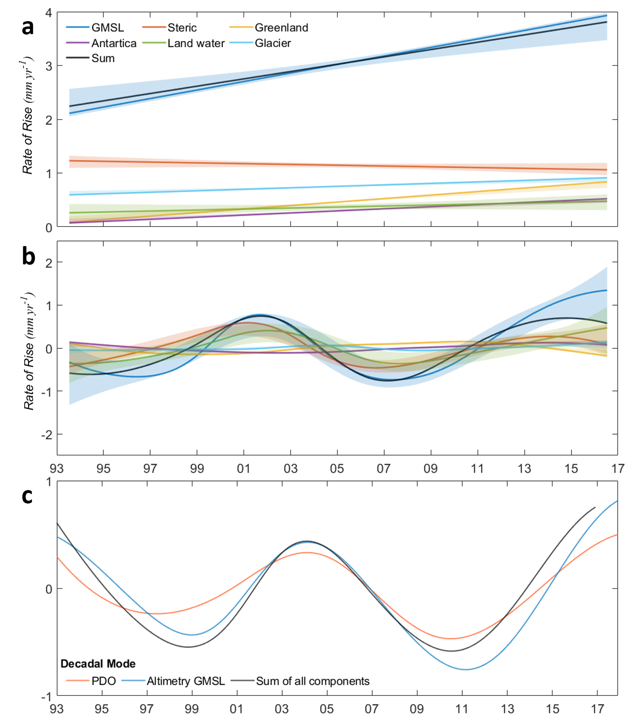
Supplementary Figure. 5 | The instantaneous rate of GMSL and decadal mode of PDO. (a) The instantaneous rate of GMSL trend from EEMD analysis. (b) The instantaneous rate of GMSL decadal-scale of each component. A bootstrap method based on random resampling to estimate confidence intervals (colored shades) is used to test the significance (see Materials and Methods). (c) EEMD-determined decadal-scale variability of PDO (red), altimetry GMSL (blue), and the sum of all components (black). The decadal-scale variability of PDO is separated by EEMD decomposition from the original PDO index (available at http://research.jisao.washington.edu/pdo/). The decadal modes for the sea-levels are normalized to directly compare with the PDO signal.

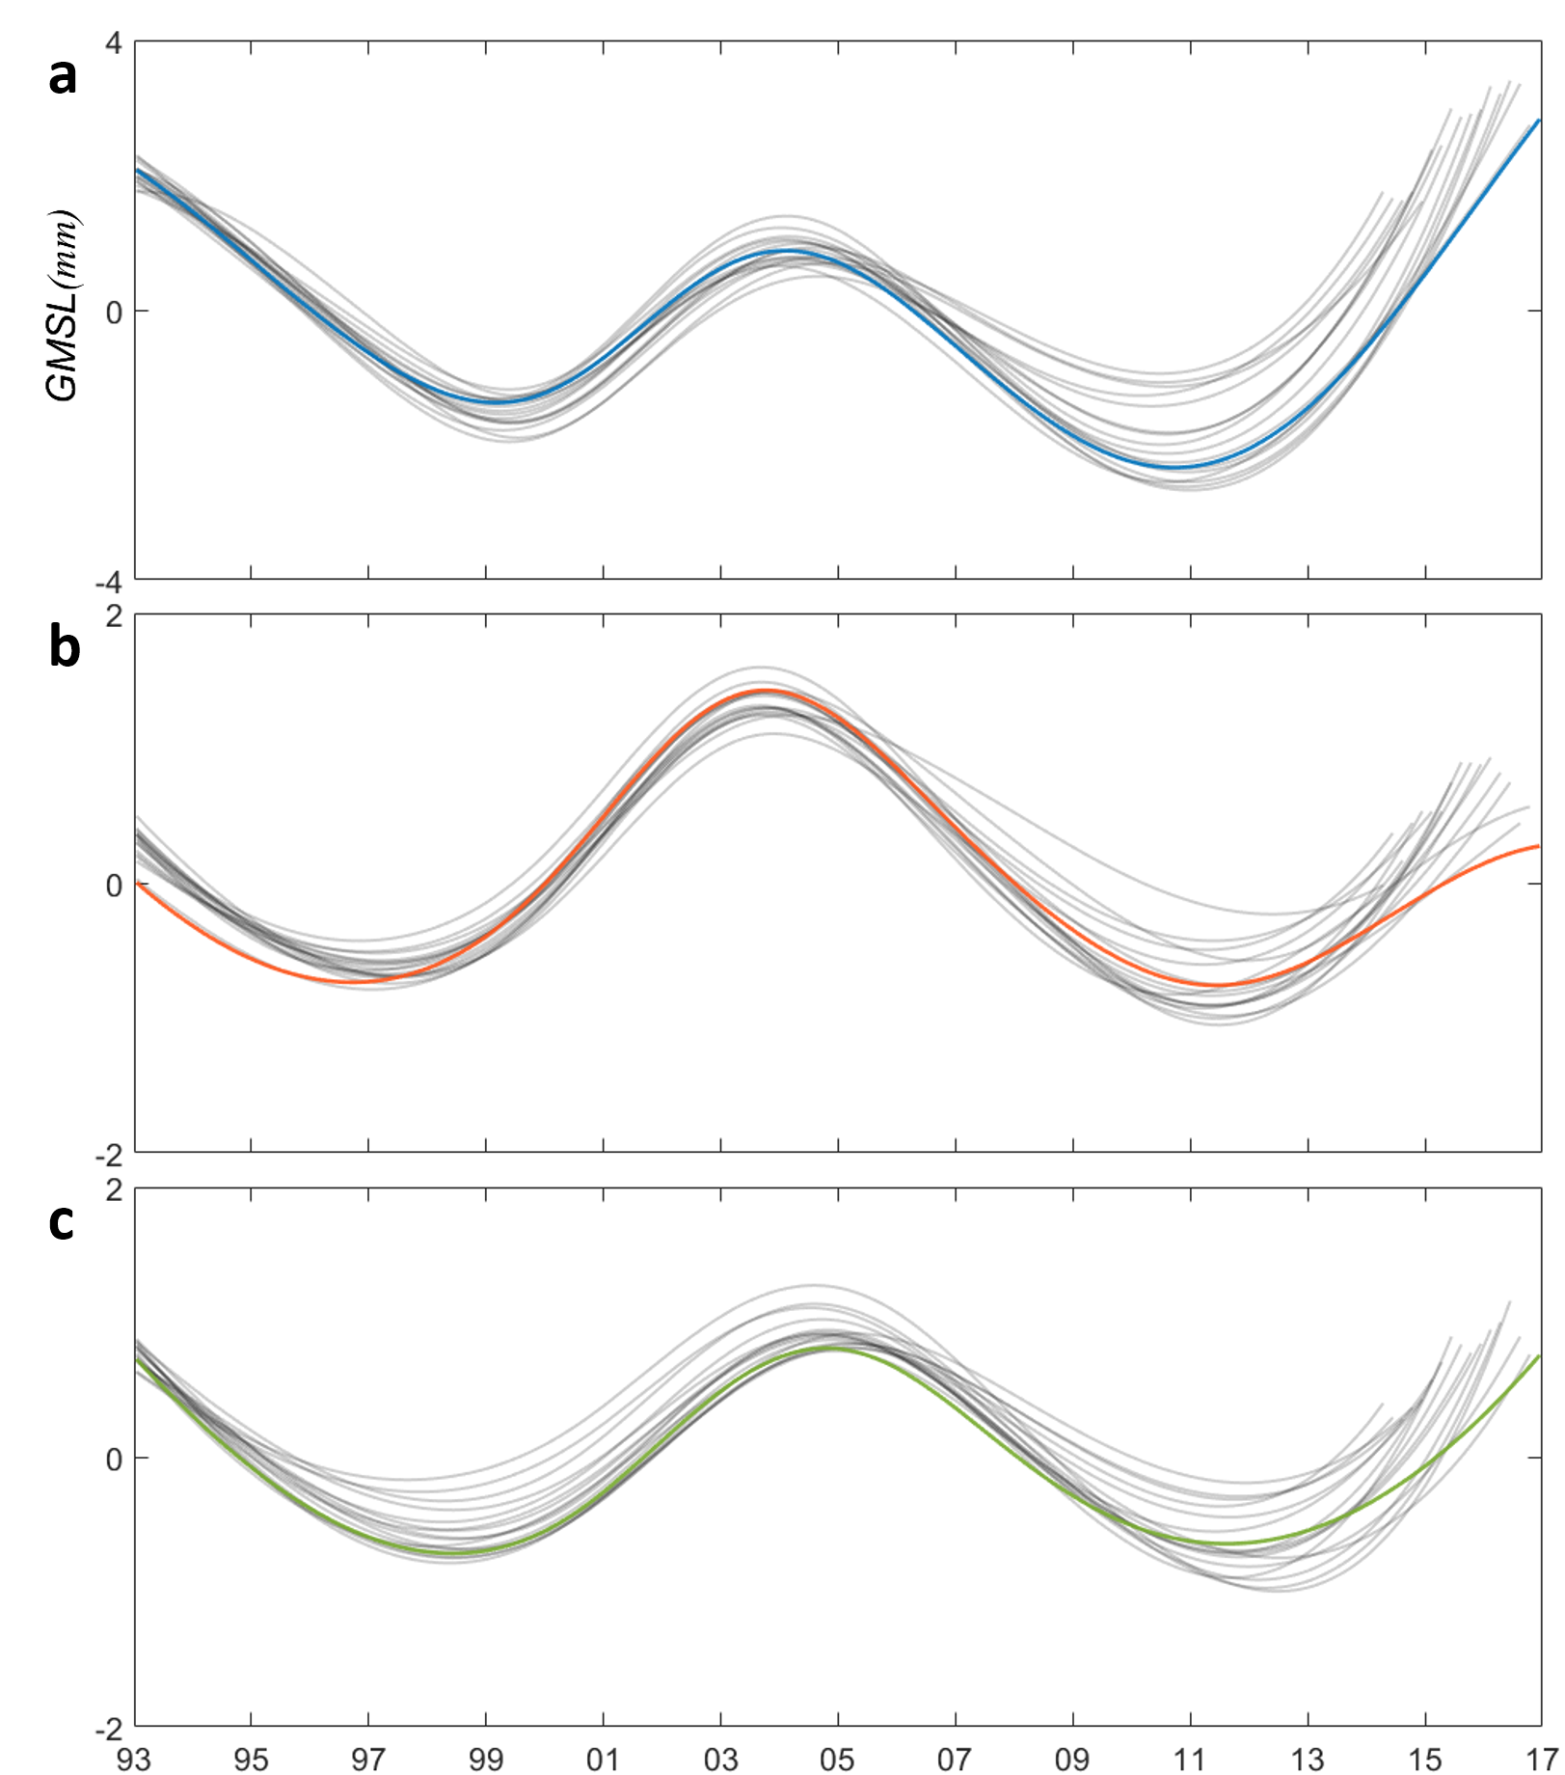
Supplementary Figure. 6 | Robustness of decadal-scale variability. Decadal modes of the full record length from (a) satellite altimetry-based GMSL, (b) steric sea level, and (c) LWS components and incrementally shortened records (grey lines) of each component by removing 0–3 years of data from the end of the time series.

